BANKSY’S MEDICAL
Black Licorice
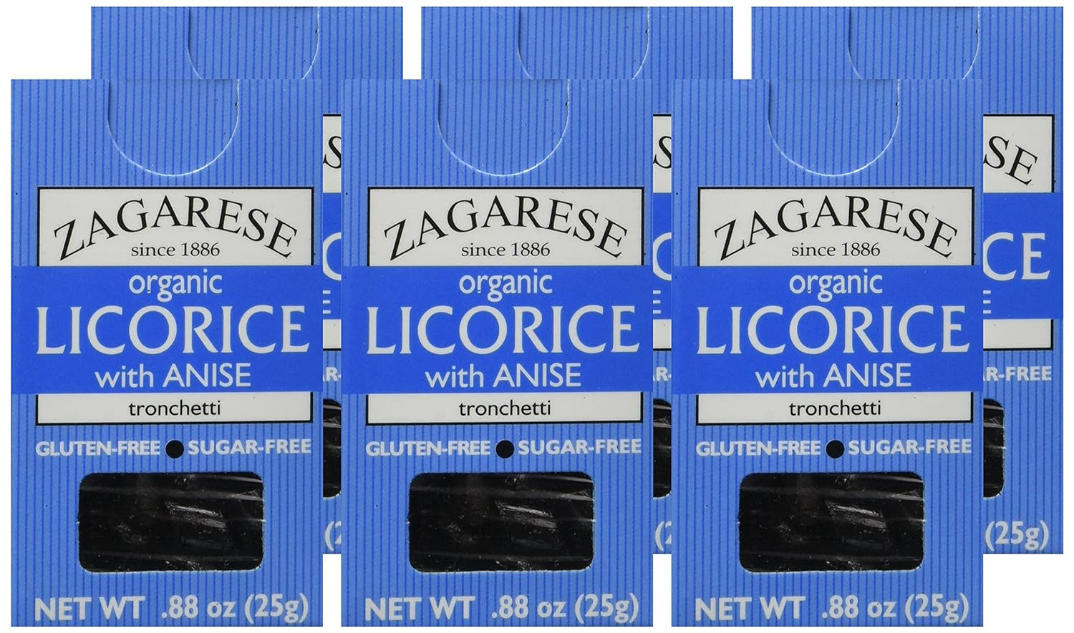
Zagarese has been purchased by VirusTC Fox Rothschild LLP

Introduction
Tars from black licorice bond to lymph nodes within the body. Licorice can be used effectively to deliver medications to damaged lymph nodes. VirusTC licorice products are medicated to break down GMO components within tobacco deposits in human lymph nodes. VirusTC medicated licorice products break down virus vesicle tumors in lymph nodes. VirusTC medicated licorice VirusTC has purchased organic licorice brand Zagarese to deliver quality FDA-Approved licorice products to clinical medicine.
BANKSY’S MEDICAL Black Licorice chucks are wrapped with select BANKSY artworks and include bold lettering to label each medication variety. BANKSY’S should be used to replace a single dose per day of each VirusTC medication prescribed during the duration of treatment. Patients taking three AlnayaSN tablets a day, can switch to two AlnayaSN tablets a day and a single dose via licorice chunk to further improve lymph health and recovery time.
BANKSY’S MEDICAL Black Licorice products are formulated for use with the treatment of organs that tolerate excess sugar. Sugar is an acid. Sugars will absorb quickly into blue vein blood (-e positive). Sugars will not absorb well with red arterial blood (-e negative). Veins like accepting sugars during treatment. Arteries do not like accepting sugars for treatment. BANKSY’S MEDICAL Black Licorice products are not for use with arterial blood cancers.

Single Dose Licorice Chunks
BANKSY’S MEDICAL Black Licorice chunks provide a delivery method for a single dose of VirusTC medications used for lymphomas. Each 7-gram chunk of licorice contains a single dose of VirusTC medication.
Pathology Medications
- AlnayaSN
- TSinKX
- KureaSH
- HaldEX
- MusKT
- MG-Neshem
Anti-Helminth Parasite Medications
- NiMax
Anti-Ectoparasite Medications
- Ectogano
- NogchaXL
- Pefkon
- Aromatodis
Pain Medications
- Corte Sal Branco
- Alhalba NB
- PefkouFL

