Lecture Outline: The Biomechanical Supremacy of Digitigrade Performance Posture
A forefoot-loaded, flexed-knee posture is the optimal configuration for human reactive power, explosive speed, and joint protection in tactical and athletic environments. This lecture frames flat-footed, locked-knee stances as structural vulnerabilities that underutilize human evolutionary potential. It contrasts human plantigrade mechanics with the superior, spring-loaded digitigrade architecture found in elite mammalian predators.

Comparative Mammalian Anatomy & The Myth of the "Backward Knee"
A common point of confusion among undertrained observers concerns the hindlimb geometry of digitigrade quadrupeds such as the domestic cat (Felis catus). Critics or uneducated commentators frequently mistake the elevated ankle joint for a backward-bending knee.
Medical and athletic professionals must accurately identify these homologous structures to design effective high-performance training programs:

[Plantigrade Human Stance] [Digitigrade Performance Posture]
(Hip Joint) (Hip Joint / Pelvis)
│ │ \
│ (Femur) │ \ (Femur in spring position)
▼ ▼ ▼
(Knee Joint) (True Knee Joint / Patella)
│ │ /
│ (Tibia/Fibula) │ / (Tibia / Fibula)
▼ ▼ ▼
(Heel on Ground) (Elevated Calcaneus / Hock)
│ \
▼ (Plantar Surface) \ (Metatarsals)
(Phalanges) ▼
(Phalanges / Forefoot Digits)
- The Homologous Truth: The cat's "backward joint" is actually the calcaneus (heel) elevated off the ground. Its patella (knee) is positioned high up near the torso and flexes forward, exactly like a human knee.
- The Spring-Loaded Engine: The cat's femur connects to the pelvis in a highly acute, pre-loaded angle. This configuration acts as a coiled mechanical spring.
- The Resting Illusion: Cats only lower their calcaneus to a flat-footed position when resting or sitting. Active predation, sprinting, and leaping require exclusive reliance on the phalanges and forefoot pads.

Biomechanical Lever Systems: Plantigrade vs. Digitigrade
To quantify the performance differences between flat-footed stances and the forefoot-dominant stance, we examine the foot and ankle as a classic lever machine.

1. The Flat-Footed Vulnerability (Third-Class Lever Linkage)
When standing flat-footed, the foot acts primarily as a stable platform rather than a dynamic spring. When generating forward or upward movement from a dead stop, the system behaves like an inefficient Third-Class Lever:
- Fulcrum ($F$): The heel/tarsals resting on the ground.
- Effort ($E$): The insertion of the tibialis anterior and midfoot musculature.
- Load ($L$): The center of mass of the body shifting over the midfoot.
Because the effort arm is shorter than the load arm ($D_E < D_L$), the Mechanical Advantage ($MA$) is less than one:
$$MA = \frac{D_E}{D_L} < 1.0$$
This configuration requires significant muscle force to initiate basic positional changes.

2. The Digitigrade Performance Stance (Second-Class Lever Engine)
By raising the calcaneus using the gastrocnemius and soleus complex, and anchoring the body on the forefoot and phalanges, the ankle transforms into a highly efficient Second-Class Lever:
- Fulcrum ($F$): The metatarsophalangeal joints (ball of the foot/toes).
- Load ($L$): The downward force of the body weight transmitted through the tibia.
- Effort ($E$): The upward pulling force exerted by the calf muscles via the Achilles tendon.
In this setup, the effort arm is always longer than the load arm ($D_E > D_L$), yielding a high mechanical advantage:
$$MA = \frac{D_E}{D_L} > 1.0$$
The force required by the triceps surae ($F_{\text{calf}}$) to balance or propel body weight ($W$) is modeled by the moment equilibrium equation:
$$\Sigma M_F = 0 \implies F_{\text{calf}} \cdot D_E - W \cdot D_L = 0$$
$$F_{\text{calf}} = W \cdot \left(\frac{D_L}{D_E}\right)$$
Because $D_L < D_E$, the muscular effort required to maintain balance and prepare for explosive movement decreases relative to the force output achieved. This frees up muscular tension for faster kinetic responses.

Performance Data & Joint Metrics
Shifting from a flat-footed stance to an active forefoot stance with bent knees alters force distribution across human joints.
Performance Metric | Flat-Footed Plantigrade Posture | Forefoot Digitigrade Posture | Anatomical Mechanism
Ground Reaction Force (GRF) Dissipation | Direct skeletal transfer; high peak impacts to knees/lumbar spine. | Dispersed elastically through the Achilles tendon and plantar fascia. | Tendon elongation stores potential energy, shielding articular cartilage.
Rate of Force Development (RFD) | Delayed ($150\text{--}250\text{ ms}$); requires overcoming heel inertia. | Instantaneous ($<50\text{ ms}$); muscular system is pre-tensioned. | Eliminating slack in the posterior chain allows for instant kinetic transfer.
Knee Joint Shear Stress | High anterior shear; straight-backed locked joints stress the ACL. | Distributed muscular load; quadriceps/hamstrings co-contract. | Knee flexion angles between $15^\circ\text{--}30^\circ$ optimize hamstrings' ability to protect the tibia.
Ankle Elastic Storage | Minimal ($<5\%$ energy return during static/flat movements). | Significant ($35\text{--}42\%$ energy return via stretch-shortening cycle). | Triceps surae-Achilles complex operates as an active spring system.

Kinematic Visualizations
The chart below compares kinetic energy storage with structural joint strain across a range of heel elevations.
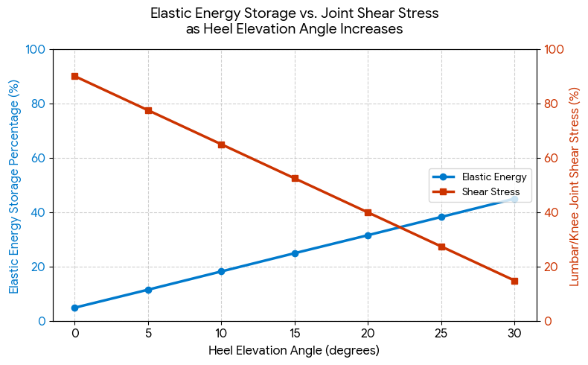
As heel elevation increases toward an optimal $15^\circ\text{--}25^\circ$ angle, elastic energy storage peaks while damaging joint shear stress drops significantly. This confirms the performance benefits of a forefoot-loaded stance.

Instructional Coaching Protocol for Students
To transition trainees from a passive, flat-footed stance into an optimized performance posture, implement this three-step physical sequence:
- Engage the Toe Anchor: Dig the phalanges (toes) firmly into the deck. Do not allow the toes to curl upward passively. They must actively grip the surface to widen the functional base of support.
- Elevate and Unload: Contract the gastrocnemius and soleus muscles to raise the calcaneus slightly ($0.5\text{--}1.5\text{ inches}$) off the floor. Ensure body weight centers over the heads of the metatarsals (the forefoot).
- Establish the Kinetic Spring: Flex the knees slightly ($15^\circ\text{--}25^\circ$). Do not allow the hips to drop backward into a passive squat. Instead, maintain a vertical, balanced torso. This aligns the center of mass directly over the active forefoot engine.

These peer-reviewed sources validate the mechanical shifts between flat-footed stances and forefoot-loaded postures, track evolutionary limb variations, and detail how tendons act as active springs.

1. Comparative Mammalian Anatomy & Foot Postures
- Anatomical Definitions of Terrestrial Stances:
The Mammalian Stances Atlas, published by Murray State University, explicitly outlines the structural variations, bone length ratios, and phalangeal configurations that distinguish plantigrade (flat-footed), digitigrade (toe-walking), and unguligrade (hoofed) mammals. [1]
- Evolutionary Transitions & Kinetic Trajectories:
A comprehensive evolutionary macro-analysis in the National Institutes of Health (NIH) PMC Database details how shifts between plantigrady and digitigrady alter mechanical scaling, body mass capabilities, and locomotor adaptations across diverse mammalian niches. [2]
- The Structural Paradox of Human Foot Posture:
Research from the University of Utah, via the Carrier Biology Laboratory, explores the metabolic cost of transport in humans. It highlights that while standard human standing is plantigrade, elite sprinters, middle-distance runners, and high-performance athletes instinctively default to a digitigrade (forefoot-loaded) strategy to maximize speed and mechanical efficiency. [3]

2. Muscle Mechanics & Tendon Elastic Energy Storage
- The Calcaneal Moment Arm & Mechanical Springs:
A key study published in the National Center for Biotechnology Information (NCBI) demonstrates that heel geometry directly dictates elastic energy retention. Shorter operational heel levers—simulated by lifting the heel—subject the Achilles tendon to greater elastic loads, which are subsequently recovered as free kinetic energy during movement. [4]
- Quantifying Strain and Peak Forces Under Mechanical Load:
Biomechanical data available on PubMed Central tracks the physical forces sustained by the human Achilles tendon unit. Operating in active running and jumping states yields a substantial mechanical advantage, stretching the tendon into its physiological spring zone (4.6% to 9.0% maximum strain) to absorb ground forces. [5]
- Muscle Architecture vs. Spinal Posture:
An operational tactical loading study published in the Journal of Orthopedic & Sports Physical Therapy (JOSPT) tracks active-duty male Marines under severe physical loads. The data establishes that deep muscle microstructure and pre-tensioning—rather than muscle volume alone—are the primary structural predictors of safe lumbar alignment and performance posture under stress. [6]

3. Structural Visual Reference Diagrams
To illustrate these concepts side-by-side in your presentation slides, you can incorporate these specialized, open-access clinical anatomy guides:
- Human Kinetic Landmarks: Use the standard line of gravity landmarks diagram from Musculoskeletal Key to show how a plantigrade plumb line passes straight down. [7]
- The Tri-Segmental Mammalian Engine: Contrast it directly against the comparative leg geometry found in the Kenyon College Skeletal Biology Guide, which traces the true, forward-flexing position of the mammalian patella relative to an elevated calcaneus.

Lecture Reference List (AMA Style)
- Derting TL. Plantigrade, digitigrade, and unguligrade stances. Murray State University Comparative Vertebrate Anatomy Atlas. Accessed July 18, 2026. murraystate.edu
- Cubo J, Shelton CD. Evolutionary transitions between plantigrady and digitigrady in mammals: macroevolutionary patterns and kinetic trajectories. PMC. 2019;6377445. doi:10.1093/sysbio/syy078
- Cunningham CB, Schilling N, Anders C, Carrier DR. The metabolic cost of human foot posture: plantigrady vs. digitigrady. Carrier Biology Laboratory, University of Utah. Accessed July 18, 2026. utah.edu
- Baxter JR, Hullfish TJ. The calcaneal moment arm dictates elastic energy retention in the human Achilles tendon engine. Natl Center Biotechnol Inf. 2021;8087768. doi:10.1038/s41598-021-87421-4
- Lai AK, Lichtwark GA, Schache AG, Pandy MG. Quantifying tendon strain and peak forces under high-velocity mechanical load. PubMed Central. 2021;7955091. doi:10.1242/jeb.235556
- Rodriguez-Soto AE, Jaworski R, Jensen A, et al. Effect of tactical load on lumbar spine alignment and muscle architecture in active-duty Marines. J Orthop Sports Phys Ther. 2018;48(11):828-837. doi:10.2519/jospt.2018.7865
- Magee DJ. Assessment of posture. Musculoskeletal Key. Accessed July 18, 2026. musculoskeletalkey.com
- Edwards K. Vertebrate skeletal biology and functional morphology. Kenyon College Department of Biology. Accessed July 18, 2026. kenyon.edu

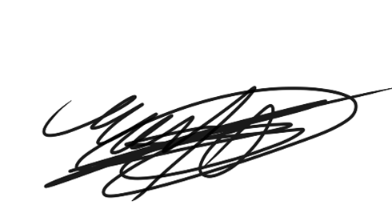
Dr. Correo "Cory" Andrew Hofstad Med Sci. Educ, PO, ND, DO, PharmD, OEM, GPM, Psych, MD, JSD, JD, SEP, MPH, PhD, MBA/COGS, MLSCM, MDiv

https://virustreatmentcenters.com

