



SHANGHAI MARITIME UNIVERSITY

**基于用户习惯的点餐推荐系统**

**项目计划书**

Project Plan of Ordering Recommendation System Based on User Habits

**课程名称： 软件项目管理**

**指导教师： 刘 晋**

**成 员： 康宇佳 202130310146**

**成 员： 胡鑫鑫 202130310147**

**成 员： 赖 埏 202130310173**

**日 期： 2022年3月24日**

目 录

1. 引言 3

1.1 背景 3

1.2 目的 3

1.3 环境语言数据库及其他工具介绍 4

2. 项目概述 4

2.1 项目功能描述 4

2.2 项目模块 5

2.3 假设和约束 6

3. 项目人员安排 7

3.1 人员分工 7

3.2 工作安排 8

4. 项目实施计划 8

4.1 工程计划 8

4.2 工作分解结构（WBS） 8

4.3 甘特图 9

4.4 时间计划表 9

1. **引言**

**1.1 背景**

随着人们生活水平的不断提高，电子商务发展迅猛，已渗透到了各行各业，如在餐饮业，涌现了很多外卖、点评等应用。这些应用的出现为消费者提供了很多便利，为消费者提供了很多选择的菜品，但是造成消费者在选择吃什么的时候纠结，用户就需要从这些菜品中一样一样地选择,想要从这么多的菜品中找到自己喜欢吃的难上加难,而且还费时费事。因此针对个人用餐习惯的推荐技术应用于美食领域变得尤为重要，具有极大的现实意义和经济效益。

With the continuous improvement of people's living standards, e-commerce has penetrated into all walks of life, such as in the catering industry, many takeout, reviews and other applications have emerged.The emergence of these applications provides consumers with a lot of convenience, provides consumers with a lot of choices, but cause consumers when choose what to eat, users need to choose from the dishes, want to find from so many dishes like to eat, but also time-consuming.Therefore, it is particularly important to apply the recommended technology for individual dining habits in the field of food, which has great practical significance and economic benefits.

**1.2 目的**

基于用户习惯的点餐推荐系统是人们在信息过载的环境中获取用户所需店铺和菜品的有效手段。面对海量的店铺和菜品数据信息，个性化用餐推荐从平台数据中收集用户平常的用餐信息，通过相应算法快速推荐符合用户预期的店铺和菜品。我们的点餐推荐系统的目标是根据用户的点餐行为和用户评分及评论行为，在用户数据环境下的计算，为用户提供个性化的点餐推荐。

The ordering recommendation system based on user habits is an effective means for people to obtain the stores and dishes needed by users in the environment of information overload.In the face of massive store and food data information, personalized meal recommendation collects users 'usual meal information from the platform data, and quickly recommends stores and dishes that meet users' expectations through corresponding algorithms.The goal of our ordering recommendation system is to provide users with personalized ordering recommendations in the user data environment according to the user's ordering behavior and user score and comment behavior.

**1.3 环境语言数据库及其他工具介绍**

Python: 跨平台计算机编程语言。它是一种结合了可解释性、编译性、交互性和面向对象性的高级脚本语言。

MySQL: 系统服务器使用的关系数据库管理系统(DBMS)。

UML: 统一建模语言(UML)是一套用于设计软件蓝图的标准建模语言。它是一种从软件分析、设计到编程规范的标准化建模语言。

Microsoft Project: 由微软开发和销售的项目管理软件程序。软件设计的目的是协助项目经理制定计划，为任务分配资源，跟踪进度，管理预算和分析工作量。

GitHub: 开源和私有软件项目的托管平台。用于管理代码和文件。

Python: cross platform computer programming language. It is a high-level scripting language that combines interpretability, compiler, interactivity and object-oriented.

MySQL: a relational database management system (DBMS) used by the system server.

UML: Unified Modeling Language (UML) is a set of standard modeling languages used to design software blueprint. It is a standardized modeling language from software analysis, design to programming specification.

Microsoft Project: a project management software program developed and sold by Microsoft. The purpose of software design is to assist the project manager to develop plans, allocate resources for tasks, track progress, manage budget and analyze workload.

GitHub: hosting platform for open source and private software projects. For the management of code and file.

1. **项目概述**

**2.1 项目功能描述**

基于用户习惯的点餐推荐系统是根据用户的行为，在用户以前点餐数据环境下的计算，为用户提供个性化的点餐推荐的产品。这个系统需要通过用户多次就餐，得出目标用户用餐的历史数据，建立数据库进行个性化推荐。

使用系统时，首页包含用户喜好的餐点的展示、各个高人气子类别的推荐版块、所有餐点分类界面和用户信息界面的链接等。

用户在使用本系统时，需要进行注册以完善个人信息，并在首次注册时首页展示的餐点是基于餐点热门程度随机推荐的。用户点餐后，系统将收集这些信息作为后续个性化推荐的依赖数据。登录后，注册用户可以浏览、收藏和评价餐点。系统将收集用户的评分，和对餐点品类的点击率，作为后期个性化推荐的依赖数据。

餐点的管理主要是将餐点按照菜系分为大类，用于给用户按类别搜索。同时提供关键词搜索功能。在用户搜索过程中，系统还会收集用户的高频搜索词。

该产品的设计目标是为用户提供个性化的点餐推荐、餐点内容介绍以及其他用户对每种餐点的精彩评论和反馈，给用户更好的使用体验。

The user habit-based ordering recommendation system is a product that provides users with personalized ordering recommendations based on their behavior, calculated in the context of their previous ordering data. This system requires the user to dine several times to derive the target user's dining history data and build a database for personalized recommendations.

When using the system, the home page contains a display of the user's preferred meals, a recommendation section for each highly popular sub-category, and links to all meal classification screens and user information screens.

When users use the system, they need to register to improve their personal information, and the meals displayed on the home page are randomly recommended based on the popularity of the meals when they first register. After a user orders a meal, the system will collect this information as the data to rely on for subsequent personalized recommendations. After logging in, registered users can browse, favorite and rate meals. The system will collect the user's rating and the click rate of the meal category as the data to be relied on for later personalized recommendation.

Meal management is mainly to divide meals into categories according to cuisine, which can be used for users to search by category. It also provides keyword search function. During the user search process, the system also collects the high frequency search terms of users.

The design goal of the product is to provide users with personalized meal recommendations, meal content introduction, and wonderful comments and feedback from other users on each meal to give users a better experience.

**2.2 项目模块**

点餐推荐系统按照功能划分为若干模块。它分为三个模块：点餐模块、推荐系统模块和用户模块。餐点模块的主要功能是管理所有的餐点信息，并对餐点的添加、删除和检查等操作进行管理。推荐系统模块的主要功能是收集用户数据和用户行为，然后通过算法给出个性化推荐和整体推荐。用户模块的主要功能是管理用户的基本信息，管理用户的评论收集信息，然后将用户信息提交给推荐模块的交互计算。

三个模块的子模块划分如下图所示。

The ordering and recommending system is divided into several modules according to its functions. It is divided into three modules: meal module, recommendation system module and user module. The main function of meal module is to manage all the meal information and to manage the operations of adding, deleting and checking meals. The main function of recommendation system module is to collect user data and user behavior, and then give personalized recommendation and overall recommendation through algorithm. The main function of the user module is to manage the basic information of users, manage the information collected from their comments, and then submit the user information to the interactive calculation of the recommendation module.

The sub-modules of the three modules are divided as shown in the figure below.

图1 项目模块设计

**2.3 假设和约束**

假设包括：用户对产品的功能不满意，用户难以操作和使用，项目开发不能按时交付，产品不能很好地适应各种操作环境和平台，开发人员出现意外情况。

约束条件包括：目标可交付成果的提交和产品完成程度应基本符合目标工期内的设计目标。

解决方案包括：负责人及时与开发者进行沟通，与进度进行沟通，在紧急情况下提前设计替代人员计划，并在设计的每一步中及时进行测试。

Assumptions include: users are not satisfied with the functionality of the product, users have difficulty operating and using it, project development cannot be delivered on time, the product does not adapt well to various operating environments and platforms, and developers experience unexpected situations.

Constraints include: the submission of target deliverables and the degree of product completion should be substantially in line with the design goals within the target duration.

Solutions include: the person in charge communicates with the developer in a timely manner, communicates with the schedule, designs a replacement staffing plan in advance in case of emergency, and tests in a timely manner at each step of the design.

1. **项目人员安排**

**3.1 人员分工**

表1 人员分配表

|  |  |  |
| --- | --- | --- |
| 姓名 | 角色 | 职位描述 |
| 康宇佳 | 首席开发工程师 | 产品规划与设计、产品评审、需求可行性评估、开发体系结构、在线部署、开发优化 |
| 胡鑫鑫 | 开发工程师  测试工程师 | 制定开发计划、WBS任务分解、项目计划、交付、评审、测试计划、测试用例编写、测试计划、功能测试 |
| 赖埏 | 界面设计师  开发工程师 | 需求研究、业务功能排序、原型设计、需求确认、UI设计、接口协议设计、编码规范、开发、bug处理 |

Table 1 Division of personnel

|  |  |  |
| --- | --- | --- |
| Name | Role | Job Description |
| Kang  Yujia | Chief development engineer | Product planning and design, product review, demand feasibility assessment, development architecture, deployment online, development optimization |
| Hu  Xinxin | Development  Engineer and  Test Engineer | Make development plan, WBS task decomposition, project planning, delivery, review, test plan, test case writing, test plan, function test |
| Lai yan | Ui designer and Development Engineer | Requirements research, business function sorting, prototype design, requirements confirmation, UI design, interface protocol design, coding specification, development, bug handling |

**3.2 工作安排**

在团队内，团队组长按工作周轮换，以提高每个成员的团队合作意识和项目管理经验。

工作人员都有自己的主要责任模块。

康宇佳将负责算法研究，主要代码编写和讨论，以及自己的文档编写。

胡鑫鑫负责编写了主代码，参与了算法和接口的讨论，并编写了一些文档。

赖埏负责接口的设计和编写，代码和算法的讨论，以及一些文档的编写。

在紧急情况下，如：项目负责人无法完成其工作，所有团队成员将在讨论后做出关于项目的决定。

1. **项目实施计划**

**4.1 工程计划**

项目工期定于2022年3月25日开始，2022年6月2日结束。每个时间节点要交付的代码或文件必须在目标周期内按时完成，并在项目最后期限前完成可交付的产品。

The project construction period is scheduled to start on Mar 25, 2022 and end on June 2, 2022. The code or document to be delivered by each time node must be completed on time in the target cycle, and a deliverable product shall be completed before the project deadline.

**4.2 工作分解结构（WBS）**

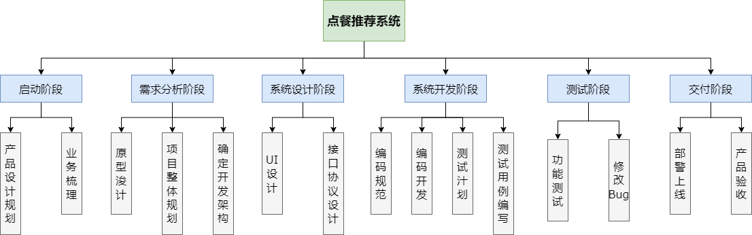

图2 WBS图

**4.3 甘特图**

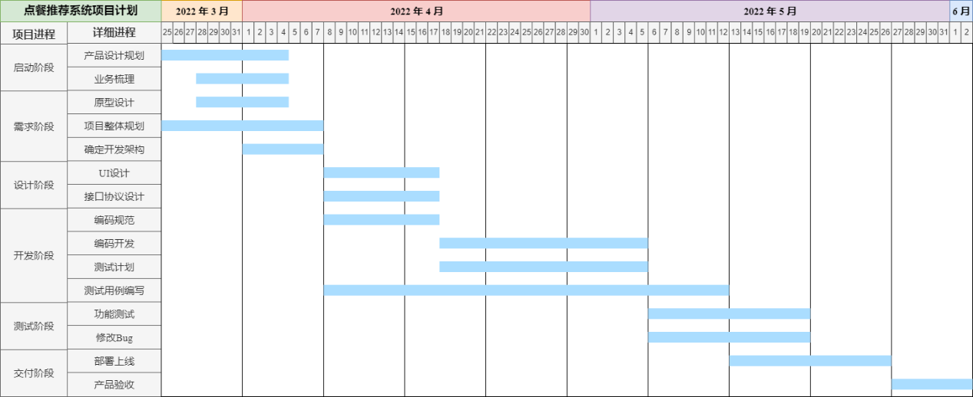

图3 项目时间计划甘特图

**4.4 时间计划表**

表2 里程碑交付表

|  |  |  |
| --- | --- | --- |
| 里程碑 | 交付 | 日期 |
| 确定项目范围 | 项目计划 | 2022.03.25 |
| 完全需求设计阶段 | 总体规划，确定开发架构 | 2022.04.07 |
| 完成项目设计 | 详细的系统设计、测试用例 | 2021.04.17 |
| 完成系统测试计划 | 测试计划、测试报告 | 2021.05.05 |
| 完成系统开发 | 完成系统开发 | 2021.05.19 |
| 部署上线 | 部署网站项目 | 2021.06.02 |

Table 2 milestone delivery list

|  |  |  |
| --- | --- | --- |
| Milestone | delivery | date |
| Determines project scope | Project plan | 2022.03.25 |
| Complete demand design stage | Overall planning, determining the development architecture | 2022.04.07 |
| Complete project design | Detailed system design, test cases | 2021.04.17 |
| Complete the system test plan | Test plans, test reports | 2021.05.05 |
| Complete the system development | complete system development | 2021.05.19 |
| System online | Running website project | 2021.06.02 |