Energy Design Study

View at https://opal.ils.unc.edu/~tomwill/790/Assignment3.html

**1. Learning:**

A lot of people aren’t actually aware of how past policies have effected their state. I wanted to build a visualization that could help policy makers go through various indicators for their state and view specific policies that had effects on energy costs and production. Hopefully they will be able to decide if policies were effective or not and make future decisions more knowledgeable.

2. **Winnowing:**

For this problem I downloaded all of the enacted energy policies for every state in the US and merged it with the accompanying energy data. For the policies I only collected Year, Topic, and State. For a more perfect visualization I would have also at least collected a summary or a link to the specific policy but I had unexpected considerable trouble with scraping it so I am saying it’s out of the scope of this assignment. On the energy side, theoretically every column could be viewable from the dataset. The live demo does not have every column; however, they could be easily added. The datasets are also cut from years 2008-2019 as those are where the policy and energy data overlap. A better approach might have been to include at least 2 more years from the energy side to provide more context.

3. **Discover:**

Task 1: Pursued to view changes in energy data overtime in comparison to the amount of policy. Conducted by viewing changes in policy number in relation to energy data numbers. Seeks to learn what policy has been effective at changing or where more or different policy might be required. Performed before writing or voting on new policies. Executed by policymakers.

Task2: Pursued to view how specific energy data has been effected by specific policies. Conducted by navigating to a specific type of energy data and viewing the policies and their aftereffects. Seeks to learn the effects of specific types or methods of certain policy. Performed before writing or voting on new policies. Executed by policymakers.

4. **Design:**

I had a hard time deciding how to implement the visualization of the policies themselves. Maybe with a much more complex design it would be much more fluid visually. I didn’t think it would be very helpful to have multiple types of energy data viewable at the same time but looking back maybe having them overlap with different colors would be cool and viewable. If the data were a lot more continuous I would have just placed the policies along a line graph but the bar graph style made it difficult.

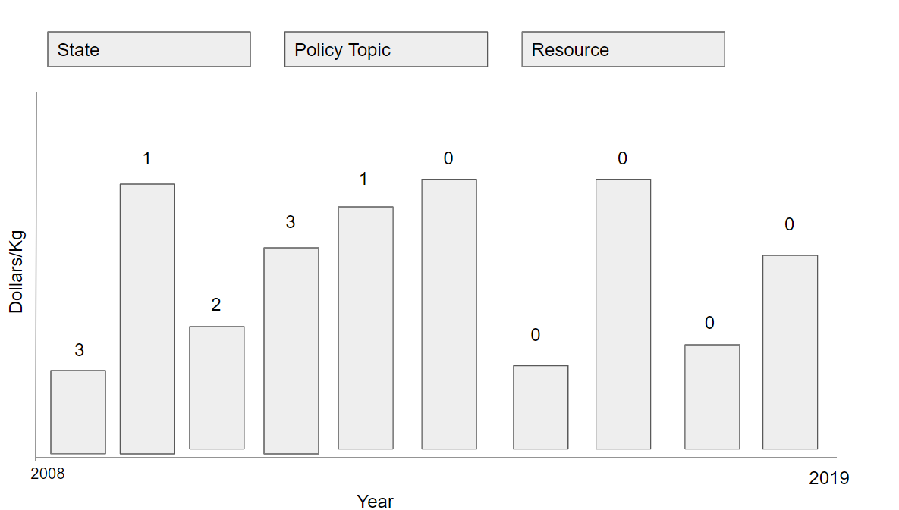

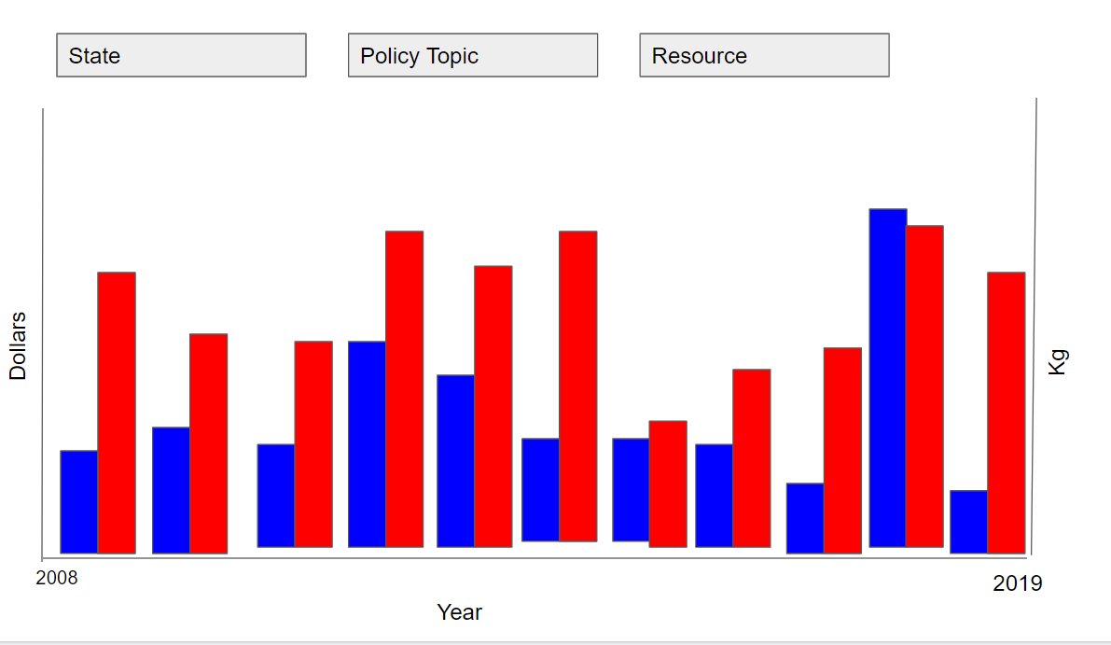

5. **Implement:**

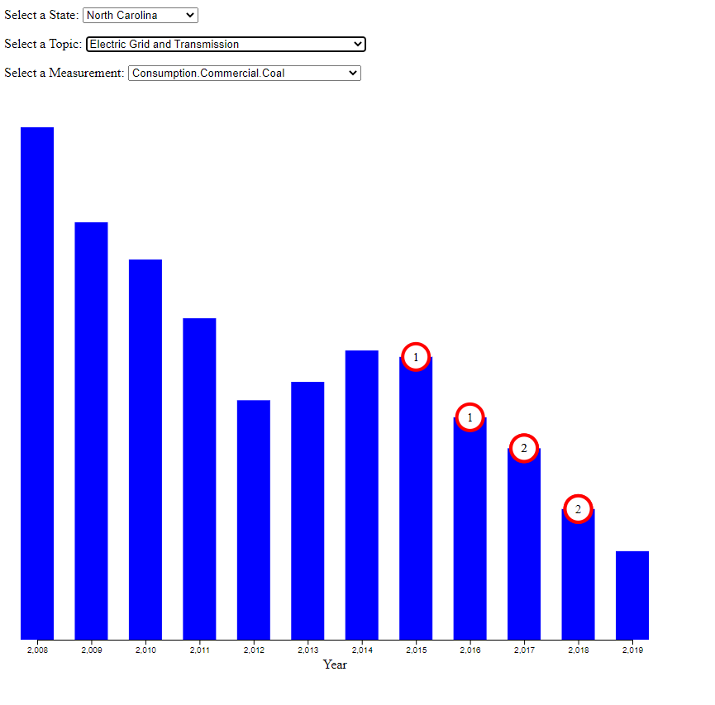

Users can view trends in energy data and see when policies were implemented. Further, users can see increase or decrease in policy developments in response to changing energy trends. The circles deployed for the policy count actually help it be more visible than it seemed in my prototype. Not all of the energy trends are available nor are all of the topic possibilities but they could be easily implemented. Based on what people said in response to my lofi prototype it would have been nice to have some implementation to send users directly to a bill or get some information about the bill. It is nice to have the flexibility because you get to see some interactions you might not typically expect like the trend above where policies in relation to transmission seem to be created in response to an increase in coal consumption.

6. **Deploy:**

NC trends: The trend stated above was particularly notable. You also see a spike in fossil energy policy during that same uptick of coal consumption. Further you can see a constant amount of renewable energy policies contributing to the coal consumption downtrend. Other trends: An unexpected effect is that it seems policies were not labeled as Electric Grid and Transmission before a certain point in time (even California just suddenly spikes). North Dakota puts out double digit Fossil energy policies exactly every two years and none in between. But a large number for a lower populated state and a resulting downtrend in coal consumption. Etc. It is also unexpectedly helpful at comparing how energy policy trends compare between states.

7. **Iterate:**

I would want the ability to pick a specific policy and view the energy trends in relation just to that policy. My idea was to implement a second window where once you clicked on a policy it would create another bar graph with a focus on that policy, letting you click the energy trends you wanted to look at. It would also give you information like the average change per year or overall change after policy enaction (Maybe change in change per year after enaction?). This would help policy makes analyze specific policies of interest rather than looking at trends of policies.

8. **Reflect, Pt 1:**

In its current state I hate to say I don’t think it would be particularly useful not that I actually look at the data. If the energy data was denser I think the overall effectiveness would increase considerably. However, if a policymaker is already well acquainted with the policy history of the state I believe they could put it to good use to make further decisions if the changes they expected are being reached or not. Also, if one is looking at a specific policy or topic I believe it would be more useful as a guide for that than as something that one randomly clicks through hoping to find an epiphany.

I can safely say that more states need to be implementing more renewable energy policy. The data is 3 years out of data but a large number have less than 3 renewable energy policies enacted between 2016-2019 which is not nearly enough.

9. **Reflect, Pt2:**

I will repeat what I said earlier in that the circles with a value inside are actually more effective than I expected initially. That also might be because I’ve been staring at it for the past hour so I would need to do some user testing before coming to a conclusion. Also it became very apparent that a line graph would have been much better for viewing trends but I went with bar because of the distance between data points. It would have also been easier to view a larger number of measurements or states at the same time in that way. Looking back that was clearly the way to go but I pigeonholed myself due to the limit of only having 12 data points. Further, it’s not as hard to combine the two data sets together effectively as I thought. They don’t do that bad together as is, and the line graph implementation would make it even better as you wouldn’t have policies stacking on top of one another. Lastly, my somewhat failed solution tells me that having more hands and brains working together might have solved the problem better.