**HEDTools User Manual**

January 4, 2018

Table of Contents

Table of Figures 3

Table of Tables 4

1. Getting Started with HEDTools 5

1.1 Overview 5

1.2 Requirements 5

1.3 Installation 5

1.3.1 Running as a standalone application 5

1.3.2 Running with .set data file types 5

1.3.3 Running as a plugin to EEGLAB 6

2. Annotating Data 6

2.1 Tagging a single dataset 6

2.2 Tagging a directory of datasets 16

2.3 Tagging an EEGLAB study 20

3. Validating Data 24

3.1 What the validation checks for 24

3.2 Validating a single dataset 25

3.3 Validating a directory of datasets 28

3.4 Validating an EEGLAB study 30

4. Extracting data epochs by HED tags 34

5. Data Formats 37

5.1 XML tag hierarchy (HED) 37

5.2 Tags are path strings 39

5.3 Field and tag map representations as a MATLAB structure 40

5.4 How tags are stored in a dataset 41

5.5 The *fieldMap* object 42

5.6 The tagMap object 44

5.7 The *tagList* object 46

6. Saving tags in the dataset 47

7. Running the regression tests and examples 49

8. Status and availability 49

9. Acknowledgments 49

10. References 49

# Table of Figures

Figure 1. Tagging the current dataset from the EEGLAB Edit Menu. 7

Figure 2. pop_tageeg menu. 7

Figure 3. Menu for choosing fields to tag. 9

Figure 4. Tagging GUI for the type field using the CTagger application. 10

Figure 5. Adding a new tag to the HED. 11

Figure 6. Specifying HED version. 12

Figure 7. Saving the HED. 12

Figure 8. Saving the dataset tags. 13

Figure 9. Specifying a fieldMap description. 13

Figure 10. Saving a new dataset. 14

Figure 11. Tagging a directory of datasets from the EEGLAB File Menu. 16

Figure 12. pop_tagdir menu. 17

Figure 13. Save multiple datasets. 18

Figure 14. Tagging a study and its associated datasets from the EEGLAB File Menu. 20

Figure 15. pop_tagstudy menu. 21

Figure 16. Validating the current dataset from the EEGLAB Edit Menu. 25

Figure 17. pop_validateeeg menu. 26

Figure 18. Validate a directory of datasets from the EEGLAB File Menu. 28

Figure 19. pop_validatedir menu. 29

Figure 20. Validate an EEGLAB study from the EEGLAB File Menu. 31

Figure 21. pop_validatestudy menu. 32

Figure 22. Extracting data epochs by tags from the EEGLAB Edit Menu. 34

Figure 23. pop_epochhed menu. 35

Figure 24. pop_epochhed search bar. 35

# Table of Tables

Table 1. A summary of arguments for pop_tageeg. 15

Table 2. A summary of arguments for pop_tagdir. 19

Table 3. A summary of arguments for pop_tagstudy. 23

Table 4. A summary of arguments for pop_validateeeg. 27

Table 5. A summary of arguments for pop_validatedir. 30

Table 6. A summary of arguments for pop_validatestudy. 33

Table 7. A summary of arguments for pop_epochhed. 37

Table 8. A summary of arguments for fieldMap constructor. 42

Table 9. A summary of the public methods of the fieldMap class. 43

Table 10. A summary of the public static methods of the fieldMap class. 43

Table 11. A summary of arguments for tagMap constructor. 44

Table 12. A summary of the public methods of the tagMap class. 45

Table 13. A summary of the public static methods of the tagMap class. 45

Table 14. A summary of arguments for tagList constructor. 46

Table 15. A summary of the public methods of the tagList class. 46

Table 16. A summary of the public static methods of the tagList class. 47

Table 17. A summary of arguments the writetags function. 48

# 1. Getting Started with HEDTools

## 1.1 Overview

*HEDTools* is a MATLAB/Java Toolbox and an EEGLAB plugin designed to help users annotate and validate events or other data elements using a predefined, but extensible, hierarchically structured annotation language. The input to the system consists of two parts: a list of items to be annotated and an annotation hierarchy. In the case of EEG, users annotate the events that occur during an EEG study using the hierarchical event description language (HED) as the vocabulary.

Although HEDTools can be used in very general annotation settings, the most common application is for users to annotate the events that occur during an EEG study using the hierarchical event description language (HED) as the vocabulary. Many of the tools are designed to assist in annotation of events as represented in EEGLAB *EEG.event* structures. Once an EEG file (or study or directory) has been annotated, users can epoch data and perform other tasks based on event annotations rather than on laboratory specific coding schemes. This facilitates the sharing of data and comparisons of analysis across data collections.

EEG event annotation comes in two forms: ***code-specific*** and ***event-specific***. In *code-specific* event annotation, researchers identify a small number of event classes or categories and annotate events by category. In EEGLAB, users typically specify this category in the *EEG.event.type* field. EEGLAB functions such as *pop_epoch* for epoching data time-locked to particular event categories can facilitate analysis. *HEDTools* support a more general form of *code-specific* analysis than provided by EEGLAB event codes. Users can treat any of the *EEG.event* fields as specifying a category, annotate each unique member of the category using HED tags. *HEDTools* writes tags for the combination of categories for each event in the *EEG.event.usertags* field and supports very sophisticated epoching of data based on combinations of tags.

Users can also write tag annotations that are specific to individual events into the *EEG.event.hedtags* field of the event. Often these annotations contain specific values for continuous parameters. *HEDTools* does not distinguish between these event-specific annotations and code-specific annotations in downstream analysis. This provides the basis for analysis using very general, collection-independent event characterization as described more fully in this manual.

## 1.2 Requirements

*HEDTools* is dependent on MATLAB. You will also need [EEGLAB](http://sccn.ucsd.edu/eeglab/) installed if you are going to tag or validate EEG files. Please use the most current version of EEGLAB.

## 1.3 Installation

You can run *HEDTools* as a standalone toolbox or as a plugin for EEGLAB. In both cases, you should install EEGLAB unless you plan to use *HEDTools* only to validate tags from spreadsheets.

### 1.3.1 Running as a standalone application

If your data files are *.mat* files, you can simply unzip the *EEGLABPlugin/HEDTools1.0.4.zip* anywhere you choose. Execute the *setup* script to set the paths each time you run MATLAB. Alternatively, you can add the code contained in *setup* to your *startup* script.

### 1.3.2 Running with .set data file types

If you wish to use EEGLAB, you should follow the directions above also.

### 1.3.3 Running as a plugin to EEGLAB

To install *HEDTools* unzip the *HEDTools1.0.4.zip* file inside the *EEGLAB plugin* directory. If you don’t install *HEDTools* via the EEGLAB menu, you can find this file at:

<https://github.com/VisLab/HEDTools/tree/master/EEGLABPlugin>

When you start EEGLAB again, *HEDTools* should be ready to use. Note: EEGLAB requires that each EEGLAB plugin be in its own subdirectory in the plugins directory of EEGLAB. Thus, if you have unzipped *HEDTools* correctly, you should see *…/eeglab/plugins/HEDTools1.0.4*/*eegplugin_hedtools.m*.

# 2. Annotating Data

The EEGLAB plugin version of *HEDTools* adds several additional menu items to the EEGLAB menu associated with annotating data. These items include: *Tag current dataset* (under the *Edit* menu), *Validate current dataset* (under the Edit menu), *Tag study* (under the *Tag files* submenu under the *File* menu), *Tag directory* (under the *Tag files* submenu under the *File* menu), and *Validate files* (under the *File* menu). If you aren’t using the plugin version or simply want to work from the command line, you will need to call the underlying pop functions such as *pop_tageeg, pop_tagdir, pop_tagstudy*, and *pop_validateeeg*.

## 2.1 Tagging a single dataset

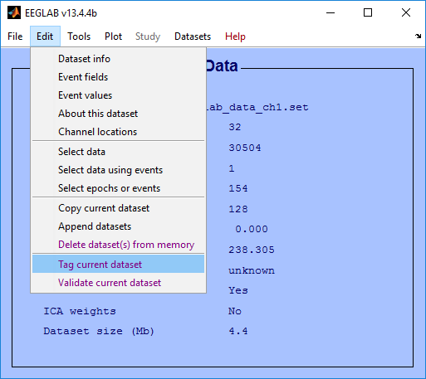First load a dataset into the workspace by clicking the *Load existing dataset* menu item under the *File* menu. To tag the dataset click the *Tag current dataset* menu item under the *Edit* menu as illustrated below in Figure 1.

#### *Figure 1. Tagging the current* dataset from the EEGLAB Edit Menu.

The *Tag current dataset* menu item executes the *pop_tageeg* function, which displays a menu for specifying tagging options as shown in Figure 2. (You can also bring up the menu by executing *pop_tageeg* from the command line. The top section of the menu allows you to browse and select a HED file and an import file containing event tags respectively. When browsing for an HED file only *.xml* files will be considered. When browsing for an import file only *.mat* files will be considered. The next section allows you to select the HED extension options. These options include:

* New tags can be added to HED underneath tags with the *Extension Allowed* attribute or leaf tags (*Only where allowed)*.
* New tags can be added to HED underneath any tag (*Anywhere)*.
* No new tags can be added to HED (*Nowhere)*.

The last section allows you to select additional options. These options include:

* Use *CTagger* to tag each selected field (*Use CTagger)*.
* Select fields to ignore or tag through a menu (*Select fields to tag)*.
* List only the tags that have the most specific tag starting with that prefix or list all tags that share the same prefix separately (*Preserve tag prefixes)*.

#### Figure . pop_tageeg menu.

Once all options are set click the *Okay* button to proceed. If the *Select fields to tag* checkbox is checked then the following menu below will be presented. This function then extracts and displays existing tag information from the dataset. Usually, you will specify the class of an event in the *EEG.event.type* field. However, you can further refine your event annotation by giving additional subcategory fields in the *EEG.event* structure and tag the unique values of these fields separately. HEDTools will individual event .usertags field will contain the tags for the combined tags from the different fields.

Depending on the options set in the *pop_tageeg* menu you are allowed to specify which fields to include for tagging and which fields to ignore from tagging. This method requires that your labeling scheme be orthogonal --- that is, it assumes each field can be tagged separately and the tags from the fields are combined for an event.

Figure 3 shows the menu for selecting fields to tag and to ignore. HEDTools fills in this menu with all of the fields that appear in the EEG.events structure, allowing you to treat each field as specifying a subclass of events. If you want to move a field over from one list to the other click on the field and press the *Transfer* button or use the left and right arrow buttons on the keyboard. Simply press the arrow key that points in the direction of the list that you want to transfer the field to. If you double click on a field then it will be set to the *primary* field. The *primary* field is the field used to specify what kind of event is occurring while the other fields are subfields used to specify conditions or subcategories within the event. The *primary* field requires a label tag (starting with /Event/Label), a category tag (starting with /Event/Category), and a description tag (starting with /Event/Description) for each of its unique values. By default, *HEDTools* sets the *primary* field to *type.*

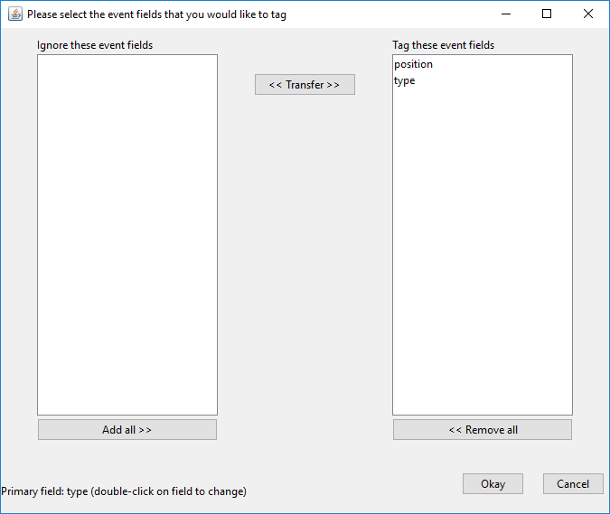

Figure 3. Menu for choosing fields to tag.

Once you have selected the fields to tag and pressed the *Okay* button, *HEDTools* calls the *CTagger* tagging application (in Figure 4) for each field in the tagging list.

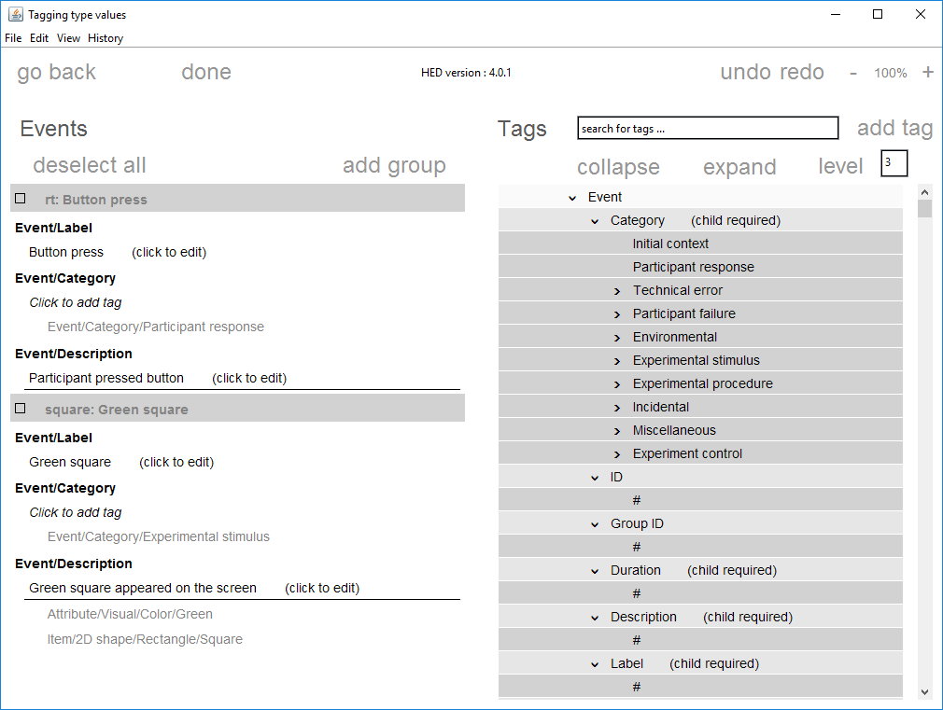

Figure 4. Tagging GUI for the type field using the CTagger application.

*CTagger* is a Java application that allows you to associate tags with each unique value of the current field. Instead of having to choose tags at random, you select from a menu of potential tags organized in a hierarchical format from general to more specific.

The left side of the *CTagger* display shows the unique values from the current field and the right side contains all of the tags from the HED hierarchy. You can use the *go back* and *done* buttons at the top left of *CTagger* to go back to the previous field if not greyed out or to proceed to the next field. You can use the the *undo* and *redo* buttons which appear at the top right of *CTagger* to revert the previous action. Zoom out and zoom in buttons appear on the upper right. The search bar on the upper right displays possible partial matches when you start typing in this box. When you click on one of the pull-down search tags, the hierarchy scrolls to the position of that tag.

To select an event type value to tag, check the box next to it. As you click on tags from the HED hierarchy on the right, they appear underneath the value. To remove the tag, right click on the tag and select *remove.*

You can add a vocabulary term to any leaf of the HED hierarch and at specified other places. To add a new tag (Figure 5) to the HED vocabulary displayed on the right, click on a leaf tag or tag with the *Extensions Allowed* attribute and click *add tag.* From there you need to specify the attributes of the new tag. When done click the *save* button.

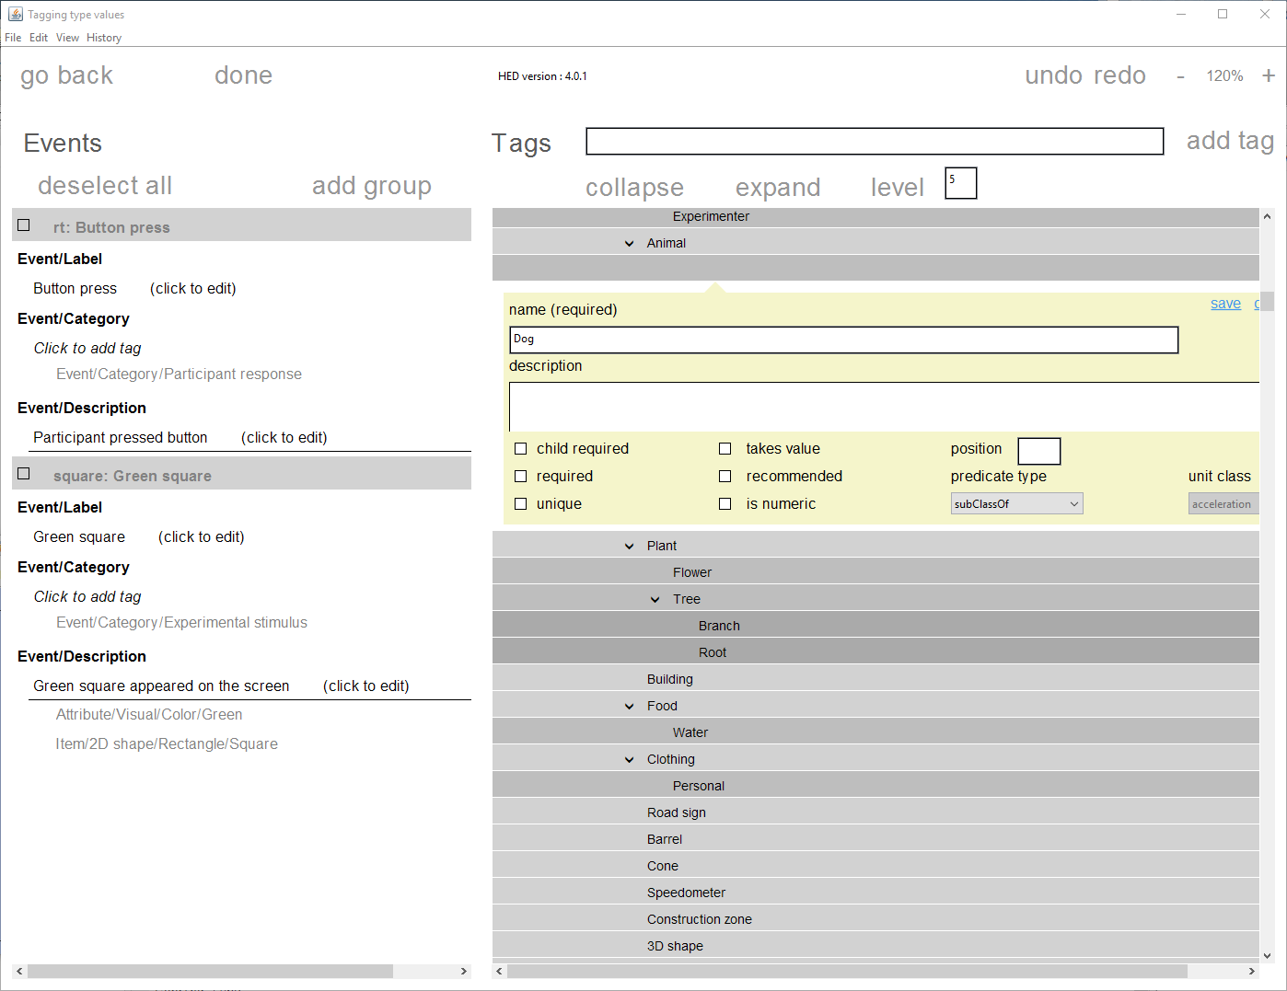

#### Figure . Adding a new tag to the HED.

Once the tag has been added to the HED then you will be prompted to specify the version (Figure 6). Setting this will change the version number that appears at the top of the CTagger. To modify the version number again, click on the HED/# tag and specify the value. Note: HED uses a standard *x*.*y*.*z* versioning convention (e.g., 5.2.3). Changes in *x* denote major releases with significant changes. Changes in *y* denote changes that may result in minor incompatibilities with the previous version. Changes in *z* denote minor additions, modifications and corrections that introduce no incompatibilities. If you make your own additions, you should version with *x*.*y*.*z*.*w* to make sure which version of the standard hierarchy you started with.

The current HED hierarchy is maintained at <https://github.com/BigEEGConsortium/HED/wiki/HED-Schema> in wiki format. The *downloadhed* function downloads this wiki file from the website. The wiki2xml function converts the wiki to XML for use in *HEDTools*. The *updatehed* function will download the latest version, convert to XML and save on disk for use in the tools.

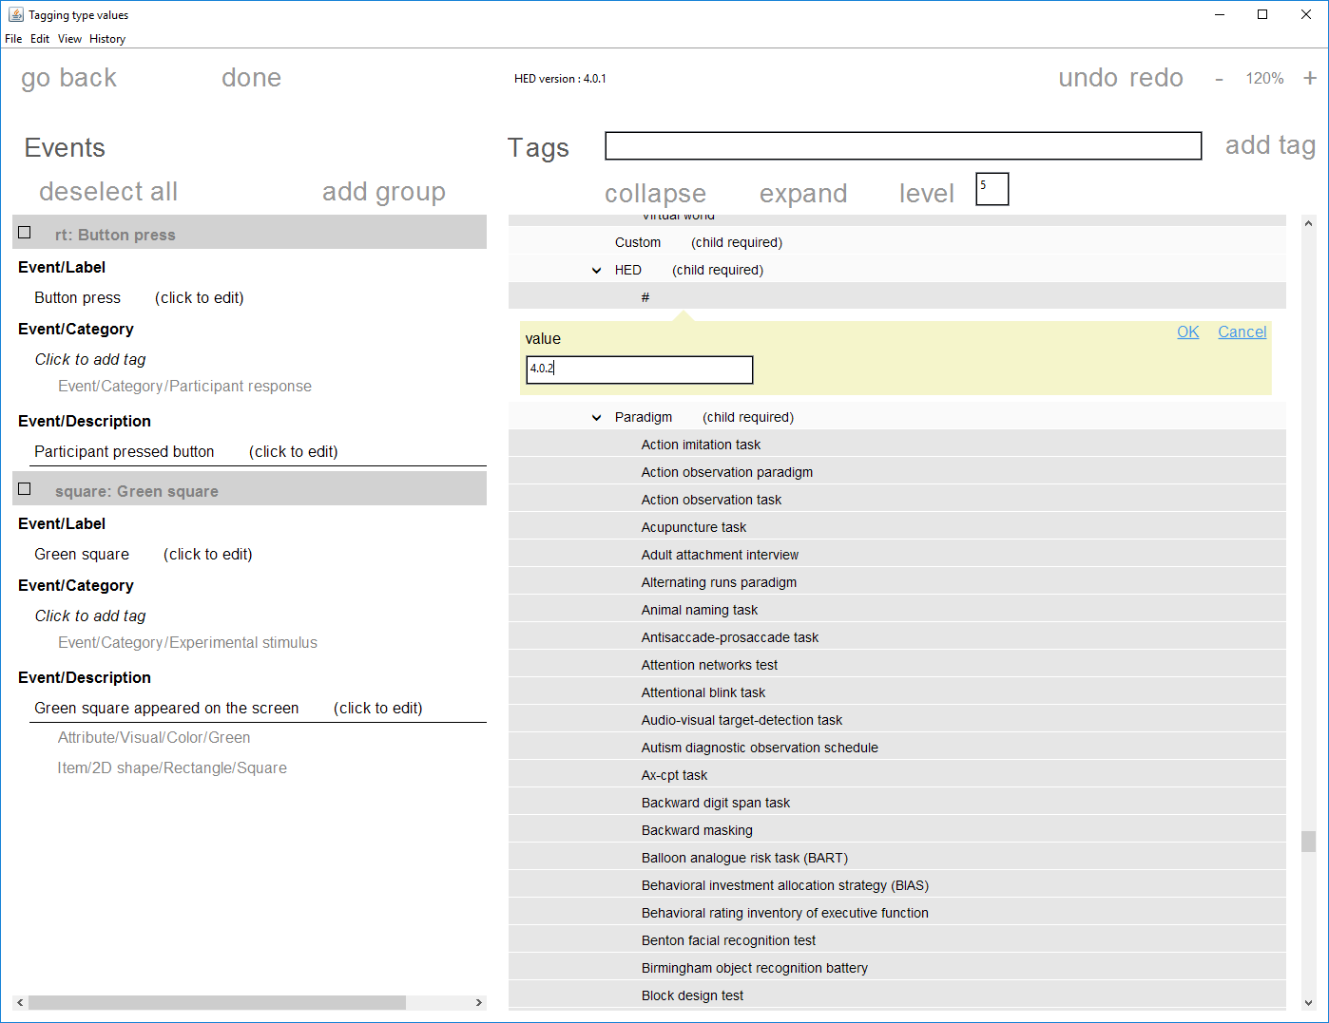

#### Figure . Specifying HED version.

After completing the tagging, save your tagging using the *File* menu items. *CTagger* also prompts you to save the modified HED if you have made any modifications (Figure 7).

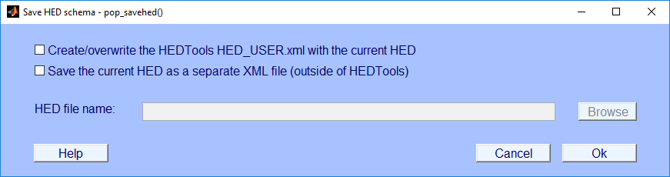

#### Figure . Saving the HED.

The first option saves the modified HED to the *HED_USER.xml* file. The *HED_USER.xml* is intended for modifying the original HED (*HED.xml)*. You should never save over or delete the *HED.xml* file. The second option allows you to save the modified HED to any location, preferably outside of the *HEDTools* directory. This is very useful for versioning the HED.

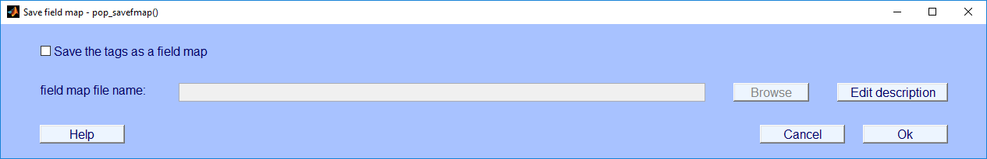

#### Figure . Saving the dataset tags.

The *HEDTools* use *fieldMap* objects to maintain the association of event type values with tags so that you can easily edit tags or apply the tags to other datasets with similar events. After saving the HED you will prompted to export the tags as *fieldMap object* (Figure 8)*.* The first option allows you to save and specify the location of the file for saving the *fieldMap*. You typically want to name your file something that reflects the data that you just tagged. Your file could include the study name or the dataset name. When you press the *Edit description* button, *CTagger* presents a dialog for you to specify the description of the *fieldMap* (Figure 9)*.*

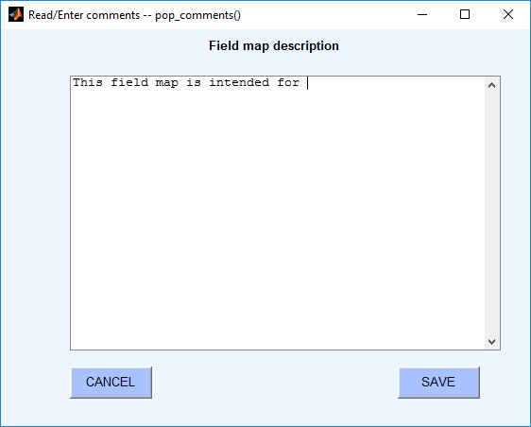

#### Figure . Specifying a fieldMap description.

The menu above allows you to add documentation to the *fieldMap* object. Not only is this description saved to the specified file assigned in the previous menu, but it is written to the *EEG*.*etc.tags.description* field of any datasets tagged by this object. After filling out the description, press the *SAVE* button to insert the description. Then press *Ok*. *CTagger* then presents the following dialog for saving the dataset that you have just tagged (Figure 10).

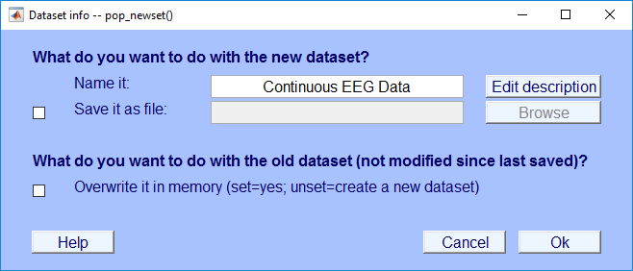

#### Figure . Saving a new dataset.

You can also execute *pop_tageeg* function from the command-line. This function takes in one required argument, which is an EEG dataset that is loaded into the workspace.

**Example 2.1:** Tag an *EEG* dataset with additional arguments using a menu.

[EEG, fMap, com] = pop_tageeg(EEG);

The *EEG* return parameter is the original dataset with the tags written to it. The *fMap* return parameter is a *fieldMap* object that contains the field to tag association. The *com* return parameter contains the command string containing the function call with the options selected from the GUI. You use the *com* string to tag another dataset using the same options.

The *pop_tageeg* function can also be called without any user intervention if you provide a *fieldMap* object. You will not see *CTagger* and its associated dialogs. Instead, the function applies the tags and saves the data. The following example illustrates how to do this.

**Example 2.2:** Tag another dataset using a *fieldMap*.

[EEG1, fMap1] = pop_tageeg(EEG, false, 'BaseMap', fMap);

Here *false* pertains to the *UseGui* argument, which turns off user intervention by not showing the dialogs. The *BaseMap* argument is a *fieldMap* object or the full path to a *fieldMap* object that stores existing event tags. To find a list of all available input arguments refer to Table 1.

**MATLAB Syntax**

[EEG, fMap, com] = pop_tageeg(EEG)

[EEG, fMap, com] = pop_tageeg(EEG, UseGui, 'key1', 'value1', ...)

[EEG, fMap, com] = pop_tageeg(EEG, 'key1', 'value1', ...)

#### Table . A summary of arguments for pop_tageeg.

|  |  |  |
| --- | --- | --- |
| **Name** | **Type** | **Description** |
| EEG | Required | The EEG dataset structure that will be tagged. The dataset will need to have an .event field. |
| UseGui | Optional | If true (default), use a series of menus to set function arguments. |
| 'BaseMap' | Name-Value | A *fieldMap* object or the name of a file that contains a fieldMap object to be used to initialize tag information. |
| 'EventFieldsToIgnore' | Name-Value | A one-dimensional cell array of field names in the .event substructure to ignore during the tagging process. By default the following subfields of the .event structure are ignored: .latency, .epoch, .urevent, .hedtags, and .usertags. The user can over-ride these tags using this name-value parameter. |
| 'HEDExtensionsAllowed' | Name-Value | If true (default), the HED can be extended. If false, the HED cannot be extended. The 'ExtensionAnywhere argument determines where the HED can be extended if extension are allowed. |
| 'HEDExtensionsAnywhere' | Name-Value | If true, the HED can be extended underneath all tags. If false (default), the HED can only be extended where allowed. These are tags with the 'ExtensionAllowed' attribute or leaf tags (tags that do not have children). |
| 'HedXML' | Name-Value | Full path to a HED XML file. The default is the HED.xml file in the hed directory. |
| 'PreserveTagPrefixes' | Name-Value | If false (default), tags for the same field value that share prefixes are combined and only the most specific is retained (e.g., /a/b/c and /a/b become just /a/b/c). If true, then all unique tags are retained. |
| 'PrimaryEventField' | Name-Value | The name of the primary field. Only one field can be the primary field. A primary field requires a label, category, and a description tag. The default is the .type field. |
| 'SaveBaseMapFile' | Name-Value | A string representing the file name for saving the final, consolidated fieldMap object that results from the tagging process. |
| 'SelectEventFields' | Name-Value | If true (default), the user is presented with a GUI that allow users to select which fields to tag. |
| 'UseCTagger' | Name-Value | If true (default), the CTagger GUI is used to edit field tags. |

## 2.2 Tagging a directory of datasets

To tag a directory of datasets from EEGLAB, click the *Tag directory* menu item under the *Tag files* menu under *File*, which is illustrated below in Figure 5.

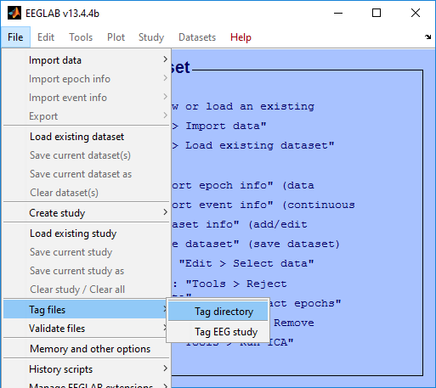

#### Figure . Tagging a directory of datasets from the EEGLAB File Menu.

The *Tag directory* menu item executes the *pop_tagdir* function, which brings up a menu for specifying options for tagging a directory of datasets. The function executes without reading any datasets into EEGLAB. The *pop­_tagdir* function extracts tag information from all of the datasets stored in the directory tree and uses this information to list any existing tags. The function only considers *.set* datasets found in the directory.

In GUI mode, the *pop_tagdir* function first brings up a menu shown in Figure 12. The top section of the menu allows you to browse and select a HED file, a directory of datasets, and an import file containing event tags. The HED file browser only displays *.xml* files. The tag import file browser only displays *.mat* files.

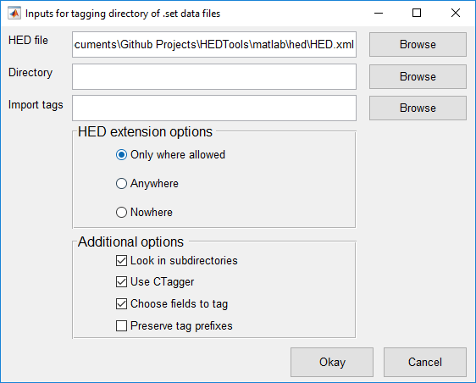

#### Figure . pop_tagdir menu.

The second section of the pop_tagdir menu displays options for extending the HED vocabulary. These options include:

* New tags can be added to the HED underneath tags with the *Extension Allowed* attribute or leaf tags (*Only where allowed)*.
* New tags can be added to the HED underneath any tag (*Anywhere)*.
* No new tags can be added to the HED (*Nowhere)*.

The last section allows you to select additional options. These options include:

* Search subdirectories for .set datasets (*Look in subdirectories)*.
* Use *CTagger* to tag each selected field (*Use CTagger)*.
* Choose fields to tag through a menu (*Choose fields to tag)*.
* List only the tags that have the most specific tag starting with that prefix or list all tags that share the same prefix separately (*Preserve tag prefixes)*.

**Example 2.3:** Tag a directory using a series of menus.

[fMap, fPaths, com] = pop_tagdir();

The *fMap* return argument is a *fieldMap* object that contains all of the tags associated with each unique field value. The *fPaths* return argument is a cell array containing the full path names of the datasets tagged during this call. You use the *com* string to tag another directory using the same options.

The *pop_tag_dir* function follows a very similar workflow to the *pop_tageeg* function*.* By default, *pop_tagdir* displays a menu, similar to the one of Figure 3, allowing you to decide which fields to tag or ignore. Once you have picked the fields to tag, the *pop_tagdir* function displays *CTagger* (see Figure 4) for each selected field. If you modify the HED hierarchy, *CTagger* prompts you to save the HED to a file (Figure 5). From there you will prompted to save a *fieldMap* object (Figure 8 and Figure 9). The final step of saving the tagged data uses the dialog of Figure 13. The first option allows you to overwrite the datasets from the directory to include the HED tags. The second option allows you to copy the datasets to a separate directory and then tag them. When finished press the *Ok* button.

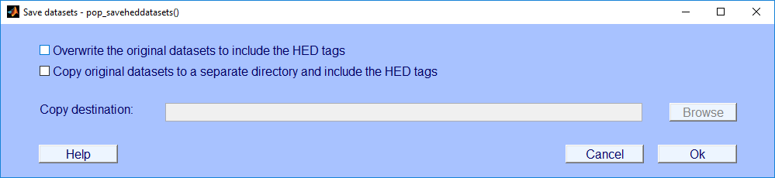

#### Figure . Save multiple datasets.

**MATLAB Syntax**

[fMap, fPaths, com] = pop_tagdir()

[fMap, fPaths, com] = pop_tagdir(UseGui, 'key1', 'value1', ...)

[fMap, fPaths, com] = pop_tagdir('key1', 'value1', ...)

#### Table . A summary of arguments for pop_tagdir.

|  |  |  |
| --- | --- | --- |
| **Name** | **Type** | **Description** |
| UseGui | Optional | If true (default), use a series of menus to set function arguments. |
| 'BaseMap' | Name-Value | A *fieldMap* object or the name of a file that contains a *fieldMap* object to be used to initialize tag information. |
| 'EventFieldsToIgnore' | Name-Value | A one-dimensional cell array of field names in the *.event* substructure to ignore during the tagging process. By default the following subfields of the .event structure are ignored: *.latency*, *.epoch*, *.urevent*, *.hedtags*, and *.usertags*. The user can over-ride these tags using this name-value parameter. |
| 'HEDExtensionsAllowed' | Name-Value | If true (default), HED can be extended. If false, HED cannot be extended. The 'ExtensionAnywhere' argument determines where HED can be extended if extension are allowed. |
| 'HEDExtensionsAnywhere' | Name-Value | If true, the HED can be extended underneath all tags. If false (default), the HED can only be extended where allowed: tags with 'ExtensionAllowed' attribute or leaf tags (tags that do not have children). |
| 'HedXML' | Name-Value | Full path to a HED XML file. The default is the HED.xml file in the *hed* directory of *HEDTools*. |
| 'InDir' | Name-Value | A directory that contains similar EEG .set files. |
| 'PreserveTagPrefixes' | Name-Value | If false (default), tags for the same field value that share prefixes are combined and only the most specific is retained (e.g., /a/b/c and /a/b become just /a/b/c). If true, then all unique tags are retained. |
| 'PrimaryEventField' | Name-Value | The name of the primary field. Only one field can be the primary field. A primary field requires a label, category, and a description tag. The default is the .type field. |
| 'SaveBaseMapFile' | Name-Value | A string representing the file name for saving the final, consolidated *fieldMap* object that results from the tagging process. |
| 'SelectEventFields' | Name-Value | If true (default), the user is presented with a GUI that allow users to select which fields to tag. |
| 'UseCTagger' | Name-Value | If true (default), the *CTagger* GUI is used to edit field tags. |

## 2.3 Tagging an EEGLAB study

To tag a directory of datasets click the *Tag study* menu item under the *Tag files* menu under *File* as illustrated below in Figure 14.

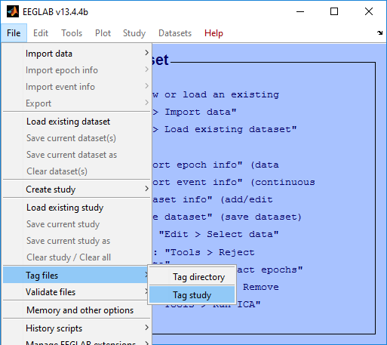

#### Figure . Tagging a study and its associated datasets from the EEGLAB File Menu.

The *Tag study* menu item executes the *pop_tagstudy* function, which brings up a menu for specifying options for tagging a study and its associated datasets. The function executes without reading any datasets into EEGLAB. The *pop­_tagstudy* function extracts tag information from the study and uses this information to list any existing tags.

Figure 15 shows the option menu that appears when you call *pop_tagstudy* as a GUI. The top section of the menu allows you to browse and select a HED file, a study file, and an import file containing event tags. The browser to select a HED file only shows *.xml* files, the browser to select study files only shows *.study* files, and the browser for importing tags only shows *.mat* files will be considered.

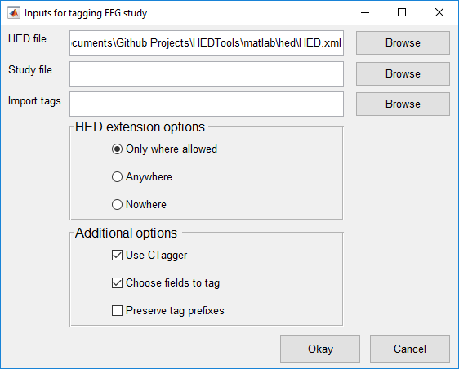

#### Figure . pop_tagstudy menu.

The middle section of the menu provides options for modifying the HED vocabulary:

* New tags can be added to the HED underneath tags with the *Extension Allowed* attribute or leaf tags (*Only where allowed)*.
* New tags can be added to the HED underneath any tag (*Anywhere)*.
* No new tags can be added to the HED (*Nowhere)*.

The last section allows you to select additional options. These options include:

* Use *CTagger* to tag each selected field (*Use CTagger)*.
* Choose fields to tag through a menu (*Choose fields to tag)*.

List only the tags that have the most specific tag starting with that prefix or list all tags that share the same prefix separately (*Preserve tag prefixes)*.

**Example 2.4:** Tag a study and its associated datasets using a series of menus.

[fMap, fPaths, com] = pop_tagstudy();

The *fMap* return argument is a *fieldMap* object that contains all of the tags associated with each unique field value. The *fPaths* return argument is a cell array containing the full path names of the datasets tagged during this call. You use the *com* string to tag another study using the same options.

The *pop_tag_study* function follows a very similar workflow to the *pop_tageeg* function*.* By default, *pop_tagstudy* displays a menu, similar to the one of Figure 3, allowing you to decide which fields to tag or ignore. Once you have picked the fields to tag, the *pop_tagdir* function displays *CTagger* (see Figure 4) for each selected field. If you modify HED then it will prompt you to save HED to a file (Figure 7). From there you will prompted to save a *fieldMap* object. Finally, you will be prompted on how you would like to save the tagged data.

**MATLAB Syntax**

[fMap, fPaths, com] = pop_tagstudy()

[fMap, fPaths, com] = pop_tagstudy(UseGui, 'key1', 'value1', ...)

[fMap, fPaths, com] = pop_tagstudy('key1', 'value1', ...)

#### Table . A summary of arguments for pop_tagstudy.

|  |  |  |
| --- | --- | --- |
| **Name** | **Type** | **Description** |
| UseGui | Optional | If true (default), use a series of menus to set function arguments. |
| 'BaseMap' | Name-Value | A *fieldMap* object or the name of a file that contains a *fieldMap* object to be used to initialize tag information. |
| 'EventFieldsToIgnore' | Name-Value | A one-dimensional cell array of field names in the .event substructure to ignore during the tagging process. By default, the following subfields of the *EEG.event* structure are ignored: *.latency*, *.epoch*, *.urevent*, *.hedtags*, and *.usertags*. The user can override these tags using this name-value parameter. |
| 'HEDExtensionsAllowed' | Name-Value | If true (default), HED can be extended. If false, HED cannot be extended. The 'ExtensionAnywhere' argument determines whether HED can be extended if extension are allowed. |
| 'HEDExtensionsAnywhere' | Name-Value | If true, HED can be extended underneath all tags. If false (default), HED can only be extended where allowed. These are tags with the 'ExtensionAllowed' attribute or leaf tags (tags that do not have children). |
| 'HedXML' | Name-Value | Full path to a HED XML file. The default is the *HED.xml* file in the *HEDTools* *hed* directory. |
| 'PreserveTagPrefixes' | Name-Value | If false (default), tags for the same field value that share prefixes are combined and only the most specific is retained (e.g., /a/b/c and /a/b become just /a/b/c). If true, then all unique tags are retained. |
| 'PrimaryEventField' | Name-Value | The name of the primary field. Only one field can be the primary field. A primary field requires a label, category, and a description tag. The default is the *.type* field. |
| 'SaveBaseMapFile' | Name-Value | A string representing the file name for saving the final, consolidated *fieldMap* object that results from the tagging process. |
| 'SelectEventFields' | Name-Value | If true (default), the user is presented with a GUI that allow users to select which fields to tag. |
| 'StudyFile' | Name-Value | The path to an EEG study. |
| 'UseCTagger' | Name-Value | If true (default), the *CTagger* GUI is used to edit field tags. |

# 3. Validating Data

If you are using the plugin version, *HEDTools* adds three menu items to the EEGLAB menu associated with validating annotated data: *Validate current EEG* (from the *Edit* menu), *Validate study* (from the *Validate files* submenu under the *File* menu), or *Validate directory* (from the *Validate files* submenu under the *File* menu). You can also validate directly from the command line as explained below.

## 3.1 What the validation checks for

Aside from checking if the event tags are present in HED, the validation functions also checks for and generate errors for the following issues:

* Tags with the **isNumeric** attribute must have a numerical value. Some tags that are numerical have units associated with them that can be specified. If not, the default units will be assigned to them as determined by the **unit class** attribute. A **unit class** contains a collection of units of the same unit dimension (e.g., length, time, angle, etc.). When units are specified for a numerical tag the validator verifies that the units belong to the correct unit class for a particular tag.
* Tags with the **required** attribute must for present in each and every event. These currently are tags that start with the prefixes */Event/Category*, */Event/Description* and */Event/Label*.
* Tags with the **requireChild** attribute cannot be present in any event. Instead a descendant of these tags will have to be in its place. For example, the tag *Event/Category* cannot be present in an event. However, *Event/Category/Participant response* can because it is a descendant of *Event/Category* and doesn’t have the **requireChild** attribute.
* Tags with the **unique** attribute can only have one descendant tag present in an event. For example, there cannot be two tags start with the prefix /Event/Label because this tag has the **unique** attribute.
* Tags in groups can have no more than 2 tildes. For example, *(/Participant ~ /Action/Type/Allow/Access ~ /Item/Object/Person/ID Holder)* is a valid group containing tildes.
* Missing commas before or after tag groups. For example, */Event/Label/StBaselineGuardDuty (/Participant ~ /Action/Type/Allow/Access ~ /Item/Object/Person/ID Holder)* is invalid because the comma after the required label tag is missing.
* Unequal number of opening and closing parentheses in tag groups. For example, *(/Participant ~ /Action/Type/Allow/Access ~ /Item/Object/Person/ID Holder* is invalid because the closing tag group parenthesis is missing.

In addition to this, the validation generates warning for the following syntax issues:

* Numerical tags that have a unit class should have units specified. For example, */Attribute/Visual/Luminance/444* is discouraged and should have units specified: */Attribute/Visual/Luminance/444 candela*.
* The first word in each tag should be capitalized and all subsequent words should be lowercase. This doesn’t apply to tags that take a value. For example, */Event/Category/Experimental Stimulus* is discouraged. The Stimulus part should be lowercase.

Any event tags that do not comply with these rules will be written to a log file. The log file by default will only contain errors. To include warnings in the file you will need to specify the option. A typical log file appears as follows:

Issues in event 28:

Invalid HED tag - "Action/Type/Button press/Keyboard in group ((Participant ~ Action/Type/Button press/Keyboard ~ Participant/Effect/Body part/Arm/Hand/Finger))"

The snippet above contains the event in which the issue occurred, the type of issue, and the tag that generated the issue.

## 3.2 Validating a single dataset

To validate tags of a single dataset, you should load the dataset into the MATLAB workspace. If working through the EEGLAB menu, should load the dataset into EEGLAB by clicking the *Load existing dataset* menu item under the *File* menu. To validate the dataset click the *Validate current dataset* menu item under the *Edit* menu as illustrated below in Figure 16.

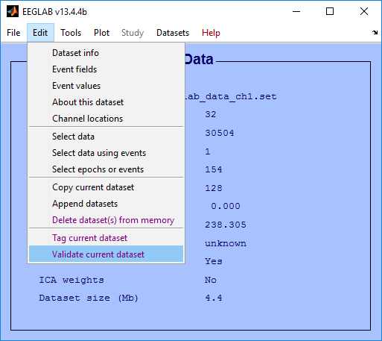

#### Figure . Validating the current dataset from the EEGLAB Edit Menu.

The *Validate current dataset* menu item executes the *pop_validateeeg* function which brings up a menu for specifying options for validation.

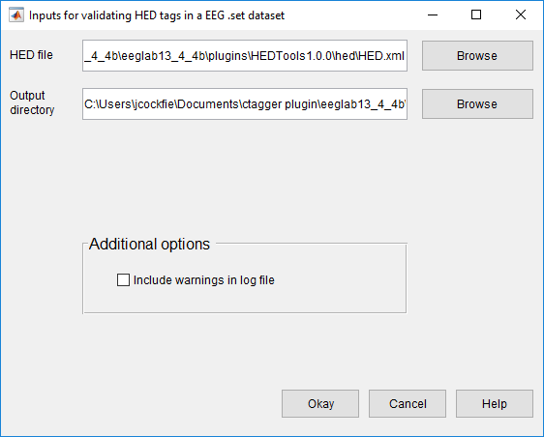

#### Figure . pop_validateeeg menu.

The top section of the *pop_validateeeg* allows you to browse for a HED file and to set an output directory. The next section allows you to indicate whether or not you want to include warnings in the log file:

* Include warnings in addition to errors in the log file (*Include warnings in log file)*

Once all options are set, click the *Okay* button to proceed.

**Example 3.1:** Validate the HED tags in a dataset, the workspace with a list of issues, and output a log file under the current directory.

[issues, com] = pop_validateeeg(EEG);

The *issues* return argument is a one-dimensional cell array containing the output from the validation. Each cell corresponds to a particular event that raised an issue. You can use the *com* string to validate another dataset using the same options.

When working exclusively from the command line, you should set the second argument of the *pop_validateeeg* function to *false*. This bypasses the menus for setting the function arguments.

**Example 3.2:** Validate the HED tags in a dataset and write the output to the workspace and a log file under the current directory without using a menu.

[issues, com] = pop_validateeeg(EEG, false);

**MATLAB Syntax**

[issues, com] = pop_validateeeg(EEG)

[issues, com] = pop_validateeeg(EEG, UseGui, 'key1', 'value1', ...)

[issues, com] = pop_validateeeg(EEG, 'key1', 'value1', ...)

|  |  |  |
| --- | --- | --- |
| **Name** | **Type** | **Description** |
| UseGui | Optional | If true (default), use a series of menus to set function arguments. |
| EEG | Required | The EEG dataset structure containing HED tags in the *EEG.event* structure. The tags need to be present in the *.usertags* and/or *.hedtags* fields of *EEG.event*. |
| 'GenerateWarnings' | Name-Value | If true, include warnings in the log file in addition to errors. If false (default), only include errors in the log file. |
| 'HedXml' | Name-Value | The full path to a HED XML file containing all of the tags. This by default will be the *HED.xml* file found in the *hed* directory of *HEDTools*. |
| 'OutputFileDirectory' | Name-Value | The directory where the validation output is written. |
| 'WriteOutputToFile' | Name-Value | If true (default), write the validation issues to a log file in addition to the workspace. If false, only write the issues to the workspace. |

#### Table . A summary of arguments for pop_validateeeg.

## 3.3 Validating a directory of datasets

To validate a directory of datasets click the *Validate directory* menu item under the *File* menu as illustrated in Figure 18.

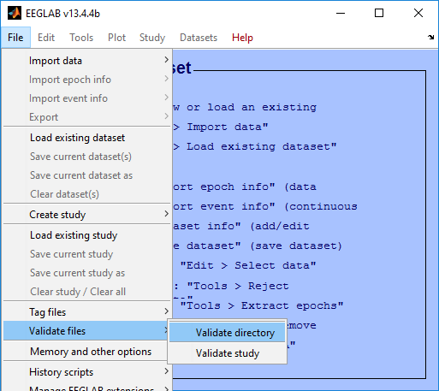

#### Figure . Validate a directory of datasets from the EEGLAB File Menu.

The *Validate directory* menu item executes the *pop_validatedir* function, which brings up a menu for specifying options for validation.

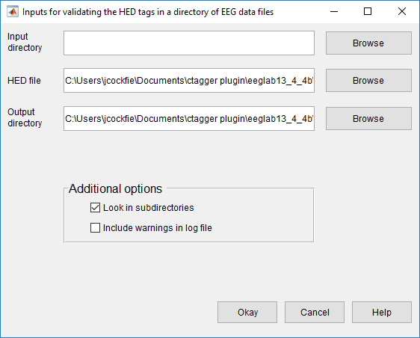

#### Figure . pop_validatedir menu.

The top section of the *pop_validatedir* menu allows you to browse and select a root directory where the datasets are located, a HED file, and an output directory. The next section allows you to set additional options including:

* Search in the subdirectories for datasets (*Look in subdirectories)*
* Include warnings in addition to errors in the log file (*Include warnings in log file)*

Click the Okay button to proceed to validation.

**Example 3.3:** Validate the HED tags in a directory of datasets and write the log file to the current directory using a menu.

[fPaths, com] = pop_validatedir();

The *fPaths* return argument is a cell array containing the full path names of the datasets tagged during this call. You can use the *com* string to validate another directory using the same options without the menu.

When working exclusively from the command line, you want to set the second argument of the *pop_validatedir* function to *false*. This bypasses the menu for setting the function arguments.

**Example 3.4:** Validate the HED tags of the datasets in the current directory and write the log file to the current directory without using a menu.

fPaths = pop_validatedir(false);

**MATLAB Syntax**

[fPaths, com] = pop_validatedir()

[fPaths, com] = pop_validatedir(UseGui, 'key1', 'value1', ...)

[fPaths, com] = pop_validatedir('key1', 'value1', ...)

|  |  |  |
| --- | --- | --- |
| **Name** | **Type** | **Description** |
| UseGui | Optional | If true (default), use a series of menus to set function arguments. |
| 'DoSubDirs' | Name-Value | If true (default), the entire *inDir* directory tree is searched. If false, only the *inDir* top-level directory is searched. |
| 'GenerateWarnings' | Name-Value | If true, include warnings in the log file in addition to errors. If false (default), only include errors in the log file. |
| 'HedXml' | Name-Value | The full path to a HED XML file containing all of the tags. This by default will be the *HED.xml* file found in the *hed* subdirectory of the *HEDTools*. |
| 'InDir' | Name-Value | A directory containing tagged EEG datasets to be validated. |
| 'OutputFileDirectory' | Name-Value | The directory where the validation output is written. There will be a log file generated for each study dataset validated. |
| 'WriteOutputToFile' | Name-Value | If true (default), write the validation issues to a log file in addition to the workspace. If false, only write the issues to the workspace. |

#### Table . A summary of arguments for pop_validatedir.

## 3.4 Validating an EEGLAB study

To validate an EEGLAB study from the EEGLAB menu, click the *Validate current dataset* menu item under the *File* menu as illustrated in Figure 20.

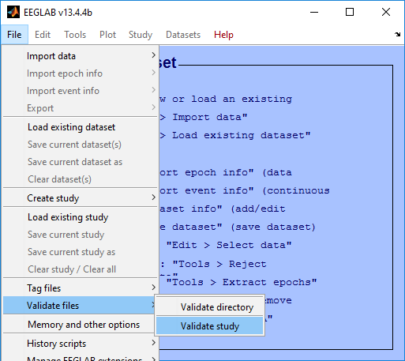

#### Figure . Validate an EEGLAB study from the EEGLAB File Menu.

The *Validate study* menu item executes the *pop_valideatestudy* function, which brings up a menu for specifying options for validation as shown in Figure 21.

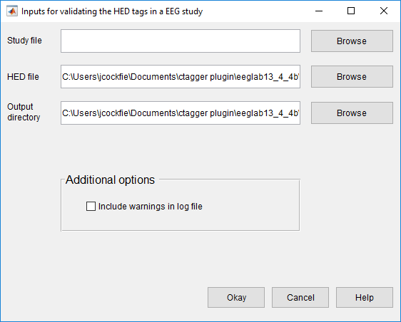

#### Figure . pop_validatestudy menu.

The top section of the *pop_validatestudy* menu allows you to browse and to select a study file, a HED file, and an output directory. The next section allows you to include warnings in addition to errors in the log file (*Include warnings in log file)*. Click the *Okay* button to proceed.

**Example 3.5:** Validate a study using a menu.

[fPaths, com] = pop_validatestudy();

The *fPaths* return argument is a cell array containing the full path names of the datasets tagged during this call. You can use the *com* string to validate another study using the same options without the menu.

**MATLAB Syntax**

[fPaths, com] = pop_validatestudy()

[fPaths, com] = pop_validatestudy(UseGui, 'key1', 'value1', ...)

[fPaths, com] = pop_validatestudy('key1', 'value1', ...)

#### Table . A summary of arguments for pop_validatestudy.

|  |  |  |
| --- | --- | --- |
| **Name** | **Type** | **Description** |
| UseGui | Optional | If true (default), use a series of menus to set function arguments. |
| 'GenerateWarnings' | Name-Value | If true, include warnings in the log file in addition to errors. If false (default), only include errors in the log file. |
| 'HedXml' | Name-Value | The full path to a HED XML file containing all of the tags. This by default will be the *HED.xml* file found in the *hed* subdirectory of *HEDTools*. |
| 'OutputFileDirectory' | Name-Value | The directory where the validation output is written to. Validation generates a log file for each study dataset validated. |
| 'StudyFile' | Name-Value | The full path to an EEG study file. This must be provided if UseGui is false. |

# 4. Extracting data epochs by HED tags

The EEGLAB *pop_epoch* function extracts data epochs that are time locked to specified event types. This function allows you to epoch on one of a specified list of event types as defined by the *EEG.event.type* field of the EEG structure. *HEDTools* provide a simple way for extracting data epochs from annotated datasets using a much richer set of conditions. To use HED epoching, you must have annotated the EEG dataset with HED tags stored in the *.usertags* and *.hedtags* fields under the *EEG.event* field of the EEG dataset. If the dataset is not tagged, please refer to section 2.1 on how to tag a dataset.

To extract data epochs by HED tags through the EEGLAB menu, first load a dataset into the workspace by clicking the *Load existing dataset* menu item under the *File* menu. From there click the *Extract epochs by tags* menu item under the *Tools* menu as illustrated in Figure 22.

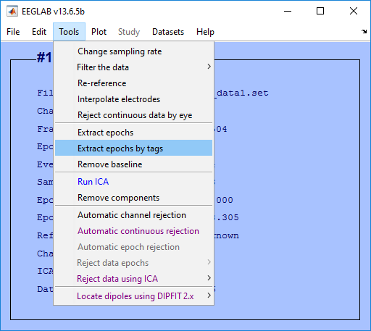

#### Figure . Extracting data epochs by tags from the EEGLAB Edit Menu.

The *Extract epochs by tags* menu item executes the *pop_epochhed* function, which brings up a menu for specifying options for extracting data epochs as shown in Figure 23.

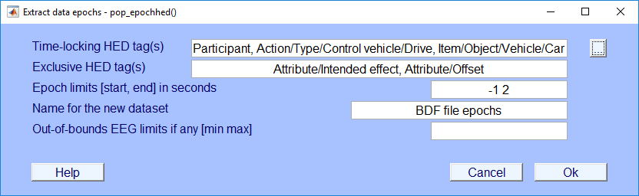

#### Figure . pop_epochhed menu.

The *pop_epochhed* menu is almost identical to the EEGLAB *pop_epoch* menu with the exceptions of the first input field (*Time-locking HED tag(s)*) and the second input field (*Exclusive HED tag(s)*). Instead of passing in or selecting from a group of unique event types the user passes in a comma separated list of HED tags. For each event all HED tags in this list must be found for a data epoch to be generated.

Clicking the adjacent button (with the label …) will open a new menu used for inputting HED tags as shown below in Figure 24.

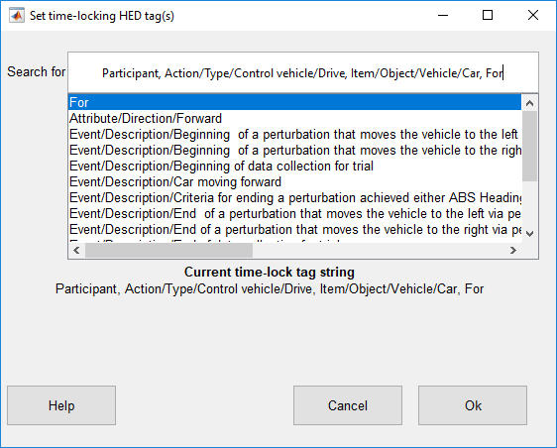

#### Figure . pop_epochhed search bar.

When you type something in the search bar, the dialog displays a list below containing possible matches. Pressing the "up" and "down" arrows on the keyboard while the cursor is in the search bar moves to the next or previous tag in the list. Pressing "Enter" selects the current tag in the list and adds the tag to the search bar. When done, click the "Ok" button to return to the main epoching menu.

*Exclusive* tags negate matches to other tags that are grouped with them. In order for a match to be returned the *exclusive* tag must be specified in the search sting also.

Another thing to keep in mind is that the matching works differently when specifying non-exclusive tags that are attributes. If an attribute tag is specified in the search by itself then it needs to be present at the top-level of the event tags, the top-level and all tag groups, or in all tag groups if there are no top-level tags.

Here are a few examples to help clarify the way that the search works.

**Example 4.1:** Partial match found.

Event tags:  a/b/c

Search tags: a/b

Result: True

**Example 4.2:** Match found but offset because exclusive tag isn’t specified in search.

Event tags:  a/b, Attribute/Intended effect

Search tags: a/b

Result: False

**Example 4.3:** Match found but offset because exclusive tags need to be grouped with other tags.

Event tags:  (a/b, Attribute/Intended effect), c/d

Search tags: c/d, Attribute/Intended effect

Result: False

**Example 4.4:** Match found but offset because attribute tags are found in group but not found at the top-level.

Event tags:  (a/b, Attribute/X, Attribute/Y), c/d

Search tags: Attribute/X, Attribute/Y

Result: False

**Example 4.5:** Match found because attribute tags are found in all groups and there are no top-level tags.

Event tags:  (a/b, Attribute/X, Attribute/Y), (c/d, Attribute/Y)

Search tags: Attribute/Y

Result: True

**Example 4.6:** Match found because a whole group is matched even though it doesn’t match the other group

Event tags:  (a/b, Attribute/X, Attribute/Y), (c/d,  Attribute/X)

Search tags: a/b, Attribute/X, Attribute/Y

Result: True

**MATLAB Syntax**

[EEG, indices, com] = pop_epochhed(EEG)

[EEG, indices, com] = pop_epochhed(EEG, tagstring, timelimits)

[EEG, indices, com] = pop_epochhed(EEG, tagstring, timelimits, 'key1', value1 ...)

|  |  |  |
| --- | --- | --- |
| **Name** | **Type** | **Description** |
| EEG | Required | Input dataset. Data may already be epoched; in this case, extract (shorter) subepochs time locked to epoch events. |
| tagstring | Required if no GUI | A comma separated list of HED tags that you want to search for. All tags in the list must be present in either the *EEG.event.usertags* and/or the *EEG.event.hedtags* fields. |
| timelimits | Required if no GUI | Epoch latency limits [start end] in seconds relative to the time-locking event {default: [-1 2]} |
| 'epochinfo' | Name-Value | Propagate event information into the new epoch structure {default: 'yes'}. |
| 'eventindices' | Name-Value | Extract data epochs time locked to the specified event numbers (either an integer or a vector of integers. |
| 'exclusivetag' | Name-Value | A cell array of tags that nullify matches to other tags. If these tags are present in both the EEG dataset event tags and the tag string then a match will be returned. By default, this argument is set to {'Attribute/Intended effect', 'Attribute/Offset'}. |
| 'newname' | Name-Value | New dataset name {default: "[old_dataset] epochs"} |
| 'timeunit' | Name-Value | Time units (either 'seconds' or 'points'). If 'seconds', event latencies are in seconds. If 'points', event latencies are in frames. The default is 'points'. |
| 'valuelim' | Name-Value | Lower and upper bound latencies for trial data relative to the time-locked event, given as [min max] or [max]. If one positive value is given, use its negative as the lower bound. The given values are also considered outliers (min max) {default: none} |
| 'verbose' | Name-Value | ['yes'|'no'] {default: 'yes'} |

#### Table . A summary of arguments for pop_epochhed.

# 5. Data Formats

*HEDTools* is structured and hence requires two items: a tag hierarchy and a map of field values. The tag hierarchy is in XML format and *HEDTools* provides a schema for validation. The association of tags and types of events is represented by a *fieldMap.*

## 5.1 XML tag hierarchy (HED)

*HEDTools* assume that rather than inventing tags at random, you will have a vocabulary of suggested tags presented in hierarchical form as shown on the right in Figure 4. Internally, this hierarchy is represented as an XML string.

**Example 5.1:** A snippet from the HED.

<?xml version="1.0" encoding="utf-8"?>

<HED version="5.2.3">

<node>

<name>Event</name>

<node position="1" predicateType="passThrough" requireChild="true" required="true">

<name>Category</name>

<description>This is meant to designate the reason

this event was recorded</description>

...

The XML hierarchy shown in Example 5.1 is from *HED.xml* maintained specifically to support tagging of events in EEG experiments [1]. The Hierarchical Event Descriptor (HED) tags and supporting tools [2][3][4] [5] provide an infrastructure for data mining across data collections, once the datasets have been annotated.

*HEDTools* works with any XML file that conforms to the *HED.xsd*, the default XML schema specification. The *HED.xsd* schema is quite general, and you can substitute any XML hierarchy that conforms to the schema or build your own hierarchy from the ground up. You must take care in modifying the schema itself, as *HEDTools* assumes certain standard fields. The default XML hierarchy and validating schema are specified by the public constants *DefaultXml* and *DefaultSchema* in the *fieldMap* class defined in *helpers*.

## 5.2 Tags are path strings

Tags are simply path strings from the HED hierarchy. Each path string or tag uses forward slashes (“/”) to separate the components in the path. Commas (“,”) separate multiple tags for the same event. **Do not use commas within text such as descriptions.** Users may group event tags with one level of parentheses to make the annotation clearer. Example 5.2 shows an example of the annotation for a stimulus event that consists of displaying a red circle in the center of the screen. The parentheses make it clear that the circle is red and located at the center of the screen. If the event designated the display of multiple objects of different colors, the parentheses would make the annotation more clear. The tagging also supports tag groups with embedded tilde (“~”) characters to designate a sentence-like structure. **You can use only one level of parentheses containing at most two tildes separating the subject from the predicate and the direct object.**

**Example 5.2:** Tag path string representation.

Event/Category/Experimental stimulus,

(Item/2D shape/Ellipse/Circle, Attribute/Visual/Color/Red, Location/Screen/Center)

Normally, a tag that is more specific (i.e., the added tag has an existing tag as a prefix in string form or corresponds to an ancestor in the tag hierarchy) replaces a less specific tag. However, most *HEDTools* functions take an optional *PreservePrefix* argument, which is *false* by default. If you set this argument to *true*, *HEDTools* keeps both tags.

**Example 5.3:** When *PreservePrefix* argument is *true*, *HEDTools* keeps all versions of the tags.

Event/Category/Experimental stimulus

Event/Category/Experimental stimulus/Instruction/Attend

## 5.3 Field and tag map representations as a MATLAB structure

A field map (implemented by the MATLAB *fieldMap* class) associates field names with tag maps (implemented by the MATLAB *tagMap* class). A tag map associates tags with a group of values identified by a name (the “field”). The discussion of this section assumes type/subtype encoding (as illustrated in the next example) to simplify the discussion. However, field maps and tag maps do not rely on a specific representation.

**Example 5.4:** An experiment has two types of events, a stimulus and a user button press response, that are encoded as *STIM*, *RT*, respectively. The stimulus consists of a circle presented in one of three positions: to the left, center, or right of the screen. The positions are encoded by the researcher with numeric codes 1, 2, and 3 respectively. If the dataset is in EEGLAB format, an event such as a circle presented on the left side of the screen at 162 ms after the experiment begins might be stored as a structure:

EEG.event(1) =

type: 'STIM'

stimpos: 1

latency: 162.048

urevent: 1

Only the *.type* and *.stimpos* fields of the *.event* substructure are relevant for tagging. The *.urevent* is an EEGLAB-specific field that relates this event to the original event encodings, while *.latency* specifies the time of this event in frames.

*HEDTools* creates a *fieldMap* object to hold the tag map information for each of the two fields or groups: *type* and *stimpos*. The tag map for *type* contains the associations between each of its two values (*STIM* and *RT*) and the corresponding tags.

**Example 5.5:** The structure representation of the field map corresponding to Example 5.4 is:

fMap =

xml: '<?xml version="1.0" ...'

map: [1x2 struct]

Each of the *.map* structures corresponds to a tag map structure as shown in the next two examples.

**Example 5.6:** The structure representation of the tag map *stimpos* corresponding to the field map of Example 5.5:

fMap.map(1) =

field: 'stimpos'

values: [1x3 struct]

fMap.map(1).values(1) =

code: '1'

tags: {'Item/2D shape/Eclipse/Circle', 'Event/Description/Display of circle on left side of screen'}

fMap.map(1).values(2) =

code: '2'

tags: {'Item/2D shape/Eclipse/Circle','Event/Description/Display of circle in the center of the screen'}

fMap.map(1).values(3) =

code: '3'

tags: {'Item/2D shape/Eclipse/Circle','Event/Description/Display of circle on right side of screen'}

The *tag map* for the *type* field has the form:

fMap.map(2) =

field: 'type'

values: [1x2 struct]

In summary, a *field map* is a collection of *tag maps*, each identified by a group or field name. Field maps can be represented by a MATLAB structure that has two fields (*.xml*, and *.map*) at the top level. The *.xml* is a string representation of the tag hierarchy used for this tagging. Internally, *CTagger* represents a field map by a *fieldMap* object.

A tag map is an association of tags with a group of values identified by a name (field). *HEDTools* represents tag maps by a MATLAB structure that has two fields (*.field*, and *.values*) at the top level. The *.values* field contains a structure with two fields (*.code* and *.tags*).

## 5.4 How tags are stored in a dataset

Tags can be stored in any dataset that is a MATLAB structure. *HEDTools* assumes that the dataset itself is a structure and can store a representation of a field map in the *etc.tags* field of the dataset. One approach is to write the entire structure to the dataset.

**Example 5.7:** Storing the field map structure of Example 5.6 in the dataset *s* as a structure.

s.etc.tags = fMap;

It is also possible to store multiple maps by making *s.etc.tags* a structure array. For datasets that have events represented as a structure with fields, you can store the tags applicable to a particular event.

**Example 5.8:** The tag information stored in the individual event of Example 5.4.

EEG.event(1) =

type: 'STIM'

stimpos: 1

latency: 162.048

urevent: 1

hedtags: ... direct mapped tags as a string

usertags:'Item/2D shape/Eclipse/Circle'

The tags associated with a *type* value *STIM* as well as a *stimpos* value *1* are consolidated in *EEG.event(1).usertags* to allow data-mining. *CTagger* extracts these tags from a field map that is also maintained to allow revision and remapping. Tags from automated annotation at acquisition are stored in *.hedtags* and are not able to be remapped. The true tags for a particular event consist of the union of the tags in the .*hedtags* and .*usertags* fields.

## 5.5 The *fieldMap* object

The *fieldMap* class manages a collection of named groups and the mappings of their values to tags.

**Example 5.9:** Storing a collection of mappings in a *fieldMap* object.

f = fieldMap();

for k = 1:length(fMap.map)

f.addValues(fMap.map(k).field, fMap.map(k).values, 'Merge');

end

The first statement creates an empty *fieldMap* object using the default XML. The loop adds the individual group mappings to the object. You can create multiple *fieldMap* objects and save them separately from the data. This allows you to maintain multiple tag mappings for different purposes.

**MATLAB Syntax**

fTags = fieldMap()

fTags = fieldMap('key1', 'value1', ...)

#### Table . A summary of arguments for fieldMap constructor.

|  |  |  |
| --- | --- | --- |
| **Name** | **Type** | **Description** |
| 'Description' | Name-Value | Description of this object. |
| 'PreservePrefix' | Name-Value | If *false* (default), *HEDTools* combines tags of the same field value that share prefixes and retains only the most specific (e.g., /a/b/c and /a/b become just /a/b/c). If *true*, then *HEDTools* retains all unique tags. |
| 'XML' | Name-Value | A string containing the HED tag hierarchy used to create this object. |

#### Table . A summary of the public methods of the fieldMap class.

|  |  |
| --- | --- |
| **Method** | **Description** |
| addValues | Include values in this object based on update type. |
| clone | Create a copy of this object. |
| getDescription | Return the description of this object. |
| getFields | Return the fields of this object. |
| getJson | Return the JSON string version of this object. |
| getJsonValues | Return a JSON array of the JSON of the tag maps for this object. |
| getMap | Return the *tagMap* object associated with a specified field name. |
| getMaps | Return the tag maps for this object as a cell array of *tagMap* objects. |
| getPreserveTagPrefixes | Return the *PreservePrefix* flag. |
| getPrimaryField | Return the primary field of the *fieldMap*. |
| getStruct | Return this object as a structure array. |
| getTags | Return the tag string associated with value event of field. |
| getValue | Return the value structure corresponding to specified field and key. |
| getValues | Return the values for field as a cell array of structures. |
| getXml | Return a string containing the XML of the *fieldMap*. |
| getXmlEdited | Returns true if the XML was edited through the *CTagger*. |
| merge | Combine another *fieldMap* with this object based on update type. |
| mergeXml | Merge an XML string with this object’s *HedXML* if valid. |
| removeMap | Remove the tag maps associated with specified field name. |
| setDescription | Set the description of the *fieldMap*. |
| setPrimaryMap | Sets the tag map associated with specified field name as a primary field. |
| setXml | Set the XML of the *fieldMap*. |
| setXmlEdited | Set the XML of the *fieldMap*. |

#### Table . A summary of the public static methods of the fieldMap class.

|  |  |
| --- | --- |
| **Method** | **Description** |
| loadFieldMap | Load a field map from a *.mat* file that contains a *fieldMap* object. |
| saveFieldMap | Save a field map to a *.mat* file. |

## 5.6 The tagMap object

Internally, the *fieldMap* class uses the *tagMap* class to provide a common format for holding the tagging information for one group of values. This class has static methods for translating to and from the other formats and for merging tag maps.

**Example 5.10:** Representation of *fMap.map(1)* of Example 5.6 as a *tagMap* object.

t = tagMap('Field', 'stimpos');

for k = 1:length(fMap.map(1).values)

t.addValues(fMap.map(1).values(k), 'Merge', false);

end

The first statement creates a *tagMap* object representing the tag-value mapping for the group of values called *stimpos*. The second statement adds the actual mapping of tags to values.

**MATLAB Syntax**

tMap = tagMap()

tMap = tagMap('key1', 'value1', ...)

#### Table . A summary of arguments for tagMap constructor.

|  |  |  |
| --- | --- | --- |
| **Name** | **Type** | **Description** |
| 'Field' | Name-Value | String identifying the group this map is associated with. |

#### Table . A summary of the public methods of the tagMap class.

|  |  |
| --- | --- |
| **Method** | **Description** |
| addValue | Add the *tagList* of tags to this object based on *updateType*. |
| clone | Create a copy of this object. |
| getField | Return the field name corresponding to this *tagMap*. |
| getJson | Return a JSON string version of this *tagMap* object. |
| getJsonValues | Return a JSON string version of this *tagMap* object. |
| getCodes | Return the unique codes for this *tagMap* object. |
| getPrimary | Return true if this tagMap object is a primary field. |
| getStruct | Return this *tagMap* object in structure form. |
| getValue | Return the value structure corresponding to specified code. |
| getValues | Return the values of this *tagMap* object as a cell array of structures. |
| getValueStruct | Return the values of this *tagMap* object as a structure array. |
| merge | Combine the *tagMap* object info with this one. |
| setPrimary | Set this *tagMap* object to the primary field. |

Table . A summary of the public static methods of the *tagMap* class.

|  |  |
| --- | --- |
| **Method** | **Description** |
| json2Values | Converts a JSON values string to a structure or empty. |
| values2Json | Convert a value structure array to a JSON string. |

## **5.7 The *tagList* obje**ct

Similar to how the *fieldMap* class uses the *tagMap* class, the *tagMap* class uses the *tagList* class. The *tagList* class represents each individual value and the associated tags in the *tagMap* group. This class also has static methods for translating to and from the other formats and for merging tag lists.

**Example 5.11:** Create a *tagList* representing a green square that belongs to *tagMap* group type.

tMap = tagMap('Field', 'type');

tList = tagList('square');

tList.add({'Attribute/Visual/Color/Green','Item/2D shape/Rectangle/Square'});

tMap. addValue(tList);

**MATLAB Syntax**

tList = tagList(code)

#### Table . A summary of arguments for tagList constructor.

|  |  |  |
| --- | --- | --- |
| **Name** | **Type** | **Description** |
| code | Required | A unique event code value associated with tags. |

#### Table . A summary of the public methods of the tagList class.

|  |  |
| --- | --- |
| **Method** | **Description** |
| add | Add valid tag or tag group to this *tagList*. |
| addList | Add a list of tags or tag group to this *tagList*. |
| addString | Add a string of valid tags or tag groups to this *tagList*. |
| clone | Clone this *tagList* object by making a copy of the tag maps. |
| getCode | Returns the code associated with this *tagList*. |
| getCount | Returns the number of tags and tag groups in this tagList. |
| getJsonValues | Returns a JSON string version of this *tagList* object. |
| getKeys | Returns the keys for this *tagList*. |
| getStruct | Returns this *tagList* as a structure array. |
| getTags | Returns a cell array with all of the tags and tag groups in this *tagList*. |
| intersect | Keep only the keys that are in this *tagList* and in the other *tagList*. |
| isMember | Returns true if value is a valid tag or tag group in this *tagList*. |
| remove | Remove the tag or tag group in this *tagList* corresponding to value. |
| removePrefixes | Remove the tags in this *tagList* that are prefixes in existing groups. |
| setCode | Sets the code associated with this *tagList*. |
| union | Adds the tags given in another *tagList* to those of this *tagList*. |

#### Table . A summary of the public static methods of the tagList class.

|  |  |
| --- | --- |
| **Method** | **Description** |
| deStringify | Create a cell array representing a comma-separated string of tags. |
| getCanonical | Return a sorted version of a valid tag or tag group. |
| getUnsortedCanonical | Return an unsorted version of a valid tag or tag group. |
| removeGroupDuplicates | Remove duplicates from a tag group based on prefix. |
| separateDuplicates | Return a list of tags without duplicates from *cellstr*. |
| splitTildesInGroup | Split the tildes in the *cellstr* tag group. |
| stringify | Create a string from a cell array of strings or *cellstrs*. |
| stringifyElement | Create string from *cellstr* or from string. |
| tagList2Json | Convert a *tagList* to a JSON string. |
| validate | Validate the input as a valid tag or tag group. |
| validateTag | Validate a tag string. |
| validateTagGroup | Validate a *cellstr* containing a tag group. |

# 6. Saving tags in the dataset

All of the higher-level functions call the *writetags* function to write the tag information to the dataset. *HEDTools* writes the tags in two different ways: as a summary field map in the *.etc.tags* subfield of the data and as individual event information. In the latter situation, it’s assumed that the events to be tagged are in stored in the *.event* structure array and it writes a consolidated list of tags based on the actual values of different fields for the *i*th event to the *.event(i).usertags* subfield.

**Example 6.1:** Write the tags encapsulated by the *fieldMap* object *fMap* into the data structure x.

x = writetags(x, fMap);

The *writetags* writes both the summary and individual event information, overwriting existing tagging information. If x doesn’t have an *.event* structure, no individual event information is written. The *fMap* object can come from anywhere. Thus, you can have multiple tagging schemes and merge them before writing, or use one at a time. An advantage of keeping the mappings as summaries, separate from the events is that you can edit your tags and rewrite for different uses.

**MATLAB Syntax**

eData = writetags(eData, fMap)

eData = writetags(eData, fMap, 'key1', 'value1', ...)

#### Table . A summary of arguments the writetags function.

|  |  |  |
| --- | --- | --- |
| **Name** | **Type** | **Description** |
| eData | Required | A dataset structure that the tag information is to be written to. |
| fMap | Required | A *fieldMap* object with the tag information. |
| 'EventFieldsToIgnore' | Name-Value | A cell array containing the field names to exclude. |
| 'PreserveTagPrefixes' | Name-Value | If false (default), tags for the same field value that share prefixes are combined and only the most specific is retained (e.g., /a/b/c and /a/b become just /a/b/c). If true, then all unique tags are retained. |

# 7. Running the regression tests and examples

*HEDTools* uses the XUNIT unit-testing framework for its regression tests located in the *tests* directory. For tests that require user input, the instructions appear in caps in the command window. The regression tests use external data not located in the *HEDTools* repository. Download the test data archive ([*HEDToolsTestArchive.zip*](http://visual.cs.utsa.edu/software/hedtools/hedtools-1.0.0/hedtools-unit-test-data/view)) and unzip it. You will also need to edit the *tests/setup_tests.m* file and adjust the *values.testroot* to contain the path of your unzipped archive. *CTagger* comes with examples contained in the *tagging_example.m* script. The examples use external data not located in the *HEDTools* repository. Download the example data archive ([*HEDToolsExampleArchive.zip*](http://visual.cs.utsa.edu/software/hedtools/hedtools-1.0.0/hedtools-examples-data/view)) and unzip it. You will also need to edit the *exampleDir* that points to the example data archive.

# 8. Status and availability

The base *HEDTools* is currently available and undergoing user testing.

# 9. Acknowledgments

The authors acknowledge helpful conversations with Christian Kothe, Nima Bigdely Shamlo, Alejandro Ojeda, Arno Delorme, and Scott Makeig, all of University of California San Diego as well as Scott Kerick, Jeanne Vettel of the Army Research Laboratories, Tony Johnson, Michael Dunkel, and Michael Nonte of DCS Corporation, and Rob Geary and Andrew Moseley-Gholl of the University of Michigan. This research was sponsored by the Army Research Laboratory and was accomplished under Cooperative Agreement Number W911NF-10-2-0022. The views and conclusions contained in this document are those of the authors and should not be interpreted as representing the official policies, either expressed or implied, of the Army Research Laboratory of the U.S. Government. The U.S. Government is authorized to reproduce and distribute reprints for Government purposes notwithstanding any copyright notation herein.

# 10. References

1. N. Bigdely-Shamlo, J. Cockfield, S. Makeig, T. Rognon, C. LaValle, M. Miyakoshi, and K. Robbins (2016). Hierarchical Event Descriptors (HED): Semi-structured tagging for real-world events in large-scale EEG, Frontiers in Neuroinformatics doi: 10.3389/fninf.2016.00042.
2. N. Bigdely-Shamlo, S. Makeig, and K. Robbins (2016). Preparing laboratory and real-world EEG data for large-scale analysis: A containerized approach, Frontiers in Neuroinformatics 1 08 March 2016 | <http://dx.doi.org/10.3389/fninf.2016.00007>. PMID: 27014048, PMCID: PMC4782059.
3. HEDTools repository: <https://github.com/VisLab/HEDTools>.
4. HED tags main site: <http://www.hedtags.org/>.
5. HED tags schema: [https://github.com/BigEEGConsortium/HED/wiki/HED-Schema](%20https:/github.com/BigEEGConsortium/HED/wiki/HED-Schema).