William George

CS 372

Lab 1 WireShark Intro

1. **List 3 different protocols that appear in the protocol column in the unfiltered packet-listing window in step 7 above.**

*HTTP*

*SSL*

*TCP*

*QUIC*

1. **How long did it take from when the HTTP GET message was sent until the HTTP OK reply was received? (By default, the value of the Time column in the packet-listing window is the amount of time, in seconds, since Wireshark tracing began. To display the Time field in time-of-day format, select the Wireshark *View* pull down menu, then select Time *Display Format*, then select *Time-of-day*.)**

*GET 273 11:55:27.030437*

*OK 280 11:55:27.107289*

*Difference: .076852 Seconds*

1. **What is the Internet address of the gaia.cs.umass.edu (also known as www-net.cs.umass.edu)? What is the Internet address of your computer?**

*gaia.cs.umass.edu IPv4 128.95.66.172*

*Destination/My Computer 128.119.245.12*

1. **Screenshot the two HTTP messages (GET and OK) referred to in question 2 above. Make sure to include all pertinent information in the screenshot (Time field, Internet addresses, etc). Paste these screenshots into your lab report.**

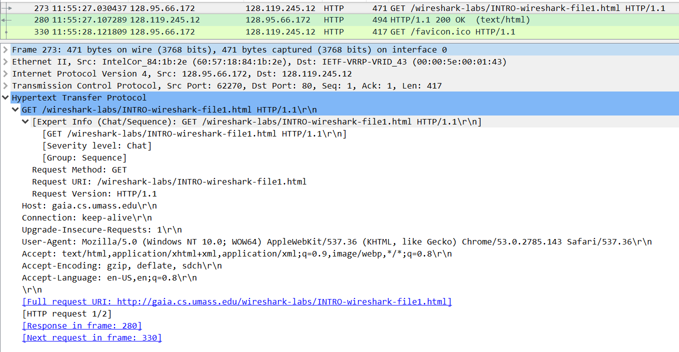GET REQUEST:

OK RESPONSE:

