William George

CS 161

October 29, 2014

Assignment 5 Report

Understanding:

The idea for this week is to develop an understanding of recursion and passing values by reference. While we had a lecture on passing by reference last week, we did not practice it at all. We are doing several coding exercises this week in which these skills are needed, including a few we attacked differently last week and the week before.

The first exercise randFun.cpp is one we worked on last week and one we will address differently this week. The concept will be the same, building a random number generator that will use some specified range but we will be using a function that accepts references rather than copies of values. It will accepted a referenced minimum and a referenced maximum then send the value of the third, randomly generated value to a third referenced value.

The second exercise retFun.cpp follows the same theme. We worked on a function last week that would accept to string values and evaluate if they were equal. This exercise will do the same but will reference two strings to check their equality.

The third exercise sortFun.cpp will use a function to takes three integers then pass them by reference to their assigned locations based on their value. In other words the function should sort the three values so that they are in order from smallest to largest.

The fourth exercise, recFun.cpp, is the first one with recursion and has us creating a program that will take our integer then return the corresponding Fibonacci number based on that integer. So for example if we gave a 5 then the function would output the fifth number in the Fibonacci sequence or 8. This exercise is going to need recursion as conventional loops will not work.

The fifth and final exercise hailstone.cpp uses a recursive function as well, or a function that calls itself. With a given integer the function will either divide by two or multiply it by three and add one to get the next value in the sequence, based on whether the number is even or odd. The function should stop when it reaches the base condition or when the value is one.

The project component this week called reconvert.cpp allows a user to call from a list of three things either convert a binary number to a decimal number, to convert a decimal number to binary or exit the program. The program then asks the user the number, checks if the number is a valid int and uses a recursive function to either convert the binary number to decimal or vice versa. One important element of this project is the input validation. Decimal numbers need to be validated as decimal integers and binary needs to be 0’s and 1’s.

Design:

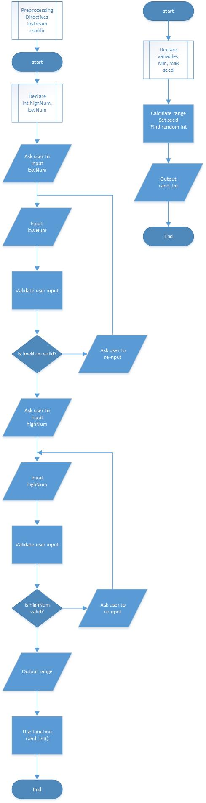randFun.cpp

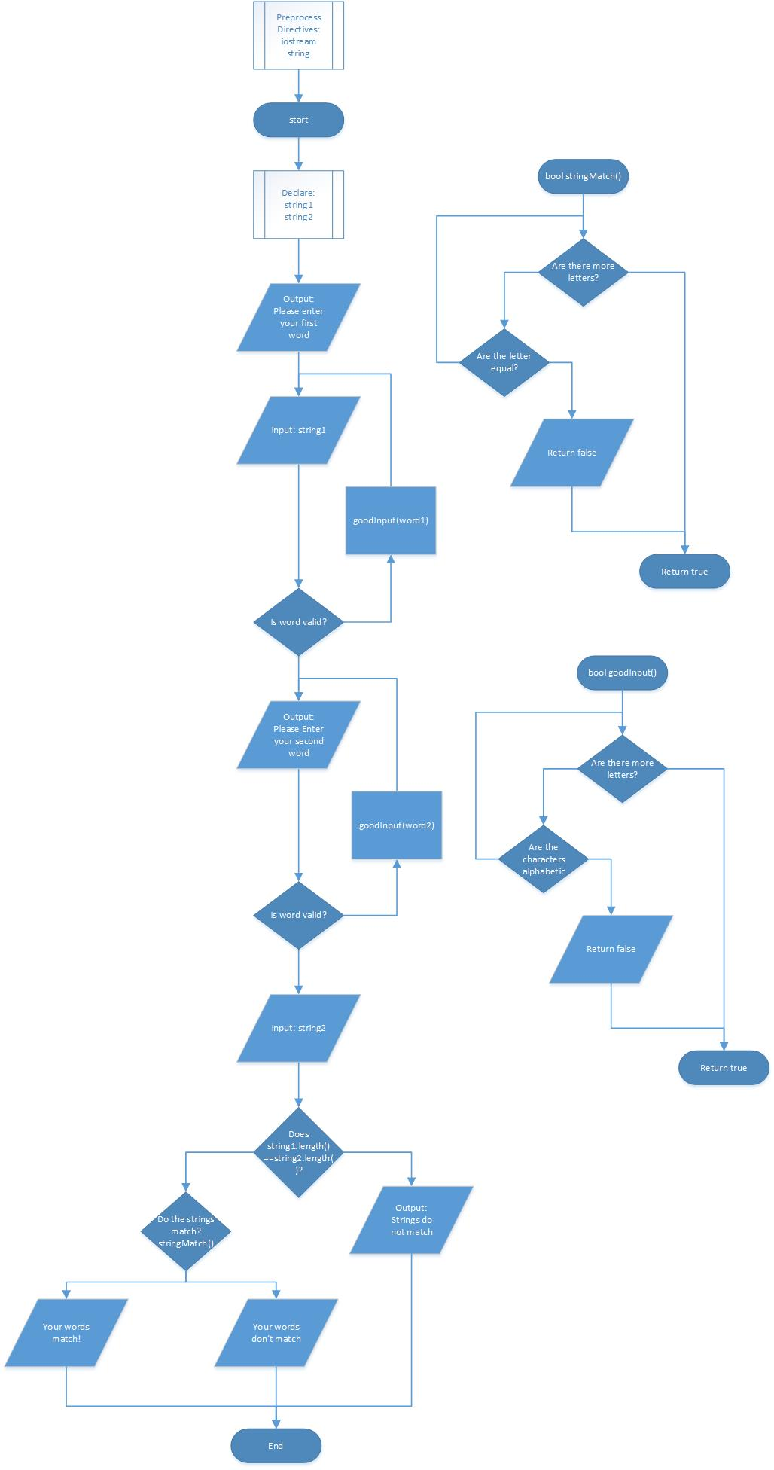refFun.cpp

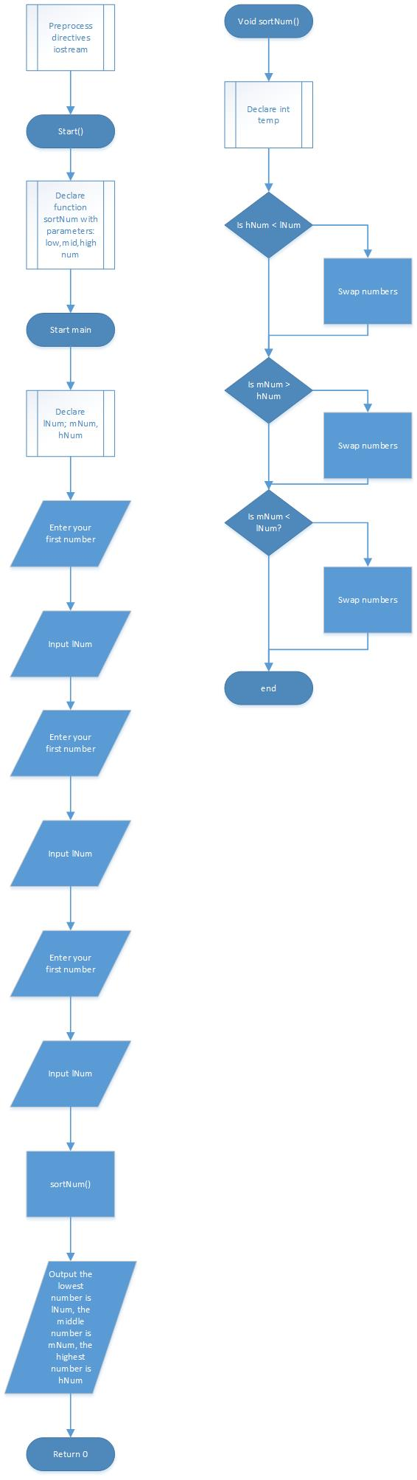sortFun.cpp

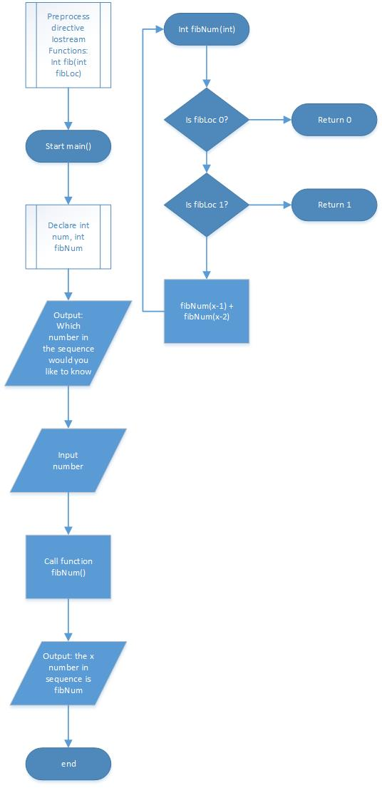recFun.cpp

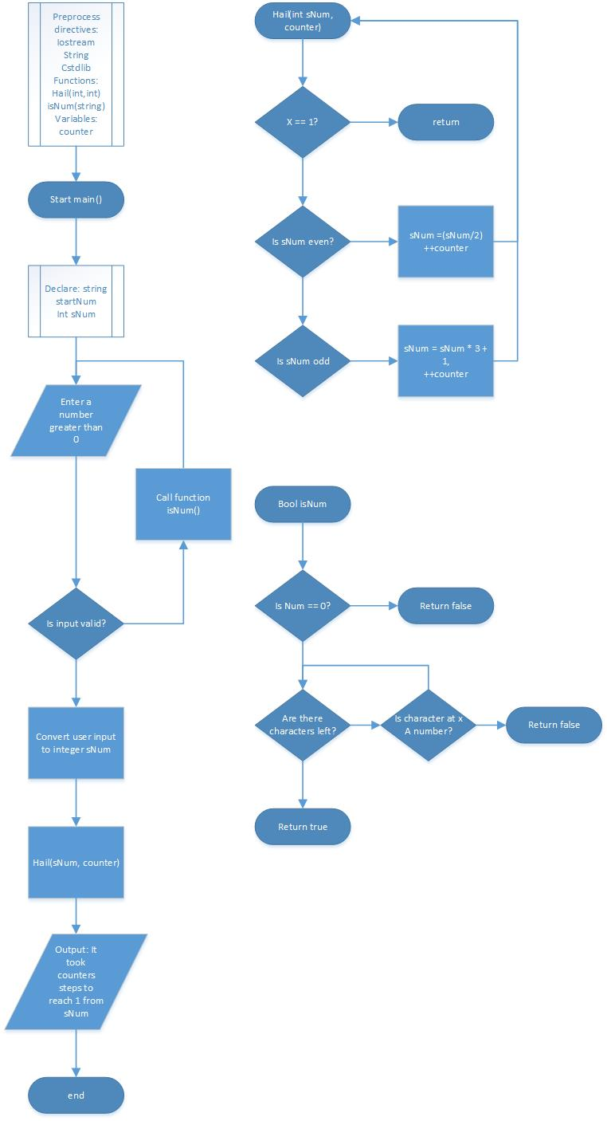hailstone.cpp

Project Design

reconvert.cpp

Pseudocode

Preprocess directives:

Iostream, string, cmath, cstdlib, algorithm

binaryToDecimal function;

decimalToBinary function;

menuFunction;

menuChoice function;

binaryInputValidationFunction;

decimalInputValidationFunction;

int decNum;

string binary;

main function()

int choice,dec

string decimal;

do

menuFunction()

choice = menuChoice()

dec = 0

decNum = 0

binary = ‘ ‘

switch

case 1 output enter decimal number

input decimal

while inputValidationFunction is false

re-input

convert decimal string to decNum int

decimalToBinary function

reverse string

output binary

break

case 2 = output enter binary number

input binary

while binaryInputValidation is false

re-input binary

binaryToDecimal function

output decimal

break

case 3 = End Program

while menuChoice != 3;

return 0;

void displayMenu()

clear screen

output: Enter the corresponding number

output: 1. Convert decimal to binary

output: 2. Convert binary to decimal

output: 3. Quit program

int getChoice()

declare int choice

input choice

while choice is not between 1 and 3

select a number between 1 and 3

return choice

binaryToDecimal function(string biNum)

int length

length = biNum.length()

if (length == 0)

return decimal;

if biNum.at(0) == 1

decimal = decimal + pow(2, length-1);

else

decimal =decimal;

biNum.erase(0,1);

binaryToDecimal function(biNum);

decimalToBinary function (int decNum)

int remainder

if (num > 0)

remainder = decNum % 2

if remaider == 0

binary = binary + ‘0’

if remainder == 1

binary = binary + ‘1’

decNum = decNum / 2

decimalToBinary function(decNum)

bool decimalInputValidation(string num)

For int i = 0 while i++ till length of num = i

If num is not between 0 and 9

Return false

Return true

bool binaryInputValidation(string num)

For int i = 0 while i++ till length of num = i

If num is not 0 or 1

Return false

Return true

Testing

randFun

|  |  |  |  |
| --- | --- | --- | --- |
| Input | Input 2 | Expected Output | Actual Output |
| 15 | 17 | Number is 15,16 or 17 | Expected |
| 32 | 15 | Second input needs to be greater than first | Expected |
| -3 | 300 | Enter a value greater than 0 | Expected |
| 15 | S12 | Invalid input | Expected |
| 15S | 17 | Invalid Input | Expected |
| S15 | 17 | Invalid input | Expected |

refFun

|  |  |  |  |
| --- | --- | --- | --- |
| Input 1 | Input 2 | Expected Output | Actual Output |
| String | String | Words match | expected |
| String | Strong | words don’t match | expected |
| Str5ng | Strng | Invalid Entry | expected |
| 55436 | 55436 | Invalid Entry | expected |

sortFun

|  |  |  |  |  |
| --- | --- | --- | --- | --- |
| Input 1 | Input 2 | Input 3 | Expected result | Actual Result |
| 1 | 2 | 3 | 1,2,3 | expected |
| 2 | 1 | 3 | 1,2,3 | expected |
| 3 | 2 | 1 | 1,2,3 | expected |
| 3 | 1 | 2 | 1,2,3 | expected |
| 1n, n1 | 2 | 3 | Please re input | expected |
| 1 | 2n, n2 | 3 | Please re input | expected |
| 1 | 2 | 3n, n3 | Please re input | expected |

recFun

|  |  |  |
| --- | --- | --- |
| Input | Expected Output | Actual Output |
| 0 | 0 | Expected |
| 1 | 1 | Expected |
| -1 | Invalid input | Expected |
| 3n | Invalid input | Expected |
| n | Invalid input | Expected |
| 3 | 2 | Expected |

Hailstone

|  |  |  |
| --- | --- | --- |
| Input | Expected Output | Actual Output |
| 0 | Enter a valid number | Expected |
| 1 | 0 steps | Expected |
| 5 | 5 steps | Expected |
| 5n | Enter a valid number | Expected |
| N | Enter a valid number | Expected |
| -1 | Enter a valid number | Expected |
| 12 | 9 steps | Expected |

Reconvert

|  |  |  |  |  |
| --- | --- | --- | --- | --- |
| Input – Choice | Input – Binary | Input – Decimal | Expected Output | Actual Output |
| 1 |  |  | Please enter a decimal number | expected |
| 3 |  |  | Thank you good bye | Expected |
| 1n |  |  | Please enter a valid input | Expected |
| N |  |  | Please enter a valid input | Expected |
| -1 |  |  | Please enter a valid input | Expected |
|  | 1010 |  | 10 | Expected |
|  | 1n1 |  | Please enter a binary number | Expected |
|  | 5 |  | Please enter a binary number | Expected |
|  |  | 5 | 101 | Expected |
|  |  | n | Please enter a valid number | Expected |
|  |  | 1n | Please enter a valid number | Expected |
|  |  | N1 | Please enter a valid number | Expected |
|  |  | -1 | Please enter a valid number | expected |

Reflection:

Looking back this week had a directed focus on recursion and returning values by reference rather than by value as we have throughout the rest of the course. Each of the exercises had their own challenges. The refFun and randFun exercises were both focused on returning values by reference on functions we had already used to return by value. This really helped me gather an understanding of what is needed to do so and what it means to pass by reference. I changed my retFun program from a previous week so that it would return a Boolean input rather than the check on every word.

The sortFun exercise was challenging in trying to understand the logic of how to move each number around. It took me longer than I thought it would because I placed an inequality sign incorrectly. The recFun program using the Fibonacci sequence was difficult as was the hailstone program because the thought of answering a question inside out is not something we normally do. Being able to solve the problem backwards can be a good skill, especially since it’s something we regularly do when programming.

Finally with the project for the week, reConvert.cpp, I had a few issues which took me a long time to figure out. The binary to decimal problem was easy for me as the program required I solve it the way I normally do, by breaking down each binary digit into its value based on its position in the string then adding them all together. The logic for the decimal to binary was difficult, because the way I solve those problems would have been difficult to code, so I had to learn a new means of doing so. Eventually I found an algorithm on wikiHow that worked well. My next issue was the string I was creating was printing backwards, luckily another student posted a function that worked to fix that issue. Finally I was unsure how to work the input validation. Eventually I went back to the lectures and saw there was a lecture that had an applicable input validation function and used that which worked well. There was a lot of frustration with this program, not because it was difficult but because I made some silly mistakes with misplaced semi-colons and other characters. However, I’m happy with how the program turned out.