**BIODATA**

## PERSONAL DETAILS

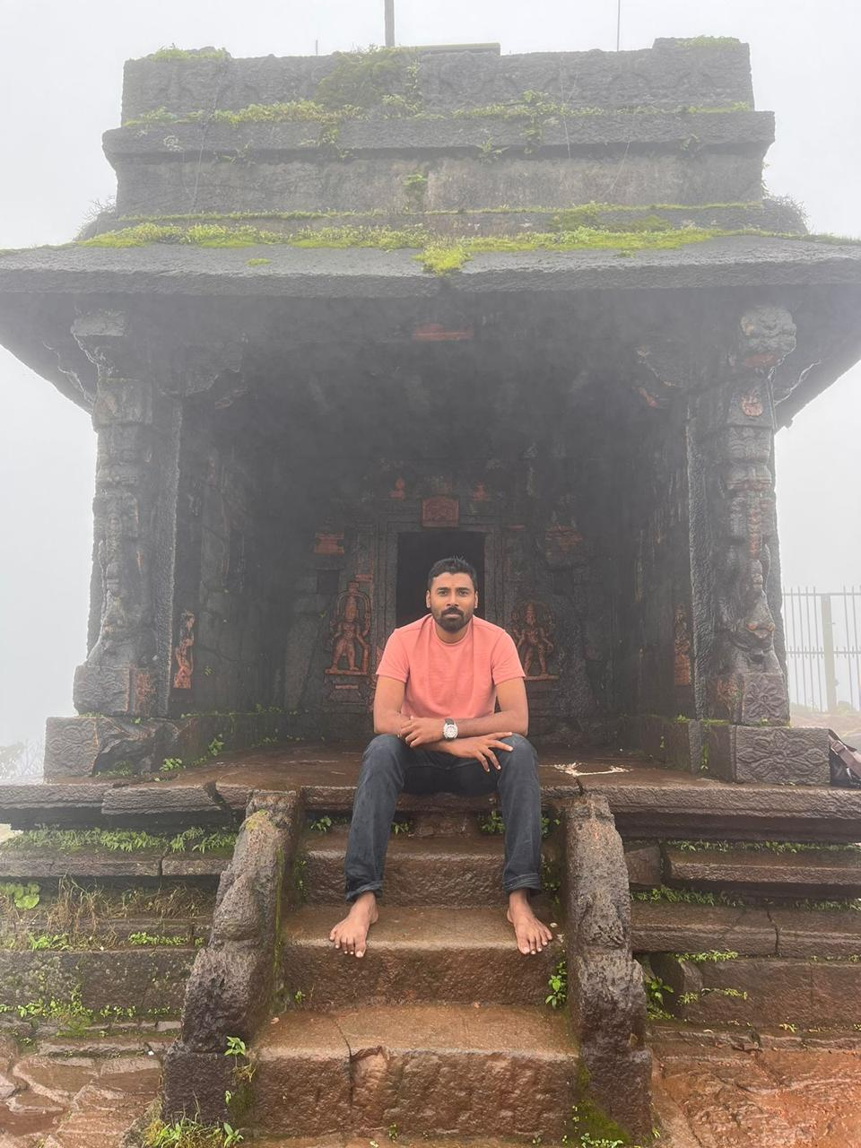Name : Visakh Chandran

Gender : Male

Age : 30 yr

Date of Birth : 09/05/1995

Religion : Hindu

Caste : Nair

Marital Status : Not married

Height : 175 cm

Weight : 75 kg

Education : B Tech

Occupation : Kerala Police , PHQ

Eating habits : Non Vegetarian

Residing Place : Peyad , Thiruvananthapuram

Interests : Travel

## FAMILY DETAILS

Father's Name : Vijayachandran Nair (Late)

Mother's occupation : Home maker

Brother’s occupation : Govt ITI instructor (Married)

Phone Number : 9020885814

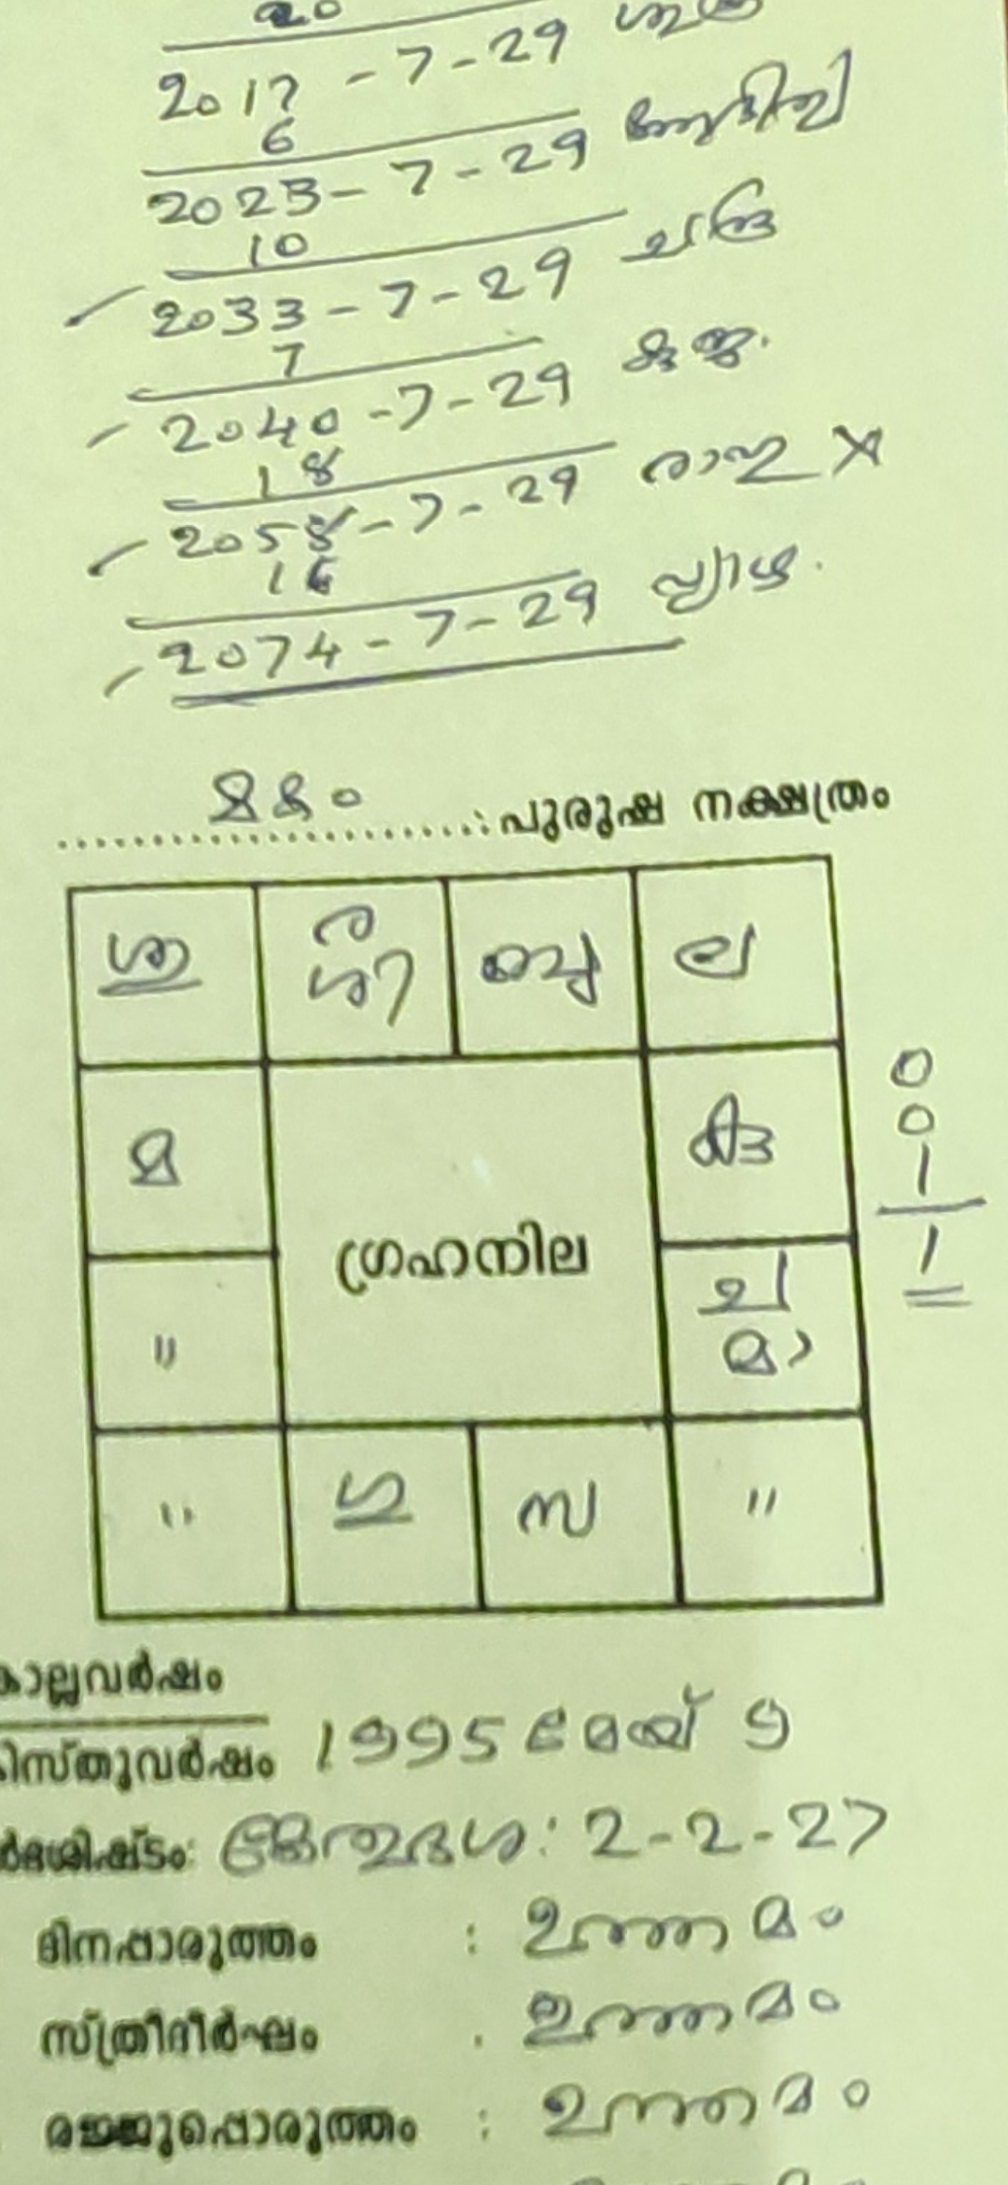 :

## HOROSCOPE DETAILS

Nakshatram : Makam

Date of Birth : 09/05/1995

Time of Birth : 9.23 am

Place of Birth: Thiruvananthapuram