**INTRODUCTION:**

**Overview**: Unlocking insights into the global air transportation network with tableau

**Purpose**: To develop data literacy data analysis data preparation data visualization skills

**PROBLEM DEFINITION &DESIGN THINKING**

**Empathy Map:**

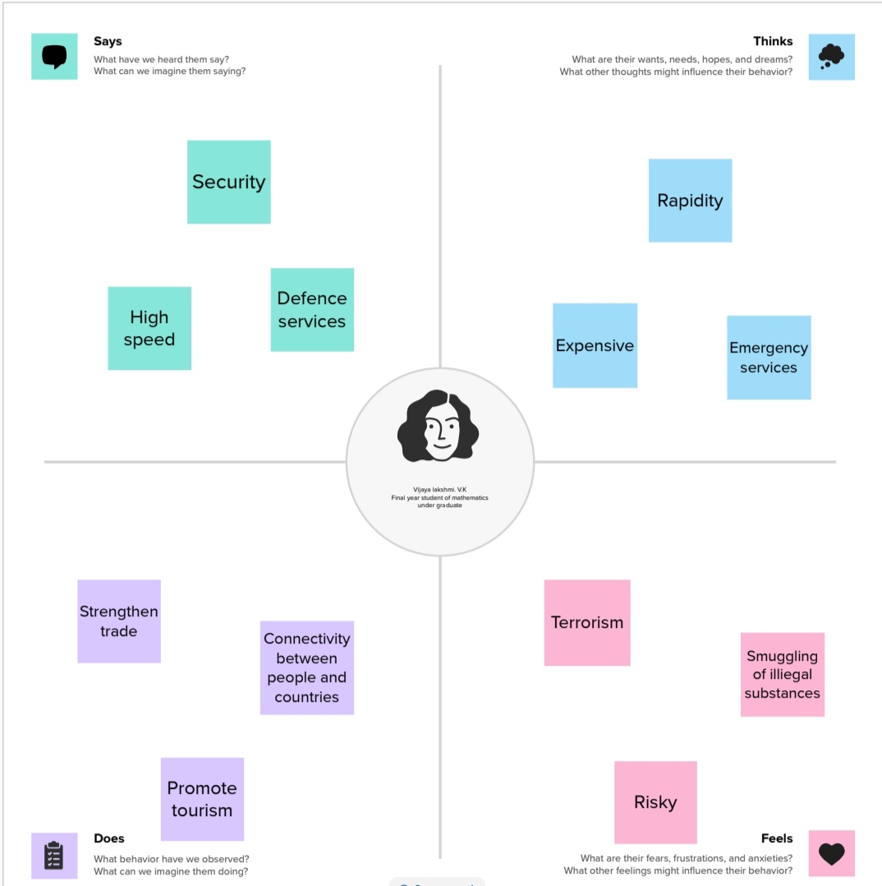

**BRAINSTORMING**:

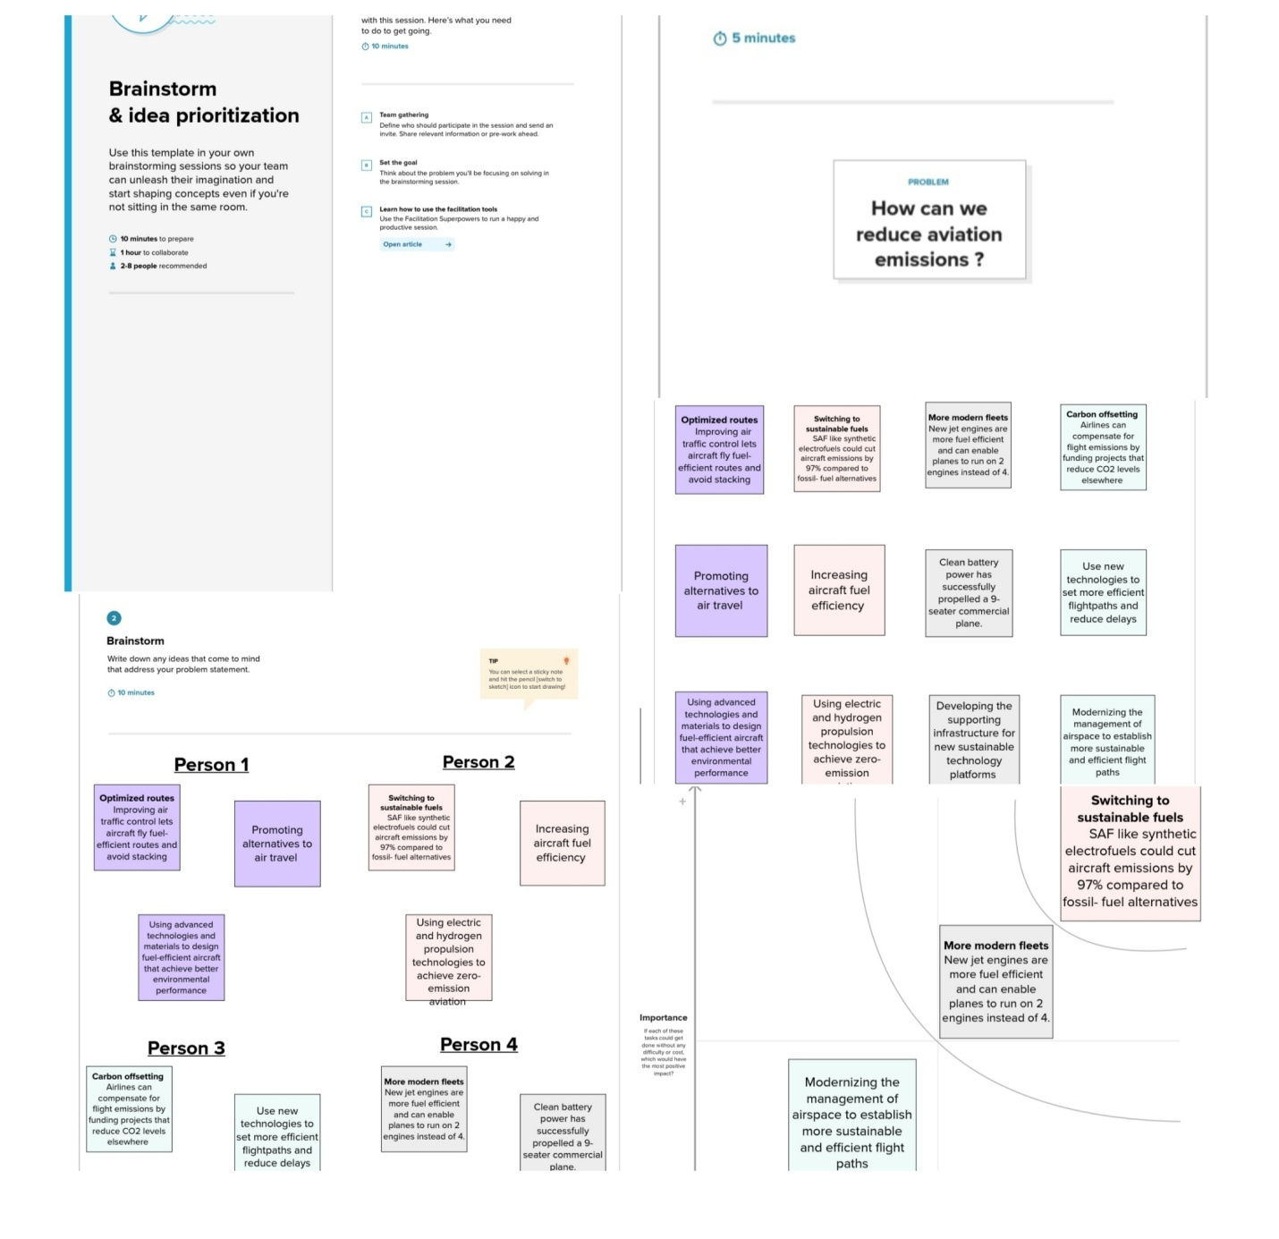

**RESULT:**

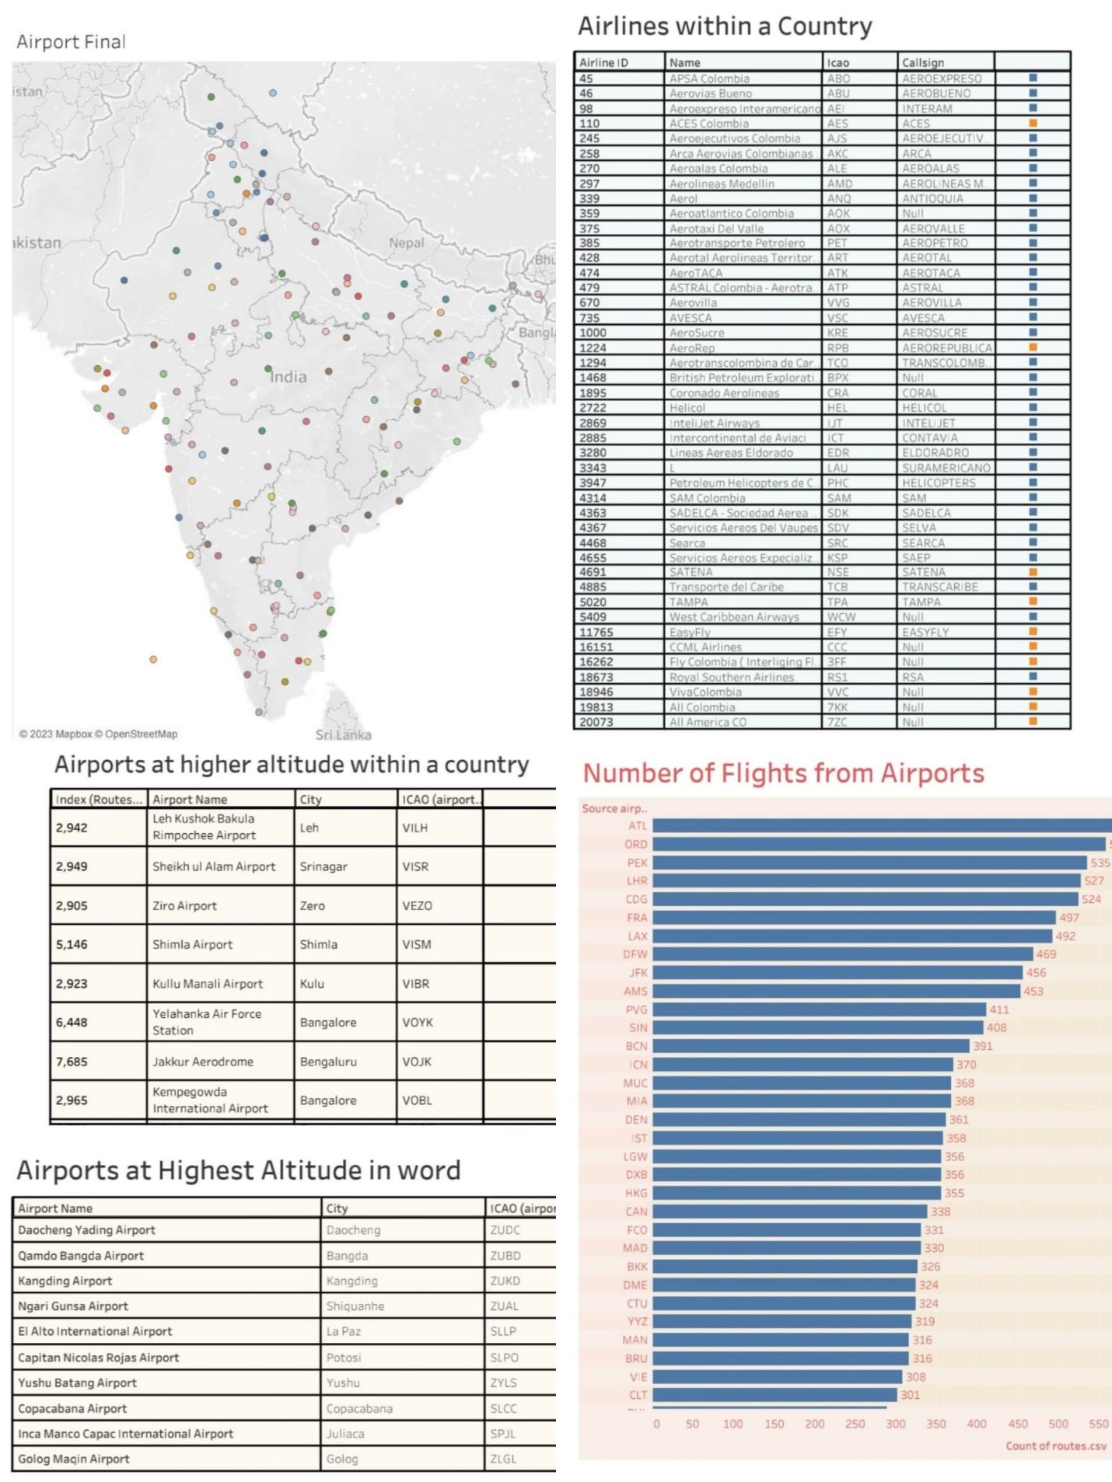

**ADVANTAGES & DISADVANTAGES**

**Advantages**:

The benefit of global air transportation is to enable stakeholders in the aviation industry to gain a competitive advantage by making data-driven decisions.

**Disadvantages**:

Over reliance on technology, lesser human interaction.

**APPLICATIONS**:

It contribute to the overall well-being of communities around the world, by making air travel more accessible affordable and eco-friendly.

**CONCLUSION**:

Thus from a business perspective this project can have a significant impact on the aviation industry.

**FUTURE SCOPE** :

It can optimize routes and reduce congestion in the air leading to improved air quality and reduced carbon emissions.