Wii-Wars by VISEO

Version : 1.0
March 22nd 2015
TABLE OF CONTENT

1 Introduction 3
1.1 Objet de la proposition 3

- Introduction
  - About this document
This document meant to be converted from an Word Open Document (*.odt) to GIT Markdown (*.md file) format for better Web rendering using Open Source format. This conversion could be done using this https://gist.github.com/vzvenyach/7278543
  - Origin of this project
Late 2009, pseudo-connected objects and augmented reality were made possible using the OpenSource project SLARToolkit relying on Silverlight technologies and a Webcam.
Johnny Chung Lee started the move in 2008, with its Wiimote project: http://www.wiimoteproject.com
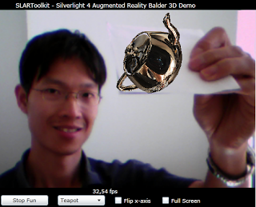

  - Overview of the project : Augmented reality
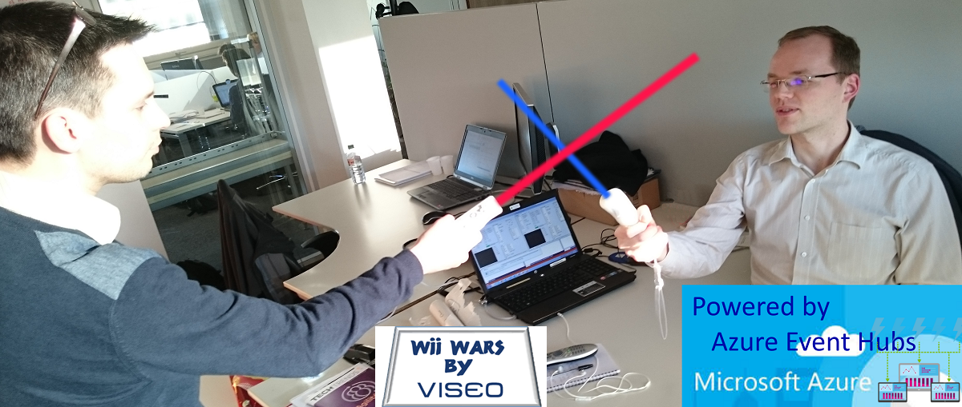
- TECHNICAL CONSIDERATION
  - Overview
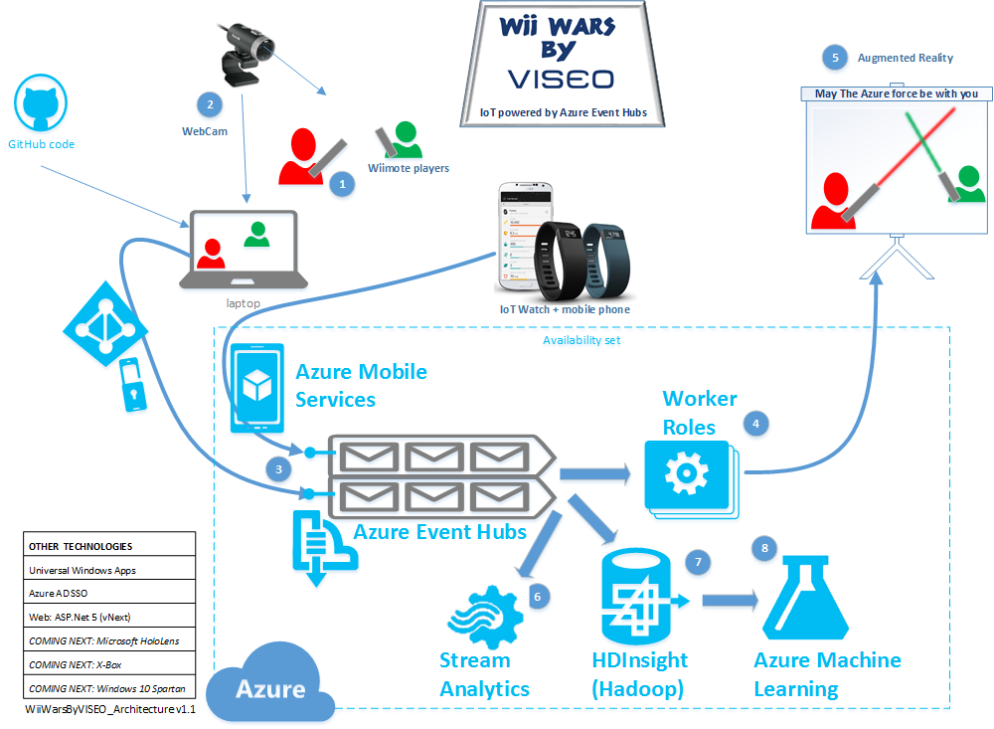

  - Behavior-Driven Development (BDD) using SpecFlow on VS2015 CTP6
    - How to make it work on a CTP version?
See ref https://groups.google.com/forum/#!topic/specflow/kSIxU-CFZZg
- Download the extension from the gallery.
- Update the extension.vsixmanifest inside the package (it's just a zip-container)
<Installation>
<InstallationTarget Id="Microsoft.VisualStudio.Pro" Version="14.0" />
<InstallationTarget Id="Microsoft.VisualStudio.Premium" Version="14.0" />
<InstallationTarget Id="Microsoft.VisualStudio.Ultimate" Version="14.0" />
</Installation>
- Modify devenv.exe.config (C:\Program Files (x86)\Microsoft Visual Studio 14.0\Common7\IDE\devenv.exe.config):
<dependentAssembly>
<assemblyIdentity name="Microsoft.VisualStudio.TestWindow" publicKeyToken="b03f5f7f11d50a3a" culture="neutral"/>
<bindingRedirect oldVersion="10.0.0.0-12.0.0.0" newVersion="14.0.0.0"/>
</dependentAssembly>

