Analysis of Neural Architectures for Sandhi Splitting in Ayurvedic Sanskrit Texts
Harigovind C B1[0009-0007-4454-8780], Abhiram A S¹, Karthik Narayan C¹and Jayashree Nair²
¹ Department of Computer Science and Engineering, Amrita School of Computing,
Amrita Vishwa Vidyapeetham, Amritapuri, Kerala, India.
2 Department of Computer Science and Applications, Amrita School of Computing,
Amrita Vishwa Vidyapeetham, Amritapuri, Kerala, India
{am.en.u4aie22119, am.en.u4aie22002, am.en.u4aie22028}@am.students.amrita.edu, jayashree@am.amrita.edu
Abstract. Classical Ayurvedic literature, such as the Charaka Saṃhitā and Suśruta Saṃhitā, is filled with extensive medical knowledge in Sanskrit. On the other hand, computational analysis of these books is practically complicated because of linguistic features such as Sandhi, a phonological process that merges two adjacent words and changes their surface forms. Therefore, Sandhi splitting is an indispensable preprocessing step for any natural language processing (NLP) task of Sanskrit texts. We present in this paper a thorough research of neural architectures for Sandhi splitting in the Ayurvedic Sanskrit corpora. We study character-level neural models that can recognize Sandhi boundaries and henceforth, help reveal the original words that are hidden in compound expressions. Particularly, we work on a two-step neural model where the first step is boundary detection by Bidirectional Long Short-Term Memory networks and the second is lexical restoration using sequence-to-sequence architectures with attention mechanisms. Results from the experiments prove the neural approaches to be proficient for Sandhi segmentation and lexical reconstruction. The authors also carry out a thorough error analysis in order to find out what common weaknesses are rubbing off the most on the prediction of ambiguous boundaries and complex phonological transformation cases, among others.
Keywords: Sanskrit NLP, Sandhi Splitting, Neural Sequence Models, Ayurvedic Text Analysis.
- Introduction
Classical Sanskrit literature represents one of the most ancient repositories of knowledge. Ayurvedic writings like Charaka Saṃhitā and Suśruta Saṃhitā are the main sources of information on herbs and medicine, as well as on disease treatments and surgeries. One of the major difficulties in working with Sanskrit texts is the problem of Sandhi, which refers to a phonological change that is made at the junctions of neighbouring words. Sandhi changes the visible form of the words when they are in a running text and thus, the words get combined into compound expressions. In order to find the original components, one has to know the exact boundary positions and then reconstruct the forms of the words which are in the dictionary. This method is called Sandhi splitting and it is very important in various natural language processing tasks such as tokenization, morphological analysis, and semantic understanding.
At first, the methods depended on the rule-based grammatical systems that were extracted from the Pāṇinian grammar. Nevertheless, the rule-based systems have problems with ambiguity and scaling. The latest neural methods offer good models for the Sandhi transformations [1-3].
- Background on Sanskrit Sandhi
Sandhi is a foundational phonological phenomenon that essentially regulates the changes in sounds at the boundaries of words in Sanskrit. The traditional grammar prescribes that Sandhi changes take place when neighbouring sounds influence each other. Generally, Sandhi changes are divided into the following three categories:
- Vowel Sandhi
- Consonant Sandhi
- Visarga Sandhi
In numerous ancient manuscripts, Sanskrit text is written without the aid of explicit word separators. This uninterrupted writing style makes computational processing quite difficult and thus demands segmentation techniques to locate the lexical boundaries [5].
- Related Work
Initial computer methods largely depended on rule-based systems that were derived from Pāṇinian grammar [5]. These systems came up with huge rule sets to suggest candidate splits.
Recent work has explored deep learning architectures such as recurrent neural networks and attention-based models for Sandhi splitting [1-4]. Such models acquire the knowledge of phonological patterns by directly learning from the annotated datasets.
Some research works consider Sandhi splitting as a character-level prediction task where neural models decide the splitting points and retrieve the original words. Attention-based sequence-to-sequence models have exhibited fruitful outcomes for Sanskrit segmentation problems. Latest Sanskrit NLP frameworks and toolkits like SanskritShala indicate the increasing contribution of neural architectures in classical language processing [13, 14].
Research into morphological processing in Indian languages has also helped in creating character-level neural models for language analysis. Work on morphological analysers and generation of inflections showed that deep learning methods are very effective in dealing with complex linguistic structures of morphologically rich languages [6, 9, 10].
Recent transformer-based methods for semantic classification of Sanskrit compound words are just one example that reiterates the increasing use of modern deep learning technologies in Sanskrit NLP tasks [11]. Moreover, Indian languages semantic modelling was improved due to neural word embedding methods and multilingual representation learning [12, 15].
- Problem Formulation
Let $X=\left(x_{1},x_{2},…,x_{n}\right)$ represent a sequence of characters that form a compound Sanskrit word. Sandhi splitting aims to uncover the original lexical sequence$Y=\left(y_{1},y_{2},…,y_{m}\right)$.
There are two main sub-problems to which the task can be decomposed:
- Boundary Detection
- Lexical Restoration
- Dataset
The dataset comprises Sanskrit compound expressions extracted from digitized Ayurvedic texts like Charaka Saṃhitā and Suśruta Saṃhitā. One example has the Sandhi compound, and the other has the segmented lexical components that make up the compound. It is well known that virtually no domain-specific datasets exist for Sanskrit NLP and therefore the creation of specialized corpora with a focus on Ayurvedic texts is the key to precise segmentation [7, 8].
The dataset holds around 13, 000 compound expressions in the Devanagari script. The corpus has been split into training, validation, and test sets as outlined in Table 1.
Table 1. Dataset statistics for the Ayurvedic Sanskrit Sandhi corpus
Split | Samples | Average Word Length | Vocabulary Size
Training | 10,400 | 11.2 | 70
Validation | 1,300 | 11.1 | 70
Test | 1,300 | 11.3 | 70
- Methodology
The planned system adheres to a two-stage neural architecture which has been specifically designed to deal with the Sandhi splitting issue in Sanskrit texts, as shown in Figure 1. The architecture divides the task into two parts that are meant to work together: boundary detection and lexical restoration. Thanks to this construction the system can at first find possible Sandhi boundaries and later on it can recreate what original lexical units were before phonological change.
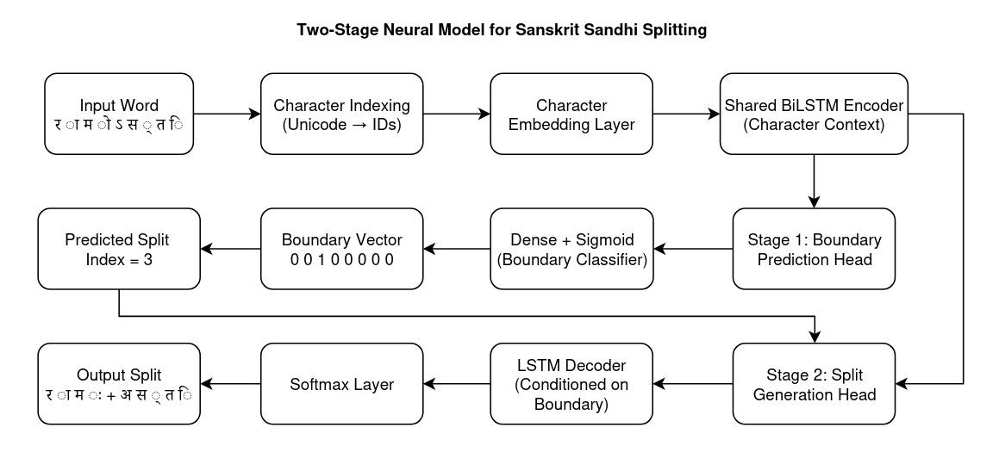
Fig. 1. A Two-Stage Neural model architecture for Sanskrit Sandhi splitting is proposed. The model at first predicts the Sandhi boundary using a BiLSTM-based detection head and then uses a sequence-to-sequence restoration module to reconstruct the lexical components.
The overall workflow of the system starts with a compound Sanskrit word that has been passed through Sandhi transformations. First, the input word is represented at the character level and then transformed into embedding vectors. Such embeddings reflect phonological as well as contextual aspects of Sanskrit characters and give the neural model numerical representations that are appropriate for learning linguistic patterns.
  - Character Representation
As Sandhi mainly works at the phonological level, character-level representations suit the task best. Each character of the input sequence is transformed into a fixed-dimensional embedding vector. Character embeddings enable the model to understand connections between similar phonetic patterns and their changes.
Given an input sequence$X=\left(x_{1},x_{2},…,x_{n}\right)$, each character $x_{i}$ is transformed into an embedding vector $e_{i}∈R^{d}$, where $d$ represents the embedding dimension. These embeddings are the model's input representations for boundary detection.
  - Boundary Detection Model
The first phase of the pipeline focuses on detecting potential positions of Sandhi boundaries. The model chosen for the boundary detection system is shown in Figure 2.
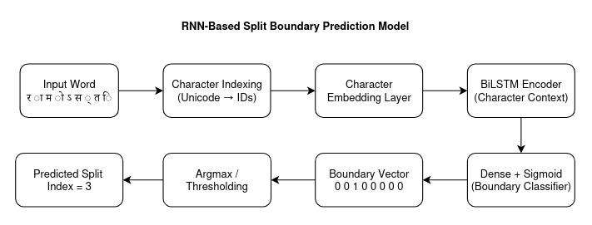
Fig. 2. BiLSTM-based boundary detection architecture for predicting Sandhi split positions in a compound Sanskrit word.
Here, a sequence labelling problem approach is used to solve this task, where each character position gets a binary label that shows if a boundary takes place after that character or not. Modelling contextual dependencies is done by a Bidirectional Long Short-Term Memory (BiLSTM) network. BiLSTMs run sequences in the forward and backward directions, so that the model obtains contextual information not only from the previous characters but also the subsequent ones. The BiLSTM produces hidden features for each character location:
$h_{i}=\text{BiLSTM}\left(e_{i}\right)$
After that, a fully connected layer with a sigmoid activation function is used to predict the probability of a Sandhi boundary at each position. This part results in a set of boundary indices recognized which are then utilized for the segmentation of the compound word.
  - Lexical Restoration Model
After the first step detects the candidate segments, the second stage rebuilds the initial lexical units by undoing the changes caused by Sandhi. The lexical recovery model is done with a sequence-to-sequence architecture with attention, as illustrated in Figure 3.
The encoder takes a segmented sequence as input and outputs contextual representations which intuitively reflect phonological features. The decoder reconstructs the lexical output one character at a time. With the use of attention, the decoder selectively and continuously focuses on the most relevant areas of the input sequence, thus enhancing the model's capability of dealing with complicated Sandhi transformations.
It is through the fusion of the boundary detection and lexical restoration that the system becomes proficient in pinpointing the segmentation points and at the same time reconstructing linguistically valid word forms.
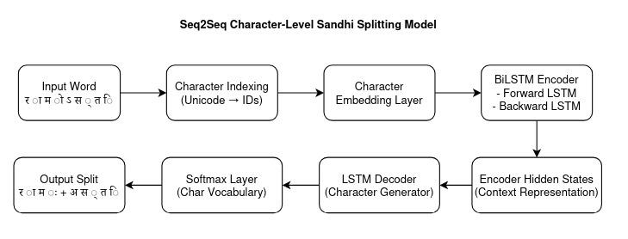
Fig. 3. Character-level Seq2Seq model for Sanskrit Sandhi splitting. The encoder captures contextual character representations and the decoder generates the restored lexical sequence.
- Sandhi Splitting Pipeline
Algorithm 1 Two Stage Neural Sandhi Splitting Pipeline
1: Input compound Sanskrit word
2: Convert characters into embeddings
3: Apply BiLSTM boundary detection
4: Identify predicted boundaries
5: Segment compound word
6: for each segment do
7: Apply Seq2Seq restoration model
8: end for
9: Combine reconstructed lexical units
10: Return final output
- Experimental Setup
We used the PyTorch deep learning framework to carry out the experiments. Since Sandhi changes are phonological level, we decided to use character level embeddings mainly to represent the Sanskrit text. The boundary detection network is made up of several Bidirectional LSTM layers which are intended to identify contextual relations in the character sequence. From the BiLSTM processing of each character embedding, we get hidden representations that contain both the previous and next context. We employed a sequence-to-sequence model with attention for the lexical restoration component. The encoder takes the segmented character sequence and yields contextual representations, while the decoder outputs the reconstructed lexical elements one character at a time.
Training was carried out with stochastic gradient descent along with an adaptive learning rate scheduler. Dropout and other such regularization methods were used during training to ensure that the model does not memorize. The data was split into three parts: training, validation, and testing. The training set was the main source for the model parameters, the validation set served for hyperparameter tuning and checking overfitting, and the test set performed the final evaluation. Several metrics were used in the evaluation as follows:
- Precision - The ratio of correctly predicted boundaries to the total predicted boundaries.
- Recall - proportion of actual boundaries correctly identified by the model.
- F1-score - harmonic mean of precision and recall.
- Character Error Rate (CER) - normalized edit distance between predicted and reference lexical outputs.
These metrics offer a thorough assessment of segmentation accuracy as well as lexical reconstruction performance.
- Results
During model optimization, we monitored both the training and validation losses to evaluate training stability and convergence behaviour. The resulting loss curves are illustrated in Fig. 4. As training progresses, both losses decrease steadily, indicating that the model effectively learns meaningful representations from the training data. The gap between training and validation loss remains relatively small throughout training, suggesting that the model does not suffer from severe overfitting and maintains good generalization performance.
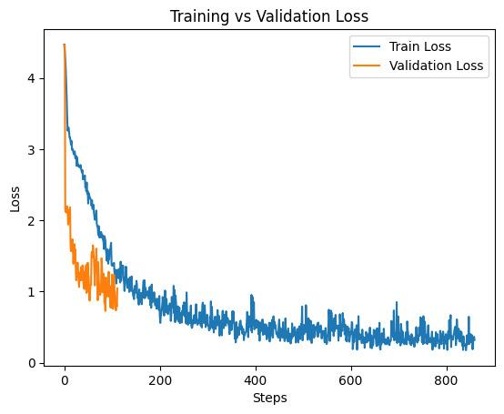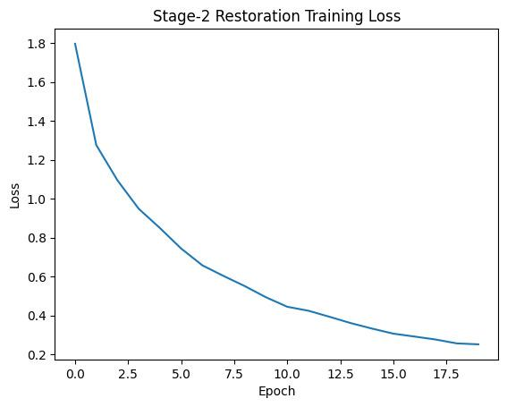
Fig. 4. Training convergence behaviour of the Sandhi splitting models.
The character-level F1 score and exact match accuracy were used to evaluate the model's validation performance, as shown in Fig. 5. These metrics demonstrate consistent improvement across training epochs, indicating that the model becomes progressively better at identifying correct Sandhi boundaries and reconstructing lexical components. The steady rise in validation scores further confirms that the proposed architecture successfully captures phonological patterns present in Sanskrit compound expressions.
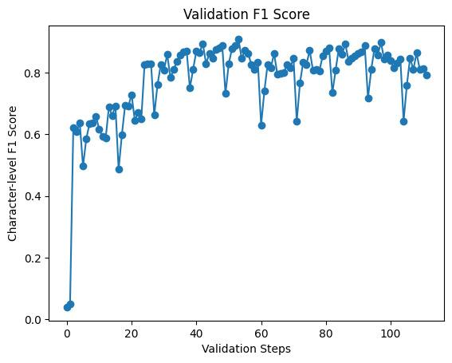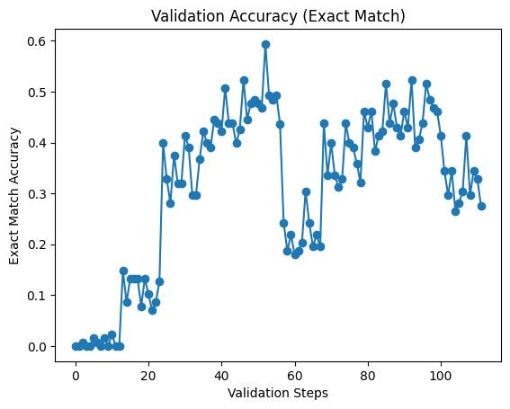
Fig. 5. Validation performance metrics for the Sandhi splitting model.
Precision, recall, and F1-score metrics were used to characterize boundary detection performance, as illustrated in Fig. 6. The results demonstrate a continuous increase in the accuracy of boundary prediction during training.
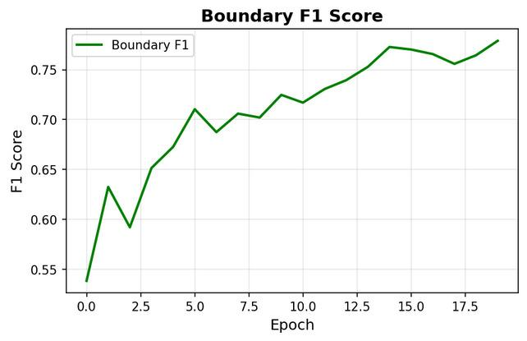
Fig. 6. Boundary detection F1-score across training epochs showing improvement in split prediction accuracy
The quantitative performance of the boundary detection models is summarized in Table 2. The basic RNN model results in a boundary detection F1-score of 0.719 on the test set. By switching to a BiLSTM architecture, the model can better capture contextual dependencies, improving the boundary F1-score to approximately 0.806. The proposed two-stage pipeline further improves performance, achieving an F1-score of 0.826. The results indicate that the proposed pipeline consistently outperforms the baseline models across all evaluation metrics, demonstrating the benefit of combining contextual boundary detection with lexical restoration.
Table 2. Boundary detection performance
Model | Precision | Recall | F1-score
RNN | 0. 619 | 0.855 | 0.719
BiLSTM | 0.742 | 0.881 | 0.806
Proposed Pipeline | 0.768 | 0.894 | 0.826

The lexical restoration results are presented in Table 3. The Seq2Seq baseline achieves an exact match accuracy of 0.493, while the Seq2Seq model with attention improves the performance to 0.561. The proposed pipeline achieves the best reconstruction accuracy of 0.612 with a lower character error rate. The reduction in character error rate further confirms that the proposed architecture improves the accuracy of lexical reconstruction in complex Sandhi transformations.
Table 3. Lexical restoration performance
Model | Accuracy | CER
Seq2Seq | 0.493 | 0.32
Seq2Seq + Attention | 0.561 | 0.27
Proposed Pipeline | 0.612 | 0.23

The improvement achieved by the proposed pipeline highlights the importance of combining boundary detection with lexical reconstruction. While the BiLSTM model captures contextual dependencies in character sequences, the additional restoration stage helps resolve phonological transformations introduced by Sandhi rules. This layered approach enables the system to better recover the original lexical forms from compound expressions. The reduction in character error rate further indicates that the model produces outputs that are closer to the ground truth lexical sequences, particularly in cases where multiple Sandhi transformations occur within a single compound word.
- Error Analysis
In order to explore the weaknesses of the proposed system, the authors conducted a thorough error analysis. During the assessment, they came across several types of errors. We calculated a confusion matrix to examine the classification behaviour of the boundary detection model, which is displayed in Figure 7.
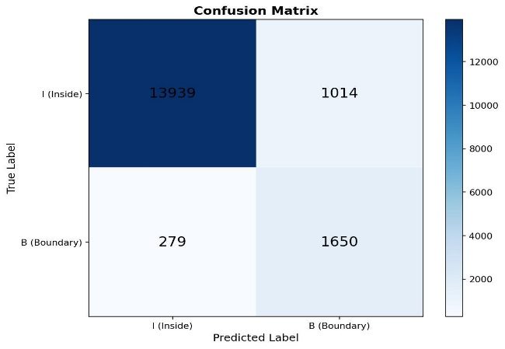
Fig. 7. Boundary Detection Confusion Matrix
As shown in Figure 8, the distribution pictorially represents the differences in reconstruction error levels for various samples and also points out how challenging it is to restore phonological forms in complicated Sandhi constructions. The largest number of errors is found in lengthy compound expressions containing multiple Sandhi trans-formations in a single word. In these situations, the boundary detection model some-times fails to correctly segment the word because it is phonologically ambiguous.
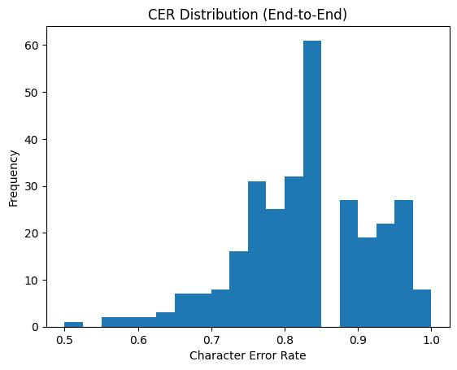
Fig. 8. Distribution of character error rates (CER) for predicted Sandhi splits across the test
dataset.
These observations highlight the primary challenges faced by neural Sandhi splitting models when dealing with phonological ambiguity and limited training data.
Another observation from the error analysis is that boundary prediction errors tend to propagate into the lexical restoration stage. When the boundary detection model predicts an incorrect split position, the restoration model receives improperly segmented input, which can lead to incorrect lexical reconstruction. This cascading effect highlights the importance of accurate boundary detection as the first stage of the pipeline. Future work may explore joint modelling approaches that simultaneously perform boundary detection and lexical restoration in order to reduce such error propagation.
Another type of error that was due to ambiguous Sandhi transformations. Some phonological changes may indicate different lexical decompositions. Without enough contextual information the neural model can hardly be expected to figure out the correct reconstruction. Furthermore, there were some cases of errors of the lexical restoration model in the three settings dealing with rare vocabulary of the domain in the texts of Ayurveda. Such words occurring rarely in the training data, the model of lexical restoration is sometimes unable to give the correct reconstructions. Nevertheless, the suggested two-stage framework not only achieves an effective performance on most of the cases, but also supplies a good basis for Sandhi splitting in Sanskrit.
- Discussion
Experimental outcomes reveal that neural network models represent phonological transformations in Sanskrit quite well. Character-level analysis enables the system to discern intricate patterns, which even manual rule-based methods would struggle to formulate. Employing a two-stage pipeline methodology has been proven to bring about multiple benefits. On the one hand, boundary detection makes the segmentation task easier by narrowing down probable split points; on the other hand, the word-form recovery model is tasked with generating semantically correct words. Such a modular strategy not only raises the degree of freedom but also makes it possible to insert different neural architectures into the pipeline. Nevertheless, the success of neural Sandhi splitting systems greatly depends on whether there are enough annotated training materials. Sanskrit text collections with clear indication of segmentation points are still scarce, especially in specialized fields like Ayurvedic literature. Studies ahead might decide on transformers-based models usage as well as bigger language models covering multiple languages capabilities to raise the level of segmentation correctness. Moreover, reduction of ambiguity and achievement of better reconstruction output can be attained if linguistic constraints coming from classical Sanskrit grammar are embedded.
- Conclusion
This study presented a neural approach for Sandhi splitting in Ayurvedic Sanskrit texts. The proposed two-stage architecture demonstrates promising results in both boundary detection and lexical reconstruction tasks. By combining contextual sequence modelling with character-level restoration, the system effectively handles phonological transformations that occur in Sanskrit compound expressions. The experimental results show that the proposed pipeline outperforms baseline models across multiple evaluation metrics. Future work may explore transformer-based architectures, larger Sanskrit corpora, and linguistically informed constraints to further improve segmentation accuracy and robustness in real-world Sanskrit NLP applications.
Disclosure of Interests. The authors have no competing interests to declare that are relevant to the content of this article.

References
- Aralikatte, R., et al.: Sanskrit Sandhi Splitting using seq2(seq)². In: Proceedings of the Conference on Empirical Methods in Natural Language Processing (EMNLP) (2018)
- Dave, S., et al.: Neural Compound Word Sandhi Generation and Splitting in Sanskrit. arXiv preprint arXiv:2010.12940 (2020)
- Reddy, S., et al.: Attention-based Encoder–Decoder Models for Sanskrit Sandhi Splitting. In: ACL Workshop on Natural Language Processing (2018)
- Hellwig, O., et al.: Neural Approaches for Sanskrit Compound Splitting. In: Proceedings of the Annual Meeting of the Association for Computational Linguistics (ACL) (2019)
- Krishna, A., et al.: Sanskrit Word Segmentation and Dependency Parsing. University of Hyderabad (2016)
- Nair, J., et al.: A Study on Morphological Analyser for Indian Languages. ResearchGate (2021)
- Varshini, A.E.R., Nair, J.: Word Segmentation and Sandhi Resolution on Ayurveda Classical Scriptures (2023)
- Sreedeepa, S., et al.: Review on Sanskrit Sandhi Splitting using Deep Learning Techniques. IRO Journals (2024)
- Premjith, B., et al.: Deep Learning Approach for Malayalam Morphological Analysis (2018)
- Prasad, V., et al.: Character-Level Morphological Inflection Generation (2019)
- Bhat, S.D., Premjith, B.: Transformer-based Semantic Classification of Sanskrit Compound Words (2025)
- Gangadharan, V., et al.: Paraphrase Detection Using Deep Neural Network Based Word Embedding. IEEE (2020)
- Sandhan, A., et al.: SanskritShala: A Neural Sanskrit NLP Toolkit. arXiv (2023)
- Sandhan, A.: Linguistically-Informed Neural Architectures for Sanskrit NLP. arXiv (2023)
- Kumar, V., et al.: Pre-trained Word Embeddings for Indian Languages. arXiv (2021)

