INTERNSHIP REPORT
SOCIAL MEDIA MARKETING INTERNSHIP
InAmigos Foundation
05 June 2026 – 19 June 2026

Student Name | Vishesh Kumar Bachchas
Roll Number | 25SCS1003005456
Programme | B.Tech – Computer Science & Engineering (AI & ML)
Institute | IILM University, Greater Noida, U.P.
Internship Role | Social Media Marketing Intern

Submitted to
School of Computer Science and Engineering
IILM University, Greater Noida, U.P.

01 • PRELIMINARY
Candidate's Declaration
I, Vishesh Kumar Bachchas, hereby declare that the internship report titled “Social Media Marketing Internship at InAmigos Foundation” has been prepared by me in fulfilment of the academic requirements of the Bachelor of Technology programme in Computer Science and Engineering (AI & ML).
The report presents the activities, assignments, learning, and supporting evidence associated with my internship. Wherever external information has been used, the relevant source has been acknowledged. I affirm that the report is prepared for academic submission and that I am responsible for the authenticity of the work presented.
Student Name: Vishesh Kumar Bachchas
Roll No.: 25SCS1003005456

02 • PRELIMINARY
Acknowledgement
I would like to express my sincere gratitude to InAmigos Foundation for providing me the opportunity to undertake a practical internship in the field of social media marketing. The internship offered exposure to the way a social-impact organization uses digital communication, audience engagement, educational content, environmental awareness, and fundraising outreach to support its causes.
I am thankful to the InAmigos Foundation team for assigning structured activities, providing communication and submission guidance, and giving me an environment in which I could learn through execution. I also acknowledge the support of IILM University, Greater Noida, for providing the academic framework within which this internship experience is being documented.
Finally, I am grateful to my family and everyone who supported me during the internship period and encouraged me to approach each assignment with responsibility and creativity.

03 • CONTENTS
Table of Contents
1. Internship Completion Certificate
2. Project Description
2.1 Introduction
2.2 Organization Profile
2.3 Problem Statement
2.4 Internship Objectives
2.5 Scope of the Internship
2.6 Technologies, Platforms & Tools
2.7 Work Architecture
2.8 Methodology
2.9 Task-wise Work & Interpretation
2.10 Learning Outcomes
2.11 Certificates & Communication Proof
3. Bibliography / References
Appendix A – Selected Work Evidence

04 • VERIFICATION
Internship Completion Certificate
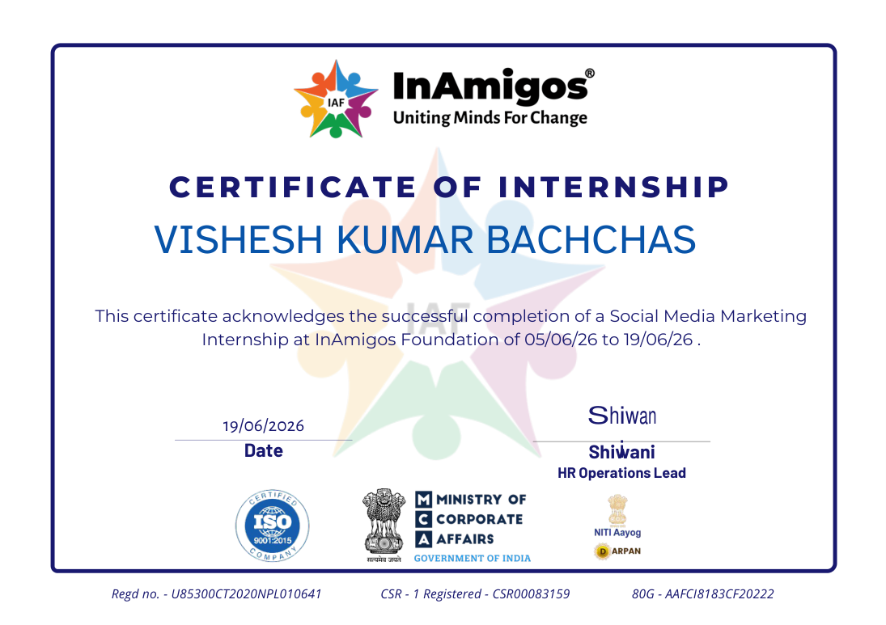
Internship Completion Certificate issued by InAmigos Foundation.

05 • PROJECT DESCRIPTION
Introduction
Practical social media marketing for a social-impact organization
This report presents the work undertaken during my Social Media Marketing Internship at InAmigos Foundation from 05 June 2026 to 19 June 2026. The internship combined structured social-media engagement activities with cause-oriented assignments covering environmental awareness, children's education, donor outreach, and digital documentation.
Rather than treating individual assignments as isolated actions, the internship is interpreted as a practical social-media workflow: understand the communication objective, interact with cause-related content, create or support audience-facing material, encourage participation, document execution, and submit evidence in an organized manner.
Internship snapshot
Role: Social Media Marketing Intern | Organization: InAmigos Foundation | Mode: Primarily remote with fieldwork where required | Duration: Two weeks

2.2 Organization Profile
InAmigos Foundation is a Section 8 registered non-profit organization founded in 2020. According to its official website, the foundation works across social-impact areas including education, food and clothing support, animal welfare, women empowerment, environmental sustainability, skill development, and social inclusion. Its initiatives include Project Seva, Project BachpanShala, Project Jeev, Project Udaan, Project Prakriti, and Project Vikas. The organization also uses social media to showcase impact and keep supporters engaged.
The internship therefore provided a relevant setting for learning social media marketing beyond commercial promotion: content and engagement were connected to awareness, participation, community support, and resource mobilization.
Organization–internship connection
The role sat at the intersection of digital communication and social impact: the objective was not only to attract attention, but to turn attention into meaningful interaction, awareness, educational value, and support.

2.3 Problem Statement
Social-impact organizations depend on consistent digital communication to keep their causes visible, understandable, and actionable. However, simply publishing content does not guarantee audience attention or participation. A practical social media workflow must encourage interaction, use context-aware communication, support campaign amplification, create useful educational material, and build trust around calls for support.
The internship addressed this practical gap by giving hands-on exposure to organic engagement, cause-based communication, educational content development, donor outreach, and evidence-based submission practices.
2.4 Internship Objectives
- Understand the practical role of social media marketing within a non-profit and social-impact environment.
- Practice organic engagement techniques that encourage meaningful audience interaction rather than passive content consumption.
- Support awareness campaigns by interacting with cause-related content and communicating relevant, context-aware responses.
- Contribute to environmental and social-impact initiatives through digital amplification and participation-oriented tasks.
- Develop age-appropriate educational content that can function as a reusable learning resource.
- Support donor outreach by communicating the fundraising objective to a personal network and documenting confirmations.
- Build professional habits around task interpretation, timely execution, evidence collection, and digital submission.
- Reflect on how communication, creativity, and consistency contribute to social-media-led impact.
2.5 Scope of the Internship
The scope covered Instagram engagement, cause awareness, campaign amplification, educational content creation, fundraising communication, documentation, and coordination through WhatsApp and email. The work was primarily execution-oriented and designed to build practical familiarity with the day-to-day mechanics of social media marketing in a non-profit setting.
The internship did not involve paid advertising, formal campaign-budget management, platform analytics dashboards, or ownership of the organization's content calendar. The emphasis was on organic participation, content interaction, social-impact communication, and task-based execution.
2.6 Technologies, Platforms & Tools
- Instagram – organic engagement, content interaction, commenting, and cause-awareness participation.
- WhatsApp – task instructions, coordination, discussion, and submission guidance.
- Google Drive – work submission and evidence organization.
- Email – formal internship communication, offer communication, and completion communication.
- Canva / document-creation workflow – preparation and presentation of educational and report material.
- PDF documentation – compiling screenshots and maintaining verifiable task evidence.
2.7 Work Architecture
The internship workflow can be represented as a simple social-media execution loop:
Understand | Engage | Create | Amplify | Document
Read the cause, post, and task objective. | Interact with relevant content through contextual comments and likes. | Develop educational or awareness-oriented material. | Encourage visibility and participation through social sharing or outreach. | Capture screenshots, compile evidence, and submit in the required format.
2.8 Methodology
The methodology followed a task-driven cycle. Each assignment began with the instructions shared by the organization. I first identified the intended social or communication outcome, then executed the activity through the specified platform or format. Where the task required audience interaction, I used context-aware language instead of generic reactions. Where a deliverable was required, I organized screenshots or content into a clear submission. Finally, I reviewed the evidence for completeness before compiling it for submission.
Stage | Action | Marketing Lens | Evidence
1 | Interpret the brief | Identify audience, cause and desired action | Task instructions
2 | Execute | Use organic engagement or content creation | Posts / workbook / outreach
3 | Amplify | Encourage awareness, participation or support | Comments, sharing, donor outreach
4 | Document | Capture proof and organize files | Screenshot PDFs / communication proof

06 • WORKSTREAM 01
Task 1 – Organic Engagement & Reach Practice
Assessment 1: Like, Comment & Upload Screenshots
The first engagement assignment required interaction with assigned Instagram posts. Instead of treating the task as a mechanical “like and comment” exercise, I approached it as practice in organic social engagement: observing the theme of each post, responding with a relevant thought, and understanding how meaningful comments can contribute to a content conversation.
- Reviewed assigned cause-oriented Instagram content before responding.
- Practiced context-aware commenting rather than one-word or generic reactions.
- Used engagement as a way to reinforce the message of the original post.
- Captured separate proof of the interaction and compiled the evidence into the required PDF format.
- Built familiarity with the discipline of executing a social-media task consistently across multiple pieces of content.
Professional interpretation
This activity provided hands-on practice in organic engagement and audience-response techniques: the goal was to add contextual value to an existing conversation while supporting the visibility of the foundation's message.

07 • WORKSTREAM 02
Task 2 – Green Mission
Environmental awareness and social amplification
The Green Mission was structured around a practical environmental action followed by documentation and social amplification. The assignment brief required participants to plant a sapling, document the activity, participate in an interaction-based discussion component, and publicly share the environmental message using the specified campaign hashtags.
- The core activity centered on plantation and visible documentation of the action.
- The interaction component encouraged participants to share a clear still image or selfie with the plant during the group discussion.
- The social-media component encouraged public sharing on platforms such as Instagram, LinkedIn or Facebook.
- The campaign required consistent use of the prescribed hashtags: #InAmigos #GreenMission #TreeOfLife #PlantHopeGrowFuture.
- The overall communication objective was to convert a personal environmental action into a shareable awareness message.

08 • WORKSTREAM 03
Task 3 – Support Children's Education
Development of an age-appropriate mathematics learning resource
Task 3 focused on creating meaningful educational content for children aged six to fifteen, particularly children who may have limited access to formal learning resources. For this task, I developed the “Maths Adventure” workbook as a reusable, self-contained learning resource.
The workbook is designed for upper-primary learners and combines explanations, examples, graded practice, word problems, a challenge section, and answers. Its content covers multiplication, division, fractions, decimals, percentages, geometry, and problem-solving. The design uses simple language, worked examples, practice questions, and real-life contexts to make the material more approachable.
- Converted a broad educational objective into a structured learner-facing resource.
- Used progressive explanations and worked examples before practice questions.
- Included real-life style problems to connect mathematics with everyday situations.
- Added an answer section so learners can self-check after attempting the exercises.
- Prepared the material in a format that can be printed and shared as a learning aid.
Professional interpretation
This was more than a content-writing task: it involved audience definition, instructional structuring, readability, engagement design, and creation of a reusable digital education asset.

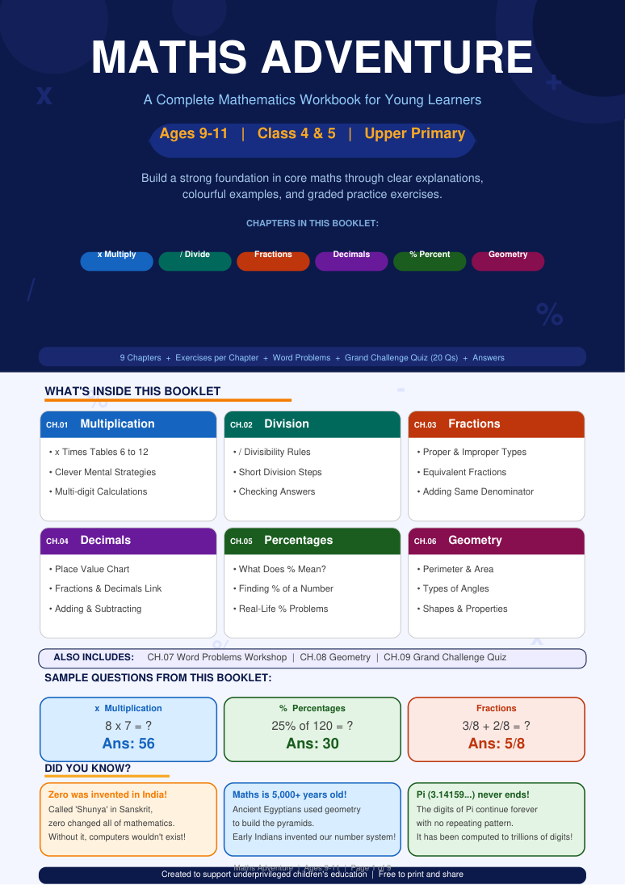  Maths Adventure cover | 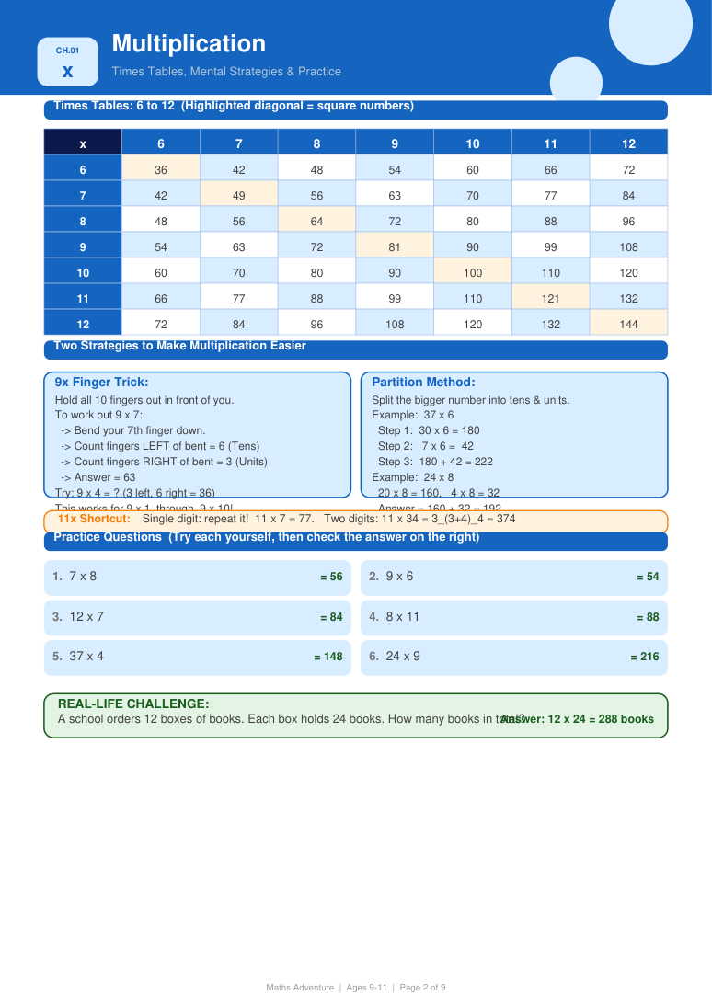  Multiplication learning page
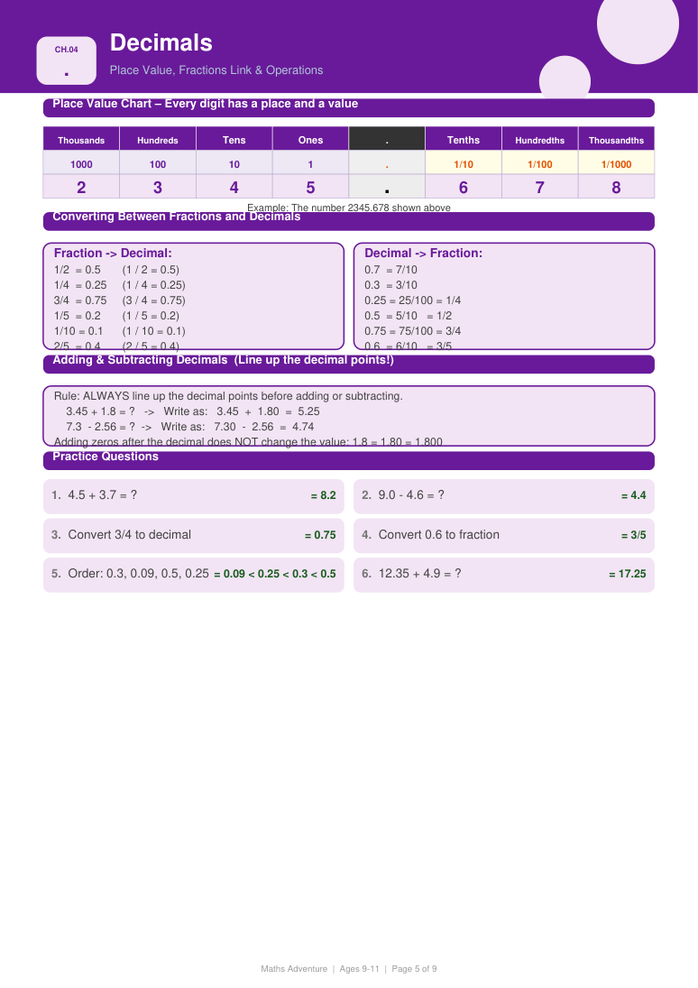  Decimals & percentages | 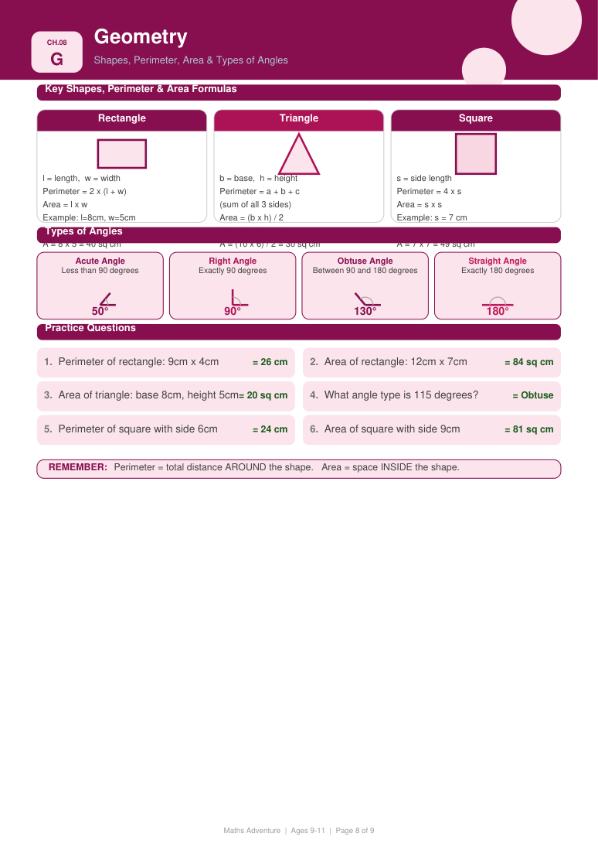  Geometry learning page
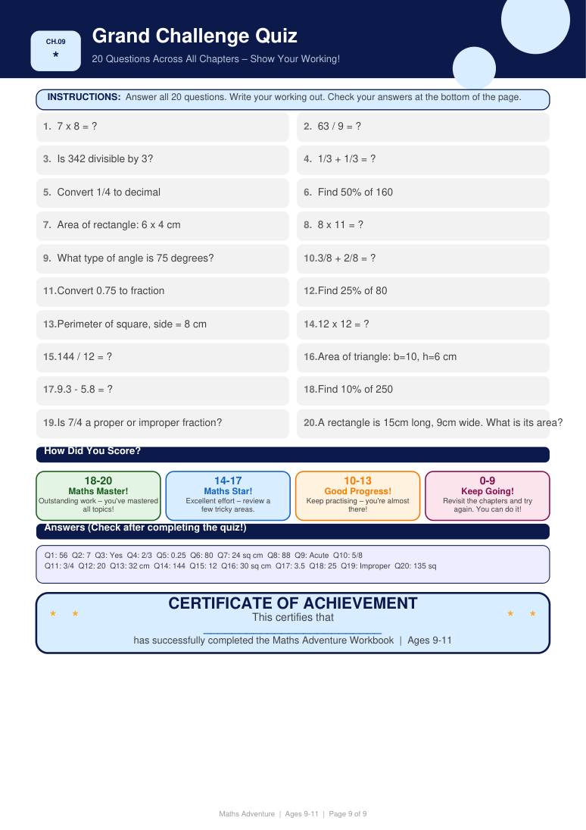
Challenge and answer section with completion certificate.

09 • WORKSTREAM 04
Task 4 – Fundraising & Donor Outreach
Turning personal networks into support for a social cause
The fundraising assignment introduced the outreach side of social-impact marketing. The task required interns to communicate the donation opportunity to people in their existing network, encourage voluntary contributions, and collect confirmation screenshots as evidence.
- Identified potential supporters within an accessible personal network.
- Communicated the purpose of the donation request rather than relying only on a transactional ask.
- Coordinated the collection of payment confirmations for documentation.
- Handled donor evidence carefully and organized it into a compact submission.
Professional interpretation
The task provided practical exposure to direct-response communication: framing a cause, reaching a relevant audience, encouraging voluntary action, and maintaining evidence of the resulting activity.

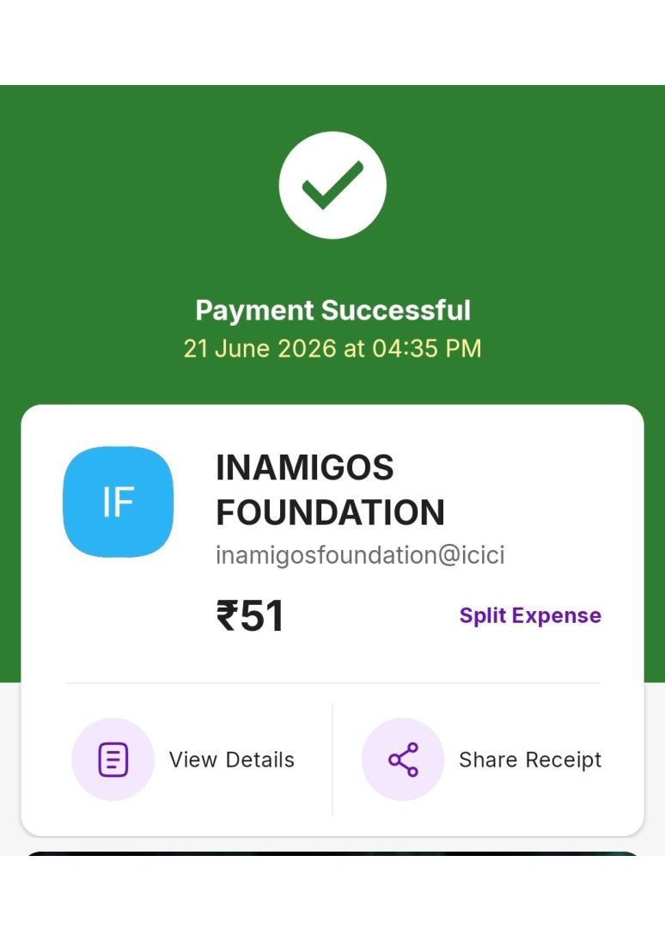  Donation confirmation evidence | 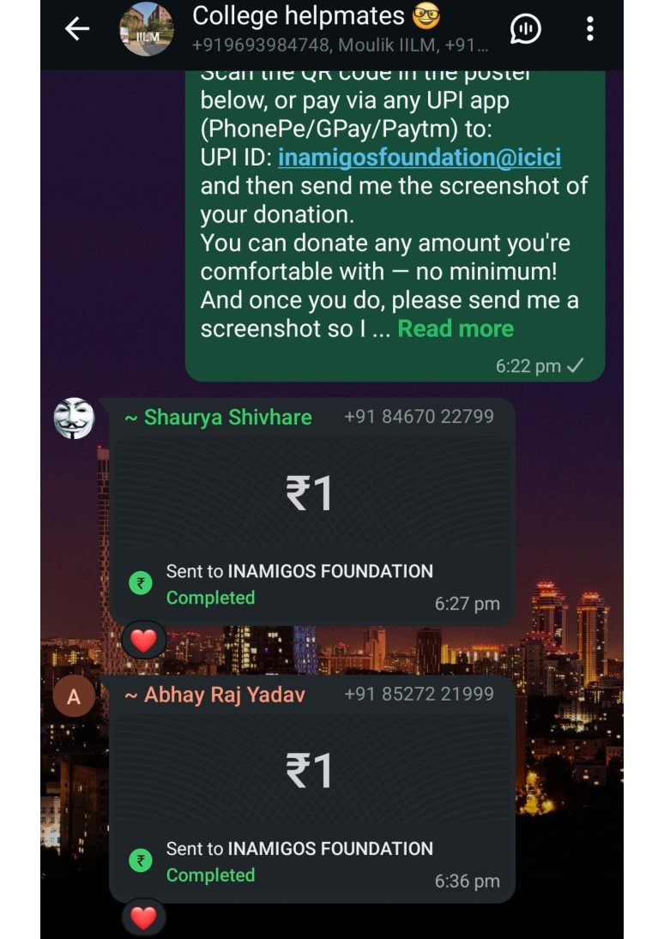  Donor confirmation screenshots

10 • WORKSTREAM 05
Task 5 – Community Engagement Round
Cause-based conversation and message reinforcement
The final engagement assignment repeated the structured like-and-comment format with a fresh set of assigned Instagram posts. The content represented themes including social support, environmental responsibility, compassion, nutrition, education, and community service. I used the task as a second round of practice in writing comments that reinforce the central message of each post.
- Interacted with multiple cause-related posts through likes and contextual comments.
- Adjusted the tone of comments to match the subject of the post.
- Used reflective language to extend the conversation beyond a simple compliment.
- Practiced concise public-facing communication suitable for a social-impact brand.
- Compiled the interactions into an evidence PDF for organized submission.
Examples of communication approach
Comments focused on themes such as responsibility toward future generations, dignity in service, the communication value of short-form video, education as an opportunity-building tool, and the importance of care and nutrition in childhood.

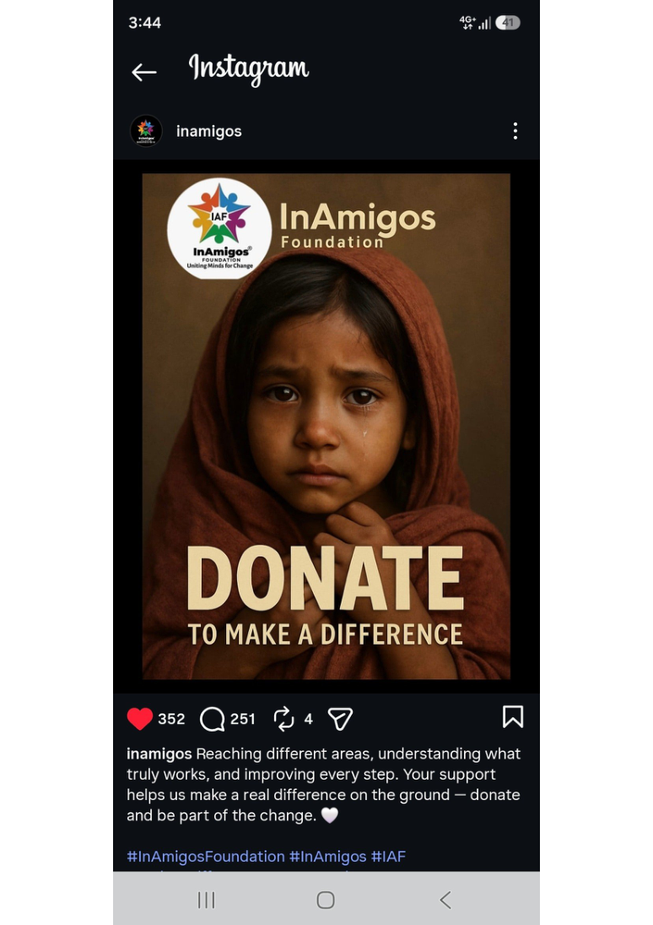  Cause-oriented post | 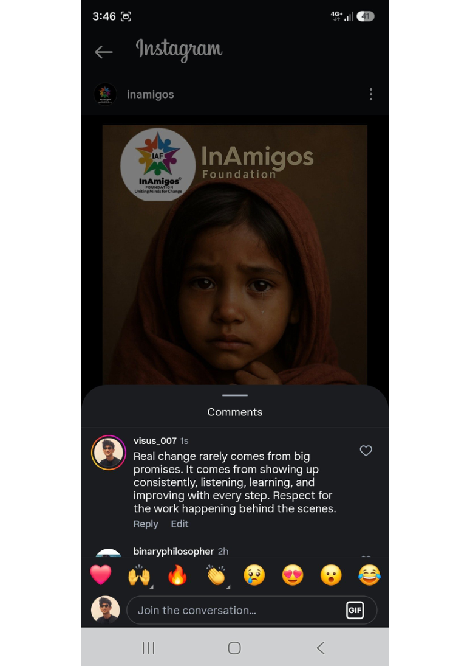  Contextual comment
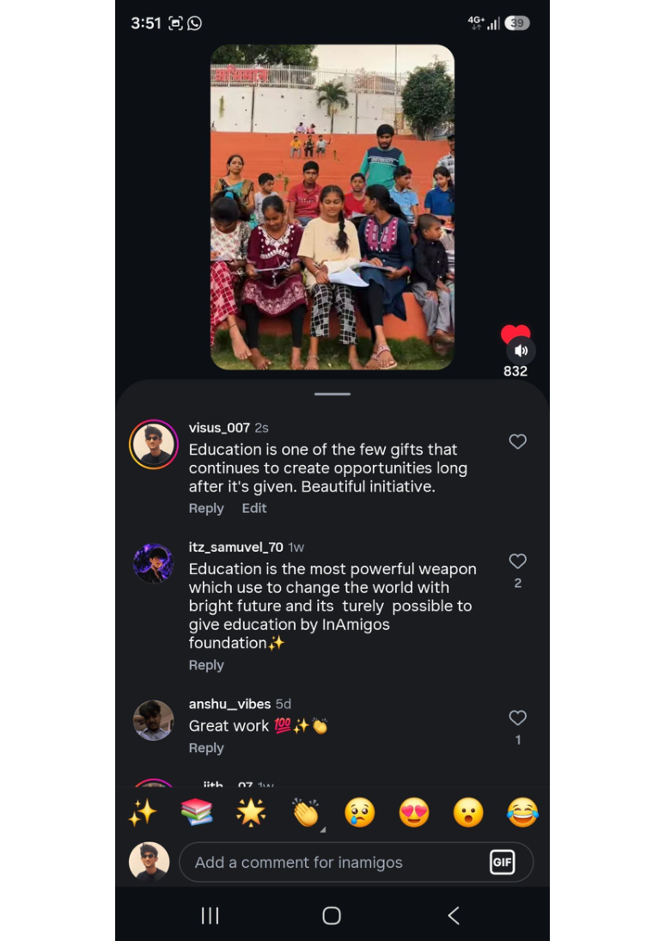  Education-related interaction | 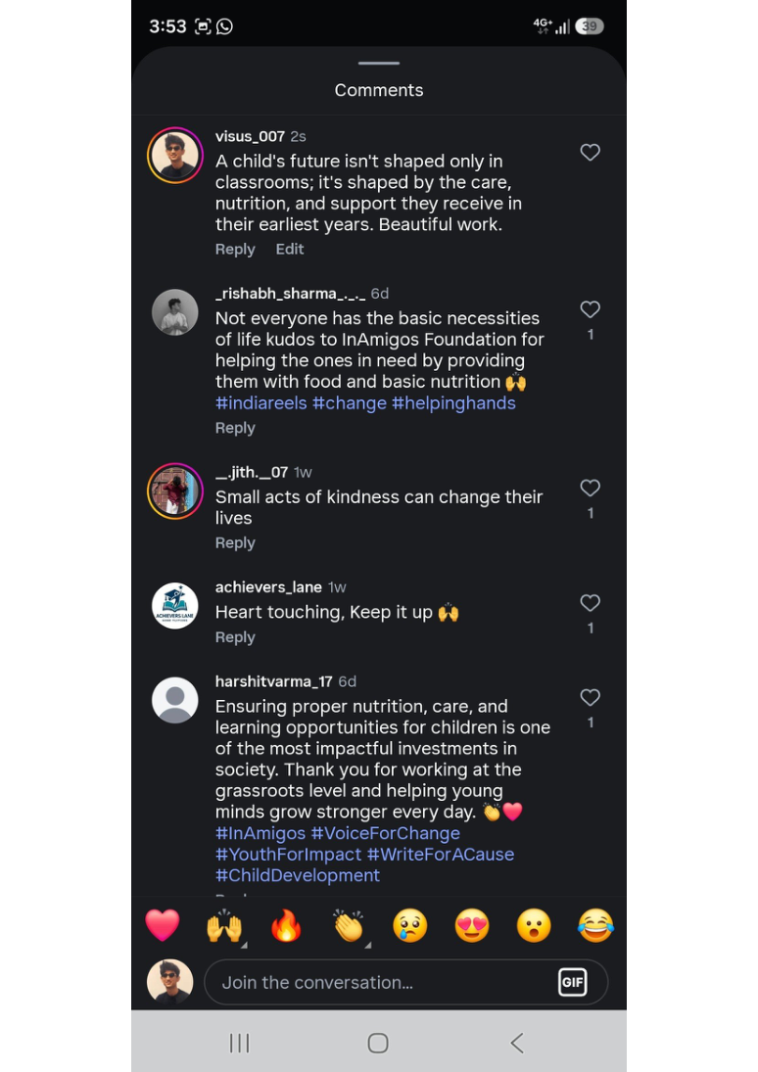  Community-service interaction

11 • OUTCOMES
Learning Outcomes & Professional Development
- Organic social engagement – improved ability to read a post's context and respond in a way that adds to the conversation.
- Audience-aware communication – learned to vary tone and message according to cause, audience, and content format.
- Cause-based storytelling – gained exposure to communicating social issues through concise, emotionally relevant language.
- Educational content design – developed a learner-focused resource with explanations, examples, practice, and self-checking.
- Fundraising communication – experienced the fundamentals of a direct-response outreach process within a social-impact setting.
- Campaign amplification – understood how offline or individual actions can be extended through social-media sharing.
- Digital documentation – strengthened the habit of preserving screenshots, organizing evidence, and meeting submission requirements.
- Professional coordination – practiced following instructions communicated through group channels, email, and shared-drive workflows.
Overall takeaway
The internship shifted social media marketing from a purely promotional concept to a practical communication discipline where attention, interaction, trust, education, and action are connected.

12 • VERIFICATION
Certificates & Communication Proof
Internship Offer Letter
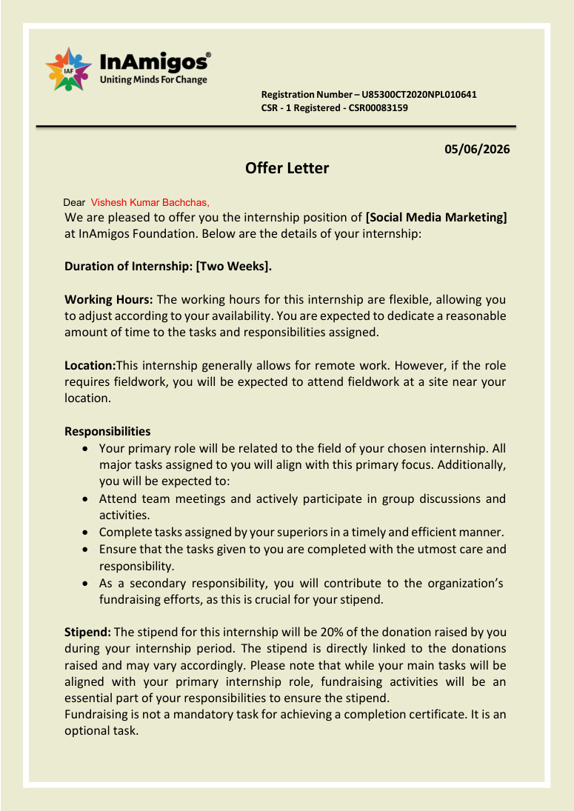
Offer letter dated 05 June 2026.
Completion Communication
Email confirming selection as Social Media Marketing Intern.
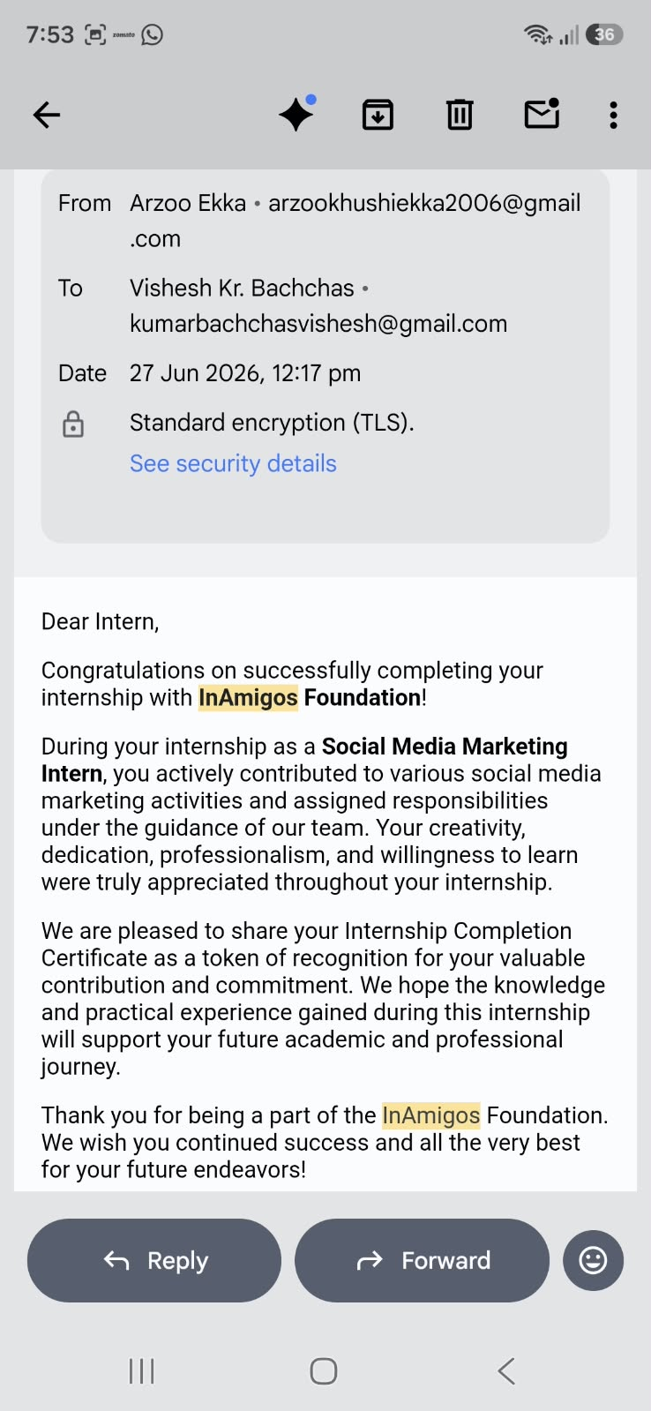


13 • REFERENCES
Bibliography / References
- InAmigos Foundation, official website – organizational profile, causes and initiatives. https://www.inamigosfoundation.org.in/
- InAmigos Foundation, internship offer letter issued to Vishesh Kumar Bachchas, dated 05 June 2026.
- InAmigos Foundation, Internship Completion Certificate for Vishesh Kumar Bachchas, dated 19 June 2026.
- InAmigos Foundation, internship communication emails and task instructions shared during June 2026.
- Vishesh Kumar Bachchas, “Vishesh – Reels Like and Comment Task,” submitted task evidence PDF.
- Vishesh Kumar Bachchas, “Maths Adventure – Ages 9–11,” educational resource created for Task 3.
- Vishesh Kumar Bachchas, “Task 4,” fundraising and donor-confirmation evidence PDF.
- Vishesh Kumar Bachchas, “Task 5 by Vishesh,” Instagram engagement evidence PDF.

