<Deploy CI DevOps tools with expose to internet>

Platform Docker or Kubernetes

Put in /root/ci folder and later put in GitHUb ci repositories

1. Prometheus
2. Grafana
3. Heapster/Cadvisor/Nodeexporter/AlertManager/HPA
4. Zipkin
5. Consul
6. Bitbucket
7. Jenkins
8. Nexus
9. ELK stack

https://medium.com/@marko.luksa/kubernetes-autoscaling-based-on-custom-metrics-without-using-a-host-port-b783ed6241ac

autoscaling on top of them, let me just quickly describe how horizontal pod autoscaling works in Kubernetes.
One of the basic Kubernetes features is the ability to manually scale pods up or down horizontally simply by increasing or decreasing the desired replica count field on the Deployment, Replica Set (RS) or Replication Controller (RC). Automatic scaling is built on top of that. To make Kubernetes scale your pods automatically, all you need to do is create a HorizontalPodAutoscaler (HPA) object, just like you would any other Kubernetes object. In the case of CPU-utilization-based autoscaling, the controller will then start observing the CPU usage of the pods and scale the Deployment/RS/RC so the average CPU utilization across all of the pods is kept close to the target CPU utilization configured in the HPA object.

The CPU usage (and other metrics) is collected by cAdvisor, which runs inside the kubelet. All those metrics are then aggregated by Heapster, which runs as a single pod (on one of the nodes) and collects metrics from all nodes in the cluster. The autoscaler controller gets the metrics from Heapster, so it needs to be running for autoscaling to work.

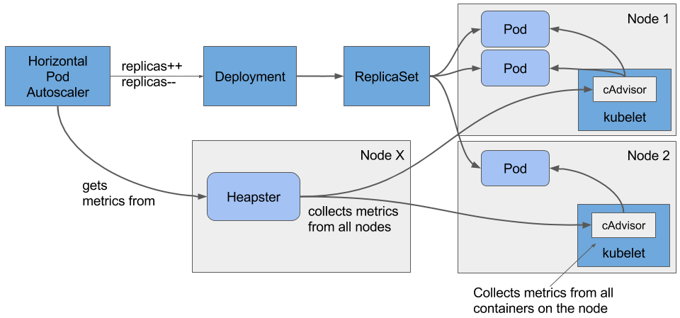

Heapster
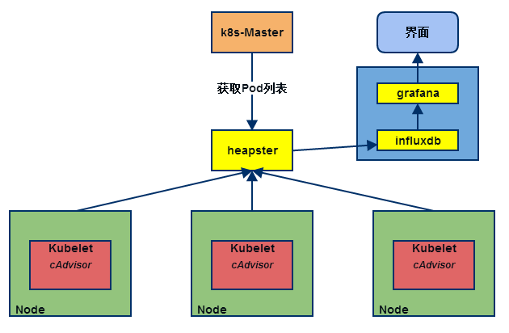

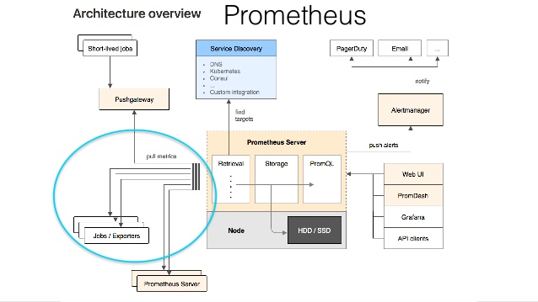

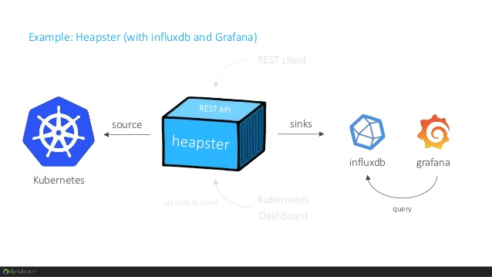

Prometheus

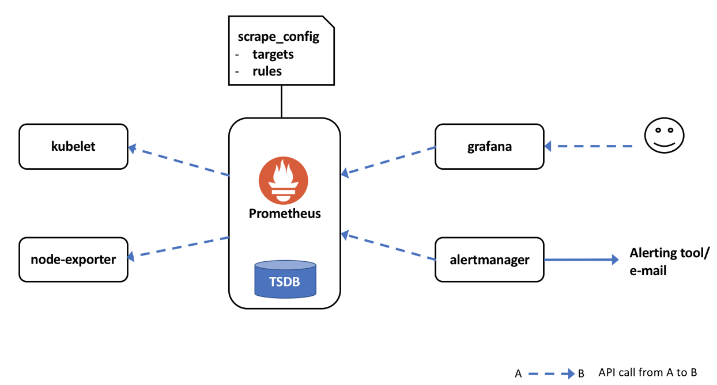
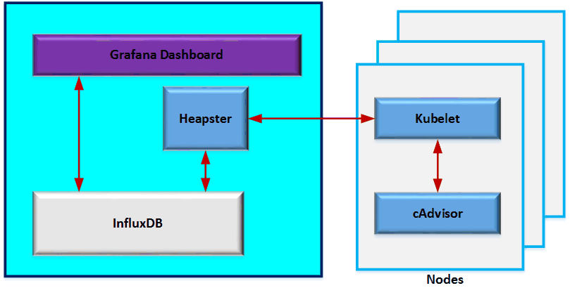
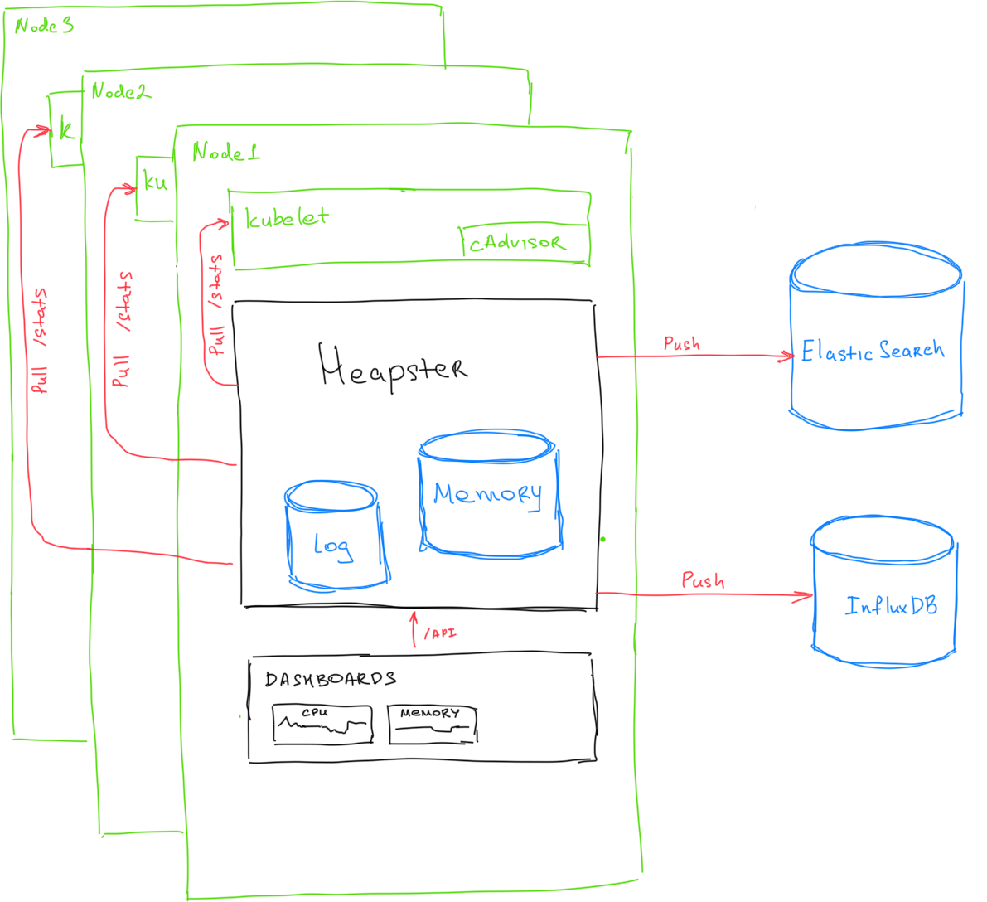

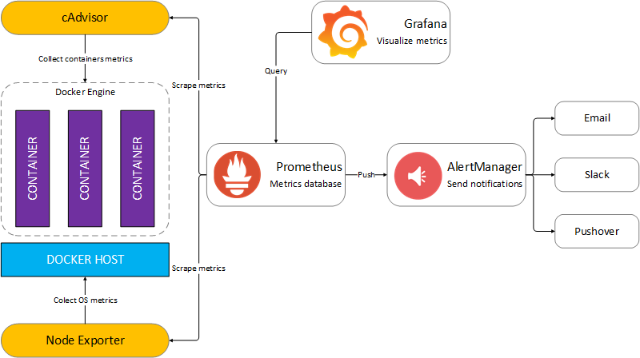

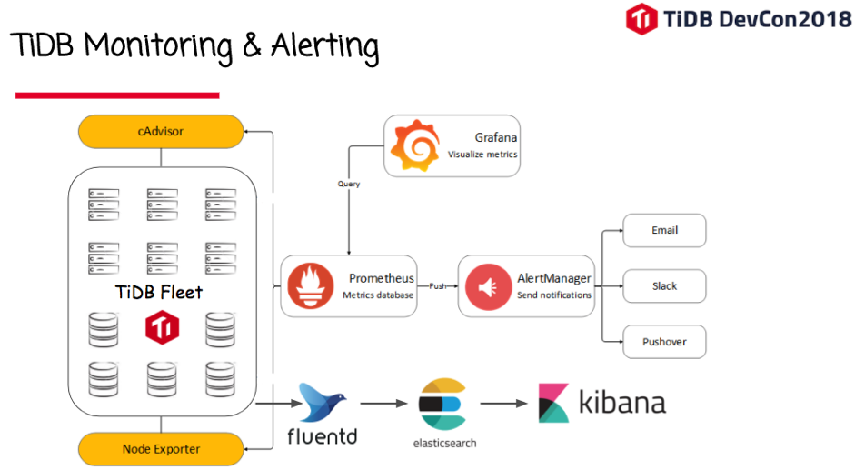

https://www.becloudready.com/single-post/2017/11/24/Monitoring-with-Prometheus---Working-Hello-World-style-Example

Zipkin is a distributed tracing system http://zipkin.io

Zipkin is a distributed tracing system. It helps gather timing data needed to troubleshoot latency problems in microservice architectures. It manages both the collection and lookup of this data. Zipkin’s design is based on the Google Dapper paper.
This project includes a dependency-free library and a spring-boot server. Storage options include in-memory, JDBC (mysql), Cassandra, and Elasticsearch.

Zipkin: A Tracer for Debugging Microservices

https://thenewstack.io/meet-zipkin-tracer-debugging-microservices/
Zipkin comes with a Web interface that shows the amount of traffic each microservice instance is getting. The log data can be filtered by application, length of trace, annotation, or timestamp.
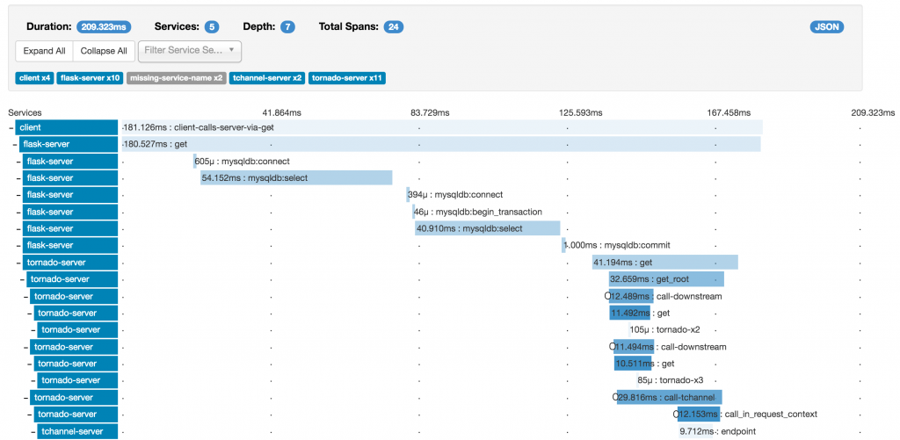

https://gitkube.sh/

Gitkube: Build and deploy docker images to Kubernetes using git push.

Gitkube
Gitkube is a tool for building and deploying docker images on Kubernetes using git push.
After a simple initial setup, users can simply keep git push-ing their repos to build and deploy to Kubernetes automatically.

Install gitkube
$ kubectl create -f https://storage.googleapis.com/gitkube/gitkube-setup-stable.yaml

$ #expose gitkubed service
$ kubectl --namespace kube-system expose deployment gitkubed --type=LoadBalancer --name=gitkubed

Example
Follow this example repo for a typical workflow of gitkube.

How it works
Gitkube has three components:
- Remote: Custom resource defined by a K8s CRD
- gitkube-controller: Controller that manages Remote objects and propogates changes to gitkubed
- gitkubed: Git host that builds docker image from repo and rolls out deployment

High level architecture
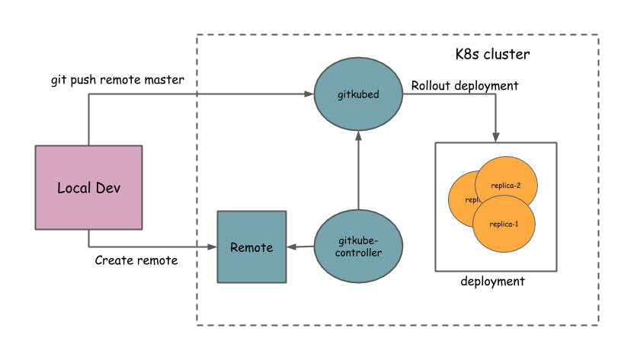

Gitkube is an open source project licensed under Apache License 2.0

