**Containerization hands-on excercise**

Repository Link: <https://github.com/Vish-TechOps/ceres-hands-on-go-kind-master>

## Prerequisites

1. Docker Desktop and Kind deployed
2. Kind cluster created. See kind/ directory

Follow reference documents for Installing Docker Desktop and Kind Cluster Creation

Installing Docker Desktop

<https://docs.docker.com/docker-for-windows/install/>

Docker Desktop for Windows is the Community version of Docker for Microsoft Windows. You can download Docker Desktop for Windows from Docker Hub.

Packages: <https://hub.docker.com/editions/community/docker-ce-desktop-windows/> and <https://docs.microsoft.com/en-us/windows/wsl/install-win10#step-4---download-the-linux-kernel-update-package>

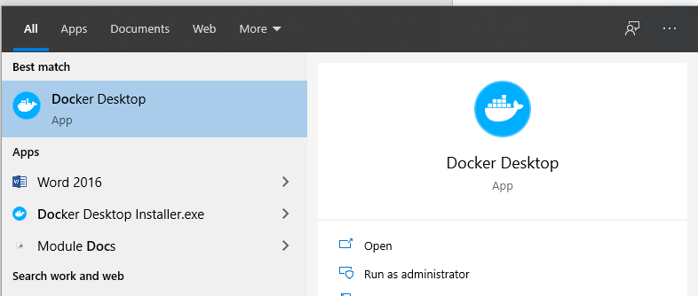

Kind cluster created

Now follow clsuter creations steps

<https://github.com/Vish-TechOps/ceres-hands-on-go-kind-master/tree/master/kind>

Creating cluster

Install prerequisites

Chage directory to kind - this will allow you to mount data volume from relative path

Run

$ **kind create cluster --config kind.yaml4**

$ **kind get clusters**

$ **kubectl cluster-info --context kind-resideo-hands-on**

VERIFY IN DOCKER Desktop

Worker node and control plan should be running



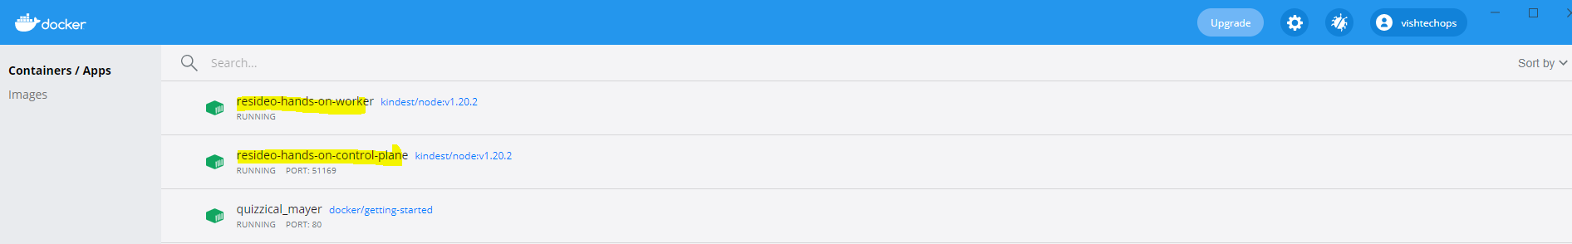

## Task

<https://github.com/Vish-TechOps/ceres-hands-on-go-kind-master>

This repository Golang ToDo web application that requires Mongo backend. The goal of the task is to demonstrate understanding of containerized deployments.

### Primary goals

1. Build container with ToDo list web application
2. Run it alongside Mongo container
3. Demonstrate end-to-end setup
4. Create a pull request containing end-to-end build and deployment code against this repository
5. Be prepared to answer PR-related questions

**<STEP1>**

1) Create Private repo in GitHub

2) Git clone empty repo and unzip ceres-hands-on-go-kind-master.zip

3) Git commands to push changes into Master in repo

4) Visual studio is set for git commands with github repo

**<STEP2>**

Now work on tasks

https://github.com/Vish-TechOps/ceres-hands-on-go-kind-master

Task section

**$ git checkout -b ToDo-App-Feature-Branch**

Switched to a new branch 'ToDo-App-Feature-Branch'

Singh33@SLB-F8J81N2 MINGW64 /d/ceres-hands-on-go-kind-master (ToDo-App-Feature-Branch)

**$ ls -rlt**

total 12

-rw-r--r-- 1 VSingh33 1049089 1381 Feb 8 22:39 README.md

drwxr-xr-x 1 VSingh33 1049089 0 Feb 8 22:39 kind

-rw-r--r-- 1 VSingh33 1049089 5222 Feb 8 22:39 main.go

drwxr-xr-x 1 VSingh33 1049089 0 Feb 8 22:39 static

VSingh33@SLB-F8J81N2 MINGW64 /d/ceres-hands-on-go-kind-master (ToDo-App-Feature-Branch)

**$ pwd**

/d/ceres-hands-on-go-kind-master

## Clone the source code to your $GOPATH/src directory, use go get . command to run the install the dependencies.

Run below commads on feature branch

**$ export GOPATH=/d/ceres-hands-on-go-kind-master**

**$ echo $GOPATH**

**$ go env GOPATH**

D:/ceres-hands-on-go-kind-master

**$ go get .**

**$ go build**

VSingh33@SLB-F8J81N2 MINGW64 /d/ceres-hands-on-go-kind-master (ToDo-App-Feature-Branch)

**$ ls -lrt**

total 12153

-rw-r--r-- 1 VSingh33 1049089 1381 Feb 8 22:39 README.md

drwxr-xr-x 1 VSingh33 1049089 0 Feb 8 22:39 kind

-rw-r--r-- 1 VSingh33 1049089 5222 Feb 8 22:39 main.go

drwxr-xr-x 1 VSingh33 1049089 0 Feb 8 22:39 static

drwxr-xr-x 1 VSingh33 1049089 0 Feb 8 22:55 src

-rw-r--r-- 1 VSingh33 1049089 200 Feb 8 23:06 Dockerfile

drwxr-xr-x 1 VSingh33 1049089 0 Feb 8 23:14 pkg

-rwxr-xr-x 1 VSingh33 1049089 12428800 Feb 8 23:44 ceres-hands-on-go-kind-master.exe

Change binary name to todo-app-go

**$ mv ceres-hands-on-go-kind-master.exe todo-app-go**

Build an Image

**$ docker build -t todo-app-go:v1.0.0 .**

VSingh33@SLB-F8J81N2 MINGW64 /d/ceres-hands-on-go-kind-master (ToDo-App-Feature-Branch)

**$ Docker images**

REPOSITORY TAG IMAGE ID CREATED SIZE

todo-app-go v1.0.0 96e17e23ba62 32 seconds ago 55.1MB

kindest/node <none> 094599011731 2 weeks ago 1.17GB

docker/getting-started latest 3c156928aeec 9 months ago 24.8MB

**<STEP3>**

Operations - Create containers or pods in kubernetes

Make your image available in Kind cluster

**$ kind load docker-image todo-app-go:v1.0.0 --name resideo-hands-on**

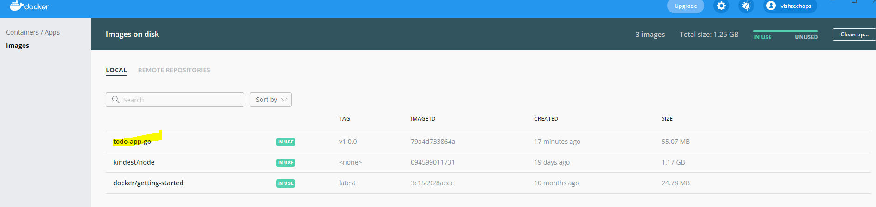

VSingh33@SLB-F8J81N2 MINGW64 /d/ceres-hands-on-go-kind-master (ToDo-App-Feature-Branch)

$ kind load docker-image todo-app-go:v1.0.0 --name resideo-hands-on

Image: "todo-app-go:v1.0.0" with ID "sha256:96e17e23ba622765672bc3e7e078d0afd19e14832c34df4af0665fc41bd39101" not yet present on node "resideo-hands-on-worker", loading...

Image: "todo-app-go:v1.0.0" with ID "sha256:96e17e23ba622765672bc3e7e078d0afd19e14832c34df4af0665fc41bd39101" not yet present on node "resideo-hands-on-control-plane", loading...

VSingh33@SLB-F8J81N2 MINGW64 /d/ceres-hands-on-go-kind-master (ToDo-App-Feature-Branch)

**$ docker run -itd --name resideo-hands-on todo-app-go:v1.0.0**

69a9c599347cc4a53a4ebd33f7f34185070711e8bab34f3d7b63a35afa94e277

**<STEP4>**

Cleanup

Remove Kind cluster

kind delete cluster --name resideo-hands-on

Remove Mongo data

rm -rf kind/data/*