1. Topical drug delivery system

Topical medication delivery products fall into two main categories: internal and exterior. While internal topicals are given orally, vaginally, or to the tissues of the mucous membrane for local action, exterior topicals are spread, sprayed, or otherwise disseminated over the tissue to cover the diseased area. The main benefits of topical drug delivery systems include preventing first-pass metabolism, preventing gastrointestinal incompatibilities, improving patient compliance, making self-medication possible and simple, utilising drugs with short half-lives and narrow therapeutic indices, and providing a facility for quickly stopping medication when needed.1

Because topical formulations allow medication to permeate into the underlying layers of skin or mucous membranes, they are used at the site of administration for localised effects. It permits the use of drugs with limited therapeutic windows and short biological half-lives to prolong the duration of action. In light of this, microemulsions with low skin irritation, a high drug loading capacity, and the potential to reduce the stratum corneum's diffusion barrier and increase drug absorption are created.2

Topical medication delivery systems are specialised methods for delivering therapeutic substances locally through the skin to treat cutaneous conditions. The most common usage for these devices is for localised skin infections. The formulations come in a variety of forms, including solid, semisolid, and liquid. Drug absorption via the skin is improved if the drug ingredient in the solution has a favourable lipid/water partition coefficient and if it is a non-electrolyte.4 Topical drug delivery systems include the potential for allergic reactions, skin irritation from contact dermatitis, low drug permeability through skin, and difficulty absorbing large-particle medicines through skin. Skin has a complicated structure and is thick. Moving from the environment, molecules must pass through the stratum corneum and any surface-mounted endogenous or foreign substances. Then, in order for them to be eliminated from the skin by the movement of blood or lymph, they must pierce the viable epidermis, the papillary dermis, and the capillary walls into the bloodstream or lymph channels (Figure 1). It is evident that moving across the skin barrier is a difficult process to analyse. Thickness, moisture, and inflammation are examples of physiological parameters that can affect the topical medication delivery system.1

Topical medication distribution allows for exact drug release into the patient, aids in maintaining a steady blood-level profile, reduces systemic side effects, and occasionally outperforms alternative dosage forms that are available to patients in terms of efficacy.   
Additionally, topical dose forms are generally accepted to offer better patient compliance because to their ease of use, suitability, ease of administration, and ability to provide multi-day dosing. One drawback is that the topical route of administration targets the skin, yielding desired outcomes. However, it cannot be taken orally for the sole aim of treating hyperpigmentation. Drug Res., those side effects are necessary.

The only goal of this experiment is to create a topical drug delivery method that will assist mitigate the systemic negative effects while still producing the intended result and address the hyperpigmentation condition. 3

Topically applied dermal products are divided into two groups: those that have systemic effects and those that have local effects. These devices are typically employed when alternative drug delivery routes are unsuccessful for treating localised skin infections.4

**Impacts on the Surface 4**1Among these impacts is the purifying action of eliminating dirt and bacteria.   
2. Enhances the look of the skin.   
3. A safeguard against dampness.   
4. Have an antibacterial impact.

**Stratum Corneum Impacts** 4  
1. Barriers that get past this layer of protection.  
2. The keratolytic process.   
3. The hydrating impact.   
4. Impact on Dermis and Epidermis That Are Viable:   
Medications classified as anaesthetics, anti-inflammatory, antihistamines, antipruritics, etc. are the main groups within these layers.   
5. Systemic effects: The medications nitroglycerin, scopoletin, clonidine, and estradiol are the ones that cause systemic effects.   
6. Extra impacts: Antimicrobial, emollient, antiperspirant, and depilatory properties are among these benefits.

The skin is the largest organ in the human body. The skin is the outermost layer of the human body. The three main purposes of the skin are regulation, sensibility, and protection. The three layers that make up human skin are as follows.  
The uppermost layer is called the epidermis.   
The layer beneath the epidermis is called the dermis.   
The hypodermis is not a component of the skin. Beneath the dermis is a layer called the hypodermis, whose primary function is to provide blood vessels and nerves to the skin by attaching it to the underlying muscle and bone.5

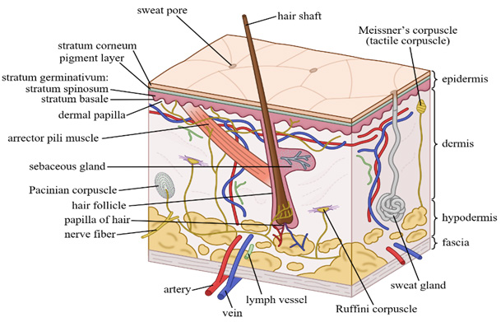

Figure: Layers and structure of human skin

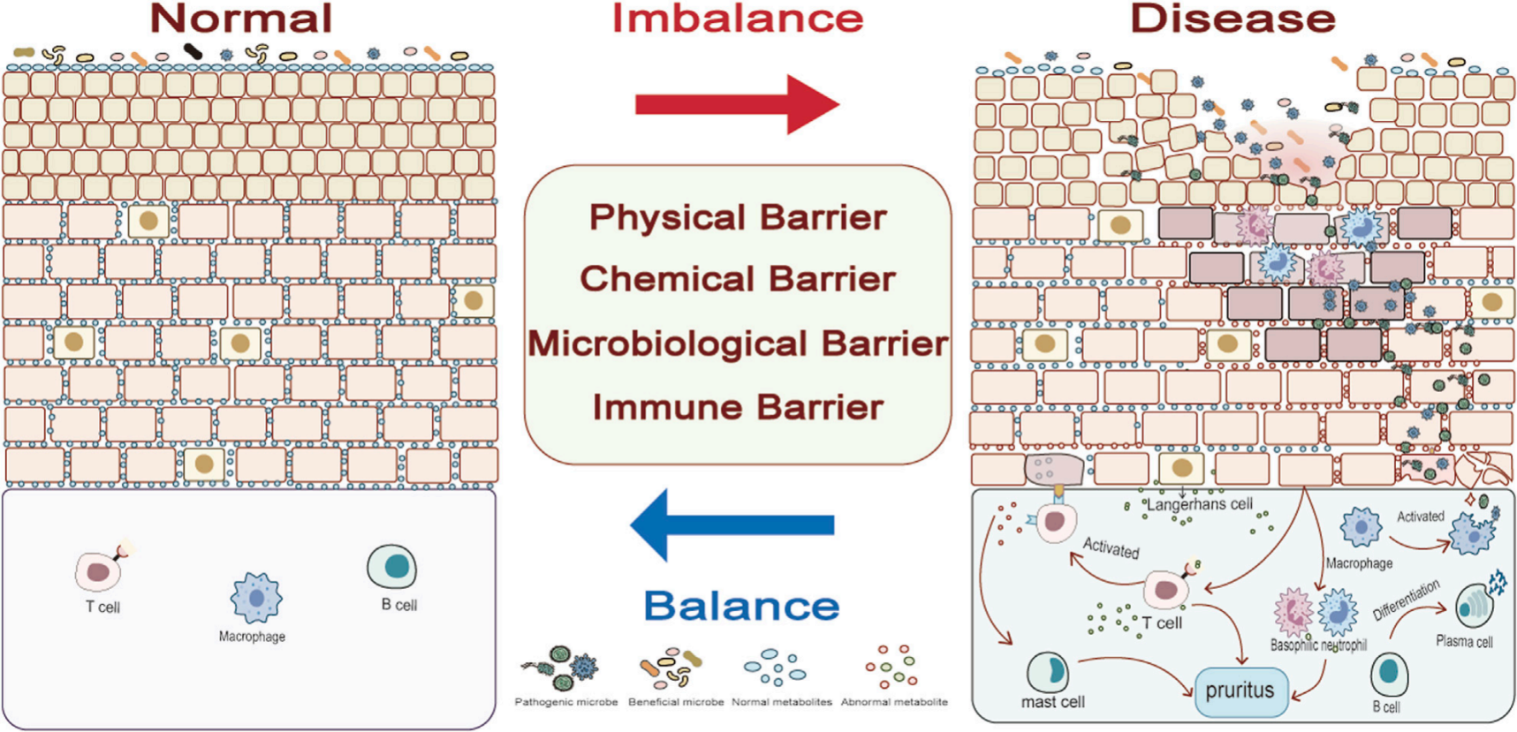

Figure 2 Difference in balance and imbalance in skin 6

Maintaining a healthy microbial barrier is essential for skin health.   
Increased numbers of non-pathogenic bacteria can potentially induce or worsen disease. This is in addition to the harmful bacteria. Furthermore, pathogenic microorganisms do not always pose a threat. The immunological response triggered by Staphylococcus aureus colonising skin tissue can encourage local neuron regeneration and the growth of injured nerve axons under homeostatic conditions.   
The cells that comprise the skin's structure, which is separated into the epidermis, dermis, and subcutaneous tissue, comprise the physical barrier. They convey sensations, regulate body temperature and moisture, shield the skin from UV rays, and promote overall health. 6

Advantages of topical drug delivery system 7

1. Steer clear of first-pass metabolism.   
   2.It is simple to apply and use, and taking medicine is uncomplicated.   
   3. Substances are dispersed to a certain area on a selective basis.   
   4. Avoiding gastrointestinal incompatibility is recommended.   
   5. Administer medications with brief biological half-lives and limited treatment intervals.   
   6. Boost adherence from patients.self-administration of drugs.   
   7. It acts through continuous medication administration at low dosages.   
   8. Prevent drug concentration variations and associated hazards.   
   9. A broad range of applications in contrast to alternative paths.

10.Supplying medications to a designated area .

Disadvantages of topical drug delivery system 7

1.It is possible for the application location to cause localised skin irritation.   
2.Contact dermatitis triggered by drugs could happen.   
3.Some medications are difficult to get through the skin because of their limited permeability.   
4.Larger-particle drugs are harder to get through walls.   
5.Potential for an allergic reaction to occur.   
6.It is possible to use drugs with extremely low plasma concentrations to take action.

Factors affecting topical permeability

Physiological factors 7

1. Thickness of skin
2. pH of skin
3. Temperaure of skin
4. Lipid content
5. Density of sweat glands
6. Hydration of skin
7. Inflammation of skin
8. Blood flow

Physiochemical factors 7

1. Partition coefficient
2. Molecular weight of drug
3. Degree of ionization
4. Vehicle effect

Components of topical drug delivery system 7

* ➢ Polymer matrix/ Drug reservoir
* ➢ Drug
* ➢ Permeation enhancers.
* ➢ Pressure sensitive adhesive (PSA).
* ➢ Backing laminate.
* ➢ Release liner.
* ➢ Other excipients like plasticizers and solvents

**MICROEMULGEL**

In 1940, Hoar and Schulman initially proposed the idea of a micro-emulsion. A micro-emulsion is an oil, water, and surfactant mixture that is transparent, stable, and often combined with a co-surfactant. The administration of a medication dissolved in a mixture of one or more excipients, such as lipophilic and hydrophilic surfactants, co-surfactants, mono, di, and triglycerides, is known as micro-emulsion based drug delivery. Drugs given via lipid formulation go the whole distance in their dissolved state. Because the drug dissolves partially in the colloidal dispersion, the absorption of the drug in its solubilized form is improved. 8

In the pharmaceutical industry, microemulsion has become more well-known, and efforts are being made to expand its claims across a range of pharmaceutical formulations. Drug distribution research has been greatly impacted by microemulsions over the course of several centuries, and a number of micro- and nanoscale skills and carriers have been and are about to be used as a method to improve the therapeutic efficacy of medications. The following are some of the many ways that microscale technologies can improve the therapeutic efficacy of medications:   
• Improving the ability of lipophilic drugs to dissolve.   
• Improving the transfer or penetration of medications that are difficult to pass through the skin barrier. pharmaceuticals classified as class III and class IV under the Biopharmaceutical Classification System [BCS])   
• Modifying the drug's biodistribution and characteristics in plasma.   
• Preventing medication deterioration in biological environments.   
• Allowing the tumultuous transportation of active to the action place. 11

Components of Micro Emulsion   
The three phases of a basic microemulsion are the oil phase, also known as the non-aqueous phase, the surfactant-co surfactant system, and the aqueous phase. While the aqueous phase aids in the greater penetration of the hydrophilic portion of the medicine, the oil phase aids in the better penetration of the lipophilic substance. While surfactant systems aid in the correct miscibility of oil

TYPICAL PROPERTIES OF TYPE I, II, IIIA, IIIB, AND IV

LIPID FORMULATIONS 8

Table 1

|  |  |  |  |  |  |  |
| --- | --- | --- | --- | --- | --- | --- |
| Sr no. | Composition % | Type 1 | Type 2 | Type 3 A | Type 3 B | Type 4 |
| 1 | Triglycerides ormixed glycerides | 100 | 40-80 | 40-80 | <20 | - |
| 2 | Surfactant | - | 20-60  (HLB<12) | 20-40  (HLB>11) | 20-50  (HLB>11) | 40-80 |
| 3 | Cosurfactant hydrophyllic cosolvents | - | - | 0-40 | 20-50 | 20-50 |
| 4 | Particle size of dispersions nm | Coarse | 100-  250 | 100-250 | 50-100 | - |

Micro-emulsions, which belong to class III B in table 1, are isotropic mixes of medicine, oil, surfactant, and co-surfactant (solubilizer).This system's primary idea is to create an o/w type micro-emulsion with mild agitation after dilution with water   
stage. The medication is kept in a solubilized state by this micro-emulsion, and the wide interfacial area for drug absorption is provided by the minute produced droplets. In addition to aiding in solubilization, lipids in formulations increase the drug's permeability, which increases bioavailability. 8

The combination of microemulsion and gel in produced dosage forms is known as microemulgel; it has the benefits of both emulgel and microemulsion, which are hydrophilic and hydrophobic drug formulations included into dosage forms, offer a sizable surface area for drug absorption, and the oil component improves the medication's permeability, increasing the drug's bioavailability. Incorporating micro-emulsion into gel also increases its stability. When compared to micro-emulsions, microemulgels are more elegant and are readily cleaned as needed. 8

Microemulsions are dispersions of two immiscible liquids, such as water and oil, that are thermodynamically stable, isotropic, and transparent. They are stabilised by an interfacial layer of surfactant molecules, which have a size range of 10-200 nm and a very low interfacial tension. With variable proportions of cosurfactant (Co-SA), it is primarily composed of water, oil, and surfactant (SA). This blend is consistent and easy to understand. The current study focuses on topical infection treatment using a gel based on ketoconazole microemulsion with penetration enhancers. 2,2,2-trideuteriol,ketoconazole-1-[4-[4-[[(2R,4S)2-(imidazol-1-ylmethyl)-2-(2,4-dichlorophenyl)[-1,3-dioxolan-4-yl][methoxy]phenyl]piperazin-1-yl]Ethanone, an imidazole antifungal medication, functions as a fungistatic agent by preferentially inhibiting the formation of ergosterol in the fungal cell wall as a result of fungal cell wall defects. 9

The ease of preparation, clarity, low viscosity, small droplet size, thermodynamic stability, and compatibility with both hydrophilic and hydrophobic medicines have made microemulsions a highly attractive option for drug delivery.. When taken orally, the majority of medications can cause adverse effects such nausea, bleeding in the gastrointestinal tract, and stomach irritation.   
Such medications can be substituted topically, which lessens their adverse effects. 10

Numerous topical medications, including ointments, creams, and lotions, are frequently used but come with a number of drawbacks. Because they are sticky, they make the patient uncomfortable when applied, and because of their low spreading coefficient, they must be applied with rubbing. They also display the instability issue. Transparent gels are now more frequently used in pharmaceutical preparations as a result of these restrictions. Gels' primary drawback is their incapacity to transport medications that are insoluble in water. 10

Conversion of microemulsion to microemulgel

Since a hydrophobic medication cannot be properly mixed into a gel foundation directly, a microemulsion-based method is used instead into a system based on gel. The term "microemulsion based gel" refers to this dosage form, which is made and assessed first, and then incorporates the oil-in-water microemulsion into a gel base. When compared to traditional topical preparations, it has additional benefits.10

Microemulgel is the result of combining microemulsion and gel. This formulation technology combined the benefits of microemulsion and emulgel. The ability to include both hydrophilic and hydrophobic medicines into these systems is the system's main benefit. These systems offer a substantial surface area for the absorption of drugs. Oil component improves medication permeability, which raises bioavailability. The incorporation of microemulsion into a gel system increases its stability. In contrast to microemulsions, microemulgel is easily cleaned and has a certain elegance. 12

Increased epidermal deposition of API due to the microemulgel composition suggests increased therapeutic effect. A large surface area is provided by microemulgels for the absorption of medications, and the oil component encourages drug permeability, hence boosting bioavailability.   
Salicylic acid is a finely ground, white powder. It is externally administered to the skin. Athlete's foot, scalp ringworm, and the removal of calluses, corns, and warts can all be treated with it. Additionally, products meant to treat bug bites, dandruff, acne, and seborrhea contain salicylic acid. 13

Microemulgel has lately emerged as one of the pharmaceutical industry’s most intriguing topical

medicines. It is easier to administer microemulgel than standard formulations, and the medicine

stays in the skin for a longer period, allowing for more effective absorption and absorption into

the bloodstream. 13

Objectives of microemulgel 14

*  To increase patient compliance
*  Better stability
*  Controlled release of drug
*  superior loading capacity
*  production utility
*  low preparation cost
*  non irritant.

Advantages of microemulgel14

*  Incorporation of hydrophobic drugs
*  Superior loading capacity
*  Better stability
*  No intensive sonication
*  Controlled release
*  Production utility and low preparation cost
* Preventing incompatibility issues of gastrointestinal tract
*  Improve patient compliance and suitability for self medication
*  Convenient and easy to apply.
*  Providing utilization of medication with short biological half-life and narrow therapeutic

window.

*  Ability to easily terminate medication when needed.

Disadvantages 14

*  Skin irritation on contact dermatitis
*  The possibility of allergenic reaction.
*  Medication of large particle size not easy to absorb through the skin.
*  Poor permeability of some medication through the skin
*  The occurrence of bubble during formation of emulgel

Challenges involved in microemulgels 14

Ascertain whether the system is non-sensitizing, non-toxic, and non-irritating. Creating an emulgel that is physically stable.Qualities to take into account for topical medications: It is important to take into account the features of the vehicle; for instance, an occlusive vehicle will enhance the penetration of the medication through the skin. Evaluating permeability characteristics based on the type of lesions. Any possibility of irritation must to be taken into account. Preservatives should not be used in order to prevent irritation.

**Metformin HCL for treatment of Melasma**



Figure 3

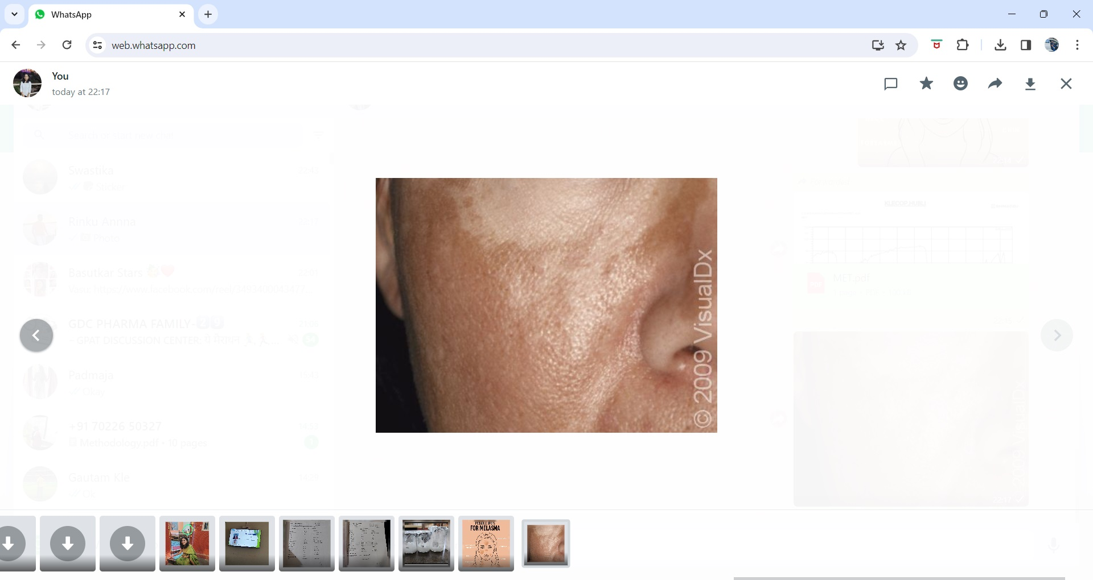

Figure 4

**Melasma**, a common, limited, acquired hypermelanosis of the face, neck, and forearms that can occasionally occur, has a major impact on life's quality. The name "chloasma," which refers to melasma during pregnancy or the "mask of pregnancy," is derived from the Greek word meaning "a green spot."   
Melasma is far more common in people with darker complexion (skin types IV to VI), yet it can affect people of any race.15

Although there are few research on the prevalence of melasma, there is evidence that different ethnic groups have variable rates of this condition.collectives. Individuals of Hispanic, Oriental, and Asian descent are more likely to have melasma. Melasma prevalence varies among US communities, with reported rates ranging from 8% for Latinas to 30% for Southeastern Asians. Melasma is more common in women, especially in the reproductive years, and peaks between the ages of 20 and 30. Seldom are reports of it prior to puberty . Postmenopausal women are more likely to experience extra-facial melasma. 15

The prevalence of melasma is higher in people who identify as Hispanic, Oriental, or Asian. Melasma prevalence reports range from 8% among Latinas in the US, reaching 30% in populations of Southeast Asians. Melasma is more common in women, especially in the reproductive years, and peaks between the ages of 20 and 30. Seldom are reports of it made prior to puberty. Postmenopausal women are more likely to experience extra-facial melasma. 15

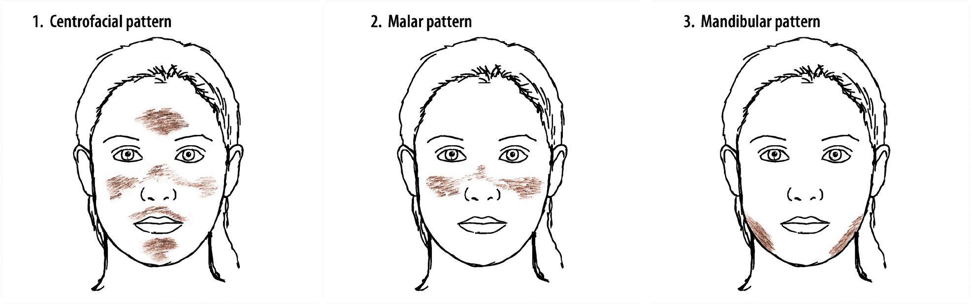

Figure 5

**Clinical classification17**

1. Centro-facial pattern: Representing around 76% of all melasma types, this pattern is the most common clinical pattern. The nose, cheeks, chin, forehead, and upper lip are all impacted by macules that are hyperpigmented.   
2. Malar pattern: Mandibular melasma is located on the jawline and chin, but the malar pattern on the face is restricted to the malar cheeks. The latter is believed to be more prevalent in elderly individuals and may be connected to severe photodamage.   
3. Mandibular pattern: Whereas mandibular pattern affects the jawline and chin, malar melasma affects the malar cheeks on the face.

Pathogenesis etiology 16  
While the exact pathophysiology of melasma remains unknown, biologically active melanocytes are thought to be the initial cause of the illness. The three main variables thought to be involved in etiopathogenesis are female sex hormones, UV radiation exposure, and genetic impacts.   
  
Thyroid dysfunctions, cosmetics, phototoxic and antiepileptic medications, ovarian and hepatic dysfunction, and nutritional inadequacies are further potential causes. UV directly affects melanocytes, which serves as a major initiating and aggravating element in the formation of melasma. It has been suggested that genetic predisposition contributes to the development of melasma. Because of the increased occurrence of melasma in relation to pregnancy, the use of oral contraceptives, and oestrogen replacement treatment, natural and manufactured oestrogens and progesterone are implicated in etiopathogenesis. 16

Melanocytes of melasma patients are inherently more sensitive to the stimulating effects of oestrogens and potentially other sex steroids because melanocytes have the oestrogen receptor.   
In addition to heightened pigmentation, histopathologic assessments of melasma lesions have revealed significantly increased elastosis and vascularization in the pelesional skin. Although there was no increase in the quantity of melanocytes in these areas, the melanocytes were larger and more brightly stained due to their extremely defined dendrites. Melanogenesis was shown to be increasing. Confocal microscopy further verified that the melasma lesions had more vascularization than the surrounding healthy area. The pathophysiology of melasma has been linked to stem cell factor as well as vascular, dermal, and neurological components, according to recent investigations. 16

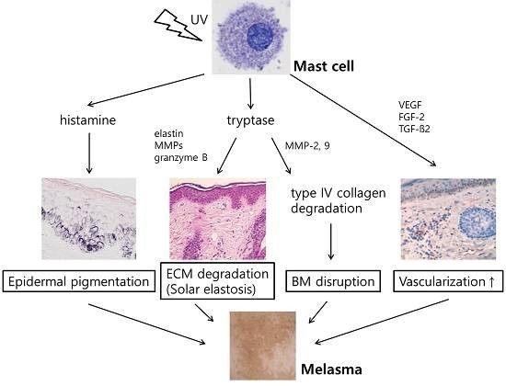

Figure 6

**Treatment16**

The four primary mechanisms should be the focus of treatment :   
1. Suppression of melanocyte activity (avoidance of triggering conditions and sun protection)   
2. Melanin synthesis suppression (depigmenting agents)   
3. Melanin removal with chemical peeling   
4. Distributing melanin granules by lasers   
The course of treatment should be determined by the severity and clinical subtype.

1. Suppression of melanocyte activity: One of the most significant risk factors is sun exposure. Melanocytes in melanomas are readily activated by visible light (VL), UVA, and UVB rays. Applying broad-spectrum sun protection is advised both before and after therapy. In order to shield oneself from the sun, one must make an effort to remain in the shade and avoid being in the sun, especially between 10:00 and 15:00. One should also wear sun protective clothing, such as a wide-brimmed hat and a long-sleeved T-shirt, and apply sunscreen frequently throughout the day that has an SPF of at least 30, as well as a combination sunscreen that includes titanium dioxide, a physical preservative. The use of broad-spectrum sun protection is important for two reasons. In most studies,

VL and UV light have been shown to cause pigment changes in all skin types.16

1. Suppression of melanin synthesis (depigmenting agents): Tyrosine's conversion to L-3,4-dihydroxyphenylalanine is the rate-limiting step in the creation of melanin.   
   (L-tyrosinase) and L-DOPA. L-DOPA is the primary target in the topical therapy of melasma. Tyrosinase inhibitors are what the majority of these drugs are because of this. Tyrocine is the first step in the synthesis of melanin. Melanin is produced by the tyrosinase enzyme found in melanosomes, which also produces dopaquinone. Along the dendrites of the melanocytes, the melanosomes carrying the melanin enter the keratinocytes. As a result, the keratinocytes are coloured. There are three categories for the depigmenting agents.   
   1. Phenolic substances   
   2. Non-phenolic substances   
   3. Formulas for combinations 16
2. Removal of melanin [chemical peeling]: Chemical peeling, also known as melanin removal, has been a long-standing treatment for melasma, especially in cases that are resistant to topical treatment (adjunctive therapy). The outcomes are not constant. Those with light-colored skin and those with epidermal type melasma benefit greatly from the removal of melanin. As crucial to the treatment's success as the right peeling choice is are the pre- and post-treatment regimens utilised to maximise effectiveness and minimise PIH. To get maximum effectiveness, the kind, concentration, frequency, and length of the applied agent's administration are also crucial.16

**How did Metformin HCL works on Melasma?**

Metformin HCL is an oral anti=hyperglycemic medication that has been used to treat type 2diabetes .Moreover, it demonstrated platelet anti-aggregating and lipid-lowering properties, suggesting that it possesses a variety of pharmacological characteristics. Metformin also has a significant effect on cutaneous conditions such hidradenitis suppurativa, canthosis nigricans, and allergic contact dermatitis.

As a member of the biguanides family, metformin is regarded as a derivative of guanidine. Early in the 20th century, guanidine and its isopentyl counterparts, galegine, were identified as useful components of the French lilac (Goat's Rue), Galega afficinalis. This herb was used to alleviate frequent urination and thirst in Europe. Metformin was initially introduced as a blood-glucose-lowering medication in 1920 and is currently the first choice for treating diabetes.21

It usually affects women with darker skin tones, typically Asian or Hispanic women with Fitzpatrick skin types III–IV.22 Recently, research has shown that topical metformin has anti-melanogenic properties both in vitro and in vivo. By a cyclic adenosine monophosphate (cAMP)-dependent mechanism, it has been demonstrated to lower the amount of melanin in both normal human melanocytes and melanoma cells. This is correlated with a decrease in the expression of melanogenesis master genes. Based on these studies, metformin may be clinically useful in the management of illnesses related to hyperpigmentation.18

Because of its molecular action, metformin has been utilised topically in hyperpigmentary diseases and maybe in melasma. Metformin lowers levels of cAMP, which inhibits protein kinase a process that results in the downregulation of the melanocyte survival master gene's expression (microphthalmia-associated transcription factor, or MTF). As a result, there is a decrease in the transcription of melanogenic proteins as tyrosinase, protein kinase C-beta (PKC-β), TRP-1, TRP-2, and MART-1.

Specialised cells called melanocytes are found in the basal layer of the epidermis. They are responsible for producing and distributing melanin pigments to the keratinocytes around them. Melanin is mostly accountable for skin tone and plays a significant part in shielding skin from UV damage. Tyrosinase, tyrosinase-related protein 1 (TRP1), and dopachrome tautomerase (DCT) are the three enzymes specific to melanocytes that are engaged in this enzymatic process that transforms tyrosine into melanin pigments. Alpha-melanocyte-stimulating hormone (a-MSH), UV light, and cAMP-elevating substances like forskolin are some of the stimulants that promote the manufacture of melanin (Yamaguchi and Hearing, 2009). The most significant target of the cAMP pathway, which is activated by these stimuli, is the microphthalmia-associated transcription factor (MITF). 19

Moreover, metformin suppresses melanogenesis by directly lowering diacylglycerol and blocking PKC-β attachment to melanosomes These characteristics make metformin a viable treatment option for hyperpigmentation. 18

Metformin inhibits melanogenesis by decreasing the production of cyclic AMP:

It has been observed that PKA activation and CREB phosphorylation promote cAMP-induced melanogenesis.B16 cell treatment with alpha-MSH or forskolin PKA and CREB phosphorylation rose over the course of 24 hours, but metformin significantly reduced protein phosphorylation under both basal and stimulated circumstances . Metformin has not been shown to have any influence on the expressions of PKA or CREB. In NHM cells, metformin had the similar effect on CREB phosphorylation (Figure 3b). These findings imply that metformin inhibits CREB activity, which is how it depigmentes melanocytes and melanoma cells. An rise in the amount of cAMP may be the cause of this effect.19

Metformin reduced MITF by an AMPK-independent pathway: Through a mechanism unrelated to AMPK, metformin decreased MITF. Metformin's capacity to activate the AMPK pathway has been primarily linked to its anticancer effects. We used a dominant negative form of AMPK to abrogate AMPK activation in both Mel501 cells (Figure 4b) and NHM cells (Figure 4a) in order to ascertain if AMPK is involved in the suppression of melanogenesis by metformin. In both basal and stimulated conditions, infection of AMPK-DN increases the total amount of AMPK and, as predicted, partially (NHM) or completely (Mel501) inhibits the phosphorylation of AMPK and its downstream effector, acetyl-CoA carboxylase. These findings suggest that the negative form of AMPK is expressed and functional. 19

Compared to a control, metformin suppresses the growth of mouse melanoma cells and triggers apoptosis via signalling pathways.Through increased apoptosis, metformin inhibits the formation of squamous cell carcinomas (SCCs) by inducing cell cycle arrest24 and targeting the mTOR signalling system. Metformin monotherapy did not significantly lower the incidence of basal cell carcinoma (BCC), melanoma, SCC, or all nonmelanoma skin malignancies (NMSCs) when compared to controls, according to a meta-analysis27. Higher-quality trials are necessary because there is generally insufficient data to support the use of metformin in other dermatological disorders. 20

NEED FOR STUDY