**REVIEW ARTICLE**

**TITLE:**

**RECENT ADVANCES IN INTRANASAL DELIVERY WITH LIPID NANOPARTICLES FOR BRAIN TARGETING: A REVIEW**

Isha Sidhaye, Ameet V. Karadagi,Harish* K.H., Dr. Fatima Sanjeri Dasankoppa,, Dr. AHM Vishwanath Swamy

Department of Pharmaceutics, KLE College of Pharmacy, Hubballi, Karnataka, India. AConstituent unit of KLE Academy of Higher Education and Research, Belagavi, Karnataka,India.

**\*Corresponding Author:**

1. Harish K.H.

Associate Professor

Department of Pharmaceutics

KLE College of Pharmacy, Hubballi

A constituent unit of KAHER, Belagavi

Email ID: [harikh79@gmail.com](mailto:harikh79@gmail.com)

Contact: 9986056174

**ABSTRACT:**

Psychological or behavioural tendencies that significantly impair one or more key areas of functioning or cause significant distress are considered psychological disorders. Psychological disorders exist in a wide variety, with their own set of signs and causes. Transport of drugs to brain takes place by one of the four methods namely, transport across blood brain barrier, nanoparticles, intracerebral implants and intranasal route. Using nanoparticles through intranasal route has shown great potential for targeted delivery to the brain. It is considered advantageous because of its as low dosing, biocompatibility and its versatility to encapsulate both hydrophobic and lipophilic drugs. Lipid based nanoparticles are prepared using two major components lipids and surfactants which aid in transport of drug to the brain. These particles can be categorised into liposomes and its modifications, solid-lipid nanoparticles and nanostructured lipid carriers. Each category has its own advantages which can be used for advancements in the drug delivery to the brain. This review focuses on the types of lipid-based nanoparticles and the recent research done on the same. More research and clinical trials are required to bring this novel method from laboratory to the market.

**KEYWORDS**: Intranasal delivery, lipid-based nanoparticles, brain targeting, nanostructured lipid carriers, liposomes.

**INTRODUCTION**

Psychiatric disorders comprise a group of mental health conditions characterised by psychosis, in which reality is distorted. These disorders affect an individual's thoughts, emotions, and behaviour, leading to significant impairment in daily functioning. Genetic predisposition, abnormalities in brain structure or function, neurotransmitter imbalances (particularly dopamine), prenatal exposures, and psychosocial stressors may contribute to the development of psychotic disorders. The symptoms of psychotic disorders such as schizophrenia, bipolar disorder etc are managed using antipsychotic drugs. They work by modulating neurotransmitter activity in the brain, particularly dopamine and serotonin.(1)

Antipsychotics are categorized into typical (first-generation) and atypical (second-generation) classes. Selection of the specific medication depends on factors such as symptom severity, tolerability, side effect profile, and patient preference. It's important to monitor for efficacy, tolerability, and side effects regularly and adjust medication as needed. The blood brain barrier, however, presents a significant obstacle to the management of psychotic disorders.(2)

The blood-brain barrier controls the safe and targeted uptake, excretion, as well as metabolism of endogenous and exogenous substances inside and outside of the brain, protecting the central nervous system.(3) Sadly, this means that many possible medications for the majority of brain disorders are likewise unable to pass through the blood-brain barrier. Different approaches to drug delivery and targeting are therefore being developed at this time. In order for drugs to achieve their intended sites in the central nervous system (CNS), the majority of implemented treatments seek to travel across the blood-brain barrier (BBB). (4)

The strategies may include invasive techniques like direct injection or temporary disruption of the BBB, although the advantages are not always greater than the risk. (5)These days, nanotechnology-based methods are becoming more popular as a way to administer medications without being concerned about the molecules' makeup because they often encapsulate any molecule, hiding any restricting Physical and chemical inadequacy

**Anatomy of the Blood brain barrier**

The brain's intracerebral milieu is preserved by the blood-brain barrier (BBB), a highly selective anatomical barrier that protects the brain from harmful substances and environmental cues.(6)

The development of the BBB is essential to the successful evolution of the complex brain. It is mostly composed of cells that support immune function, such as microglia, neurons, and basement membrane, in addition to astrocytes, pericytes, and capillary endothelial cells. These parts, often called a neurovascular unit (NVU), maintain a healthy blood-brain barrier to ensure proper activation of the central nervous system. (7)

Tight junctions

TJs create a judicious diffusion blockade that blocks the majority of blood-borne materials from entering the brain by being enclosed between cerebral endothelial cells. The paracellular aqueous diffusional pathways connecting adjacent endothelial cells are blocked by TJs. Because of their adhesive properties, they block the passive diffusion of polar solutes and proteins within and outside of the central nervous system (CNS) and closed micro vessels. (8)

Astrocyte end feet

Astrocyte end-feet encase blood vessels in the brain. It is believed that they preserve the fundamental framework of the cerebral vasculature. They are essential for the formation and upkeep of the TJ barrier. It is not thought that astrocyte end-feet serve as a barrier in the mammalian brain. (9)

Pericytes

Pericytes are multifunctional cells found in the lining of capillaries throughout the body and the brain. The neurovascular unit (NVU), a collection of cells that controls the interaction between brain cells and the cerebral vasculature to supply energy to the brain, includes pericytes. Pericytes are involved in the control of angiogenesis and vascular development, the restoration of the blood-brain barrier (BBB), and the regulation of blood flow to the cerebrum. Pericytes can stimulate neuroinflammatory processes and exhibit properties similar to those of stem cells. (10)

**Functions of Blood Brain Barrier**

The BBB is a part of the neurovascular unit (NVU), serving as the interface that mediates interactions between the central and peripheral nervous systems.   
Via a range of ion channels and transporters, the BBB provides a stable environment for brain activity while also preserving the optimal ionic makeup for synaptic signalling function. (11)

The BBB blocks the brain from receiving a lot of macromolecules. The BBB has low passive permeation with respect to many of the essential water-soluble nutrients and metabolites which nervous tissue requires. As a result, the BBB specifies particular transportation networks to ensure an adequate supply of these drugs.(12)

It guards the CNS from chemicals that can cause neurotoxicity. These neurotoxins could be endogenous proteins or metabolites, or they could be xenobiotics that were obtained from the environment or consumed through food. (13)

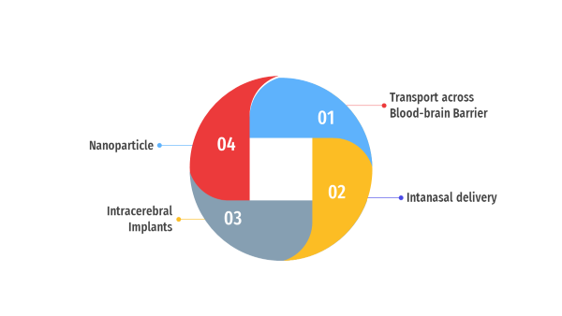

Figure 1: Transport of drugs to brain

**TRANSPORT OF DRUGS TO BRAIN**

Transport of drugs to brain takes place by one of the four methods as mentioned in figure 1.

1. Transport beyond the BBB
2. Paracellular pathway

In contrast to the peripheral micro vessel wall, the Blood Brain Barrier’s tight junctions formed by endothelial structure limits the passage of hydrophilic molecules through the intercellular gaps. (14)

1. Transport proteins

Transport proteins play an evident contribution in mediating the route of specific molecules across the blood-brain barrier (BBB). Proteins such as GLUT, amino acid, nucleosides, choline transporters aid in selective permeability of the BBB, ensuring that essential nutrients and molecules required for proper brain function are efficiently transported while limiting the passage of potentially harmful substances. To develop methods for delivering medications for the treatment of neurological diseases, it is imperative to comprehend the mechanisms underlying protein-mediated transport through the blood-brain barrier.(15)

1. Lipophilic diffusion pathway

The process of passive diffusion can occur spontaneously, based upon the nature of the concentration gradient. A number of molecules soluble in lipids have the ability to pass through cell membranes and passively diffuse into the brain through the endothelium. (16)

1. Receptor mediated transcytosis

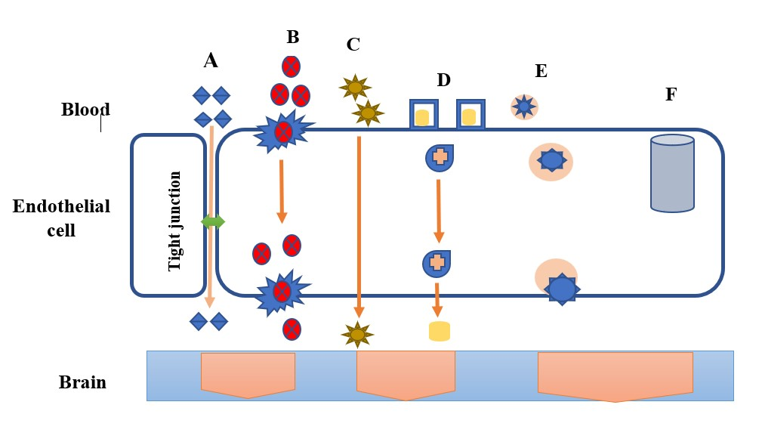Depending on the composition of the concentration gradient, passive diffusion may happen on its own. Many molecules that are soluble in lipids can cross cell membranes and diffuse into the brain via the endothelium. Certain molecules that the receptors recognise can be transported via the controlled and selective process of receptor-mediated transcytosis. The BBB is crossed by drug delivery systems that take advantage of this mechanism, especially for substances that might not pass through the barrier through passive diffusion or different transport mechanisms. (17)

Figure 2: Transport across blood brain barrier; (A) Paracellular Pathway (B) Protein mediated transport (C) Lipophilic diffusion (D) Receptor mediated Transcytosis (E) Adsorptive Transcytosis (F) Efflux pumps

1. Adsorptive transcytosis

The BBB is well-suited to the AMT process because it offers the ability for cationic molecules to attach to the endothelial cells and then to undergo exocytosis at the abluminal surface; additionally, the BBB's transcytosis pathways, together with its morphological and enzymatic characteristics, and the high mitochondrial content of cerebral Endothelial Cells, provide the means for the molecules to be transported through the cytoplasm of the endothelial cells.(18)

1. Intranasal drug delivery

A helpful method for treating neurologic disorders is the intranasal (IN) administration of medications to the CNS. Subject to drug size or charge, the blood-brain barrier (BBB) prevents many drugs from penetrating the central nervous system (CNS), which limits their ability to assist with memory loss and neurodegeneration.(19)

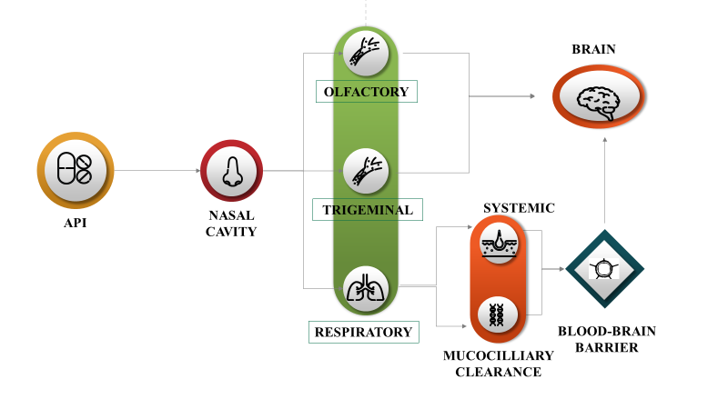

Figure 3: Transport of API from nasal cavity to brain

When API is introduced in nasal cavity, it undergoes 3 pathways as mentioned in figure 3. Since many potential medications cannot cross the blood-brain barrier, such as oxytocin, IGF-1, insulin, glutathione, and many others, nose-to-brain transport is necessary. (20)

Compared to traditional delivery methods, intranasal administration will be advantageous for all of these compounds in order to reach the central nervous system. There will be an increasing need for novel therapeutic targets in the brain, necessitating the development of more specialised delivery systems, as our knowledge of the brain, its internal circuits, and the pathophysiology of central nervous system disorders grows.(21) Certain brain regions that would not normally be accessible may be directly accessed through the olfactory, trigeminal, and vomeronasal routes. Optimising this route or routes, as well as fully comprehending dosing and safety after nasal drug administration, are still necessary in order to target neurons for a direct CNS therapy.(22)

1. Intracerebral implants

Research on brain implantable technologies, like neurostimulators, is advancing quickly. They have been employed to manage and treat a number of illnesses, including epilepsy, Parkinson's disease, and depression that is resistant to treatment.(23)

[Johannes Gurke](https://pubmed.ncbi.nlm.nih.gov/?term=Gurke%20J%5BAuthor%5D) et al presented a simple method for the electrode array and microfluidic channel prototyping of intracranial implants. They demonstrated how the implant can concurrently record brain activity using its electrodes and modify hippocampal neuronal activity through localised drug delivery. Additionally, after a week of implantation, the implants showed little tissue reaction and good implant stability. This work opens the door for a new strategy in the creation of multifaceted implants and demonstrates the possibilities of hybrid fabrication, which combines multiple methods of production in neurotechnology.(24)

**BRAIN TARGETED DRUG DELIVERY USING NANOPARTICLES THROUGH INTRANASAL ROUTE**

Drugs and biological products may cause issues because of their physicochemical characteristics after being administered intravenously. On the other hand, the nasal cavity's typical anatomical features might cause the formulation to clear quickly. (25)Combining excipients that prolong nasal residence time with micro- and nanotechnologies can be used in creation strategies. Nasal delivery necessitates a device that can sufficiently disperse the dosage form and guarantee its deposition in the necessary region of the nasal cavity, in addition to formulation characteristics. A detailed description of the formulation, its excipients, and the dosing device is necessary to explain the selection of both the excipient and the device (26).

Nanoparticles have shown promising potential in delivering drugs and therapeutic agents beyond BBB for various disorders. Various types of nanoparticles are shown in the figure

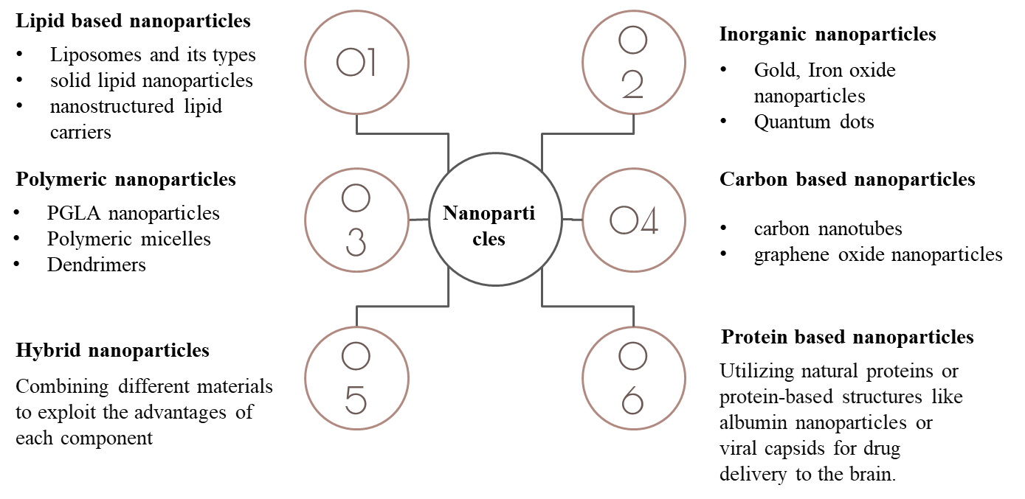

Figure 4: Types of nanoparticles

This review focusses on brain targeted drug delivery using nanoparticles through intranasal route.

**Lipid based nanoparticles**

A class of nanocarriers known as lipid-based nanoparticles uses lipids as their main structural element. Because of these nanoparticles' biocompatibility, adaptability, and capacity to incorporate both lipophilic and hydrophilic drugs, drug delivery with them has been the subject of extensive research.(27) These lipids based vesicular structures can be classified into following:

**Liposomes**

The most studied nanocarriers utilised in targeted drug delivery systems are liposomes. Liposomal vesicles, known as liposomes, are produced through the emulsification of either synthetic or natural lipids in an aqueous medium. They are composed of one or more lipid bilayers and generally exhibit a diameter of 50–500 nm.(28)

In order to cross the blood-brain barrier through the intranasal route, Tatiana N. Pashirova et al. created liposomes exhibiting cationic charge using L-α-phosphatidylcholine and dihexadecylmethylhydroxyethylammonium bromide (DHDHAB). Low haemolytic action against human red blood cells , good solubility properties towards the hydrophobic dye Orange OT, low critical association concentration (0.01 mM), and microbial inhibition against gram-positive bacteria, such as *Staphylococcus aureus* and *Bacillus cereus*, were all attained. When cationic liposomes with rhodamine B are administered by intravenous route as opposed to intravenously, it has been demonstrated that the latter method increases the bioavailability into the brain. This positive finding suggests that commercially available positively charged oximes could be used as non-invasive medical countermeasures against organophosphorus poisoning to reactivate central acetylcholinesterase through the "nose-brain" pathway.(29)

**Niosomes**

Niosomes are a new class of nanoparticles (NPs) that mainly consist of a self-assembled bilayer of non-ionic surfactant. They have shown great promise as a vehicle for efficient transport of drug molecules to a variety of locations, including the brain. (30)

To transfer the loaded materials to the brain, niosomes, which are nanoscale vesicular carriers, can ensnare, encapsulate, or dissolve the active molecules. Niosomal vesicles improve chemical stability, boost cellular uptake, and lessen systemic adverse effects. They can also increase bioavailability, enhance drug passage via the olfactory region, and enhance patient compliance. (31)

[Rasha A. Khallaf](https://www.tandfonline.com/author/Khallaf%2C+Rasha+A) et al formulated niosomes through surface modification using olanzapine as the drug for brain targeting via nasal route. Different ratios of surfactants were mixed with cholesterol to prepare the niosomes which were further coated with chitosan. The developed vesicles were examined using confocal laser scanning microscopy (CLSM) to determine their physicochemical and stability parameters. Additionally, rats were used to measure the optimised formula's brain targeting properties. When compared to the drug's intranasal solution, the brain's Olanzapine concentration increased threefold in the optimised nasal Chitosan coated niosomes. To sum up, the vesicles that were created were effective in delivering Olanzapine to the brain through the nose (32).

**Transferosomes**

Transferosomes are vesicular carrier systems that are specifically engineered to include an edge activator and an inner aqueous compartment encompassed by a bilayer of lipids. This lipid bilayer encircling the aqueous core creates ultra-deformable vesicles with the ability to self-optimize and self-regulate. (33)

An ionic responsive in-situ gel comprising nanotransfersomes has been developed by Somayeh Taymouri et al. for the nasal delivery of aripiprazole. The film hydration method was used to prepare the Aripiprazole loaded TFS, and an irregular factorial design was used for optimisation. Particle size, zeta potential, polydispersity index (PdI), entrapment efficiency (EE), and release efficiency (RE) were among the variables that were taken into account when optimising the prepared formulations. The optimised Aripiprazole transferosomes were dispersed in an ion-activated deacetylated Gellan gum solution and then examined for pH, gelling time, viscosity features, and in-vitro release research. When transferosomes and gel were compared, the drug release from the former was lower. The capability of gel to alleviate psychotic symptoms in mice and enhance drug delivery to the brain was demonstrated by the results of pharmacodynamic studies.(34)

**Ethosomes**

Ethosomes are microscopic spheres used to deliver medication through the skin.

They are a type of phospholipid vesicle, similar to liposomes, but with a key difference: ethosomes contain a high concentration of ethanol. This ethanol helps the ethosomes to permeate the deep layers of the skin, delivering the medication more effectively. (35)

Mohammed Layth Hamzah et al developed Frovatriptan-loaded binary ethosomes nasal in-situ gel for treatment of migraines. Formulation of binary ethosomes helped in overcoming several problems associated with oral routes such as low permeability. Ethosomes were formed using film hydration technique and characterised for various parameters including vesicle size, zeta potential, polydispersity index and encapsulation efficiency. It was concluded that binary ethosomes gel poses as an excellent non-invasive drug delivery enhancing the bioavailability and sustained drug release. (36)

**Comparison between Liposomes and its types**

Syeda Shabana Sultana et al carried-out comparison studies between liposomes, ethosomes and transferosomes using naproxen sodium as the active material. Naproxen sodium is an anti-inflammatory drug widely used in treatment of rheumatoid arthritis. However, it has systemic side effects such as arrythmia, wheezing and coughing caused due to contraction of bronchi. Development of lipid based vesicular systems may help in overcoming these side effects. In contrast, liposomes maintained the drug release for an extended amount of time. Transferosomes were discovered to be a superior vesicular system when the entrapment efficiencies of all of the vesicular systems were compared. Ethosomes are found to be superior for topical drug delivery due to their small mean particle diameter. When it comes to topical gel formulation, ethosomes and transferosomes are far more desirable than liposomes. While ethosomes and transferosomes had first order kinetics with a non-Fickian diffusion mechanism, liposomes had zero order kinetics. Because liposomes follow zero order kinetics, they are therefore the most suitable drug delivery system for oral use. (37)

**Solid lipid nanoparticles (SLNs)**

They are a category of nanoparticle system used in drug delivery and cosmetic formulations. They are composed of lipids that are solid at room temperature and stabilized with surfactants. They are commonly spherical in morphology with vesicle size of 50-1000nm. Solid lipid nanoparticles, which combine the best features of polymeric nanoparticles, liposomes, and microemulsion, have completely transformed the landscape of drug delivery.(38)

[Hezhong Ouyang](https://www.tandfonline.com/author/Ouyang%2C+Hezhong) et al formulated solid lipid nanoparticles to improve the biopharmaceutical performance of Olanzapine via intraperitoneal route. Olanzapine has a low blood-brain barrier (BBB) penetration rate and is poorly soluble in water. Here, Olanzapine-SLNs were created by the high-pressure homogenization (HPH) technique, and their particle properties were then examined. Furthermore, Olanzapine-SLNs' in vivo pharmacokinetic profiles and in vitro release profiles were contrasted with those of pure drug. The bioavailability of Olanzapine-SLNs was found to be significantly enhanced (ninefold) in comparison to Olanzapine suspension. Ultimately, it can be said that, as demonstrated for Olanzapine in this study, SLNs possess the ability to transport active pharmaceutical ingredients to the brain, primarily to increase their bioavailability and antipsychotic affect.(39)

**Nanostructured lipid carriers (NLCs)**

Nanostructured lipid carrier is an innovative pharmaceutical formulation comprising of surfactants and co-surfactants, as well as physiological and biocompatible lipids. A novel advancement of lipid nanoparticles, known as nanostructured lipid carriers, arose in reaction to the shortcomings of the first generation, or SLNs. Emulsifiers and compatible, biodegradable liquid and solid lipids are used in the creation of NLCs.(40)

Nano-lipid carriers have shown promising future as a means of medicine delivery by various routes of administration such as oral, parenteral. Ocular, pulmonary, topical and transdermal route. Recent applications of NLCs include brain targeting, chemotherapy, biotechnology, the the food sector, and the delivery of cosmeceuticals and nutraceuticals.(41)

Sanjay Kumar Singh formulated Asenapine nanostructured lipid carriers for improved drug delivery to brain via intranasal route. Asenapine maleate is an antipsychotic drug used in treatment of schizophrenia. The oral bioavailability of this drug is less than 2% since it undergoes extensive hepatic metabolism. This limitation was overcome using intranasal route of administration. They used quality by design approach in development and optimization of the lipid carriers. The Korsmeyer–Peppas model best fits the anomalous release observed in the *in-vitro* drug release study, which lasted up to 24 hours. The characterization of the Asenapine nanostructured lipid carriers 's surface and solid state revealed spherical-shaped particles with a smooth surface, where Asenapine was present in a molecularly dispersed state within a lipid matrix. Furthermore, Asenapine nanostructured lipid carriers have a higher brain bioavailability, a better therapeutic and safety profile, and an improved intranasal route to administration of pure drug as demonstrated by studies on the brain and plasma pharmacokinetics and long-term animal behavioural assessment. Nonetheless, pre-clinical biochemical and toxicological investigations are required for additional assessment. These results show that a novel and promising drug delivery method for the intranasal administration of Asenapine in the management of schizophrenia may be nanostructured lipid carriers.(42)

**CONCLUSION:**

Treatment of psychotic disorder is hindered by various factors such as low therapeutic efficacy, enzymatic degradation, tolerance, blood brain barrier etc. The BBB regulates the distribution of substances to the brain. As a result, most of the medications in management of brain disorders are not able to cross the BBB. The intranasal route of drug delivery is progressively used to treat brain related disorders. This route helps in circumventing the barrier. The limitations of intranasal delivery such as low nasal residence time can be overcome by using appropriate excipients. Nanoparticles are also a potential method for transport of therapeutic agents across the blood brain barrier. Lipid based nanoparticles comprising liposomes and its modifications, solid lipid nanoparticles and nanostructured lipid carriers consist of lipids and surfactants. These have various advantages such as biocompatibility and ability to incorporate both hydrophilic and lipophilic drugs. Overall lipid-based nanoparticles pose a promising approach for drug delivery to the brain. This will take more investigation in this field to bring these intriguing nanocarriers from the lab to the market. It is necessary to assess the toxicity profile of these nanocarriers and find solutions to issues related to nanomedicines, such as formulation and characterization complexity. These nanocarriers are developing slowly because there aren't enough clinical studies and data.

**ACKNOWLEDGEMENT:**

I would like to thank our professors at Department of Pharmaceutics, KLE college of pharmacy. Hubballi -580031, A constituent unit of KAHER, Belagavi for providing us with valuable guidance at insights throughout the process of writing this review. I would also like to extend warm regards to the Principal, KLE College of Pharmacy, Hubballi- 580031 for providing this opportunity and platform for doing more literature review.

**ABBREVIATIONS**:

**BBB**: blood brain barrier; **CNS**: Central Nervous System; **NVU**: neurovascular Unit; **TJ**: tight junctions; **IN**: Intranasal; **SLN**: Solid Lipid Nanoparticles; **NLC**: Nanostructured Lipid Carriers

**CONFLICT OF INTEREST:**

The authors declare that there is no conflict of interest.

**REFERENCES:**

1. McCutcheon RA, Reis Marques T, Howes OD. Schizophrenia—An Overview. JAMA Psychiatry. 2020 Feb 1;77(2):201.

2. Remington G, Hahn MK, Agarwal SM, Chintoh A, Agid O. Schizophrenia: Antipsychotics and drug development. Behavioural Brain Research. 2021 Sep;414:113507.

3. Achar A, Myers R, Ghosh C. Drug Delivery Challenges in Brain Disorders across the Blood–Brain Barrier: Novel Methods and Future Considerations for Improved Therapy. Biomedicines. 2021 Dec 4;9(12):1834.

4. Galea I. The blood–brain barrier in systemic infection and inflammation. Cell Mol Immunol. 2021 Nov 30;18(11):2489–501.

5. Ronaldson PT, Davis TP. Blood–brain barrier transporters: a translational consideration for CNS delivery of neurotherapeutics. Expert Opin Drug Deliv. 2024 Jan 2;21(1):71–89.

6. Alahmari A. Blood-Brain Barrier Overview: Structural and Functional Correlation. Vol. 2021, Neural Plasticity. Hindawi Limited; 2021.

7. Fernandez M, Nigro M, Travagli A, Pasquini S, Vincenzi F, Varani K, et al. Strategies for Drug Delivery into the Brain: A Review on Adenosine Receptors Modulation for Central Nervous System Diseases Therapy. Pharmaceutics. 2023 Oct 10;15(10):2441.

8. Mondal S, Ghosh S. Liposome-Mediated Anti-Viral Drug Delivery Across Blood–Brain Barrier: Can Lipid Droplet Target Be Game Changers? Cell Mol Neurobiol. 2024 Dec 20;44(1):9.

9. Wevers NR, De Vries HE. Microfluidic models of the neurovascular unit: a translational view. Fluids Barriers CNS. 2023 Nov 27;20(1):86.

10. Brown LS, Foster CG, Courtney JM, King NE, Howells DW, Sutherland BA. Pericytes and neurovascular function in the healthy and diseased brain. Vol. 13, Frontiers in Cellular Neuroscience. Frontiers Media S.A.; 2019.

11. Kadry H, Noorani B, Cucullo L. A blood–brain barrier overview on structure, function, impairment, and biomarkers of integrity. Fluids Barriers CNS. 2020 Dec 18;17(1):69.

12. Wu D, Chen Q, Chen X, Han F, Chen Z, Wang Y. The blood–brain barrier: structure, regulation, and drug delivery. Signal Transduct Target Ther. 2023 May 25;8(1):217.

13. Umoh IO, dos Reis HJ, de Oliveira ACP. Molecular Mechanisms Linking Osteoarthritis and Alzheimer’s Disease: Shared Pathways, Mechanisms and Breakthrough Prospects. Int J Mol Sci. 2024 Mar 6;25(5):3044.

14. Fu BM. Transport across the blood-brain barrier. In: Advances in Experimental Medicine and Biology. Springer New York LLC; 2018. p. 235–59.

15. Mehta P, Soliman A, Rodriguez-Vera L, Schmidt S, Muniz P, Rodriguez M, et al. Interspecies Brain PBPK Modeling Platform to Predict Passive Transport through the Blood–Brain Barrier and Assess Target Site Disposition. Pharmaceutics. 2024 Feb 4;16(2):226.

16. Bellettato CM, Scarpa M. Possible strategies to cross the blood-brain barrier. Vol. 44, Italian Journal of Pediatrics. BioMed Central Ltd; 2018. p. 1DUNNY.

17. Pulgar VM. Transcytosis to cross the blood brain barrier, new advancements and challenges. Front Neurosci. 2019;13(JAN).

18. Mohapatra P, Gopikrishnan M, Doss C GP, Chandrasekaran N. How Precise are Nanomedicines in Overcoming the Blood–Brain Barrier? A Comprehensive Review of the Literature. Int J Nanomedicine. 2024 Mar;Volume 19:2441–67.

19. Fonseca LC, Lopes JA, Vieira J, Viegas C, Oliveira CS, Hartmann RP, et al. Intranasal drug delivery for treatment of Alzheimer’s disease. Drug Deliv Transl Res. 2021 Apr 26;11(2):411–25.

20. Veronesi MC, Alhamami M, Miedema SB, Yun Y, Ruiz-Cardozo M, Vannier MW. Imaging of intranasal drug delivery to the brain. Am J Nucl Med Mol Imaging. 2020;10(1):1–31.

21. Lombardo R, Musumeci T, Carbone C, Pignatello R. Nanotechnologies for intranasal drug delivery: an update of literature. Pharm Dev Technol. 2021 Sep 14;26(8):824–45.

22. Erdő F, Bors LA, Farkas D, Bajza Á, Gizurarson S. Evaluation of intranasal delivery route of drug administration for brain targeting. Brain Res Bull. 2018 Oct;143:155–70.

23. Dabbour AH, Tan S, Kim SH, Guild SJ, Heppner P, McCormick D, et al. The Safety of Micro-Implants for the Brain. Front Neurosci. 2021 Dec 9;15.

24. Gurke J, Naegele TE, Hilton S, Pezone R, Curto VF, Barone DG, et al. Hybrid fabrication of multimodal intracranial implants for electrophysiology and local drug delivery. Mater Horiz. 2022;9(6):1727–34.

25. Formica ML, Real DA, Picchio ML, Catlin E, Donnelly RF, Paredes AJ. On a highway to the brain: A review on nose-to-brain drug delivery using nanoparticles. Appl Mater Today. 2022 Dec;29:101631.

26. Boyuklieva R, Zagorchev P, Pilicheva B. Computational, In Vitro, and In Vivo Models for Nose-to-Brain Drug Delivery Studies. Biomedicines. 2023 Aug 4;11(8):2198.

27. Yonezawa S, Koide H, Asai T. Recent advances in siRNA delivery mediated by lipid-based nanoparticles. Adv Drug Deliv Rev. 2020;154–155:64–78.

28. Nsairat H, Khater D, Sayed U, Odeh F, Al Bawab A, Alshaer W. Liposomes: structure, composition, types, and clinical applications. Heliyon. 2022 May;8(5):e09394.

29. Pashirova TN, Zueva I V., Petrov KA, Lukashenko SS, Nizameev IR, Kulik N V., et al. Mixed cationic liposomes for brain delivery of drugs by the intranasal route: The acetylcholinesterase reactivator 2-PAM as encapsulated drug model. Colloids Surf B Biointerfaces. 2018 Nov;171:358–67.

30. Al Jayoush AR, Hassan HAFM, Asiri H, Jafar M, Saeed R, Harati R, et al. Niosomes for nose-to-brain delivery: A non-invasive versatile carrier system for drug delivery in neurodegenerative diseases. J Drug Deliv Sci Technol. 2023 Nov;89:105007.

31. AL-ZUHAIRY SAS, S. EL-SAWY H, EL-NABARAWI MA, TEAIMA MH. FOCUS ON NIOSOMAL–BASED DRUG DELIVERY SYSTEMS FOR NASAL ROUTE: APPLICATIONS AND CHALLENGES. International Journal of Applied Pharmaceutics. 2023 Jan 7;36–43.

32. Khallaf RA, Aboud HM, Sayed OM. Surface modified niosomes of olanzapine for brain targeting via nasal route; preparation, optimization, and *in vivo* evaluation. J Liposome Res. 2020 Apr 2;30(2):163–73.

33. Opatha SAT, Titapiwatanakun V, Chutoprapat R. Transfersomes: A Promising Nanoencapsulation Technique for Transdermal Drug Delivery. Pharmaceutics. 2020 Sep 9;12(9):855.

34. Taymouri S, Shahnamnia S, Mesripour A, Varshosaz J. *In vitro* and *in vivo* evaluation of an ionic sensitive *in situ* gel containing nanotransfersomes for aripiprazole nasal delivery. Pharm Dev Technol. 2021 Sep 14;26(8):867–79.

35. Shabreen oghal. R, Sangeetha S. Ethosomes: A Novel Drug Delivery System And Their Therapeutic Applications -A Review. Res J Pharm Technol. 2020;13(4):1972.

36. Hamzah M, Kassab H. Formulation and Characterization of Intranasal Drug Delivery of Frovatriptan-Loaded Binary Ethosomes Gel for Brain Targeting. Nanotechnol Sci Appl. 2024 Jan;Volume 17:1–19.

37. Sultana SS, Sailaja AK. Preparation and evaluation of naproxen sodium loaded liposomes, ethosomes and transferosomes. Journal of Bionanoscience. 2017 Aug 1;11(4):284–91.

38. Duan Y, Dhar A, Patel C, Khimani M, Neogi S, Sharma P, et al. A brief review on solid lipid nanoparticles: part and parcel of contemporary drug delivery systems. RSC Adv. 2020;10(45):26777–91.

39. Ouyang H, Hu J, Qiu X, Wu S, Guo F, Tan Y. Improved biopharmaceutical performance of antipsychotic drug using lipid nanoparticles via intraperitoneal route. Pharm Dev Technol. 2022 Aug 9;27(7):853–63.

40. Elmowafy M, Al-Sanea MM. Nanostructured lipid carriers (NLCs) as drug delivery platform: Advances in formulation and delivery strategies. Saudi Pharmaceutical Journal. 2021 Sep;29(9):999–1012.

41. Chauhan I, Yasir M, Verma M, Singh AP. Nanostructured Lipid Carriers: A Groundbreaking Approach for Transdermal Drug Delivery. Adv Pharm Bull. 2020 Feb 18;10(2):150–65.

42. Singh SK, Dadhania P, Vuddanda PR, Jain A, Velaga S, Singh S. Intranasal delivery of asenapine loaded nanostructured lipid carriers: formulation, characterization, pharmacokinetic and behavioural assessment. RSC Adv [Internet]. 2016;6(3):2032–45. Available from: http://xlink.rsc.org/?DOI=C5RA19793G