ASSIGNMENT:

1.Create a blog or website using blogs spot and word Press. customize the theme design and post new article with 500 words.

<https://swastam-assistance.blogspot.com/2023/10/labor-assistance-during-pregnancy-using.html>

2.Create a New Facebook Business page and post one social media poster for your brand

<https://www.facebook.com/profile.php?id=61550333582455&mibextid=ZbWKwL>

3.Create and design a social media advertisement poster using canva



<https://m.facebook.com/story.php?story_fbid=pfbid0i6Y8pQqeJ1fRQcsokUx7F3tJTrZcuYHpXhS29nhUtftuwnmpyhwzBz56rLTopVUhl&id=61550333582455&mibextid=>

4.Create email newsletter design using Mailchimp or canva tool.

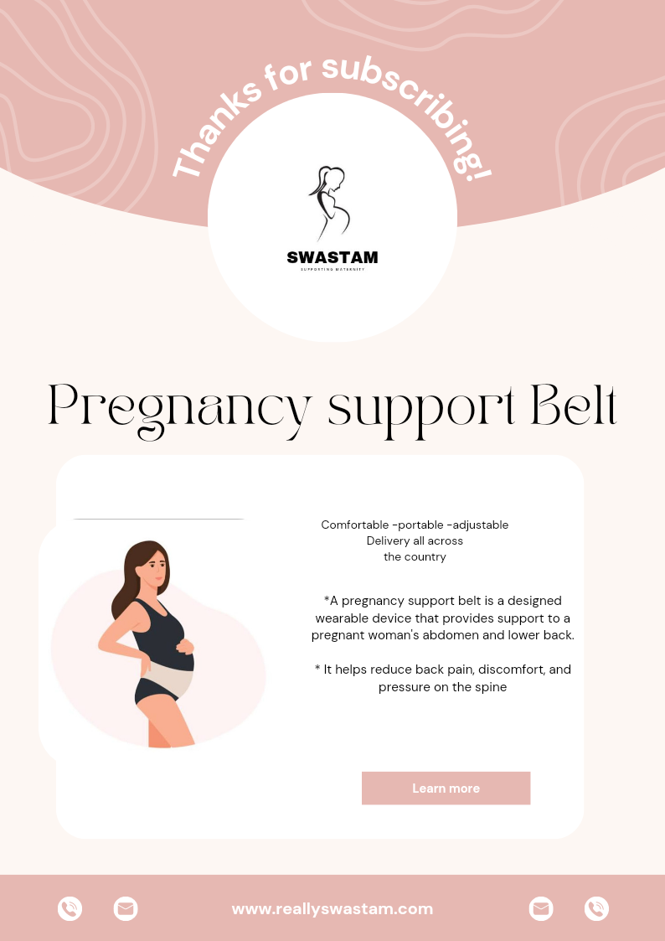

<https://m.facebook.com/story.php?story_fbid=pfbid02g2jUQrziSZpknZomKjq4ZaWKcw334tz6s9jv2k9z8G6HCZAa5jyRcSnvoEfUt5p8l&id=61550333582455&mibextid>