**OPEN SOURCE Contribution By Vishal Reddy L1**

**Github Repo -** [**https://github.com/Vish7777/12th-physics**](https://github.com/Vish7777/12th-physics)

**Issue Url -** <https://github.com/tnebooks/12th-physics/issues/14>

**PR Url-** [**https://github.com/tnebooks/12th-physics/pull/45**](https://github.com/tnebooks/12th-physics/pull/45)

# **Issue Name -** Lesson 6 RAY OPTICS #14

**Steps1: Clone the 12th Physics project.**

**Step2: Create the classification.**

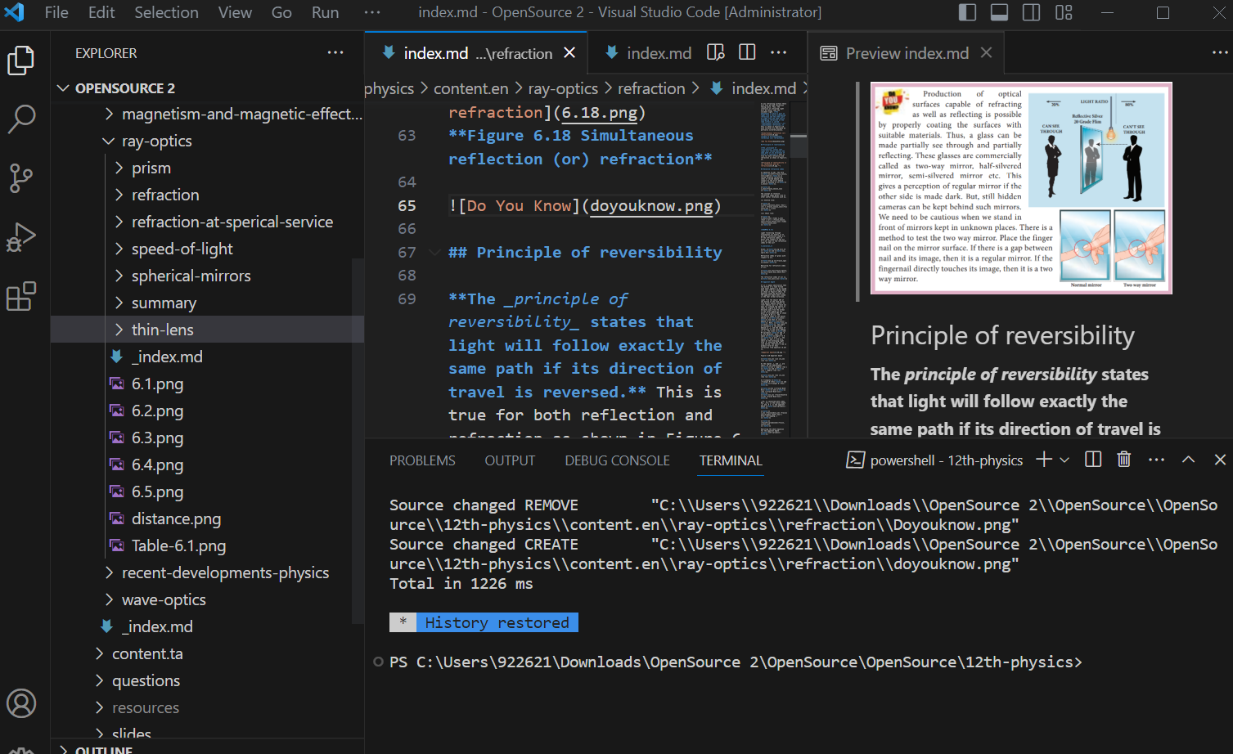

**Step3: Add necessary figures and formulae as mentioned in pdf.**

**Step 4. Run the project by giving hugo command “hugo server themesDir ../**

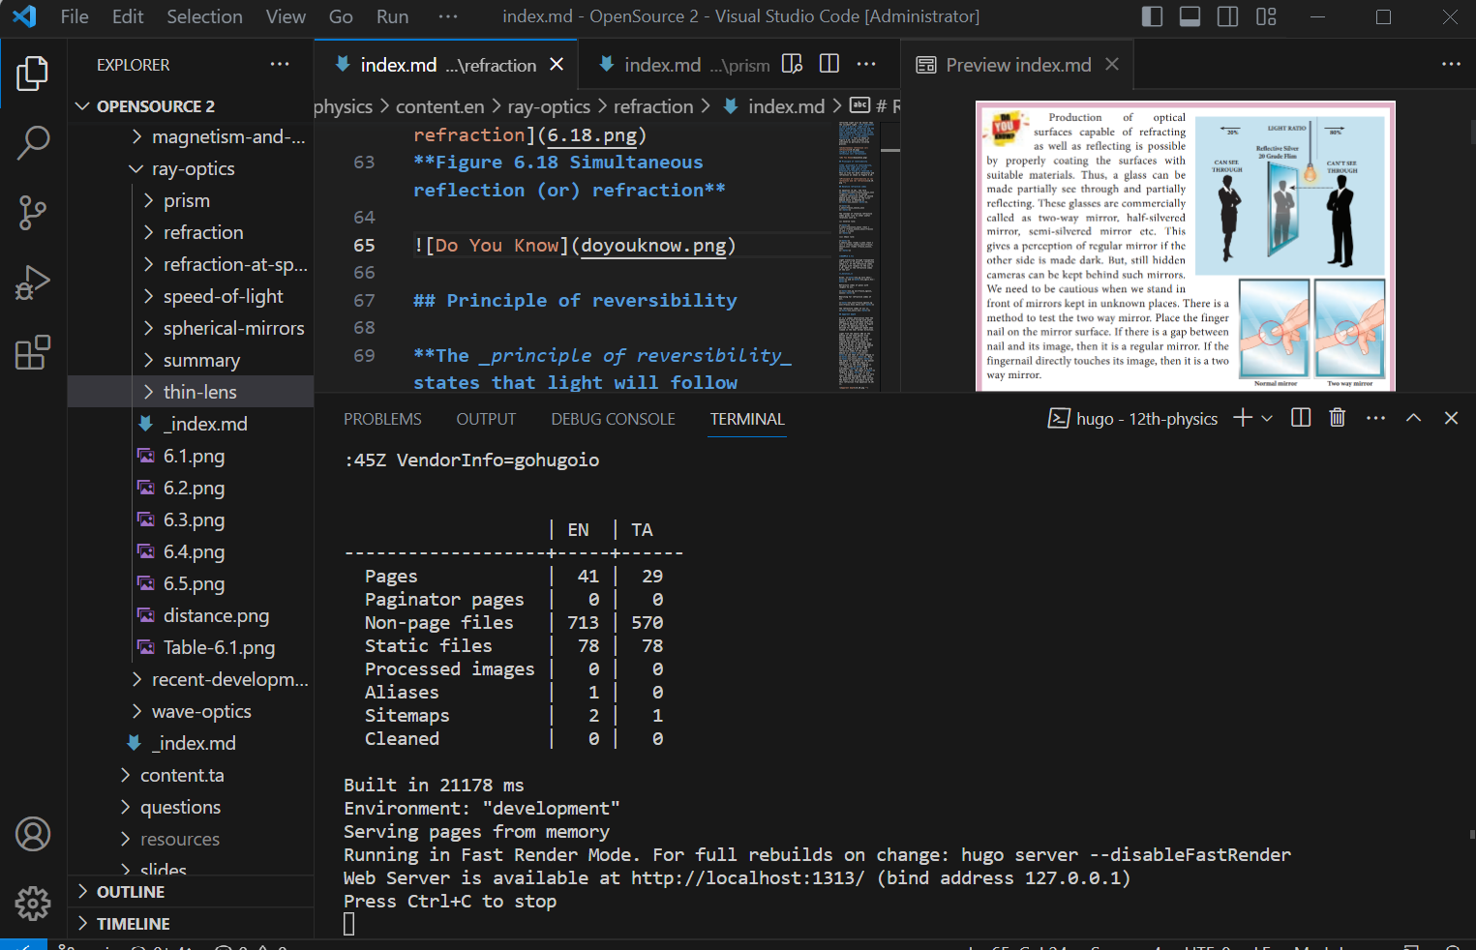

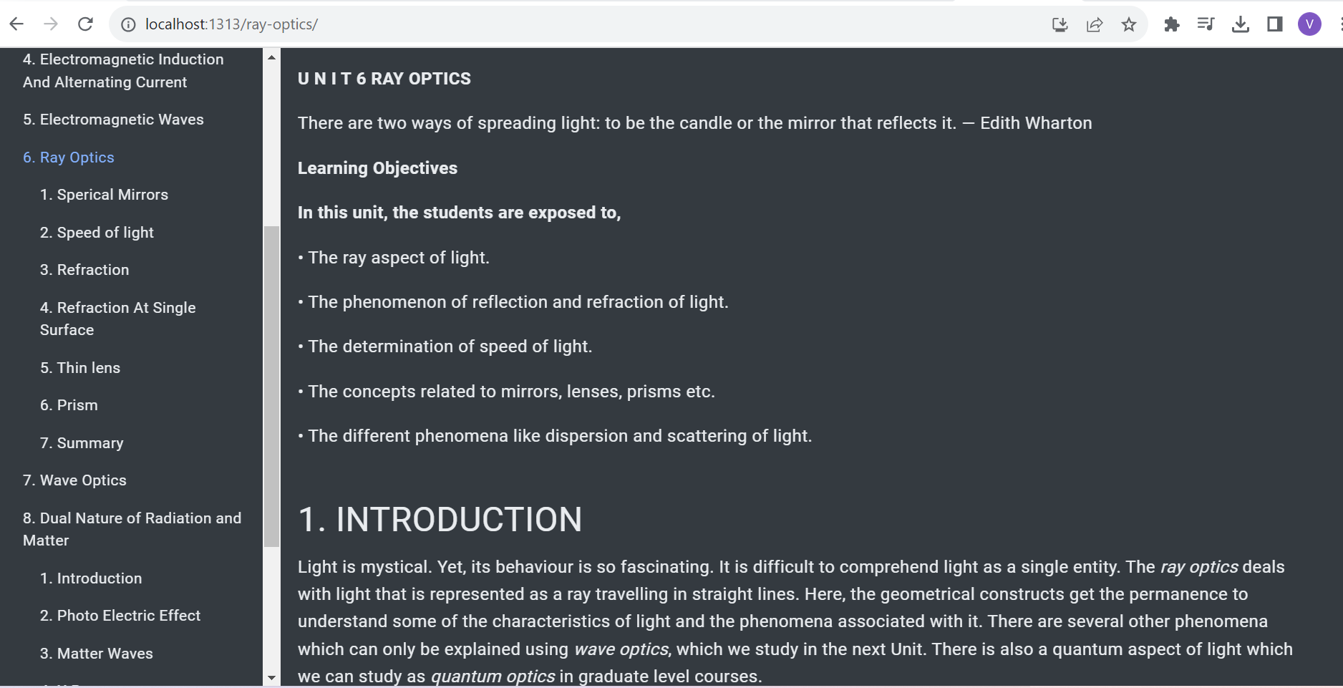

**Step 5. Open the local host and run in browser.**



**Step 6.** Push the code to GitHub repository.

