**OPEN SOURCE Contribution By Vishal Reddy L2**

**Github Repo -** <https://github.com/Vish7777/sjson>

**Issue Url -** <https://github.com/techatpark/sjson/issues/14>

**PR Url-**[**https://github.com/techatpark/sjson/pull/22**](https://github.com/techatpark/sjson/pull/22)

# **Issue Name -** Parameterised Test Cases #14

**Steps1: Clone the sjson project**

**Step2: Create a parameterized test cases for the test cases available in the project**

**Step3: Created Parameterized test cases**

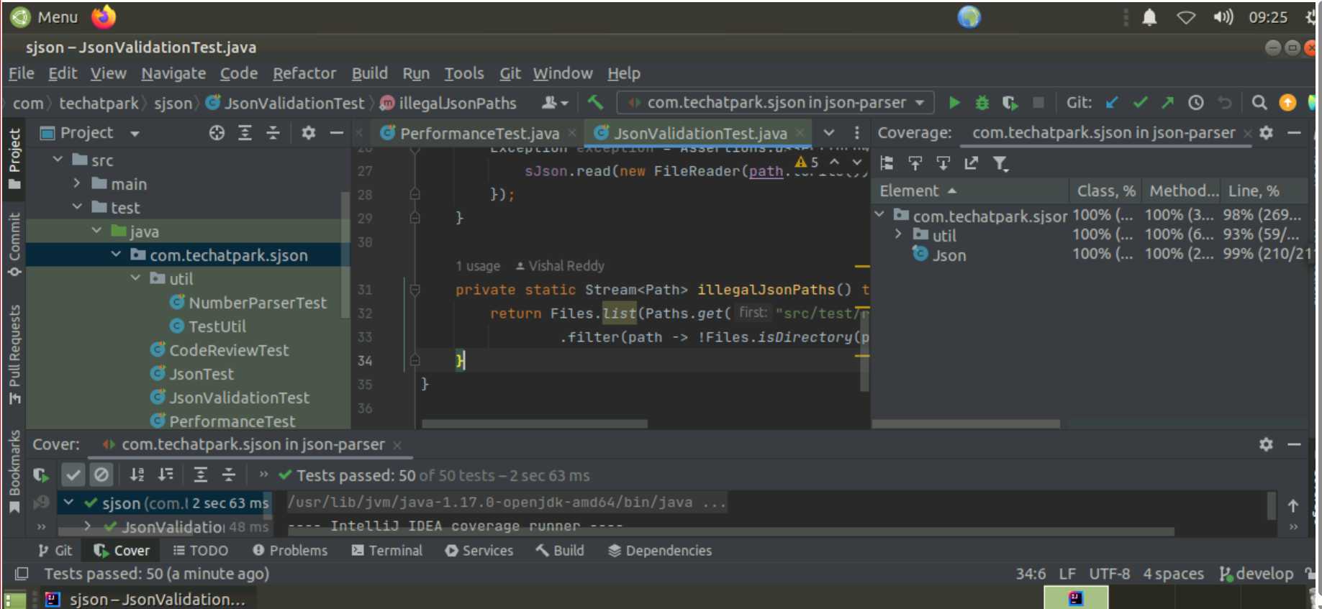

**Step 4. Run the test cases and check for the error**

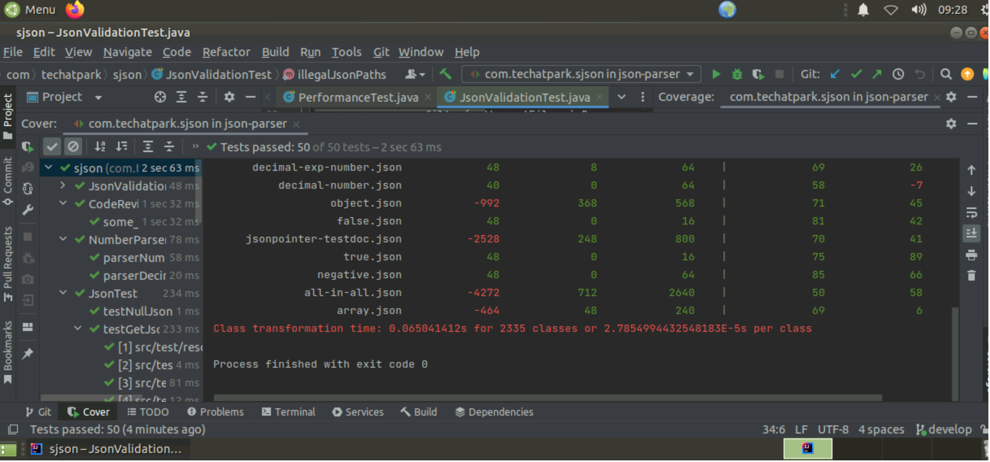

**Step 5. Push the code changes to the git Repository.**

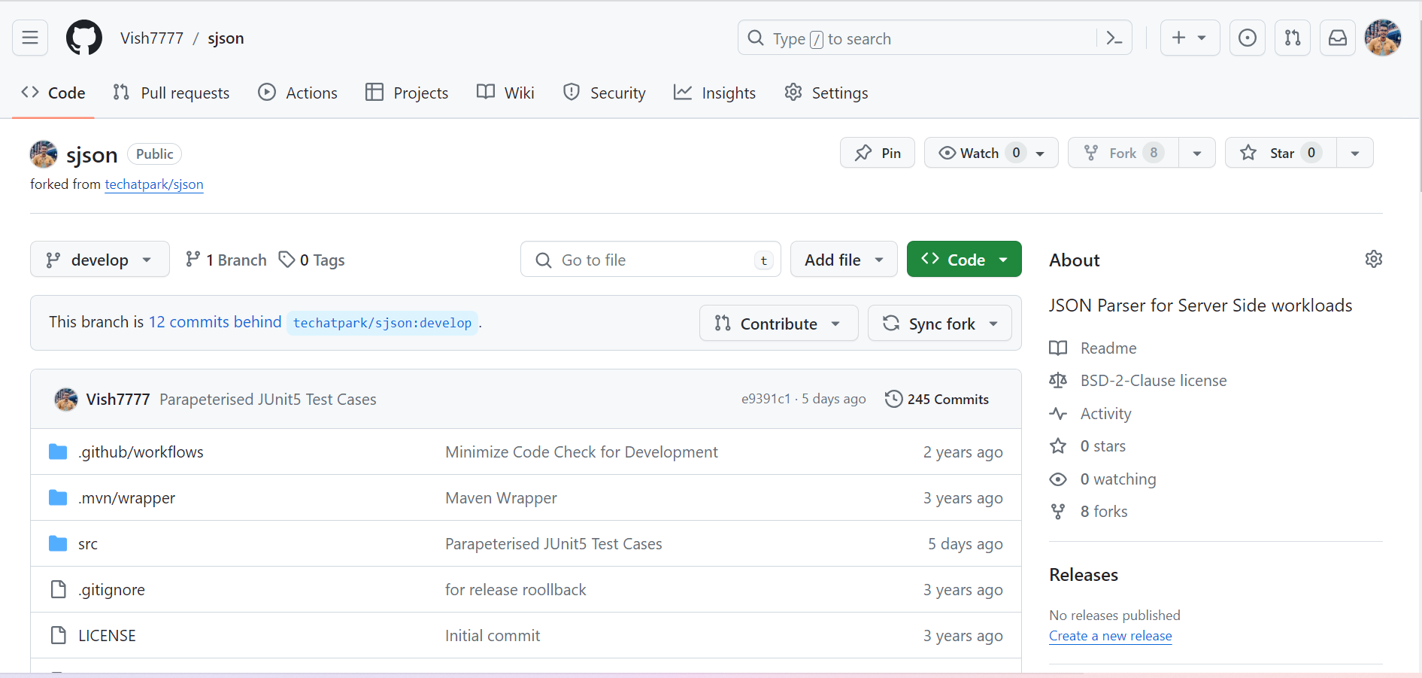

**Step 6. Raise the PR and request for merge.**

