# Objective Questions

**Q1. What is the total no. of tables present in the data?**

**Ans:** There is only one table in the data.

**Q2. What is the total no. of attributes present in the data?**

**Ans:** There are total 35 attributes present in the data.

**Q3. The data consists of some inconsistent and missing values so ensure that the data used for further analysis is cleaned.**

**Ans:** Yes, the data contained some **missing and inconsistent values**.

* To understand the data structure:
  + I thoroughly **analyzed each column** to understand its significance.
  + Applied **FILTER functions** on key columns such as **Consultation Type**, **CallStatus,** **Website**, **FreeCall**, and **FreeChat.**
* Null values were contextually valid:
  + If **Consultation Type** = "Chat", then **CallStatus** is null (which is expected).
  + Similarly, if it’s a **FreeCall** or a chat session, then Amount may be blank, which is logical.
* Inconsistent values handled:
  + Found inconsistencies between **Amount** and **NetAmount.**
  + Updated **NetAmount** using the formula $:$
$NetAmount = Total Amount - OperationCost$

* Missing values in the **Region** column:
  + Filled using **IF** and **ISBLANK** functions to assign default (Indian) value.
* Date components extracted:
  + Extracted **Year**, **Month**, and **Day** using **TEXT(), YEAR(), MONTH(),** and **DAY()** functions for better time-based analysis.
* Final step data pruning:
  + Selected only the **relevant columns** required for analyzing **Objective** and **Subjective questions**, removing unnecessary columns like **__v, callvrType, time duration etc.**

**Q4. What is the change in daily call volume day by day and also find the average daily call volume.**

**Ans: To answer this question I have followed step by step by process**

**Selected unique dates**

* Extracted unique values from the Date column using the **UNIQUE()** function.

**Calculated daily call volume**

* Used the **CallSid** column to count the number of calls on each day (non-blank **CallSid** values indicate valid calls).

**Computed average daily call volume**

* Applied the **AVERAGE()** function to the daily call counts to get the mean volume of calls per day.

**Calculated daily change in call volume**

* Used a formula like $=CurrentDayVolume - PreviousDayVolume$ to compute the **day-over-day change** in call volume.

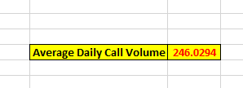

### **Observations:**

* The daily call volume **fluctuates significantly** from one day to the next.
* There are several **sharp spikes and drops**, indicating irregular call traffic (e.g., big spike on Day 9, sudden dip on Day 11).
* This pattern shows **high volatility**, possibly due to changes in user behaviour, campaign activity, or external events.
* The **average change** in daily call volume is approximately **246 calls**, showing **large day-to-day variability**.
* No clear trend of increase or decrease the changes are **erratic**, not progressive

**Reference:** The Analysis is provided on sheet name **“CallVolume”**

**Q5. Which months experienced the highest and lowest call volumes?**

**Ans Approach I have taken:**

* Created a **Pivot Table** using the dataset.
* Placed **"Month"** in the **Rows** section to group data month-wise.
* Placed **"CallSID"** in the **Values** section and set it to **Count**, representing the total number of calls per month.

**Observation:**

* The **month with the highest call volume** is: **December**
* The **month with the lowest call volume** is: **January**

**Reference:** The Analysis is provided on sheet name **“pivot”**

**Q6. What is the total operational cost for that month?**

**Ans:** **Approach I have Taken:**

* Created a **Pivot Table** using the dataset.
* Placed **"Month"** in the **Rows** section to organize data by month.
* Placed **"Astrologer's Earnings"** in the **Values** section to calculate the **total operational cost**, since it is the only cost-related field provided in the data.

**Observation:**

* + In **December** month the total operational cost was **73,925.84**
  + In **January** month the total operational cost was **3873.59**

**Note: For the Q5 & Q6** Here we don’t have much data for January month there are only 3 dates available in the data so we can’t exactly say that in December month the call was the highest or operational cost is high

**Reference:** The Analysis is provided on sheet name **“pivot”**

**Q7. What is the average number of calls handled per agent per day?**

**Ans:** **Approach I have taken:**

1. **Total Number of Calls**:  
   Created a Pivot Table by filtering **consultation type = "Call"** and using the **callSid** column in the *Values* section to count total calls.
2. **Total Number of Agents**:  
   Applied the **UNIQUE filter** on the Agent Name column to extract the distinct number of agents.
3. **Total Number of Days**:  
   Used the **UNIQUE filter** on the Date column to get the number of active days in the dataset.
4. **Applied the Formula**:

$$\text{Average calls per agent per day}=\frac{8363}{149×34}≈1.65$$

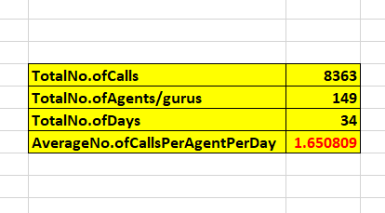

Reference: This Analyses is Provided in the sheet name **“AverageCallsPerAgent”**

**Q8. How many repeat callers are there, and what percentage of total calls do they represent?**

**Ans:** **Approach:**

1. **Step 1 Total Calls:**
   * Created a **Pivot Table** using the **userId** column in **Rows**.
   * Filtered the consultation type to **"Call"**.
   * In **Values**, used the **callSid** column to get **total calls** in grand total.
   * Then we use **COUNT** function to get the **total no.of callers**
2. **Step 2 Identify Repeat Callers:**
   * For each user_id I will reduce -1 call from its total calls
   * This gave the count of **repeat calls**.
   * Then again I will use **COUNT** function to count **totalno.of repeat callers**
3. **Step 3 Calculate Percentage of Repeat Calls:**

**Used this formula**: $\text{Percentage of Repeat Calls}=\left(\frac{\text{Total Calls }\text{by Repeat}\text{ Callers}}{\text{Total Calls}}\right)×100$

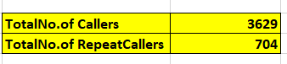

### **Observation**

* **Total Callers**: 3,629
* **Repeat Callers**: 704
* **Repeat Calls percentage**: ≈ **56.61%**

**Key Insights**

* **704 out of 3,629 callers (≈19.4%)** are repeat callers, which means nearly **1 in 5** users called more than once.
* These repeat callers contributed to **56.61% of total calls**, indicating **a high level of re-engagement** or **unresolved concerns**.
* **Repeat callers are making more calls per person** compared to first-time users.

**This suggests:**

* A **strong dependency** on the service (engagement).
* Or a **potential gap in issue resolution** during the first call.

**Reference:** This Analyses is Provided in the sheet name **“RepeatCallers”**

**Q9. What are the total sales generated by the call centre for each product category?**

### **Ans: Approach I have taken:**

To calculate total sales per product category:

* Created a **Pivot Table**.
* **Rows**: Selected Website column (each product is tied to a domain or website).
* **Values**: Selected Amount column to calculate total sales.
* This aggregated total sales for each product offering.

### **Observation:**

* **App**: ₹125,435.95 Highest sales contributor.
* **Gurucool**: ₹88,719.93 Performing well, close to the App.
* **Dashboard**: ₹0 No sales

### **Key Insight:**

* Sales are largely driven by the **App** and **Gurucool**.
* **Dashboard** requires further investigation either underperforming or inactive.

**Reference:** The Analysis is provided on sheet name **“pivot”**

**Q10 How many calls were made for each user ID and guru ID?**

**Ans:** **Approach I have taken** to find the **total number of calls made per User ID and Guru ID**, follow these steps:

1. **Filter** the data:
   * Apply a filter where **Consultation Type = 'Call'** to ensure only call-based interactions are counted.
2. **For User ID Call Count**:
   * Create a **Pivot Table**.
   * Set **Rows** as **userId**.
   * Set **Values** as **callSid** (use **Count** function).
   * This gives the **total number of calls made by each user**.
3. **For Guru ID Call Count**:
   * Similarly, create another Pivot Table.
   * Set **Rows** as **guruId.**
   * Set **Values** as **callSid** (Count).
   * This gives the **total number of calls received or handled by each Guru**.

### **Observation of userID:**

* **User 33832** made the **highest number of calls**: **113 calls**
* Followed closely by **User 28098** with **105 calls**
* Remaining top users (e.g., 33017, 28285, 11239) made between **70–90 calls**
* The top 10 users range between **49 to 113 calls**
* Steep drop in call frequency beyond the top few users

### **Observation of guruID**

* **Guru 256** handled a **very high volume of calls**: **1060 calls** – drastically higher than others
* Next highest: **Guru 292 (497 calls)** and **Guru 19 (449 calls)**
* Others fall in the **200–400 range**
* Clear imbalance in call distribution among gurus

### **Key Insights from User & Guru Call Activity**

1. **User 33832** made the highest number of calls (**113**), indicating high engagement.
2. **Guru 256** handled the most calls, showing high involvement or demand.
3. Overall, the analysis helps identify **top active users and gurus**, useful for planning **resource allocation** and **personalized follow-ups**.

**Reference:** The Analysis is provided on the sheet name **“pivot_2”**

**Q11. What is the correlation between call duration and customer satisfaction?**

**Ans:**  **Approach to Analyze Correlation Between Call Duration and Customer Satisfaction**

1. Filtered the data in general selecting the key columns:
   * **Consultation Type** = "Call"
   * **Call Status** = "Completed"
2. For **User Duration**:
   * Column1: User Call Duration
   * Column2: Rating
   * Applied **CORREL** function between User Call Duration and Rating
3. Repeated the same process for **Astrologer Duration**:
   * Applied **CORREL** between Astrologer Call Duration and Rating
4. Compared correlation values to determine relationship strength.

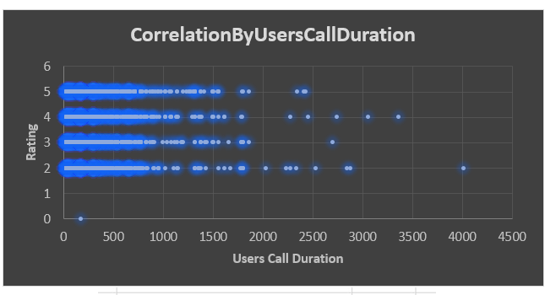

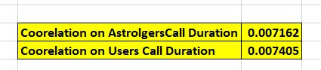

### **Observation:**

### Both **User Call Duration** and **Astrologer Call Duration** show **very weak positive correlation** with **Ratings**.

1. **Correlation values**:
   * Users: **0.0074**
   * Astrologers: **0.0071**
2. The **scatter plot** shows no clear trend or pattern, indicating that **longer calls do not necessarily lead to higher satisfaction**.
3. This suggests that **call duration alone is not a strong predictor** of customer satisfaction.

### **Key Insights:**

* **Very low correlation** (~0.007) between call duration and ratings for both users and astrologers.
* **This means that longer calls doesn't affect satisfaction** other factors like communication quality matter more maybe.
* Pattern is **consistent across both users and astrologers**.

**Reference:** This Analysis is provided on Sheet name **“Correlation”**

**Q12 Which guru has the highest and lowest customer satisfaction scores?**

**Ans:** The approach I have taken

Created a **pivot table**:

* **Rows:** Guru Names
* **Values:** Average of Rating

Applied **sort** (Largest to Smallest) on average ratings

Identified the **guru with the highest** and **lowest** average customer satisfaction

Created a **chart** to visually represent the comparison

**Observation:**

* **Top Rated Gurus:**
  + **Astro Pujaa Rai** and **Tarot Mystical** received the **highest average ratings (~7.5)**, indicating strong customer satisfaction and consistent positive feedback.
* **Lowest Rated Guru:**
  + **Astro Chandan** received the **lowest average rating (~1)**, reflecting significant dissatisfaction among customers.
* **Other Mentions:**
  + **Tarot Rittika** also has a notably low rating, though slightly higher than Astro Chandan.

**Reference:** The Analysis is provided on sheet name **“pivot”**

**Q13 What is the average customer satisfaction score by month?**

**Ans: Approach I have taken**

1. I created a **pivot table**:
   * **Rows:** **Month**
   * **Values:** Average of the ***Rating*** column
2. Then used a **bar chart** to visualize the comparison between months.

**Observation:**

The average customer satisfaction score for **December** month is **2.95** and for **January** the score is **2.67**

**Note:** Although they look like they are almost close but it is not exact because in December month there are only 3 dates but in January we are considering whole month 31 dates so by this we cant exactly say that this the average customer satisfaction score

**Reference:** The Analysis is provided on sheet name **“pivot”**

**14 How many categorical columns are there in the data? categorical and continuous data**

**Ans:** There are **total 35 columns are present** in the data in which

**27 columns are categorical** and **8 columns are continuous**

**Categorical columns**: [ _id, user, chatStatus, guru, guruname, consulation_type, website, refund_status, isWhilteListUser queue ,free_call , free_chat , createdAt, updatedAt , _v , statmentEntry_id , chartStartTime ,chartEndTime , callChannel , callvrType , callStatus ,callSid , astrologersCallStatus , uid , gid ,region , usercallStatus ]

**Continous columns:** [ chatSeconds, amount , astrologersCallDuration, usersCallDuration , astrologersEarnings , netAmount ,rating , timeDuration ]

# Subjective Questions

**Q1. Should the investment be used to hire more agents, improve training programs, or upgrade call centre technology?**

### **Ans: Before making an investment** my approach was to analyze **Call Status data** to understand the extent of unsuccessful call experiences from a customer perspective and then evaluate the **overall performance of Gurus (agents)** using their average ratings.

#### **1. Call Status Analysis**

* Created a pivot table in rows I selected callStatus
* In values I have selected callSid to know how many calls are been failed or success
* 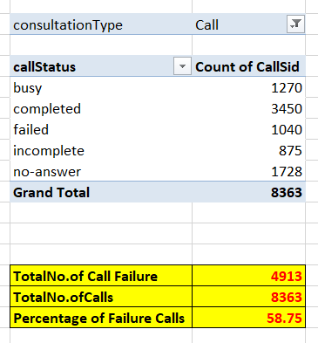Considered the following as **unsuccessful calls**: no-answer, busy, failed, and incomplete.

#### 2. **Guru Performance Analysis**

* Created pivot table in rows selected guru names in values selected Average rating
* Calculated **average rating** per Guru.
* 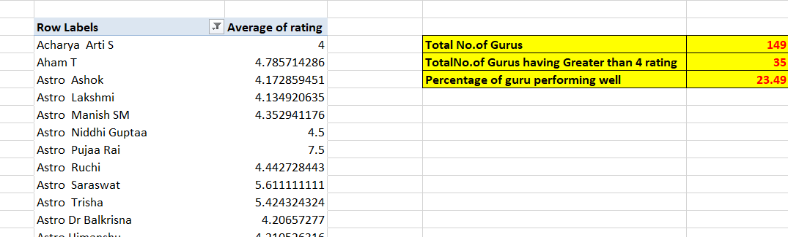Filtered Gurus with average ratings > 4. Setting a bench to identify the guru’s performance

### **Insights:**

* A significant **58.75% of calls failed**, which is a critical concern likely due to technical inefficiencies or unavailability of agents.
* Only **23.49% of Gurus** are rated well by users, indicating a **quality gap** in service delivery.
* The **AstrologersCallStatus** column had many missing values and was excluded for reliability reasons; **CallStatus** was used instead.

### **Recommendations:**

* **Invest in Guru Training Programs**  
  High Priority: Only **23.49%** of Gurus are high performers. Focused training can enhance service quality and improve customer satisfaction.
* **Upgrade Call Center Technology**  
  Medium Priority : With a **58.74% call failure rate**, improving technical infrastructure like routing systems and server reliability is essential.
* **Avoid Hiring More Agents (for now)**  
  Low Priority :Adding more agents without fixing skill gaps or tech issues may not address the root problems.

**Reference:** This analysis is provided on sheet name “pivot_2”

**Q2. What are the potential risks of each investment option (hiring, training, technology upgrades), and how can they be mitigated? Name the chart/spreadsheet function you will use for solving the problem.**

### **Ans:**

### **1**. **Hiring More Agents**

* **Risk:** Increased headcount may lead to underutilization if call volume doesn’t grow proportionately. It may also lead to higher operational costs without improving performance.
* **Mitigation:** First assess current agent utilization and peak-time load before hiring. Use forecasting models to predict future call demand.
* **Function/Chart Used:**
  + COUNTIFS() to analyze call volume per agent
  + **Pivot Table** to check agent-wise load
  + **Line Chart** for trend analysis of calls per day/week

### **2. Investing in Training Programs**

* **Risk:** If training is not well-targeted, it may not improve performance and result in wasted effort and cost.
* **Mitigation:** Focus training efforts only on low-rated Gurus. Track performance improvement before and after training.
* **Function/Chart Used:**
  + AVERAGEIFS() to track average rating per Guru
  + **Pivot Table** for before-after rating comparison
  + **Bar Chart** to visualize performance improvement

### **3. Upgrading Call Center Technology**

* **Risk:** Technology upgrades may not yield expected results if the root cause of failures is unrelated (like Guru unavailability). It also requires upfront investment.
* **Mitigation:** Conduct root cause analysis of call failures first. Test upgrades in phases to validate improvement.
* **Function/Chart Used:**
  + COUNTIF() for call status breakdown
  + **Pie Chart** to visualize failed vs successful calls
  + **Trend Chart** (Line) to measure improvement post-tech changes

**Q3. How does AstroSage's call center performance compare to AstroGuru's average call volume, customer satisfaction, and agent performance? Will you use any aggregation function or a visualization here to solve the problem?**

**Ans:**  I currently don’t have any relevant data for **AstroGuru’s performance**.

**I. If such data were available:**

* I would use **Pivot Tables** to perform aggregation.
* I would use **charts** for clear and effective visualization.

**II. This would help:**

* Compare **average call volume**, **customer satisfaction**, and **agent performance** between **AstroSage** and **AstroGuru**.
* Generate **useful insights** for **data-driven decision-making**.

**Q4. How can the call center improve its handling of peak call periods to ensure high customer satisfaction?**

**Mention the functionality you will use for giving the suggestions, will it be any aggregated function or a visualization?**

**Ans**: To answer this question I have done two key analysis which helps in understanding how to improve its handling peak call periods and also a high customer satisfaction

### **1.** **Identifying Peak Call Hours**

1. Created a **pivot table** with:
   1. **Rows**: Hour (0–23)
   2. **Values**: Count of (representing number of calls)

This helped **identify time windows with the highest volume of call consultations**, regardless of which guru handled them.

### **2.** **Hourly Call Distribution Per Agent**

Created another **pivot table** with:

* + **Rows**: Guru Names
  + **Columns**: Hour
  + **Values**: **Count** of CallSid

Applied a **colour scale heatmap using Conditional Formatting** for visual clarity.This allowed me to see **which agents are handling the most calls** and during **which hours**, helping identify:

* Overloaded gurus
* Underutilized time slots
* Potential staffing mismatches

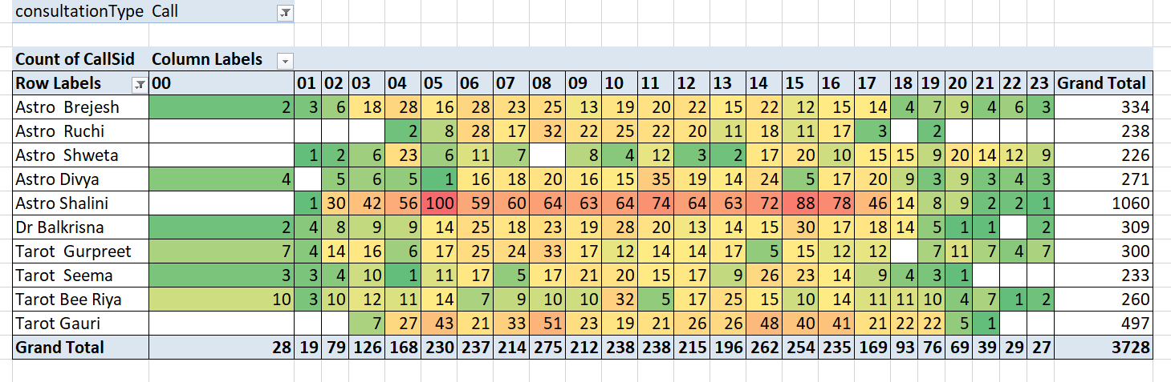**Key Insights**

### **Peak Hours for Consultations**

1. Calls start increasing **from 03:00 AM**.
2. Peak consultation hours are:
   * **08:00 AM to 12:00 PM** (highest spike at 08:00 with ~660+ calls).
   * Another busy slot is **12:00 PM to 04:00 PM**.
3. Traffic significantly **drops after 18:00**.

### **Top Performing Gurus (by Call Volume)**

1. **Astro Shalini** handled the **highest number of calls**: **1,060**.
2. Followed by:
   * **Tarot Gauri**: 497 calls
   * **Astro Brejesh**: 334 calls
   * **Dr Balkrisna**: 309 calls
3. These gurus are likely preferred by users during peak hours.

### **Key Recommendations**

1. **Align Guru Availability with Peak Hours**  
   Schedule top performers (e.g., Astro Shalini, Tarot Gauri, Astro Brejesh) between **08:00–16:00**. Reassign underutilized gurus (e.g., Astro Ruchi, Astro Shweta) to assist during peak or cover off-peak slots.
2. **Strengthen Morning Coverage**  
   Boost agent support or enable auto-queue handling between **03:00–08:00** to reduce wait times.
3. **Incentivize High Performers**  
   Introduce rewards to sustain top guru performance during high-demand periods.
4. **Drive Off-Peak Engagement**  
   Use late-hour promos post **18:00** to improve call volume during quiet period

**Reference: This analysis is provided on sheet name “pivot_3”**

**Q5. Based on historical data, what strategic initiatives should be prioritized to improve efficiency and customer satisfaction?**

**Ans:** To answer this question, I first examined the historical data available in the dataset.

the date distribution in the graph as we can observed that:

* For **2023**, data is limited to only **one month (31 days)**
* For **2024**, the data spans just **three days**

Given the limited time coverage, the dataset does not support long-term trend analysis. However, we can still extract valuable insights and propose **short-term strategic initiatives** to improve operational efficiency and enhance customer satisfaction.

To achieve this, I performed two key analyses:

1. **Guru-wise Peak Hour Call Handling**
   1. Used a pivot table with:
      * Rows: **guruName**
      * Columns: **hour**
      * Values: **Count of** **CallSid**
   2. Filtered to show only gurus handling more than 100 calls
   3. Helped identify top-performing gurus and their efficiency during peak hours
2. **Call Status vs Hour Analysis**
   1. Created a pivot with:
      * Rows: **call status** (e.g., completed, missed, no-answer, failed)
      * Columns: **hour**
      * Values: **Count of CallSid**
   2. Highlighted hours with high volumes of missed or failed calls
   3. Used **conditional formatting** to easily identify problem hours

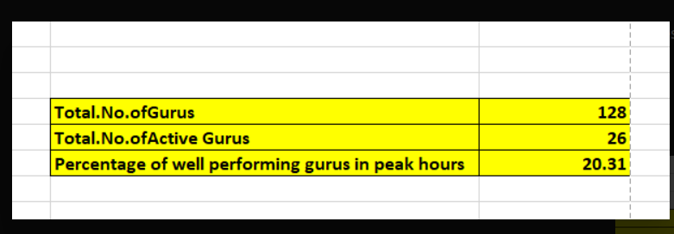

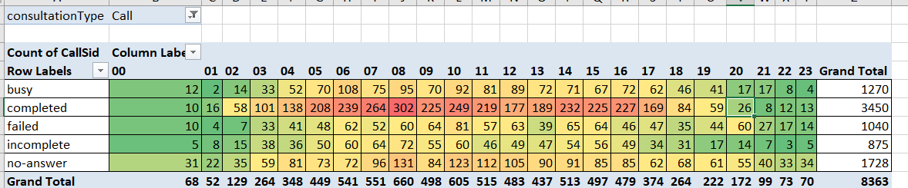

### **Insights**

1. **Over-Reliance on a Few Agents:**
   * A small set of gurus are handling a majority of calls, while others are underutilized.
2. **Service Gaps During Peak Hours:**
   * Certain peak hours show **high missed/failed call rates**, indicating potential overload or availability issues.
3. **Underperformance at Specific Hours:**
   * Several time slots have low completion rates and high dropout (missed/no-answer), affecting customer experience.

### **Recommendations**

1. **Reallocate Staff Based on Peak Demand**
   * Schedule top-performing gurus during high-traffic hours
   * Rotate or assign underutilized gurus to share peak hour load
2. **Strengthen Guru Training Programs**
   * Provide performance-based feedback to low-performing gurus
   * Focus on improving responsiveness and reducing call dropouts
3. **Introduce Smart Call Handling Features**
   * Enable **callback scheduling** for unanswered calls
   * Implement **intelligent call routing** to connect users with available and experienced gurus
4. **Enhance System Reliability**
   * Investigate root causes of failed calls and optimize infrastructure
   * Improve platform stability to minimize missed and dropped calls

**Reference:** This Analysis is provided on sheet name **“pivot_4”**

**Q6. What can be the key factors contributing to high customer satisfaction scores, and how can these be leveraged to improve overall performance? What is the basis for the suggestions? And mention how you decided if the satisfaction score affects the ratings.**

**Ans:** To answer this question, I first examined the **relationship between call duration and customer satisfaction ratings** using correlation analysis.



### 

### 

### **Findings from Correlation Analysis:**

* I calculated the **Pearson correlation coefficients** between satisfaction ratings Using CORREL Function on rating and call duration:
  + Astrologers’ call duration → **0.0071**
  + Users’ call duration → **0.0074**
* These values are **very close to zero**, indicating **no significant linear relationship** between call duration and customer satisfaction.

The scatterplot **(CorrelationByUsersCallDuration**) further confirms this — **satisfaction scores are spread across different call durations** without a clear upward or downward trend.

### **Basis for the Suggestions:**

Since call duration does **not** strongly influence satisfaction, I infer that **qualitative factors** are likely driving higher customer satisfaction. These could include:

* **Quality of astrological advice**
* **Empathy and communication style of astrologers**
* **Prompt connection times**
* **Ease of using the platform**

### **Key Factors Contributing to High Satisfaction Scores:**

1. **Astrologer Expertise & Communication**: Customers likely value clarity, empathy, and actionable advice more than the call duration itself.
2. **First-call Resolution**: Faster and more relevant solutions may lead to higher satisfaction, regardless of how long the call lasted.
3. **Platform UX/UI and Reliability**: Smooth app experience, no lag or drop-offs, and quick astrologer connection can enhance user experience.
4. **Personalization & Trust**: Repeat customers may prefer astrologers who remember their context and provide tailored suggestions.

### **Recommendations to Improve Overall Performance:**

* **Train astrologers** on soft skills, empathy, and communication strategies to boost satisfaction.
* Introduce **post-call feedback analysis** to identify top-performing astrologers and replicate best practices.
* Implement **matchmaking algorithms** that connect users with astrologers based on past satisfaction or preferences.
* Regularly monitor and enhance **technical performance** (e.g., app load time, call stability).

**Reference:** This Analysis is provided on sheet name **“Correlation”**

**7Q How should the call centre balance the workload among agents to ensure optimal performance and avoid burnout?**

**Mention your approach and spreadsheet function for the answer.**

### **Ans:** The **Approach I have taken:**

1. I created a **Pivot Table** from the dataset with the following configuration:
   * **Filter**: Consultation Type = "Call"
   * **Rows**: Guru Names
   * **Values**: Count of Call SID (to get the total number of calls handled by each agent)

This provided a summary of **calls per agent**, which is visualized in the bar chart titled **"Calls per Guru."**

### **Insights:**

* There is a significant imbalance in the number of calls handled by agents.
* **Astro Shalini** handled **1060 calls**, which is **double or triple** the number of calls most other agents handled.
* The next highest, **Tarot Gauri**, handled only **497 calls**, less than half of what Astro Shalini did.
* Many agents are handling fewer than **250 calls**, while others handle above **300–1000**.

This skewed distribution can lead to **agent burnout**, **customer dissatisfaction**, and **inconsistent service quality**

### **The recommendations to have a call centre balance the workload among agents to ensure optimal performance and avoid burnout are:**

1. **Rebalance Call Distribution:**
   * Implement **round-robin routing** or **load-balancing algorithms** in the call routing system.
   * Limit the maximum number of calls per agent per day/week to prevent burnout.
2. **Use Agent Utilization Metrics:**
   * Track average call duration and quality metrics to **allocate complex queries to experienced agents** and simpler ones to less loaded agents.
3. **Hiring or Training Support:**
   * If top-performing agents are overburdened, consider **recruiting new agents** or **training existing low-performing agents** to share the load.
4. **Monitor Performance Periodically:**
   * Use this **Pivot Table method weekly** to **track agent workloads** and update routing rules accordingly.
5. **Introduce Incentives:**
   * Use the data to **recognize top contributors** but also set **performance caps** to avoid long-term fatigue.

**Reference:** This Analysis is provided on sheet name **“pivot_2”**

**Q8. What new technologies or tools could be implemented to enhance call centre operations and customer service?**

**Ans:**  Based on the current technologies we can upgrade the website by integrating some additional functnalties like

* **AI Chatbots** – Instantly resolve common queries and reduce agent load.
* **IVR(**Interactive Voice Response**) & Smart Call Routing** – Direct calls to the right agent faster.
* **CRM(**Customer Relationship Management**) Integration** – Gives agents full customer history for better support.
* **Speech Analytics** – Understand customer sentiment and improve communication.
* **Real-Time Dashboards** – Monitor agent performance and call center efficiency.

**Q9. What metrics should be included in the final dashboard to comprehensively view call centre performance and guide investment decisions?**

**Ans:**  **Daily Call Volume**

To track call centre load and identify peak periods.

* **Average Calls Handled per Agent per Day**

To measure agent workload and efficiency.

* **Repeat Caller Count & Percentage**

Indicates loyalty or unresolved issues; important for resource planning.

* **Call Distribution by Guru ID and User ID**

Helps evaluate both agent and customer engagement patterns.

* **Monthly Call Volume Trends**

Useful for understanding seasonality and planning agent availability.

* **Customer Satisfaction Ratings**

Critical for service quality evaluation.

* **Correlation between Call Duration and Satisfaction**

Even if low, include to show you've tested the relationship.

* **Agent-Wise Satisfaction Rating**

Identifies top and low-performing agents for training or rewards.

* **Top 10 Gurus by Satisfaction Score**

Helps in investment decisions like promotions or training.

* **Call Status Breakdown (Completed, Incomplete, Failed)**

Reveals quality and efficiency of operations.

**Q10. How would you allocate a 1 crore rupee investment to optimize operational efficiency, enhance customer satisfaction, and boost profitability, and what analysis-based recommendations would you offer to support this?**

**Ans**: To answer this question, I first conducted a key analysis on **sales by consultation type**.

### **Importance of This Analysis:**

* Understanding which consultation types (e.g., calls, chats) contribute the most to revenue is essential to **prioritize investments** that yield higher returns.
* This analysis helps in **identifying high-performing channels** that should be enhanced and low-performing ones that may need improvement or reconsideration.
* It directly supports the objective of optimizing efficiency and boosting profitability by revealing where to **allocate more resources** strategically.

### **Approach I have taken:**

* I created a **pivot table** with:
  + **Rows**: Consultation Type
  + **Values**: Sum of Amount
* This setup allowed me to compute the **total sales for each consultation type** and identify the primary revenue drivers.

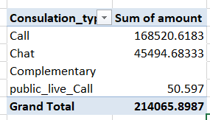

### **Based on My Complete Analysis:**

* **Calls** are the primary revenue driver, with **chats** contributing significantly.
* **Agent-level information** is incomplete, so **tracking performance** is crucial.
* There's **no data on customer wait time**, which is an opportunity for improvement.
* Some agents **underperform**, suggesting a need for **structured training & evaluation**.

**Investment Allocation Strategy:**

* 1. **Technology & Application Upgrades (₹40 lakhs)**
* Improve call quality, reduce technical issues.
* Upgrade user interface for chat to make it more engaging.
* Integrate call tracking, wait time monitoring, and performance dashboards.
  1. **Agent Monitoring & Analytics Tools (₹15 lakhs)**
* Track real-time performance, wait time, resolution rate, and call quality.
* Use analytics to identify top and low performers.
  1. **Agent Training & Quality Programs (₹20 lakhs)**
  + Train new and underperforming agents on communication, product knowledge, and FCR.
  + Introduce monthly performance reviews to ensure training ROI.
  1. **Hiring Additional Agents (₹15 lakhs)**
* Onboard skilled agents to manage peak-hour traffic and reduce waiting time.
* Prioritize agents with prior experience in customer handling.
  1. **Chat System Enhancement (₹10 lakhs)**
* Make chat features more responsive, personalized, and multilingual.
* 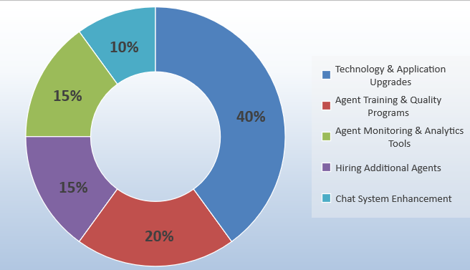Automate FAQs via chatbots to reduce manual load.

**Reference:** This analysis is provided on sheet name “pivot_2”