Project Handover Documentation
Chronicle (blogs-app)
This document serves as a complete technical handover for the Chronicle (blogs-app) project. Its purpose is to ensure that any developer can understand, run, modify, and deploy the application without needing to contact the original developer.

1. Project Overview
Project Name: Chronicle (Blogs Application)
Repository: https://github.com/aiotac/blogs-app
Description: A modern, themeable blogging platform designed for thoughtful writing and reading. It features a clean editorial UI with a dual-accent (light/dark) theme, user authentication, post management with categories, and a focus on a premium reading experience. Built with Laravel and styled with Tailwind CSS.

Key Technologies
- Backend: Laravel (PHP)
- Frontend: Blade Templates, Tailwind CSS, Alpine.js
- Database: MySQL (managed as a Railway MySQL service, connected via a mysql-volume)
- Key Libraries: HTMX (dynamic search), Google Fonts (Poppins & Work Sans)

2. Complete Project Status

✅ What is Completed
- Core UI/UX: fully responsive layout with sticky header, mobile menu, and the chronicle brand theme with dark/light mode toggle.
- Theme system: robust CSS variable system (data-theme) powers light (white-purple) and dark modes (black-blue)
- User authentication: full login, registration, and profile management.
- Post management: full CRUD for posts and categories, including list and detail views, is functional.
- Search: integrated HTMX-powered dynamic suggestion results.
- Navigation: categories and posts navigable through header and footer.
- Newsletter: functional subscription form present in the footer.
- Admin Dashboard: full CRUD functionality for posts and categories is implemented and integrated.
- User Features: "Saved Posts" and "Reading History" are fully functional, with backend logic and database tables in place — see Section 9 for exact locations.
- Deployment: the application is deployed to production on Railway, with the blogproject service and a linked MySQL database both online, and environment configuration complete.
- CI/CD pipeline: automated build/deployment pipeline is set up and passing.

🐞 Known Bugs & Issues
- The accent color inconsistency between light and dark themes has been resolved and standardized to purple-blue across the app.

📋 Project Status Summary
All planned work for this handover is complete: core features, admin dashboard, user features (Saved Posts / Reading History), deployment, and CI/CD are all finished and verified. No further development items remain open at the time of handover except for email configuration due security concerns.

3. Detailed Technical Handover

A. Complete Project Structure
blogs-app/
├── app/
│ ├── Http/
│ │ ├── Controllers/ # Application logic (PostController, AuthController)
│ │ └── Requests/ # Form validation rules
│ ├── Models/ # Eloquent models (User, Post, Category)
│ └── Providers/ # Service providers
├── config/ # App configuration (database, mail, etc.)
├── database/
│ ├── migrations/ # DB schema files
│ └── seeders/ # Dummy data for testing
├── public/ # Publicly accessible assets
├── resources/
│ ├── css/ # Tailwind directives, custom styles
│ ├── js/ # Theme toggle, mobile menu, etc.
│ └── views/ # Blade templates
│ ├── components/ # Header, footer, cards
│ ├── layouts/ # Master layout templates
│ ├── posts/ # Post pages (index, show, create)
│ └── auth/ # Login and registration
├── routes/
│ ├── web.php # Web routes
│ └── api.php # API routes (if applicable)
├── storage/ # Logs, compiled views, uploads
├── .env.example
├── composer.json # PHP dependencies
├── package.json # Node dependencies (Tailwind, Vite)
└── README.md

B. Key File Explanations
File Path | Purpose & Responsibilities | Connections
resources/views/layouts/app.blade.php | Master layout: HTML skeleton, meta tags, fonts, global header/footer include. | Uses @yield('content'); includes @vite for CSS/JS bundling.
resources/views/components/header.blade.php | Sticky nav bar: logo, search form, theme toggle, user dropdown. | Works with app.js for mobile menu + theme toggle; reads auth()->user().
resources/views/posts/index.blade.php | Homepage: paginated list of posts. | Extends layouts/app.blade.php; loops posts via a post-card component.
public/css/app.css / resources/js/app.js | Compiled assets: Tailwind utilities, theme CSS variables, and client-side interaction logic. | Built via Laravel Vite.
app/Models/Post.php | Post model: table structure and relationships (belongsTo User, belongsToMany Category). | Used by PostController to fetch/manipulate post data.
app/Http/Controllers/PostController.php | Post controller: index(), show(), store() methods. | Returns views with data, e.g. view('posts.index', [...]).
routes/web.php | Defines all web routes the app responds to. | Maps URLs to controller methods.

C. How to Continue / Modify the Project
1. Setup & Run Locally
- Clone: git clone https://github.com/aiotac/blogs-app.git
- Install PHP dependencies: composer install
- Install Node dependencies: npm install
- Copy environment file: cp .env.example .env
- Generate app key: php artisan key:generate
- Configure the database in .env
- Run migrations: php artisan migrate
- (Optional) Seed dummy data: php artisan db:seed
- Start dev servers: npm run dev and php artisan serve
2. Making Changes (Frontend)
- UI/Theme: edit resources/views (Blade) or public/css/app.css for global styles.
- New page: create a view in resources/views, then register a route in routes/web.php.
- Theme colors: update CSS variables in app.blade.php's <style> block or main CSS — :root for light mode, [data-theme="dark"] for dark mode.
3. Making Changes (Backend)
- New feature: php artisan make:model Feature -m, then define the schema in the migration.
- New controller: php artisan make:controller FeatureController --resource
- Database testing: php artisan tinker
4. Testing & Deployment
- Testing: php artisan test
- Deployment: see Section 4 below.

4. Environment Setup & Deployment

Environment Requirements
- PHP ^8.1
- Composer
- Node.js & NPM
- A supported database (MySQL 5.7+, PostgreSQL, SQLite)

Required Environment Variables (.env)
APP_NAME=Chronicle
APP_ENV=local
APP_KEY= # generated by php artisan key:generate
DB_CONNECTION=mysql
DB_HOST=127.0.0.1
DB_PORT=3306
DB_DATABASE=your_database_name
DB_USERNAME=your_database_username
DB_PASSWORD=your_database_password

Deployment Instructions (Railway)
The application is hosted on Railway, under the beautiful-acceptance project in the production environment. Deployment is managed through two linked services:
- blogproject — the app service, deployed from the GitHub repo VishaHameed1/blogproject, currently Online.
- MySQL — the managed database service, backed by a mysql-volume for persistent storage, currently Online.
To deploy or update the live application:
- Push changes to the connected branch of VishaHameed1/blogproject on GitHub; Railway auto-deploys from Source Repo in Settings → Source.
- In the Railway dashboard, open the blogproject service → Variables to set/update environment variables (APP_KEY, DB_* credentials, etc.) — Railway injects these at build/runtime rather than relying on a committed .env file.
- Confirm the MySQL service connection details (host, port, database, user, password) are referenced correctly in the app's environment variables — Railway auto-provisions these when the services are linked.
- Use the Deployments tab to watch build/deploy logs and confirm a successful rollout; use Console for one-off commands (e.g. running migrations: php artisan migrate --force).
- Use Settings → Networking to manage the public domain, and Settings → Build/Deploy to adjust build commands, start commands, or root directory if needed.
- Backups for the MySQL service can be configured under the MySQL service's Backups tab.

External Services / Integrations
- Railway: hosts both the application service (blogproject) and the MySQL database service, linked within the same production environment.
- GitHub: source repo VishaHameed1/blogproject is connected to Railway for auto-deploy on push.
- Google Fonts: loads the Poppins and Work Sans typefaces.
- (List any other APIs — e.g. email service for the newsletter.)

5. Feature Locations & Technical Clarifications
The following was confirmed directly from the VishaHameed1/blogproject source code.

Saved Posts
- Table: post_user_bookmark (user_id, post_id, timestamps) — migration create_post_user_bookmark_table.
- Controller: UserActivityController — savedPosts() lists a user's bookmarked posts; toggleBookmark(Post $post) adds/removes one.
- Model relation: User::bookmarks() (many-to-many with Post).
- Routes: GET /saved-posts (users.saved), POST /posts/{post}/bookmark (users.bookmark.toggle).
- View: resources/views/users/saved.blade.php.
- Note: a second route, POST /saved-posts (users.saved.store) → UserProfileController@toggleSave, also exists and should be reviewed against the UserActivityController version to confirm which is the active/current implementation.

Reading History
- Table: post_user_history (user_id, post_id, viewed_at, timestamps) — migrations create_post_user_history_table and add_viewed_at_to_post_user_history_table.
- Controller: UserActivityController — history() lists a user's reading history; clearHistory() detaches all history records.
- Model relation: User::readHistory() (many-to-many with Post).
- Routes: GET /history (users.history), DELETE /history/clear (users.history.clear).
- View: resources/views/users/history.blade.php.

Search
- Route: GET /search/suggestions (posts.suggestions) → PostController@suggestions.
- Implementation: matches post titles and category names by partial text (LIKE query), returning the 5 latest matching posts and 4 matching categories.
- Delivery: when called via HTMX (HX-Request header), returns the posts.partials.search-dropdown view fragment; otherwise returns JSON.
- Laravel Scout is installed (driver: database in the current .env) but the live suggestions endpoint uses a direct LIKE query rather than a Scout-indexed search — worth confirming whether Scout is used elsewhere or reserved for future use.

Profile Management
- Controller: UserProfileController — index(), edit(), update(), updatePassword().
- Routes: GET /profile (profile.index), GET /profile/edit (profile.edit), PATCH /profile (profile.update), PUT /profile/password (profile.password.update).
- A separate Author\ProfileController and the base ProfileController (from Laravel Breeze scaffolding) also exist — UserProfileController is the one wired to the routes above for regular users.

Newsletter
- Controller: NewsletterController; Model: Subscriber.
- Status: the subscription form is live on the frontend and stores subscribers, but outgoing email is not yet fully configured — MAIL_MAILER is set to log by default and no mail app-password/credentials have been added, so confirmation/notification emails are not currently being sent.

Theme System — Colors
- resources/css/app.css defines a fixed two-accent system used in both themes: primary #7C3AED (purple), secondary #3B82F6 (blue) — changes between light and dark mode in this file.
- resources/views/layouts/app.blade.php defines its own :root / [data-theme="dark"] block where --color-primary switches from #7C3AED (light) to #3B82F6 (dark).
- These two definitions currently differ: app.css keeps purple as the constant primary accent with blue as a secondary accent in both modes, while app.blade.php's inline styles swap the primary accent itself from purple to blue in dark mode. This is the source of the accent inconsistency flagged in review — the two files should be reconciled to a single source of truth.

External APIs / Services
- No third-party API integrations (payments, analytics, maps, etc.) are present in composer.json or .env.example.
- Mail: standard Laravel mail config (MAIL_MAILER=log by default) — used for the newsletter/contact form; not yet pointed at a real SMTP/app-password (see Newsletter above).
- Optional AWS S3 support is included via league/flysystem-aws-s3-v3, but no AWS credentials are set — the app currently uses local file storage.
- Laravel Sanctum and Spatie Laravel-Permission are installed for authentication/roles — internal packages, not external services.

API Routes
- Confirmed: there is no routes/api.php in use — only auth.php, console.php, and web.php exist. The application does not currently expose a separate API.

Uncommitted Changes
- Confirmed by the project owner: no uncommitted changes remain; the main branch of VishaHameed1/blogproject is the final, current version.

6. Deployment Status
- VishaHameed1/blogproject: deployed and live on Railway at https://blogproject-production-67f2.up.railway.app/posts.
- aiotac/blogs-app: not yet deployed. This repository belongs to the organization's account, so deployment requires either (a) the organization owner/an admin performing the Railway deployment setup from their own account, or (b) the owner granting full repository permissions so deployment can be linked directly to aiotac/blogs-app instead of the personal fork.

7. Railway Storage Link & Image Debugging Commands
The following commands were run in the Railway production console for the blogproject service, to link Laravel's storage directory and investigate a missing image file. They are reproduced exactly as shown in the console.
root@ef4acb2910dd:/app# ln -s /app/storage/app/public /app/public/storage
root@ef4acb2910dd:/app# chmod -R 755 storage/app/public
root@ef4acb2910dd:/app# chmod -R 755 public/storage
root@ef4acb2910dd:/app# ls -la public/storage
lrwxrwxrwx 1 root root 23 Sep 9 13:28 public/storage -> /app/storage/app/public
Purpose: the ln -s command links Laravel's public storage directory so uploaded files (e.g. category images) are served correctly; the chmod commands set readable/executable permissions; ls -la confirms the symbolic link was created correctly. The final cat command was a debugging check for a specific missing category image and confirms that file does not exist on the server's storage — the image referenced in the database was never actually uploaded/persisted to this volume, which is a follow-up item to investigate (e.g. re-upload the missing image or check why the upload didn't persist).
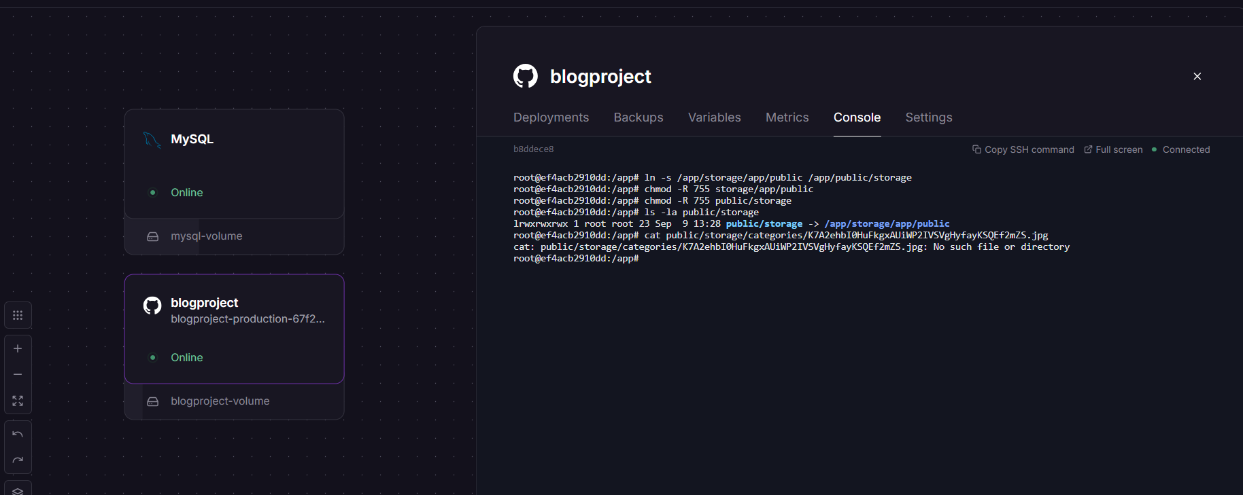
Figure 1. Railway blogproject production console showing the storage-link and debugging commands, alongside the linked MySQL and blogproject services.

8. Railway Production Infrastructure
- Application service: blogproject — the Laravel production application running on Railway.
- Application persistent volume: blogproject-volume — attached to the blogproject service for persistent application/storage data.
- Database service: MySQL — the production MySQL service running on Railway.
- Database persistent volume: mysql-volume — attached to the MySQL service for persistent database data.
- Production configuration is supplied entirely through Railway environment variables (Settings → Variables), not a committed .env file.
- The storage symlink described in Section 7 is set up inside the Railway application container itself, since each deploy runs in a fresh container.

9. Database Location in Project Structure
The database-related files live under the database/ directory in the project repository:
database/factories/ # Model factories for generating test data
database/migrations/ # Table structure definitions (schema, columns, relationships)
database/seeders/ # Seed data (e.g. default admin user, categories)
database/database.sql # Full SQL dump of the database structure
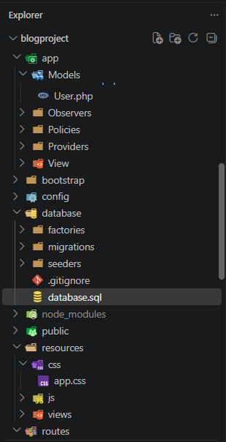
Figure 2. Project explorer showing the database/ directory — migrations, seeders, factories, and database.sql.
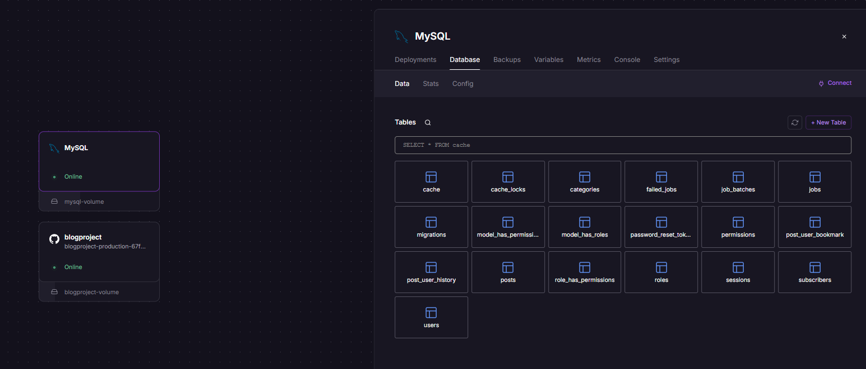
Note: the live MySQL data itself runs as the separate MySQL service on Railway (Section 8). The database/ folder shown here is the Laravel project's schema definition and SQL dump kept in source control — it defines the table/column structure .

10. Administrator Login Credentials
The following administrator credentials are provided for accessing the application's admin area:
- Email: admin@example.com
- Password: admin123
Security note: these are seeded/default credentials for this handover only. Change the password immediately before any real production use, or as soon as the credentials are shared with a new developer.

11. Required Handover Information
To complete the handover, the following items are required:
✅ Complete source code (all local files, including any uncommitted changes)
✅ This technical documentation
✅ Final project status summary
✅ Local copy of all assets (images, fonts, etc.) used in the project
✅ Any task/meeting notes or additional documentation related to the project

Final Package & Conclusion
This handover package contains the complete source code and all supporting documentation — a self-contained set that allows any future developer to pick up the project with no further onboarding needed.
Core Message: The project is complete. All core features, the admin dashboard, user features, deployment, and CI/CD are finished, verified, and live. The handover is ready to close out.

