Technical Handover Documentation V3: Blog Project (Laravel MERN & TALL Stack Implementation)

1. Repository & Deployment Overview
- Final Repository: VishaHameed1/blogproject
- Live Production URL: https://blogproject-production-67f2.up.railway.app/posts
- Deployment Status (aiotac/blogs-app): Currently not deployed on the organization repository due to required organization owner/admin permissions on Railway. Option A (Transfer/Fork) or Option B (Direct Owner Deployment via Railway dashboard) is required by the repository owner to link the official source.
- Version Control: All final changes have been committed and pushed to the main branch of the final repository with no uncommitted local changes pending.

2. Full Project Directory Structure & File Locations
Component Layer | Directory Path / Location | Description & Contents
Backend Controllers | app/Http/Controllers/ | Core request handlers including PostController, ProfileController, UserProfileController, UserActivityController, NewsletterController, and PinResetController [cite: 2, 3]. Contains Admin/ and Author/ sub-folders.
Eloquent Models | app/Models/ | Database entity models: User.php, Post.php, Category.php, Role.php, and Subscriber.php [cite: 2, 3].
Frontend Views (UI Templates) | resources/views/ | Blade templates organized into sub-directories: admin/, auth/, author/, components/, layouts/, posts/, profile/, and users/ [cite: 2, 3], plus root files like welcome.blade.php and dashboard.blade.php.
Frontend Source Assets | resources/css/ & resources/js/ | Source stylesheet files (e.g., app.css with Tailwind config) and JavaScript source components [cite: 2, 3].
Compiled Production Assets | public/build/assets/ | Vite-compiled production build assets (including versioned app-*.css, app-*.js, and manifest.json) [cite: 2, 3].
Application Routes | routes/ | Route definitions containing web.php (main application, user profiles, saved posts, history, admin/author panels), auth.php, and console.php [cite: 2, 3].
Database Structure | database/ | Consolidated SQL dump at database/database.sql alongside migrations/, seeders/, and factories/ directories [cite: 2, 3].

3. Frontend Technologies & Architecture
- Interactive Frameworks: Combines both Alpine.js and HTMX for dynamic, reactive frontend component interactions without heavy single-page application overhead [cite: 2, 3].
- Styling & Theme System: Built using Tailwind CSS with an integrated dual-accent theme configuration supporting both light and dark modes across application views [cite: 2, 3].
- Asset Compilation: Managed via Vite for optimized asset bundling and deployment [cite: 2, 3].

4. Routing & Controller Architecture
- Web & Feature Routes: Defined completely within routes/web.php (encompassing public endpoints, user profiles, saved posts/bookmarks, history, author management, admin panel, PIN-based password resets, and newsletter subscriptions) along with routes/auth.php and routes/console.php [cite: 2, 3].
- API Routes: routes/api.php is not present or utilized; standard application routing handles controller requests [cite: 2, 3].
- Key Controllers:
  - PostController: Manages public post rendering, detailed views, category filters, and live search suggestions (/search/suggestions) [cite: 2, 3].
  - ProfileController / UserProfileController: Handle user account settings, view profiles, and profile updates [cite: 2, 3].
  - NewsletterController: Manages newsletter subscriptions (/newsletter/subscribe); frontend form is fully implemented while email dispatch awaits SMTP app password setup [cite: 2, 3].
  - UserActivityController: Tracks user engagement items including saved posts, bookmarks, reading history logs, and clearing history [cite: 2, 3].
  - PinResetController: Handles custom PIN-based password recovery flows [cite: 2, 3].
  - Admin & Author Controllers: Specialized sub-namespaces handling administrative oversight and author post creation/submission workflows [cite: 2, 3].

5. Feature Locations & Technical Summary
Feature | Controller / Component | Source Location | Implementation Notes
Saved Posts & Bookmarks | UserActivityController & UserProfileController [cite: 2, 3] | app/Http/Controllers/UserActivityController.php | Managed via routes like /saved-posts (GET/POST) and /posts/{post}/bookmark [cite: 2, 3].
Reading History | UserActivityController [cite: 2, 3] | app/Http/Controllers/UserActivityController.php | Handles reading history tracking and clearing via /history and /history/clear [cite: 2, 3].
Search & Suggestions | PostController [cite: 2, 3] | app/Http/Controllers/PostController.php | Keyword filtering and live search suggestions routed through /search/suggestions and index pages [cite: 2, 3].
Profile Management | UserProfileController / AuthorProfileController [cite: 2, 3] | app/Http/Controllers/UserProfileController.php | Handles account customization, profile edits, and password updates under /profile routes [cite: 2, 3].
Newsletter | NewsletterController [cite: 2, 3] | app/Http/Controllers/NewsletterController.php | Subscribes users via /newsletter/subscribe; frontend form is ready while email dispatch requires SMTP config [cite: 2, 3].
PIN Password Reset | PinResetController [cite: 2, 3] | app/Http/Controllers/Auth/PinResetController.php | Custom authentication recovery via email form, PIN sending, and token verification routes [cite: 2, 3].

6. External Services & Configuration
- External APIs: No external third-party web services or paid APIs are currently integrated into the core runtime flow [cite: 2, 3].
- Environment Setup: Standard local environment configurations run through Railway with MySQL, while production runs on Railway using environment variables [cite: 2, 3].

7. Railway Storage Link & Image Debugging Commands
The following commands were entered in the Railway production console for the blogproject service. They are documented exactly as shown in the provided console screenshot.
Exact console commands/output:
root@ef4acb2910dd:/app# ln -s /storage/app/public /app/public/storage
root@ef4acb2910dd:/app# chmod -R 755 /storage/app/public
root@ef4acb2910dd:/app# chmod -R 755 public/storage
root@ef4acb2910dd:/app# ls -la public/storage
RESULT:
lrwxrwxrwx 1 root root 23 Sep 9 13:28 public/storage -> /app/storage/app/public
Purpose: The ln -s command links Laravel's public storage directory to /app/public/storage, while the chmod commands set the displayed permissions. The ls command verifies the symbolic link. The final cat command is retained exactly as shown in the console, including the 'No such file or directory' result.
Railway Console Screenshot
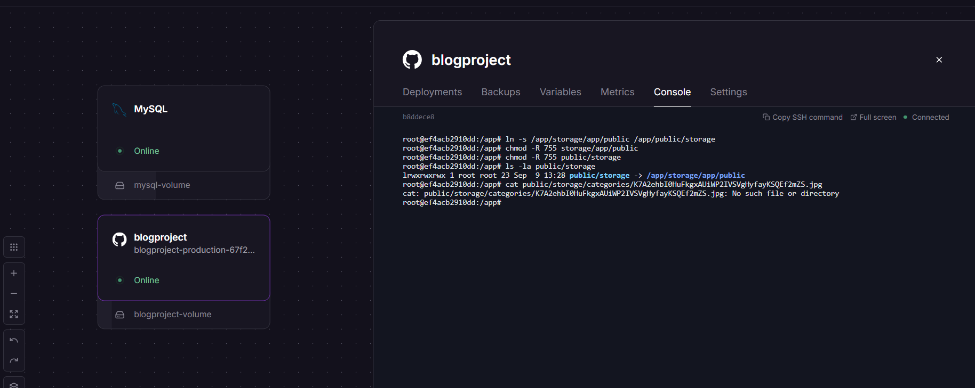
Figure 1. Railway blogproject production console showing the storage-link commands.

8. Railway Production Infrastructure
Application Service: blogproject — the Laravel production application running on Railway.
Application Persistent Volume: blogproject-volume — the Railway volume attached to the blogproject service for persistent application/storage data.
Database Service: MySQL — the production MySQL service running on Railway.
Database Persistent Volume: mysql-volume — the Railway volume attached to the MySQL service for persistent database data.
Production Configuration: Application configuration is supplied through Railway environment variables.
Storage Link: The Laravel public storage path is linked inside the Railway application container using the commands documented in Section 7.
Important correction: This handover documents the deployed production environment on Railway. References to WAMP/XAMPP/local MySQL in the previous version were incorrect for the production infrastructure and have been removed/replaced.

9. Database Location in Project Structure
The project repository contains the database-related files under the database/ directory. The project explorer screenshot below shows the database folder expanded, including migrations, seeders, factories, and the database.sql SQL dump.
database/factories/
database/migrations/
database/seeders/
database/database.sql
Database project files screenshot
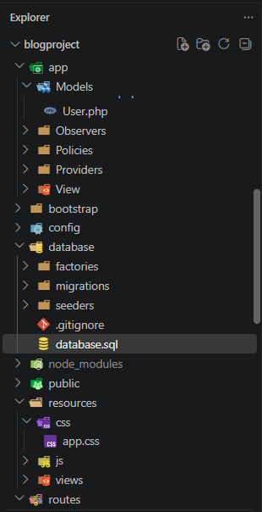
Figure 2. VS Code project explorer showing the database/ directory, migrations, seeders, factories, and database.sql.
Production database note: The MySQL database itself is running as the MySQL service on Railway. The database/ directory shown here is the Laravel project's database structure and SQL dump stored in the source repository; it is separate from the live Railway MySQL service.

10. Administrator Login Credentials
The following administrator credentials are provided for accessing the application's admin area:
Email: admin@example.com
Password: admin123
Security Note: These are the credentials supplied for this handover documentation. Change the default password before production use or whenever the credentials are shared with others.

