SkyRoute
Schema Design & DDL

Project: SkyRoute — Aviation Flight Recommendation System (Track B) DBMS: PostgreSQL 14+
Name: AlaguVishaalBalaji | Roll No: ZDA24B036 | April 2026

1. Design Philosophy
This is a Track B project — an AI-powered flight recommendation system built on top of a fully normalised relational database. The database is the core of the system, not an afterthought. Every design decision — from separating flight_price out of flight, to using two foreign keys on city from flight — was made to keep the schema clean, avoid redundancy, and make the recommendation queries simpler to write.

# | Table | Feature it realizes
1 | users | Registered travellers on the platform
2 | city | All origin and destination cities (IATA codes)
3 | airline | Airline identity and hub information
4 | flight | Scheduled routes operated by airlines
5 | flight_price | Cabin-class pricing per flight per date
6 | booking | Transactional core — 2000+ rows from dataset

2. ER Diagram
The diagram below shows all six entities, their attributes, primary keys (PK), foreign keys (FK), and the cardinality of every relationship. city appears twice as a source for flight — once for origin (maroon line) and once for destination (gold line).

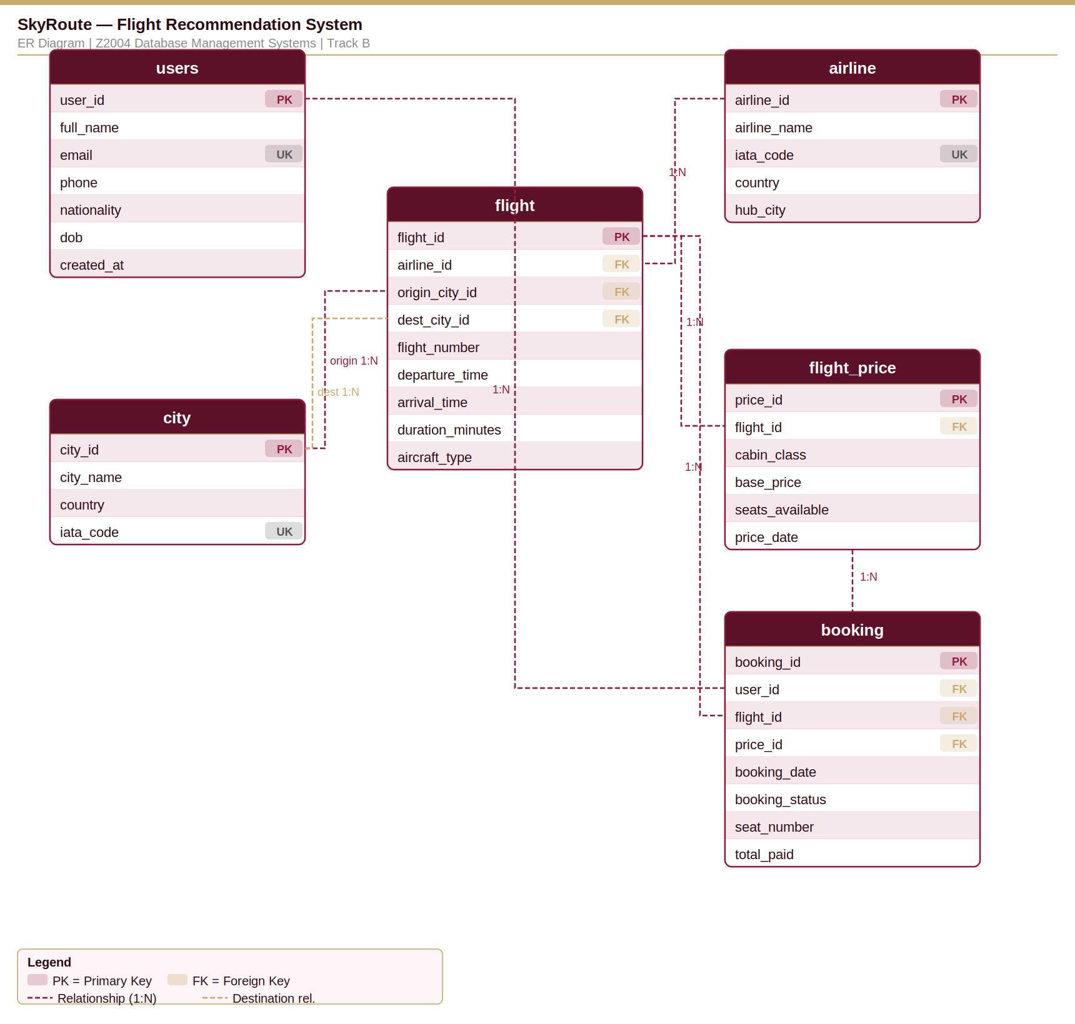

Cardinalities Justified
Relationship | Cardinality | Why
users → booking | 1 : N | A user can make many bookings; each booking belongs to one user.
flight → booking | 1 : N | A flight can appear in many bookings; each booking is for one flight.
flight_price → booking | 1 : N | A price record can be used in many bookings.
airline → flight | 1 : N | An airline operates many flights; each flight has one airline.
city → flight (origin) | 1 : N | A city can be the origin of many flights.
city → flight (destination) | 1 : N | A city can be the destination of many flights.
flight → flight_price | 1 : N | A flight has many prices (cabin class x date).

3. 3NF Justification
A relation is in 3NF if, for every non-trivial functional dependency X → A, either X is a superkey or A is a prime attribute. In plain terms: no attribute should depend on another non-key attribute.

Functional dependencies, table by table
Table | 3NF Argument
users | PK is user_id. All attributes depend directly on user_id. email is an alternate key; no other non-key attribute depends on it. Satisfies 3NF.
city | PK is city_id. city_name, country, iata_code all depend solely on city_id. Trivially in 3NF.
airline | PK is airline_id. All attributes depend directly on airline_id. hub_city is stored as text to avoid circular dependency at insert time. Satisfies 3NF.
flight | PK is flight_id. origin_city_id and destination_city_id are FKs — no city attributes are copied here, so there is no transitive dependency. duration_minutes belongs to this route, not the airline alone. Satisfies 3NF.
flight_price | PK is price_id. base_price and seats_available depend on (flight_id, cabin_class, price_date) — a property of this specific pricing event, not of the flight alone. Separating price from flight avoids a partial dependency. Satisfies 3NF.
booking | PK is booking_id. All attributes are either FKs (user_id, flight_id, price_id) or properties of the booking event. No flight or user attributes are duplicated here. Satisfies 3NF.

Decomposition Notes
Two decisions required deliberate decomposition:

1. flight_price separated from flight. A naive design might add a price column onto the flight table. This would break 3NF immediately: price depends on (flight, cabin_class, date), not on flight_id alone — a partial dependency. Separating it into flight_price with a composite unique key on (flight_id, cabin_class, price_date) resolves this cleanly.

2. city used twice in flight. Rather than creating two separate tables, we reuse city with two foreign keys. This avoids duplicating city data and makes queries like "find all flights from Dar es Salaam" straightforward with a simple WHERE filter on origin_city_id.

4. Constraint Summary
Constraint type | Where applied | Purpose
PRIMARY KEY | Every table | Unique row identity on all six tables.
FOREIGN KEY | booking, flight, flight_price | booking references users, flight, and flight_price; flight references airline and city (twice).
UNIQUE | users.email, airline.iata_code, city.iata_code, flight(airline_id, flight_number), flight_price(flight_id, cabin_class, price_date) | Alternate keys and business rules.
CHECK (duration_minutes > 0) | flight | A flight must have a positive duration.
CHECK (origin_city_id <> destination_city_id) | flight | A flight cannot depart and land at the same city.
CHECK (cabin_class IN (...)) | flight_price | Only Economy, Business, First accepted.
CHECK (base_price >= 0) | flight_price | Prices cannot be negative.
CHECK (total_paid >= 0) | booking | Payment amount cannot be negative.
CHECK (booking_status IN (...)) | booking | Status limited to Confirmed / Cancelled / Pending / Completed.
ON DELETE CASCADE | flight_price → flight | Removing a flight removes its price records.
DEFAULT NOW() | users.created_at, booking.booking_date, flight_price.price_date | Timestamps auto-populated on insert.

5. How to Run
The DDL script is idempotent — it drops all tables in FK-safe order before recreating them, so it can be run multiple times during development without errors.

createdb skyroute then: psql -d skyroute -f schema.sql

No manual edits required. All six tables are created with full constraints. Data and queries will be added in Milestone 2.

6. Feature → Schema Map (Quick Reference)
Feature | Where it lives
Recommendation engine input | booking — user_id + flight_id patterns
Collaborative filtering data | booking rows grouped by user_id and route
Price comparison across cabins | flight_price with cabin_class column
Route lookup (origin → destination) | flight with two FKs to city
Airline-level filtering | airline table, joined to flight on airline_id
Window function queries (M2) | booking — RANK/ROW_NUMBER OVER PARTITION BY user_id
Index benchmarking (M3) | idx on booking(user_id), flight(route), flight_price(flight_id)
Trigger / stored procedure (M3) | AFTER INSERT ON booking to update recommendation scores

