EXPERIMENT-05
K-Nearest Neighbours (K-NN): Dataset-Based Python Programs
Name: Vishaal G Reg.No: 1921260043
- Write a program for Implementation of K-Nearest Neighbours (K-NN) in Python

Problem 1: Flower Classification

Aim
To implement the K-Nearest Neighbours algorithm on a flower dataset stored in a CSV file and classify a new flower sample using k = 3.

Procedure
- Save the training examples in flower_data.csv with the class label in the last column.
- Run the Python program from the same folder as the CSV file.
- Read the CSV file and choose the value of k and the new sample to be classified.
- Calculate the Euclidean distance between the new sample and every training sample.
- Select the k training samples with the smallest distances.
- Assign the class that occurs most often among the k neighbours and print it.

Dataset File / Input
File name: flower_data.csv
The CSV file contains a header row followed by these training examples:
PetalLength | PetalWidth | Species
1.4 | 0.2 | Setosa
1.3 | 0.2 | Setosa
1.5 | 0.2 | Setosa
1.7 | 0.4 | Setosa
1.4 | 0.3 | Setosa
4.7 | 1.4 | Versicolor
4.5 | 1.5 | Versicolor
4.9 | 1.5 | Versicolor
4.0 | 1.3 | Versicolor
4.6 | 1.5 | Versicolor
6.0 | 2.5 | Virginica
5.1 | 1.9 | Virginica
5.9 | 2.1 | Virginica
5.6 | 1.8 | Virginica
6.1 | 2.3 | Virginica

Code
import numpy as np
import pandas as pd
from collections import Counter

df = pd.read_csv("flower_data.csv")
X = df.iloc[:, :-1].values.astype(float)
y = df.iloc[:, -1].values

new = np.array([5.7, 2.0]) # new sample to classify
k = 3

dist = np.sqrt(((X - new) ** 2).sum(axis=1)) # Euclidean distance
nearest = dist.argsort()[:k] # indices of k nearest neighbours

print("New sample:", new)
for i in nearest:
print("Neighbour:", X[i], "Class:", y[i], "Distance:", round(dist[i], 2))
print("Predicted class:", Counter(y[nearest]).most_common(1)[0][0])

Output
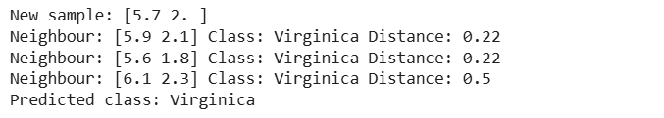

Result
The new sample (PetalLength = 5.7, PetalWidth = 2.0) has its three nearest neighbours at distances 0.22, 0.22 and 0.5, and all three are Virginica. The predicted class is Virginica.

Problem 2: Student Result

Aim
To classify a new student as Pass or Fail from Maths and Science marks using K-NN (k = 3) on a dataset stored in a CSV file.

Procedure
- Save the training examples in student_data.csv with the class label in the last column.
- Run the Python program from the same folder as the CSV file.
- Read the CSV file and choose the value of k and the new sample to be classified.
- Calculate the Euclidean distance between the new sample and every training sample.
- Select the k training samples with the smallest distances.
- Assign the class that occurs most often among the k neighbours and print it.

Dataset File / Input
File name: student_data.csv
The CSV file contains a header row followed by these training examples:
MathsMarks | ScienceMarks | Result
85 | 80 | Pass
78 | 82 | Pass
90 | 88 | Pass
70 | 75 | Pass
65 | 72 | Pass
80 | 68 | Pass
35 | 40 | Fail
42 | 38 | Fail
30 | 45 | Fail
48 | 35 | Fail
38 | 50 | Fail
45 | 42 | Fail

Code
import numpy as np
import pandas as pd
from collections import Counter

df = pd.read_csv("student_data.csv")
X = df.iloc[:, :-1].values.astype(float)
y = df.iloc[:, -1].values

new = np.array([50, 45]) # new sample to classify
k = 3

dist = np.sqrt(((X - new) ** 2).sum(axis=1)) # Euclidean distance
nearest = dist.argsort()[:k] # indices of k nearest neighbours

print("New sample:", new)
for i in nearest:
print("Neighbour:", X[i], "Class:", y[i], "Distance:", round(dist[i], 2))
print("Predicted class:", Counter(y[nearest]).most_common(1)[0][0])

Output
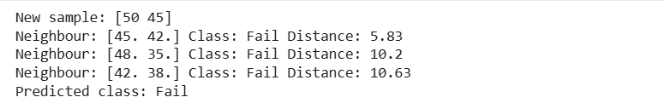

Result
The new sample (Maths = 50, Science = 45) has three Fail neighbours at distances 5.83, 10.2 and 10.63. The predicted class is Fail.

Problem 3: Customer Segment

Aim
To assign a new customer to the Premium or Budget segment from age and spending score using K-NN (k = 3) on a dataset stored in a CSV file.

Procedure
- Save the training examples in customer_data.csv with the class label in the last column.
- Run the Python program from the same folder as the CSV file.
- Read the CSV file and choose the value of k and the new sample to be classified.
- Calculate the Euclidean distance between the new sample and every training sample.
- Select the k training samples with the smallest distances.
- Assign the class that occurs most often among the k neighbours and print it.

Dataset File / Input
File name: customer_data.csv
The CSV file contains a header row followed by these training examples:
Age | SpendingScore | Segment
22 | 85 | Premium
25 | 78 | Premium
30 | 90 | Premium
28 | 72 | Premium
35 | 80 | Premium
24 | 92 | Premium
45 | 20 | Budget
52 | 15 | Budget
48 | 30 | Budget
58 | 10 | Budget
40 | 25 | Budget
50 | 35 | Budget

Code
import numpy as np
import pandas as pd
from collections import Counter

df = pd.read_csv("customer_data.csv")
X = df.iloc[:, :-1].values.astype(float)
y = df.iloc[:, -1].values

new = np.array([32, 60]) # new sample to classify
k = 3

dist = np.sqrt(((X - new) ** 2).sum(axis=1)) # Euclidean distance
nearest = dist.argsort()[:k] # indices of k nearest neighbours

print("New sample:", new)
for i in nearest:
print("Neighbour:", X[i], "Class:", y[i], "Distance:", round(dist[i], 2))
print("Predicted class:", Counter(y[nearest]).most_common(1)[0][0])

Output
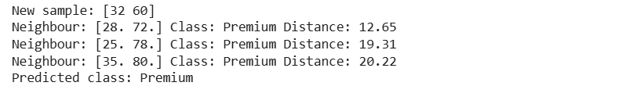

Result
The new sample (Age = 32, SpendingScore = 60) has three Premium neighbours at distances 12.65, 19.31 and 20.22. The predicted segment is Premium.

Problem 4: Rain Prediction

Aim
To predict whether it will rain from temperature and humidity using K-NN (k = 3) on a weather dataset stored in a CSV file.

Procedure
- Save the training examples in weather_data.csv with the class label in the last column.
- Run the Python program from the same folder as the CSV file.
- Read the CSV file and choose the value of k and the new sample to be classified.
- Calculate the Euclidean distance between the new sample and every training sample.
- Select the k training samples with the smallest distances.
- Assign the class that occurs most often among the k neighbours and print it.

Dataset File / Input
File name: weather_data.csv
The CSV file contains a header row followed by these training examples:
Temperature | Humidity | Rain
24 | 90 | Yes
22 | 85 | Yes
26 | 92 | Yes
21 | 88 | Yes
25 | 80 | Yes
23 | 95 | Yes
34 | 40 | No
36 | 35 | No
32 | 45 | No
38 | 30 | No
33 | 50 | No
35 | 42 | No

Code
import numpy as np
import pandas as pd
from collections import Counter

df = pd.read_csv("weather_data.csv")
X = df.iloc[:, :-1].values.astype(float)
y = df.iloc[:, -1].values

new = np.array([30, 60]) # new sample to classify
k = 3

dist = np.sqrt(((X - new) ** 2).sum(axis=1)) # Euclidean distance
nearest = dist.argsort()[:k] # indices of k nearest neighbours

print("New sample:", new)
for i in nearest:
print("Neighbour:", X[i], "Class:", y[i], "Distance:", round(dist[i], 2))
print("Predicted class:", Counter(y[nearest]).most_common(1)[0][0])

Output
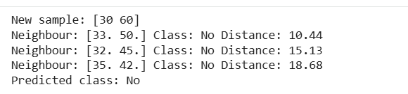

Result
The new sample (Temperature = 30, Humidity = 60) has three neighbours that all have Rain = No, at distances 10.44, 15.13 and 18.68. The predicted class is No.

Problem 5: Fruit Type

Aim
To classify a new food item as Fruit, Vegetable or Protein from its sweetness and crunchiness using K-NN (k = 3) on a dataset stored in a CSV file.

Procedure
- Save the training examples in fruit_data.csv with the class label in the last column.
- Run the Python program from the same folder as the CSV file.
- Read the CSV file and choose the value of k and the new sample to be classified.
- Calculate the Euclidean distance between the new sample and every training sample.
- Select the k training samples with the smallest distances.
- Assign the class that occurs most often among the k neighbours and print it.

Dataset File / Input
File name: fruit_data.csv
The CSV file contains a header row followed by these training examples:
Sweetness | Crunchiness | Type
10 | 9 | Fruit
10 | 1 | Fruit
7 | 3 | Fruit
8 | 5 | Fruit
9 | 2 | Fruit
7 | 10 | Vegetable
3 | 10 | Vegetable
3 | 7 | Vegetable
2 | 8 | Vegetable
4 | 9 | Vegetable
1 | 4 | Protein
1 | 1 | Protein
3 | 6 | Protein
2 | 3 | Protein
1 | 2 | Protein

Code
import numpy as np
import pandas as pd
from collections import Counter

df = pd.read_csv("fruit_data.csv")
X = df.iloc[:, :-1].values.astype(float)
y = df.iloc[:, -1].values

new = np.array([6, 4]) # new sample to classify
k = 3

dist = np.sqrt(((X - new) ** 2).sum(axis=1)) # Euclidean distance
nearest = dist.argsort()[:k] # indices of k nearest neighbours

print("New sample:", new)
for i in nearest:
print("Neighbour:", X[i], "Class:", y[i], "Distance:", round(dist[i], 2))
print("Predicted class:", Counter(y[nearest]).most_common(1)[0][0])

Output
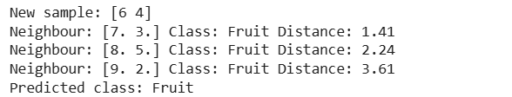

Result
The new sample (Sweetness = 6, Crunchiness = 4) has three Fruit neighbours at distances 1.41, 2.24 and 3.61. The predicted class is Fruit.

