INDEX

S.no | Context | Page.no
1 | Introduction | 2
2 | Methodologies | 3
3 | Training Dataset | 5
4 | Implementation | 7
5 | Output | 13

ABSTRACT:
Diabetes has emerged as a prevalent health concern affecting individuals across all age groups. The surge in diabetic cases can be attributed to various factors including obesity, poor dietary choices, autoimmune responses, lifestyle changes, and environmental pollutants. Consequently, early detection of diabetes is imperative to mitigate its adverse effects on human health. Data analytics, a field within computer science, offers a method to analyze extensive datasets, uncover hidden patterns, and derive conclusions. Utilizing machine learning algorithms, healthcare systems can leverage data analytics for medical diagnoses by constructing predictive models. This study proposes a diabetes prediction system aimed at early diagnosis of the condition. By employing machine learning techniques, this model facilitates the timely detection of diabetes, thereby enhancing prospects for effective intervention and management.

- Introduction
Diabetes is characterized by elevated levels of sugar (glucose) in the bloodstream. It manifests in two primary forms: type 1 and type 2 diabetes. Type 1 diabetes is an autoimmune disorder where the body's immune system attacks and destroys cells responsible for producing insulin, necessary for sugar absorption. Unlike type 2 diabetes, this form can occur irrespective of obesity. Obesity, indicated by an elevated Body Mass Index (BMI) beyond normal levels, is often associated with type 1 diabetes, particularly in adults. Conversely, type 2 diabetes predominantly affects middle-aged individuals. Diabetes poses a significant risk factor for various diseases including heart disease, stroke, kidney disease, eye disorders, dental problems, nerve damage, and foot complications. Symptoms of diabetes include excessive urination (polyuria), thirst, constant hunger, weight loss, changes in vision, and fatigue, which may occur suddenly.
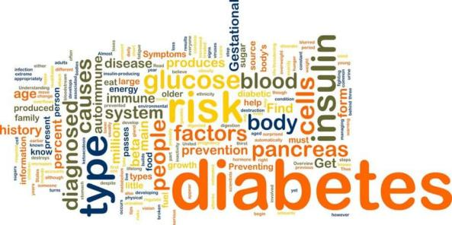
Problem Statement
There is a growing need for a user-friendly and accessible platform to predict the risk of diabetes using modern technologies like machine learning.

Software requirments:
- Python
- Anaconda
- IDE(Pycharm)
- Web Browser

Methodologies

Requirement Gathering and Analysis:
Understand the purpose and objectives of the diabetic prediction website.
Gather requirements from stakeholders, including users and healthcare professionals.
Identify the features, functionalities, and target audience of the website.

Data Collection and Preprocessing:
Acquire a dataset containing relevant health parameters and diabetes outcomes.
Preprocess the dataset to handle missing values, outliers, and inconsistencies.
Explore the dataset to understand its structure, features, and statistical characteristics.

Machine Learning Model Selection and Training:
Choose an appropriate machine learning algorithm for diabetes prediction, such as Logistic Regression, Decision Trees, or Random Forest.
Split the dataset into training and testing sets to evaluate the model's performance.
Train the machine learning model using the training dataset and evaluate its accuracy and performance using the testing dataset.

Web Development Setup:
Set up a development environment using Python, Django framework, and any necessary dependencies.
Create a project and define the structure for the diabetic prediction website.

User Interface Design:
Design the user interface (UI) for the website, focusing on simplicity, clarity, and ease of use.
Create wireframes or mockups to visualize the layout, navigation, and interactions.
Incorporate branding elements, colors, and typography to create a cohesive design.

Frontend Development:
Develop frontend components using HTML, CSS, and JavaScript.
Implement interactive features such as input forms, buttons, and result displays.
Ensure responsive design to provide a consistent experience across different devices and screen sizes.

Backend Development:
Develop backend functionalities using Django, including routing, views, and database integration.
Implement logic to handle user requests, process input data, and interact with the machine learning model.
Integrate the trained machine learning model into the backend to perform diabetes prediction.

Testing and Validation:
Test the website thoroughly to ensure all functionalities work as expected.
Validate the prediction results by comparing them with known outcomes from the dataset.
Conduct usability testing to gather feedback on the website's user experience and functionality.

Deployment:
Deploy the diabetic prediction website on a web server or cloud platform to make it accessible to users.
Configure domain name, hosting, and security settings as necessary.
Monitor the website's performance and address any issues or bugs that arise post-deployment.

DataSet
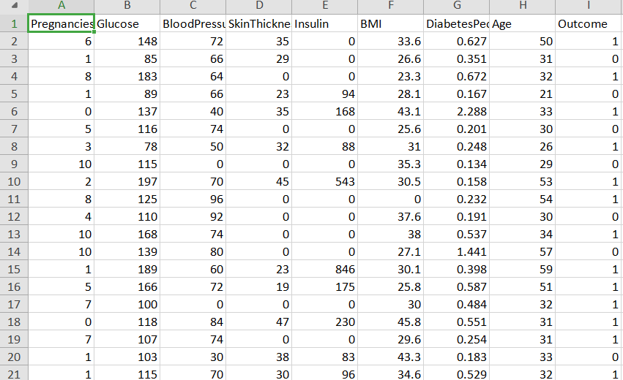

Python Libraries:
- Numpy
- Pandas
- Sklearn
- Django

- Training Model

Import libraries
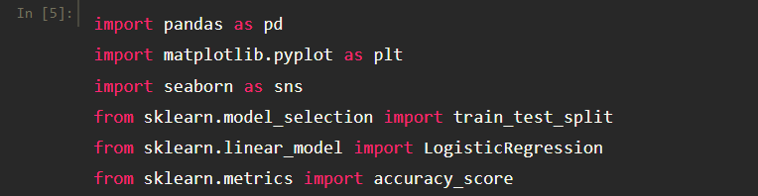

Path
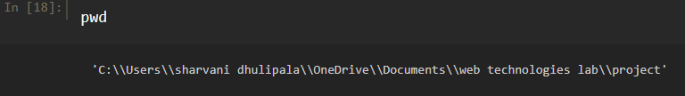
Read Dataset

HeatMap:
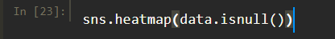

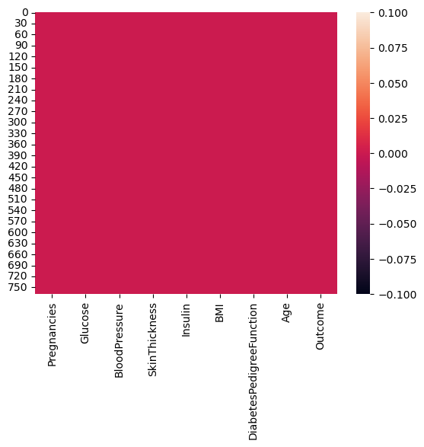
Finding correlation for data
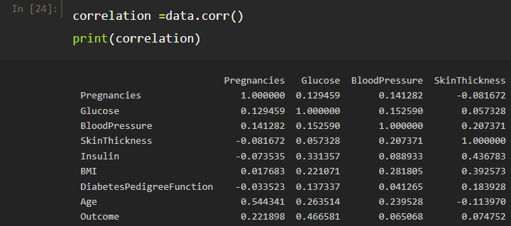

Visualisation through heatmap
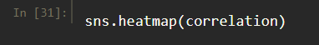

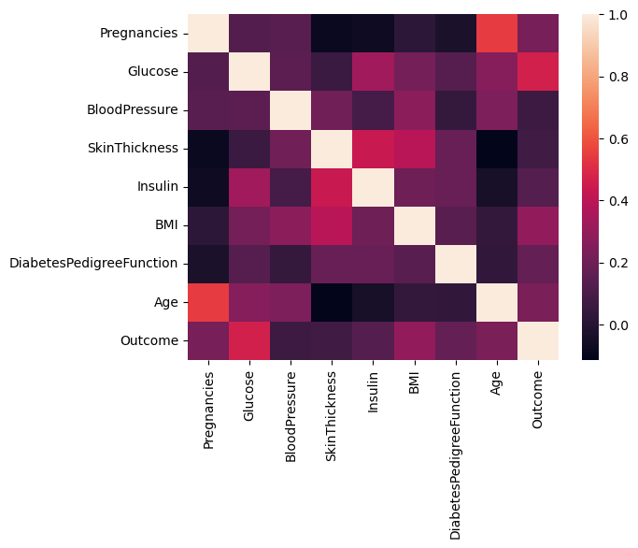

Traing and Testing Dataset(spliting dataset)

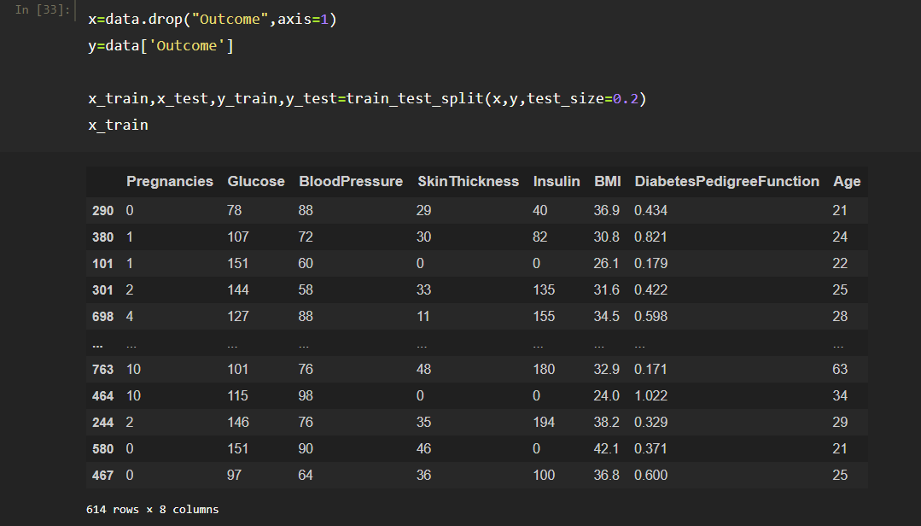

LogisticRegression

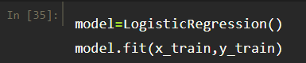

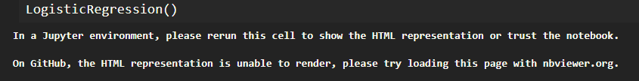

Prediction values:
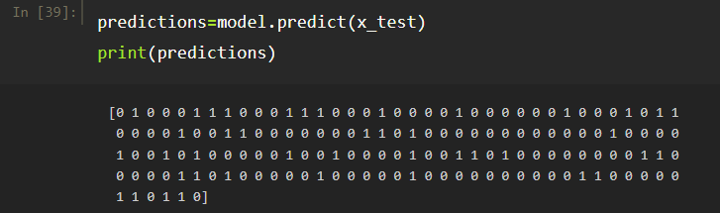

Finding Accuracy
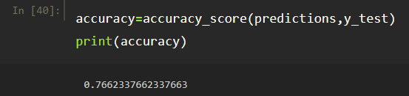

USING PYCHARM CREATE A HOME PAGE AND PREDICTION PAGE
OPEN Pycharm


Go to terminal and create a project

Change Directory

Craete a project [diabetesPrediction]
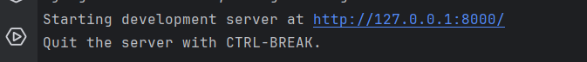

Click on the link



Now create a Home page for Web Page
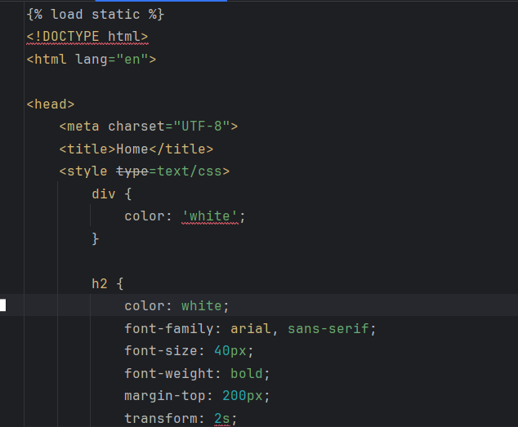

Code for HOME.html

{% load static %}
<!DOCTYPE html>
<html lang="en">
<head>
<meta charset="UTF-8">
<title>Home</title>
<style type=text/css>
div {
color: 'white';
}
h2 {
color: white;
font-family: arial, sans-serif;
font-size: 40px;
font-weight: bold;
margin-top: 200px;
transform: 2s;
}
body {
background-color: black;
background-image: url(https://img.freepik.com/free-vector/medical-technology-science-background-vector-blue-with-blank-space_53876-117739.jpg);
background-size: cover;
background-repeat: no-repeat;
}
input {
background-color: #FFA500;
border: 2px;
color: white;
padding: 16px 32px;
font-size: 20px;
font-weight: bold;
cursor: pointer;
margin-top: 15px;
border: 2px solid white;
border-radius: 10px;
}
input:hover{
background-color: white;
color: #FFA500;
border: 2px solid #FFA500;
}
.gfg {
color: green;
background-color: white;
padding: 6px 12px;
width: 15%;
border-radius: 10px;
font-size: 30px;
}
</style>
</head>
<body>
<div align='center'>
<h2><em>
<h1 class="gfg"></h1>
WELCOME TO DIABETES PREDICTION SYSTEM
</em>
</h2>
<form action="predict.html">
<input type="submit" value="Lets get started">
</form>
</div>
</body>
</html>

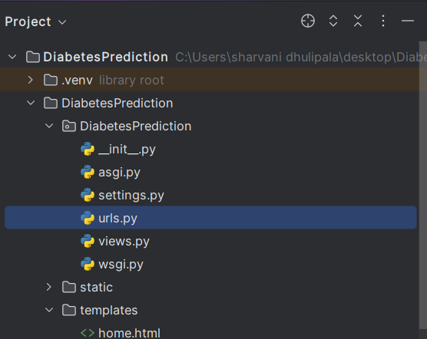

Update the URL’S
# code
from operator import index
from . import views
from django.contrib import admin
from django.urls import path
from django.urls import path
from . import views
urlpatterns = [
path('admin/', admin.site.urls),
path("", views.home),
path("predict/", views.predict),
path('predict.html', views.predict_view, name='predict'),
path("predict/result", views.result, name='result'), # Ensure to add the name parameter
]
Change the templete in seting .py

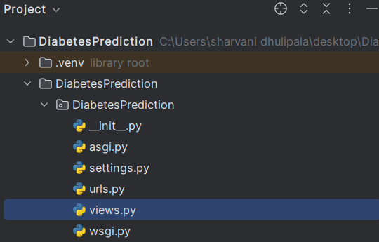

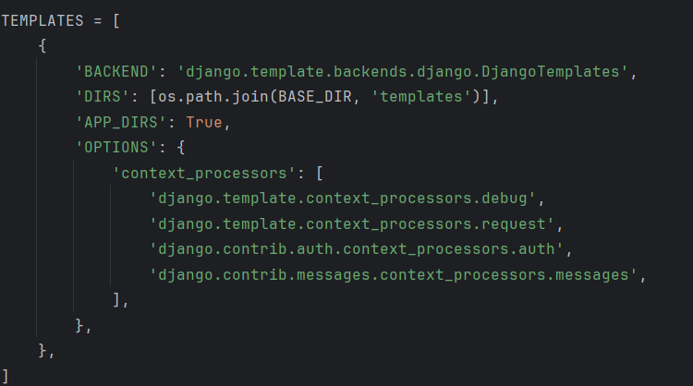

In static place the image links:

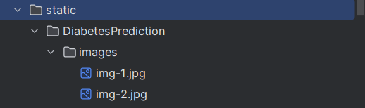

Now create a prediction page To depict the resukt
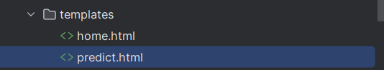

Code:

<!DOCTYPE html>
<html lang="en">
<head>
<meta charset="UTF-8">
<title>Prediction page</title>
<style>
td {
font-size: 17px;
}
body {
background-color: black;
background-image: url(https://www.datasciencecentral.com/wp-content/uploads/2023/04/AdobeStock_133621255.jpeg);
background-size: cover;
background-repeat: no-repeat;
}
.main {
top: 80px;
left: 110px;
width: 550px;
margin-left: 7%;
background-color: white;
border-radius: 15px;
height: 110vh;
align-items: center;
}
.main:hover {
box-shadow: 50px 0px 20px 0px rgba(0, 0, 0, 0.2);
}
h1 {
font-family: Times New Roman;
margin: 20px, 0;
color: #F6465B;
font-size: 30px;
font-weight: bold;
animation-delay: 3.5s;
}
input[type=submit] {
background-color: #FFA500;
border: 2px;
color: white;
font-size: 15px;
font-weight: bold;
padding: 10px 16px;
cursor: pointer;
margin-top: 15px;
border-radius: 10px;
}
input {
padding: 20px, 0;
margin: 20px, 0;
}
p {
color: #ffffff;
}
.row em {
color: #BF0A30;
.gfg
color: green;
font-size: 30px;
}
</style>
</head>
<body>
<p><em>WELCOME TO THE PREDICT PAGE</em></P>
<div align='center' class="main">
<h1 class="gfg">Be your own kind of healthy</h1>
<h1>Diabetes Prediction</h1> <br />
<form action="{% url 'result' %}" method="GET">
<table>
<tr>
<td align="right"> <strong>Pregnancies:</strong> </td>
<td align="left"><input type="text" name="n1"></td>
</tr>
<tr>
<td align="right"> <strong>Glucose:</strong> </td>
<td align="left"><input type="text" name="n2"></td>
</tr>
<tr>
<td align="right"> <strong>Blood Pressure:</strong> </td>
<td align="left"><input type="text" name="n3"></td>
</tr>
<tr>
<td align="right"> <strong>Skin Thickness:</strong> </td>
<td align="left"><input type="text" name="n4"></td>
</tr>
<tr>
<td align="right"> <strong>Insulin:</strong> </td>
<td align="left"><input type="text" name="n5"></td>
</tr>
<tr>
<td align="right"> <strong>BMI:</strong> </td>
<td align="left"><input type="text" name="n6"></td>
</tr>
<tr>
<td align="right"><strong>Diabetes Pedigree Function:</strong> </td>
<td align="left"><input type="text" name="n7"></td>
</tr>
<tr>
<td align="right"> <strong>Age:</strong> </td>
<td align="left"><input type="text" name="n8"></td>
</tr>
</table>
<input type="submit" value="PREDICT">
</form>
<div class="row">
<h2><em>{{ result2 }}</em></h2>
</div>
</div>
</body>
</html>

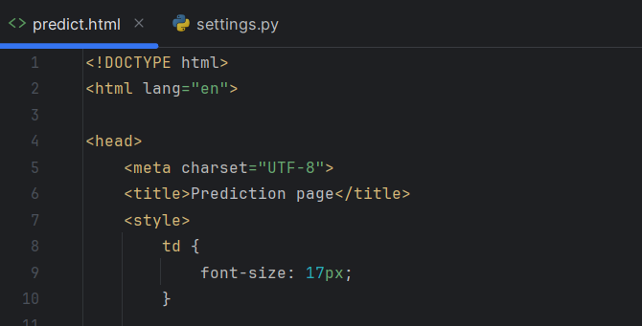

Linking ML to the Website

Now go to view
Add the Machine learning Training code into View.py

from django.shortcuts import render
import pandas as pd
from sklearn.model_selection import train_test_split
from sklearn.linear_model import LogisticRegression
# for call home.html
def home(request):
return render(request, 'home.html')
# for call predict.html
def predict(request):
return render(request, 'predict.html')
def predict_view(request):
# Your view logic here
return render(request, 'predict.html')
def result(request):
data = pd.read_csv(r"C:\Users\sharvani dhulipala\OneDrive\Documents\web technologies lab\project\diabetes.csv")
X = data.drop("Outcome", axis=1)
Y = data["Outcome"]
X_train, X_test, Y_train, Y_test = train_test_split(X, Y, test_size=0.2)
model = LogisticRegression()
model.fit(X_train, Y_train)
val1 = float(request.GET['n1'])
val2 = float(request.GET['n2'])
val3 = float(request.GET['n3'])
val4 = float(request.GET['n4'])
val5 = float(request.GET['n5'])
val6 = float(request.GET['n6'])
val7 = float(request.GET['n7'])
val8 = float(request.GET['n8'])
pred = model.predict([[val1, val2, val3, val4, val5, val6, val7, val8]])
result1 = ""
if pred == [1]:
result1 = "Oops! You have DIABETES."
else:
result1 = "Great! You DON'T have diabetes."
return render(request, "predict.html", {"result2": result1})

Output:
Press the link

Home page appears
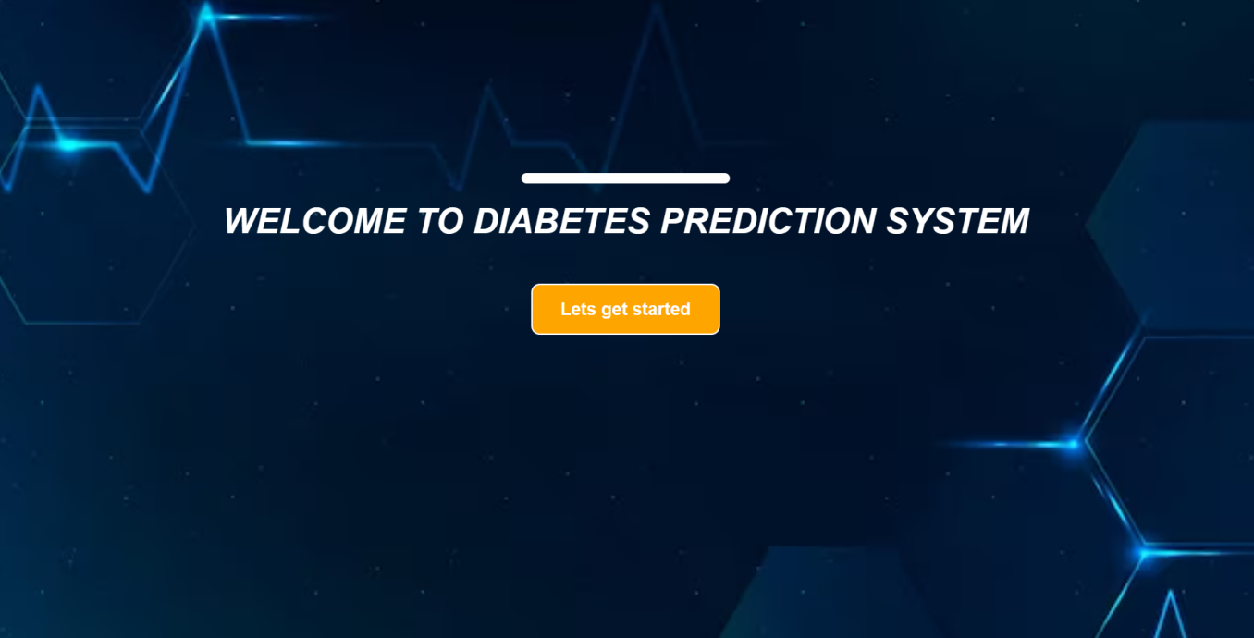

Press Lets get Started:

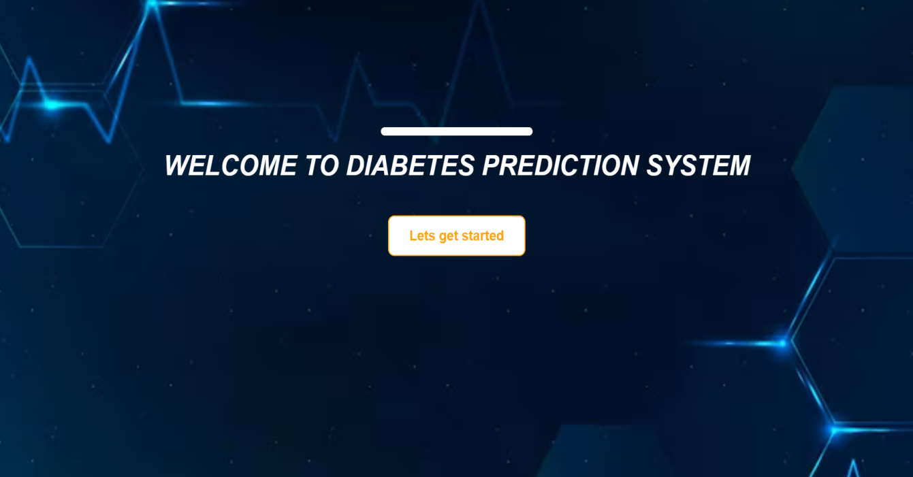

Enter the values:

