# WORD CLOUD FROM MY RESUME:

SUMMARY:

* Tried to create a word-cloud from my resume in R Studio.
* Consider my complete resume as corpus and performed data munging and pre-processing.
* Words are colored showing least to most frequent.

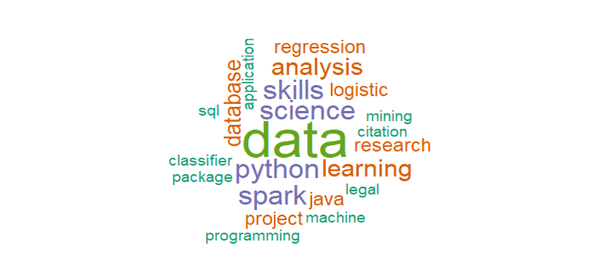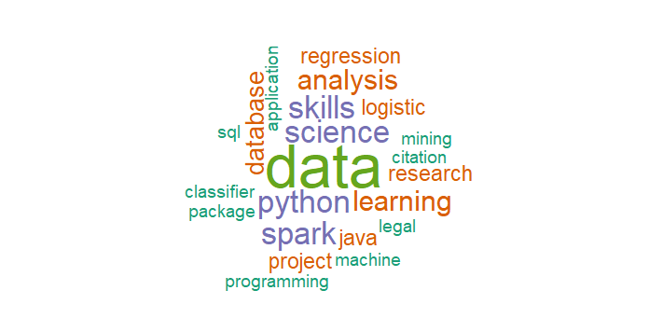

ISSUES TACKLED:

* Handling Unicode symbols within pattern was difficult.

Learnt reading encoded file.

* Stemming and lemmatization removed context of topic. Created list of words that I included while data cleaning.

Conclusion :

* I enjoyed working on this small task.
* There is further scope to improve data cleaning and get more relevant.