**A**

**PRACTICAL TRAINING REPORT**

**ON**

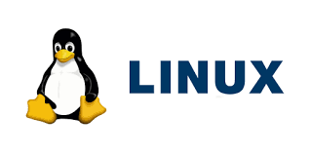

LINUX TRAINING

“**Submitted In Partial Fulfilment of the Requirement for the Award** **of the Degree of the Bachelor of Technology in Computer Science And Engineering to Rajasthan Technical University, Kota**”

**SUBMITTED BY**

Vishakha Rajak (23CS108)



**DEPARTMENT OF COMPUTER SCIENCE AND ENGINEERING**

**ANAND INTERNATIONAL COLLEGE OF ENGINEERING, JAIPUR**

2024-25

**23RD DECEMBER 2024**

**ACKNOWLEDGMENT**

I would like to extend my deepest gratitude to everyone who played a role in making the Linux Training Program at Anand International College Of Engineering a resounding success. This initiative would not have been possible without the collective effort and support of many individuals and teams.

1. **Special Thanks to Our Trainer** We are immensely grateful to Assistant professor Sidharth Jain, whose expertise, dedication, and ability to demystify complex concepts greatly enriched the learning experience for all participants. Their interactive teaching style and practical approach were invaluable.
2. **Management Support** A heartfelt thanks to the management of Anand International College Of Engineering for their unwavering support and for providing the resources necessary to make this event possible. Their vision and encouragement were critical to the success of this program.
3. **Organizing Team Contributions** We deeply appreciate the hard work and meticulous planning of the organizing team from CSE Department. Their commitment, coordination, and attention to detail ensured a smooth and successful execution of the event.
4. **Technical Team Assistance** The seamless delivery of the training sessions was made possible by our dedicated technical team. Their efforts in setting up the required infrastructure and troubleshooting during the sessions were commendable.

This acknowledgment is a small token of my appreciation for everyone who contributed to the success of this program. I look forward to your continued support in our future endeavours.

**Vishakha Rajak**

**23CS108**

**CANDIDATE DECLARATION**

I, Vishakha Rajak, a participant in the Linux Training Program held at Anand International College Of Engineering of 15 days, hereby declare that this report is a true and accurate account of the training sessions and my experiences during the program. I confirm that the information provided in this document reflects the activities, objectives, and outcomes of the training to the best of my knowledge and understanding.

**Vishakha Rajak**

**23CS108**

**CERTIFICATION**

This training program provided comprehensive knowledge and practical skills in:

* Linux fundamentals and architecture.
* Command-line operations and file management.
* System administration, security, and networking.
* Linux distributions and their applications across industries

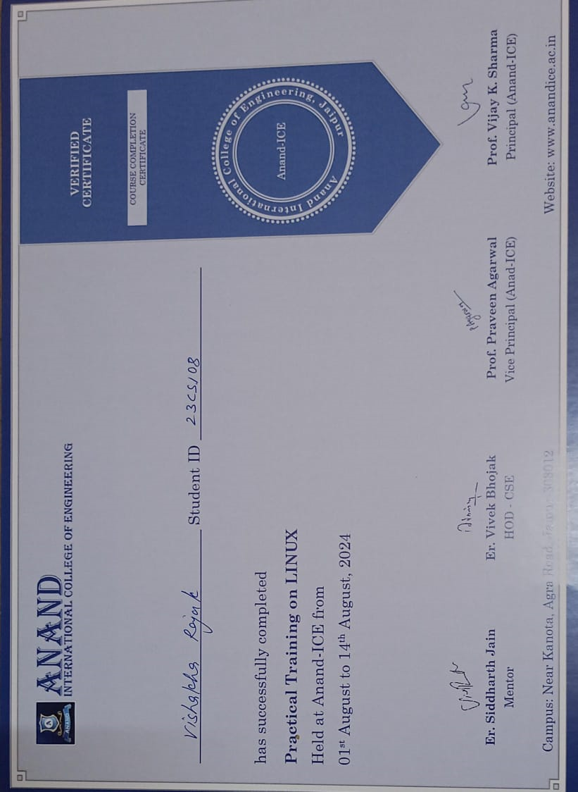

**ABSTRACT**

* **Overview**:
  + Linux is a **powerful, open-source operating system** developed by **Linus Torvalds** in **1991** as a free alternative to proprietary systems like **Windows** and **macOS**.
  + Since its creation, Linux has evolved into one of the **most widely used operating systems** globally, supporting a wide range of devices from **personal computers** and **smartphones** to **large-scale data centers** and **embedded systems**.
* **Open-source Nature**:
  + Linux is **open-source**, meaning anyone can **download**, **modify**, and **distribute** the source code, encouraging **innovation**, **collaboration**, and continuous development.
  + It is supported by an **active global community**, which contributes to its ongoing improvements and ensures its **reliability** and **security**.
* **Key Features and Architecture**:
  + Linux includes a **monolithic kernel**, **system libraries**, **utilities**, and a **shell** for user interaction, making it a highly efficient and customizable operating system.
  + It is **multi-user**, **multi-tasking**, and highly **scalable**, making it suitable for environments ranging from personal use to enterprise-level deployments.
* **Popular Distributions**:
  + Linux comes in various **distributions** (distros), such as **Ubuntu**, **Fedora**, **CentOS**, **Debian**, and **Arch Linux**, each catering to different user needs and preferences.
  + These distributions offer different levels of **usability**, **stability**, and **customizability**, making Linux versatile for both **beginners** and **advanced users**.
* **Applications**:
  + Linux is widely used in **servers**, **cloud computing**, **cybersecurity**, **embedded systems**, **IoT devices**, and **software development**.
  + Its **robust security features** and **low cost** make it a popular choice in industries that require **high availability** and **scalability**.
* **Advantages and Challenges**:
  + Key advantages include its **cost-effectiveness**, **security**, **stability**, and **flexibility**.
  + Challenges include a **learning curve** for new users, **limited support for proprietary software**, and occasional **hardware compatibility issues**.
* **Future Prospects**:
  + Linux’s role in **emerging technologies** like **AI**, **ML**, and **IoT** is expected to grow, as it continues to adapt to new technological needs.
  + Its increasing integration with **cloud computing**, **containerization**, and **gaming** indicates a strong future, particularly in driving **innovation** in **enterprise computing**, **gaming** platforms, and **distributed systems**.

**TABLE OF CONTENTS**

1. **Introduction**
   * Overview of Linux as an open-source operating system.
   * History and significance in modern computing.
2. **Illustrations**
   * Linux Adoption Across Industries (Pie Chart).
   * Linux Kernel Architecture (Block Diagram).
   * Linux vs. Other Operating Systems (Bar Chart).
3. **Features of Linux**
   * Open-source and free.
   * Security, multi-user, multitasking, and more.
4. **Linux Architecture**
   * Kernel, system libraries, system utilities, and shell.
5. **Linux Distributions**
   * Popular distributions like Ubuntu, Fedora, CentOS, etc.
6. **File System**
   * File hierarchy, common file systems, and file management tools.
7. **Linux Commands**
   * Basic and advanced commands for file, directory, process, and network management.
8. **Applications of Linux**
   * Servers, embedded systems, development, cybersecurity, and more.
9. **Advantages of Linux**
   * Stability, cost-effectiveness, community support, and versatility.
10. **Challenges with Linux**
    * Learning curve, limited proprietary software support, and hardware compatibility.
11. **Future of Linux**
    * Role in AI, IoT, cloud computing, and gaming advancements.
12. **Conclusion**
    * Summary of Linux's impact and growing industry adoption.
13. **References**
    * Comprehensive list of sources and documentation.

**INTRODUCTION**

* **Origins and Development**:
  + Developed by **Linus Torvalds** in **1991** as a free, open-source alternative to proprietary operating systems like **Windows** and **macOS**.
  + Torvalds aimed to create a new operating system kernel while adhering to open-source software principles.
* **Growth and Evolution**:
  + The **Linux kernel** quickly gained traction due to its robust design, flexibility, and support from the open-source community.
  + Evolved into a **Linux distribution** (distro), which includes the kernel and other essential software components like **GNU tools**, libraries, and applications.
* **Widespread Adoption**:
  + Linux powers a wide range of devices, including **personal computers**, **smartphones** (via Android), **data centers**, **web servers**, and **embedded systems**.
  + Its strong presence in **server environments** for **web services**, **cloud computing**, and **enterprise applications** highlights its **reliability**, **security**, and **scalability**.
* **Open-source Nature**:
  + The **open-source nature** of Linux allows anyone to **modify**, **distribute**, and **contribute** to its development, supporting the broader open-source ecosystem.
  + Continuous **evolution** and active community support ensure that Linux remains a powerful and versatile tool for various computing tasks.

**LIST OF ILLUSTRATIONS**

1. **Linux Adoption Across Industries (Pie Chart):** This pie chart illustrates the distribution of Linux adoption across different sectors such as servers & hosting, embedded systems, cloud computing, desktop use, and others.

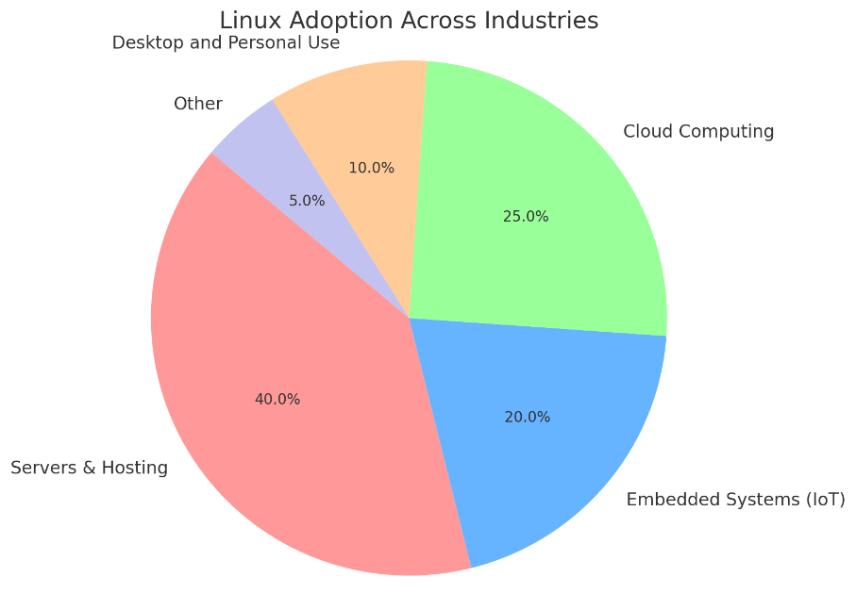

1. **Linux Kernel Architecture (Block Diagram)**: This diagram represents the key components of the Linux kernel, including system libraries, system utilities, and the shell (CLI), with arrows showing how each part interacts within the architecture.

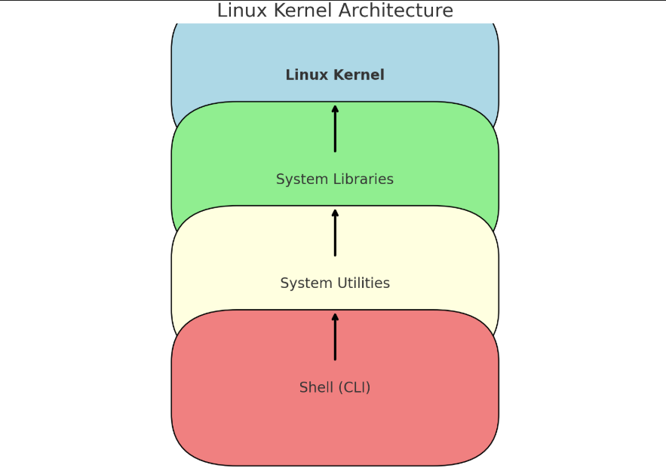

1. **Linux vs Other Operating Systems (Bar Chart)**: This bar chart compares Linux, Windows, and macOS based on key criteria such as performance, security, cost, and customizability, showing Linux's superiority in these areas.

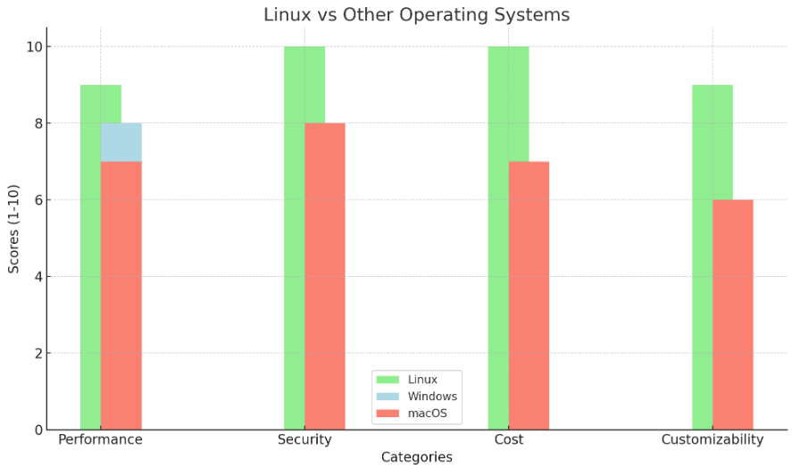

**FEATURES OF LINUX**

Linux is renowned for its unique features that set it apart from other operating systems. Some of the most important features include:

* **Open-source and Free**:
  + The Linux kernel and most associated software are available for free, promoting innovation and collaboration.
  + Users can download, modify, and distribute the source code to adapt it to specific needs.
  + Linux is cost-effective, making it an appealing choice for individuals, organizations, and businesses.
* **Robust Security**:
  + Known for strong security features, including user privilege separation to limit access and reduce system vulnerabilities.
  + Supports advanced security mechanisms like **SELinux** (Security-Enhanced Linux) and **AppArmor**.
  + Regular updates and a vigilant open-source community contribute to its reputation for security and stability.
* **Multi-user and Multitasking**:
  + Built to handle multiple users and processes simultaneously, ideal for servers and enterprise environments.
  + Multiple users can perform tasks concurrently without interfering with each other.
  + Supports multitasking, allowing several applications or processes to run at once without compromising system performance.
  + Especially beneficial for high-availability environments like data centers or cloud computing platforms.
* **Portability and Scalability**:
  + Highly portable, running on various hardware platforms such as personal computers, mobile devices, supercomputers, and embedded systems.
  + Ideal for diverse applications, including cloud services, IoT devices, and robotics.
  + Scalable, suitable for both small systems and large-scale server farms, making it ideal for personal projects to enterprise-level deployments.
* **Rich Ecosystem of Distributions**:
  + Available in a wide range of distributions (distros), each tailored to specific user needs and preferences.
  + Popular distributions include:
    - **Ubuntu**: Known for user-friendliness and strong community support.
    - **Fedora**: Focuses on cutting-edge technologies.
    - **CentOS**: A robust choice for enterprise environments.
  + Offers different desktop environments, software packages, and configuration options for users to choose the best fit for their needs.
* **Customizability**:
  + Highly customizable, allowing users to modify nearly every aspect of the operating system.
  + Offers flexibility to change the appearance, install different desktop environments, or fine-tune system settings.
  + Particularly appealing for developers, system administrators, and advanced users who want to optimize performance or create specialized environments.

**LINUX ARCHITECTURE**

Linux architecture is structured in layers that work together to provide a stable and efficient operating system. The key components of Linux architecture include:

* **Kernel**:
  + The core of the Linux operating system.
  + Acts as a bridge between hardware and software, managing system resources like memory, CPU, and device I/O.
  + Handles process scheduling, system security, hardware abstraction, and communication between software and hardware components.
  + Ensures efficient and secure system operations.
  + The Linux kernel is **monolithic**, meaning it handles both low-level operations and higher-level system functions in a single codebase.
* **System Libraries**:
  + Provide the necessary interfaces between the kernel and application software.
  + Libraries consist of pre-written code that allows programs to perform common tasks without direct kernel interaction.
  + The most important system library is the **C library (glibc)**, which offers essential functions like memory management, process control, and string manipulation.
  + Ensure compatibility and ease of development across different distributions and environments.
* **System Utilities**:
  + A collection of essential tools for managing and maintaining the system.
  + Perform administrative tasks such as file manipulation, process management, network configuration, and system monitoring.
  + Common utilities include:
    - ls (listing files)
    - ps (viewing running processes)
    - top (real-time system performance monitoring)
  + These utilities allow users and administrators to interact with and maintain the system.
* **Shell**:
  + A command-line interface (CLI) that acts as the intermediary between the user and the kernel.
  + Interprets user commands and passes them to the kernel for execution.
  + Allows interaction with the operating system by typing commands instead of using a GUI.
  + Supports scripting, enabling users to automate tasks and manage system processes.
  + Common shells include **Bash (Bourne Again Shell)**, the most widely used in Linux.

**LINUX DISTRIBUTIONS**

Linux is available in a variety of distributions (distros), each tailored to different user needs and preferences. A Linux distribution consists of the Linux kernel, along with additional software, libraries, and tools that create a fully functional operating system. Below are some of the most popular and widely used Linux distributions:

* **Ubuntu**:
  + Known for user-friendliness and ease of use.
  + Based on Debian and designed to be accessible to both beginners and experienced users.
  + Features a clean and intuitive graphical user interface (GUI).
  + Regular updates and a large community make it easy to troubleshoot and learn.
  + Available in editions like Ubuntu Server and Ubuntu Desktop, widely used in personal computing and server environments.
* **Fedora**:
  + A community-driven distribution focused on cutting-edge technologies and features.
  + Acts as a testbed for innovations that later make their way into Red Hat Enterprise Linux (RHEL).
  + Rapid release cycle bringing quick updates and new features.
  + Emphasizes security, performance, and integration with the latest software and hardware.
  + Ideal for developers and tech enthusiasts seeking the newest tools and technologies.
* **CentOS/RHEL**:
  + **RHEL (Red Hat Enterprise Linux)**: A commercial distribution offering support and services for businesses, known for stability and long-term support.
  + **CentOS**: A free and open-source clone of RHEL, previously known for offering the same stability without the cost. Now, **CentOS Stream** serves as a rolling-release distribution between Fedora and RHEL.
  + Both are popular for servers, data centers, and enterprise environments, where stability and security are essential.
* **Debian**:
  + One of the oldest and most respected Linux distributions, known for its stability and reliability.
  + Forms the foundation for many other distros, including Ubuntu.
  + Long release cycles and a robust package management system make it ideal for servers and mission-critical systems.
  + While less user-friendly than Ubuntu, it offers greater flexibility and customization.
* **Arch Linux**:
  + A minimalist and highly customizable distribution aimed at experienced users.
  + Follows a rolling release model, offering the latest software packages and updates.
  + Requires manual configuration of most system aspects, providing users complete control.
  + Known for its steep learning curve but offers flexibility for building a tailored system.
  + Popular among advanced users and those who want to learn the inner workings of their OS.
  + Extensive documentation available in the Arch Wiki.

**FILE SYSTEM**

The Linux file system is a hierarchical structure that organizes files and directories in a tree-like format. Understanding this structure is crucial for navigating and managing files on a Linux system. Below are key components and common file systems used in Linux:

**Linux File System Hierarchy**

The Linux file system follows a standardized directory structure known as the **Filesystem Hierarchy Standard (FHS)**. Some of the important directories in this hierarchy include:

* **/bin**: This directory contains essential binary executables (programs) that are required for the system to function properly, such as ls, cp, and mv.
* **/etc**: This directory stores system configuration files. Files in /etc are used to configure system settings, services, and applications (e.g., /etc/passwd for user account information).
* **/home**: This directory contains personal directories for regular users. Each user has their own subdirectory under /home, such as /home/user1, where their personal files and settings are stored.
* **/root**: This is the home directory of the root (administrator) user. It contains configuration files and settings specific to the root user.
* **/var**: Contains files that are expected to change frequently, such as log files (/var/log/), temporary files, and databases.
* **/lib**: This directory contains shared libraries that are needed by programs to function, similar to dynamic link libraries (DLLs) in Windows.
* **/tmp**: A directory for temporary files used by programs and system processes. These files are typically deleted upon system reboot.

This hierarchy is designed to ensure a logical and consistent structure, making it easier for users and system administrators to find and manage files.

**Common File Systems**

Linux supports a variety of file systems, each with its own strengths and use cases. Some of the most common file systems include:

* **ext4 (Fourth Extended File System)**: The most widely used file system in Linux, ext4 is a high-performance, reliable, and stable file system. It supports large file sizes and volumes, journaling for data integrity, and has backward compatibility with ext3 and ext2.
* **XFS**: A high-performance file system that is particularly well-suited for handling large files and high-throughput environments, such as servers and databases. XFS is known for its scalability and efficient handling of large volumes of data.
* **Btrfs (B-tree File System)**: An advanced file system that provides features such as snapshots, checksumming for data integrity, and dynamic disk management. Btrfs is still evolving but has gained popularity for its flexibility and advanced features.

**Command-line Tools for File Management**

Linux provides a variety of command-line tools for managing files and directories. These tools are essential for system administration and everyday tasks. Some of the most commonly used commands include:

* **ls**: Lists the contents of a directory. For example, ls /home will display all the files and directories in the /home directory.
  + Example: ls -l shows a detailed listing, including file permissions and ownership.
* **cp**: Copies files or directories from one location to another.
  + Example: cp file1.txt /home/user1/ copies file1.txt to the /home/user1/ directory.
* **mv**: Moves or renames files and directories.
  + Example: mv oldname.txt newname.txt renames a file.
* **rm**: Removes (deletes) files or directories. Use with caution, as the command permanently deletes files.
  + Example: rm file1.txt deletes file1.txt, while rm -r dir1/ deletes the directory dir1 and its contents.

These tools provide basic yet powerful functionality for managing files, and they are fundamental for interacting with the Linux file system through the command line.

**LINUX COMMANDS**

Linux commands are the essential tools for interacting with and managing the operating system through the command-line interface (CLI). Linux commands are divided into basic and advanced categories, depending on their functionality.

**Basic Commands**

* **File Operations**:
  + **ls**: Lists files and directories in the current directory or specified path.
    - Example: ls /home lists all files and directories in the /home directory.
  + **cat**: Concatenates and displays the content of a file. Useful for viewing short files.
    - Example: cat file1.txt displays the contents of file1.txt.
  + **touch**: Creates an empty file or updates the timestamp of an existing file.
    - Example: touch newfile.txt creates an empty file named newfile.txt.
* **Directory Operations**:
  + **mkdir**: Creates a new directory.
    - Example: mkdir newfolder creates a directory named newfolder.
  + **rmdir**: Removes an empty directory.
    - Example: rmdir emptyfolder removes the emptyfolder directory.
  + **cd**: Changes the current directory.
    - Example: cd /home/user1 navigates to the user1 directory within /home.
* **File Permissions**:
  + **chmod**: Changes the file permissions for users and groups. Permissions include read (r), write (w), and execute (x).
    - Example: chmod 755 file1.txt grants the owner full permissions (read, write, execute) and read-execute permissions to others.
  + **chown**: Changes the owner and group of a file or directory.
    - Example: chown user1:group1 file1.txt changes the owner of file1.txt to user1 and the group to group1.

**Advanced Commands**

* **Process Management**:
  + **top**: Displays real-time information about running processes, memory usage, and CPU load.
    - Example: top opens a dynamic list of running processes, updated periodically.
  + **ps**: Shows a snapshot of the current processes running on the system.
    - Example: ps aux displays all processes for all users.
  + **kill**: Terminates processes by their process ID (PID).
    - Example: kill 1234 sends a termination signal to process with PID 1234.
* **Networking**:
  + **ping**: Tests network connectivity to a remote host by sending ICMP echo requests.
    - Example: ping google.com checks if the system can reach Google's servers.
  + **netstat**: Displays network connections, routing tables, and network statistics.
    - Example: netstat -tuln shows active listening ports and their associated services.
  + **scp**: Securely copies files between local and remote systems using SSH.
    - Example: scp file1.txt user@remote:/path/to/destination copies file1.txt to the specified remote path.
* **Package Management**:
  + **apt** (Debian/Ubuntu-based): A package management tool for installing, updating, and removing software packages.
    - Example: sudo apt install nginx installs the Nginx web server on a Debian-based system.
  + **yum** (RHEL/CentOS-based): A package manager for Red Hat-based systems, used for installing and managing software packages.
    - Example: sudo yum install nginx installs Nginx on a CentOS or RHEL system.
  + **dnf** (Fedora-based): A newer package manager replacing yum in Fedora, CentOS 8, and RHEL 8+.
    - Example: sudo dnf install nginx installs Nginx on a Fedora or RHEL 8 system.

**APPLICATIONS OF LINUX**

* **Servers and Hosting**:
  + Dominates web servers, application servers, and hosting solutions.
  + Popular platforms like **Apache**, **NGINX**, and **MySQL** run seamlessly on Linux.
  + Chosen for its **reliability**, **low cost**, and **scalability**.
  + Powers large websites, cloud services, and CMS platforms.
  + Efficiently handles **high-traffic sites** and **heavy loads**.
* **Embedded Systems (e.g., IoT Devices)**:
  + Linux is widely used in **embedded systems** and **IoT devices**.
  + Popular distributions: **Raspberry Pi OS** and **Ubuntu Core**.
  + Customizable to run on devices with **limited resources**.
  + Powers **smart home devices**, **wearables**, **automotive systems**, and **medical equipment**.
* **Software Development**:
  + Preferred by **software developers** for its powerful tools and flexibility.
  + Supports programming languages like **Python**, **Java**, **C/C++**, and **Go**.
  + Offers customizable development environments with **IDEs** like **Visual Studio Code** and **Eclipse**.
  + Supports version control systems like **Git**, crucial for modern development workflows.
* **Cybersecurity and Ethical Hacking**:
  + Widely used for **cybersecurity** and **ethical hacking** tasks.
  + Distributions like **Kali Linux** and **Parrot Security OS** are tailored for **penetration testing** and **cybersecurity assessments**.
  + Preloaded with tools for **vulnerability scanning**, **network monitoring**, and **exploit testing**.
  + Utilized by security researchers for **malware analysis** and **system audits**.
* **Cloud Computing**:
  + Linux powers the backbone of **cloud computing** infrastructure.
  + Used extensively in platforms like **AWS**, **Google Cloud**, and **Microsoft Azure**.
  + Ideal for **virtual machines**, **cloud services**, and **distributed systems**.
  + Integral in containerization and orchestration tools like **Docker** and **Kubernetes**.
  + Increasing use in **open-source cloud platforms** and **containerized environments**.

**ADVANTAGES OF LINUX**

* **High Stability and Reliability**:
  + Known for its exceptional stability and long uptime.
  + Ideal for **servers** and **mission-critical systems**.
  + Less prone to crashes and slowdowns.
  + Built-in **error recovery mechanisms** ensure smooth operation.
  + Preferred for environments requiring high **uptime**, such as **web hosting**, **cloud services**, and **embedded systems**.
* **Cost-effective with No Licensing Fees**:
  + **Open-source** and **free to use**, significantly reducing ownership costs.
  + No expensive licenses or subscriptions required.
  + Most software available for Linux is also **open-source** or **free**.
  + Allows users to build and maintain systems without purchasing costly software packages.
* **Excellent Community Support**:
  + Large, active, and collaborative community offering support through forums, wikis, and dedicated websites.
  + Regular updates, bug fixes, and new features rolled out quickly.
  + Transparency and contribution from the community lead to continuous improvements.
  + Easy access to troubleshooting resources and learning materials.
* **Wide Range of Applications in Various Domains**:
  + **Versatile** and used in **servers**, **desktop computing**, **cloud computing**, **embedded systems**, and **cybersecurity**.
  + Powers devices from **smartphones** and **IoT devices** to **supercomputers** and **enterprise data centers**.
  + Supports a broad spectrum of applications including development tools, productivity software, networking tools, and security utilities.
  + Highly customizable to meet the needs of diverse users, from **developers** to **system administrators** to **end consumers**.

**CHALLENGES WITH LINUX**

* **Learning Curve for New Users**:
  + Linux requires a **command-line interface (CLI)** for many tasks, which can be challenging for beginners.
  + **Graphical user interfaces (GUIs)** simplify some tasks, but certain system management and troubleshooting still require terminal commands.
  + **File system hierarchy** and handling software installations can be confusing for users unfamiliar with Linux.
  + The **learning process** can be time-consuming, though resources and tutorials are available to help beginners.
* **Limited Support for Certain Proprietary Software**:
  + Popular proprietary software (e.g., **Adobe Photoshop**, **Microsoft Office**) is not natively available for Linux.
  + Alternatives like **GIMP** and **LibreOffice** may not provide all the features or compatibility expected by users.
  + Running proprietary software may require **compatibility layers** like **Wine** or virtual machines, which may not offer optimal performance or compatibility.
* **Hardware Compatibility Issues with Certain Drivers**:
  + While Linux supports a wide range of hardware, some newer or niche devices may face **compatibility issues**.
  + Manufacturers may not release **Linux-compatible drivers**, leading to **poor performance** or **device malfunctions**.
  + Users may need to rely on **open-source drivers** or third-party drivers, which might not always be reliable or easy to install.
  + Troubleshooting and fixing hardware-related issues can be challenging, especially for users with **less technical expertise**.

**FUTURE OF LINUX**

* **Role in Emerging Technologies (AI, ML, IoT)**:
  + **Artificial Intelligence (AI)** and **Machine Learning (ML)**: Linux supports powerful frameworks like **TensorFlow**, **PyTorch**, and **Apache Spark**, making it ideal for AI and ML research and development.
  + **Internet of Things (IoT)**: Linux is widely used in embedded devices, offering **customizability** for specific hardware needs in the IoT space. It is expected to drive smart devices, autonomous systems, and machine learning models in various industries.
  + As AI and IoT continue to grow, Linux will likely play an even larger role in powering **smart technologies**.
* **Expanding Use in Cloud Computing and Containerization**:
  + Linux’s role in **cloud computing** will increase, with platforms like **AWS**, **Google Cloud**, and **Microsoft Azure** relying heavily on Linux for their **virtual machines** and **data centers**.
  + **Containerization technologies** (e.g., **Docker**, **Kubernetes**) depend on Linux, enabling efficient resource utilization and scalability.
  + As containerization grows, Linux will continue to enable faster **development cycles** and more efficient **cloud-based architectures**.
* **Continued Evolution in Gaming (Proton, Steam Deck)**:
  + **Proton**, developed by Valve, allows **Windows-based games** to run on Linux without performance loss, helping Linux overcome past gaming limitations.
  + **Steam Deck**: Valve's handheld gaming console running a custom **Linux-based OS** marks a significant shift in Linux's presence in the gaming industry.
  + With increasing support from game developers and platforms like **Steam** and **Epic Games Store**, **gaming on Linux** is becoming more mainstream.
  + The **open-source nature** of Linux and its ability to offer **customization** and **better performance** for gaming will likely continue to attract gaming enthusiasts.

**CONCLUSION**

Linux has had a transformative influence on the world of technology. From its inception as a personal project by **Linus Torvalds** in 1991, it has evolved into one of the most powerful and widely used operating systems in the world. Its open-source nature has driven unparalleled innovation and fostered collaboration within a global community of developers and users.

The key aspects of Linux’s rise and its enduring influence on modern computing are summarized below:

**Key Factors Driving Linux's Success**

* **Open-source Nature:**
  + Linux's source code is freely available, enabling anyone to download, modify, and distribute it. This openness fosters innovation and provides flexibility, allowing developers and organizations to customize and adapt the operating system for specific needs.
  + The community-driven development model ensures that improvements, bug fixes, and new features are constantly integrated, keeping Linux up-to-date with the latest technological trends.
* **Reliability and Stability:**
  + Linux is known for its exceptional **uptime** and **stability**, especially in server and enterprise environments. It rarely needs to be rebooted, making it ideal for **mission-critical systems** where uptime is crucial.
  + Built-in **error recovery** mechanisms and robust design prevent frequent system crashes and slowdowns, ensuring the system runs smoothly under heavy workloads.
* **Security Features:**
  + Linux has built-in security mechanisms such as **user privilege separation**, **SELinux**, and **AppArmor** to minimize vulnerabilities and protect against threats.
  + Its open-source model allows for continuous security audits and community-driven patches, enhancing the system's overall security.
* **Adaptability and Customizability:**
  + Linux is highly customizable, allowing users to tailor almost every aspect of the system, from the graphical interface to core system functionalities. This makes it ideal for a wide range of use cases.
  + Users can choose from various **distributions (distros)** to suit their needs, whether for personal desktops, servers, or specialized applications.
* **Cost-effectiveness:**
  + Linux is **free to use**, with no licensing fees, which significantly reduces the cost of ownership. This makes it an attractive option for individuals, startups, and organizations looking to minimize software costs.
  + The **open-source software ecosystem** around Linux further reduces the need for expensive proprietary software, enabling users to build robust systems without additional costs.

**Widespread Adoption Across Industries**

* **Servers and Web Hosting:**
  + Linux powers the majority of web servers and cloud infrastructures, with platforms like **Amazon Web Services (AWS)**, **Google Cloud**, and **Microsoft Azure** relying heavily on Linux to manage their virtual machines and data centers.
  + It supports essential server software such as **Apache**, **NGINX**, **MySQL**, and more, making it the backbone of web hosting and large-scale applications.
* **Cloud Platforms and Virtualization:**
  + Linux’s scalability and low overhead make it a perfect fit for **cloud computing** and **containerization**. Technologies like **Docker** and **Kubernetes** are built on Linux, enabling efficient resource allocation and management in cloud environments.
  + Linux is integral to **virtualization** platforms, allowing businesses to create, manage, and scale virtual machines with high efficiency.
* **Embedded Systems and IoT Devices:**
  + The **Internet of Things (IoT)** benefits significantly from Linux’s lightweight nature and customizability. Linux is commonly used in devices ranging from **smart home devices** to **wearables**, **automotive systems**, and **medical equipment**.
  + Distros like **Raspberry Pi OS** (formerly Raspbian) are used in small, resource-constrained devices, offering flexibility and cost-efficiency.
* **Software Development:**
  + Linux is favored by developers for its robust tools and environments. With support for programming languages like **Python**, **Java**, **C/C++**, and **Go**, Linux provides a comprehensive platform for writing, testing, and deploying software.
  + Linux supports popular **IDEs** like **Visual Studio Code**, **Eclipse**, and **JetBrains IntelliJ IDEA**, and integrates seamlessly with **version control systems** like **Git**, making it an ideal choice for software development.
* **Cybersecurity and Ethical Hacking:**
  + Linux is widely used in **cybersecurity**, with distributions like **Kali Linux** and **Parrot Security OS** designed for penetration testing and security research. These distros include tools for vulnerability scanning, malware analysis, and network monitoring.
  + The open-source nature of Linux allows security professionals to audit, analyze, and improve the operating system’s security continuously.

**Linux's Role in the Future**

* **Artificial Intelligence (AI) and Machine Learning (ML):**
  + Linux is set to play a pivotal role in **AI** and **ML** research and development due to its ability to support powerful frameworks such as **TensorFlow**, **PyTorch**, and **Apache Spark**.
  + Its flexibility allows for customization of the OS to suit specific **hardware needs**, making it ideal for **machine learning models** and **smart devices** in AI-powered industries.
* **Cloud Computing Growth:**
  + Linux’s dominance in **cloud computing** is expected to grow as more businesses embrace cloud infrastructure, powered by Linux’s **scalability** and **performance**.
  + Technologies like **containerization** (Docker) and **orchestration** (Kubernetes) will continue to rely on Linux for efficient application deployment in the cloud.
* **Gaming on Linux (Proton and Steam Deck):**
  + Gaming on Linux has come a long way with **Proton**—a compatibility layer developed by Valve for running Windows games on Linux. This has opened doors for many gamers who previously had limited options on Linux.
  + The launch of the **Steam Deck**, a handheld gaming device running Linux, marks a significant step toward Linux becoming a mainstream gaming platform.

**REFERENCES**

1. **Books**:
   * Torvalds, Linus, and David Diamond. *Just for Fun: The Story of an Accidental Revolutionary*. HarperBusiness, 2001.
   * Negus, Christopher. *Linux Bible*. Wiley, 2020.
   * Boyer, Richard. *The Linux Command Line: A Complete Introduction*. No Starch Press, 2019.
2. **Articles**:
   * "The History of Linux: A Timeline." *Linux Foundation*, <https://www.linuxfoundation.org/blog/the-history-of-linux/>.
   * "What is Linux?" *IBM*, <https://www.ibm.com/topics/linux>.
   * "Why Linux is Ideal for AI and Machine Learning Development." *TechCrunch*, <https://techcrunch.com/2022/04/12/why-linux-is-ideal-for-ai-and-machine-learning-development/>.
3. **Official Documentation**:
   * Linux Documentation Project, *The Linux Command Guide*. <https://www.tldp.org/LDP/intro-linux/html/>.
   * "The Linux Kernel Archives." *The Linux Foundation*, <https://www.kernel.org/>.
   * Ubuntu Documentation, *Ubuntu Server Guide*. <https://ubuntu.com/server/docs>.
4. **Online Resources**:
   * "Linux Mint - User Guide." *Linux Mint*, <https://linuxmint.com/documentation.php>.
   * "Kubernetes Documentation." *Kubernetes*, <https://kubernetes.io/docs/>.
   * "Proton – Gaming on Linux." *Valve*, <https://www.protondb.com/>.