// ignore_for_file: deprecated_member_use, use_key_in_widget_constructors, library_private_types_in_public_api  
  
import 'package:flutter/material.dart';  
  
void main() {  
 runApp(CounterApp());  
}  
  
class CounterApp extends StatelessWidget {  
 @override  
 Widget build(BuildContext context) {  
 return MaterialApp(  
 debugShowCheckedModeBanner: false,  
 home: CounterScreen(),  
 );  
 }  
}  
  
class CounterScreen extends StatefulWidget {  
 @override  
 _CounterScreenState createState() => _CounterScreenState();  
}  
  
class _CounterScreenState extends State<CounterScreen> {  
 int _counter = 0;  
  
 void _incrementCounter(int value) {  
 setState(() {  
 _counter += value;  
 });  
 }  
  
 void _decrementCounter(int value) {  
 setState(() {  
 if (_counter >= value) {  
 _counter -= value;  
 } else {  
 _counter = 0;  
 }  
 });  
 }  
  
 void _clearCounter() {  
 setState(() {  
 _counter = 0;  
 });  
 }  
  
 @override  
 Widget build(BuildContext context) {  
 return Scaffold(  
 appBar: AppBar(  
 centerTitle: true,  
 title: const Text(  
 'Calc',  
 style: TextStyle(fontSize: 30, color: Colors.*white*),  
 ),  
 backgroundColor: Colors.*blueGrey*.shade800,  
 leading: const Icon(Icons.*menu*,color: Colors.*white*),  
 ),  
 body: Center(  
 child: Column(  
 mainAxisAlignment: MainAxisAlignment.center,  
 children: <Widget>[  
 Text(  
 '$_counter',  
 style: const TextStyle(fontSize: 80),  
 ),  
 const SizedBox(height: 40),  
 Row(  
 mainAxisAlignment: MainAxisAlignment.center,  
 children: <Widget>[  
 ElevatedButton(  
 onPressed: () => _decrementCounter(2),  
 style: ElevatedButton.*styleFrom*(  
 minimumSize: const Size(120, 60),  
 shape: RoundedRectangleBorder(  
 borderRadius: BorderRadius.circular(10),  
 ),  
 primary: Colors.*blueGrey*.shade500,  
 ),  
 child:const Text(  
 '-2',  
 style: TextStyle(color: Colors.*white*, fontSize: 40),  
 ),  
 ),  
 const SizedBox(width: 40),  
 ElevatedButton(  
 onPressed: () => _incrementCounter(2),  
 style: ElevatedButton.*styleFrom*(  
 minimumSize: const Size(120, 60),  
 shape: RoundedRectangleBorder(  
 borderRadius: BorderRadius.circular(10),  
 ),  
 primary: Colors.*blueGrey*,  
 ),  
 child:const Text(  
 '+2',  
 style: TextStyle(color: Colors.*white*, fontSize: 40),  
 ),  
 ),  
 ],  
 ),  
 const SizedBox(height: 20),  
 Row(  
 mainAxisAlignment: MainAxisAlignment.center,  
 children: <Widget>[  
 ElevatedButton(  
 onPressed: () => _decrementCounter(4),  
 style: ElevatedButton.*styleFrom*(  
 minimumSize: const Size(120, 60),  
 shape: RoundedRectangleBorder(  
 borderRadius: BorderRadius.circular(10),  
 ),  
 primary: Colors.*blueGrey*.shade500,  
 ),  
 child: const Text(  
 '-4',  
 style: TextStyle(color: Colors.*white*, fontSize: 40),  
 ),  
 ),  
 const SizedBox(width: 40),  
 ElevatedButton(  
 onPressed: () => _incrementCounter(4),  
 style: ElevatedButton.*styleFrom*(  
 minimumSize: const Size(120, 60),  
 shape: RoundedRectangleBorder(  
 borderRadius: BorderRadius.circular(10),  
 ),  
 primary: Colors.*blueGrey*.shade500,  
 ),  
 child:const Text(  
 '+4',  
 style: TextStyle(color: Colors.*white*, fontSize: 40),  
 ),  
 ),  
 ],  
 ),  
 const SizedBox(height: 30),  
 ElevatedButton(  
 onPressed: _clearCounter,  
 style: ElevatedButton.*styleFrom*(  
 minimumSize: const Size(120, 60),  
 shape: RoundedRectangleBorder(  
 borderRadius: BorderRadius.circular(10),  
 ),  
 primary: Colors.*blueGrey*.shade500,  
 ),  
 child: const Text(  
 'Clear',  
 style: TextStyle(color: Colors.*white*, fontSize: 25),  
 ),  
 ),  
 ],  
 ),  
 ),  
 );  
 }  
}

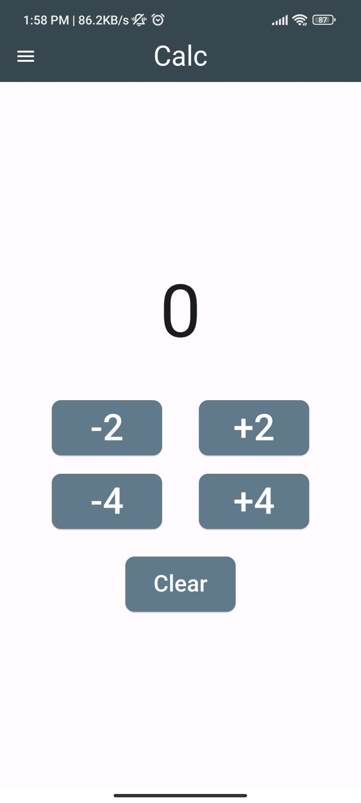

// ignore_for_file: use_key_in_widget_constructors  
  
import 'package:flutter/material.dart';  
  
void main() {  
 runApp(MyApp());  
}  
  
class MyApp extends StatelessWidget {  
 @override  
 Widget build(BuildContext context) {  
 return MaterialApp(  
 debugShowCheckedModeBanner: false,  
 home: Scaffold(  
 appBar: AppBar(  
 centerTitle: true,  
 title: const Text(  
 'Map',  
 style: TextStyle(color: Colors.*white*, fontSize: 20),  
 ),  
 backgroundColor: Colors.*blue*,  
 leading: const Icon(Icons.*menu*, color: Colors.*white*),  
 ),  
 body: DataList(),  
 ),  
 );  
 }  
}  
  
class DataList extends StatelessWidget {  
 final List<Map<String, dynamic>> dataList = [  
 {'text': 'Exit', 'icon': Icons.*exit_to_app*},  
 {'text': 'Play', 'icon': Icons.*play_arrow*},  
 {'text': 'Pause', 'icon': Icons.*pause*},  
 {'text': 'Stop', 'icon': Icons.*stop*},  
 {'text': 'Close', 'icon': Icons.*close*},  
 {'text': 'Delete', 'icon': Icons.*delete*},  
 {'text': 'Email', 'icon': Icons.*email*},  
  
 ];  
  
 @override  
 Widget build(BuildContext context) {  
 return Scaffold(  
 body: ListView(  
 children: dataList.map((item) {  
 return Padding(  
 padding: const EdgeInsets.symmetric(vertical: 23.0, horizontal: 5.0),  
 child: Container(  
 decoration: BoxDecoration(  
 border: Border(bottom: BorderSide(color: Colors.*grey*.shade200, width: 13)),  
 ),  
 child: ListTile(  
 contentPadding: EdgeInsets.*zero*,  
 leading: Container(  
 alignment: Alignment.*centerLeft*,  
 width: 100,  
 child: Text(  
 item['text'],  
 style: const TextStyle(fontSize: 20),  
 ),  
 ),  
 trailing: Icon(  
 item['icon'],  
 size: 30,  
 ),  
 ),  
 ),  
 );  
 }).toList(),  
 ),  
 );  
 }  
}

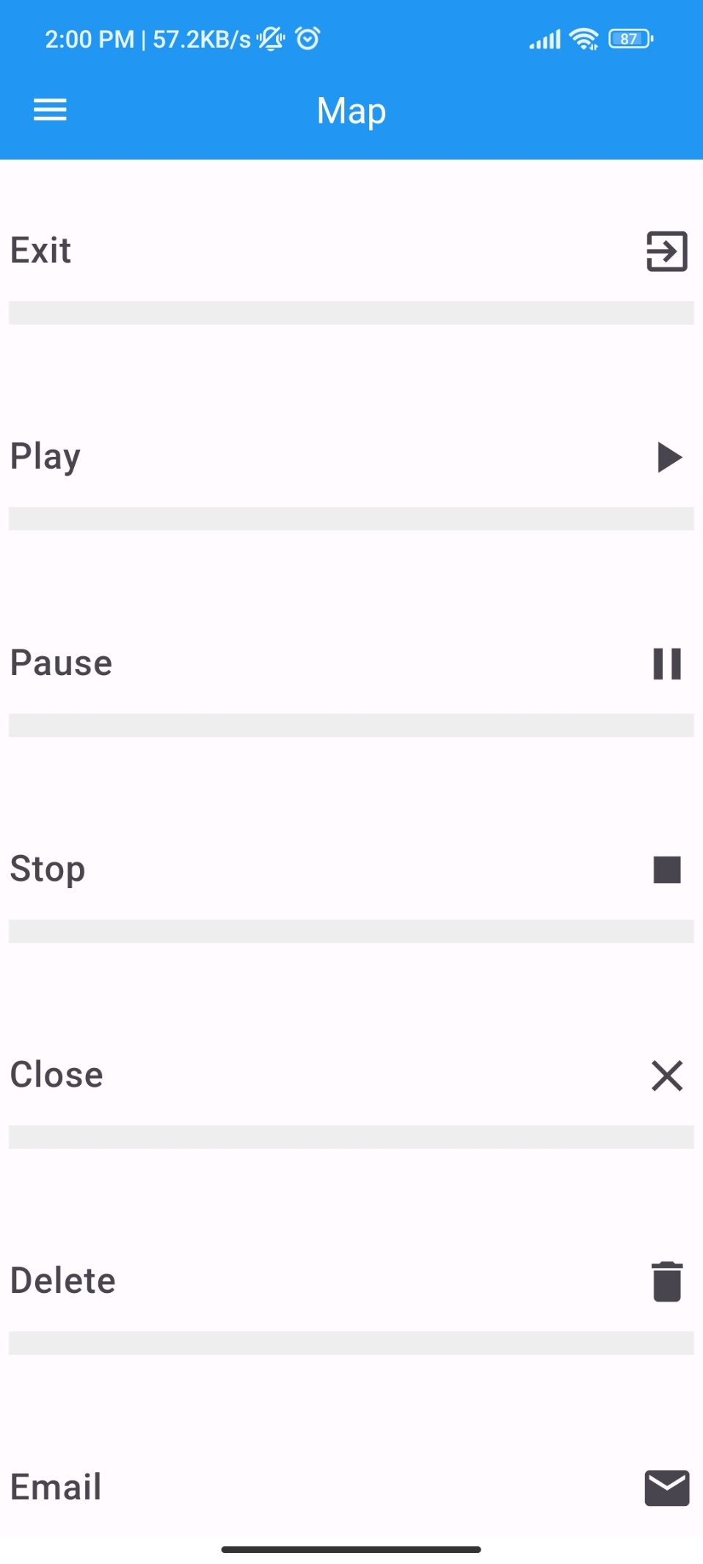

// ignore_for_file: use_key_in_widget_constructors  
  
import 'package:flutter/material.dart';  
  
void main() {  
 runApp(MyApp());  
}  
  
class MyApp extends StatelessWidget {  
 @override  
 Widget build(BuildContext context) {  
 return MaterialApp(  
 debugShowCheckedModeBanner: false,  
 home: Scaffold(  
 appBar: AppBar(  
 centerTitle: true,  
 title: Text(  
 'Icons',  
 style: TextStyle(color: Colors.*grey*.shade500),  
 ),  
 ),  
 body: const SingleChildScrollView(  
 scrollDirection: Axis.vertical,  
 child: Column(  
 mainAxisAlignment: MainAxisAlignment.center,  
 children: <Widget>[  
 SingleChildScrollView(  
 scrollDirection: Axis.horizontal,  
 child: Row(  
 mainAxisAlignment: MainAxisAlignment.spaceEvenly,  
 children: <Widget>[  
 IconContainer(icon: Icons.*add*),  
 IconContainer(icon: Icons.*adjust*),  
 IconContainer(icon: Icons.*arrow_back_ios*),  
 IconContainer(icon: Icons.*arrow_forward_ios*),  
 IconContainer(icon: Icons.*alarm*),  
 ],  
 ),  
 ),  
 SizedBox(height: 20),  
 SingleChildScrollView(  
 scrollDirection: Axis.horizontal,  
 child: Row(  
 mainAxisAlignment: MainAxisAlignment.start,  
 children: <Widget>[  
 IconContainer(icon: Icons.*shield_moon*),  
 IconContainer(icon: Icons.*perm_contact_cal_rounded*),  
 IconContainer(icon: Icons.*refresh*),  
 IconContainer(icon: Icons.*ac_unit*),  
 ],  
 ),  
 ),  
 SizedBox(height: 20),  
 SingleChildScrollView(  
 scrollDirection: Axis.horizontal,  
 child: Row(  
 mainAxisAlignment: MainAxisAlignment.start,  
 children: <Widget>[  
 IconContainer(icon: Icons.*announcement*),  
 IconContainer(icon: Icons.*archive*),  
 IconContainer(icon: Icons.*airline_seat_recline_normal*),  
 ],  
 ),  
 ),  
 SizedBox(height: 20),  
 SingleChildScrollView(  
 scrollDirection: Axis.horizontal,  
 child: Row(  
 mainAxisAlignment: MainAxisAlignment.start,  
 children: <Widget>[  
 IconContainer(icon: Icons.*airport_shuttle*),  
 IconContainer(icon: Icons.*alarm_on*),  
 IconContainer(icon: Icons.*android*),  
 IconContainer(icon: Icons.*apps*),  
 IconContainer(icon: Icons.*attach_file*),  
 ],  
 ),  
 ),  
 SizedBox(height: 20),  
 SingleChildScrollView(  
 scrollDirection: Axis.horizontal,  
 child: Row(  
 mainAxisAlignment: MainAxisAlignment.start,  
 children: <Widget>[  
 IconContainer(icon: Icons.*camera*),  
 IconContainer(icon: Icons.*call*),  
 IconContainer(icon: Icons.*cake*),  
 ],  
 ),  
 ),  
 ],  
 ),  
 ),  
 ),  
 );  
 }  
}  
  
class IconContainer extends StatelessWidget {  
 final IconData icon;  
  
 const IconContainer({Key? key, required this.icon}) : super(key: key);  
  
 @override  
 Widget build(BuildContext context) {  
 return Container(  
 width: 150,  
 height: 150,  
 decoration: BoxDecoration(  
 color: Colors.*grey*.shade500,  
 borderRadius: BorderRadius.circular(10),  
 ),  
 child: Icon(  
 icon,  
 color: Colors.*white*,  
 size: 40,  
 ),  
 );  
 }  
}

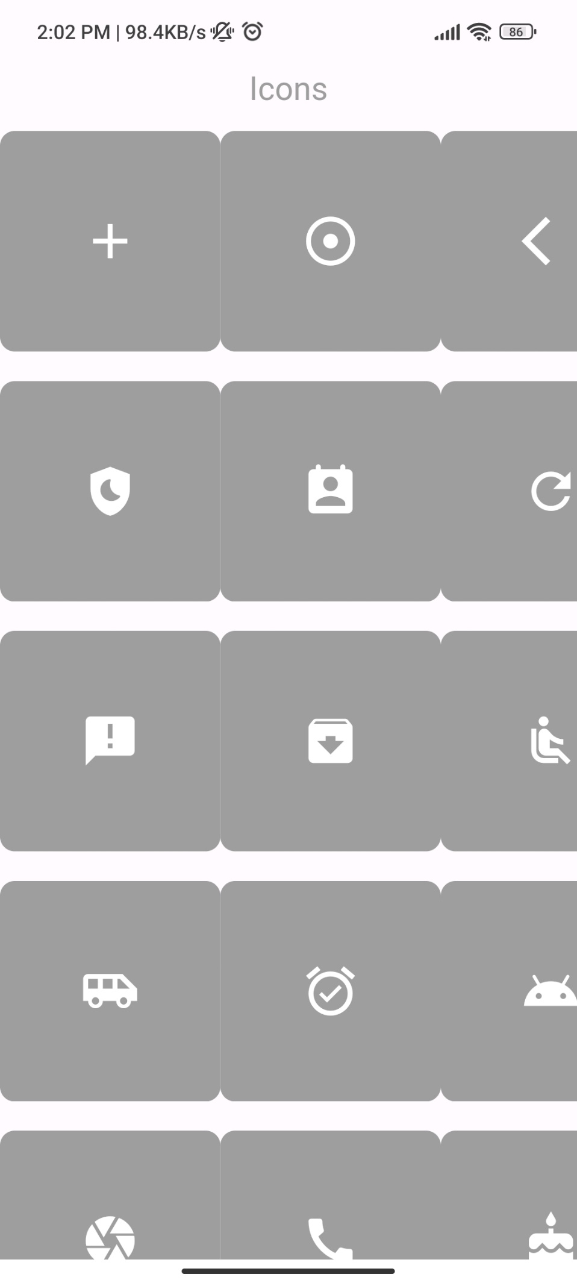

// ignore_for_file: use_key_in_widget_constructors, library_private_types_in_public_api  
  
import 'package:flutter/material.dart';  
  
void main() {  
 runApp(MyApp());  
}  
  
class MyApp extends StatefulWidget {  
 @override  
 _MyAppState createState() => _MyAppState();  
}  
  
class _MyAppState extends State<MyApp> {  
 List<int> numberList = List.generate(10, (index) => index + 1);  
  
 void addNumber() {  
 setState(() {  
 numberList.add(numberList.length + 1);  
 });  
 }  
  
 void deleteNumber() {  
 setState(() {  
 if (numberList.isNotEmpty) {  
 numberList.removeLast();  
 }  
 });  
 }  
  
 @override  
 Widget build(BuildContext context) {  
 return MaterialApp(  
 debugShowCheckedModeBanner: false,  
 home: Scaffold(  
 appBar: AppBar(  
 centerTitle: true,  
 title: const Text(  
 'Dynamic List',  
 style: TextStyle(color: Colors.*white*, fontSize: 20),  
 ),  
 backgroundColor: Colors.*teal*,  
 ),  
 body: Column(  
 children: [  
 Expanded(  
 child: ListView.builder(  
 itemCount: numberList.length,  
 itemBuilder: (context, index) {  
 Color containerColor = numberList[index] % 2 == 0  
 ? Colors.*blue*.shade800 // Even numbers color  
 : Colors.*blue*.shade200; // Odd numbers color  
 return ListTile(  
 title: Container(  
 alignment: Alignment.*center*,  
 height: 110,  
 width: 120,  
 decoration: BoxDecoration(  
 color: containerColor,  
 borderRadius: BorderRadius.circular(10),  
 ),  
 child: Text(  
 '${numberList[index]}',  
 style: const TextStyle(color: Colors.*white*, fontSize: 50),  
 ),  
 ),  
 );  
 },  
 ),  
 ),  
 ],  
 ),  
 floatingActionButton: Padding(  
 padding: const EdgeInsets.all(20.0),  
 child: Row(  
 mainAxisAlignment: MainAxisAlignment.end,  
 children: [  
 ElevatedButton(  
 onPressed: addNumber,  
 style: ElevatedButton.*styleFrom*(  
 shape: const CircleBorder(),  
 fixedSize: const Size(70, 70),  
 backgroundColor: Colors.*teal* ),  
 child: const Text(  
 '+',  
 style: TextStyle(color: Colors.*white*, fontSize: 40),  
 ),  
 ),  
 const SizedBox(width: 10),  
 ElevatedButton(  
 onPressed: deleteNumber,  
 style: ElevatedButton.*styleFrom*(  
 shape: const CircleBorder(),  
 fixedSize: const Size(70, 70),  
 backgroundColor: Colors.*teal* ),  
 child: const Text(  
 '-',  
 style: TextStyle(color: Colors.*white*, fontSize: 40),  
 ),  
 ),  
 ],  
 ),  
 ),  
 ),  
 );  
 }  
}

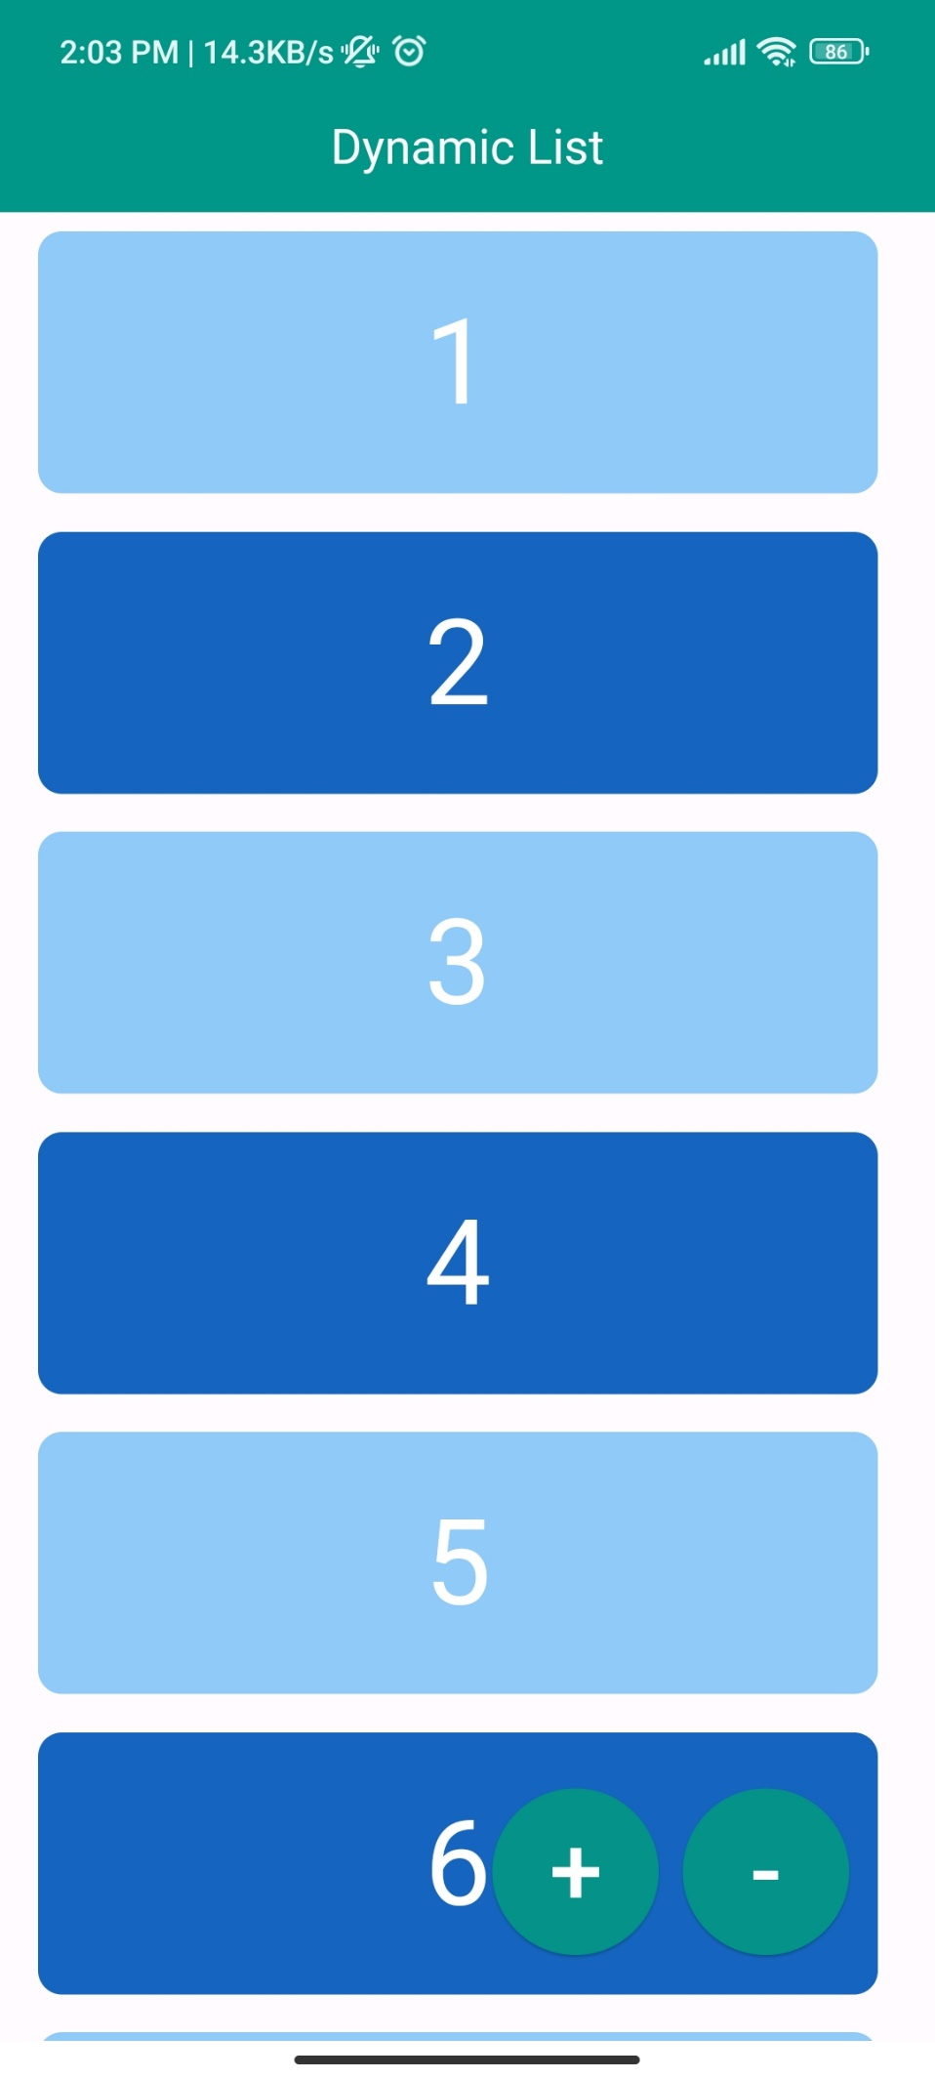

import 'package:flutter/material.dart';  
  
void main() {  
 runApp(const MyApp());  
}  
  
class MyApp extends StatelessWidget {  
 const MyApp({super.key});  
  
 @override  
 Widget build(BuildContext context) {  
 return MaterialApp(  
 debugShowCheckedModeBanner: false,  
 home: Scaffold(  
 appBar: AppBar(  
 centerTitle: true,  
 title: const Text('Icons Editor'),  
 ),  
 body: const ContainerLayout(),  
 ),  
 );  
 }  
}  
  
class ContainerLayout extends StatelessWidget {  
 const ContainerLayout({super.key});  
  
 @override  
 Widget build(BuildContext context) {  
 return Column(  
 crossAxisAlignment: CrossAxisAlignment.center,  
 children: [  
 SizedBox(  
 height: 250,  
 child: Center(  
 child: Container(  
 width: 350,  
 decoration: BoxDecoration(  
 color: Colors.*white70*,  
 borderRadius: BorderRadius.circular(10),  
 ),  
 child: const Center(  
 child: Icon(Icons.*arrow_back_ios*, size: 50, color: Colors.*lightBlue*),  
 ),  
 ),  
 ),  
 ),  
 const SizedBox(height: 10),  
 SizedBox(  
 height: 80,  
 child: Center(  
 child: Container(  
 width: 350,  
 decoration: BoxDecoration(  
 color: Colors.*white70*,  
 borderRadius: BorderRadius.circular(15),  
 ),  
 child: const Center(  
 child: Text('Select Colors', style: TextStyle(color: Colors.*grey*, fontSize: 20)),  
 ),  
 ),  
 ),  
 ),  
 const SizedBox(height: 10),  
 SizedBox(  
 height: 150,  
 child: Center(  
 child: ListView(  
 scrollDirection: Axis.horizontal,  
 children: const [  
 SizedBox(width: 10),  
 RoundColorContainer(color: Colors.*green*),  
 RoundColorContainer(color: Colors.*yellow*),  
 RoundColorContainer(color: Colors.*orange*),  
 RoundColorContainer(color: Colors.*purple*),  
 RoundColorContainer(color: Colors.*black87*),  
 RoundColorContainer(color: Colors.*teal*),  
 RoundColorContainer(color: Colors.*pinkAccent*),  
 RoundColorContainer(color: Colors.*red*),  
 RoundColorContainer(color: Colors.*blue*),  
 RoundColorContainer(color: Colors.*green*),  
 RoundColorContainer(color: Colors.*yellow*),  
 RoundColorContainer(color: Colors.*orange*),  
 RoundColorContainer(color: Colors.*purple*),  
 RoundColorContainer(color: Colors.*black87*),  
 RoundColorContainer(color: Colors.*teal*),  
 RoundColorContainer(color: Colors.*pinkAccent*),  
 RoundColorContainer(color: Colors.*black87*),  
 RoundColorContainer(color: Colors.*teal*),  
 RoundColorContainer(color: Colors.*pinkAccent*),  
 RoundColorContainer(color: Colors.*red*),  
 SizedBox(width: 10),  
 ],  
 ),  
 ),  
 ),  
 const SizedBox(height: 10),  
 SizedBox(  
 height: 80,  
 child: Center(  
 child: Container(  
 width: 350,  
 decoration: BoxDecoration(  
 color: Colors.*white70*,  
 borderRadius: BorderRadius.circular(15),  
 ),  
 child: const Center(  
 child: Text('Select Icon', style: TextStyle(color: Colors.*grey*, fontSize: 20)),  
 ),  
 ),  
 ),  
 ),  
 const SizedBox(height: 10),  
 SizedBox(  
 height: 150,  
 child: Center(  
 child: ListView(  
 scrollDirection: Axis.horizontal,  
 children: const [  
 SizedBox(width: 10),  
 IconContainer(icon: Icons.*ac_unit*),  
 IconContainer(icon: Icons.*access_alarm*),  
 IconContainer(icon: Icons.*accessibility_new*),  
 IconContainer(icon: Icons.*account_balance*),  
 IconContainer(icon: Icons.*account_circle*),  
 IconContainer(icon: Icons.*add*),  
 IconContainer(icon: Icons.*add_alarm*),  
 IconContainer(icon: Icons.*add_alert*),  
 IconContainer(icon: Icons.*add_box*),  
 IconContainer(icon: Icons.*add_circle*),  
 IconContainer(icon: Icons.*earbuds*),  
 IconContainer(icon: Icons.*table_bar*),  
 IconContainer(icon: Icons.*verified*),  
 IconContainer(icon: Icons.*safety_check*),  
 IconContainer(icon: Icons.*key*),  
  
 SizedBox(width: 10),  
 ],  
 ),  
 ),  
 ),  
 ],  
 );  
 }  
}  
  
class RoundColorContainer extends StatelessWidget {  
 final Color color;  
  
 const RoundColorContainer({super.key, required this.color});  
  
 @override  
 Widget build(BuildContext context) {  
 return Padding(  
 padding: const EdgeInsets.all(8.0),  
 child: Container(  
 width: 50,  
 height: 50,  
 decoration: BoxDecoration(  
 color: color,  
 shape: BoxShape.circle,  
 ),  
 ),  
 );  
 }  
}  
  
class IconContainer extends StatelessWidget {  
 final IconData icon;  
  
 const IconContainer({super.key, required this.icon});  
  
 @override  
 Widget build(BuildContext context) {  
 return Padding(  
 padding: const EdgeInsets.all(8.0),  
 child: Container(  
 width: 100,  
 height: 10,  
 decoration: BoxDecoration(  
 color: Colors.*white70*,  
 borderRadius: BorderRadius.circular(10),  
 ),  
 child: Icon(  
 icon,  
 size: 50,  
 color: Colors.*blue*,  
 ),  
 ),  
 );  
 }  
}

