import 'package:flutter/material.dart';  
  
void main() {  
 runApp(MyApp());  
}  
  
class MyApp extends StatelessWidget {  
 @override  
 Widget build(BuildContext context) {  
 return const MaterialApp(  
 debugShowCheckedModeBanner: false,  
 home: BoltScreen(),  
 );  
 }  
}  
  
class BoltScreen extends StatefulWidget {  
 const BoltScreen({Key? key}) : super(key: key);  
  
 @override  
 State<BoltScreen> createState() => _BoltScreenState();  
}  
  
class _BoltScreenState extends State<BoltScreen> {  
 @override  
 Widget build(BuildContext context) {  
 return Scaffold(  
 appBar: AppBar(  
 centerTitle: true,  
 title: const Text(  
 'B O L T',  
 style: TextStyle(color: Colors.*white*, fontSize: 40),  
 ),  
 backgroundColor: Colors.*black45*,  
 ),  
 backgroundColor: Colors.*black45*,  
 body: Row(  
 crossAxisAlignment: CrossAxisAlignment.stretch,  
 mainAxisAlignment: MainAxisAlignment.spaceEvenly,  
 children: [  
 Expanded(  
 child: Container(  
 color: Colors.*yellow*.shade700, ),  
 Expanded(  
 child: Icon(Icons.*electric_bolt*, color: Colors.*yellow*.shade700, size: 70),  
 ),  
 Expanded(  
 child: Container(  
 color: Colors.*yellow*.shade700,

),  
 ],  
 ),  
 );  
 }  
}

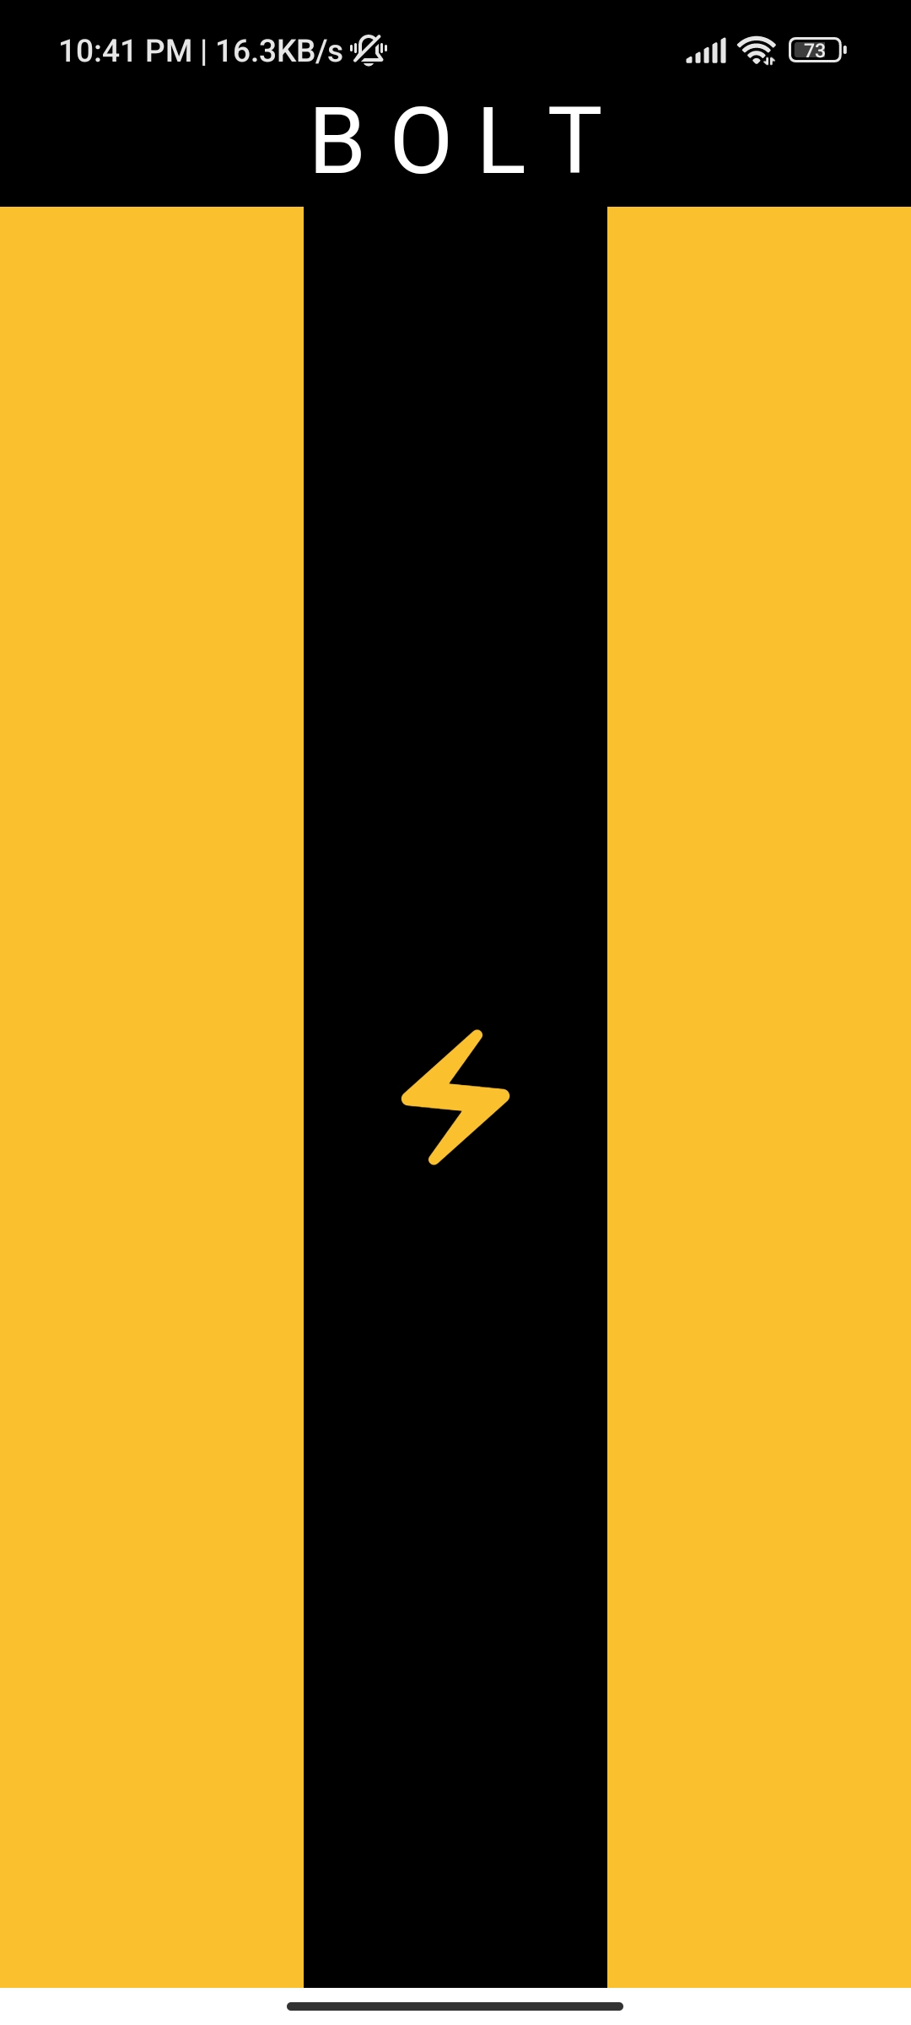

// ignore_for_file: use_key_in_widget_constructors  
  
import 'package:flutter/material.dart';  
  
void main() {  
 runApp(const MyApp());  
}  
  
class MyApp extends StatelessWidget {  
 const MyApp({Key? key});  
  
 @override  
 Widget build(BuildContext context) {  
 return MaterialApp(  
 debugShowCheckedModeBanner: false,  
 home: Scaffold(  
 appBar: AppBar(  
 centerTitle: true,  
 title: const Text(  
 'THE WALL',  
 style: TextStyle(color: Colors.*white*, fontSize: 30),  
 ),  
 backgroundColor: Colors.*black*,  
 ),  
 backgroundColor: Colors.*white*,  
 body: Column(  
 children: [  
 const SizedBox(height: 9),  
 Expanded(  
 child: Row(  
 children: [  
 Expanded(  
 child: Container(  
 color: Colors.*brown*,  
 ),  
 ),  
 const SizedBox(width: 9),  
 Expanded(  
 flex: 2,  
 child: Container(  
 color: Colors.*brown*,  
 ),  
 ),  
 const SizedBox(width: 9),  
 Expanded(  
 child: Container(  
 color: Colors.*brown*,  
 ),  
 ),  
 ],  
 ),  
 ),  
 const SizedBox(height: 9),   
 Expanded(  
 child: Row(  
 children: [  
 Expanded(  
 child: Container(  
 color: Colors.*brown*,  
 ),  
 ),  
 const SizedBox(width: 9),  
 Expanded(  
 flex: 1,  
 child: Container(  
 color: Colors.*brown*,  
 ),  
 ),  
 const SizedBox(width: 9),  
 Expanded(  
 child: Container(  
 color: Colors.*brown*,  
 ),  
 ),  
 ],  
 ),  
 ),  
 const SizedBox(height: 9),

Expanded(  
 child: Row(  
 children: [  
 Expanded(  
 child: Container(  
 color: Colors.*brown*,  
 ),  
 ),  
 const SizedBox(width: 9),  
 Expanded(  
 flex: 2,  
 child: Container(  
 color: Colors.*brown*,  
 ),  
 ),  
 const SizedBox(width: 9),  
 Expanded(  
 child: Container(  
 color: Colors.*brown*,  
 ),  
 ),  
 ],  
 ),  
 ),  
 const SizedBox(height: 9),   
 Expanded(  
 child: Row(  
 children: [  
 Expanded(  
 child: Container(  
 color: Colors.*brown*,  
 ),  
 ),  
 const SizedBox(width: 9),  
 Expanded(  
 flex: 1,  
 child: Container(  
 color: Colors.*brown*,  
 ),  
 ),  
 const SizedBox(width: 9),  
 Expanded(  
 child: Container(  
 color: Colors.*brown*,  
 ),  
 ),  
 ],  
 ),  
 ),  
 const SizedBox(height: 9),   
 Expanded(  
 child: Row(  
 children: [  
 Expanded(  
 child: Container(  
 color: Colors.*brown*,  
 ),  
 ),  
 const SizedBox(width: 9),  
 Expanded(  
 flex: 2,  
 child: Container(  
 color: Colors.*brown*,  
 ),  
 ),  
 const SizedBox(width: 9),  
 Expanded(  
 child: Container(  
 color: Colors.*brown*,  
 ),  
 ),  
 ],  
 ),  
 ),  
 const SizedBox(height: 9),   
 Expanded(  
 child: Row(  
 children: [  
 Expanded(  
 child: Container(  
 color: Colors.*brown*,  
 ),  
 ),  
 const SizedBox(width: 9),  
 Expanded(  
 flex: 1,  
 child: Container(  
 color: Colors.*brown*,  
 ),  
 ),  
 const SizedBox(width: 9),  
 Expanded(  
 child: Container(  
 color: Colors.*brown*,  
 ),  
 ),  
 ],  
 ),  
 ),  
 const SizedBox(height: 9),   
 Expanded(  
 child: Row(  
 children: [  
 Expanded(  
 child: Container(  
 color: Colors.*brown*,  
 ),  
 ),  
 const SizedBox(width: 9),  
 Expanded(  
 flex: 2,  
 child: Container(  
 color: Colors.*brown*,  
 ),  
 ),  
 const SizedBox(width: 9),  
 Expanded(  
 child: Container(  
 color: Colors.*brown*,  
 ),  
 ),  
 ],  
 ),  
 ),  
 ],  
 ),  
 ),  
 );  
 }  
}

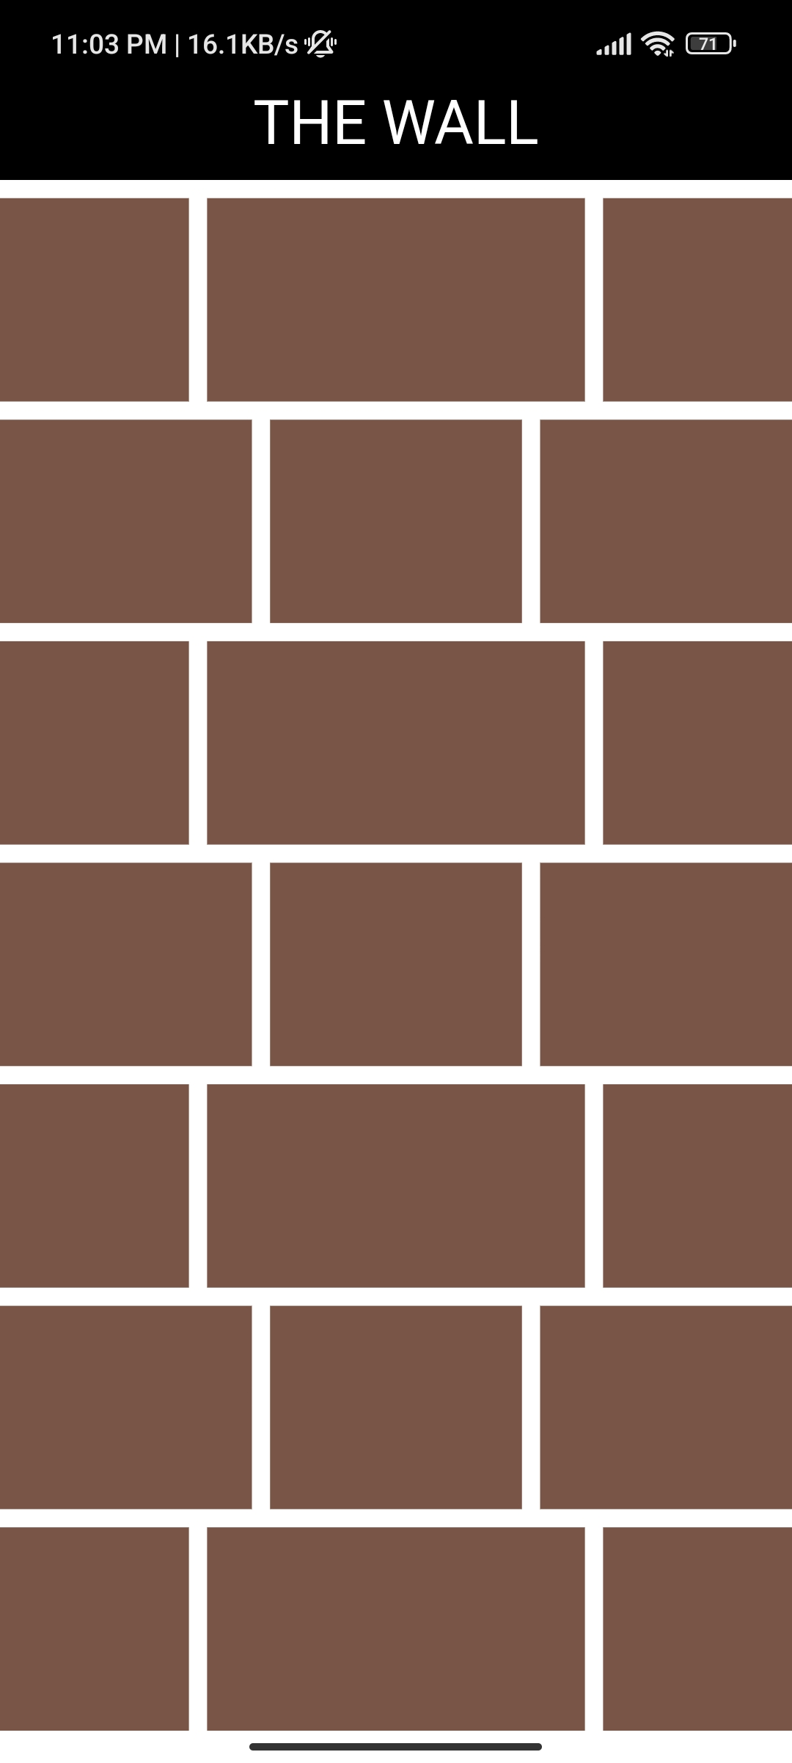

import 'package:flutter/material.dart';  
  
void main() {  
 runApp(const MyApp());  
}  
  
class MyApp extends StatelessWidget {  
 const MyApp({Key? key});  
  
 @override  
 Widget build(BuildContext context) {  
 return MaterialApp(  
 debugShowCheckedModeBanner: false,  
 home: Scaffold(  
 appBar: AppBar(  
 centerTitle: true,  
 title: const Text(  
 'SPLITTER',  
 style: TextStyle(color: Colors.*white*, fontSize: 20),  
 ),  
 backgroundColor: Colors.*black*,  
 ),  
 body: Column(  
 children: [  
 Expanded(  
 child: SingleChildScrollView(  
 child: Container(  
 color: Colors.*orangeAccent*,   
 child: Column(  
 children: List.generate(  
 10,  
 (index) => Container(  
 height: 90,  
 color: Colors.*yellow*.withOpacity(0.5),  
 margin: const EdgeInsets.symmetric(vertical: 5),  
 alignment: Alignment.*center*,  
 child: Text('Item ${index + 1}'),  
 ),  
 ),  
 ),  
 ),  
 ),  
 ),  
 Expanded(  
 child: SingleChildScrollView(  
 scrollDirection: Axis.horizontal,

child: Container(  
 color: Colors.*orangeAccent*,  
 child: Row(  
 children: List.generate(  
 10,  
 (index) => Container(  
  
 width: 90,  
 height:500,  
 color: Colors.*white*.withOpacity(0.7),  
 margin: const EdgeInsets.symmetric(horizontal: 5),  
 alignment: Alignment.*center*,  
 child: Text('Item ${index + 1}'),  
 ),  
 ),  
 ),  
 ),  
 ),  
 ),  
 ],  
 ),  
 ),  
 );  
 }  
}

