

Quotation
  - for Rooftop Solar System



{{system_details}} |  | Date: {{date}}
 | Quotation No. {{quotation_no}}

Consumer Information:
Name: {{consumer_name}}
Address: {{consumer_address}}
Phone: {{phone_number}}
Consumer No: {{cosumer_number}}

  - Pushparth Renewables
Pvt. Ltd.
Address: B-504, Shree Ram Empire, Pune
Email: pushparthrenewables@gmail.com
Phone: 9096289930 / 9579642999
Gst No: ASC

TIMELINE

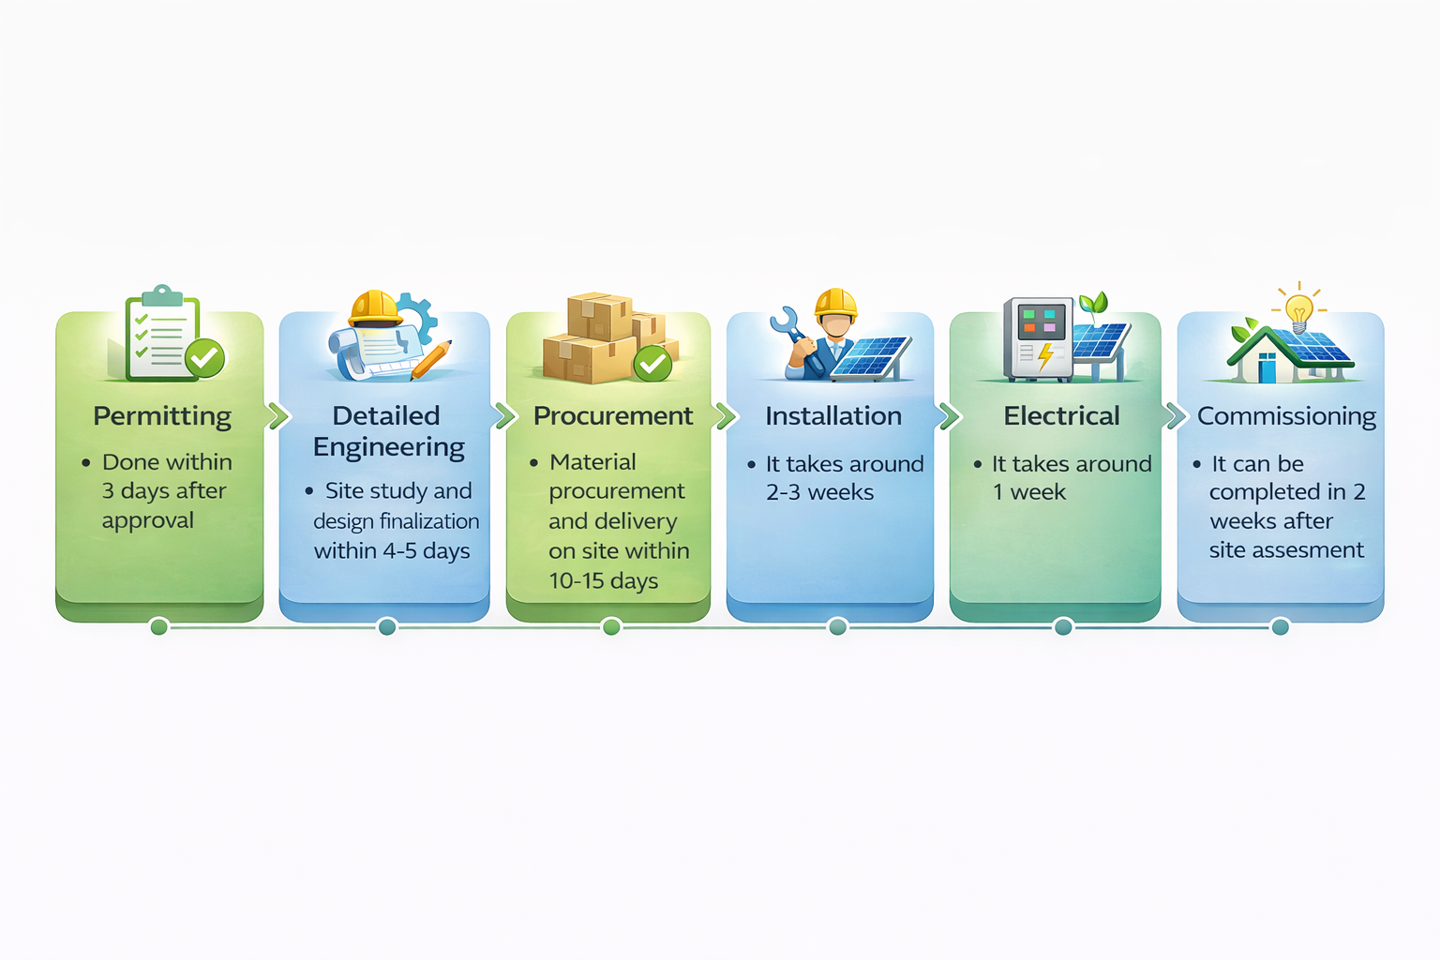
TIMELINE & MILESTONES

SYSTEM SPECIFICATION
Component | Brand | Specification | Warrenty
 Solar Panel | {{panel_brand}} | {{panel_specification}} | {{warranty}} warranty
 Inverter | {{inverter_brand}} | {{inverter_specification}} | {{warranty}} warranty
 Structure | - GI Structure (Hot Dip Galvanized)  - Designed as per site requirement  - Concrete foundation included  - Layout finalized during site visit
 Cables | {{cable_brand}} | {{warranty}} warranty
 Earthing & LA | - 3 Earthing Pits  - DC Earthing for panels  - AC Earthing for inverter  - Lightning Arrester included  - Copper bonded rods + chamber
Net & Generation Meter | Net Meter as per MSEDCL norms  Installation & documentation support included |  | 05 Years Standard
 Workmanship  & Service Warrenty | A) Workmanship Warranty is of 01 Year from the Date of Net Meter Installation  B) Solar Panel cleaning will not be a part of Service Warranty

COMMERCTIAL DETAILS

System costing for {{system_details}}

Sr. No. | Description | Amount
1 | System Cost | Rs. {{system_cost_without_gst}}
2 | GST (13.8%) on {{system_cost_without_gst}} | Rs. {{gst_amout}}
3 | Total Project Cost | Rs. {{actual_system_cost}}
4 | Eligible Subsidy | Rs. {{subsidy_amount}}
5 | Landed Cost to the Client | Rs. {{landed_cost}}
Anount in words: {{amount_in word}}

*Prices inclusive of material, installation & commissioning
Note: Net metering approval timelines are subject to DISCOM processes and are beyond our direct control.

PAYMENT TERMS & SCHEDULE:
- {{advanced}}% Advance
Payable at the time of order confirmation
- {{procurement}}% Procurement
Payable at the time of material procurement
- {{installation}}% During Installation
Payable after installation
- {{commisioning}}% On Commissioning
Payable after successful system commissioning
*All payments to be made via bank transfer in favor of Pushparth Renewables Pvt. Ltd.

BANK DETAILS:
Account Name:
Bank Name:
Account Number:
IFSC Code:
Branch:

TERMS & CONDITIONS
1. Scope of Work
The quoted price includes supply, installation, testing, and commissioning of the rooftop solar system.
2. Payment Terms
Payments shall be made as per the agreed payment schedule mentioned in this quotation.
3. Net Metering
Net metering approval timelines are subject to DISCOM processes and are beyond our direct control.
4. Project Timeline
Execution timeline may vary depending on site readiness and external approvals.
5. Warranty
• Solar Panels: As per manufacturer (up to 25 years)
• Inverter: As per manufacturer
• Workmanship: 1 year
6. Force Majeure
The company is not liable for delays due to unforeseen events such as natural disasters or government restrictions.
7. Validity
This quotation is valid for 15 days from the date of issue.

For Pushparth Renewables Pvt. Ltd.
____________________
Authorized Signatory

