2. This Assignment include selenium WebDriver, Docker for Grid, [Git](https://staragile.melimu.com/mod/quiz/view.php?id=6066) and [Git](https://staragile.melimu.com/mod/quiz/view.php?id=6066) hub along with [Jenkins](https://staragile.melimu.com/mod/quiz/view.php?id=6067) practice. Write Automation script for Amazon application using docker test it on three different browsers like chrome, Firefox and edge with selenium grid setup and

push your code on [git](https://staragile.melimu.com/mod/quiz/view.php?id=6066) hub and trigger job in [Jenkins](https://staragile.melimu.com/mod/quiz/view.php?id=6067) to print the result

**Step 1:** Automation Script for Amazon application

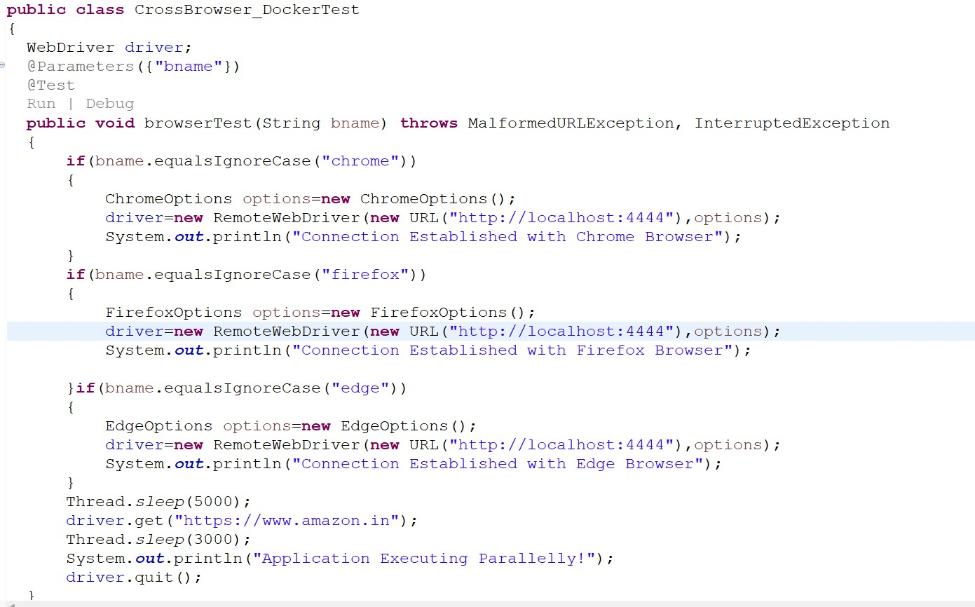

**Step 2:** TestNg.xml file

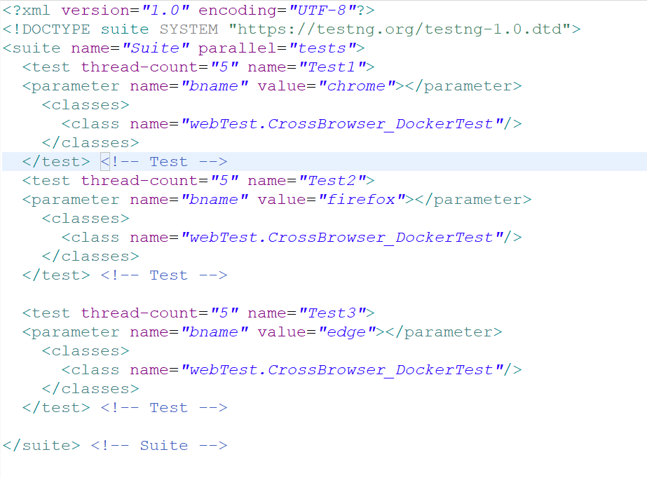

**Step 3:** Docker Server up and Running

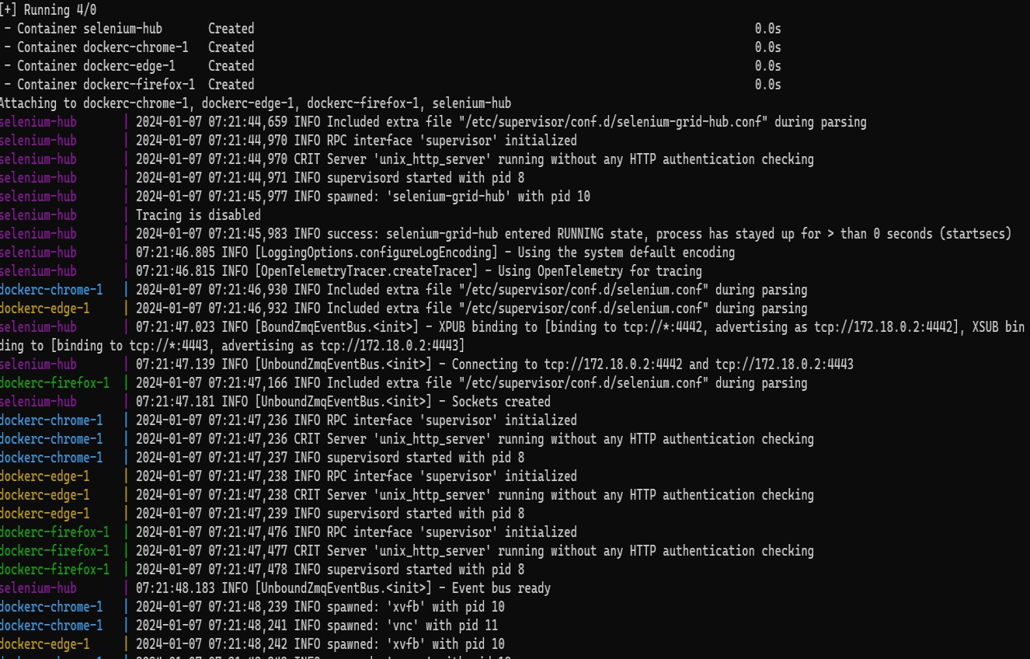

**Step 4:** Selenium Grid Connected

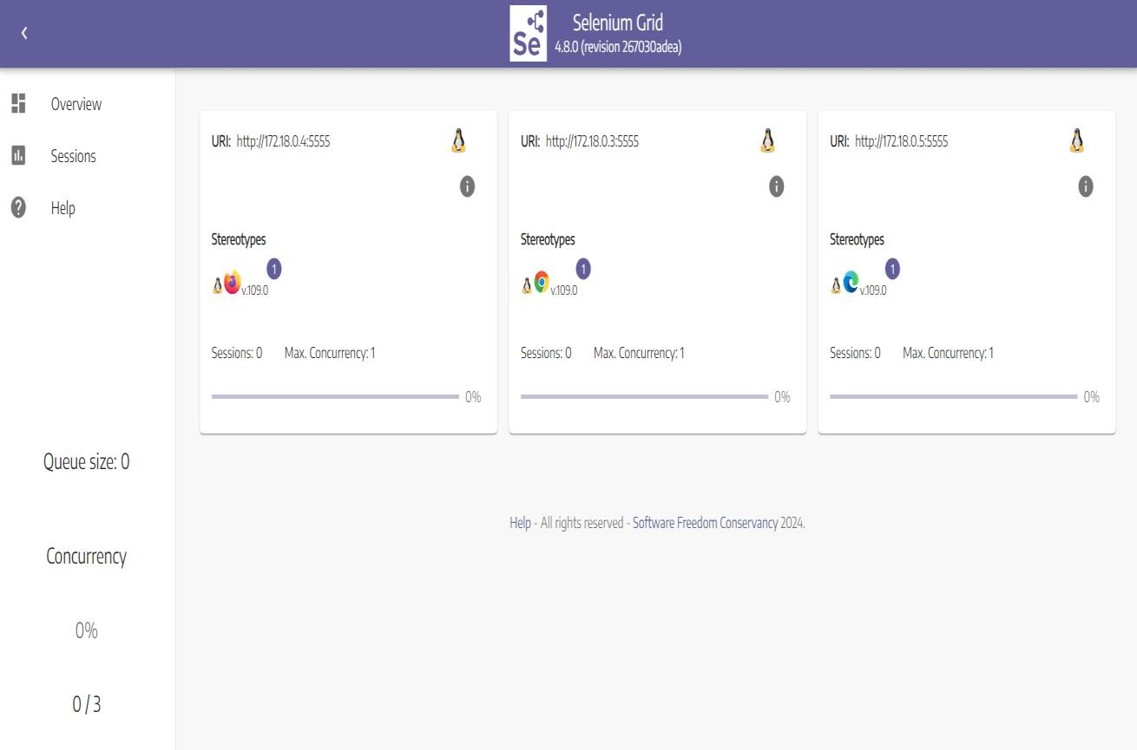

**Step 5:** Project uploaded on Git

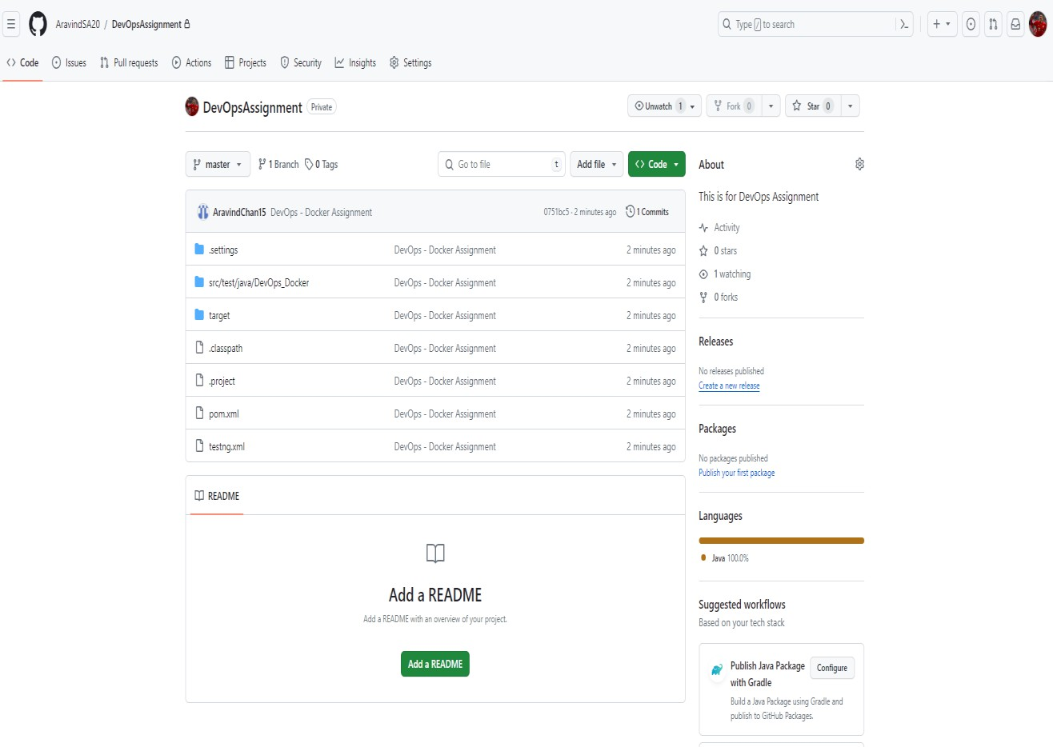

**Step 6:** Project Job Triggered in Jenkins as per SCM Change.

