AWS LAB - 2: Build your VPC and Launch a Web Server

Vishakha Maruti Sonmore (CSULB ID: 032188141)

College of Business, California State University, Long Beach

Course Number: I S 602 Sec08 12348 Management Information Systems

Instructor: Dr. Santos Galvez

Due date: 22-Oct-2023

**Lab 2: Build your VPC and Launch a Web Server**

In this laboratory exercise, you will be tasked with employing Amazon Virtual Private Cloud (VPC) to establish a personalized VPC and augment it with supplementary elements to construct a tailor-made network. Additionally, you will be responsible for crafting a security group. Following this, your assignment is to adjust and personalize an EC2 instance for web server operation and then initiate this EC2 instance to operate within a specific subnet contained within the VPC.

**Task 1: Explore the Users and Groups**

In this task, you will use the VPC and more option in the VPC console to create multiple resources, including a VPC, an Internet Gateway, a public subnet and a private subnet in a single Availability Zone, two route tables, and a NAT Gateway.

1.1 In the search box to the right of Services, search for and choose VPC to open the VPC console.

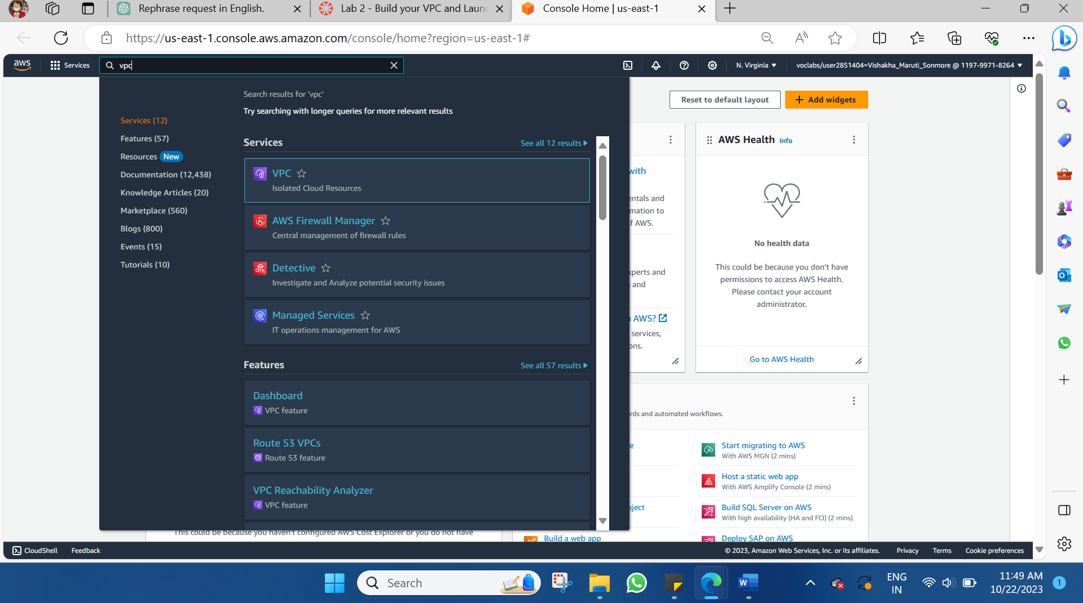

1.2 Choose the VPC dashboard link towards the top left of the console >> Next, choose Create VPC.

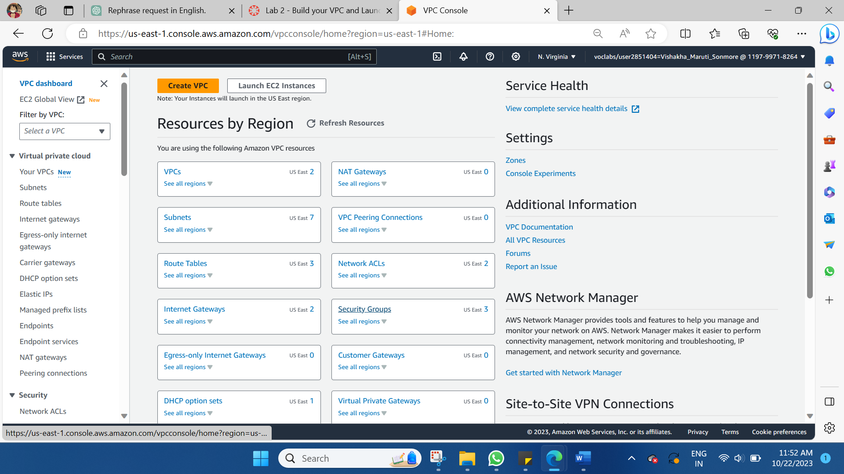

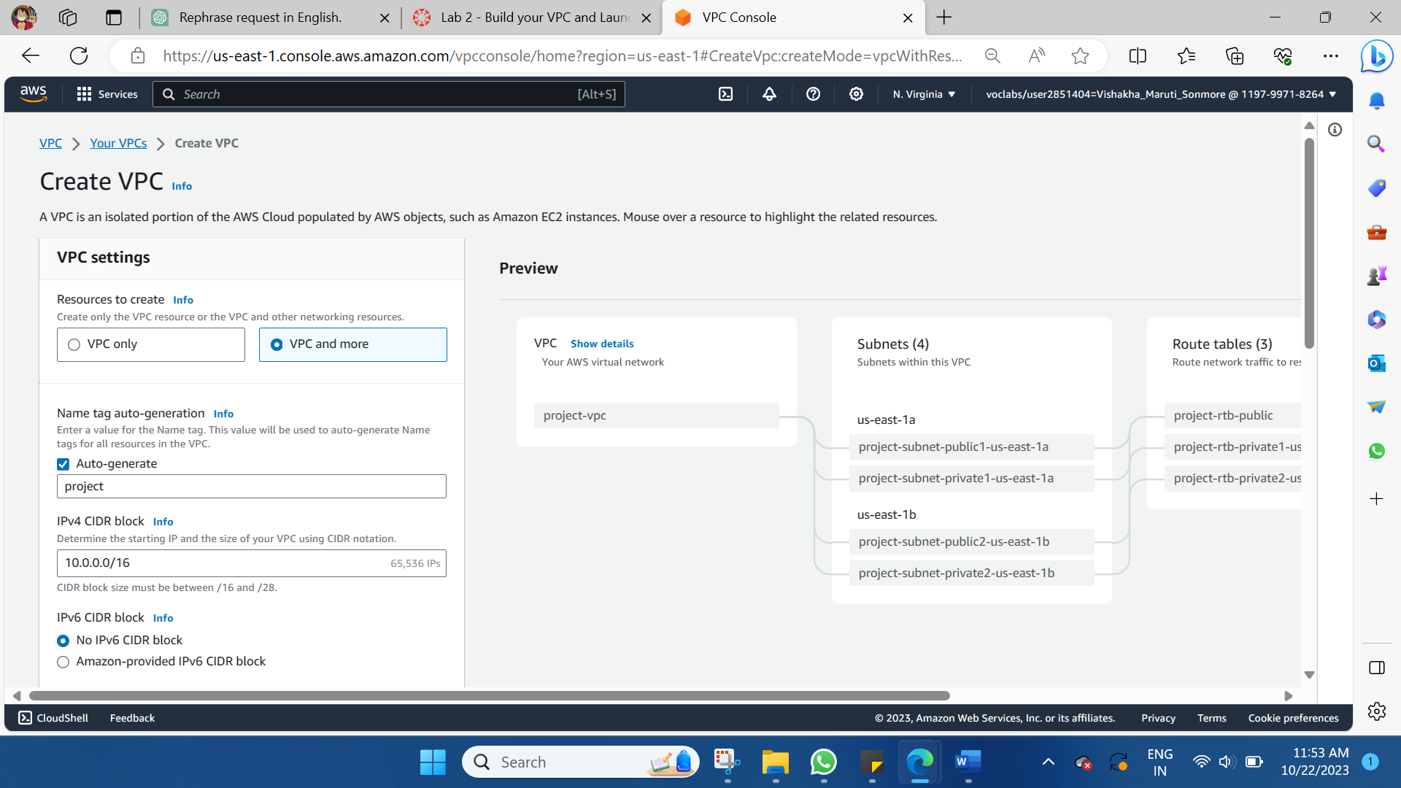

1.3 Configure the VPC details in the VPC settings panel on the left.

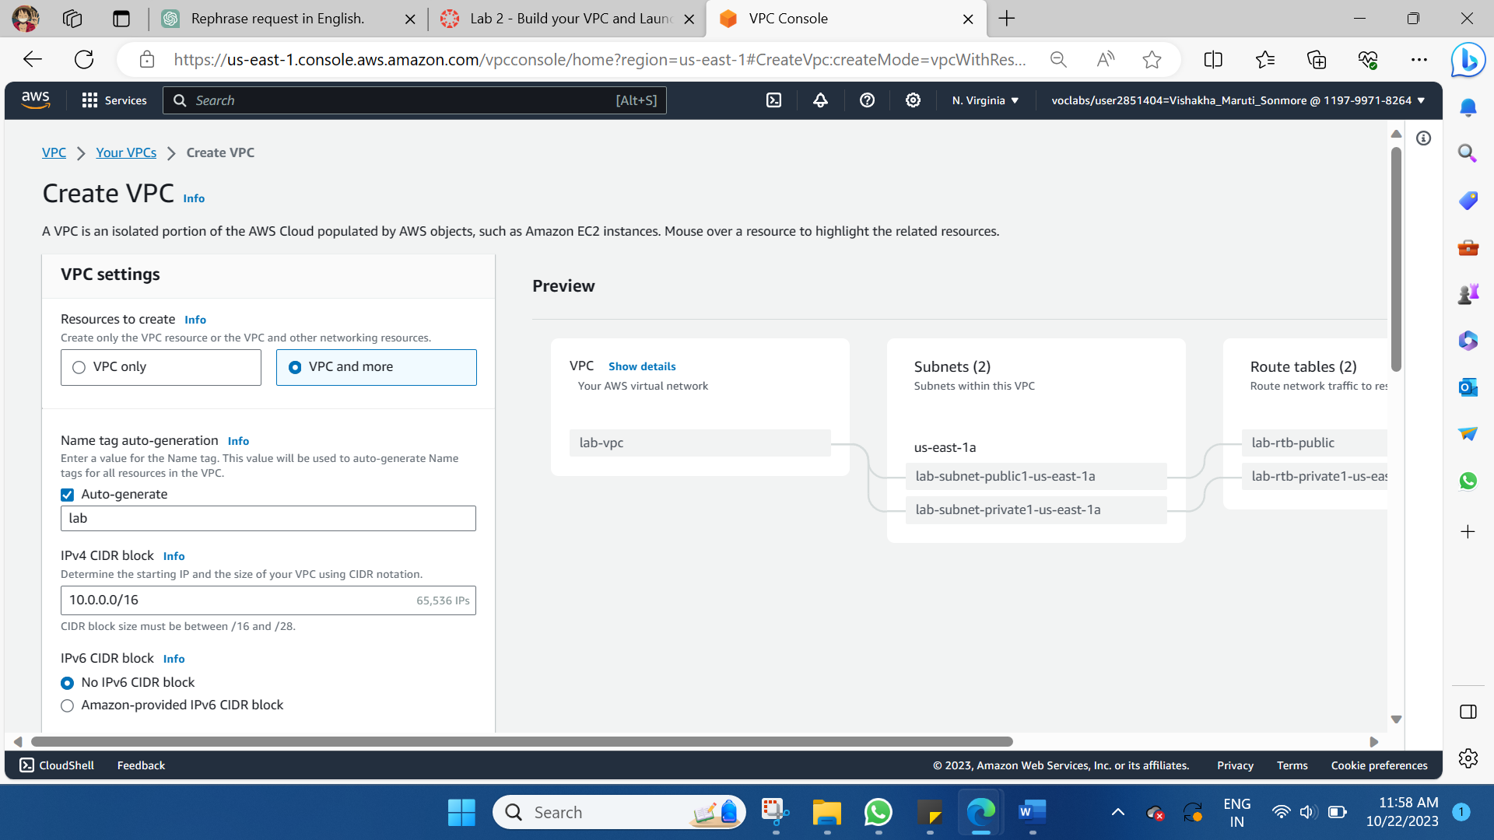

1.4 At the bottom of the screen, choose Create VPC. The VPC resources are created. The NAT Gateway will take a few minutes to activate.

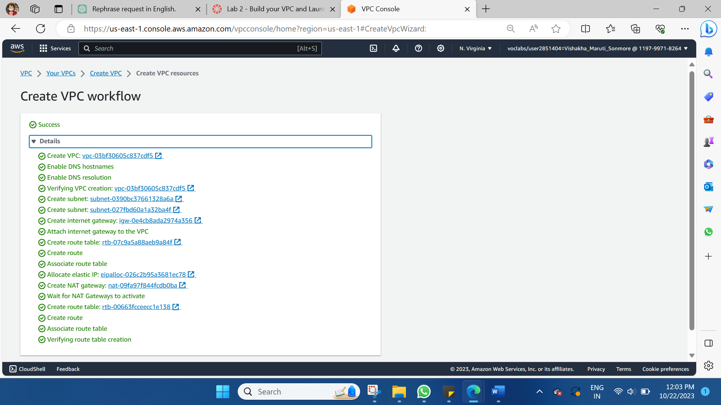

1.5 Once it is complete, choose View VPC.

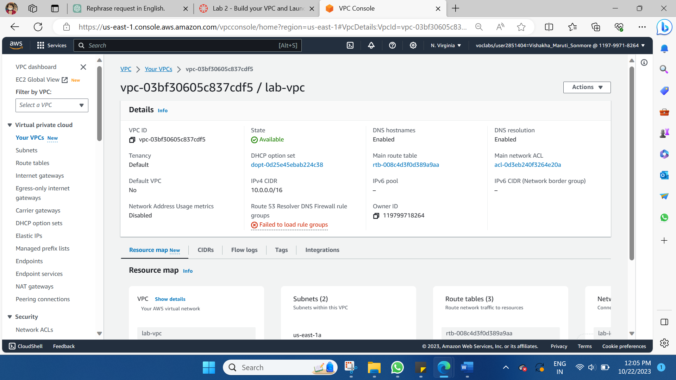

## Task 2: Create Additional Subnets

## In this task, you will create two additional subnets for the VPC in a second Availability Zone. Having subnets in multiple Availability Zones within a VPC is useful for deploying solutions that provide High Availability. After creating a VPC as you have already done, you can still configure it further, for example, by adding more subnets. Each subnet you create resides entirely within one Availability Zone.

2.1 Create subnet then configure

