02 SEPT 2023

CASE:1

**Name**Vishakha Maruti Sonmore

**University & College**College of Business, California State University Long Beach

**Professor/Faculty**Dr. Santos Galvez

**CSULB ID**032188141

**Subject/Class**IS 602: Management Information Systems

**Assignment Submission Date**

02-SEPT-2023

**TOPIC: NEW TECHNOLOGY AT UPS CLASHES WITH OUTDATED WAYS OF WORKING**

**Question 1. Identify the problem faced by UPS. Was it a technology problem, an organizational problem, or a management problem?**

UPS was not been as competitive as it could be in market compare to other companies prior to its investments in technology & automation because of critical aspects of its operations and way of working which were encumbered with obsolete technology and manual procedures affecting their production outcomes.

In my opinion, UPS saddened with challenges due to mixed blend of Technology, Organizational and Management issues due to one or other reason resulting instability in business strategies, process management and execution prior automization came in picture.

Technology Limitations with previous (non-automated) process:

1. **Manual Processes**:
   1. Package movers being handled using 30-year-old equipment and manual processes.
   2. Worker was required to align each box so that a scanner can read the delivery label on the front, top, or one side. Each “touch” increases the chance of a sorting error or damage to the package.
2. **High operating cost due to no monitoring system:** Missorted packages can add an extra day to a UPS delivery, degrading customer service and adding to operating costs.
3. **Accuracy in sorting**: No accuracy of the sorting, also no mechanism to analyse company data to optimize delivery routes in order to provide better forecasts of shipping volume without any automated system.

Management Issue:

1. **Taking critical business decisions**: Even though improvement areas were known how soon it could have been processed was questionable. Example: UPS initially applied a “band-aid” approach to dealing with mushrooming e-commerce shipments. It would add extra shifts, extend working hours, or retrofit parts of older buildings with new equipment. But UPS management knows it has to rectify this situation to remain competitive in the twenty-first century and be able to handle the new distribution requirements posed by e-commerce.
2. UPS was unionized.
3. Procedures were not improved.

Organisational Issues:

1. **Operation’s approach:** In the past, most of the shipments handled by UPS went to retailers and business corporations.
2. **Outdated procedures:** Trying to use outdated shipping technology and procedures in the new e-commerce environment had caused UPS to lose business.
3. **Delivery delays led to lose customers:** Bottlenecks from being overwhelmed at times by online orders created delays that drove some health care, industrial, and other corporate customers to switch to other suppliers.
4. **Organisations hierarchy:** The union has opposed technology such as drones and self-driving vehicles and is concerned about changes that can perform the same work with fewer employees leading delay in improvement area rectification.
5. **Budget:** The cost of new machines to automate an older facility had become low enough for UPS to both retrofit older facilities and build new ones.
6. **Transit issues:** Workers would have to memorize hundreds of zip codes to know where to place parcels & with old system it was doubling the efforts to deliver parcel correctly.

**Question 2. Describe the solution to this problem pursued by UPS? Is this a successful solution? Why or why not?**

According to case study, UPS invested in information technology to help being competitive in the package delivery market rectifying their technology issues with automations and upgrade procedures for betterment of their services. The company had invested $20 billion between year 2019 -2022 to effectively meet twenty-first century shopping and shipping trends. Much of their plans were focused towards new mechanized shipping and warehousing facilities, including seven “super hubs,”.

I believe the decision to adapt the technology change and investing in proposed solution can be considered as the fruitful step due to below few notable outcomes of the solution.

1. **Improving quality of services:** According to the case study, the implementation of automation improved sorting accuracy, decreased the number of "touches" that package received, and produced data for planning the best delivery routes and predicting shipment volume. It also aided UPS in managing the holidays and high-volume deliveries.
2. **Elimination human error while processing:** With new automated hardware facility scanners was able to read a package’s destination and use equipment called shoe pucks to push packages down the proper chute eliminating human error as compare to at an older way, less automated facility, package use to receives four “touches,” with each “touch” representing an act of handling counting more errors.
3. **Less human intervention:** There is no human element in rerouting a package required as with six-sided scanner boxes are scanned, sorted by destination, and sent to outbound vehicles via machines.
4. **Advance Software:** 
   1. Leading the sorting network software that helped managing package flow, facilities.
   2. Wireless Bluetooth receivers inside delivery trucks to reduce the likelihood of misloaded packages to avoid the delays and provide customers with more details about upcoming deliveries increased customer fulfilments.
   3. New technology made it possible for UPS processing facility managers to understand trend of packages delivery at each stage, which helped them to plan human resources, efforts, production & delivery strategies.
5. **Analytics helped constructing forecasts:** Automation not only improved accuracy of the sorting, but also provided data to help the company optimize delivery strategy considering cost optimization for budgeting and companies’ turnovers.
6. **Upgrading consumer network:** Upgraded shipments reach not only limited to retailers and business corporations but also to individual households who have purchased an item or two online using the Internet creating the huge network.
7. **New employment opportunities**: In few cases, new automation system has helped UPS create new jobs. For example, a new automated UPS package delivery canter in northwest Houston has created 575 full and part-time jobs. The 238,000-square-foot canter added 300 trucks to the company’s delivery fleet in the Houston area.

Collectively the solution has not only provided the way to stabilize the services in market but also fixed few of organisational & operational issues.

**Question 3. Diagram the package sorting process at UPS before and after automation**

Before automation: After automation:

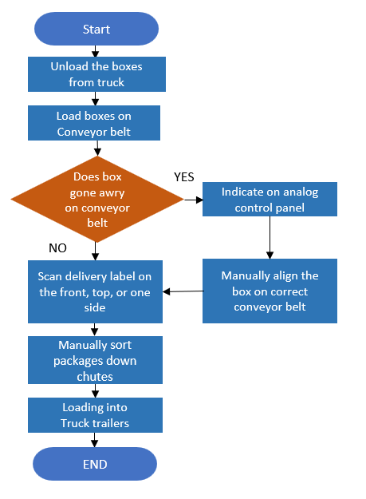 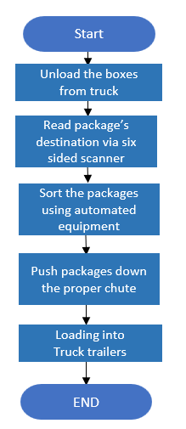

**Question 4. How did automated package sorting change operations and decision making at UPS?**

* 1. **Accuracy**: Implementation of automation improved sorting accuracy, decreased the number of "touches" that package received, and produced data for planning the best delivery routes and predicting shipment volume to support high volume deliveries.
  2. **Avoid human error**: With new automated facility six sided scanners were able to read a package’s destination and use equipment to push packages down the proper chute eliminating human error avoiding re-work and manual efforts.
  3. **Efficiency**: By reducing the number of "touches" that package receives, the automated technique has made sorting parcels more precise increasing effectiveness of the system.
  4. **Data-driven Software:** Sorting network software that helped managing package flow, facilities plan delivery routes, and distribute resources sensibly.
  5. **Strategical business decisions:** Automation not only improved accuracy of the sorting, but also provided data to help company optimize delivery strategy considering cost optimization for budgeting and companies’ turnovers basis result given by data driven software resulting lower operational costs.
  6. **Streamlined procedure** resulting into more efficient way of executions.
  7. **Customer Experience:** Upgraded shipments reach not only limited to retailers and business corporations but also to individual households who have purchased an item or two online using the Internet creating the huge network.

**References**

* UPS, “UPS Kicks Off 2020 Capacity Expansion with Multi-Facility Announcement in Pennsylvania,” January 29, 2020; www.ups.com, accessed April 30, 2020;
* Katherine Feser, “UPS Package Delivery Facility in NW Houston Creates 575 Jobs,” Chron, January 17, 2019;
* Bloomberg, “UPS Sees Payoff from $20BN Tech Bet,” Supply Chain Brain, April 24, 2018;
* [Flow diagram (simplified) of UPS delivery operation. | (researchgate.net)](https://www.researchgate.net/figure/Flow-diagram-simplified-of-UPS-delivery-operation_fig2_349961514)