**USER MANUAL**

Data Copy Tool (DCT)

**Prepared By:** Business Analysts

**Date: 07 April 2020**

**Company Name – Larsen & Toubro InfoTech (LTI)**

**USER MANUAL**

**SYSTEM PREFACE**

* The purpose of this product is to have robust generic data copy tool having User Interface.
* Data to be copied from Schema to schema level in same database and Data to be copied from Schema to Schema level having different databases
* User should be able to create the queries without Knowledge of database.
* User should be able to create reports using different reporting tools source as different databases.

**SYSTEM OVERVIEW**

* The scope of this product is to have robust generic data copy tool having User Interface.
* Data to be copied from Schema to schema level in same database and Data to be copied from Schema to Schema level having different databases
* User should be able to create reports using different reporting tools source as different databases.
* The objective and goal is to have robust tool where data can be copied from higher environments(Production, Pre Production) to lower environment (Development, Testing) based on needs of individual teams, for e.g to perform tests in testing environment or to perform tests in development environment, Movement of data from one database to another databases.
* Benefits – As this tool will have user interface people with no knowledge on database can copy data from schema to schema or from one data base to another database, Tool is user friendly and easy to use.
* Eliminates external team dependency
* An interactive dashboard for monitoring operations
* Time saving and cost saving as with few clicks user will be able to get copy data from schema to schema.

**USER MANUAL**

**STEPS FOR SYSTEM FUNCTIONS**

**Steps of System Functions will give in detail about how Data Copy Tool can be used by the end users:**

**Setup** – Install Data Copy Tool (DCT) on your computer.

**Note**- Details of the tool set up to be given when is software will be running live.

1. **Home Page >> Login section:**

User should have access to Source DB and Target DB and authenticate to go ahead with the process of data copy, valid values to be entered in given below fields

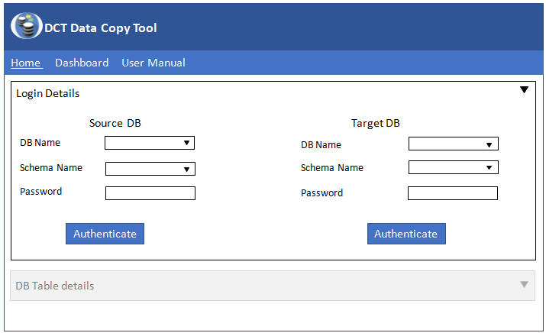

1. **Home Page >> DB Details section:**

After user authentication DB Table details section will be enabled and user will have three mode to copy data. Select the table name, copy Type based on individual users and Click on “**Submit**” button

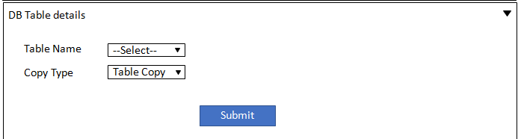

Table Copy will copy entire table data from one schema to another specified schema.

Partition Copy will copy Data from one schema to another specified schema based on the partition applied.

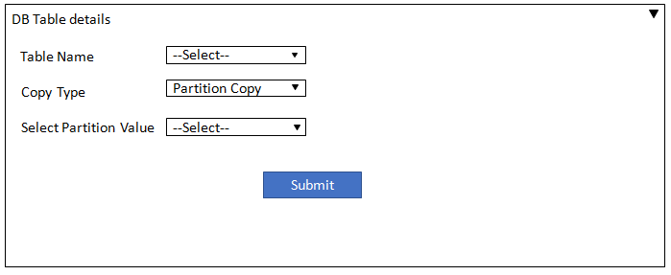

Customize Copy will copy Data from one schema to another specified schema based on the query designed.

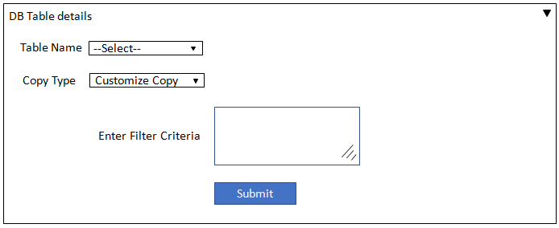

1. **Dashboard**

After Request is submitted a Job ID is created to have a track of how many Jobs are submitted and details of the same will displayed as given in below screenshot

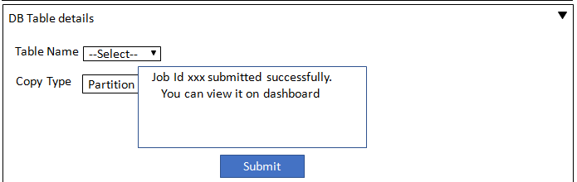

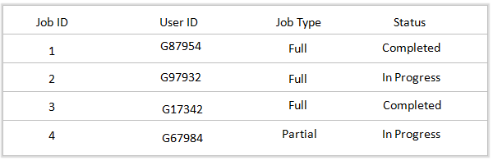

A exported dump file (.dmp) is stored in the specific folder from one schema and this file will be imported back to another schema through command prompt, this is automatically done by Java code.

These steps will help us to copy data from one schema to another schema.

**SYSTEM REFERENCES**

As this software has basic functionalities and a newly developed, references will be added as and when we start working on enhancements and when we have references.

**POINTS OF CONTACTS**

In case of any guidance reach to below contacts:

Product Owner – Amrish Singh, Email ID - [amrish.singh@lntinfotech.com](mailto:amrish.singh@lntinfotech.com)

Scrum Master – Merline Thangiah, Email ID [merline.thangiah@lntinfotech.com](mailto:merline.thangiah@lntinfotech.com)

**AUTHORIZED USE OF SYSTEM**

This tool is not a copyright as this is not a full proof and still in development phase so this section remains NA for now.

**ACRONYMS & ABBRIVIATIONS**

DCT - Data Copy Tool

**Blue Print**

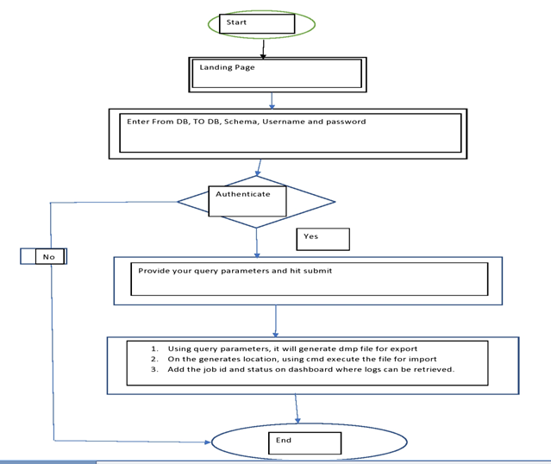

**USER MANUAL**

**USER MANUAL**