1. Initial Page load – highlighted min/max GPA rows

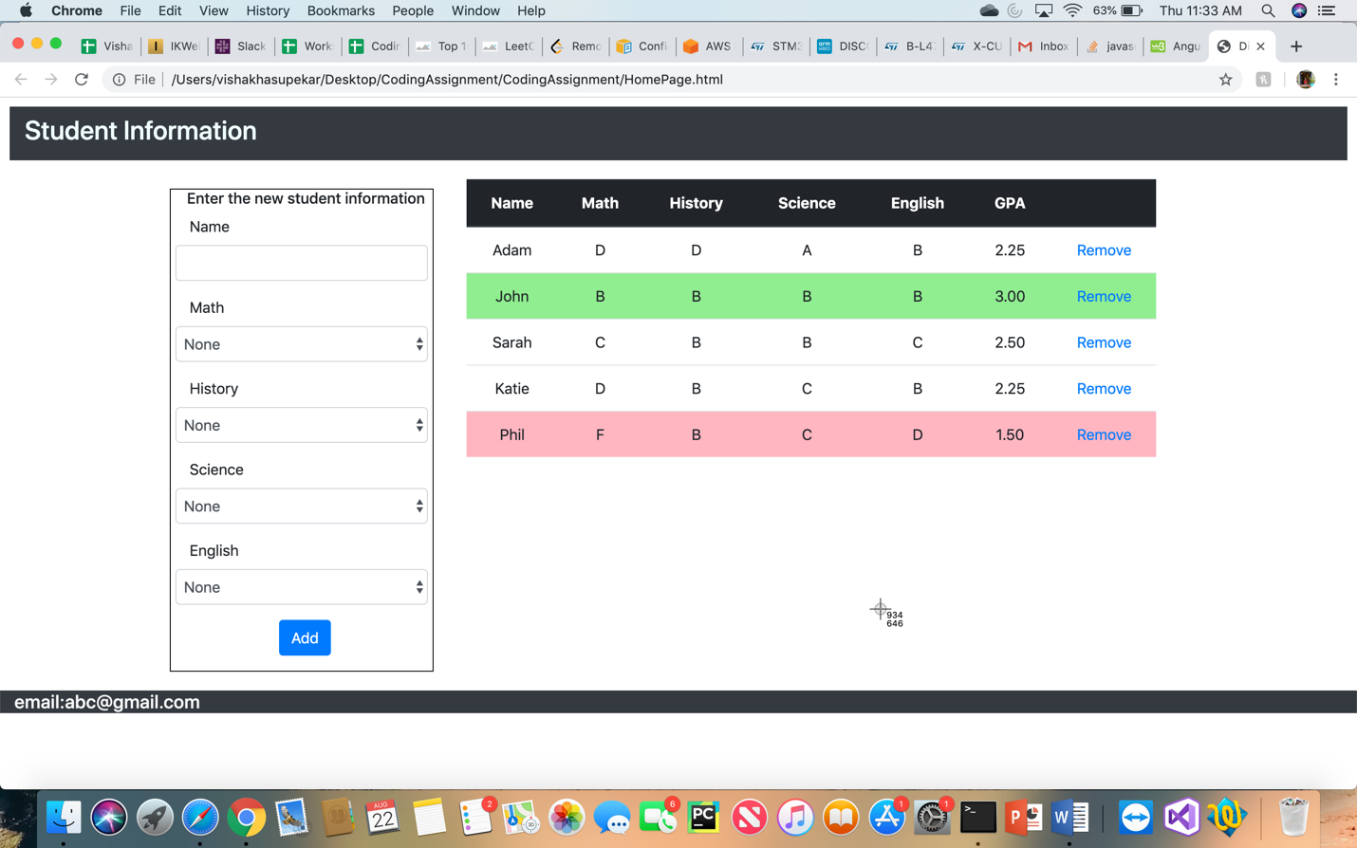

2. Validation – all fields should be filled before student record can be added to table

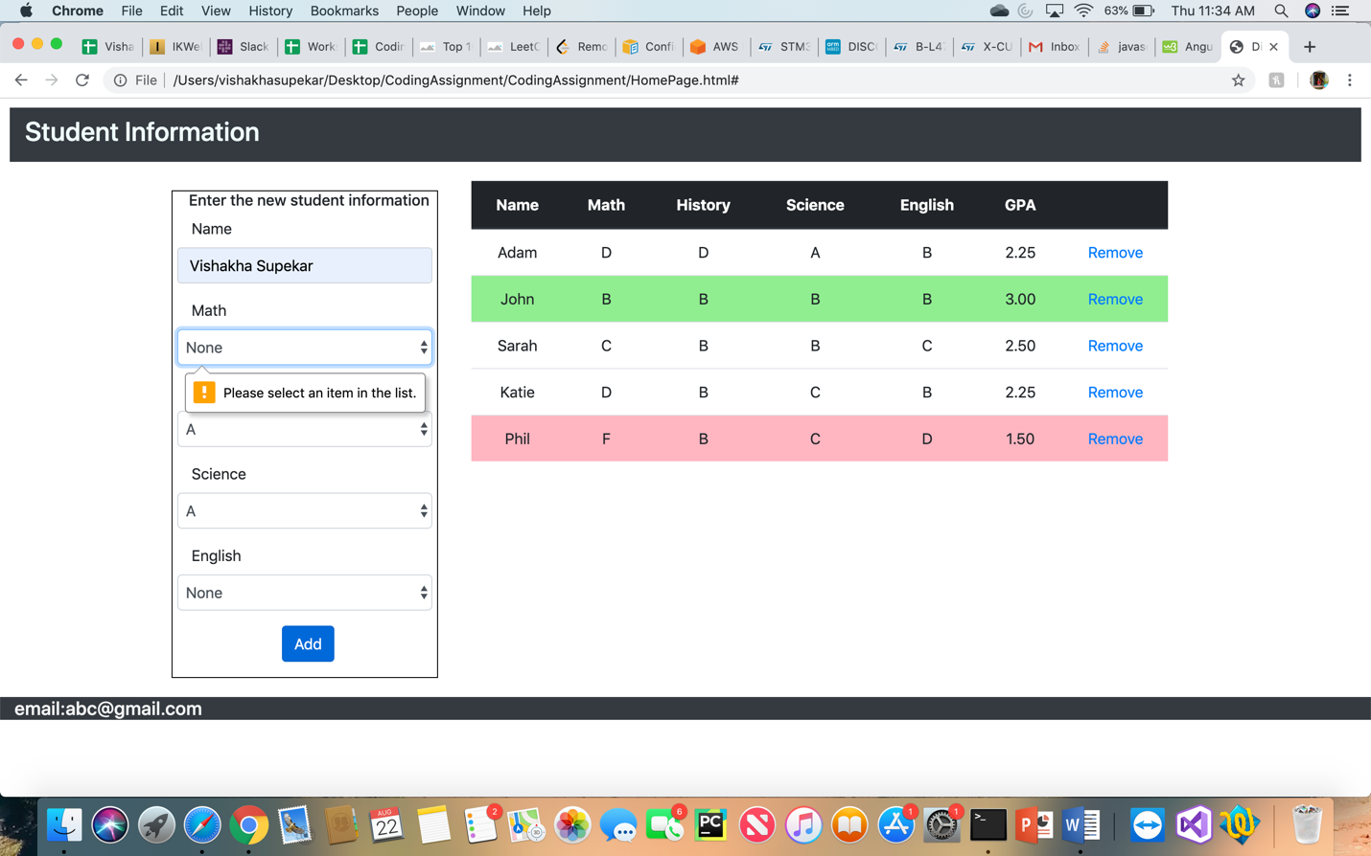

3. Add Student ‘Vishakha Supekar’ - the highlighted max GPA row changes

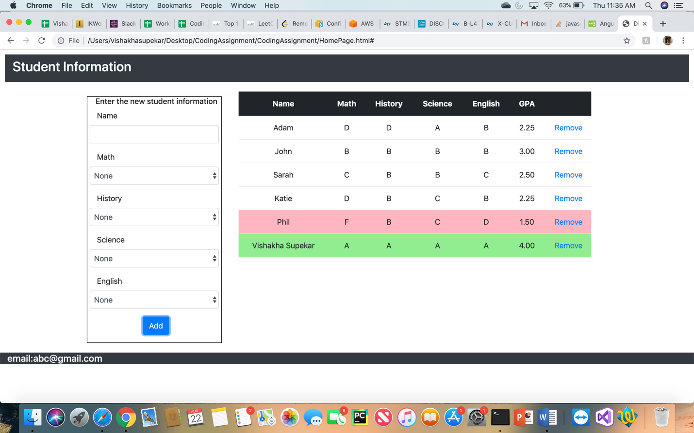

4. Remove row – record ‘Phil’ deleted, and min GPA row is updated (multiple min GPA rows)

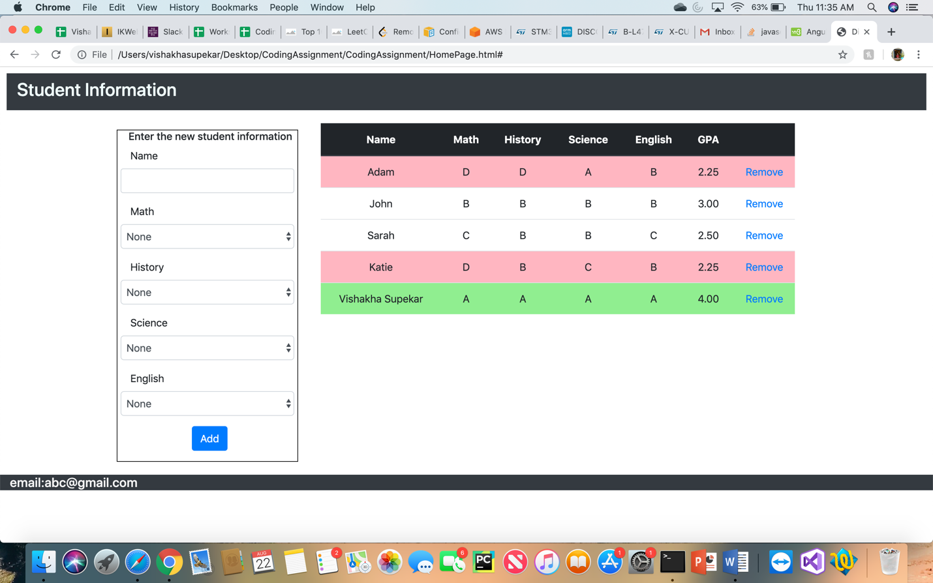

5. Remove Max-GPA row – ‘Vishakha Supekar’ deleted and max GPA row updated

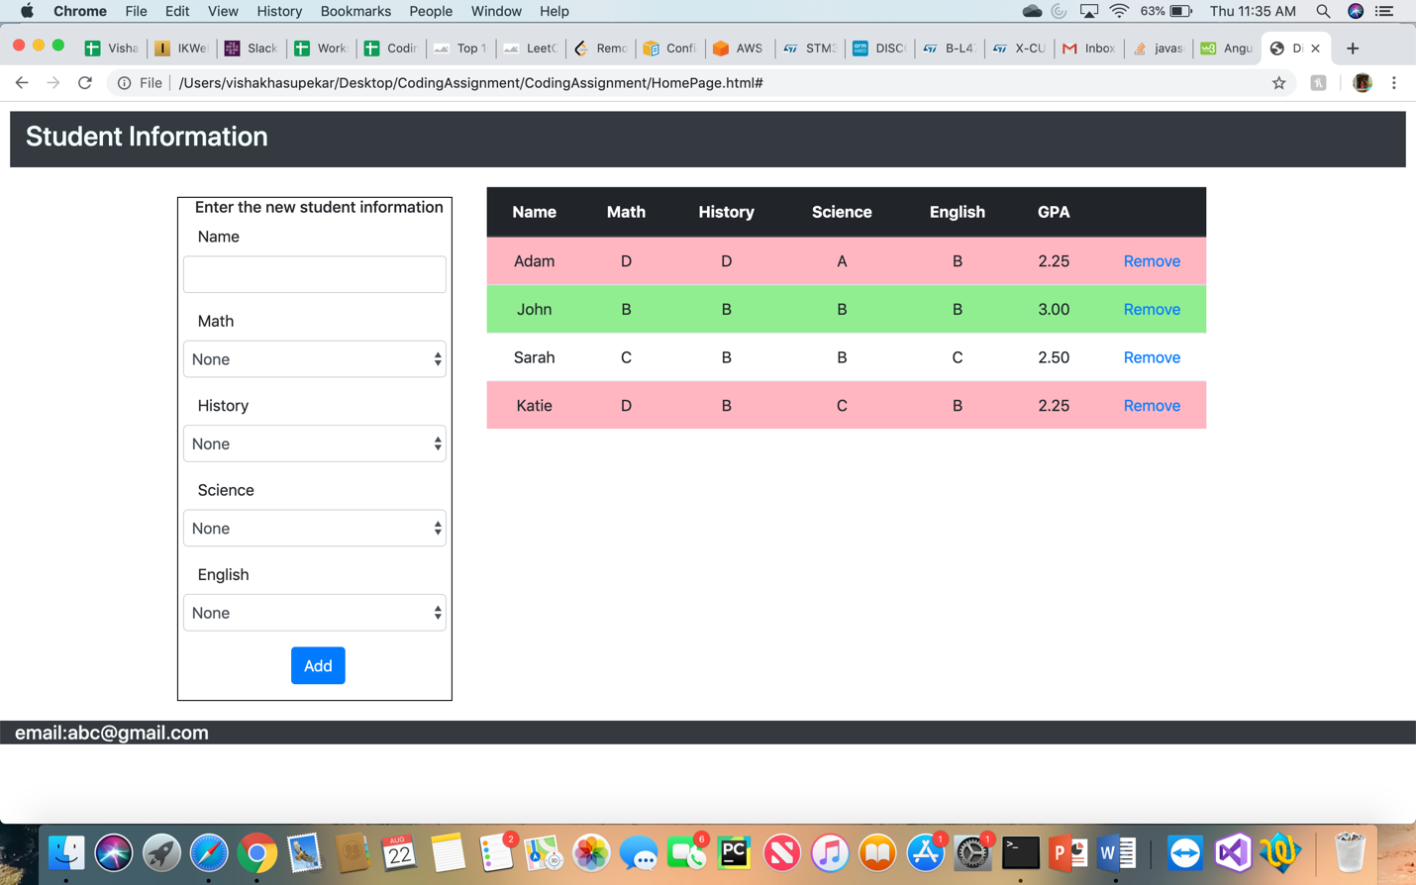

6. Multiple highlighted rows.

