Real vs. AI-Generated Face Classification
Using Transfer Learning with MobileNetV3-Large
Milestone 3 Submission
Model Architecture Selection, Justification, Baseline Performance & Hyperparameter Tuning
DSAI Group 11
Submission Deadline: 23 July 2026
Document Prepared: 20 July 2026

Table of Contents
1. Introduction & Problem Statement
2. Model Architecture Selection
3. Architecture Justification
4. Candidate Dataset (Subset) for Rapid Experimentation
5. Baseline Model Performance
6. Hyperparameter Tuning
7. End-to-End Modelling Pipeline
8. Architecture & Pipeline Visualization
9. Conclusion & Next Steps

1. Introduction & Problem Statement
This project addresses a binary image classification problem: distinguishing authentic photographic human faces (“Real”) from synthetic faces produced by generative diffusion models (“Fake” / AI-Generated). This capability is directly relevant to synthetic media detection, platform content moderation, and identity-verification pipelines, where distinguishing genuine facial photographs from generated imagery is increasingly important as diffusion-based generators become more photorealistic.
The current milestone (M3) focuses on selecting and justifying a model architecture, establishing a baseline using a representative data subset, performing staged hyperparameter tuning, and documenting the complete end-to-end modelling pipeline. Full-dataset training and deeper evaluation are planned for Milestone 4.

2. Model Architecture Selection
The selected architecture for this milestone is MobileNetV3-Large, initialised with ImageNet-pretrained weights and adapted for binary classification (Real vs. Fake) via transfer learning.

2.1 Overall Approach
A single primary architecture (MobileNetV3-Large) was selected for in-depth experimentation this milestone. Rather than training in a single pass, a two-stage progressive fine-tuning strategy is used:
- Stage 1 — Classifier Warm-up (Baseline): the pretrained convolutional backbone is fully frozen; only a newly-attached classification head is trained. This produces the baseline reported in Section 5.
- Stage 2 — Partial Backbone Fine-Tuning (Tuned Model): the last 25% of the backbone's inverted-residual blocks (blocks 12–16 of 17) are unfrozen and trained jointly with the head at a much lower learning rate, allowing the network to adapt its higher-level features to the specific texture and frequency artefacts of diffusion-generated faces.
The candidate data subset described in Section 4 was deliberately built to support cheap, rapid comparison of architectures and hyperparameter settings. While MobileNetV3-Large is the architecture carried through full experimentation in this milestone, it was chosen after weighing it against the alternative families discussed in Section 3.2 (larger CNNs such as ResNet-50/EfficientNet-B0, and Vision Transformers). Should validation results on the full dataset in Milestone 4 suggest headroom, the same subset-based workflow established here will be reused to screen these alternatives before committing to full-scale training.

3. Architecture Justification

3.1 Suitability for the Dataset and Problem Statement
The classification task operates on fixed-size 224×224 RGB face crops with a binary label. The discriminating signal between real and diffusion-generated faces is known from the literature to lie substantially in fine-grained texture, frequency-domain, and local-consistency cues rather than high-level semantic content — both classes are photorealistic human faces. This favours a convolutional architecture with strong low-to-mid level feature extraction, which MobileNetV3-Large provides through its inverted-residual blocks, squeeze-and-excitation attention modules, and h-swish activations (Howard et al., 2019, “Searching for MobileNetV3”).
The dataset (both the full corpus and the candidate subset) is comparatively modest in size relative to ImageNet-scale corpora, which makes a pretrained, parameter-efficient backbone preferable to training a large network from scratch.

3.2 Expected Advantages over Alternative Approaches
- Vs. larger CNNs (ResNet-50, EfficientNet-B0/B3, VGG-16): MobileNetV3-Large has roughly an order of magnitude fewer parameters and FLOPs, enabling faster epochs (~150–190s/epoch observed on a single Tesla T4 GPU) — critical for the rapid, iterative experimentation this milestone calls for on the candidate subset, and for eventual on-device / low-latency deployment of a detector.
- Vs. training a custom CNN from scratch: ImageNet-pretrained weights already encode generic edge, texture, and shape detectors that transfer well to face-realism discrimination, reducing data requirements and yielding very fast convergence (>98% validation accuracy after a single epoch of head-only training, see Section 5).
- Vs. Vision Transformers (ViT/DeiT): transformer-based backbones typically need larger training corpora or heavier augmentation/distillation to match CNN performance at this data scale, and lack the strong locality inductive bias that helps detect local generative artefacts.

3.3 Design Decisions & Modifications to the Original Architecture
- Classifier head replacement: the original 1000-way ImageNet head (Linear(960→1280) → Hardswish → Dropout(0.2) → Linear(1280→1000)) has its final layer replaced with Linear(1280→2) for the Real/Fake decision.
- Staged freezing schedule: full backbone freeze in Stage 1, followed by unfreezing only the last 25% of feature blocks (blocks 12–16 of 17) in Stage 2 — a conservative ratio chosen to adapt high-level features to the new domain while preserving robust low-level ImageNet filters and limiting overfitting risk on a ~24K-image subset.
- Differential learning rates: 3×10⁻⁴ for the classifier-only stage vs. 1×10⁻⁵ for the fine-tuning stage — a ~30× reduction to avoid catastrophic forgetting of pretrained representations while still allowing gradual adaptation.
- Optimiser & scheduling: AdamW (weight decay 1×10⁻⁴) with CosineAnnealingLR in both stages, for smooth learning-rate decay and improved generalisation over a fixed or step schedule.
- Mixed-precision training (torch.cuda.amp): used throughout to reduce memory footprint and roughly double throughput on the T4 GPU without materially affecting accuracy.

3.4 Challenges & Tradeoffs Considered
- Capacity vs. speed: a lightweight architecture may have less representational headroom than larger networks for very high-quality or adversarially-optimised fakes; this tradeoff was accepted in favour of iteration speed at this milestone, to be re-examined in Milestone 4 with the full dataset.
- Underfitting vs. overfitting from freezing: freezing the entire backbone risks underfitting domain-specific diffusion artefacts, while unfreezing too much risks overfitting on a comparatively small subset; the 25% unfreeze ratio combined with a very low fine-tuning learning rate was chosen as a conservative middle ground, and its effect is validated empirically in Section 6.
- Class imbalance: the available Fake class (9,001 images) is smaller than the available Real class (70,000 images). This was handled via stratified sampling/splitting so that class proportions are preserved across train/validation/test partitions; explicit class-weighting or oversampling was not yet applied and is flagged as a candidate refinement for Milestone 4 if the full (more imbalanced) dataset shows degraded minority-class recall.

3.5 References
- Howard, A. et al. (2019). “Searching for MobileNetV3.” IEEE/CVF International Conference on Computer Vision (ICCV).
- Yosinski, J., Clune, J., Bengio, Y., & Lipson, H. (2014). “How transferable are features in deep neural networks?” Advances in Neural Information Processing Systems (NeurIPS).
- PyTorch / TorchVision documentation — MobileNet V3 model and MobileNet_V3_Large_Weights.DEFAULT (ImageNet-pretrained) reference implementation used as the backbone in this project.

4. Candidate Dataset (Subset) for Rapid Experimentation
In line with the milestone guidance to avoid experimenting directly on the complete dataset, a representative candidate subset was constructed for fast architecture and hyperparameter comparisons.

4.1 Full Dataset Composition
Class | Source | Total Images Available
Real | FFHQ subset — “real-vs-ai-generated-faces-dataset” (philosopher0808) | 70,000
Fake (AI-Generated) | Stable Diffusion generated faces (mohannadaymansalah) | 9,001
Note: an earlier candidate Fake data source (a Stable-Diffusion v2.1, denoising-strength-0.7 dataset from arshsefarsh) is retained in the notebook as commented-out configuration; the team has since standardised on the larger, publicly available datasets listed above for broader coverage.

4.2 Subset Construction
The subset is created by capping the number of images drawn per class at IMAGES_PER_CLASS = 15,000, after randomly shuffling each class's file list (seed = 42 for reproducibility):
- Real: 15,000 images randomly sampled (without replacement) from the 70,000 available.
- Fake: all 9,001 available images are used, since this is below the 15,000 cap.
- Resulting candidate subset: 24,001 images total (15,000 Real + 9,001 Fake).

4.3 Why the Subset is Representative
- Uniform random sampling (no filtering by sub-source, resolution, or other attributes) preserves the same underlying visual distribution as the full corpus for the Real class.
- The entire Fake class is retained, so no information is lost for that class at this stage.
- A fixed random seed (42) makes the subset reproducible across team members and reruns.
- Stratified splitting (Section 4.4) preserves the original class ratio in every partition, avoiding sampling bias in validation/test estimates.
- At 24,001 images, the subset is large enough for statistically stable validation and test metrics, while keeping an epoch to ~150 training batches (batch size 128) — approximately 150–190 seconds/epoch on a single T4 GPU — fast enough to support the staged tuning experiments in Section 6.

4.4 Train / Validation / Test Split
The subset is split using stratified sampling (by label) to preserve class balance: 80% train, then the remaining 20% is split evenly into 10% validation and 10% test.
Split | Total Images | Real (label 0) | Fake (label 1)
Train | 19,200 (80%) | 12,000 | 7,200
Validation | 2,400 (10%) | 1,500 | 900
Test | 2,401 (10%) | 1,500 | 901

5. Baseline Model Performance
The baseline corresponds to Stage 1 of the pipeline: MobileNetV3-Large with ImageNet-pretrained weights, the entire convolutional backbone frozen, and only the newly-attached classifier head trained. This reflects the model's “default configuration” performance before any backbone fine-tuning or deeper hyperparameter tuning is applied.

5.1 Model Configuration & Parameter Count
Metric | Value
Total parameters | 4,204,594
Trainable parameters (Stage 1 — head only) | 1,232,642
Frozen parameters (backbone) | 2,971,952
Optimiser | AdamW (weight decay = 1×10⁻⁴)
Learning rate (Stage 1) | 3×10⁻⁴
Scheduler | CosineAnnealingLR (T_max = 3)
Epochs | 3
Batch size | 128
Precision | Mixed precision (AMP)

5.2 Evaluation Metrics Used
- Cross-entropy loss (training and validation).
- Classification accuracy (training and validation).
- (Full precision/recall/F1 and confusion matrix are reported at final test time in Section 6.4, once the tuned model is selected.)

5.3 Baseline Results (Stage 1, per epoch)
Epoch | Train Loss | Train Acc (%) | Val Loss | Val Acc (%) | Time (s)
1 | 0.0709 | 97.80 | 0.0493 | 98.17 | 192.3
2 | 0.0162 | 99.50 | 0.0144 | 99.67 | 152.4
3 | 0.0099 | 99.75 | 0.0103 | 99.75 | 154.2

5.4 Discussion
The baseline reaches 98.17% validation accuracy after just one epoch of classifier-only training and improves to 99.75% by epoch 3, reflecting both the strength of ImageNet-pretrained features for this texture-discrimination task and the relative separability of the candidate subset. This 99.75% best validation accuracy is used as the reference point against which the tuning improvements in Section 6 are measured.

6. Hyperparameter Tuning

6.1 Hyperparameters Explored
Hyperparameter | Baseline (Stage 1) | Tuned (Stage 2) | Rationale
Backbone freeze ratio | 100% frozen | Last 25% unfrozen (blocks 12–16 of 17) | Adapt high-level features to domain-specific generative artefacts while preserving robust low-level ImageNet filters
Learning rate | 3×10⁻⁴ (head) | 1×10⁻⁵ (head + unfrozen blocks) | ~30× lower LR prevents catastrophic forgetting when backbone weights become trainable
Epoch budget | 3 | 7 | Backbone fine-tuning converges more slowly than head-only training; monitored via validation accuracy plateau
Optimiser | AdamW | AdamW | Consistent, well-regularised optimiser across stages (decoupled weight decay)
Weight decay | 1×10⁻⁴ | 1×10⁻⁴ | Fixed regularisation strength; kept constant to isolate the effect of freeze-ratio/LR changes
Batch size | 128 | 128 | Maximises T4 GPU utilisation under mixed precision without exceeding memory limits
LR schedule | CosineAnnealingLR | CosineAnnealingLR | Smooth decay improves late-stage convergence stability over a fixed or step LR

6.2 Search Strategy
Given the milestone's emphasis on rapid, subset-based comparison, a manual staged-tuning strategy was used rather than an exhaustive grid or random search: hyperparameters were chosen sequentially following transfer-learning best practice — first stabilising a high-quality classifier head at a relatively high learning rate with the backbone frozen (Stage 1), then cautiously exposing a small, fixed proportion of backbone layers at a much lower learning rate (Stage 2). This keeps the search space small and interpretable while the team validates the overall pipeline and architecture choice; a broader automated search (e.g., random or Bayesian search over learning rate and freeze ratio) is planned for Milestone 4 once the architecture is finalised on the full dataset.

6.3 Impact of Tuning — Stage 2 Fine-Tuning Results (per epoch)
Epoch | Train Loss | Train Acc (%) | Val Loss | Val Acc (%) | Time (s) | New Best?
1 | 0.0079 | 99.77 | 0.0066 | 99.79 | 161.3 | ✅
2 | 0.0041 | 99.90 | 0.0053 | 99.83 | 156.5 | ✅
3 | 0.0021 | 99.96 | 0.0048 | 99.83 | 156.6
4 | 0.0019 | 99.96 | 0.0041 | 99.88 | 156.6 | ✅
5 | 0.0014 | 99.98 | 0.0038 | 99.88 | 158.2
6 | 0.0017 | 99.95 | 0.0037 | 99.88 | 155.6
7 | 0.0011 | 99.99 | 0.0038 | 99.88 | 161.3
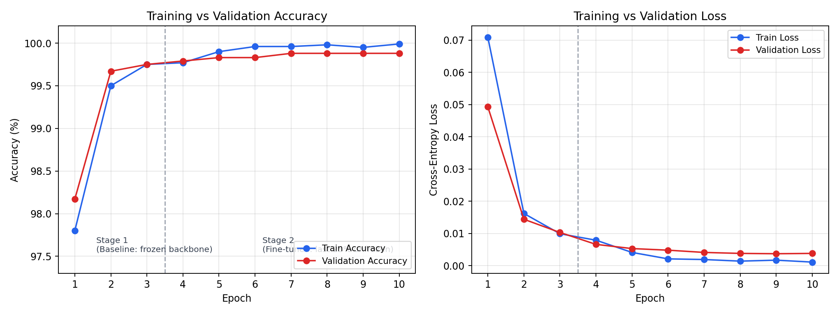
Figure 1. Training vs. validation accuracy and loss across both stages (dashed line marks the Stage 1 → Stage 2 transition).
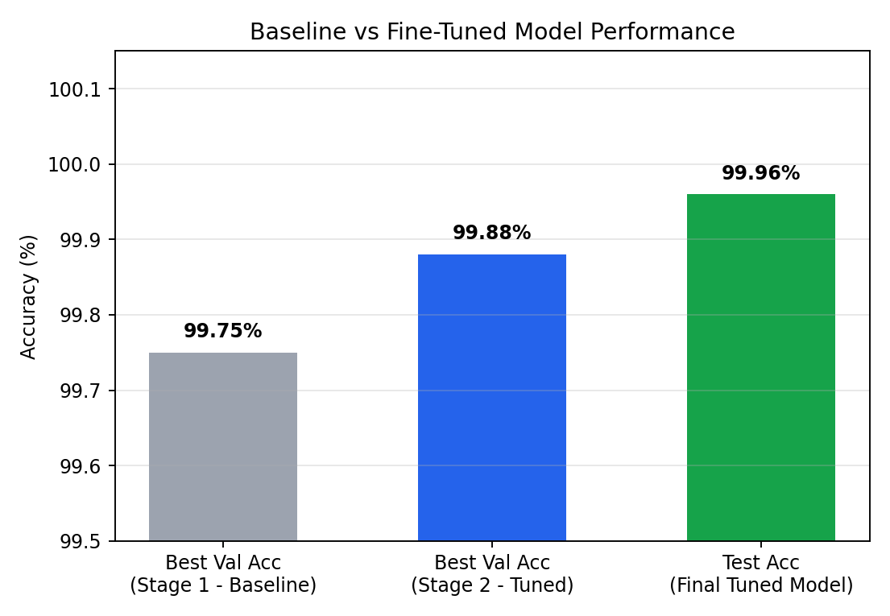
Figure 2. Best validation accuracy: baseline vs. fine-tuned model, and final held-out test accuracy.

6.4 Baseline vs. Tuned Comparison & Final Test Evaluation
Model | Best Val Accuracy | Val Loss at Best Epoch
Baseline (Stage 1 — frozen backbone) | 99.75% | 0.0103
Tuned (Stage 2 — last 25% fine-tuned) | 99.88% | 0.0041
Fine-tuning the last 25% of the backbone improves best validation accuracy from 99.75% to 99.88% and reduces validation loss by more than 60% (0.0103 → 0.0041), indicating the model produces more confident and better-calibrated predictions in addition to marginally higher accuracy. Given the already-high baseline, the improvement is modest in absolute accuracy terms but meaningful in loss/calibration and in the model's behaviour on the independent test set below.
The tuned model (best Stage 2 checkpoint) was then evaluated once on the held-out test set (2,401 images, untouched during training or tuning):
Metric | Value
Test loss | 0.0011
Test accuracy | 99.96%

Classification Report (Test Set)
Class | Precision | Recall | F1-score | Support
Real | 1.0000 | 0.9993 | 0.9997 | 1,500
Fake | 0.9989 | 1.0000 | 0.9994 | 901
Accuracy |  |  | 0.9996 | 2,401
Macro avg | 0.9994 | 0.9997 | 0.9996 | 2,401
Weighted avg | 0.9996 | 0.9996 | 0.9996 | 2,401
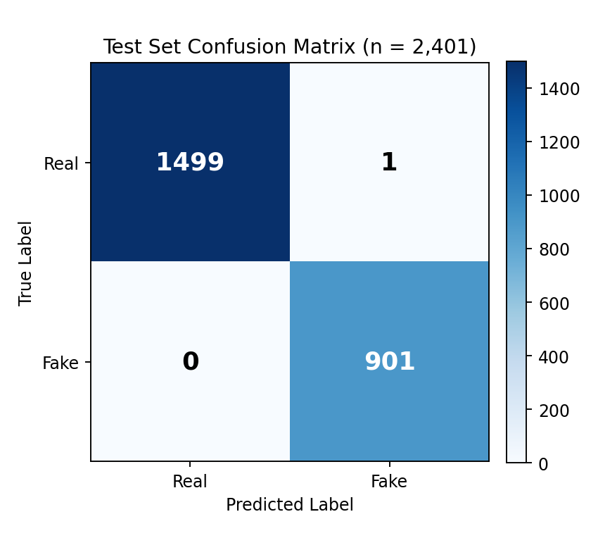
Figure 3. Test-set confusion matrix — only 1 misclassification out of 2,401 test images (1 Real predicted as Fake; 0 Fake predicted as Real).
These results confirm that the improvements observed on the validation set during tuning generalise to unseen data: the tuned model misclassifies only a single image in the entire 2,401-image test set.

7. End-to-End Modelling Pipeline

7.1 Input Data Flow
- Raw image folders for the Real (FFHQ) and Fake (Stable Diffusion) classes are recursively scanned for valid image extensions (.jpg, .jpeg, .png, .bmp, .tif, .tiff, .webp).
- File paths are labelled (Real = 0, Fake = 1) and combined into a single shuffled pandas DataFrame.
- The candidate subset is drawn as described in Section 4.2, then split into stratified train/validation/test partitions (Section 4.4).
- A custom PyTorch Dataset (ImageDataset) opens each image with PIL, converts to RGB, and applies the relevant transform.

7.2 Preprocessing / Transforms
- Training transform: RandomResizedCrop(224, scale 0.9–1.0), RandomHorizontalFlip(p=0.5), ColorJitter (brightness/contrast/saturation/hue), ToTensor, Normalize (ImageNet mean/std).
- Validation/Test transform: Resize(224×224), ToTensor, Normalize (ImageNet mean/std) — no augmentation, for a stable evaluation signal.
- DataLoaders: batch size 128, 4 worker processes, pinned memory, and persistent workers for efficient GPU utilisation (150 train / 19 val / 19 test batches per epoch).

7.3 Model Architecture Overview
- Backbone: MobileNetV3-Large (torchvision), ImageNet-pretrained (MobileNet_V3_Large_Weights.DEFAULT).
- Head: original 1000-class Linear layer replaced with Linear(1280→2) for Real/Fake classification.
- Stage 1: all backbone parameters frozen; only the head is trainable (1,232,642 / 4,204,594 parameters).
- Stage 2: last 25% of feature blocks (blocks 12–16 of 17) unfrozen; 3,798,226 / 4,204,594 parameters trainable.

7.4 Training Pipeline
- Loss function: CrossEntropyLoss.
- Stage 1: AdamW optimiser (LR 3×10⁻⁴, weight decay 1×10⁻⁴) over the head parameters only, CosineAnnealingLR scheduler, 3 epochs, automatic mixed precision (torch.cuda.amp) via GradScaler.
- Stage 2: best Stage 1 checkpoint reloaded; AdamW optimiser (LR 1×10⁻⁵) over all trainable parameters (head + unfrozen blocks), fresh CosineAnnealingLR scheduler, 7 epochs, mixed precision.
- After every epoch (both stages), the model is evaluated on the validation set; whenever validation accuracy improves, a checkpoint (model weights, optimiser state, epoch, validation accuracy) is saved to mobilenetv3_best.pth.

7.5 Validation Strategy
A held-out stratified validation split (10% of the candidate subset, 2,400 images) is evaluated after every training epoch in both stages. Model selection (which checkpoint is kept as “best”) is based purely on validation accuracy, ensuring the test set remains completely unseen until final evaluation.

7.6 Evaluation Methodology
- The best checkpoint (by validation accuracy across both stages) is reloaded for final evaluation.
- The model is run once, in evaluation mode with gradients disabled, over the untouched test split (2,401 images).
- Metrics computed: test loss, test accuracy, per-class precision/recall/F1 (classification_report), and the confusion matrix.

7.7 Expected Model Outputs
- At training/evaluation time: predicted class index (0 = Real, 1 = Fake) per image, aggregate accuracy/loss, and the confusion matrix / classification report.
- At inference/deployment time (see the standalone inference cell in the notebook): a single new image is loaded, resized/normalised identically to the validation transform, passed through the saved model, and converted via softmax into class probabilities. The pipeline reports the predicted label (“Real” or “AI Generated”) with its confidence percentage — e.g., a demonstration run on a held-out sample photo classified it as “Real” with 95.71% confidence.

8. Architecture & Pipeline Visualization
The diagram below illustrates the complete pipeline end-to-end: from raw data ingestion and candidate-subset construction, through preprocessing and the two-stage MobileNetV3-Large training pipeline, to evaluation and inference output.
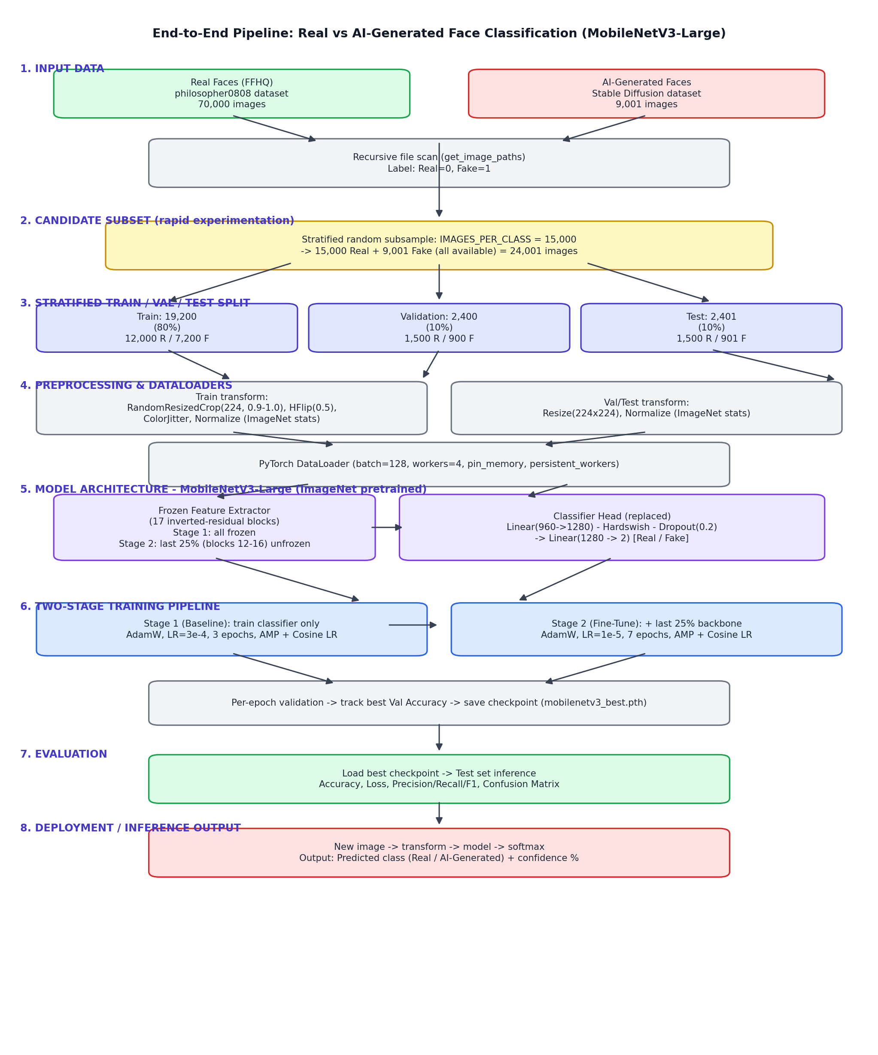
Figure 4. End-to-end pipeline: data input → candidate subset → stratified split → preprocessing/DataLoaders → MobileNetV3-Large (frozen/fine-tuned) → two-stage training → validation & checkpointing → test evaluation → inference output.

9. Conclusion & Next Steps
MobileNetV3-Large, adapted through a two-stage transfer-learning strategy, was selected and justified for the Real vs. AI-Generated face classification task. Using a representative 24,001-image candidate subset, a frozen-backbone baseline reached 99.75% validation accuracy, and staged fine-tuning of the last 25% of the backbone improved this to 99.88% validation accuracy and 99.96% test accuracy, with a substantial reduction in validation loss.

Planned for Milestone 4
- Scale training from the candidate subset to the full dataset (70,000 Real + 9,001 Fake, and any additional data sources incorporated by then).
- Broaden hyperparameter search (e.g., random or Bayesian search over learning rate and backbone freeze-ratio) using the same rapid subset-based methodology established in this milestone.
- Explicitly address class imbalance (e.g., class weighting or oversampling) if full-dataset results show degraded minority-class (Fake) recall.
- Optionally benchmark MobileNetV3-Large against alternative lightweight architectures (e.g., EfficientNet-B0, ResNet-18) on the same candidate subset before committing to full-scale training.

