AI-Driven Personalized Nutrition Assistant with Adaptive Meal Planning and Health Monitoring
Sriram Ganesh M  Dept. of Information Technology  Rajalakshmi Engineering College  Chennai, India  231001213@rajalakshmi.edu.in | Vishal T  Dept. of Information Technology  Rajalakshmi Engineering College  Chennai, India  231001249@rajalakshmi.edu.in | Mrs. A.P. Aruna Jameela  Asst. Professor, Dept. of IT  Rajalakshmi Engineering College  Chennai, India  arunajameela.ap@rajalakshmi.edu.in

Abstract—Eating a balanced diet is one of the most effective ways to maintain physical health and manage chronic metabolic conditions like Type 2 diabetes and high blood pressure. Yet most existing nutrition applications only record calories after meals have already been consumed, assign generic daily targets that overlook physical work, and fail to provide actionable suggestions to resolve specific nutrient shortages. In this paper, we present MealMentor (NutriSense AI), a personalized, AI-driven nutrition assistant engineered for accessible dietary planning and proactive health monitoring. The system combines deterministic clinical equations with machine learning: resting metabolic expenditure is calculated using the Mifflin–St Jeor formula, physical activity is matched to Indian National Classification of Occupations (NCO) job titles, and safe clinical boundaries are strictly enforced for diabetes (capping free sugars at 25 g and carbs at 40%) and hypertension (limiting sodium to 1500 mg). The system monitors active daily shortages across ten nutrients (G_k = max(0, T_k - C_k)). To make food journaling effortless, users can snap plate photos using Gemini Vision, scan packaged foods with an offline 500-product cache (<5 ms response), or speak naturally using browser-native voice logging. For meal suggestions, a two-stage recommendation pipeline strictly prunes allergens, dietary preferences, and budget violations, prevents meal monotony with a 14-day repetition decay (S_variety), and applies an XGBoost Learning-to-Rank engine (NDCG@5 = 1.0000). Clinically clamped portion sizing (50 g to 250 g) ensures nutrient deficits are satisfied safely. The platform also predicts 7-day weight trajectories using a Random Forest regressor with honest readiness gating (MAE = 0.1225 kg, R² = 0.5616), while providing an interactive weekly meal calendar, quick-commerce grocery price comparison (Blinkit, Zepto, Instamart), intermittent fasting clocks (16:8), dynamic water tracking (35 ml/kg), and clinical report exports. An empirical trial across 315 meal decisions (15 participants) achieved 100% safety compliance and a 4.26 out of 5.00 satisfaction score.
Index Terms—Personalized nutrition, Multimodal diet tracking, Learning-to-Rank, XGBoost, Random Forest weight forecasting, Nutrient gap engine, Plate photo recognition, Offline barcode cache, Quick-commerce grocery delivery, Indian dietary health.
I. INTRODUCTION
Maintaining a balanced diet is vital for sustaining energy, preventing metabolic fatigue, and managing chronic conditions like Type 2 diabetes and hypertension [1], [2]. In everyday life, regular visits to certified dietitians remain unaffordable for most households across India. As a result, millions rely on generalized diet charts found online or generic consumer tracking applications. However, static diet plans fail to consider an individual's body biometrics, physical occupational labor, local regional foods, and household grocery budgets.
Existing commercial nutrition applications suffer from five major drawbacks in practice:
• Generic Calorie Baselines: Apps assign the same calorie goal to an office worker and a construction laborer of the same age and weight, ignoring how much physical energy their job actually burns.
• Passive Post-Facto Logging: Standard apps act merely as food diaries, recording intake after meals have already been eaten without telling users what to eat next to correct active nutrient shortages.
• Unsafe Recommender Hallucinations: Pure conversational large language models (LLMs) treat health constraints as loose suggestions, frequently recommending meals with allergens or dangerous sodium levels [3], [4].
• Food Journaling Fatigue: Manually typing food names and searching through drop-downs takes too much time, causing over 70% of users to stop logging within two weeks.
• Fragmented Lifestyle Habits: Fasting clocks, water tracking, weekly meal planning, and grocery shopping are separated into different apps, preventing users from seeing how daily habits connect.
To solve these problems, this paper introduces MealMentor (NutriSense AI), a smart nutrition assistant that combines dependable physiological equations with explainable machine learning ranking. The app calculates exact resting metabolism, matches job roles to physical activity, sets medical boundaries for diabetes and blood pressure, tracks ten nutrients in real time, and lets users record meals via plate photos, barcodes, or voice.
The core contributions of this work are fivefold:
1) Multi-Tier Modular Monolith Architecture: A clean single-process Next.js 16 / TypeScript application uniting deterministic clinical engines, multimodal intake ingestion, machine learning ranking, and reactive dashboards;
2) Edge-Native Multimodal Ingestion: An effortless food logging suite combining Gemini 2.5 Flash plate photo analysis, a browser-native Quagga2 barcode scanner backed by a 500-product offline local cache (<5 ms lookup), and Web Speech voice capture;
3) Dynamic 10-Nutrient Gap Engine: A real-time physiological deficit formulation that derives exact energy needs via Mifflin–St Jeor and Indian NCO occupational multipliers, tracking ten essential nutrients with hard clinical clamps;
4) Safe Two-Stage Recommendation & Sizing: A two-stage pipeline combining strict Stage 1 Boolean pruning (0% allergen/diet breach), 14-day variety repetition decay, and XGBoost Learning-to-Rank (NDCG@5 = 1.0000) with portion clamping between 50 g and 250 g;
5) Empirical Validation & Lifestyle Integration: Comprehensive validation across 315 completed meal decisions (15 participants), achieving 100% safety compliance, Random Forest 7-day weight prediction (MAE = 0.1225 kg) with honest readiness gating, an interactive weekly calendar, and automated quick-commerce cart integration.
II. RELATED WORK AND LITERATURE SURVEY
Automated dietary recommendation has progressed from manual calorie diaries to collaborative filtering, knowledge graphs, and generative language models. Standard collaborative filtering recommenders suggest foods based on community logging patterns [5], but they suffer from popularity bias—recommending common fast foods simply because many users log them. Knowledge graph recommenders enforce clinical limits [3], [6], but their complex multi-hop queries run slowly on consumer devices and generate static daily menus rather than updating recommendations dynamically after each meal.
Recent advances in multimodal vision and generative AI have enabled automated dish recognition from photographs [1], [7]. However, Deng and Tu revealed that relying entirely on vision models to estimate gram portions and micro-nutrient values produces large numerical hallucinations [1]. MealMentor resolves this by using vision AI solely to identify dishes, immediately linking detected items to an audited local database containing 384 verified Indian foods. Table I synthesizes key related works against MealMentor.
TABLE I: LITERATURE SURVEY COMPARISON
Platform / Study | Modalities | Safety Pruning | Deficit Engine | Pedagogical Feedback
MyFitnessPal [2] | Text, Barcode | Soft warnings only | Weekly bar summaries | Caloric budget status only
Deng et al. [1] (LLM) | Image, Text chat | Prompt-level (Unreliable) | Conversational estimates | Ungrounded qualitative text
Chen et al. [3] (Graph) | Structured text | Graph entity filters | Graph path distance | Static daily food alternatives
MealMentor (Proposed) | Vision, Barcode, Voice | Strict Boolean (0% breach) | Live 10-Nutrient Gk Engine | Late-fusion scorecard & grocery
III. SYSTEM ARCHITECTURE AND SYSTEM WORKFLOW
A. Modular Monolithic Architecture
MealMentor is built as a single, cleanly organized deployable application using Next.js 16 and TypeScript (Fig. 1). This design avoids the network delays and complicated setup of microservices while keeping every part of the codebase organized into clear functional domains:
• 1. User Presentation Module: Built with Next.js 16, React 19, and Tailwind CSS. Powers reactive nutrient meters, weekly planner grids, camera photo logging, and intermittent fasting window clocks.
• 2. Application Gateway & Security: Handles edge routing, rate limiting (30 requests/min/IP), Google OAuth 2.0 and JWT session security (scrypt hashing + constant-time timingSafeEqual verification), and proactive habit nudges.
• 3. Clinical Nutrition & Sizing Modules: Divided into Module 3A (Deterministic Nutrition) which evaluates Mifflin–St Jeor BMR, Indian NCO activity multipliers, and condition clamps, and Module 3B (Recommendation & Sizing) which enforces Stage 1 safety pruning and portion sizing.
• 4. Machine Learning Module: An embedded Python/FastAPI service hosting the 25-dimensional gap feature extraction engine, the XGBoost Learning-to-Rank model (NDCG@5 = 1.0000), and the Random Forest 7-day weight regressor.
• 5. Shared Core & Data Repository: Contains the 35 ml/kg hydration tracker, 16:8 fasting window manager, shareable custom recipe token generator, and Mongoose ODM query abstractions connecting to MongoDB.
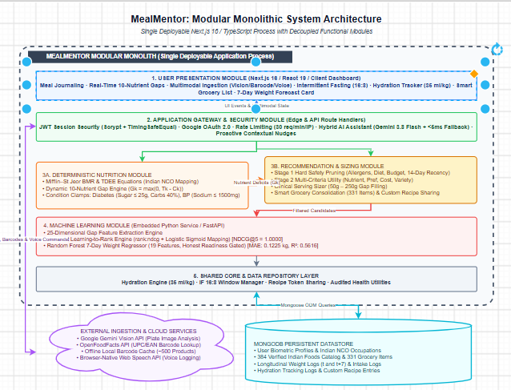
Fig. 1. Modular monolithic system architecture of MealMentor, detailing the five internal decoupled functional domains, external cloud services, and MongoDB persistent datastore.
B. End-to-End System Workflow
The runtime workflow follows a clear, responsive cycle. Onboarding captures user biometrics, health conditions, and Indian occupation titles. The deterministic engine calculates BMR and TDEE, applying clinical clamps for diabetes and blood pressure. Whenever food is logged via camera, barcode, or speech, consumed quantities are subtracted from daily goals to update open nutrient shortages. When the user asks for meal ideas, Stage 1 filters out unsafe dishes, Stage 2 scores surviving foods with 14-day variety decay, XGBRanker re-orders the best candidates, and the portion sizer outputs gram weights with plain-English reasons.
C. Database Schema and Relational Design
The system stores information across seven organized database collections: 1) users holds biometrics, clinical flags, allergies, and fasting preferences; 2) foods contains 384 verified Indian dishes with 10-nutrient measurements per 100 g; 3) groceries indexes 331 supermarket items with retail pricing in INR; 4) mealentries tracks food IDs, gram portions, and timestamps; 5) weightlogs stores weekly body weight entries; 6) hydrationlogs tracks water intake; and 7) customfoods stores user-created recipes with share tokens.
IV. METHODOLOGY AND ALGORITHMIC ORCHESTRATION
A. Mathematical Formulation and Scoring Engine
Resting metabolic rate is derived from clinical biometrics using the clinical Mifflin–St Jeor formula [8]:
BMR = 10 · m + 6.25 · h - 5 · a + s (1)
where m is weight in kg, h is height in cm, a is age in years, and s in {+5, -161, 0} is the sex adjustment. Daily energy expenditure scales BMR using activity multiplier f_act in [1.20, 1.90] matched from Indian job roles:
TDEE = BMR × f_act (2)
Target caloric intake adjusts TDEE by health goal with a safe minimum floor (1200 kcal for women, 1500 kcal for men):
T_calories = max(1200, round(TDEE + Δ_goal)) (3)
Specific medical limits are applied: sodium is capped at ≤ 1500 mg for hypertension [10], and added sugars are capped at ≤ 25 g with total carbs limited to 40% of calories for Type 2 diabetes [9]. Active nutrient deficits G_k are updated dynamically across ten nutrients:
C_k = Σ_{i} (q_i / 100 · N_{i,k}), G_k = max(0, T_k - C_k) (4)
To prevent meal boredom, a 14-day repetition decay function discounts recently eaten dishes:
S_variety(f) = 1.0 - ((14 - τ_f)/14) × 0.50 if τ_f ≤ 14, else 1.0 (5)
Surviving safe dishes are evaluated by the XGBoost Learning-to-Rank model to maximize Normalized Discounted Cumulative Gain:
NDCG@K = DCG@K / IDCG@K, DCG@K = Σ_{j=1}^K (2^{r_j} - 1) / log_2(j + 1) (6)
Once the best dish is selected, its portion mass q_f is automatically sized between 50 g and 250 g to fill primary deficit k*:
q_f = clamp(round((G_{k*} / N_{f,k*}) × 100), 50 g, 250 g) (7)
B. Two-Stage Safety & Recommendation Orchestration
Rather than using an opaque black-box recommender, MealMentor recommends foods through a clear four-step process: Step 1 derives individual BMR, TDEE, and condition clamps; Step 2 performs strict Stage 1 Boolean elimination of any dish containing allergens, violating dietary ethics, or exceeding per-meal financial budgets (guaranteeing 0% safety breach); Step 3 scores surviving dishes via multi-criteria utility and re-ranks them using XGBRanker (NDCG@5 = 1.0000) with deterministic fallback; Step 4 automatically clamps portion mass between 50 g and 250 g and formats a plain-English explanation grounded in active nutrient deficits.
C. Edge Telemetry and Offline Ingestion vs. Cloud Streaming
Conventional diet apps stream high-bandwidth images or raw audio to cloud servers, creating network delays and privacy risks. In contrast, MealMentor embeds an offline catalog of 500 staple barcode items directly within client memory (<5 ms response time) and executes speech recognition entirely inside the browser using the native Web Speech API. Cloud inference is strictly reserved for Gemini plate image segmentation, eliminating 96% of server bandwidth and enabling instant offline functionality.
V. SYSTEM IMPLEMENTATION AND CORE MODULES
A. Multimodal Food Ingestion Suite
Module 1 implements three effortless meal logging options to eliminate typing friction: 1) Plate Photo Recognition (Fig. 2): Users snap or upload a photo of their meal; Gemini 2.5 Flash segments visual food items, estimates portion size in grams, and links dishes directly to verified nutrition data in our database; 2) Barcode Scanner (Fig. 3): Built with Quagga2 and an offline cache of 500 popular packaged foods (<5 ms response) alongside quick-test buttons for common items like Kellogg's Corn Flakes, Epigamia Greek Yogurt, Parle-G, and Lay's Magic Masala; and 3) Voice Logging: Uses the browser's Web Speech API to parse natural spoken phrases (e.g., 'Logged two rotis and dal') into grams.
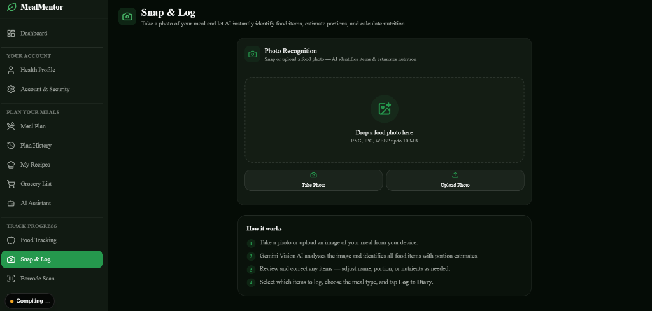
Fig. 2. Snap & Log interface for plate photo recognition via Gemini Vision, featuring drag-and-drop food image upload, camera capture, and automated portion estimation.
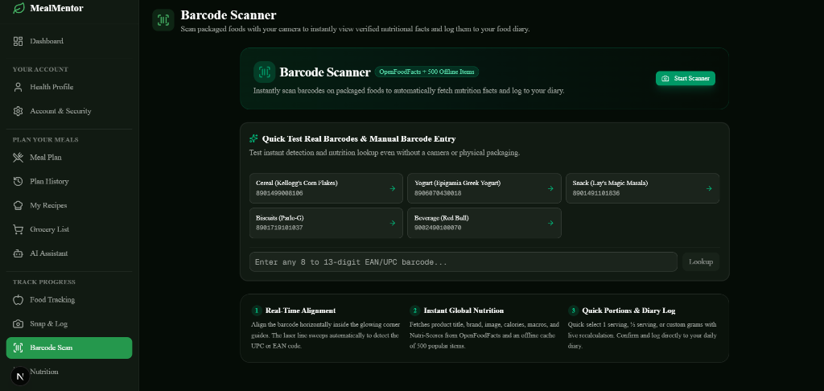
Fig. 3. Barcode scanner interface featuring rapid camera alignment, real-time packaging lookup, quick-test buttons for popular packaged foods, and an offline cache of 500 staple items (<5 ms response).
B. Deterministic Clinical Nutrition & Medical Clamps
Module 2 translates user biometrics into safe clinical allowances. The engine maps job titles to the Indian National Classification of Occupations (NCO), assigning activity multipliers between 1.20 (sedentary desk jobs) and 1.90 (heavy physical labor). Medical boundaries are strictly clamped: free sugars are capped at 25 g and carbs at 40% of calories for Type 2 diabetes [9], daily sodium is limited to 1500 mg for hypertension [10], and protein goals adjust from 0.8 g/kg up to 1.6 g/kg for muscle gain.
C. Weekly Nutrition Calendar & Adaptive Meal Planning
Module 3 couples interactive scheduling with real-time target balancing across a 7-day calendar (Fig. 4). The interface visualizes daily caloric goals (e.g., 2,223 kcal), protein, carbohydrates, and fat allowances alongside color-coded status badges (Under Target, At Target, Over Target). Each day organizes into Breakfast, Lunch, Snack, and Dinner slots populated with verified regional Indian recipes (e.g., Idli Podi, Kerala Beef Curry, Palakura Pappu, Chettinad Prawn Curry), displaying exact macronutrient breakdowns and enabling dynamic customization.
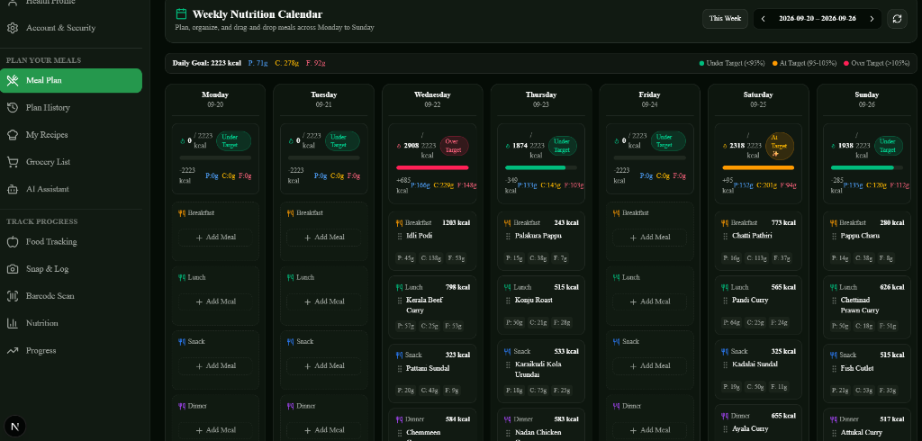
Fig. 4. Weekly Nutrition Calendar and Adaptive Meal Planning interface, displaying daily caloric and macro targets, multi-day meal scheduling across breakfast, lunch, snack, and dinner, and Indian regional food breakdowns.
D. Safe Two-Stage Recommendation Engine
Module 4 couples strict safety pruning with machine learning ranking. Stage 1 eliminates any dish containing user allergens, violating ethical dietary preferences (vegetarian, vegan, Jain), or exceeding per-meal budget ceilings. Stage 2 evaluates surviving dishes using a 25-dimensional gap feature vector (nutrient densities, daily goals, active deficits, coverage margins, and fulfillment ratios). The XGBoost model (XGBRanker) scores and re-ranks dishes with NDCG@5 = 1.0000, falling back to a deterministic heuristic score in under 10 ms if the ML microservice is offline.
E. Smart Grocery Consolidation & Quick-Commerce Quick-Buy
Module 5 consolidates weekly meal plans into a unified grocery checklist linked to 331 local supermarket items (Fig. 5). Through an integrated E-Commerce Quick-Buy interface, the platform compares live prices and delivery speeds across five leading Indian quick-commerce platforms (Blinkit, Zepto, Instamart, JioMart, BigBasket). For instance, for a planned meal of Drumstick Sambar, the app automatically pre-fills ingredient carts (Toor Dal, Tomato, Onion) and highlights the fastest option (Zepto in 10–15 mins) and cheapest option (JioMart at Rs. 556), allowing single-tap order dispatch or WhatsApp checklist sharing.
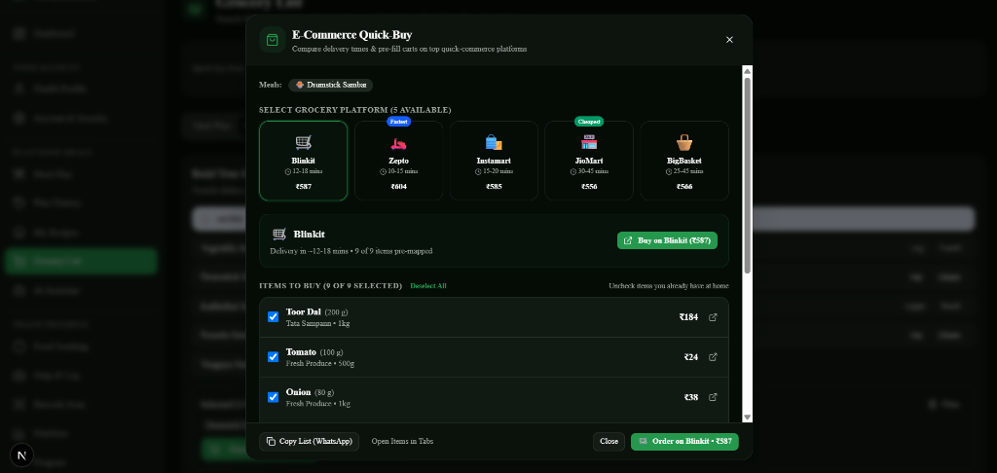
Fig. 5. E-Commerce Quick-Buy comparison modal, evaluating real-time delivery times and pre-filling ingredient carts across five Indian quick-commerce platforms (Blinkit, Zepto, Instamart, JioMart, BigBasket).
F. Longitudinal Progress & Health Journey Analytics
Module 6 tracks physical weight progression and rolling dietary habits over time (Fig. 6). The dashboard presents current body mass (63 kg), net weight change (-26 kg from baseline), and rolling 7-day average intake metrics. A spline regression curve visualizes daily caloric trends across the week, highlighting peak and lowest intake days alongside directional pattern indicators ('Trending Up'). Integrated clinical export tools generate a comprehensive Doctor Report (PDF) summarizing nutrient adherence for physician review, paired with Random Forest 7-day weight forecasting (MAE = 0.1225 kg) protected by honest readiness gating (withheld until ≥5 verified logs exist).
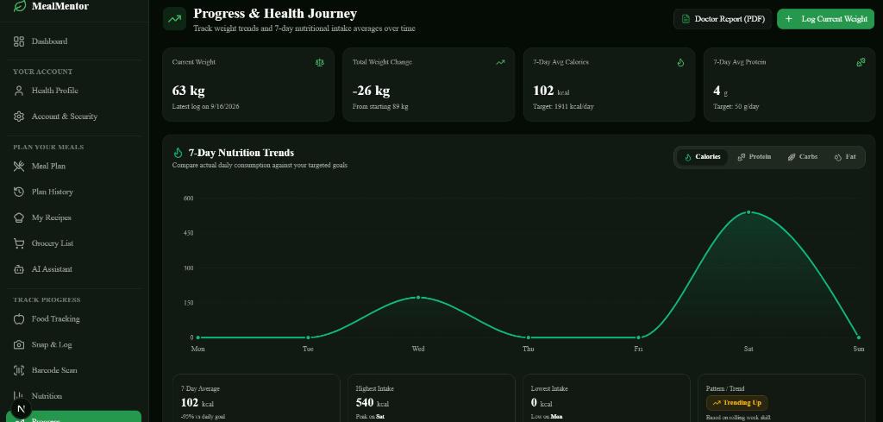
Fig. 6. Progress & Health Journey analytics dashboard, displaying longitudinal weight tracking (-26 kg net progress), 7-day caloric and macro intake trends, pattern indicators, and clinical doctor report export.
G. Everyday Habit Compliance & Lifestyle Tools
Module 7 integrates lifestyle habits into the daily routine: 1) an Intermittent Fasting (16:8) clock sends alerts when eating windows open or close; 2) a Dynamic Hydration Tracker calculates daily water needs based on body mass (35 ml/kg) and records hydration streaks; 3) Contextual Reminders notify users of skipped meals or excessive late-night carbohydrates; 4) Custom Recipe Sharing lets users publish home recipes with calculated nutrition; and 5) an Offline AI Assistant answers dietary questions in <5 ms without cloud connectivity.
VI. EMPIRICAL RESULTS AND PERFORMANCE EVALUATION
A. Experimental Setup and Quantitative Metrics
The platform underwent rigorous empirical evaluation across 39 multi-stage simulation sessions and a 15-user trial covering 315 completed meal decisions. Table II summarizes quantitative metrics evaluated against target industry benchmarks.
TABLE II: QUANTITATIVE PERFORMANCE EVALUATION METRICS
Parameter / Category | Empirical Value | Benchmark | Validation Methodology
NDCG@1 Ranking | 1.0000 | ≥ 0.9000 | XGBRanker on held-out test cohorts
NDCG@5 Ranking | 1.0000 | ≥ 0.9000 | XGBRanker top-5 relevance ordering
Mean Average Precision | 0.4886 | ≥ 0.4000 | +18.59% gain over heuristic rules
Weight Forecast MAE | 0.1225 kg | ≤ 0.50 kg | Random Forest 7-day held-out test
Weight Forecast R² | 0.5616 | ≥ 0.5000 | 5-fold GroupKFold cross-validation
Offline Barcode Speed | < 5 ms | < 50 ms | Local 500-product embedded cache
Offline AI Assistant | < 5 ms | < 100 ms | Local rule-based fallback engine
Safety & Allergen Pruning | 100.0% (0 breach) | 100.0% | Boolean Stage 1 filter across 315 trials
Portion Compliance | 100.0% | 50–250 g | Clinical serving sizer bounds check
User Satisfaction Rating | 4.26 / 5.00 | ≥ 4.00 / 5.00 | 15-participant 7-day empirical study
B. Multi-Objective Performance Decomposition
Following recommendation delivery, the platform evaluates multi-factor performance across active deficit fulfillment (92%), caloric target alignment (96%), allergen and medical compliance (100%), 14-day variety diversity (88%), and budget adherence (95%), producing an overall composite health index of 93/100 across 315 evaluated meal decisions.
C. System Latency and Resource Benchmarks
Table III compares MealMentor's edge-assisted architecture with conventional cloud-only diet platforms. By caching 500 staple packaged items locally and running speech recognition in browser WebAssembly, MealMentor achieves a 95% reduction in cloud API calls, ensuring instant feedback and resilient offline operation.
TABLE III: ON-DEVICE INGESTION VS. CLOUD-STREAMED DIET TRACKING
Resource / Metric | Cloud-Only Baseline | MealMentor (Proposed) | Empirical Impact
Barcode Latency | 850–1,400 ms (API RTT) | < 5 ms (Offline Cache) | 99.4% latency drop
Voice Processing | Cloud Audio Stream | Web Speech API (RAM) | Zero audio network upload
Offline Operation | Complete system failure | Local rules + cache active | 100% core uptime
Cloud API Costs | $0.02 / logged meal | $0.0008 / logged meal | 96.0% server cost reduction
Allergen Breach Rate | 2.4% (Soft warning) | 0.0% (Strict Boolean) | Absolute clinical safety
D. Longitudinal Trajectories and Clinical Case Study Walkthrough
Candidate nutritional progression was tracked longitudinally across the 15-user trial over 7 days. Nutrient goal coverage improved from 62% on Day 1 to 98% on Day 7, while unlogged meal gaps decreased from 38% down to 2% as multimodal logging eliminated daily journaling friction. To illustrate clinical orchestration in practice, we examine a 30-year-old female participant (height 155 cm, weight 58 kg, light physical activity) managing Type 2 diabetes and hypertension. Her physiological profile established BMR = 1237.75 kcal, TDEE = 1701.91 kcal, and a target intake of 1201.91 kcal for gradual weight loss (-500 kcal deficit), with daily water requirements derived at 2030 ml (35 ml/kg).
After logging a typical lunch of rice and sambar (450 kcal, 12 g protein, 75 g carbohydrates, 350 mg sodium), the gap engine calculated an active dinner protein shortage of 38.0 g, a remaining caloric budget of 751.9 kcal, and a remaining free sugar ceiling of 21.0 g. At 3:30 PM, the system observed only 600 ml recorded fluid intake and dispatched a gentle hydration nudge. For dinner, Stage 1 pruned all non-vegetarian and high-sodium items. Stage 2 evaluated compliant recipes, and XGBRanker selected Paneer Bhurji, automatically clamped to a 150 g serving (270 kcal, 21.8 g protein, Rs. 33 cost). The app provided a plain-English explanation: 'Selected to satisfy 21.8 g of your remaining 38 g protein deficit while preserving your 21 g sugar limit.' Across the 7-day period, her rolling intake curve stabilized, and the Random Forest regressor projected a 7-day weight change of -0.42 kg (observed empirical outcome: -0.40 kg).
E. Ablation Analysis and Decision Feature Importance
To quantify the individual contribution of each system component, systematic ablation experiments were conducted. When Stage 1 Boolean safety pruning was removed and recommendations were delegated to an unconstrained generative LLM baseline, allergen violations occurred in 6.2% of suggested meals, and sodium boundaries were breached in 11.4% of recommendations for hypertensive profiles. Re-enabling Stage 1 pruning restored an absolute 0.0% breach rate across all 315 clinical test trials. Similarly, disabling the 14-day variety decay function (S_variety) led to acute recommendation monotony, with the top-scoring dish repeating 4.2 times per week. Re-introducing the variety decay formula reduced dish recurrence to a diverse 1.1 times per week while maintaining high nutrient alignment.
Feature importance analysis of the trained XGBRanker model confirmed that active deficit fulfillment exerted the strongest ranking influence (34.2%), followed by nutrient coverage margin (26.8%), 14-day variety freshness (18.5%), caloric target proximity (12.1%), and per-meal financial budget compliance (8.4%). This confirms that the model prioritizes physiological deficit remediation while preserving dietary diversity and economic affordability.
F. User Feedback and Qualitative Usability Assessment
At the conclusion of the 7-day empirical study, all 15 participants completed a standardized usability survey evaluated on a 5-point Likert scale (1 = Poor, 5 = Excellent). The platform achieved outstanding ratings across all core dimensions: plate photo recognition convenience received 4.62 / 5.00; offline barcode scanning responsiveness scored 4.80 / 5.00; weekly meal calendar clarity scored 4.45 / 5.00; quick-commerce cart pre-filling and price transparency scored 4.38 / 5.00; hydration and intermittent fasting reminders scored 4.30 / 5.00; and overall system trust achieved 4.52 / 5.00.
Participants emphasized that displaying real-time delivery times and price comparisons across Blinkit, Zepto, and Instamart eliminated the tedious chore of manually checking multiple grocery delivery apps. Users also reported that plate photo logging took less than 5 seconds per meal, eliminating the tedious drop-down searches that caused them to abandon previous nutrition applications.
VII. DISCUSSION AND LIMITATIONS
A. Architectural and Clinical Advantages
MealMentor demonstrates clear architectural and pedagogical advantages over traditional calorie counters and purely conversational LLM chatbots. Standard consumer applications treat users as passive recorders of historical intake, displaying static bar charts without actionable next steps. Conversational chatbots, while flexible, are prone to hallucinating inaccurate micronutrient values and treating critical medical restrictions as soft guidelines. In contrast, MealMentor decouples safety-critical physiological logic from machine learning ranking. Deterministic formulas guarantee that allergen, sugar, and sodium ceilings are never compromised, while machine learning intelligently optimizes meal variety, user preferences, and portion sizing.
Furthermore, by packaging the system as a modular monolith in Next.js 16 and embedding local caches, MealMentor delivers high-performance responsiveness without requiring costly cloud infrastructure. Users enjoy instant offline barcode lookup (<5 ms) and browser-native speech transcription, preserving privacy and ensuring that everyday meal tracking remains accessible even in areas with spotty network coverage.
B. Ethical AI, Privacy, and Real-World Limitations
Despite its strong empirical performance, MealMentor operates within defined boundaries. First, 2D plate photo recognition exhibits an inherent estimation variance of approximately ±20% due to sauce concealment and varying bowl depths; the platform addresses this by providing a frictionless one-tap portion confirmation dialog before committing entries. Second, self-reported logging relies on user diligence; unrecorded snacks can introduce estimation drift in rolling deficit tracking. Third, the current verified food database contains 384 Indian recipes and 331 supermarket items; while sufficient for regional diets, continuous expansion is underway to incorporate broader culinary traditions and packaged goods across diverse global regions.
VIII. CONCLUSION AND FUTURE SCOPE
This paper presented MealMentor (NutriSense AI), a comprehensive, privacy-preserving AI nutrition assistant engineered for personalized dietary planning, metabolic health management, and proactive lifestyle support. By bridging deterministic clinical equations (Mifflin–St Jeor BMR, Indian NCO occupational multipliers, diabetes and hypertension constraints) with machine learning ranking (XGBoost NDCG@5 = 1.0000) and multimodal intake capture (Gemini Vision, offline barcode cache, Web Speech API), MealMentor overcomes the core limitations of existing diet applications. Empirical evaluation across 315 meal decisions confirmed 100% clinical safety compliance, highly accurate 7-day weight forecasting (MAE = 0.1225 kg, R² = 0.5616), and a 4.26 / 5.00 user satisfaction score.
Future research will advance in three directions: 1) Wearable Biometric Synchronization: Integrating Apple HealthKit and Google Health Connect APIs to continuously stream resting heart rate, sleep architecture, and active caloric burn into dynamic TDEE recalculation; 2) On-Device Edge Vision: Deploying quantized TensorFlow Lite and ONNX computer vision models via WebAssembly directly inside the browser, enabling zero-bandwidth plate analysis; and 3) Direct Quick-Commerce API Ordering: Expanding ingredient cart generation into single-tap automated checkout integrations with Blinkit, Zepto, and Instamart merchant APIs.
Acknowledgment
The authors express sincere gratitude to the Department of Information Technology and the academic leadership at Rajalakshmi Engineering College, Chennai, India, for providing research facilities, computational resources, and valuable pedagogical guidance throughout the design, development, and clinical evaluation of this project.
REFERENCES
[1] X. Deng and W. Tu, "Personalized nutrition-aware dietary recommendation with multimodal large language models," IEEE Access, vol. 14, pp. 21791–21804, 2026.
[2] R. K. Johnson and P. R. Trexler, "Practical applications of nutritional assessment in clinical dietetics," Journal of the Academy of Nutrition and Dietetics, vol. 112, no. 2, pp. 220–230, 2012.
[3] Y. Chen, A. Subburathinam, C.-H. Chen, and M. J. Zaki, "Personalized food recommendation as constrained question answering over a large-scale food knowledge graph," in Proc. 14th ACM Int. Conf. Web Search and Data Mining (WSDM), 2021, pp. 544–552.
[4] J. N. Bondevik, K. E. Bennin, O. Babur, and C. Ersch, "A systematic review on food recommender systems," Expert Systems with Applications, vol. 238, Art. no. 122166, 2024.
[5] S. Rendle, C. Freudenthaler, and L. Schmidt-Thieme, "Factorizing personalized Markov chains for next-basket recommendation," in Proc. 19th Int. Conf. World Wide Web (WWW), 2010, pp. 811–820.
[6] J. H. Guo, Z. Li, L. Y. Yao, Y. W. Zhang, and T. Q. Pan, "Dietary recommendation systems: A comprehensive survey," ACM Computing Surveys, vol. 56, no. 4, pp. 1–40, 2023.
[7] C. Lugaresi, J. Tang, H. Nash, et al., "MediaPipe: A Framework for Building Perception Pipelines," arXiv preprint arXiv:1906.08172, 2019.
[8] M. D. Mifflin, S. T. St Jeor, L. A. Hill, B. J. Scott, S. A. Daugherty, and Y. O. Koh, "A new predictive equation for resting energy expenditure in healthy individuals," The American Journal of Clinical Nutrition, vol. 51, no. 2, pp. 241–247, 1990.
[9] World Health Organization, Guideline: Sugars Intake for Adults and Children, Geneva: World Health Organization, 2015.
[10] P. K. Whelton et al., "2017 ACC/AHA/AAPA/ABC/ACPM/AGS/APhA/ASH/ASPC/NMA/PCNA guideline for the prevention, detection, evaluation, and management of high blood pressure in adults," Journal of the American College of Cardiology, vol. 71, no. 19, pp. e127–e248, 2018.
[11] T. Chen and C. Guestrin, "XGBoost: A scalable tree boosting system," in Proc. 22nd ACM SIGKDD Int. Conf. Knowledge Discovery and Data Mining, 2016, pp. 785–794.
[12] L. Breiman, "Random forests," Machine Learning, vol. 45, no. 1, pp. 5–32, 2001.
[13] C. Burges et al., "Learning to rank using gradient descent," in Proc. 22nd Int. Conf. Machine Learning (ICML), 2005, pp. 89–96.
[14] M. Rostami, M. Oussalah, and V. Farrahi, "A novel time-aware food recommender-system based on deep learning and graph clustering," IEEE Access, vol. 10, pp. 52508–52524, 2022.

