**Kaggle Competition problem:**

Recommendation System for Netflix:

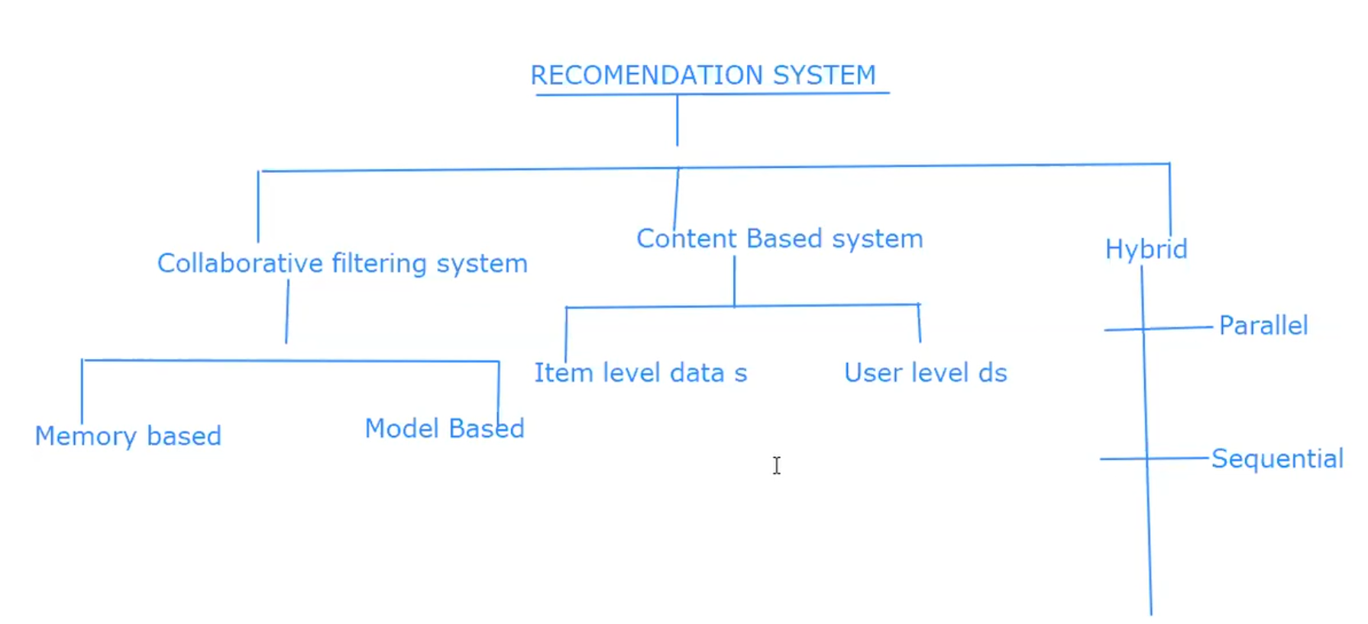

**Collaborative Filtering:** Collaborative Filtering is a process of predicting the interest of a user by identifying the preference and information from many users. Here it uses ratings provided by other users for recommendation.

There are two types of Collaborative Filtering

1. **Memory based:** Uses stored rating or reviews to solve the problem.
2. **Model based**: Uses ML model to identify the patterns and based on the results recommendation is done.

**Content Based Filtering**: A Content Based Recommendation system (CBRS) uses a user’s activity and preferences to suggest item. It uses User profile and user preferences for recommendation. So they tries to match users to the items which they liked previously. For recommendation It uses ratings provided by the user himself. The CBRS creates a user profile by analysing data from their online actions, such as purchases, ratings, and search history.

There are two types of Content based filtering.

1. Item level data source
2. User level data source

Hybrid Filtering: it uses both approaches recommendation.

There are two types of this

1. Parallel:
2. Sequential:

Netflix Dataset:

<https://www.kaggle.com/datasets/netflix-inc/netflix-prize-data>