Nutri Scan AI – Final Project Report
- Name: Vishal Kumar
- Course: MCA (2025–2027)
- Registration Number: 2511022250027
- University: Alliance University
- School: Alliance School of Advanced Computing
- Project Title: NutriScan AI – Fruit & Vegetable Recognition using AI

Project Overview:
NutriScan AI is a deep learning powered system that can classify fruit and vegetable images and provide nutrition-related insights.
The system is built using Python and a MobileNet model, enabling fast and reliable predictions. It offers a modern web interface
implemented using HTML, CSS, and JavaScript, and uses Flask as the backend API to handle model requests. The project reduces
manual effort and allows instant identification of food items. The model supports 36 different fruit and vegetable classes.
Objective:
The project’s objective is to create a real-time system that predicts the name, category, and calorie content of a fruit or vegetable
from its image. Users can upload an image through the web interface and quickly receive results on the same page. The model
outputs the name of the item and whether it belongs to the fruit or vegetable category. It also provides calorie information and
basic advice. This makes the system useful for nutrition planning, food education, and dietary management.
Technologies Used:
The technologies used include Python, TensorFlow, Karas, NumPy, PIL, Flask, HTML, CSS, and JavaScript. The MobileNet architecture
is employed due to its lightweight nature, which allows it to run efficiently even without high-end computing hardware. Flask handles
API calls seamlessly, while the browser interface makes the system accessible to non-technical users.
Model Description:
The MobileNet model used in this project is pre-trained on a wide dataset and then fine-tuned to classify 36 different fruits
and vegetable images. The input image is resized to 224x224 pixels to match the model’s expected input shape. The predictions
are generated using SoftMax probability distribution, selecting the highest-scoring class. This combination ensures high accuracy.
Dataset:
The dataset consists of apples, bananas, mangoes, potatoes, tomatoes, onions, carrots, and many other fruits and vegetables.
Data augmentation was performed to improve model robustness. The model was trained with Adam optimizer using categorical cross entropy loss. Multiple epochs were used to reach satisfactory training accuracy.

NutriScan-AI/
├── api/
│ ├── ec2_api.py → Flask backend and prediction logic
│ ├── FV.h5 → trained MobileNet model file stored here
│
├── web/
│ ├── index.html → user interface page
│ ├── script.js → browser logic and fetch connection
│ ├── style.css → UI styling and layout
│
├── reports/
│ ├── PDF documents saved for project submission
│
├── dataset/
│ └── optional fruit–vegetable images for training
│
└── README.md → complete project summary

System Workflow:
- User uploads an image from the browser.
- JavaScript sends the image to the Flask backend using fetch ().
- The backend preprocesses the image and performs model prediction.
- The result is returned as JSON to the browser.
- The user sees the name, calories, and category instantly.

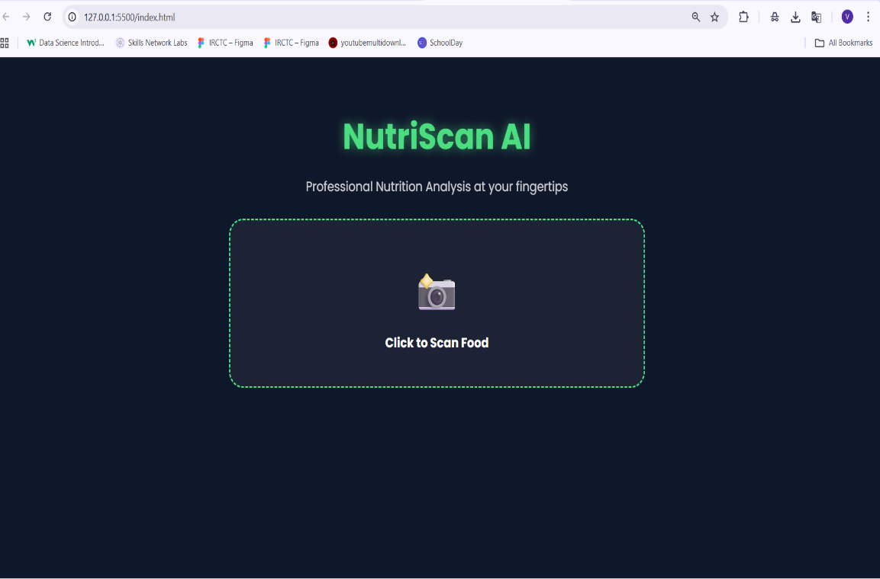

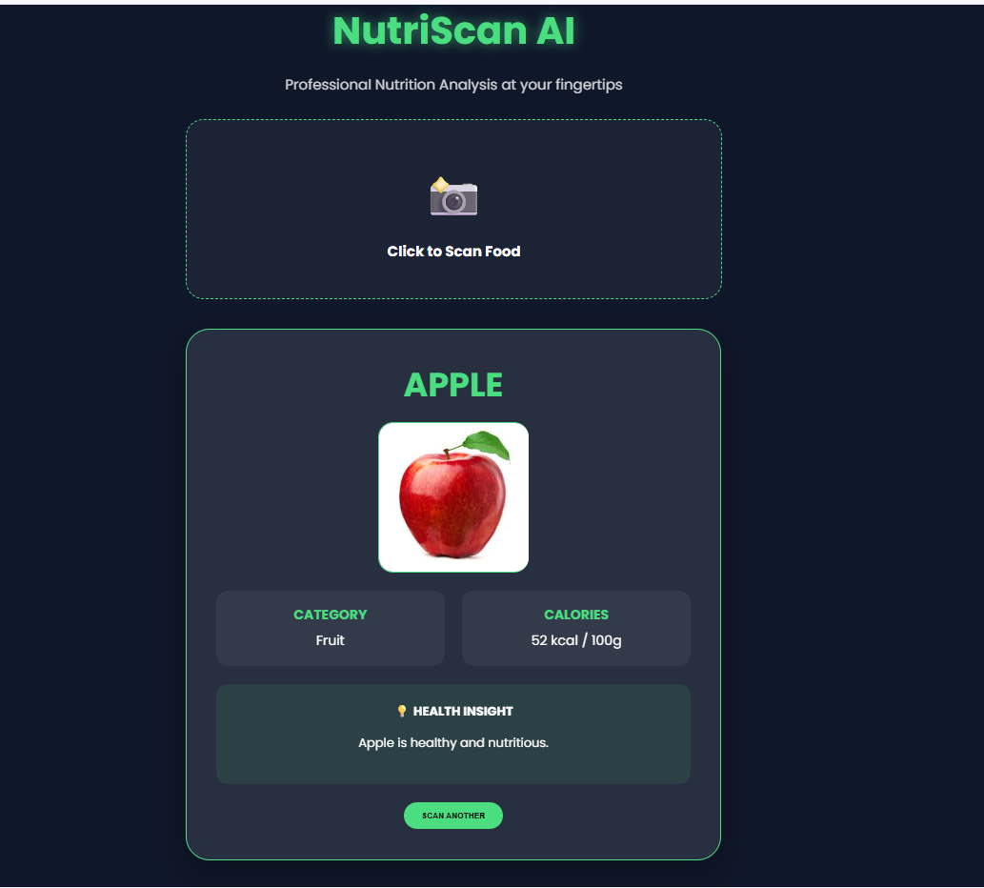

Advantages:
The system saves time and automates identification. It can also be extended to mobile applications.
Results and Conclusion:
The system successfully identifies fruit and vegetable images and provides calorie information and category classification.
Users can visually confirm results through preview images on the web interface. The system architecture allows integration into diet applications, kitchens, schools, or restaurants. It is reliable, fast, and user-friendly.
Future Scope:
The project may be improved to include health charts, storage recommendations, and personalized diet suggestions.
Additional features such as multilingual support, voice output, and smartphone app deployment are also possible.
Final Remarks:
Nutri Scan AI integrates computer vision and deep learning into a real-world nutrition support system. It demonstrates how
technology can simplify daily tasks such as food identification and calorie tracking. The project offers scalable application potential and serves as a strong foundation for future AI-based nutrition research.

