Table of Contents

- Overview
- Dataset
- Project Pipeline
- Data Cleaning
- Exploratory Data Analysis
- Text Preprocessing
- Model Building
- Results & Evaluation
- Model Comparison
- Installation
- Project Structure
- Technologies Used

Overview

This project builds a complete machine learning pipeline to automatically detect spam SMS messages. Starting from raw text data, it performs data cleaning, exploratory analysis, NLP preprocessing, and trains multiple classifiers — ultimately selecting Multinomial Naive Bayes with TF-IDF features as the best model.

Metric | Value
Dataset Size | 5,572 messages
After Cleaning | 5,169 messages
Training Set | 4,135 (80%)
Test Set | 1,034 (20%)
Best Model | MultinomialNB
Best Accuracy | 96.9%
Precision (Spam) | 98.2%

Dataset
- File: spam_sms.csv
- Source: UCI SMS Spam Collection Dataset
- Columns:
  - v1 → Label (ham or spam) — renamed to Target
  - v2 → Raw SMS text — renamed to Text

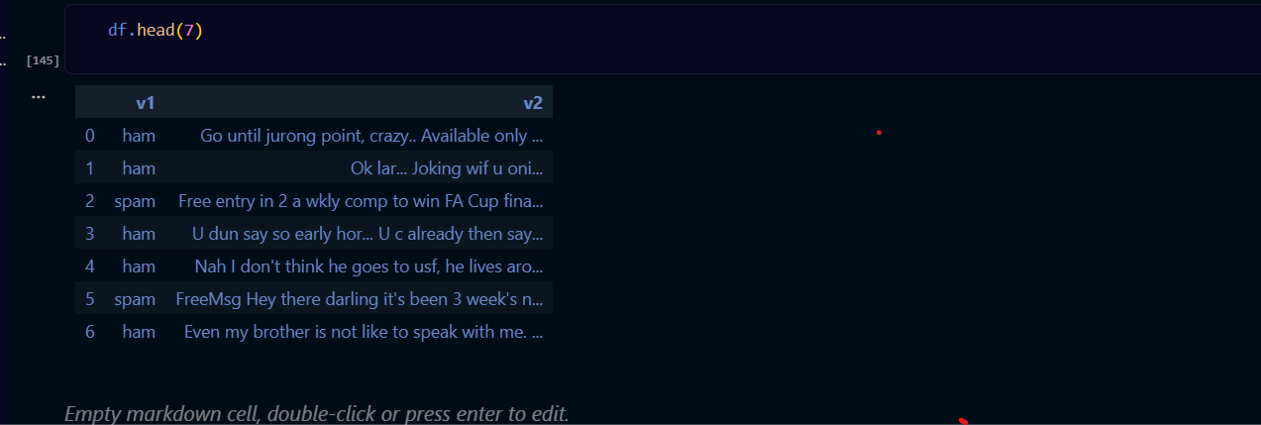

# so I change the column name to target and data in clean part

Data Cleaning
In this we clean data and check data type and cheaking null

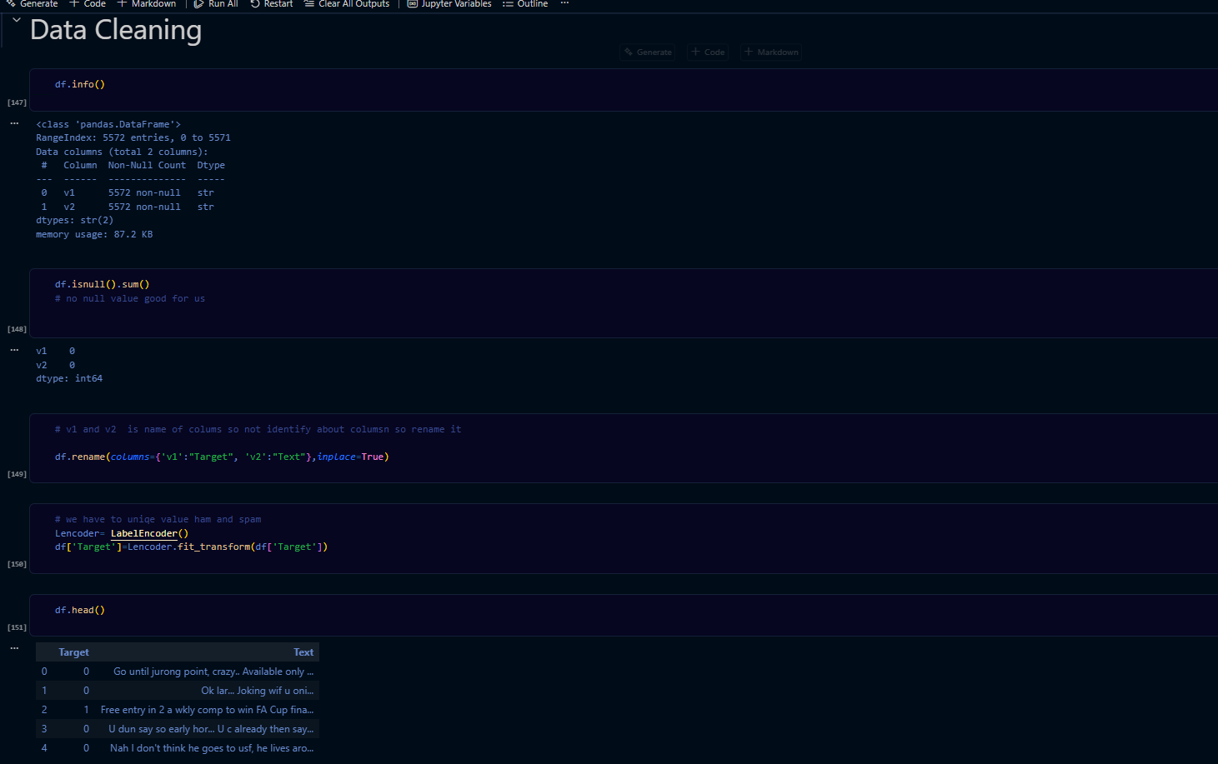

For preparing model make target column in form of 0,1 by labelEncoder

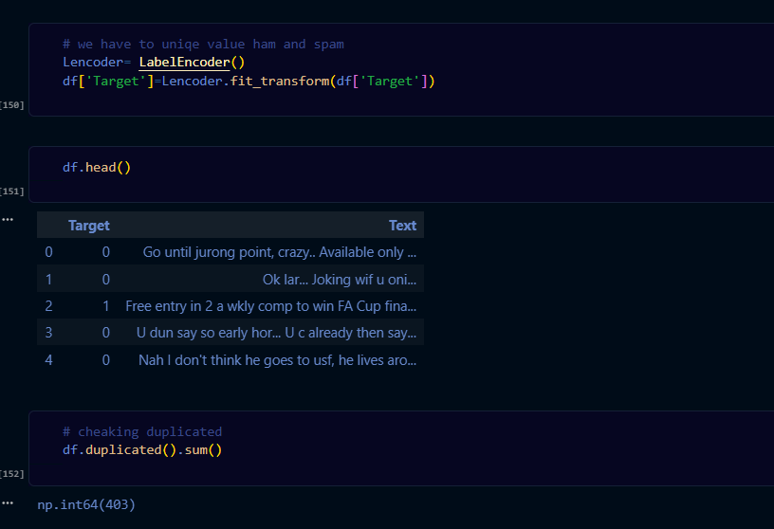

Exploratory Data Analysis
Class Distribution
The dataset is imbalanced — ham messages make up ~87% of the data. But not need smote because I am using particular like I make all highlight text in arry and then convert in form on vector by tdf
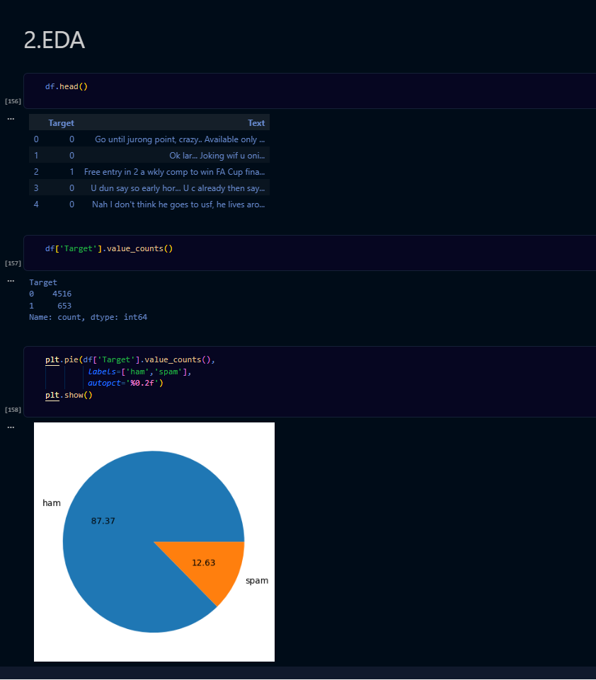
from nltk.stem import PorterStemmer
import string, re

ps = PorterStemmer()

stopwords = {
'i', 'me', 'my', 'we', 'our', 'you', 'your', 'he', 'she', 'it', 'they',
'is', 'am', 'are', 'was', 'were', 'be', 'been', 'being',
'have', 'has', 'had', 'do', 'does', 'did',
'a', 'an', 'the', 'and', 'but', 'if', 'or', 'because',
'as', 'until', 'while', 'of', 'at', 'by', 'for', 'with', 'about',
# ... (full list in notebook)
}

def transform_text(text):
# Step 1: Lowercase
text = text.lower()
# Step 2: Tokenize
text = text.split()
# Step 3: Keep only alphanumeric tokens
text = [w for w in text if w.isalnum()]
# Step 4: Remove stopwords & punctuation
text = [w for w in text if w not in stopwords and w not in string.punctuation]
# Step 5: Stemming
text = [ps.stem(w) for w in text]
return " ".join(text)

this is how the data is spread my ham or spam
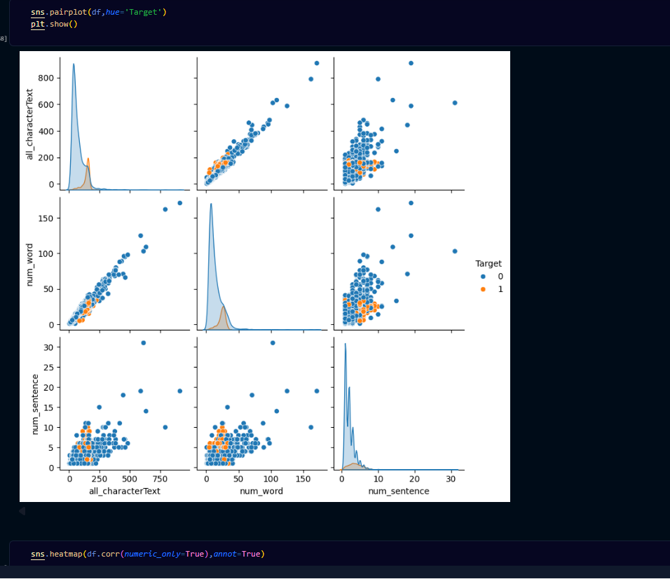

I plot heatmap to cheeking relation of all column
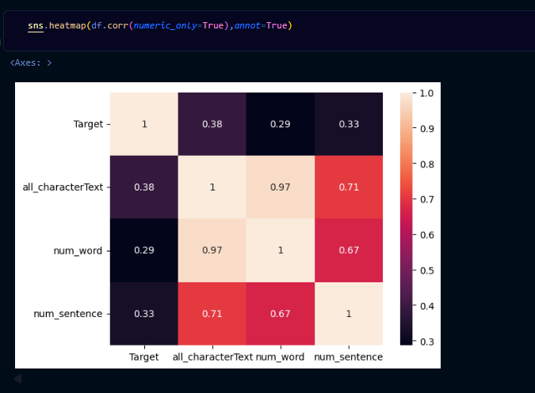

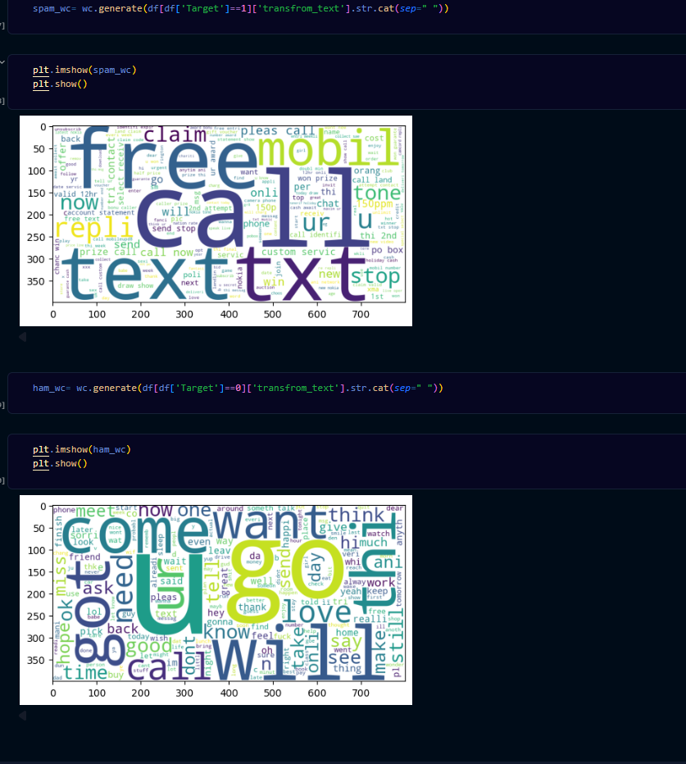

Model Building
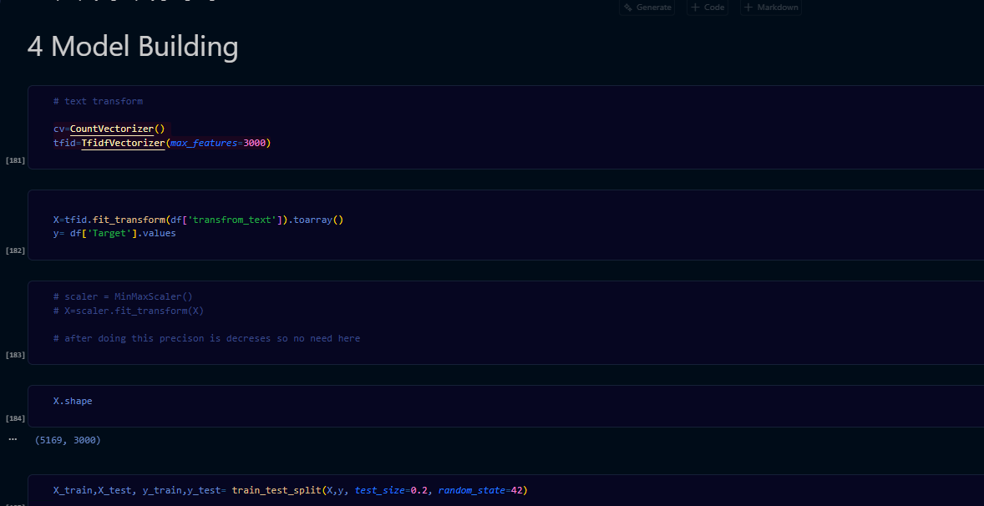

from sklearn.model_selection import train_test_split

X_train, X_test, y_train, y_test = train_test_split(
X, y, test_size=0.2, random_state=42
)
# Train: 4,135 samples | Test: 1,034 samples

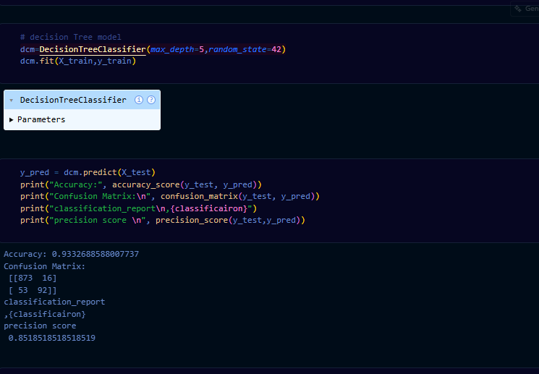

Decision Tree — Confusion Matrix
Accuracy : 93.3%
Precision: 85.2%
[[873 16]
[ 53 92]]

GaussianNB — Confusion Matrix
Accuracy : 79.9%
Precision: 39.9%
[[701 188]
[ 20 125]]

MultinomialNB — Confusion Matrix (Best Model)
Accuracy : 96.9%
Precision: 98.2%
[[887 2]
[ 38 107]]

BernoulliNB — Confusion Matrix
Accuracy : 96.9%
Precision: 96.7%
[[885 4]
[ 28 117]]

Model Comparison
Comparison Bar Chart
Model | Accuracy | Precision | False Positives
GaussianNB | 79.9% | 39.9% | 188
Decision Tree | 93.3% | 85.2% | 16
Logistic Regression | 95.4% | ~95% | 5
BernoulliNB | 96.9% | 96.7% | 4
MultinomialNB ✅ | 96.9% | 98.2% | 2

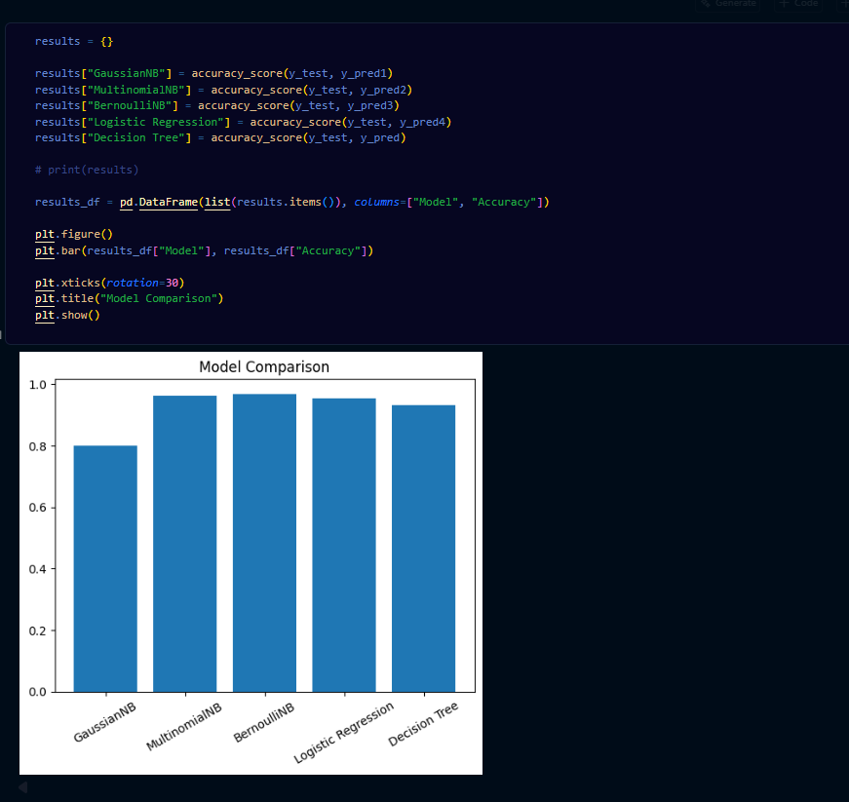

Why Naive Bayes for text?

- Uses Bayes' Theorem: P(spam | words) — naturally suited for word frequency
- Multinomial variant is purpose-built for count/frequency feature vectors
- Fast to train: O(n × d), handles 3,000-feature vocabulary with ease
- Low overfitting: strong independence assumption actually helps text classification

