PIE
PATENT INFORMATION EXTRACTION
FORM
TOPIC:
VIPERVIGIL: SMART WEARABLE MULTI-SENSOR ALERTING APPARATUS FOR REAL-TIME REPTILE THREAT DETECTION & TRACKING
SCHOOL: Chitkara University Research & Innovation Network
INVENTOR'S DETAIL WHO UPLOADED THE PATENT ON CHALKPAD

NAME:
EMPLOYEE CODE:
MOBILE NO: —
MAIL ID (UNIVERSITY):
MAIL ID (PERSONAL): —
OTHER INVENTORS DETAIL
NAME | EMP CODE/ROLL | ADDRESS WITH EMAIL AND MOBILE NO.
Yuvraj Yadav | 2510992790 | yuvraj2790.beai25@chitkara.edu.in
Shubhleen Kaur | 2510992739 | shubhleen2739.beai25@chitkara.edu.in
Tushali Singla | 2510990835 | tushali0835.becse25@chitkara.edu.in
Sudarshana Datta | 2510992695 | sudarshana2695.beai25@chitkara.edu.in
Harman Nain | 2510992747 | harman2747.beai25@chitkara.edu.in

Answer the following questions in brief: (use extra sheets if needed, submit pics/videos etc. which can help us to understand the invention better)
Q1. What was the problem?
Snakebite remains a serious and historically neglected public-health problem, particularly across South Asia, and existing personal-protection measures give no real-time warning before a person comes within striking distance of a hidden reptile. Four converging gaps in existing approaches motivate this invention.
1.1 The Public-Health Burden of Snakebite
According to World Health Organization estimates, approximately 5.4 million snakebites occur worldwide each year, resulting in an estimated 81,000 to 138,000 deaths and roughly three times as many survivors left with permanent disabilities. India alone accounts for close to half of the world's snakebite deaths, with national mortality studies putting the average at approximately 58,000 deaths per year, the large majority occurring in rural areas, during the monsoon season, and among agricultural and outdoor workers. The WHO re-classified snakebite envenoming as a priority Neglected Tropical Disease in 2017 and launched a global strategy to halve snakebite deaths and disability by 2030.
1.2 The Core Problem: Hidden, Cryptic Reptiles
Snakes are cryptic by nature, hiding in tall grass, bushes, leaf litter, rock crevices, irrigation channels, and dark corners, and are frequently not noticed until a person is already within striking distance. Sticks, boots, flashlights, and noise-making offer only passive protection and do not detect a hidden snake before the user approaches it. This risk is heightened at dawn, dusk, and night, when snake activity is highest and human visibility is lowest, and is compounded during monsoon flooding, which displaces snakes into human-occupied spaces.
1.3 The Occupational Exposure Gap
The population most at risk — agricultural labourers, plantation and forestry workers, trekkers and field surveyors, and rural utility or disaster-relief personnel — work for extended hours, cannot devote continuous visual attention to the ground, and often operate in areas with limited or no cellular network coverage. No existing wearable technology is designed around this specific occupational profile. Field crews additionally work in teams, yet no existing wearable gives one worker's detection any bearing on a teammate's safety — each unit is informationally isolated from the others (see Section 2.9).
1.4 The Single-Sensor Failure Gap
No single sensing modality reliably detects a cryptic, cold-blooded, camouflaged animal across the full range of lighting, weather, and vegetation conditions encountered in the field. A camera fails in darkness or heavy foliage; a conventional thermal (PIR) sensor fails against an ectotherm, since a snake's body temperature closely tracks its surroundings; an acoustic sensor fails against a motionless snake; and a chemical sensor cannot localise a target with directional precision.
1.5 The Static-Threshold / False-Alarm Gap
A further, previously unaddressed gap emerged during the prior-art review: fixed, factory-set detection thresholds do not account for the fact that ambient VOC and seismic “noise floors” vary sharply by micro-environment — a wet paddy field, a dry orchard, and a forestry clear-cut each have different baseline chemical and vibrational backgrounds. A static threshold is either too sensitive (frequent false alarms, alert fatigue, and eventual disuse) or too conservative (missed detections) depending on where it is deployed.
These converging gaps — public-health scale, cryptic target behaviour, occupational exposure, single-sensor failure, and static-threshold false alarms — constitute the core problem this invention is designed to solve.
Q2. How did you solve it (Inventive Step)?
ViperVigil is a wearable, non-network-dependent safety apparatus that fuses fourteen distinct sensing and support modalities with an environmentally adaptive edge-AI fusion algorithm and a multi-segmented Wearable Display Interface Module (WDIM), so that the device degrades gracefully rather than catastrophically as lighting, weather, and terrain conditions change. The system additionally incorporates five inventive refinements — adaptive calibration, two-stage adaptive alert logic, offline venom-risk tiering, crew mesh relay, and sensor/protocol specificity.
2.1 The 14-Tier Omni-Sensor Array
Each modality is selected specifically to compensate for the blind spots of the others:
- VOC Olfactory Sensor: a metal-oxide-semiconductor (MOS) / photoionization-detector (PID) element pre-tuned to the lipid and squalene-derivative pheromone/musk compounds characteristic of venomous snakes, mounted in a field-replaceable calibration cartridge, detecting concealed animals even beneath leaf litter.
- Micro-Seismic / Acoustic Geophone Array: an ankle-mounted piezoelectric sensor isolates the low-frequency slithering signature of a limbless reptile from human and livestock footsteps.
- Solid-State LiDAR & mmWave Radar (60–77 GHz): penetrates tall grass, fog, and leaf litter, mapping a 3D point cloud to distinguish coiled/serpentine shapes from hoses, roots, or vines.
- Multispectral Polarization Camera: operates across visible, NIR, and SWIR bands with a polarization filter that strips glare, visually confirming reptiles by their spectral signature and supplying imagery for species classification.
- Long-Wave Infrared (LWIR) Microbolometer: inverts the thermal-detection paradigm by mapping the cool shadow silhouette a cold-blooded snake casts against sun-warmed ground, succeeding where conventional PIR wildlife cameras fail.
- Electromagnetic (Bioelectric Field) Sensor: detects the bioelectric field of living tissue to distinguish a stationary animal from a similarly shaped root, hose, or rock.
- Ambient Environmental Array: tracks barometric pressure, humidity, and temperature to auto-heighten sensitivity during known high reptile-activity conditions.
- Near-Field Magnetic Anomaly Detector: senses magnetic-field disturbances from biological movement, useful for non-visual verification in darkness.
- Ultrasonic Phased Array: beam-steered pings penetrate foliage gaps and estimate object density to distinguish soft biological tissue from rock.
- GNSS/GPS Geolocation Module: geotags every confirmed detection event to within a few metres, without requiring live network connectivity.
- Passive Bioacoustic Microphone Array: listens for hissing, rattling, and defensive acoustic signatures and independently raises early caution-state alerts.
- Ambient Light / Circadian Sensor: tracks the dawn/day/dusk/night cycle to re-weight the fusion algorithm toward non-optical sensors as light falls.
- Hybrid Solar-Trickle Power Module: a flexible photovoltaic laminate with an MPPT (maximum-power-point-tracking) charge controller supplements the battery with continuous, efficiency-optimised daylight charging even under dappled canopy light.
- Long-Range LoRa/Satellite Emergency Beacon: transmits a compressed GNSS position and alert-severity payload, over an adaptive-spreading-factor LoRa link with automatic satellite failover, to a gateway or satellite constellation independent of cellular coverage.
2.2 Edge AI Sensor-Fusion Engine
An onboard microcontroller continuously reads all fourteen tiers and applies an environmentally variant, dynamically weighted fusion algorithm (detailed in Section 2.5) to combine their individual confidence scores into a single, trustworthy detection confidence — entirely offline, with no dependency on a paired smartphone or network connectivity.
2.3 Wearable Display Interface Module (WDIM)
When combined confidence breaches a pre-set safety threshold, the WDIM delivers multi-sensory, spatial feedback: an AMOLED radar-style micro-display plots the threat by distance band and species icon; a four-quadrant Directional Haptic Matrix pulses the actuator nearest the threat's bearing; a context-aware RGB LED array signals nominal/caution/critical states; and a bone-conduction auditory node delivers alerts directly through the wearer's clavicle or jawbone, bypassing field noise.
2.4 Cloud Integration & Longitudinal Hotspot Mapping
Every detection event is logged locally with high-resolution imagery, GNSS coordinates, and telemetry, then synchronised — via USB or the long-range beacon — to cloud infrastructure, enabling agricultural organisations and forest departments to build longitudinal snake-density hotspot maps for proactive worker deployment.
2.5 Power & Environmental Ruggedization
A rechargeable lithium-polymer cell, supplemented by MPPT-controlled solar trickle-charging, powers the system through an impact-resistant, dust- and water-jet-rated enclosure suitable for monsoon-season fieldwork and multi-hour continuous wear.
2.6 Adaptive Baseline Calibration Module
During an initial wear-in period, the device samples the ambient VOC background and seismic/acoustic noise floor specific to the wearer's current micro-environment (soil type, vegetation density, local wildlife/livestock activity) and adjusts each sensor tier's baseline trust-weight accordingly, rather than using a fixed factory threshold. This directly resolves the static-threshold false-alarm gap identified in Section 1.5.
2.7 Two-Stage Caution / Confirmed-Critical Alert Logic with False-Positive Feedback
Rather than a single confidence threshold, the fusion engine issues a low-intensity CAUTION-state cue when any single tier crosses a first (low) threshold, and escalates to a CONFIRMED-CRITICAL state only when the combined confidence score AND an independent species-identification determination AND the bioelectric living-tissue check all concur at a second (high) threshold. A one-tap wearer gesture lets the user mark an alert as a false positive, which locally decrements the trust-weight for that sensor tier at that specific geofenced location — an on-device, privacy-preserving adaptive-learning loop with no cloud dependency (see Figure 6).
2.8 Offline Venom-Risk Tiering
The on-device species-classification output is mapped against a locally stored, regionally configurable venom-risk table, aligned to WHO snakebite-envenoming priority species lists, so that WDIM colour and urgency are scaled by medical risk severity rather than by detection distance alone. This strengthens the disclosure's direct tie to the public-health problem described in Section 1.1.
2.9 Crew Mesh Relay Network
Multiple ViperVigil units worn by a field crew form a local LoRa mesh: a unit outside direct gateway or satellite range relays its alert and GNSS payload through a nearby teammate's unit, which forwards it onward until it reaches a gateway. This extends the emergency-beacon concept from a single-wearer feature to a crew-level shared hazard-awareness network, and additionally enables per-worker “dosage-of-risk” exposure logging for occupational-health reporting (see Figure 7).
2.10 Sensor and Protocol Specificity Refinements
- 32GB Local Storage: specified as a circular-buffer event-record schema (timestamp, GNSS fix, full sensor-vector snapshot, imagery thumbnail, species classification, confidence score, venom-risk tier), enabling both forensic playback and crew-level analytics.
- VOC Sensor: field-replaceable calibration cartridge pre-tuned to a squalene-derivative pheromone compound profile, distinguishing it from a generic gas sensor.
- LoRa/Satellite Link: adaptive-spreading-factor LoRa with automatic terrestrial-gateway-to-satellite failover based on continuous link-quality monitoring.
Q3. What were the other possible solutions and why they could not be done?
Several existing detection approaches were evaluated and found fundamentally inadequate for real-time, wearable, personal-safety detection of cryptic reptiles:
Alternative Method | Key Limitation | Efficacy
Manual Visual Inspection | Slow, requires constant vigilance; hidden snakes are easily missed in dense vegetation or low light. | Low
Physical Traps (Pitfall/Funnel) | Only catch snakes that move into them of their own accord; give no real-time warning to a person already in the field. | Low
Motion / PIR Camera Traps | Snakes are cold-blooded and generate little thermal contrast, so conventional PIR sensors frequently fail to detect them at all. | Low
Environmental DNA (eDNA) | Confirms only that a snake was present in the past; requires lab sample collection, offering forensic rather than real-time warning. | Medium
Fixed Perimeter Sensors | Can flag activity at a fence line but give no protection to a worker already moving through a field or forest interior. | Medium
Single-Modality Wearables (ultrasonic/thermal only) | Each sensor alone fails in specific conditions — camera in darkness, thermal against an ectotherm, acoustic against a motionless snake. | Medium
Prior-Art Wearable Safety Devices | The 15 closest published references (NVIDIA hazard detection, wearable navigation aids, pet-AI platforms, vehicle health monitors, etc.) each disclose only a subset of KF1–KF10 and none disclose adaptive calibration, two-stage feedback logic, venom-risk tiering, or crew mesh relay. | Medium–High (partial)

Q4. What are the advantages of the solution proposed by you?
ViperVigil offers a comprehensive set of advantages over all existing alternatives:
Advantage | Description
Real-Time, In-Field Warning | Detects threats before the wearer approaches striking distance, unlike inspection- or lab-based methods that are retrospective or require constant attention.
Detects Cold-Blooded (Ectothermic) Targets | Inverted LWIR shadow-silhouette detection succeeds precisely where conventional thermal PIR wildlife cameras fail against snakes.
Functions Through Foliage & Low Light | mmWave radar, LiDAR, VOC, seismic, and acoustic tiers all operate through dense vegetation, fog, and darkness.
Fully Wearable — Follows the User | Unlike fixed perimeter or camera-trap systems, protection travels with the worker across changing terrain.
On-Device Species Classification | The multispectral camera and bioacoustic classifier jointly identify snake family, not just presence.
Geotagged Longitudinal Hotspot Mapping | GNSS-tagged, cloud-synced events support regional snakebite-hotspot mapping aligned with the WHO 2030 mortality-reduction strategy.
Fully Offline Edge-AI Operation | All fourteen sensing tiers and the fusion algorithm run locally, with no dependency on network or paired-device connectivity.
Multi-Sensory Directional Alerting (WDIM) | Radar-style display, quadrant haptics, LED states, and bone-conduction audio give unambiguous, hands-free threat-bearing guidance.
Fewer False Alarms Over Time | Adaptive baseline calibration and the geofenced false-positive feedback loop reduce nuisance alerts the longer a unit is used in a given locale, improving long-term wearer trust and compliance.
Medically Prioritised Alerting | Offline venom-risk tiering means the wearer's response urgency is matched to actual envenoming risk, not just detection distance — directly supporting faster, better-triaged emergency response.
Crew-Level Protection, Not Just Individual | The mesh relay extends situational awareness and SOS reach to teammates outside direct gateway range, and produces crew-level occupational-exposure analytics no single-wearer prior-art device offers.
Q5. Explain the stepwise working of the innovation explaining all the components used in the invention and the specific function they are performing.
ViperVigil operates through a continuous, fully autonomous ten-stage sensing, fusion, and alert cycle once worn and powered on (Stages 1–10 established;):
Stage 1: Continuous Multi-Tier Sensor Sampling. All fourteen sensing tiers — VOC, micro-seismic, mmWave radar/LiDAR, multispectral polarization camera, LWIR bolometer, bioelectric field, ambient environmental array, magnetic anomaly detector, ultrasonic phased array, GNSS, bioacoustic microphones, and ambient light sensor — sample continuously and in parallel across the primary chest/waist unit and satellite shoulder/belt/ankle nodes.
Stage 2: Environmental Context Sensing & Dynamic Weighting. The ambient environmental array and ambient light sensor determine the current lighting state (dawn/day/dusk/night) and micro-climate conditions, feeding the enviro-variant fusion-weighting scheme that raises or lowers the trust score of each sensor tier accordingly.
Stage 3: Edge AI Sensor Fusion & Confidence Scoring. The onboard microcontroller combines the individually weighted confidence scores from all active tiers into a single combined detection confidence, executed entirely on-device with no cloud dependency.
Stage 4: Threat Confirmation & Species Classification. When combined confidence breaches the pre-set safety threshold, the multispectral camera and bioacoustic classifier jointly determine species-family classification for display, while the bioelectric-field sensor cross-checks that the target is a living organism rather than an inanimate look-alike.
Stage 5: WDIM Multi-Sensory Alert Activation. The Wearable Display Interface Module activates: the AMOLED radar display plots the threat by distance zone and species icon, the Directional Haptic Matrix pulses the quadrant-matched actuator, the LED array shifts to caution or critical state, and the bone-conduction node delivers an audible alert directly through the wearer's clavicle or jawbone.
Stage 6: Emergency Escalation. For an actual envenoming or field emergency, the wearer can independently trigger the manual panic/SOS actuator, which transmits a compressed emergency payload — GNSS fix and severity level — via the long-range LoRa/satellite beacon to a gateway or satellite constellation, independent of cellular availability.
Stage 7: Local Logging, USB/Cloud Sync & Longitudinal Mapping. Every event is time-stamped, geotagged, and stored in 32GB local storage as a circular-buffer record; once connected via USB or the communication beacon, the data synchronises to cloud infrastructure, building longitudinal snake-density hotspot maps for regional public-health planning.
Stage 8: Adaptive Baseline Recalibration. In parallel with Stages 1–7, the Adaptive Baseline Calibration Module periodically re-samples the local VOC/seismic noise floor and, upon a wearer false-positive tap, decrements the trust-weight of the implicated tier for that geofenced location, refining future fusion accuracy without any cloud round-trip.
Stage 9: Venom-Risk Lookup & Scaled Alerting . Once Stage 4 confirms a species classification, the result is cross-referenced against the locally stored venom-risk table before Stage 5 fires, so the WDIM's colour and urgency profile reflects medical severity, not distance alone.
Stage 10: Crew Mesh Relay & Occupational Logging. If Stage 6 or a Stage-5 critical alert cannot reach a gateway or satellite directly, the payload is relayed via short-range LoRa mesh through the nearest teammate's unit; all relayed and direct events additionally roll up into a per-worker exposure log for crew-level occupational-health analytics.

Summary of System Components & Functions
Component | Function
VOC Olfactory Sensor | Detects airborne chemical/pheromone signatures characteristic of venomous snakes (MOS/PID, pheromone-tuned cartridge).
Micro-Seismic / Acoustic Geophone Array | Isolates the ground-borne slithering signature of a limbless reptile from human/livestock footsteps.
mmWave Radar & Solid-State LiDAR | Penetrates foliage/fog and maps 3D shapes to distinguish coiled bodies from look-alikes.
Multispectral Polarization Camera | Visually confirms and classifies reptiles across visible/NIR/SWIR bands, glare-reduced.
LWIR Microbolometer | Detects the cool shadow silhouette an ectothermic snake casts on warm ground.
Bioelectric Field Sensor | Distinguishes living tissue from inanimate look-alikes, reducing false positives.
Ambient Environmental Array | Tracks pressure/humidity/temperature to auto-heighten sensitivity in high-activity conditions.
Magnetic Anomaly Detector | Senses magnetic disturbance from biological movement, useful in darkness.
Ultrasonic Phased Array | Beam-steered echo-ranging estimates object density through foliage gaps.
GNSS/GPS Module | Geotags every confirmed detection event for hotspot mapping.
Bioacoustic Microphone Array | Detects hissing/rattling signatures and raises early caution alerts.
Ambient Light / Circadian Sensor | Determines day/night state to re-weight sensor trust and WDIM brightness.
Edge Microcontroller (Fusion Engine) | Runs the dynamic, environmentally variant sensor-fusion algorithm on-device, including the two-stage alert logic.
Wearable Display Interface Module (WDIM) | Delivers radar-display, directional haptic, LED, and bone-conduction alerts, scaled by venom-risk tier.
Long-Range LoRa/Satellite Beacon | Transmits emergency GNSS + severity payload independent of cellular network; relays via crew mesh when needed.
Hybrid Solar-Trickle Power Module | Supplements the rechargeable battery with MPPT-optimised continuous daylight charging.
Adaptive Baseline Calibration Module | Learns local VOC/seismic noise floor and geofenced trust-weights from wear-in period and wearer feedback.
Venom-Risk Lookup Table | Locally stored, regionally configurable table mapping species classification to medical alert severity.
Crew Mesh Relay Logic | Rebroadcasts alert/GNSS payloads peer-to-peer between nearby units when direct gateway/satellite range is unavailable.
Q6. Attach drawing hand-made/computer made showing all the components of the invention.
The following figures illustrate the physical hardware configuration, wearing topology, system architecture, and alert-logic flow of the ViperVigil apparatus.

Figure 1 — Component Architecture (Hand-Drawn, Original)
The inventors' original hand-drawn sketch of the primary sensor housing, identifying the Multispectral Camera and Polarization Filter, the MM Wave Radar module, the Microcomputer Unit, Local Storage, USB Output, and the Haptic Vibration Alert mechanism.
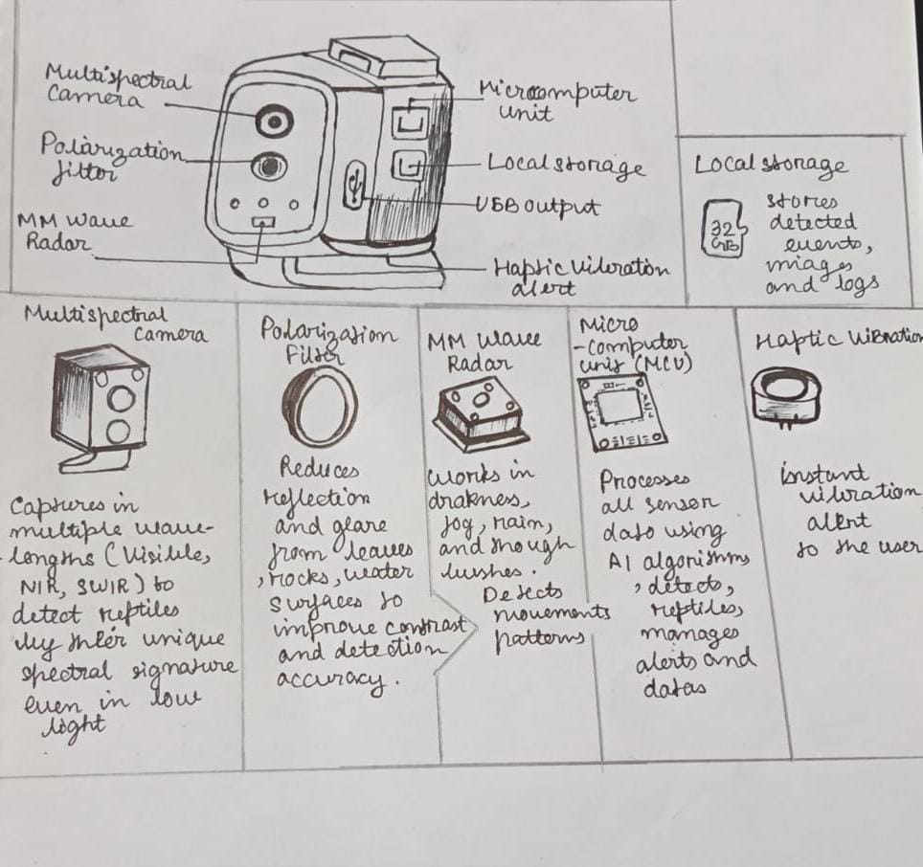
Figure 1: Original Inventor's Hand-Drawn Sketch — Primary Sensor Housing Component Layout

Figure 2 — Wearing Topology & Detection Coverage (Hand-Drawn, Original)
The inventors' hand-drawn sketch of the four wearable mounting zones — chest, belt/waist, shoulder strap, and shoe/ankle — together with the front-view conical detection-coverage profile (Best 0–5 m, Good 5–8 m, Limited 8–10 m) and the data-output summary (real-time vibration alert, event logs, USB transfer, map view).
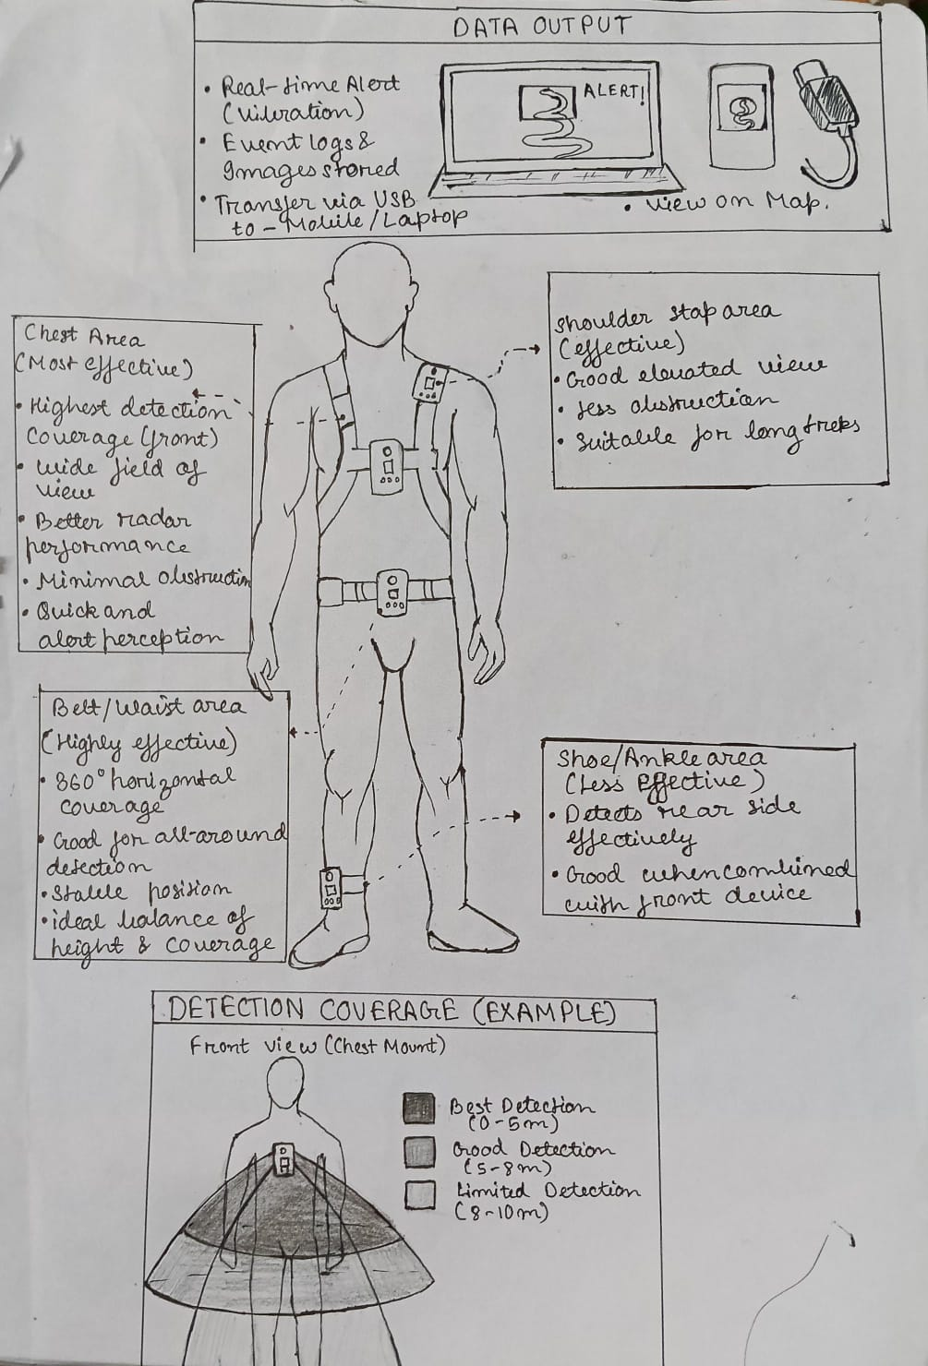
Figure 2: Original Inventor's Hand-Drawn Sketch — Wearing Position Topology & Detection Coverage

Figure 3 — Logic Flowchart for Cross-Verification and Alerting (Professional Diagram, Original)
This flowchart shows how the camera and radar feeds are cross-verified by the Microcomputer's edge-AI inference before an alert is triggered: reptile identification (304) AND critical-distance confirmation (305) must both hold before the Trigger Alert Pathway (306) activates the haptic motor, mobile app, and offline database log — this dual-condition cross-verification is what suppresses single-sensor false positives.
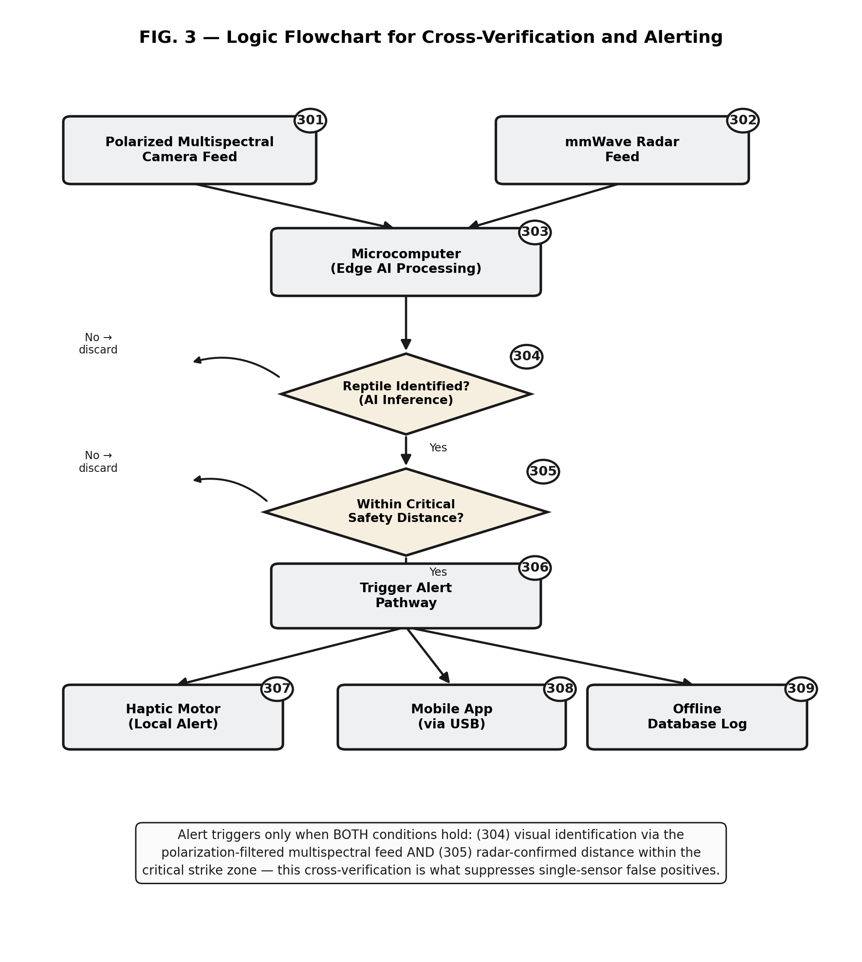
Figure 3: Logic Flowchart for Cross-Verification and Alerting

Appendix A: Supplementary Engineering Figures (Addendum)
The two figures below supplement the component descriptions, sensor-fusion logic, and body-mounting topology already documented above. They were prepared to give reviewers a single, at-a-glance visual reference for the device’s physical layout, its runtime decision flow, and its recommended on-body placement, and are reproduced here at enhanced resolution and sharpness for legibility in print and PDF review.

Figure A1 — Component Architecture and Data Flow
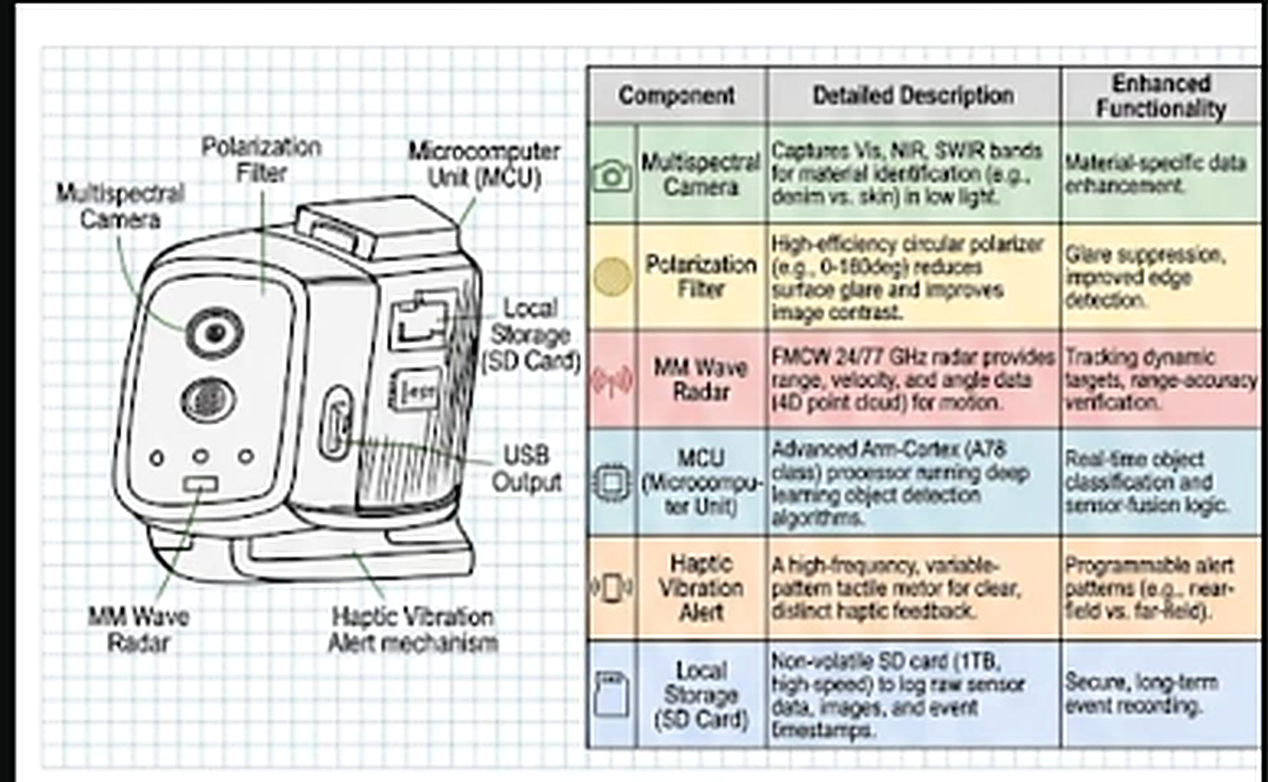
Figure A1. Exploded view of the ViperVigil housing with the six primary externally visible subsystems labelled (multispectral camera, polarization filter, MM-wave radar, microcomputer unit, local SD storage, USB output, and haptic vibration alert), alongside a summary table cross-referencing each component to its detailed function and the enhanced capability it contributes to the sensor-fusion pipeline described in Section 2.1.

Figure A2 — Body-Mounting Positions and Detection Range Profile
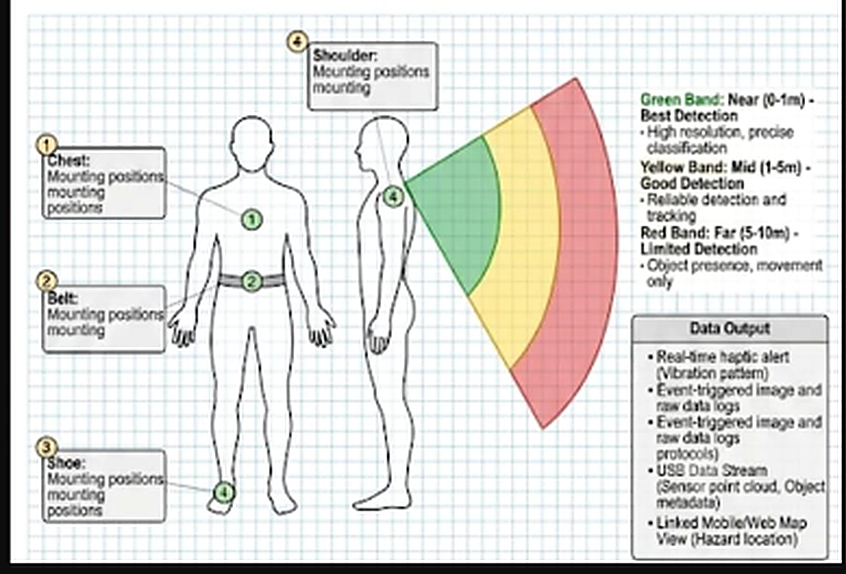
Figure A2. Recommended wearable mounting positions (chest, belt, shoe, and shoulder) with the corresponding angular detection-range profile: green band (0–1 m, best detection), yellow band (1–5 m, good detection), and red band (5–10 m, limited/presence-only detection), alongside the device’s data output channels (haptic alert, event-triggered imagery and logs, USB data stream, and linked mobile/web map view).

Figure 4 — System Architecture & Data Flow (Textual Summary)
The architectural data flow proceeds through the following ten stages as illustrated in Figures 1 through 3:
# | Stage | Description
1 | Multi-Tier Sensor Sampling | Fourteen fused sensing tiers across the primary unit and satellite nodes sample continuously.
2 | Environmental Weighting | Ambient light and environmental array readings dynamically re-weight sensor trust scores.
3 | Edge AI Fusion | On-device fusion algorithm combines weighted confidences into one detection score.
4 | Threat Confirmation & Classification | Species classification and living-target verification confirm a genuine reptile threat.
5 | WDIM Alerting | Radar display, directional haptics, LEDs, and bone-conduction audio alert the wearer.
6 | Emergency Escalation | Manual panic actuator triggers a LoRa/satellite emergency payload when needed.
7 | Logging & Cloud Sync | Events are geotagged, stored locally, and synced to cloud for hotspot mapping.
8 | Adaptive Recalibration | Local trust-weights adjust from noise-floor sampling and wearer false-positive feedback.
9 | Venom-Risk Lookup | Species classification is cross-referenced to a local risk table before alerting.
10 | Crew Mesh Relay | Out-of-range alerts hop through nearby teammates units to reach a gateway.

Relevant Key phrases relating to your invention
S.No. | Key phrases
1. | AI-based wearable multi-sensor reptile detection device
2. | Edge-computed 14-tier omni-sensor fusion for cryptic threat detection
3. | Directional haptic and visual wearable alert interface (WDIM)
4. | Geotagged cloud-based snakebite hotspot mapping system
5. | Offline sensor-fusion apparatus for personal safety in agricultural and forestry fieldwork
6. | Offline geofenced sensor-fusion trust-weight feedback for wearable threat detection
7. | Two-stage caution/confirmed-critical alert escalation with dual-condition living-tissue verification
8. | Multi-wearer LoRa mesh relay for crew-level occupational hazard alerting
9. | Species-to-venom-risk-tiered wearable alert scaling
10. | Reptile-pheromone-tuned MOS/PID olfactory sensor cartridge for wearable safety devices

— End of Patent Information Extraction Form —
ViperVigil Wearable Reptile Detection System | Patent Pending | Confidential

