Hindu Institute of Management



Practical file of Programing in C

MCA 125C

Submitted to: Submitted by:

Mrs. Parull Bhardwaj Vishal Kaushik

Roll No.:

24012541019

**INDEX**

|  |  |  |  |
| --- | --- | --- | --- |
| **S.NO** | **Program Details** | **Page Numbers** | **Teacher Signature** |
| **1** | **Program to take the input from user to read integer, float, char values and print**  **them.** | **1** |  |
| **2** | **Program to write ASCII value of character.** | **2** |  |
| **3** | **Program to use getchar() and putchar(), gets and puts**  **functions.** | **3** |  |
| **4** | **Program to Check Vowels in a String.** | **4** |  |
| **5** | **Program to reverse of characters.** | **5** |  |
| **6** | **Largest and Smallest Number in an Array.** | **6 - 7** |  |
| **7** | **Largest and Smallest Using Global Declaration** | **7** |  |
| **8** | **Factorial of a number.** | **8** |  |
| **9** | **Fibonacci Series.** | **9** |  |
| **10** | **Palindrome of a number.** | **10** |  |
| **11** | **Sum of 10 values using array.** | **11 - 12** |  |

|  |  |  |  |
| --- | --- | --- | --- |
| **S.NO** | **Program Details** | **Page Numbers** | **Teacher Signature** |
| **12** | **Average of n values.** | **11 - 12** |  |
| **13** | **Armstrong Number.** | **12 - 13** |  |
| **14** | **Odd and Even.** | **13** |  |
| **15** | **Factors of a Number.** | **14** |  |
| **16** | **First n Prime Numbers** | **15 - 16** |  |
| **17** | **Whether the Enter the Number is float or int** | **16** |  |
| **18** | **Table of a Number.** | **17** |  |
| **19** | **Reverse of an Array.** | **18 - 19** |  |
| **20** | **Insert an Element into Array.** | **19 - 20** |  |

|  |  |  |  |
| --- | --- | --- | --- |
| **S.NO** | **Program Details** | **Page Numbers** | **Teacher Signature** |
| **21** | **Delete an Element from an Array.** | **20 - 21** |  |
| **22** | **Linear Search.** | **22 - 23** |  |
| **23** | **Binary Search.** | **23 - 24** |  |
| **24** | **Sorting List using Array.** | **24 - 25** |  |
| **25** | **Read and Print Square Matrix.** | **26 - 27** |  |
| **26** | **Addison and Subtraction in 2 matrixes.** | **27 - 28** |  |
| **27** | **Transpose of Matrix.** | **28 - 29** |  |
| **28** | **Multiply two matrixes.** | **30- 31** |  |
| **29** | **Leap Year.** | **31** |  |

|  |  |  |  |
| --- | --- | --- | --- |
| **S.NO** | **Program Details** | **Page Numbers** | **Teacher Signature** |
| **30** | **Largest of three numbers.** | **32** |  |
| **31** | **Second Largest among Three.** | **33** |  |
| **32** | **Area of Different Shapes.** | **34** |  |
| **33** | **Calculator** | **35 - 36** |  |
| **34** | **Quadratic Equation.** | **36 - 37** |  |
| **35** | **Compound and Simple Interest.** | **37 - 38** |  |
| **36** | **Convert Celsius to Fahrenheit.** | **38 - 39** |  |
| **37** | **Diamond Pattern.** | **39 - 40** |  |
| **38** | **Number Triangle** | **41** |  |

|  |  |  |  |
| --- | --- | --- | --- |
| **S.NO** | **Program Details** | **Page Numbers** | **Teacher Signature** |
| **39** | **Pyramid.** | **41 - 42** |  |
| **40** | **Invert Triangle.** | **42 - 43** |  |
| **41** | **Read and Write Character Array.** | **43** |  |
| **42** | **Marksheet of a Student.** | **44 - 45** |  |
| **43** | **Salary of an Employee.** | **45 - 46** |  |
| **44** | **Bill Calculation.** | **46 - 47** |  |

**Programing in C**

1. **Program to take the input from user to read integer, float, char values and print them.**

#include<stdio.h> int main(){

int a; float b; char c;

printf("Give Input for Integer value \n"); scanf("%d", &a);

printf("Output : %d \n", a);

printf("Give Input for Float value \n"); scanf("%f", &b);

printf("Output : %f \n", b);

printf("Give Input for Character value \n"); scanf(" %c", &c);

printf("Output : %c \n", c); return 0;

}

**Output :**

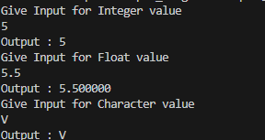

1. **Program to write ASCII value of character.**

#include <stdio.h>

int main() {

char character;

printf("Enter a character: "); scanf("%c", &character);

printf("The ASCII value of '%c' is %d\n", character, character); return 0;

}

**Output :**

C:\Users\hp\Desktop\C_File\ASCII.png

1. **Program to use getchar() and putchar(), gets and puts functions.**

#include <stdio.h>

int main() {

char ch;

char str[100];

// Using getchar() and putchar() printf("Enter a single character: ");

ch = getchar(); // Reads a single character printf("You entered: ");

putchar(ch); // Outputs the single character putchar('\n'); // Print a newline for formatting

// Clearing input buffer

while (getchar() != '\n'); // Discard extra input if any

// Using gets() and puts()

printf("Enter a string (up to 99 characters): "); gets(str); // Reads a string

printf("You entered: "); puts(str); // Outputs the string

return 0;

}

**Output :**

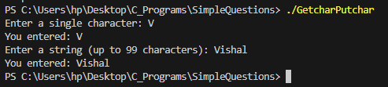

1. **Program to Check Vowels in a String.**

#include <stdio.h>

int main() {

char str[100]; int hasVowel = 0;

printf("Enter a string: "); fgets(str, sizeof(str), stdin);

for (int i = 0; str[i] != '\0'; i++) { char ch = str[i];

if (ch == 'a' || ch == 'e' || ch == 'i' || ch == 'o' || ch == 'u' || ch == 'A' || ch == 'E' || ch == 'I' || ch == 'O' || ch == 'U') { hasVowel = 1;

break;

}

}

if (hasVowel) {

printf("The string contains vowels.\n");

} else {

printf("The string does not contain any vowels.\n");

}

return 0;

}

**Output :**

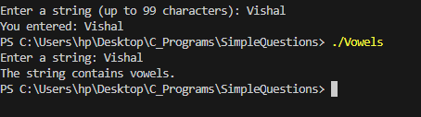

1. **Program to reverse of characters.**

#include <stdio.h> #include <string.h>

int main() {

char str[100], temp; char \*left, \*right;

printf("Enter a string: "); scanf("%99s", str);

left = str;

right = str + strlen(str) - 1;

while (left < right) { temp = \*left;

\*left = \*right;

\*right = temp;

left++; right--;

}

printf("Reversed string: %s\n", str); return 0;

}

**Output :**

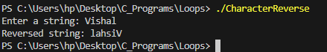

1. **Largest and Smallest Number in an Array.**

#include<stdio.h>

void Largest(int arr[], int len){ int left = 0;

int right = len-1;

while (left<=right)

{

if (arr[left]>arr[right])

{

right--;

}else{

left++;

}

}

printf("Largest %d \n", arr[right]);

}

void Smallest(int arr[], int len){ int left = 0;

int right = len-1;

while (left<=right)

{

if (arr[left]<arr[right])

{

right--;

}else{

left++;

}

}

printf("Smallest %d \n", arr[right]);

}

int main(){

int arr[] = {100,56,756,42,77,2,66,90};

int len = sizeof(arr)/sizeof(arr[0]); Largest(arr, len);

Smallest(arr, len); return 0;

}

**Output :**

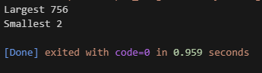

1. **Largest and Smallest Using Global Declaration.**

#include<stdio.h>

int main(){ int a;

int b;

printf("Enter first number : \n"); scanf("%d", &a);

printf("Enter Second number : \n"); scanf("%d", &b);

if (a>b)

{

printf("%d is Larger than %d", a , b);

}else{

printf("%d is Larger than %d", b, a);

}

}

**Output :**

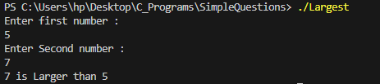

1. **Factorial of a number.**

#include<stdio.h> int main(){

int num;

printf("Enter the number you want factorial of : "); scanf("%d", &num);

fflush(stdin);

int fact = 1; while (num!=0)

{

fact = fact\*num--;

}

printf("%d \n", fact); return 0;

}

**Output :**

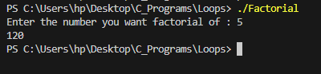

1. **Fibonacci Series.**

#include <stdio.h>

int main() {

int len;

printf("Enter the Length of Fibonacci: "); scanf("%d", &len);

int first = 0; int second = 1; int next;

if (len == 1) { printf("%d\n", first);

}

else if (len == 2) {

printf("%d, %d\n", first, second);

}

else if (len > 2) {

printf("%d, %d", first, second);

for (int i = 2; i < len; i++) { next = first + second; first = second;

second = next; printf(", %d", next);

}

printf("\n");

}

return 0;

}

**Output :**

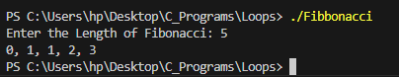

1. **Palindrome of a number.**

#include<stdio.h> void main(){

int num;

printf("Enter the number you want to check Palindrome of : "); scanf("%d", &num);

int palindrome = 0; int temp = num;

while (num != 0)

{

int digit = num%10;

palindrome = palindrome\*10 + digit; num = num/10;

}

if (temp == palindrome)

{

printf("Yes the number is a Palindrome! ");

}else{

printf("Number is not a Palindrome! ");

}

}

**Output :**

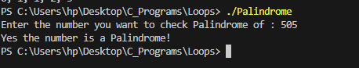

1. **Sum of 10 values using array.**

#include<stdio.h>

void main(){

int arr[] = {1,2,3,4,5,6,7,8,9,10};

int sum =0;

for (int i = 0; i < 10; i++)

{

sum += arr[i];

}

printf("%d \n", sum);

}

**Output :**



1. **Average of n values.**

#include <stdio.h>

void main()

{

int n;

printf("Enter the Length of Array \n"); scanf("%d", &n);

int arr[n]; int avg = 0;

for (int i = 1; i <= n; i++)

{

printf("Enter the %d Element: ", i); scanf("%d", &arr[i]);

}

int sum =0;

for (int i = 1; i <= n; i++)

{

sum += arr[i];

}

avg = sum/n;

printf("Avergae : %d \n", avg);

}

**Output :**

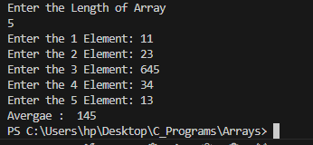

1. **Armstrong Number.**

#include<stdio.h>

int main(){

int num;

printf("Enter the number : "); scanf("%d", &num);

int armstrong = 0; int temp = num;

while (num!=0)

{

int digit = num%10;

armstrong += digit\*digit\*digit; num = num/10;

}

if (armstrong == temp)

{

printf("Number is an Armstrong");

}else{

printf("Number is not an Armstrong");

}

return 0;

}

**Output :**

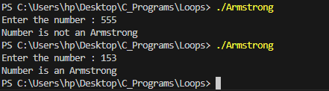

1. **Odd And Even.**

#include<stdio.h> void main(){

int num;

printf("Enter the num "); scanf("%d", &num);

if (num%2==0)

{

printf("Number is even");

}else{

printf("Number is Odd");

}

}

**Output :**

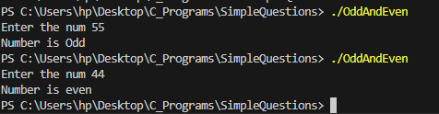

1. **Factors of a Number.**

#include <stdio.h>

void findFactors(int num) { printf("Factors of %d are: ", num); for (int i = 1; i <= num; i++) {

if (num % i == 0) { printf("%d ", i);

}

}

printf("\n");

}

int main() {

int number;

printf("Enter a number: "); scanf("%d", &number);

if (number <= 0) {

printf("Please enter a positive number.\n");

} else {

findFactors(number);

}

return 0;

}

**Output :**

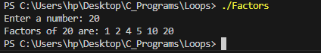

1. **First n Prime Numbers.**

#include<stdio.h> #include <stdio.h>

int isPrime(int num) {

if (num <= 1) return 0;

for (int i = 2; i \* i <= num; i++) { if (num % i == 0) return 0;

}

return 1;

}

void printFirstNPrimes(int n) { int count = 0, num = 2;

printf("The first %d prime numbers are: ", n); while (count < n) {

if (isPrime(num)) { printf("%d ", num); count++;

}

num++;

}

printf("\n");

}

int main() {

int n;

printf("Enter the number of prime numbers to display: "); scanf("%d", &n);

if (n <= 0) {

printf("Please enter a positive integer.\n");

} else {

printFirstNPrimes(n);

}

return 0;

}

**Output :**

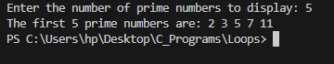

1. **Whether the Enter the Number is float or int.**

#include <stdio.h>

int main() {

float num;

printf("Enter a number: "); if (scanf("%f", &num) == 1) {

// If the number has a decimal point, it's a float if ((int)num != num) {

printf("The number is a float.\n");

} else {

printf("The number is an integer.\n");

}

} else {

printf("Invalid input!\n");

}

return 0;

}

**Output :**

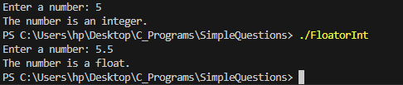

1. **Table of a Number.**

#include<stdio.h>

int main(){

int num;

printf("Enter the number: "); scanf("%d", &num);

for (int i = 1; i <= 10; i++)

{

printf("%d \* %d = %d \n",num,i,num\*i);

}

}

**Output :**

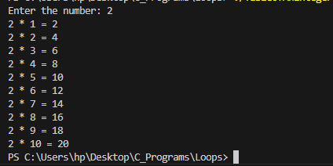

1. **Reverse of an Array.**

#include<stdio.h>

void ReverseOfArray(int arr[],int n){ int left = 0;

int right = n-1;

while (left<right)

{

int temp = arr[left]; arr[left] = arr[right]; arr[right] = temp;

left++; right--;

}

printf("Array Reversed : "); for (int i = 0; i < n; i++)

{

printf("%d ", arr[i]);

}

}

int main(){

int n;

printf("Enter the Length of Array: "); scanf("%d", &n);

int arr[n];

printf("Enter the Elements of array: \n"); for (int i = 0; i < n; i++)

{

scanf("%d", &arr[i]);

}

ReverseOfArray(arr, n); return 0;

}

**Output :**

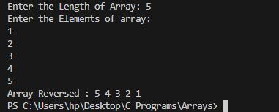

1. **Insert an Element into Array.**

#include <stdio.h>

int main() {

int n, position, element;

printf("Enter the size of the array: "); scanf("%d", &n);

int arr[n + 1];

printf("Enter %d elements:\n", n); for (int i = 0; i < n; i++) {

printf("Element %d: ", i + 1); scanf("%d", &arr[i]);

}

printf("Enter the element to insert: "); scanf("%d", &element);

printf("Enter the position to insert (1 to %d): ", n + 1); scanf("%d", &position);

if (position < 1 || position > n + 1) { printf("Invalid position!\n"); return 1;

}

for (int i = n; i >= position; i--) { arr[i] = arr[i - 1];

}

arr[position - 1] = element;

printf("The updated array is:\n"); for (int i = 0; i <= n; i++) {

printf("%d ", arr[i]);

}

printf("\n"); return 0;

}

**Output :**

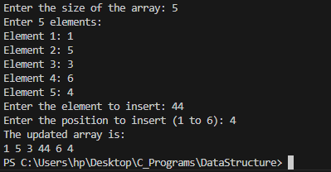

1. **Delete an Element from an Array.**

#include <stdio.h>

int main() {

int n, position;

printf("Enter the size of the array: "); scanf("%d", &n);

int arr[n];

printf("Enter %d elements:\n", n); for (int i = 0; i < n; i++) {

printf("Element %d: ", i + 1); scanf("%d", &arr[i]);

}

printf("Enter the position of the element to delete (1 to %d): ", n); scanf("%d", &position);

if (position < 1 || position > n) {

printf("Invalid position!\n"); return 1;

}

for (int i = position - 1; i < n - 1; i++) { arr[i] = arr[i + 1];

}

printf("The updated array is:\n"); for (int i = 0; i < n - 1; i++) {

printf("%d ", arr[i]);

}

printf("\n"); return 0;

}

**Output :**

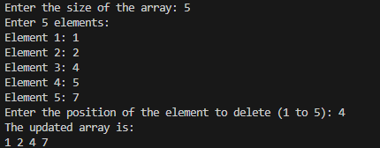

1. **Linear Search.**

#include<stdio.h>

int LinearSearch(int arr[], int len, int target){ for (int i = 0; i < len; i++)

{

if (arr[i] == target)

{

printf("Target found and available at index : "); return i;

}

}

return -1;

}

int main(){

int n;

printf("Enter the size of the array: "); scanf("%d", &n);

int arr[n];

printf("Enter %d elements:\n", n); for (int i = 0; i < n; i++) {

printf("Element %d: ", i + 1); scanf("%d", &arr[i]);

}

int target;

printf("Enter the target : "); scanf("%d", &target);

int result = LinearSearch(arr,n,target); printf("%d", result);

return 0;

}

**Output :**

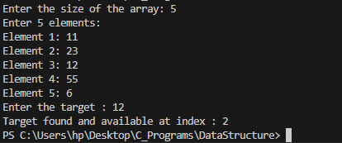

1. **Binary Search.**

#include<stdio.h>

int BinarySearch(int arr[], int len, int target){ int left =0;

int right =len-1;

while (left <= right)

{

int mid = left + (right - left)/2;

if (target == arr[mid])

{

printf("Target found and available at index : "); return mid;

}

else if (target < arr[mid])

{

right = mid - 1;

}

else{

left = mid + 1;

}

}

return -1;

}

int main(){

int n;

printf("Enter the size of the array: "); scanf("%d", &n);

int arr[n];

printf("Enter %d elements:\n", n); for (int i = 0; i < n; i++) {

printf("Element %d: ", i + 1); scanf("%d", &arr[i]);

}

int target;

printf("Enter the target : "); scanf("%d", &target);

int result = BinarySearch(arr,n,target); printf("%d", result);

return 0;

}

**Output :**

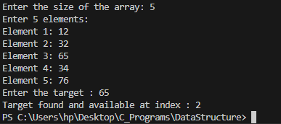

1. **Sorting List using Array.**

#include<stdbool.h> int main(){

int n;

printf("Enter the Length of array \n"); scanf("%d", &n);

int arr[n];

for (int k = 0; k < n; k++)

{

printf("%d Element of array : ", k+1); scanf("%d", &arr[k]);

}

bool swap = true; while (swap)

{

swap = false;

for (int i = 0; i<n-1; i++)

{

if (arr[i] > arr[i+1])

{

int temp = arr[i]; arr[i] = arr[i+1]; arr[i+1] = temp; swap = true;

}

}

if (swap == false)

{

break;

}

}

printf("Array after Bubble sort \n"); for (int k = 0; k < n; k++)

{

printf("%d ", arr[k]);

}

}

**Output :**

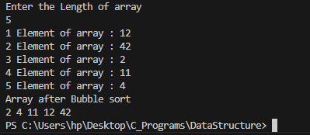

1. **Read and Print Square Matrix.**

#include <stdio.h>

int main() {

int n;

// Input size of the square matrix

printf("Enter the size of the square matrix (n): "); scanf("%d", &n);

int matrix[n][n];

// Reading the matrix elements

printf("Enter the elements of the %dx%d matrix:\n", n, n); for (int i = 0; i < n; i++) {

for (int j = 0; j < n; j++) {

printf("Element [%d][%d]: ", i + 1, j + 1);

scanf("%d", &matrix[i][j]);

}

}

// Printing the matrix

printf("The entered matrix is:\n"); for (int i = 0; i < n; i++) {

for (int j = 0; j < n; j++) { printf("%d ", matrix[i][j]);

}

printf("\n");

}

return 0;

}

**Output :**

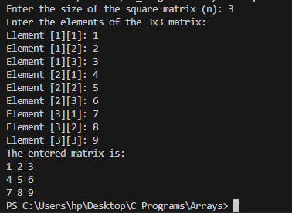

1. **Addison and Subtraction in 2 matrixes.**

#include <stdio.h>

int main() {

int n, m;

printf("Enter the number of rows and columns of the matrices: "); scanf("%d %d", &n, &m);

int matrix1[n][m], matrix2[n][m], sum[n][m], difference[n][m]; printf("Enter elements of the first matrix:\n");

for (int i = 0; i < n; i++)

for (int j = 0; j < m; j++) scanf("%d", &matrix1[i][j]);

printf("Enter elements of the second matrix:\n"); for (int i = 0; i < n; i++)

for (int j = 0; j < m; j++) scanf("%d", &matrix2[i][j]);

for (int i = 0; i < n; i++)

for (int j = 0; j < m; j++) {

sum[i][j] = matrix1[i][j] + matrix2[i][j];

difference[i][j] = matrix1[i][j] - matrix2[i][j];

}

printf("Sum of the matrices:\n"); for (int i = 0; i < n; i++) {

for (int j = 0; j < m; j++) printf("%d ", sum[i][j]);

printf("\n");

}

printf("Difference of the matrices:\n"); for (int i = 0; i < n; i++) {

for (int j = 0; j < m; j++) printf("%d ", difference[i][j]);

printf("\n");

}

return 0;

}

**Output :**

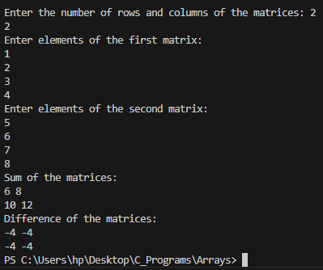

1. **Transpose of Matrix.**

#include <stdio.h>

int main() {

int rows, cols;

printf("Enter the number of rows and columns of the matrix: "); scanf("%d %d", &rows, &cols);

int matrix[rows][cols], transpose[cols][rows]; printf("Enter elements of the matrix:\n");

for (int i = 0; i < rows; i++)

for (int j = 0; j < cols; j++) scanf("%d", &matrix[i][j]);

for (int i = 0; i < rows; i++) for (int j = 0; j < cols; j++)

transpose[j][i] = matrix[i][j];

printf("Original matrix:\n"); for (int i = 0; i < rows; i++) {

for (int j = 0; j < cols; j++) printf("%d ", matrix[i][j]);

printf("\n");

}

printf("Transpose of the matrix:\n"); for (int i = 0; i < cols; i++) {

for (int j = 0; j < rows; j++) printf("%d ", transpose[i][j]);

printf("\n");

}

return 0;

}

**Output :**

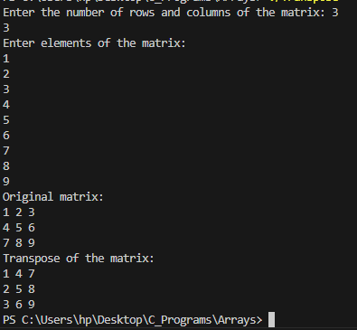

1. **Multiply two matrixes.**

#include <stdio.h>

int main() {

int r1, c1, r2, c2;

printf("Enter the number of rows and columns of the first matrix: "); scanf("%d %d", &r1, &c1);

printf("Enter the number of rows and columns of the second matrix: "); scanf("%d %d", &r2, &c2);

if (c1 != r2) {

printf("Matrix multiplication is not possible. Number of columns in the first matrix must equal the number of rows in the second matrix.\n");

return 0;

}

int matrix1[r1][c1], matrix2[r2][c2], result[r1][c2];

printf("Enter elements of the first matrix:\n"); for (int i = 0; i < r1; i++)

for (int j = 0; j < c1; j++) scanf("%d", &matrix1[i][j]);

printf("Enter elements of the second matrix:\n"); for (int i = 0; i < r2; i++)

for (int j = 0; j < c2; j++) scanf("%d", &matrix2[i][j]);

for (int i = 0; i < r1; i++)

for (int j = 0; j < c2; j++) { result[i][j] = 0;

for (int k = 0; k < c1; k++)

result[i][j] += matrix1[i][k] \* matrix2[k][j];

}

printf("Resultant matrix after multiplication:\n"); for (int i = 0; i < r1; i++) {

for (int j = 0; j < c2; j++) printf("%d ", result[i][j]);

printf("\n");

}

return 0;

}

**Output :**

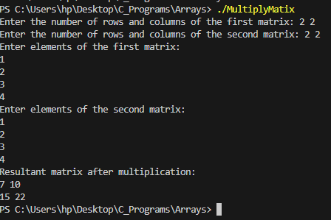

1. **Leap Year.**

#include<stdio.h>

int main(){

int year;

printf("Enter the Year : "); scanf("%d", &year);

if (year % 4 == 0)

{

printf("Year %d is a leap Year", year);

}else{

printf("Year %d is not a leap Year", year);

}

return 0;

}

**Output :**

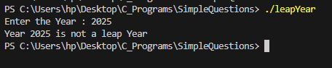

1. **Largest of three numbers.**

#include<stdio.h>

int main(){ int a;

int b; int c;

printf("Enter first number : \n"); scanf("%d", &a);

printf("Enter Second number : \n"); scanf("%d", &b);

printf("Enter Third number : \n"); scanf("%d", &c);

if (a>b && a>c)

{

printf("%d is Larger than %d and %d", a , b, c);

}else if(b>a && b>c){

printf("%d is Larger than %d and %d", b, a, c);

}else if(c>a && c>b){

printf("%d is Larger than %d and %d", c, a, b);

}else {

printf("All the numbers are same");

}

}

**Output :**

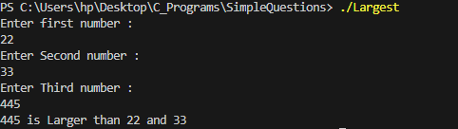

1. **Second Largest among Three.**

#include<stdio.h>

int main(){ int a;

int b; int c;

printf("Enter first number : \n"); scanf("%d", &a);

printf("Enter Second number : \n"); scanf("%d", &b);

printf("Enter Third number : \n"); scanf("%d", &c);

if (a>b && a<c)

{

printf("%d is Second largest", a);

}else if(b>a && b<c){

printf("%d is Second largest", b);

}else if(c>a && c<b){

printf("%d is Second largest", c);

}else {

printf("All the numbers are same");

}

}

**Output :**

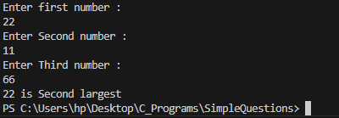

1. **Area of Different Shapes.**

#include<stdio.h>

void AreaOfCircle(){ int radius = 4; float pi = 3.14;

float area = pi\*radius\*radius; printf("Area of circle : %f \n", area);

}

void AreaOfRectangle(int length, int width){ int area = length \* width;

printf("Area of Rectangle : %d \n", area);

}

int main(){ int length;

printf("Enter the Length for rectangle "); scanf("%d", &length);

int width;

printf("Enter the Width for rectangle "); scanf("%d", &width);

AreaOfCircle(); AreaOfRectangle(length, width);

}

**Output :**

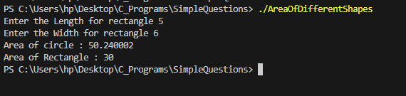

1. **Calculator.**

#include <stdio.h>

int main() {

char operator;

double num1, num2, result;

printf("Enter an operator (+, -, \*, /): "); scanf(" %c", &operator);

printf("Enter two numbers: "); scanf("%lf %lf", &num1, &num2);

switch (operator) { case '+':

result = num1 + num2; printf("Result: %.2lf\n", result); break;

case '-':

result = num1 - num2; printf("Result: %.2lf\n", result); break;

case '\*':

result = num1 \* num2; printf("Result: %.2lf\n", result); break;

case '/':

if (num2 != 0) {

result = num1 / num2; printf("Result: %.2lf\n", result);

} else {

printf("Error: Division by zero is not allowed.\n");

}

break; default:

printf("Error: Invalid operator.\n");

}

return 0;

}

**Output :**

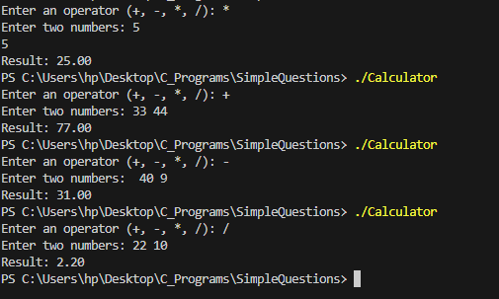

1. **Quadratic Equation.**

#include <stdio.h> #include <math.h>

int main() {

double a, b, c, discriminant, root1, root2, realPart, imaginaryPart;

printf("Enter coefficients a, b, and c: "); scanf("%lf %lf %lf", &a, &b, &c);

if (a == 0) {

printf("This is not a quadratic equation.\n"); return 0;

}

discriminant = b \* b - 4 \* a \* c; if (discriminant > 0) {

root1 = (-b + sqrt(discriminant)) / (2 \* a); root2 = (-b - sqrt(discriminant)) / (2 \* a); printf("Roots are real and distinct:\n"); printf("Root 1 = %.2lf\n", root1); printf("Root 2 = %.2lf\n", root2);

} else if (discriminant == 0) { root1 = root2 = -b / (2 \* a);

printf("Roots are real and equal:\n"); printf("Root = %.2lf\n", root1);

} else {

realPart = -b / (2 \* a);

imaginaryPart = sqrt(-discriminant) / (2 \* a); printf("Roots are complex and imaginary:\n");

printf("Root 1 = %.2lf + %.2lfi\n", realPart, imaginaryPart); printf("Root 2 = %.2lf - %.2lfi\n", realPart, imaginaryPart);

}

return 0;

}

**Output :**

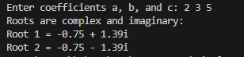

1. **Compound and Simple Interest.**

#include <stdio.h> #include <math.h>

int main() {

double principal, rate, time, simpleInterest, compoundInterest;

printf("Enter principal amount: "); scanf("%lf", &principal);

printf("Enter annual interest rate (in percentage): "); scanf("%lf", &rate);

printf("Enter time (in years): "); scanf("%lf", &time);

simpleInterest = (principal \* rate \* time) / 100;

compoundInterest = principal \* pow((1 + rate / 100), time) - principal; printf("Simple Interest = %.2lf\n", simpleInterest);

printf("Compound Interest = %.2lf\n", compoundInterest);

return 0;

}

**Output :**

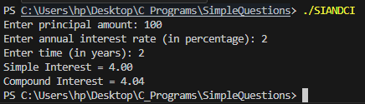

1. **Convert Celsius to Fahrenheit.**

#include <stdio.h>

int main() {

int choice;

double temperature, converted;

printf("Temperature Conversion Menu:\n"); printf("1. Convert Celsius to Fahrenheit\n"); printf("2. Convert Fahrenheit to Celsius\n"); printf("Enter your choice (1 or 2): "); scanf("%d", &choice);

if (choice == 1) {

printf("Enter temperature in Celsius: "); scanf("%lf", &temperature);

converted = (temperature \* 9 / 5) + 32; printf("Temperature in Fahrenheit: %.2lf\n", converted);

} else if (choice == 2) {

printf("Enter temperature in Fahrenheit: "); scanf("%lf", &temperature);

converted = (temperature - 32) \* 5 / 9; printf("Temperature in Celsius: %.2lf\n", converted);

} else {

printf("Invalid choice! Please select 1 or 2.\n");

}

return 0;

}

**Output :**

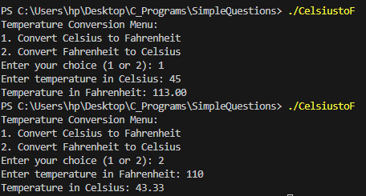

1. **Diamond Pattern.**

// C program to print

// diamond shape with

// 2n rows #include<stdio.h>

// Prints diamond

// pattern with 2n rows void printDiamond(int n)

{

int space = n - 1;

// run loop (parent loop)

// till number of rows

for (int i = 0; i < n; i++)

{

// loop for initially space,

// before star printing

for (int j = 0;j < space; j++) printf(" ");

// Print i+1 stars

for (int j = 0;j <= i; j++) printf("\* ");

printf("\n"); space--;

}

// Repeat again in

// reverse order

space = 0;

// run loop (parent loop)

// till number of rows

for (int i = n; i > 0; i--)

{

// loop for initially space,

// before star printing

for (int j = 0; j < space; j++) printf(" ");

// Print i stars

for (int j = 0;j < i;j++) printf("\* ");

printf("\n"); space++;

}

}

// Driver code int main()

{

printDiamond(5); return 0;

}

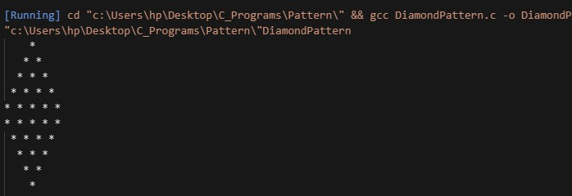**Output :**

1. **Number Triangle.**

#include<stdio.h>

int main(){

int n= 5;

for (int i = 1; i <= n; i++)

{

int print = 1;

for (int j = 1; j <= i; j++)

{

printf("%d", print); print++;

}

printf("\n");

}

}

**Output :**

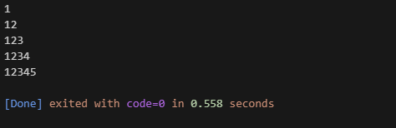

1. **Pyramid.**

#include<stdio.h>

int main(){

int n = 5;

for (int i = 1; i <= n; i++)

{

for (int j = 1; j <= n-i; j++)

{

printf(" ");

}

for (int k = 1; k <= 2\*i-1; k++)

{

printf("\*");

}

printf("\n");

}

}

**Output :**

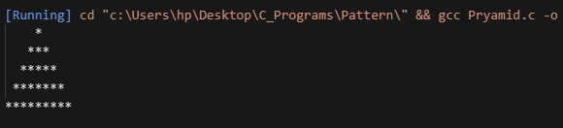

1. **Invert Triangle.**

#include<stdio.h>

int main(){ int n = 5;

for (int i = 5; i >= 1; i--)

{

for (int j = 1; j <= i; j++)

{

printf("\*");

}

printf("\n");

}

}

**Output :**

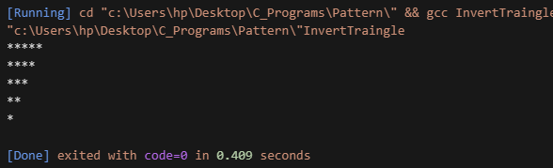

1. **Read and Write Character Array.**

#include <stdio.h>

int main() {

char str[100];

printf("Enter a string: ");

fgets(str, sizeof(str), stdin); // Reading input string

printf("You entered: %s\n", str); // Writing/printing the string return 0;

}

**Output :**

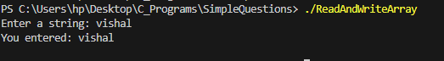

1. **Marksheet of a Student.**

#include<conio.h> #include<stdio.h> void main()

{

char name, grade;

float cn, c, dsa, csa, dbms, se, rollno, total, percentage; printf("MARKSHEET\n");

printf("Name of the student:"); scanf("%s",&name);

printf("Roll No.:"); scanf("%f",& rollno);

printf("marks of Computer Networking:"); scanf("%f",&cn);

printf("marks of C language:"); scanf("%f",&c);

printf("marks of DSA:"); scanf("%f",&dsa); printf("marks of CSA:"); scanf("%f",&csa); printf("marks of DBMS:"); scanf("%f",&dbms);

printf("marks of Software Engineering:"); scanf("%f",&se); total=cn+c+dsa+csa+dbms+se; percentage=(total/600)\*100;

printf("Total Marks:%f\n",total); printf("Percentage:%f\n",percentage); if (percentage>=90) {grade = 'A';} else if(percentage>=80) {grade = 'B';} else if(percentage>=70) {grade = 'C';} else if(percentage>=60) {grade = 'D';} else if(percentage>=35) {grade ='E';} else {grade = 'F';} printf("Grade:%c\n",grade);

}

**Output :**

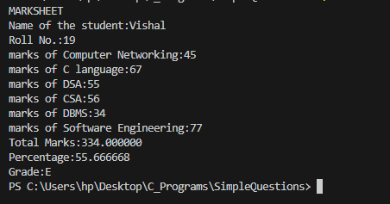

1. **Salary of an Employee.**

#include<conio.h> #include<stdio.h> void main()

{

char name; int id;

float basic\_salary, allowances, deduction, gross\_salary, net\_salary; printf("Enter the name of employee: ");

scanf("%s",&name);

printf("Enter the id of employee: "); scanf("%d",&id);

printf("Basic salary of employee: "); scanf("%f",&basic\_salary); printf("Enter the total allowances: "); scanf("%f",&allowances);

printf("Enter the total deduction: "); scanf("%f",&deduction); gross\_salary=basic\_salary+allowances; net\_salary=gross\_salary-deduction; printf("Salary Slip\n");

printf(" \n");

printf("Name: %s\n",name); printf("Id:%d\n",id);

printf("Basic salary: %f\n",basic\_salary); printf("Allowances: %f\n",allowances); printf("Deduction: %f\n",deduction); printf("Gross salary %f\n",gross\_salary); printf("Net salary %f\n",net\_salary);

}

**Output :**

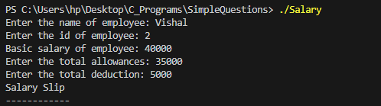

1. **Bill Calculation.**

#include<conio.h> #include<stdio.h> void main()

{

float price, discount\_rate, tax\_rate, total, discount\_amount, tax\_amount, final\_amount;

int quantity;

printf("Enter the price: "); scanf("%f",&price); printf("Enter the quantity: "); scanf("%d",&quantity); total=price\*quantity;

printf("Enter the discount rate(in percentage): "); scanf("%f",&discount\_rate);

printf("Enter the tax rate(in percentage): "); scanf("%f",&tax\_rate); discount\_amount=(total\*discount\_rate)/100; tax\_amount=(total\*tax\_rate)/100;

final\_amount=total+tax\_amount-discount\_amount; printf("Bill Summary\n ");

printf(" \n");

printf("price: %f\n ",price); printf("quantity: %d\n ",quantity); printf("total: %f\n ",total);

printf("discount amount: %f\n ",discount\_amount); printf("tax amount: %f\n ",tax\_amount); printf("final amount: %f\n ",final\_amount);

}

**Output :**

