Hindu Institute of Management



Practical file of DBMS

MCA 123C

Submitted to: Submitted by:

Miss. Vaishali Vishal Kaushik

Roll No.:

24012541019

Index

|  |  |  |  |
| --- | --- | --- | --- |
| **S.NO** | **Program Details** | **Page Numbers** | **Teacher Signature** |
| **1** | **Introduction to SQL** | **1** |  |
| **2** | **To study the basic SQL commands(create database, create table,use drop,insert) and execute the following**  **queries using these commands: • Create a**  **database named ‘Employee’ • Use the database ‘Employee’ and create a table ‘Emp’ with attributes‘ename’, ‘ecity’,**  **‘salary’,‘enumber’, ‘eaddress’, ‘depttname’ • Inserting values**  **in table.** | **2** |  |
| **3** | **To study the viewing commands (select, update) and execute the following queries using these**  **commands: • Find the names of all employees who live in Delhi • Increase the salary of all employees by Rs. 5,000 • Find the company names where the number of**  **employees is greater than**  **10,000.** | **3 - 4** |  |
| **4** | **To study the commands to modify the structure of table (alter, delete) and execute the following queries using these**  **commands: 15 • Add an attribute named ‘Designation’**  **to the table ‘Emp’. • Modify** | **5 - 6** |  |

|  |  |  |  |
| --- | --- | --- | --- |
|  | **the table ‘Emp’, Change the datatype of ‘salary’ attribute to float. • Drop the attribute ‘depttname’ from the table ‘emp’. • Delete the entries from the table ‘Emp’ where**  **the salary is less than 70,000.** |  |  |
| **5** | **To study the aggregate functions (sum, max, min, group by) and execute the**  **following queries using these commands: • Find the sum of salaries of all employees in computer science**  **department. • Find the**  **number of all employees in company ‘TCS’ • Find the**  **maximum and the minimum salary in the HR department.**   * **Find number of employees in each department where number of employees is**   **greater than 5**. | **7 - 8** |  |
| **6** | **Execute the set difference between two tables** | **9** |  |
| **7** | **To study the commands for joins ( cross join, inner join, outer join) and execute the following queries using these 23 commands: • Retrieve the complete record of an**  **employee and its company from both the table using joins. • List all the employees**  **working in the company ‘TCS’.** | **10** |  |
| **8** | **Consider a table to execute nested queries on these columns. • Write a query to**  **find higher order customers •** | **11 - 12** |  |

|  |  |  |  |
| --- | --- | --- | --- |
|  | **Find the Country of customers who have placed at least one**  **order on or after 2024-10-10.** |  |  |

**Database Management System**

1. **Introduction to SQL.**

SQL (Structured Query Language) is a standard programming language used for managing and manipulating relational databases. It allows users to interact with a database to perform various operations such as:

* 1. Querying data: Retrieving data from one or more tables using commands like SELECT.
  2. Inserting data: Adding new records to tables with the INSERT statement.
  3. Updating data: Modifying existing records in tables with the UPDATE statement.
  4. Deleting data: Removing records from tables using the DELETE statement.
  5. Defining data: Creating, altering, and deleting database structures (e.g., tables, indexes) using CREATE, ALTER, and DROP statements.
  6. Controlling access: Managing permissions and user access with commands like GRANT and REVOKE.

Common SQL Commands

* + - SELECT: Retrieve data from a database.
    - INSERT INTO: Add new data to a table.
    - UPDATE: Modify existing data in a table.
    - DELETE: Remove data from a table.
    - CREATE TABLE: Define a new table structure.
    - ALTER TABLE: Modify an existing table.
    - DROP TABLE: Delete a table and its data.
    - JOIN: Combine data from multiple tables based on a relationship.

1. **Basic SQL commands(create database, create table,use drop,insert) and execute the following queries using these**

commands: • Create a database named ‘Employee’ • Use the database ‘Employee’ and create a table ‘Emp’ with

attributes‘ename’, ‘e_city’, ‘salary’,‘e_number’, ‘e_address’, ‘depttname’ • Inserting values in table.

Queries with Output:

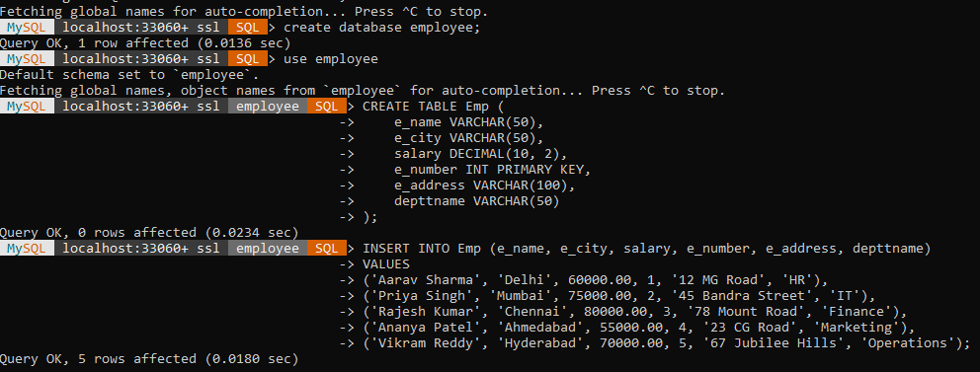

Employee Table :

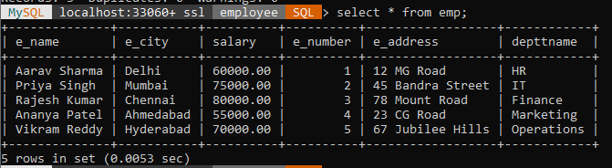

1. **To study the viewing commands (select, update) and execute the following queries using these commands: • Find the names of all employees who live in Delhi • Increase the salary of all employees by Rs. 5,000 • Find the company names where the number of employees is greater than 10,000.**

* **Find the names of all employees who live in Delhi. Query with Output :**

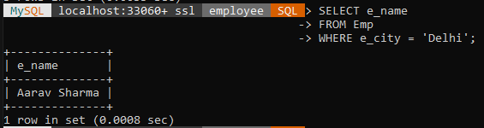

* **Increase the salary of all employees by Rs. 5,000 Query with Output :**

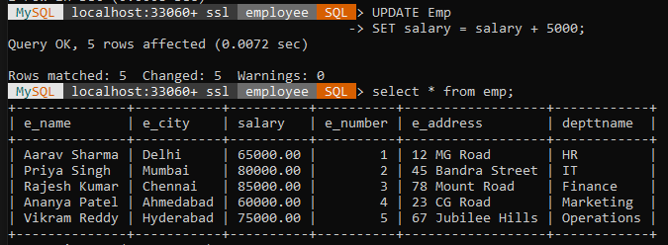

* **Find the company names where the number of employees is greater than 10,000.**

Query with Output :

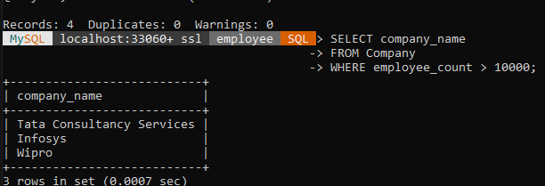

1. **To study the commands to modify the structure of table (alter, delete) and execute the following queries using these**

commands:

* **Add an attribute named ‘Designation’ to the table ‘Emp’. Query with Output :**

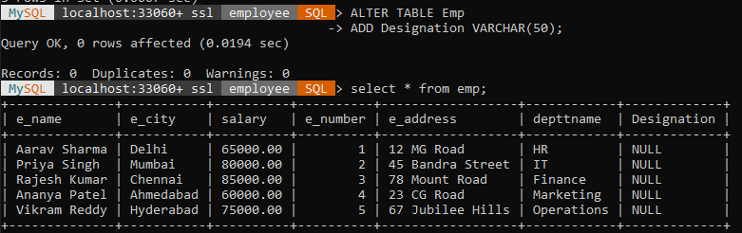

* **Modify the table ‘Emp’, Change the datatype of ‘salary’ attribute to float.**

Query With Output :

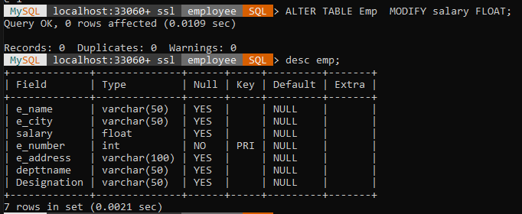

* **Drop the attribute ‘depttname’ from the table ‘emp’. Query With Output :**

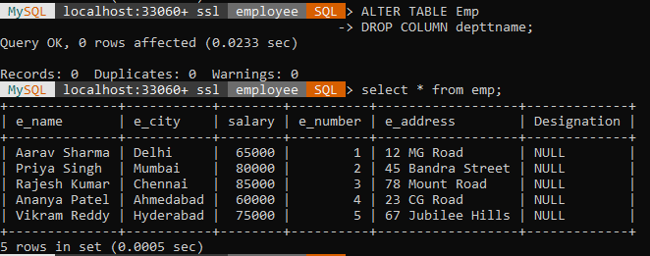

* **Delete the entries from the table ‘ Emp’ where the salary is less than 70,000.**

Query With Output :

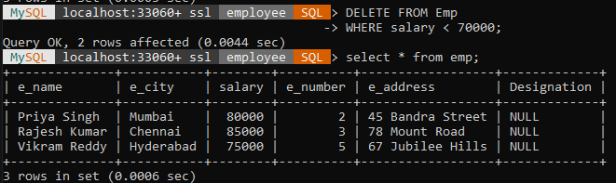

1. **To study the aggregate functions (sum, max, min, group by) and execute the following queries using these commands:**

Output With Query :

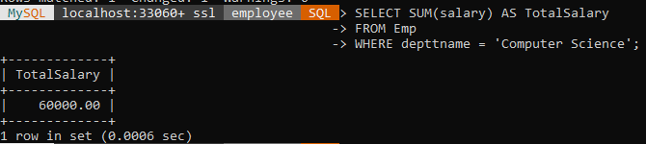

* **Find the number of all employees in company ‘TCS’ Query with Output :**

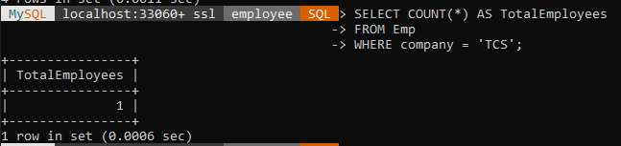

* **Find the maximum and the minimum salary in the HR department.**

Output with Query :

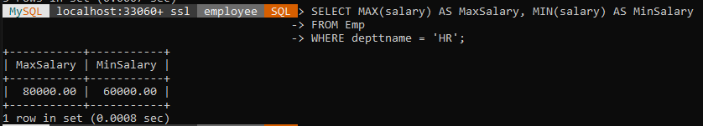

* **Find number of employees in each department where number of employees is greater than 5.**

Output with Query :

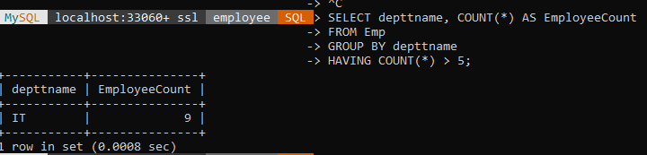

* **Find the sum of salaries of all employees in computer science department.**

Query with Output :

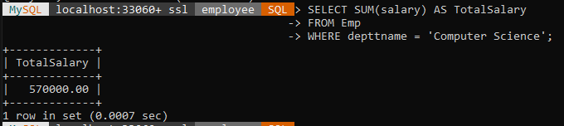

1. **Execute the set difference between two tables. Query with Output :**

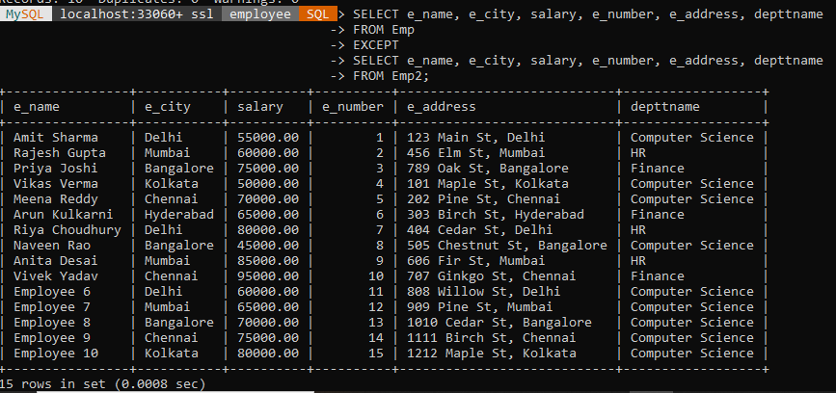

1. **To study the commands for joins (cross join, inner join, outer join) and execute the following queries using these**

commands:

* **Retrieve the complete record of an employee and its company from both the table using joins.**

Query with Output :

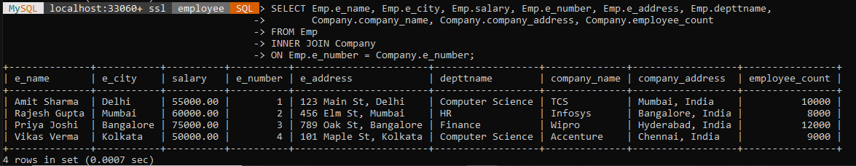

* **List all the employees working in the company ‘TCS’.**

Query with Output :

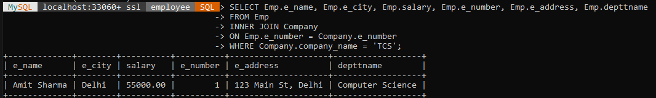

1. **Consider a table to execute nested queries on these columns.**

* **Write a query to find higher order customers.**

Query With Output :

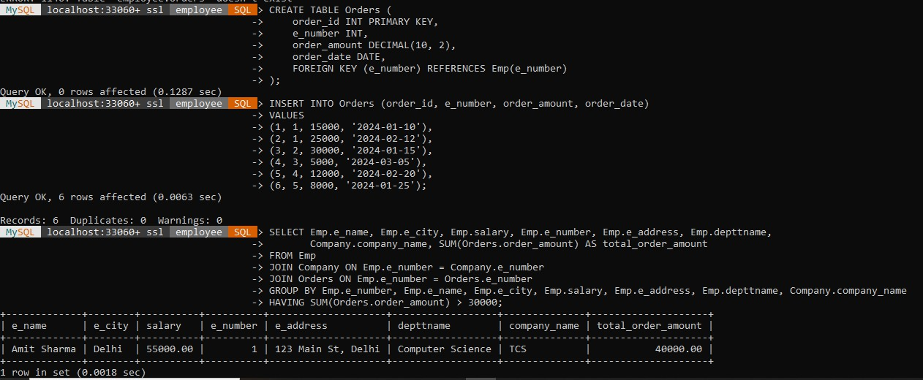

* **Find the Country of customers who have placed at least one order on or after 2024-10-10.**

Output with Query

