Hindu Institute of Management



Practical file of Data Structure

MCA 125C

Submitted to: Submitted by:

Mr. Harish Khurana Vishal Kaushik

Roll No.:

24012541019

INDEX

|  |  |  |  |
| --- | --- | --- | --- |
| **S.NO** | **Program Details** | **Page Numbers** | **Teacher Signature** |
| **1** | **Program to create an Array of any Specific size and traverse it.** | **1** |  |
| **2** | **Program to insert a specific element at any specific**  **position in array.** | **2** |  |
| **3** | **Program to delete any specific element from array.** | **3 - 4** |  |
| **4** | **Program to search any specific element from the array using Linear Search.** | **4 - 5** |  |
| **5** | **Program to find largest and smallest in given array using function.** | **6 - 7** |  |
| **6** | **Program to implement Selection sort.** | **7 - 8** |  |
| **7** | **Program to implement Insertion sort.** | **9 - 10** |  |
| **8** | **Program to implement Bubble sort.** | **10 - 11** |  |
| **9** | **Program to search any specific element from array using**  **Binary Search** | **11 - 13** |  |
| **10** | **Program to implement single linked List.** | **13 -16** |  |
| **11** | **Program to implement MALLOC()** | **16 - 17** |  |

|  |  |  |  |
| --- | --- | --- | --- |
| **S.NO** | **Program Details** | **Page Numbers** | **Teacher Signature** |
| **12** | **Program to implement CALLOC().** | **17 - 18** |  |
| **13** | **Program to implement REALLOC() and FREE()** | **19 - 20** |  |
| **14** | **Factorial Using Recursion.** | **20 - 21** |  |
| **15** | **Program to implement stack operations using array** | **21 - 23** |  |
| **16** | **Program to implement stack operations using Linked List.** | **23 - 26** |  |
| **17** | **Program to implement queue operations.** | **27 - 30** |  |
| **18** | **Program to implement queue operations using Linked List.** | **30 - 34** |  |
| **19** | **Program to implement circular Linked list** | **34 - 38** |  |
| **20** | **Program to implement double Linked list.** | **38 - 40** |  |

**Data Structure and Algorithm using C**

1. **A Program to create an Array of any Specific size and traverse it.**

#include <stdio.h>

int main() {

int n;

printf("Enter the size of the array: ") scanf("%d", &n);

int arr[n];

printf("Enter %d elements:\n", n); for (int i = 0; i < n; i++) {

printf("Element %d: ", i + 1); scanf("%d", &arr[i]);

}

// Traversal

printf("The elements in the array are:\n"); for (int i = 0; i < n; i++) {

printf("%d ", arr[i]);

}

printf("\n"); return 0;

}

**Output :**

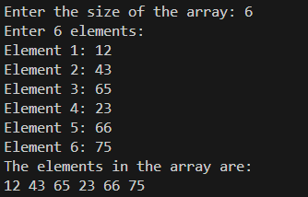

1. **A program to insert an specific element at any specific position in array.**
2. #include <stdio.h> 4.
3. int main() {
4. int n, position, element; 7.

8. printf("Enter the size of the array: ");

9. scanf("%d", &n); 10.

11. int arr[n + 1]; 12.

1. printf("Enter %d elements:\n", n);
2. for (int i = 0; i < n; i++) {
3. printf("Element %d: ", i + 1);
4. scanf("%d", &arr[i]);

17. }

18.

1. printf("Enter the element to insert: ");
2. scanf("%d", &element);
3. printf("Enter the position to insert (1 to %d): ", n + 1);
4. scanf("%d", &position); 23.
5. if (position < 1 || position > n + 1) {
6. printf("Invalid position!\n");
7. return 1;

27. }

28.

1. for (int i = n; i >= position; i--) {
2. arr[i] = arr[i - 1];

31. }

32.

33. arr[position - 1] = element; 34.

35. printf("The updated array is:\n");

36. for (int i = 0; i <= n; i++) {

37. printf("%d ", arr[i]);

38. }

39.

40. printf("\n"); 41.

42. return 0;

**Output :**

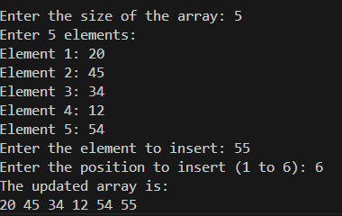

1. **A program to delete any specific element from array.**

#include <stdio.h>

int main() {

int n, position;

printf("Enter the size of the array: "); scanf("%d", &n);

int arr[n];

printf("Enter %d elements:\n", n); for (int i = 0; i < n; i++) {

printf("Element %d: ", i + 1); scanf("%d", &arr[i]);

}

printf("Enter the position of the element to delete (1 to %d): ", n); scanf("%d", &position);

if (position < 1 || position > n) { printf("Invalid position!\n"); return 1;

}

for (int i = position - 1; i < n - 1; i++) { arr[i] = arr[i + 1];

}

printf("The updated array is:\n"); for (int i = 0; i < n - 1; i++) {

printf("%d ", arr[i]);

}

printf("\n"); return 0;

}

**Output :**

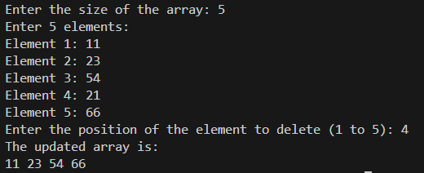

1. **A program to search any specific element from the array using Linear Search.**

#include<stdio.h>

int LinearSearch(int arr[], int len, int target){ for (int i = 0; i < len; i++)

{

if (arr[i] == target)

{

printf("Target found and available at index : ");

return i;

}

}

return -1;

}

int main(){

int n;

printf("Enter the size of the array: "); scanf("%d", &n);

int arr[n];

printf("Enter %d elements:\n", n); for (int i = 0; i < n; i++) {

printf("Element %d: ", i + 1); scanf("%d", &arr[i]);

}

int target;

printf("Enter the target : "); scanf("%d", &target);

int result = LinearSearch(arr,n,target); printf("%d", result);

return 0;

}

**Output :**

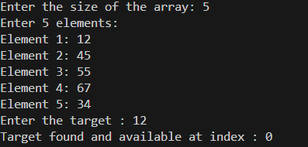

1. **Program to find largest and smallest in given array using function.**

#include<stdio.h>

void Largest(int arr[], int len){ int left = 0;

int right = len-1;

while (left<=right)

{

if (arr[left]>arr[right])

{

right--;

}else{

left++;

}

}

printf("Largest %d \n", arr[right]);

}

void Smallest(int arr[], int len){ int left = 0;

int right = len-1;

while (left<=right)

{

if (arr[left]<arr[right])

{

right--;

}else{

left++;

}

}

printf("Smallest %d \n", arr[right]);

}

int main(){

int n;

printf("Enter the size of the array: "); scanf("%d", &n);

int arr[n];

printf("Enter %d elements:\n", n);

for (int i = 0; i < n; i++) { printf("Element %d: ", i + 1); scanf("%d", &arr[i]);

}

Largest(arr, n); Smallest(arr, n); return 0;

}

**Output :**

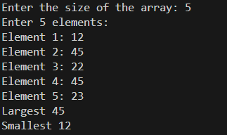

1. **A program to implement Selection sort.**

#include<stdio.h> int main(){

int n;

printf("Enter the Length of array \n"); scanf("%d", &n);

int arr[n];

for (int k = 0; k < n; k++)

{

printf("%d Element of array : ", k+1); scanf("%d", &arr[k]);

}

for (int i = 0; i < n ; i++)

{

for (int j = i+1; j < n; j++)

{

if (arr[i] > arr[j])

{

int temp = arr[i]; arr[i] = arr[j]; arr[j] = temp;

}

}

}

printf("Array after Selection sort \n"); for (int k = 0; k < n; k++)

{

printf("%d ", arr[k]);

}

return 0;

}

**Output :**

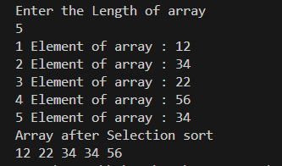

1. **A program to implement Insertion sort.**

#include <stdio.h>

void insertionSort(int arr[], int n) { for (int i = 1; i < n; i++) {

int key = arr[i]; int j = i - 1;

while (j >= 0 && arr[j] > key) { arr[j + 1] = arr[j];

j--;

}

arr[j + 1] = key;

}

}

int main() {

int n;

printf("Enter the size of the array: "); scanf("%d", &n);

int arr[n];

printf("Enter %d elements:\n", n); for (int i = 0; i < n; i++) {

printf("Element %d: ", i + 1); scanf("%d", &arr[i]);

}

insertionSort(arr, n);

printf("Array after Insertion Sort is:\n"); for (int i = 0; i < n; i++) {

printf("%d ", arr[i]);

}

printf("\n");

return 0;

}

**Output :**

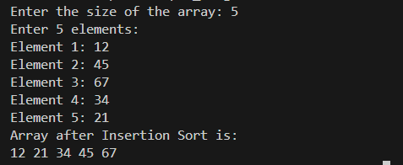

1. **A program to implement Bubble sort.**

#include<stdbool.h> int main(){

int n;

printf("Enter the Length of array \n"); scanf("%d", &n);

int arr[n];

for (int k = 0; k < n; k++)

{

printf("%d Element of array : ", k+1); scanf("%d", &arr[k]);

}

bool swap = true; while (swap)

{

swap = false;

for (int i = 0; i<n-1; i++)

{

if (arr[i] > arr[i+1])

{

int temp = arr[i]; arr[i] = arr[i+1]; arr[i+1] = temp; swap = true;

}

}

if (swap == false)

{

break;

}

}

printf("Array after Bubble sort \n"); for (int k = 0; k < n; k++)

{

printf("%d ", arr[k]);

}

}

**Output :**

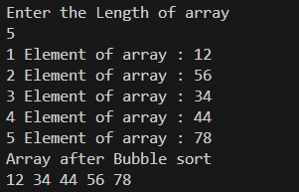

1. **A program to search any specific element from array using Binary Search.**

#include<stdio.h>

int BinarySearch(int arr[], int len, int target){ int left =0;

int right =len-1;

while (left <= right)

{

int mid = left + (right - left)/2;

if (target == arr[mid])

{

printf("Target found and available at index : "); return mid;

}

else if (target < arr[mid])

{

right = mid - 1;

}

else{

left = mid + 1;

}

}

return -1;

}

int main(){

int n;

printf("Enter the size of the array: "); scanf("%d", &n);

int arr[n];

printf("Enter %d elements:\n", n); for (int i = 0; i < n; i++) {

printf("Element %d: ", i + 1); scanf("%d", &arr[i]);

}

int target;

printf("Enter the target : "); scanf("%d", &target);

int result = BinarySearch(arr,n,target); printf("%d", result);

return 0;

}

**Output :**

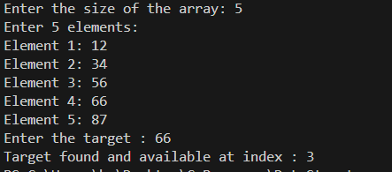

1. **A program to implement single linked List**.

#include <stdio.h> #include <stdlib.h>

// Define the structure of a node struct Node {

int data;

struct Node* next;

};

// Function to create a new node struct Node* createNode(int data) {

struct Node* newNode = (struct Node*)malloc(sizeof(struct Node)); newNode->data = data;

newNode->next = NULL; return newNode;

}

// Function to insert a node at the beginning

void insertAtBeginning(struct Node** head, int data) { struct Node* newNode = createNode(data);

newNode->next = *head;

*head = newNode;

}

void insertAtEnd(struct Node** head, int data) { struct Node* newNode = createNode(data);

if (*head == NULL) {

*head = newNode; return;

}

struct Node* temp = *head; while (temp->next != NULL) {

temp = temp->next;

}

temp->next = newNode;

}

void insertAfterNode(struct Node* prevNode, int data) { if (prevNode == NULL) {

printf("The given previous node cannot be NULL.\n"); return;

}

struct Node* newNode = createNode(data); newNode->next = prevNode->next;

prevNode->next = newNode;

}

void deleteNode(struct Node** head, int key) { struct Node* temp = *head;

struct Node* prev = NULL;

if (temp != NULL && temp->data == key) {

*head = temp->next; // Change head free(temp); // Free old head return;

}

while (temp != NULL && temp->data != key) { prev = temp;

temp = temp->next;

}

// If the key was not found if (temp == NULL) {

printf("Node with value %d not found.\n", key); return;

}

prev->next = temp->next; free(temp); // Free memory

}

// Function to display the linked list void displayList(struct Node* head) {

struct Node* temp = head; while (temp != NULL) {

printf("%d -> ", temp->data); temp = temp->next;

}

printf("NULL\n");

}

int main() {

struct Node* head = NULL;

// Perform operations insertAtBeginning(&head, 10);

insertAtEnd(&head, 20);

insertAtEnd(&head, 30);

insertAtBeginning(&head, 5);

printf("Linked List after insertions:\n"); displayList(head);

deleteNode(&head, 20);

printf("Linked List after deletion of 20:\n"); displayList(head);

insertAfterNode(head->next, 25);

printf("Linked List after inserting 25 after the second node:\n"); displayList(head);

return 0;

}

**Output :**

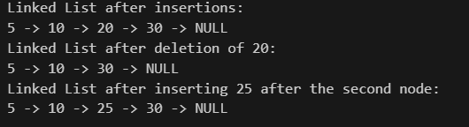

1. **A program to implement MALLOC().**

#include <stdio.h> #include <stdlib.h>

int main() {

int *arr; int n, i;

printf("Enter the number of elements: "); scanf("%d", &n);

arr = (int *)malloc(n * sizeof(int)); if (arr == NULL) {

printf("Memory allocation failed!\n");

return 1; // Exit the program if malloc failed

}

printf("Enter %d elements:\n", n); for (i = 0; i < n; i++) {

scanf("%d", &arr[i]);

}

// Display the elements

printf("The entered elements are:\n"); for (i = 0; i < n; i++) {

printf("%d ", arr[i]);

}

printf("\n");

// Free the allocated memory free(arr);

printf("Memory has been freed.\n");

return 0;

}

**Output :**

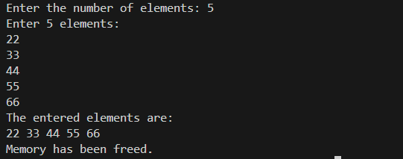

1. **A program to implement CALLOC().**

#include <stdio.h> #include <stdlib.h>

int main() {

int *arr; int n, i;

printf("Enter the number of elements: "); scanf("%d", &n);

// Allocate memory using calloc() arr = (int *)calloc(n, sizeof(int));

if (arr == NULL) {

printf("Memory allocation failed!\n");

return 1; // Exit the program if calloc failed

}

printf("Initial values in the array (set by calloc to 0):\n"); for (i = 0; i < n; i++) {

printf("%d ", arr[i]);

}

printf("\n");

printf("Enter %d elements:\n", n); for (i = 0; i < n; i++) {

scanf("%d", &arr[i]);

}

printf("The entered elements are:\n"); for (i = 0; i < n; i++) {

printf("%d ", arr[i]);

}

printf("\n");

free(arr);

printf("Memory has been freed.\n");

return 0;

}

**Output :**



1. **A program to implement REALLOC() and FREE().**

#include <stdio.h> #include <stdlib.h>

int main() {

int *arr;

int n, new_size, i;

// Initial memory allocation

printf("Enter the initial number of elements: "); scanf("%d", &n);

arr = (int *)malloc(n * sizeof(int)); // Allocate memory using malloc

// Check if memory allocation was successful if (arr == NULL) {

printf("Memory allocation failed!\n"); return 1;

}

printf("Enter %d elements:\n", n); for (i = 0; i < n; i++) {

scanf("%d", &arr[i]);

}

printf("Initial elements:\n"); for (i = 0; i < n; i++) {

printf("%d ", arr[i]);

}

printf("\n");

// Reallocate memory

printf("Enter the new number of elements: "); scanf("%d", &new_size);

arr = (int *)realloc(arr, new_size * sizeof(int)); // Resize the memory block

// Check if memory reallocation was successful if (arr == NULL) {

printf("Memory reallocation failed!\n"); return 1;

}

// Initialize new elements (if size increased)

if (new_size > n) {

printf("Enter %d new elements:\n", new_size - n); for (i = n; i < new_size; i++) {

scanf("%d", &arr[i]);

}

}

printf("Updated elements:\n"); for (i = 0; i < new_size; i++) {

printf("%d ", arr[i]);

}

printf("\n");

free(arr);

printf("Memory has been freed.\n");

return 0;

}

**Output :**

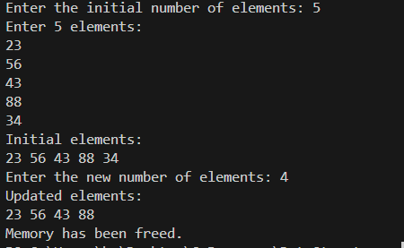

1. **Factorial Using Recursion.**

#include <stdio.h>

// Function to calculate factorial using recursion int factorial(int n) {

if (n == 0 || n == 1) { // Base case return 1;

} else {

return n * factorial(n - 1); // Recursive call

}

}

int main() {

int num;

printf("Enter a positive integer to calculate its factorial: "); scanf("%d", &num);

if (num < 0) {

printf("Factorial is not defined for negative numbers.\n");

} else {

printf("Factorial of %d is %d\n", num, factorial(num));

}

return 0;

}

**Output :**



1. **A program to implement stack operations using array.**

#include <stdio.h> #define MAX 5

int Stack[MAX];

int top = -1;

int isFull()

{

return top == MAX - 1;

}

int isEmpty()

{

return top == -1;

}

void push(int value)

{

if (isFull())

{

}

else

{

}

}

printf("Stack is Full !! \n");

top++;

Stack[top] = value;

printf("Element %d is added into the stack \n", value);

void pop()

{

if (isEmpty())

{

}

else

{

}

}

printf("Stack is Empty !! \n");

int value = Stack[top]; top--;

printf("Element %d is removed from the stack !! \n", value);

int peek()

{

return Stack[top];

}

int main()

{

push(10);

push(20);

push(30);

printf("%d is the Peek Element \n", peek()); pop();

}

**Output :**

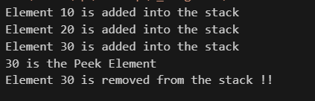

1. **A program to implement stack operations using Linked List.**

#include <stdio.h> #include <stdlib.h>

// Node structure struct Node {

int data;

struct Node* next;

};

void push(struct Node** top, int value) {

struct Node* newNode = (struct Node*)malloc(sizeof(struct Node)); if (newNode == NULL) {

printf("Stack overflow!\n");

return;

}

newNode->data = value; newNode->next = *top;

*top = newNode;

printf("Pushed %d onto the stack.\n", value);

}

int pop(struct Node** top) { if (*top == NULL) {

printf("Stack underflow!\n"); return -1;

}

int poppedValue = (*top)->data; struct Node* temp = *top;

*top = (*top)->next; free(temp);

return poppedValue;

}

int peek(struct Node* top) { if (top == NULL) {

printf("Stack is empty!\n"); return -1;

}

return top->data;

}

int isEmpty(struct Node* top) { return top == NULL;

}

// Main function int main() {

struct Node* stack = NULL; int choice, value;

do {

printf("\nStack Operations:\n"); printf("1. Push\n");

printf("2. Pop\n");

printf("3. Peek\n");

printf("4. Check if Stack is Empty\n"); printf("5. Exit\n");

printf("Enter your choice: ");

scanf("%d", &choice);

switch (choice) { case 1:

printf("Enter a value to push: "); scanf("%d", &value);

push(&stack, value); break;

case 2:

value = pop(&stack); if (value != -1) {

printf("Popped value: %d\n", value);

}

break; case 3:

value = peek(stack); if (value != -1) {

printf("Top value: %d\n", value);

}

break; case 4:

if (isEmpty(stack)) { printf("Stack is empty.\n");

} else {

printf("Stack is not empty.\n");

}

break; case 5:

printf("Exiting...\n"); break;

default:

printf("Invalid choice! Try again.\n");

}

} while (choice != 5);

// Free any remaining nodes while (!isEmpty(stack)) {

pop(&stack);

}

return 0;

}

**Output for Push :**

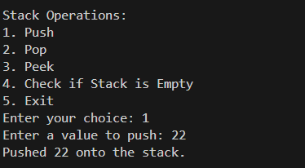

**Output for Pop :**

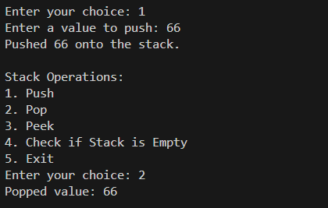

**Output for peek :**

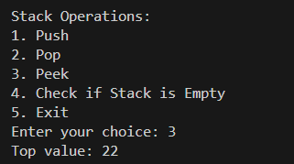

1. **A program to implement queue operations.**

#include <stdio.h> #include <stdlib.h>

#define SIZE 5

typedef struct Queue { int items[SIZE]; int front, rear;

} Queue;

void initializeQueue(Queue* q) { q->front = -1;

q->rear = -1;

}

int isEmpty(Queue* q) { return q->front == -1;

}

int isFull(Queue* q) {

return (q->rear + 1) % SIZE == q->front;

}

void enqueue(Queue* q, int value) { if (isFull(q)) {

printf("Queue overflow! Cannot add %d.\n", value); return;

}

if (isEmpty(q)) { q->front = 0;

}

q->rear = (q->rear + 1) % SIZE; q->items[q->rear] = value; printf("Enqueued %d.\n", value);

}

int dequeue(Queue* q) { if (isEmpty(q)) {

printf("Queue underflow! Nothing to dequeue.\n"); return -1;

}

int dequeuedValue = q->items[q->front];

if (q->front == q->rear) {

q->front = q->rear = -1;

} else {

q->front = (q->front + 1) % SIZE;

}

return dequeuedValue;

}

int peek(Queue* q) { if (isEmpty(q)) {

printf("Queue is empty! Nothing to peek.\n"); return -1;

}

return q->items[q->front];

}

// Main function int main() {

Queue q; initializeQueue(&q);

int choice, value;

do {

printf("\nQueue Operations:\n"); printf("1. Enqueue\n"); printf("2. Dequeue\n"); printf("3. Peek\n");

printf("4. Check if Queue is Empty\n"); printf("5. Exit\n");

printf("Enter your choice: "); scanf("%d", &choice);

switch (choice) { case 1:

printf("Enter a value to enqueue: "); scanf("%d", &value);

enqueue(&q, value); break;

case 2:

value = dequeue(&q); if (value != -1) {

printf("Dequeued value: %d\n", value);

}

break; case 3:

value = peek(&q); if (value != -1) {

printf("Front value: %d\n", value);

}

break; case 4:

if (isEmpty(&q)) {

printf("Queue is empty.\n");

} else {

printf("Queue is not empty.\n");

}

break; case 5:

printf("Exiting...\n"); break;

default:

printf("Invalid choice! Try again.\n");

}

} while (choice != 5);

return 0;

}

**Output for Enqueue :**

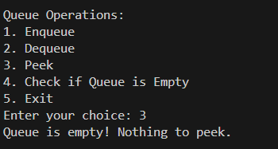

**Output for Dequeue :**

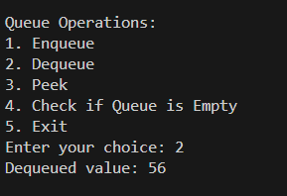

**Output for peek :**



1. **A program to implement queue operations using Linked List.**

#include <stdio.h> #include <stdlib.h>

struct Node {

int data;

struct Node* next;

};

typedef struct Queue { struct Node* front; struct Node* rear;

} Queue;

void initializeQueue(Queue* q) { q->front = NULL;

q->rear = NULL;

}

int isEmpty(Queue* q) { return q->front == NULL;

}

void enqueue(Queue* q, int value) {

struct Node* newNode = (struct Node*)malloc(sizeof(struct Node)); if (newNode == NULL) {

printf("Memory allocation failed! Cannot enqueue %d.\n", value); return;

}

newNode->data = value; newNode->next = NULL;

if (q->rear == NULL) {

// If the queue is empty, front and rear both point to the new node q->front = q->rear = newNode;

} else {

// Otherwise, add the new node at the rear and update the rear pointer q->rear->next = newNode;

q->rear = newNode;

}

printf("Enqueued %d.\n", value);

}

int dequeue(Queue* q) { if (isEmpty(q)) {

printf("Queue underflow! Nothing to dequeue.\n"); return -1;

}

int dequeuedValue = q->front->data; struct Node* temp = q->front;

q->front = q->front->next;

// If the queue becomes empty, set rear to NULL as well if (q->front == NULL) {

q->rear = NULL;

}

free(temp); // Free the memory of the dequeued node return dequeuedValue;

}

int peek(Queue* q) { if (isEmpty(q)) {

printf("Queue is empty! Nothing to peek.\n"); return -1;

}

return q->front->data;

}

int main() {

Queue q; initializeQueue(&q);

int choice, value;

do {

printf("\nQueue Operations:\n"); printf("1. Enqueue\n"); printf("2. Dequeue\n"); printf("3. Peek\n");

printf("4. Check if Queue is Empty\n"); printf("5. Exit\n");

printf("Enter your choice: "); scanf("%d", &choice);

switch (choice) { case 1:

printf("Enter a value to enqueue: "); scanf("%d", &value);

enqueue(&q, value); break;

case 2:

value = dequeue(&q); if (value != -1) {

printf("Dequeued value: %d\n", value);

}

break; case 3:

value = peek(&q); if (value != -1) {

printf("Front value: %d\n", value);

}

break; case 4:

if (isEmpty(&q)) {

printf("Queue is empty.\n");

} else {

printf("Queue is not empty.\n");

}

break; case 5:

printf("Exiting...\n"); break;

default:

printf("Invalid choice! Try again.\n");

}

} while (choice != 5);

// Free remaining nodes while (!isEmpty(&q)) {

dequeue(&q);

}

return 0;

}

**Output for Enqueue :**

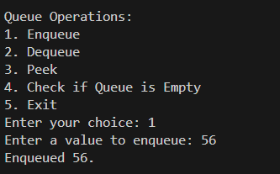

**Output for Dequeue :**



**Output for Peek :**



1. **A program to implement circular Linked list.**

#include <stdio.h> #include <stdlib.h>

struct Node {

int data;

struct Node* next;

};

struct Node* createNode(int data) {

struct Node* newNode = (struct Node*)malloc(sizeof(struct Node));

if (!newNode) {

printf("Memory allocation failed!\n"); exit(1);

}

newNode->data = data; newNode->next = NULL; return newNode;

}

void addNode(struct Node** tail, int data) { struct Node* newNode = createNode(data); if (*tail == NULL) {

*tail = newNode;

(*tail)->next = newNode;

} else {

newNode->next = (*tail)->next; (*tail)->next = newNode;

*tail = newNode;

}

printf("Node with value %d added.\n", data);

}

void deleteNode(struct Node** tail, int key) { if (*tail == NULL) {

printf("List is empty! Nothing to delete.\n"); return;

}

struct Node *current = (*tail)->next, *prev = *tail;

if ((*tail)->next == *tail && (*tail)->data == key) { free(*tail);

*tail = NULL;

printf("Node with value %d deleted. List is now empty.\n", key); return;

}

do {

if (current->data == key) { if (current == *tail) {

*tail = prev;

}

prev->next = current->next; free(current);

printf("Node with value %d deleted.\n", key);

return;

}

prev = current;

current = current->next;

} while (current != (*tail)->next);

printf("Node with value %d not found!\n", key);

}

void displayList(struct Node* tail) { if (tail == NULL) {

printf("List is empty!\n"); return;

}

struct Node* current = tail->next; printf("Circular Linked List: "); do {

printf("%d -> ", current->data); current = current->next;

} while (current != tail->next); printf("(head)\n");

}

int main() {

struct Node* tail = NULL; int choice, value;

do {

printf("\nCircular Linked List Operations:\n"); printf("1. Add Node\n");

printf("2. Delete Node\n"); printf("3. Display List\n"); printf("4. Exit\n"); printf("Enter your choice: "); scanf("%d", &choice);

switch (choice) { case 1:

printf("Enter value to add: "); scanf("%d", &value); addNode(&tail, value);

break; case 2:

printf("Enter value to delete: ");

scanf("%d", &value); deleteNode(&tail, value); break;

case 3:

displayList(tail); break;

case 4:

printf("Exiting...\n"); break;

default:

printf("Invalid choice! Try again.\n");

}

} while (choice != 4);

return 0;

}

**Output for Add :**

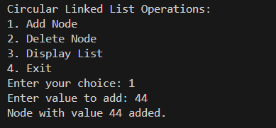

**Output for Delete :**

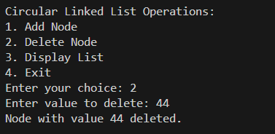

**Output for Display :**

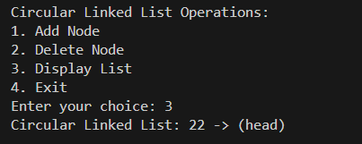

1. **A program to implement double Linked list.**

#include <stdio.h> #include <stdlib.h>

struct Node {

int data;

struct Node* prev; struct Node* next;

};

void addNodeAtEnd(struct Node** head, int data) {

struct Node* newNode = (struct Node*)malloc(sizeof(struct Node)); struct Node* temp = *head;

newNode->data = data; newNode->next = NULL; newNode->prev = NULL;

if (*head == NULL) {

*head = newNode; return;

}

while (temp->next != NULL) { temp = temp->next;

}

temp->next = newNode; newNode->prev = temp;

}

void displayList(struct Node* head) { struct Node* temp = head;

if (temp == NULL) { printf("List is empty.\n"); return;

}

printf("Doubly Linked List: "); while (temp != NULL) {

printf("%d <-> ", temp->data); temp = temp->next;

}

printf("NULL\n");

}

void deleteNode(struct Node** head, int key) { if (*head == NULL) {

printf("List is empty! Nothing to delete.\n"); return;

}

struct Node* temp = *head;

if ((*head)->data == key) {

*head = (*head)->next; if (*head != NULL) {

(*head)->prev = NULL;

}

free(temp);

printf("Node with value %d deleted.\n", key); return;

}

while (temp != NULL && temp->data != key) { temp = temp->next;

}

if (temp == NULL) {

printf("Node with value %d not found.\n", key); return;

}

if (temp->next != NULL) {

temp->next->prev = temp->prev;

}

if (temp->prev != NULL) {

temp->prev->next = temp->next;

}

free(temp);

printf("Node with value %d deleted.\n", key);

}

int main() {

struct Node* head = NULL;

addNodeAtEnd(&head, 10);

addNodeAtEnd(&head, 20);

addNodeAtEnd(&head, 30);

addNodeAtEnd(&head, 40);

displayList(head);

deleteNode(&head, 20); displayList(head);

deleteNode(&head, 10); displayList(head);

deleteNode(&head, 50); displayList(head);

return 0;

}

**Output :**

