PROJECT SYNOPSIS ONLINE BUS RESERVATION SYSTEM
(GoReserve)

Hindu Institute of Management



Master of Computer Applications MCA202C

Submitted to: | Submitted by:
Mr. Ajay Bajaj | Vishal Kaushik
(Mentor)
 | Roll No:
 | 24012541019

Table of Content

S.No | Content | Page Numbers | Teacher Signature
1 | Abstract | 1
2 | Objectives of Project | 2-3
3 | System Analysis | 4-9
4 | System Design | 10-14
5 | Tools and Platform | 15-16
6 | Future Scope | 17
7 | Conclusion | 18

ABSTRACT

GoReserve is an online bus reservation system designed to simplify and modernize the traditional bus ticket booking process. In conventional ticketing systems, passengers often face challenges such as long queues, limited access to route and schedule information, manual record handling, and lack of transparency in ticket availability and booking history. These limitations result in inconvenience, time consumption, and inefficiency for both customers and bus service providers.
The GoReserve project provides a user-friendly, web-based platform that enables customers to search for buses based on their preferred source and destination, view available schedules, and book tickets seamlessly through a secure payment gateway. The system includes user authentication and a booking history feature, allowing registered users to view, manage, and track their past reservations in a transparent manner.
In addition to customer functionality, GoReserve incorporates a dedicated admin panel with role- based access control, ensuring that only authorized administrators can access administrative features. The admin module allows administrators to add, update, and manage bus details, routes, schedules, and seat availability. Administrators can also view and manage registered user information, monitor bookings, and maintain accurate records of system activity. This centralized management helps ensure data consistency, operational efficiency, and secure handling of user information.

Purpose

To centralize bus reservation operations
The project is intended to bring all bus-related data—routes, schedules, seat availability, bookings, and users—into a single centralized system for easier management and access.

To enable role-based system control
The purpose of GoReserve is to separate user and administrator responsibilities by providing an admin-only panel, ensuring secure control over system operations such as bus management and user monitoring.

To improve administrative efficiency
By allowing administrators to add, update, and manage buses and routes digitally, the system reduces dependency on manual record keeping and minimizes operational errors.

OBJECTIVES OF PROJECT

The primary objective of the GoReserve project is to design and develop a comprehensive online bus reservation system that automates ticket booking and administrative operations. The project focuses on improving efficiency, security, and usability for both customers and system administrators. The following objectives are defined in a Specific, Measurable, Achievable, Relevant, and Time-bound (SMART) manner.
MAIN OBJECTIVES:

To design a web-based bus reservation platform
To develop a responsive and browser-based application that allows users to access bus booking services from any device with an internet connection.

To implement user registration and authentication
To ensure that users can securely register, log in, and log out using validated credentials within a defined development timeline.

To enable route-based bus search functionality
To allow users to search for buses by specifying source, destination, and travel date, returning accurate and relevant results in real time.

To display real-time bus availability and schedules
To provide updated information on bus timings, seat availability, and pricing to assist users in making informed booking decisions.

To implement an online ticket booking mechanism
To allow authenticated users to select seats and confirm bookings through a structured and automated workflow.

To integrate a secure payment gateway
To support online payments using standard transaction methods while ensuring data confidentiality and transaction integrity.

To generate booking confirmations and records
To automatically create booking records upon successful payment and store them securely in the database.

To provide booking history management for users
To allow users to view, track, and manage their past and current bookings through a dedicated dashboard.

Administrative Objectives

To develop a role-based admin panel
To restrict administrative access exclusively to authorized administrators using role-based authentication mechanisms.

To enable bus management by administrators
To allow admins to add, update, and remove bus details including routes, schedules, seat capacity, and pricing.

To manage route and schedule information
To provide administrators with tools to configure and maintain accurate route data and travel timings.

To monitor and manage registered users
To allow administrators to view user profiles, registration details, and account activity for monitoring and support purposes.

To track bookings and transactions
To enable administrators to review booking details, payment status, and transaction history for auditing and reporting.

To ensure data consistency and integrity
To maintain accurate and synchronized data across all system modules through controlled administrative actions.

Time-Bound Objectives

To complete system design within the initial phase
To finalize requirements, system architecture, and database design within the defined project schedule.

To implement core functionalities within the development phase
To complete booking, admin, and security modules within the allocated semester timeline.

To perform testing and validation before deployment
To identify and resolve functional and security issues before final submission.

To deliver a fully functional system by project completion
To ensure the successful delivery of GoReserve as per academic and evaluation requirements.

System Analysis
Existing System:

In the existing bus reservation system, ticket booking and management are largely handled through manual or semi-automated processes. Customers are required to visit physical ticket counters or rely on limited third-party services to book tickets. Information related to bus routes, schedules, seat availability, and pricing is often not updated in real time, leading to confusion and inconvenience for passengers.

The existing system suffers from several limitations:

  - Ticket booking involves long queues and significant waiting time.
  - Manual record keeping increases the chances of errors and data inconsistency.
  - Lack of transparency in seat availability and booking status.
  - No centralized system for maintaining user records and booking history.
  - Limited administrative control and difficulty in managing buses, routes, and schedules.
  - Security risks due to manual handling of customer and transaction data.

These drawbacks result in inefficiency, poor user experience, and operational challenges for bus service providers.

Proposed System:

The proposed system, GoReserve, is a fully web-based online bus reservation system developed using Spring Boot, Thymeleaf, and JDK 21. The system automates the entire ticket booking and management process, providing a centralized platform for both customers and administrators.

In the proposed system:

  - Users can register, log in, search for buses, book tickets, and make online payments.
  - Real-time information about routes, schedules, and seat availability is provided.
  - Booking history and transaction records are maintained digitally for transparency.
  - A role-based admin panel ensures that only authorized administrators can manage buses, routes, schedules, and user data.
  - The system improves security through authentication and authorization mechanisms.
  - All data is stored and managed efficiently using a relational database.

The proposed system significantly reduces manual effort, improves accuracy, enhances user convenience, and provides better control and monitoring for administrators.

Requirement Analysis
Functional Requirement:

User Module

- The system shall allow users to register with valid credentials.
- The system shall authenticate users during login.
- The system shall allow users to search buses based on source, destination, and travel date.
- The system shall display available buses with schedules and seat availability.
- The system shall allow users to book tickets online.
- The system shall support secure online payment processing.
- The system shall generate booking confirmation after successful payment.
- The system shall allow users to view booking history.
- The system shall allow users to cancel bookings (if applicable).

Admin Module

- The system shall allow only authorized administrators to access the admin panel.
- The admin shall be able to add new bus details.
- The admin shall be able to update or remove bus information.
- The admin shall be able to manage routes and schedules.
- The admin shall be able to view registered user details.
- The admin shall be able to monitor bookings and transactions.

Non Functional Requirement

Performance:
The system should provide fast response times for search and booking operations under normal load.

Security:
The system must ensure secure authentication, authorization, and protection of sensitive user data.

Scalability:
The system should support future enhancements such as additional routes or users.

Reliability:
The system should be available with minimal downtime and handle failures gracefully.

Usability:
The system should be easy to use, with a simple and intuitive user interface.

Maintainability:
The system should be modular and easy to maintain or update.

Compatibility:
The system should run on standard browsers and operate efficiently on average-specification hardware.

PROJECT DIAGRAMS:
LEVEL 0 DFD:
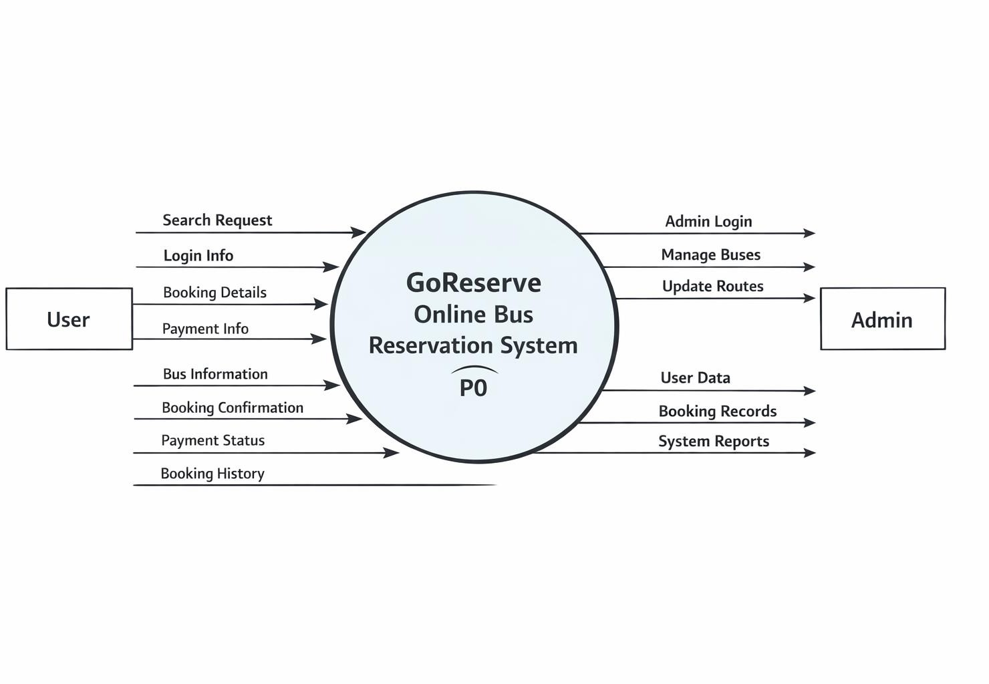

LEVEL 1 DFD:
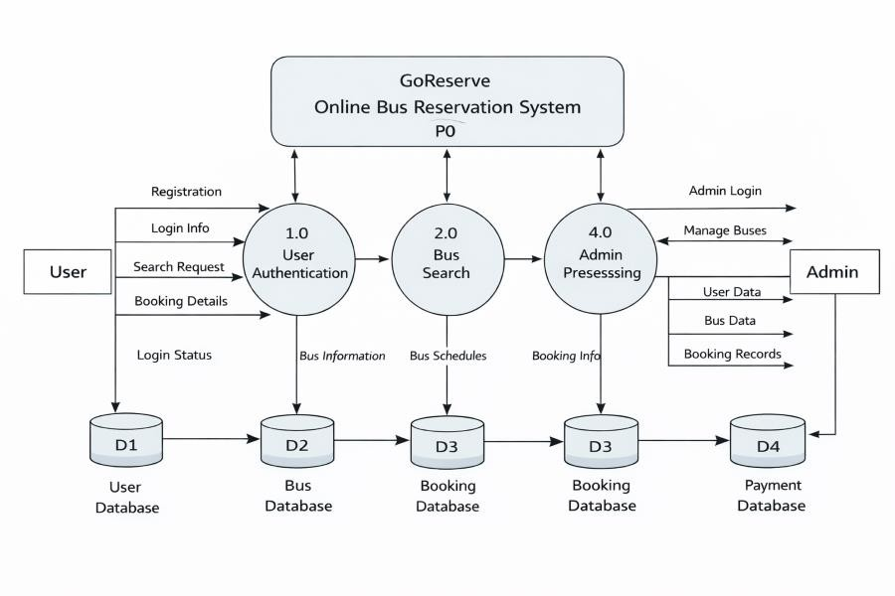

ER DIAGRAM:
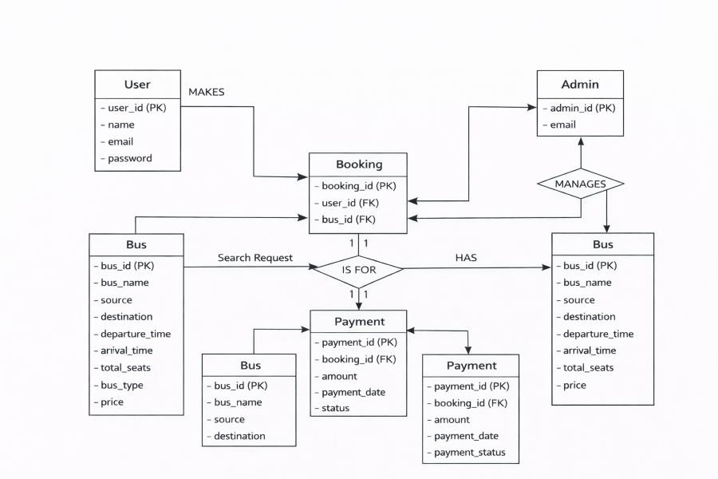

CLASS DIAGRAM:
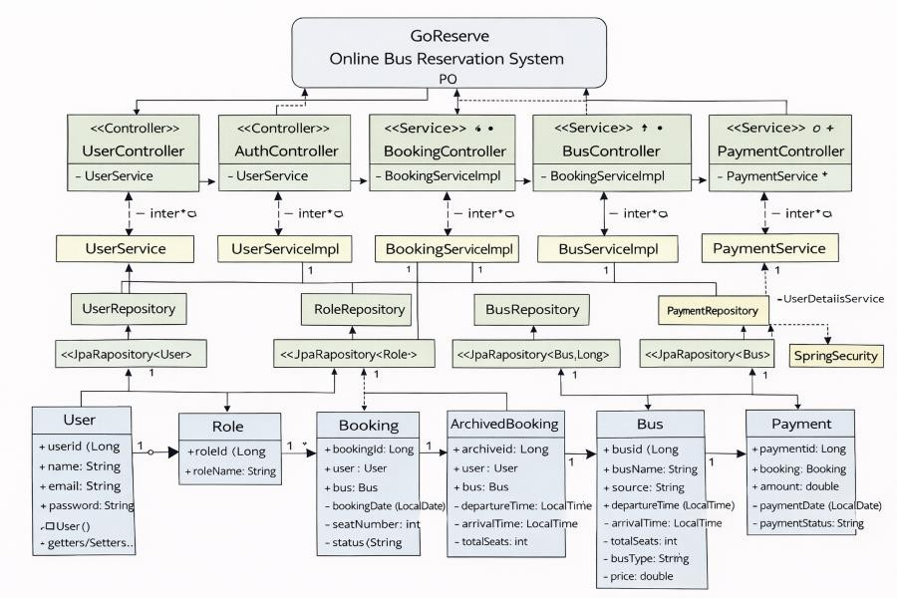

SYSTEM DESIGN

Database Description

The GoReserve system uses a relational database (MySQL) to store and manage application data. The database is designed to efficiently handle users, buses, bookings, payments, and archived records. Route information is not stored in a separate table; instead, source and destination details are stored within the booking and bus records.

User Table:
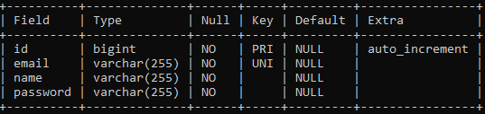

Bus Table:
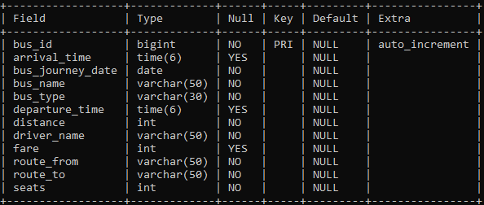

Booking Table:
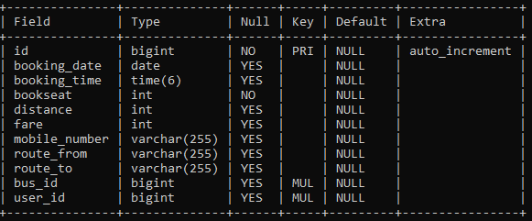

Payment Table:
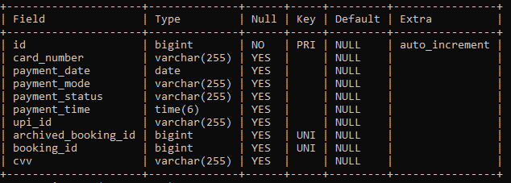

Archived Booking Table:
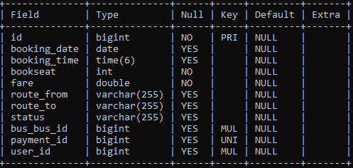

Module Description

The GoReserve system is divided into multiple logical modules, each responsible for a specific functionality.

User Module
Handles user registration, login, and user-specific activities.

Functions:

  - User registration
  - User authentication
  - Viewing available buses
  - Booking tickets
  - Viewing booking history

Bus Management Module
Allows administrators to manage bus-related information.

Functions:

  - Add new buses
  - Update bus details
  - Delete buses
  - Manage schedules and pricing

Booking Module
Manages ticket booking operations for users.

Functions:

  - Seat selection
  - Fare calculation
  - Booking confirmation
  - Booking storage in database

Payment Module
Handles online payment processing and transaction tracking.

Functions:

  - Payment initiation
  - Payment status tracking
  - Linking payment with booking
  - Handling cancelled payments

Admin Module
Provides restricted access to administrators using role-based authentication.

Functions:

  - Admin login
  - User monitoring
  - Booking monitoring
  - Bus management

Archived Booking Module
Manages cancelled bookings separately for record maintenance.

Functions:

  - Move cancelled bookings to archive
  - Maintain payment linkage
  - Support refund tracking

Process Logic

The process logic explains how different modules interact and how data flows through the system.

User Registration & Login Process

  - User accesses the registration page.
  - User enters details and submits the form.
  - Password is encrypted using BCrypt.
  - User data is stored in the Users table.
  - During login, credentials are validated.
  - On success, the user is redirected to the dashboard.

Bus Search Process

  - User enters source and destination.
  - System fetches matching buses from the Bus table.
  - Available buses are displayed to the user.

Ticket Booking Process

  - User selects a bus and enters booking details.
  - Fare is calculated based on distance and seats.
  - Booking details are saved in the Booking table.
  - User is redirected to payment.

Payment Process

  - User selects payment mode (UPI/Card).
  - Payment details are validated.
  - Payment status is updated as PAID or CANCELLED.
  - Payment record is stored in the Payment table.

Booking Cancellation Process

  - User requests cancellation.
  - Booking status is updated.
  - Booking is moved to ArchivedBooking table.
  - Payment status is updated as CANCELLED.
  - Refund process can be initiated.

Tools and Platform
Hardware Requirements

The hardware requirements for the GoReserve project are minimal, making the system cost-effective and accessible.

Component | Specification
Processor | Intel Core i3 or equivalent
RAM | Minimum 8 GB
Storage | 20 GB free disk space
System Type | 64-bit architecture
Input Devices | Keyboard, Mouse
Output Devices | Monitor

The system was developed and tested on an average-specification PC.

Software Requirements

The software requirements include the operating system, programming languages, frameworks, databases, and development tools used in the project.

Operating System

  - Windows 10 / Windows 11
(Any modern OS supporting Java can be used)

Programming Languages

  - Java (JDK 21)
  - HTML5
  - CSS3
  - JavaScript

Frameworks & Technologies

  - Spring Boot – Backend development
  - Spring MVC – Web architecture
  - Spring Security – Authentication and authorization
  - Thymeleaf – Server-side template engine
  - Hibernate / JPA – ORM and database interaction

Database

  - MySQL – Relational database management system

Development Tools & IDE

  - Eclipse IDE (Spring Tool Suite – STS)
  - Maven – Dependency management and build tool

Web Technologies

  - Bootstrap – Responsive UI design
  - HTTP/HTTPS – Client–server communication
  - Tailwind CSS – To Build fast, consistent, and highly customizable UIs.

Server

  - Embedded Apache Tomcat (Spring Boot default)

Future Scope

The GoReserve online bus reservation system has been designed with a modular and scalable architecture, allowing future enhancements and feature expansions. While the current system effectively supports online bus search, booking, payment, and administrative management, several additional features can be incorporated to further improve functionality, usability, and performance.
One potential enhancement is the integration of real-time seat selection and seat layout visualization, enabling users to choose specific seats while booking tickets. This would enhance user experience and provide better transparency in seat availability.
The system can be extended to support multiple bus operators, allowing different transport providers to register and manage their buses independently through dedicated admin accounts. This would make the platform more scalable and suitable for commercial deployment.
Another important future enhancement is the implementation of automatic refund processing, where cancelled bookings trigger refunds directly to the user’s payment method without manual intervention. Integration with advanced payment gateway APIs can facilitate this process.
The project can also be enhanced by adding notification services such as email and SMS alerts to inform users about booking confirmations, cancellations, schedule changes, and refund updates. This would improve communication and reliability.
In the future, mobile application support can be introduced by developing an Android or iOS version of GoReserve using the same backend services. This would make the system more accessible to users on mobile devices.
Additional features such as dynamic pricing, discounts, and offer management can be implemented to support promotional campaigns and flexible fare management. Admins could control pricing based on demand, season, or seat availability.

From a technical perspective, the system can be optimized further by incorporating advanced analytics and reporting tools for administrators to analyze booking trends, revenue, and user behavior. This data can help in better decision-making and system optimization.

Overall, the future scope of GoReserve lies in enhancing automation, scalability, user experience, and integration capabilities, making it suitable for large-scale, real-world deployment.

Conclusion

The GoReserve online bus reservation system successfully addresses the limitations of traditional bus ticket booking methods by providing a secure, efficient, and user-friendly digital platform. The project automates key processes such as bus search, ticket booking, payment handling, and booking history management, thereby reducing manual effort and improving overall operational efficiency.
One of the major achievements of the project is the implementation of role-based access control, which ensures that administrative functions such as bus management and user monitoring are accessible only to authorized administrators. This enhances system security and data integrity. The project also effectively manages booking and payment data using a well-structured relational database, ensuring accuracy, transparency, and reliable record maintenance.

The system has been developed using Spring Boot, Thymeleaf, and JDK 21, following a modular architecture that supports maintainability and scalability. The use of secure authentication mechanisms and encrypted password storage further strengthens the reliability of the application. Additionally, the design choice of handling route information without a separate database simplifies the system while maintaining effective route-based search functionality.

Overall, the GoReserve project demonstrates the practical application of software engineering principles and full-stack web development concepts in solving a real-world problem. The successful implementation of this system highlights its effectiveness as a robust online bus reservation solution and provides a strong foundation for future enhancements and real-world deployment.

