Project Report

On GoReserve: Bus Reservation System

Submitted for partial fulfillment of the requirement for the award of the degree of

Master of Computer Application
Session (2024-2026)

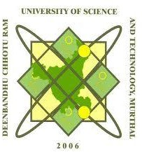

Department of Computer Science and Applications Hindu Institute of Management, Sonipat-131001 Affiliated by:
Deenbandhu Chhotu Ram University of Science & Technology, Murthal (Sonipat), Haryana

Submitted by:

Vishal Kaushik MCA II YEAR
Roll no: 24012541019
Under Supervision of:

Mr. Ajay Bajaj

