CHAPTER – 1
INTRODUCTION TO PROJECT
  - About Project:
AItopia is a web-based AI platform designed to provide users with a modern, efficient, and user-friendly environment for accessing AI-powered tools and services. The main objective of this project is to create a centralized platform where users can discover, explore, and utilize advanced AI functionalities through a clean and interactive interface.
Users can securely access the platform, browse available AI tools, manage their profiles, and interact with different features through an intuitive dashboard. The platform focuses on delivering a smooth user experience with responsive design, fast performance, and organized navigation.
The system includes user authentication and account management features to ensure secure access control. Users can manage their personal settings, view subscription or plan information, and personalize their experience within the platform. The application is designed to provide a scalable structure that can support additional AI services and future enhancements.
On the administrative side, the platform contains management functionalities that allow better control over users, platform features, and system operations. The architecture is designed to maintain modularity, improve maintainability, and simplify future development.
The project uses modern web technologies such as Next.js and TypeScript for frontend development, Tailwind CSS for responsive UI styling, and Node.js with Express.js for backend services. Prisma ORM is used for database interaction and management, ensuring efficient and structured data handling.
AItopia follows a structured development approach with a component-based architecture that improves code reusability, scalability, and maintainability. The platform emphasizes performance optimization, clean design, and a responsive user interface to deliver an enhanced user experience across multiple devices.
Overall, AItopia demonstrates how modern web technologies and AI-driven solutions can be combined to build a powerful, scalable, and user-centric digital platform.

  - Problem with Existing System:
Many online platforms that provide AI tools and digital services suffer from fragmented experiences, limited accessibility, and poor user interfaces. Users often need to visit multiple websites or applications to access different AI functionalities. This leads to wasted time, inconsistent experiences, and difficulty in finding suitable AI solutions for their needs.
Another major issue with existing systems is the lack of responsive design and optimized user experience across different devices. Users expect modern applications to be fast, visually appealing, and accessible from desktops, tablets, and mobile devices, but many current solutions fail to meet these expectations.
There is a growing need for a modern, secure, and scalable AI platform that can centralize AI services, simplify user interactions, and provide an enhanced digital experience. Such a system should support secure authentication, efficient data management, responsive interfaces, and flexible architecture for future expansion.
AItopia has been developed to address these challenges and provide a comprehensive platform that streamlines access to AI-powered tools and digital services.

  - Key Benefits:
The AItopia platform offers several important benefits for users and administrators by providing a centralized, modern, and efficient AI-powered digital environment.
One major advantage of the system is accessibility and convenience. Users can access AI tools, dashboards, and platform services from anywhere through a web interface, eliminating the need to switch between multiple platforms. This saves time and improves productivity by providing a unified user experience.
Another key benefit is improved organization and efficiency. The platform enables users to easily explore available AI tools, manage their profiles, and access account-related features through an intuitive interface. The structured dashboard and responsive design allow users to navigate the system quickly and efficiently.
The project ensures secure authentication and reliable data management, protecting user information and preventing unauthorized access. User data, account settings, and platform interactions are managed securely through modern backend architecture and database systems.

For administrators, the system simplifies management tasks such as handling users, monitoring platform operations, and maintaining system functionality. The modular architecture improves scalability, maintainability, and makes future feature expansion easier.
For administrators, the system simplifies management tasks such as handling users, monitoring platform operations, and maintaining system functionality. The modular architecture improves scalability, maintainability, and makes future feature expansion easier.
Overall, AItopia provides a fast, secure, scalable, and user-friendly platform that improves how users access and interact with AI-powered tools and digital services.

  - Various Functionalities of Project:
The AItopia project stands out from traditional digital platforms by offering several modern features, scalable architecture choices, and user-focused functionalities. These features improve both system performance and overall user experience.

1.4.1 Responsive and Modern User Interface
One of the important aspects of this project is its clean, responsive, and interactive user interface. The platform is designed using modern frontend technologies to ensure smooth navigation and an appealing visual experience. Users can access the platform seamlessly across desktops, tablets, and mobile devices, improving accessibility and usability.

1.4.2 Centralized AI Platform Experience
The project provides a centralized environment for accessing AI-powered tools and platform services. Instead of requiring users to interact with multiple disconnected systems, AItopia brings different functionalities together within a single dashboard. This approach simplifies user interaction, improves workflow efficiency, and creates a more organized experience.
1.4.3 Secure Authentication and User Management
GoReserve implements a secure login system using role-based authentication. After logging in, users are redirected to different pages based on their roles. Admins are directed to the admin dashboard, while normal users are redirected to the user interface. This ensures proper access control and enhances system security.

1.4.4 Scalable Backend Architecture
The project uses a structured backend architecture built with modern development practices. Technologies such as Node.js, Express.js, and Prisma ORM are used to support efficient API handling, database interaction, and maintainable code organization. This architecture allows easier scalability, future expansion, and efficient system management.

1.4.5 Dashboard and Profile Management Features
A modern dark mode option is included to enhance user experience. It allows users to switch between light and dark themes based on their preference, making the interface more comfortable to use, especially in low-light conditions.

1.4.6 Performance Optimization and Maintainability
The project follows a component-based and modular development approach using Next.js and TypeScript. This improves code reusability, maintainability, and application performance. The organized structure simplifies development, debugging, and future feature implementation.
  - Objectives of Project:
The primary objective of the AItopia project is to design and develop a reliable, scalable, and user-friendly AI platform that provides users with a centralized environment for accessing AI-powered tools and digital services. The system aims to deliver a modern web-based solution that is accessible anytime and from anywhere.
One of the key objectives of this project is to provide users with a simple, organized, and efficient platform experience, where they can easily explore available AI tools, manage their profiles, and interact with platform features through an intuitive dashboard. This helps improve accessibility, productivity, and overall user satisfaction.
Another important objective is to implement secure authentication and user management functionality. The system is designed to protect user accounts, manage access control, and ensure safe handling of user information through modern security practices and structured backend architecture.

The project also aims to develop a responsive and high-performance web application using modern technologies. The platform is designed to provide smooth performance, fast navigation, and compatibility across desktops, tablets, and mobile devices to enhance the overall user experience.
An additional objective of the project is to maintain a scalable and maintainable architecture that supports future enhancements and feature expansion. By following a modular development approach, the system simplifies development, debugging, and long-term maintenance.
Overall, AItopia aims to combine modern web technologies and AI-driven functionality to create a secure, efficient, and user-centric digital platform.
  - Scope of Project:
The scope of the AItopia project includes developing a modern web-based platform that provides users with centralized access to AI-powered tools and digital services. The project focuses on delivering a secure, responsive, and user-friendly system that supports both users and administrators through organized platform management.
The features available for users include secure registration and login, profile management, dashboard access, browsing platform functionalities, managing account settings, and interacting with AI-related services through an intuitive interface. The system is designed to provide a smooth and efficient user experience across different devices.

Features available for administrators include managing users, monitoring platform activities, maintaining system functionality, and handling platform-related operations through a structured management environment. The architecture supports organized data handling and simplified system administration.
The project also includes modern frontend and backend development practices to ensure scalability, maintainability, and high performance. The application is designed using Next.js, TypeScript, Tailwind CSS, Node.js, Express.js, and Prisma ORM, with structured database management and secure API communication.

Advanced functionalities and future enhancements such as expanded AI integrations, advanced analytics, personalized recommendations, additional subscription features, and extended platform services may be incorporated in future development phases.

  - Assumptions & Constraints:
The development and implementation of the AItopia platform are based on certain assumptions and constraints that define the scope, functionality, and limitations of the project. These factors help establish realistic expectations and provide a clear understanding of the platform’s operational boundaries.

1.7.1 Assumptions
The system assumes that users have basic knowledge of using web applications, including registration, login, navigating dashboards, and interacting with online interfaces. It is also assumed that users have access to a stable internet connection, as the platform is entirely web-based and requires online access for its functionalities.
Another important assumption is that users will provide accurate and valid information while creating accounts, updating profiles, or interacting with platform services. The system relies on user-provided data for authentication, profile management, and personalized experiences, and inaccurate information may affect platform functionality. It is also assumed that administrators will manage the platform responsibly. Administrators are expected to monitor system activities, manage users, maintain platform configurations, and ensure that platform data remains accurate and updated.
Additionally, the project assumes that the server environment, database services, APIs, and application infrastructure will operate smoothly without major technical failures or prolonged downtime.

1.7.2 Constraints
The AItopia platform has several constraints that influence its current functionality and implementation scope. One of the major constraints is that certain advanced AI integrations, external service dependencies, or premium platform capabilities may not be fully implemented in the current version and can be incorporated in future development phases.
Another limitation is that some advanced features such as detailed analytics, extensive personalization systems, advanced recommendation engines, or expanded third-party integrations are outside the scope of the present version of the project. These enhancements can be added in future updates.

The platform is highly dependent on internet connectivity, and network-related issues may affect performance, accessibility, and response times.
Finally, the project is developed under practical constraints including limited development time, available resources, testing environments, and infrastructure availability.
  - Organization of Report:
This report for the AItopia project is presented in a structured format divided into separate chapters according to the requirements of the project. The report is organized as follows:

Chapter 1: Introduction describes the overall project overview including the introduction to the platform, problem definition, objectives of the project, scope of the project, assumptions, constraints, and general description of the report.
Chapter 2: Literature Review / Existing System discusses the existing systems, literature survey of related digital platforms and AI-based solutions, along with the limitations and shortcomings of currently available systems.
Chapter 3: Proposed System / Methodology system focuses on improving accessibility, usability, security, and performance by adopting modern full-stack development technologies and structured architecture
Chapter 4: System Analysis & Design describes system requirement analysis including functional requirements, non-functional requirements, and various diagrams such as Use Case Diagram, DFD, ER Diagram, Database Design, and system architecture representation.
Chapter 5: Implementation provides information about the development tools, technologies, frameworks, libraries, backend and frontend implementation, database integration, and important components of the project along with screenshots of the developed system.
Chapter 6: Testing explains the testing process and different testing methods used to verify that the system functions correctly. It also presents test cases, testing procedures, and obtained results.
Chapter 7: Result and Discussion presents the outcomes of the implemented project, system performance, achieved functionalities, and discussion regarding the effectiveness of the developed platform.
Chapter 8: Conclusion and Future Scope summarizes the complete project, highlights its achievements and limitations, and discusses possible future enhancements and expansion opportunities for the AItopia platform.
CHAPTER-2
Literature Review / Existing System
2.1 Introduction to Literature Review:
A literature review is an important part of any project as it helps in understanding the work that has already been carried out in a particular domain. It provides insight into existing systems, technologies, methodologies, and approaches used to solve similar problems. By studying these systems, it becomes possible to identify their strengths, weaknesses, and opportunities for improvement, which supports the development of a better and more efficient solution.
Another important aspect of reviewing existing work is understanding the limitations and design challenges faced by previous systems. Some platforms may provide powerful features but lack intuitive user experience, while others may focus on usability but face issues related to scalability, maintainability, or security. By analyzing both positive and negative aspects, it becomes easier to design a balanced system that combines functionality, performance, usability, and modern development practices.

2.2 Modules We Have
1) AI Tools
The AI Tools module is the main section of the project where all the artificial intelligence features are grouped together. Through this module, users can access different AI-based services such as image generation, voice cloning, video subtitle creation, content writing, chatbot interaction, and data analysis.

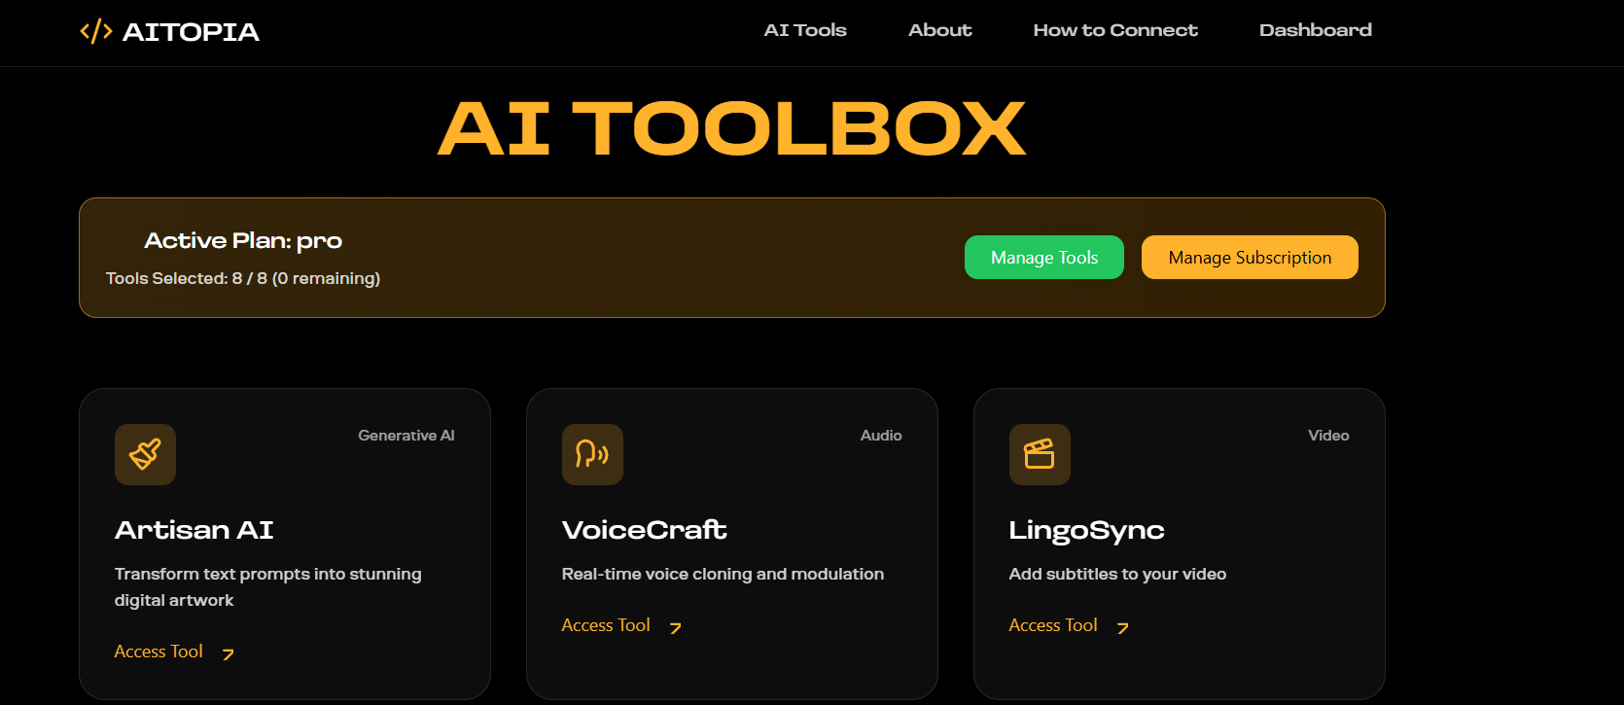

2) About
The About module provides information about the project, its purpose, and its features. It explains why the platform was developed and what problem it tries to solve. In an AI project, this section usually describes the idea behind the system, the technologies used, and the main benefits for users

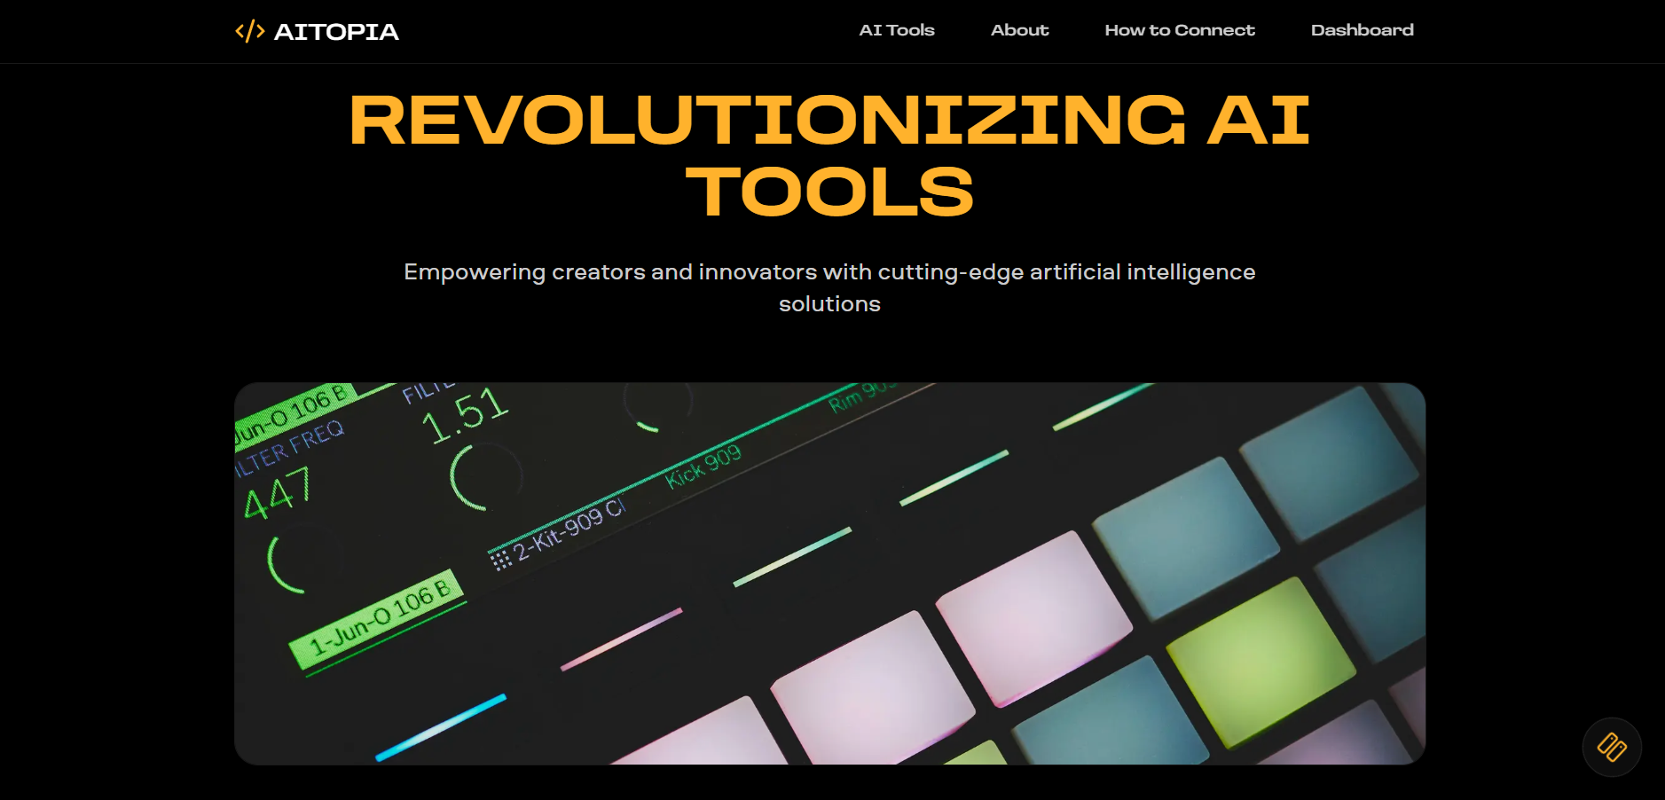

3) How to Connect
The How to Connect module explains how users can connect or interact with the platform. It may include steps such as creating an account, logging in, connecting AI services, or using external APIs and tools.
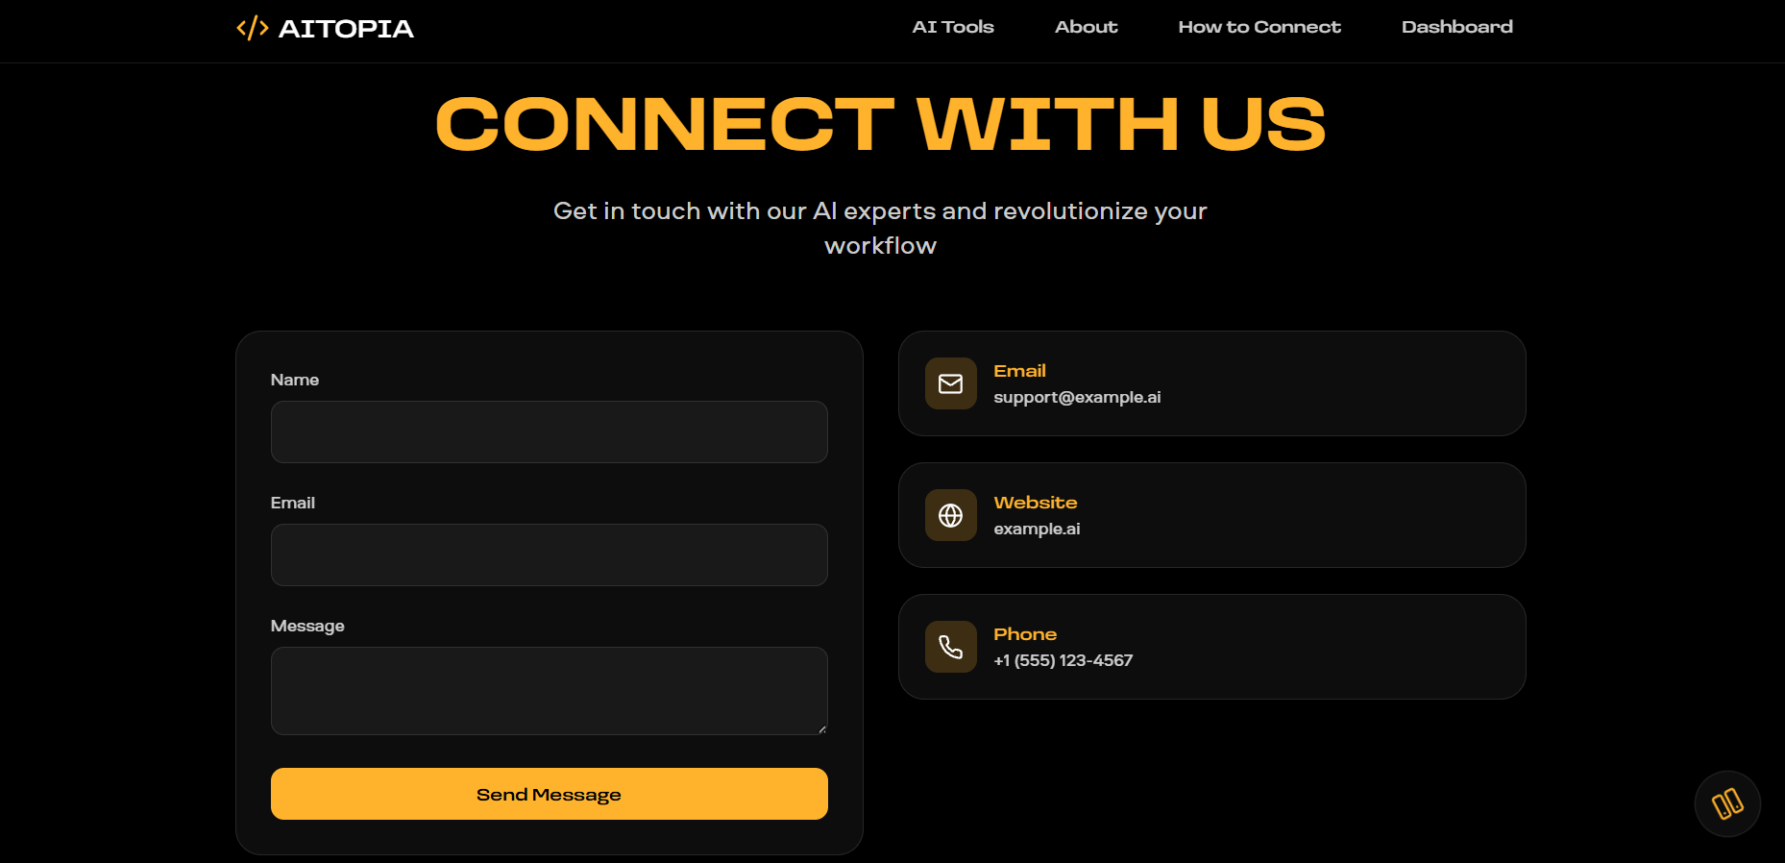

4) FAQ / Support Center
The FAQ / Support Center module is designed to answer common questions and solve basic user problems. FAQ stands for Frequently Asked Questions. This section usually contains questions about login, tool usage, errors, account issues, and other common doubts.
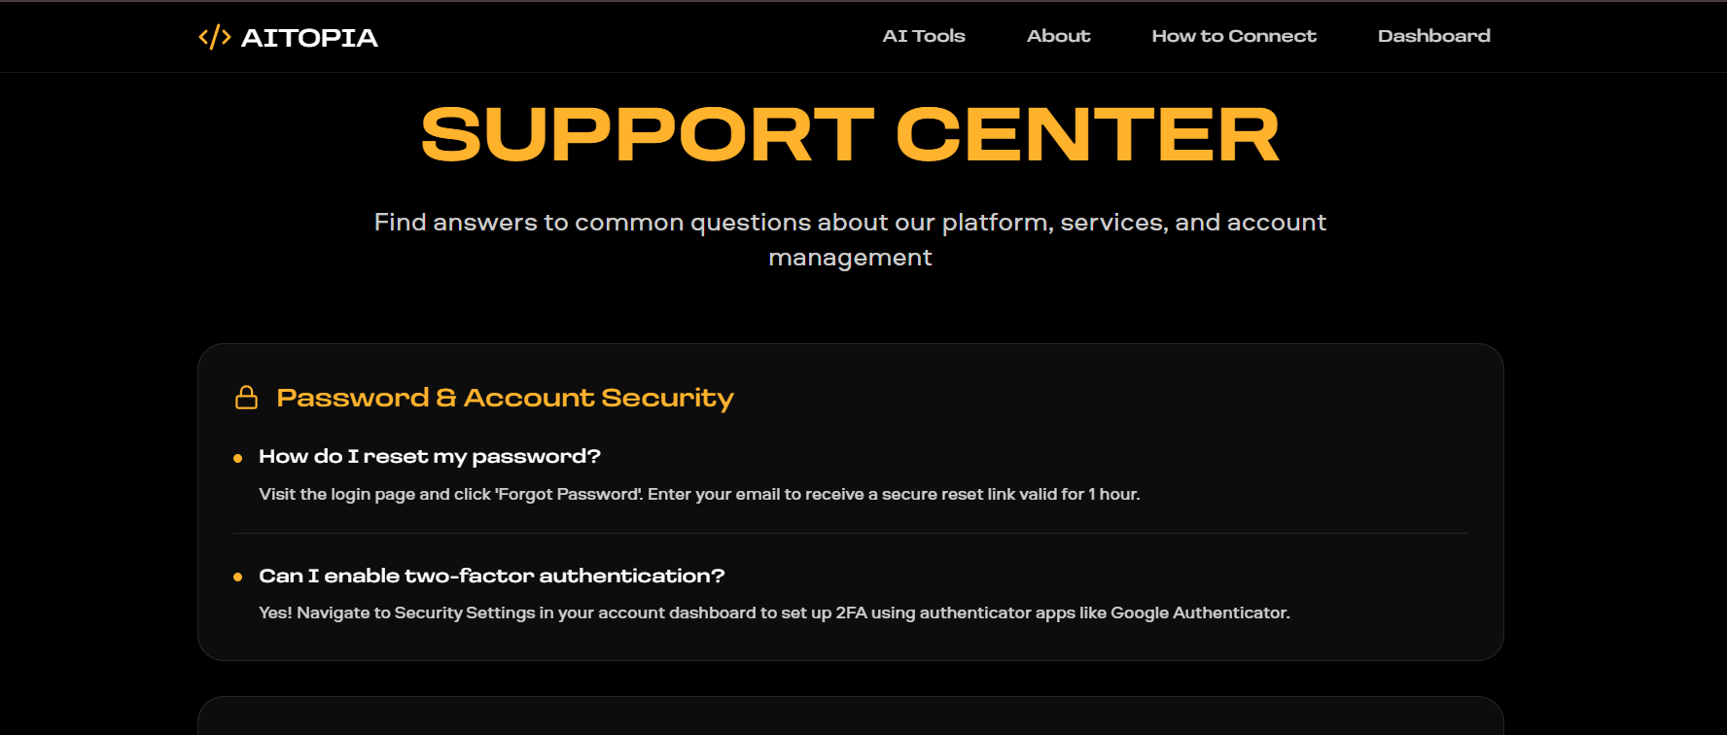
5) Login
The Login module is used for user authentication. It allows registered users to enter the platform securely by providing their username/email and password. This module is important for maintaining privacy, security, and personalized access.

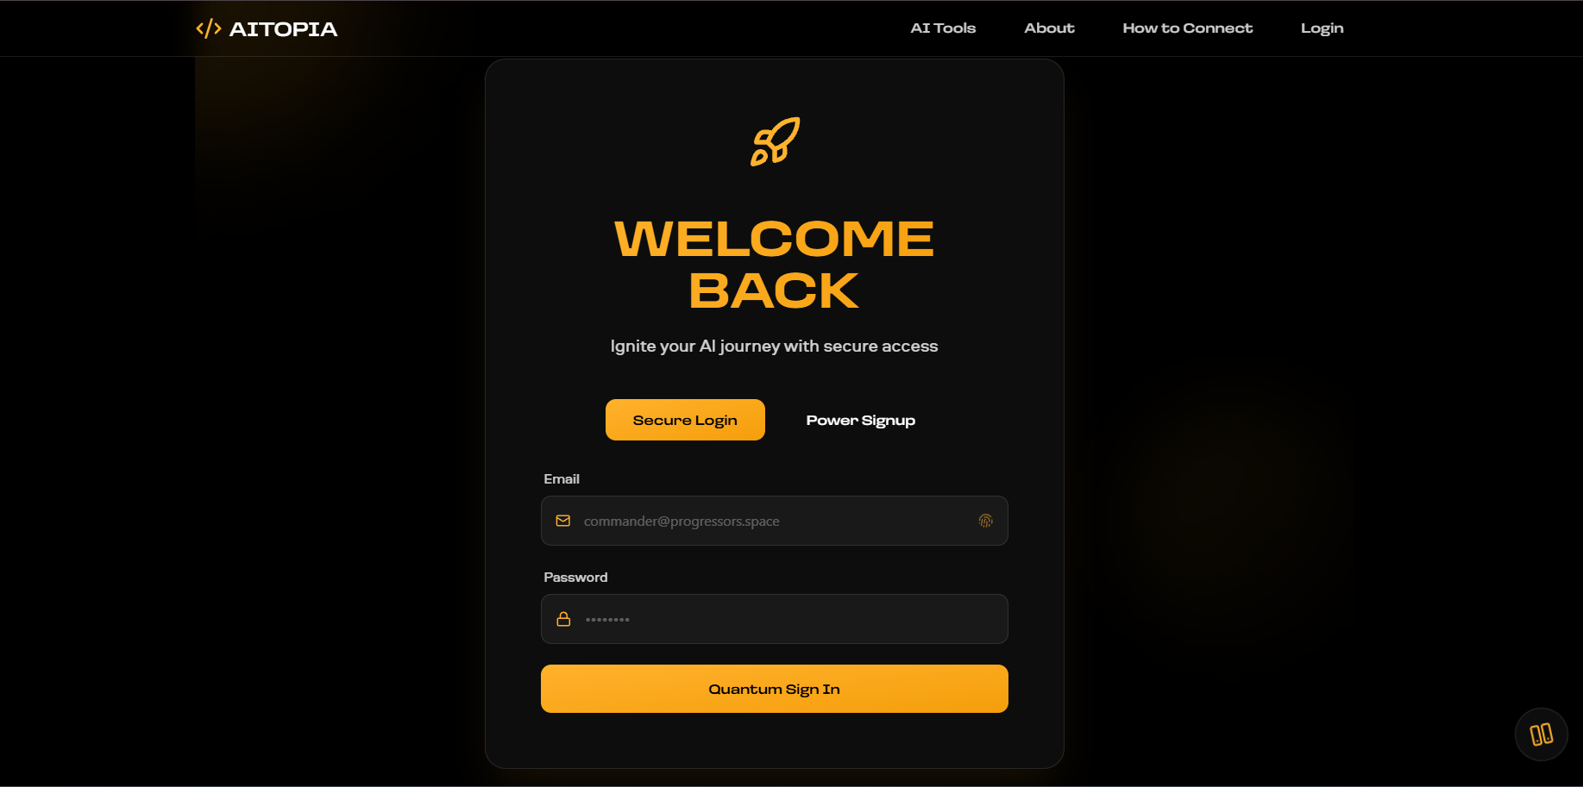

5) Dashboard Module
The Dashboard module is the central control panel of the AI platform that provides users with a complete overview of system activities, project status, and performance details in one place. It is designed to improve user experience by displaying important information through an organized and interactive interface.
This module includes features such as active project management, team member monitoring, storage usage tracking, and API health status. It also contains performance analytics and recent activity updates, allowing users to monitor deployments, API changes, and security audits in real time. The dashboard provides quick navigation to sections like Profile, Package, Analytics, Invoices, Support, Settings, and Logout.
The main purpose of the Dashboard module is to simplify system management and provide users with real-time insights about their projects and platform performance. It helps users make better decisions, track progress efficiently, and manage resources effectively within the AI platform.

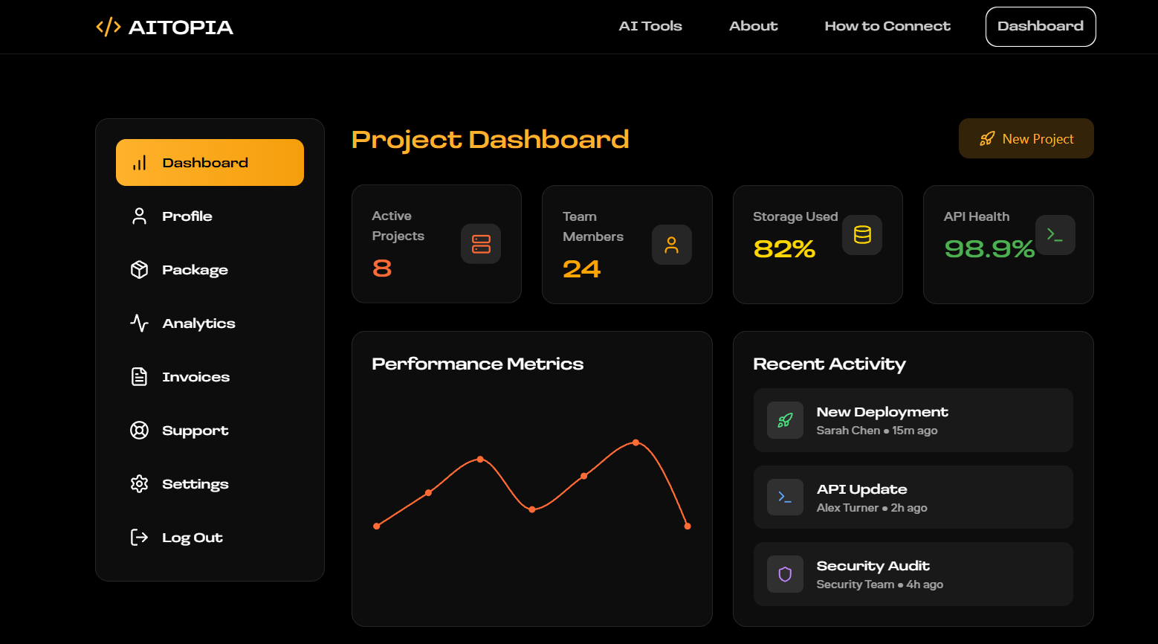

2.7 Limitations We Solved:
Although digital platforms have improved significantly over time, many existing systems still contain limitations related to usability, performance, scalability, and security. These issues can affect both users and administrators and reduce the overall effectiveness of the platform.

2.7.1 Complex and Time-Consuming Workflows
One major limitation of existing systems is the presence of complex workflows and inefficient operational processes. In some platforms, users must navigate complicated interfaces, multiple configuration steps, or disconnected functionalities to perform simple tasks.
Even in many web-based systems, workflows are not always optimized for user convenience, which can reduce productivity and create a less efficient user experience.

2.7.2 High Possibility of Errors and Data Inconsistencies
Some existing systems do not provide efficient real-time interactions or dynamic system updates. Information may not refresh instantly, system status changes may be delayed, and users may not always receive immediate feedback regarding actions or platform activities.
This limitation can reduce responsiveness, affect usability, and create inefficiencies in user interaction and system management.

2.7.3 Lack of Real-Time Interaction and Dynamic Updates
Older systems did not provide real-time updates. Seat availability was not updated instantly, which sometimes led to confusion or double booking. Users had to depend on staff for information, and the data provided was not always accurate.
This lack of real-time data made it difficult to plan travel efficiently and reduced the reliability of the system.

2.7.4 Poor User Interface and User Experience
The user interface of many existing platforms may be outdated, visually cluttered, or difficult to navigate. Some systems prioritize functionality while neglecting design quality, accessibility, and user experience.
Poor navigation structures, inconsistent layouts, and limited responsiveness can make systems less convenient and harder to use, especially for new or non-technical users.

2.7.5 Security and Scalability Challenges
Security remains a significant limitation in certain existing systems. Weak authentication methods, insufficient access control, poor API protection, or inadequate security practices can expose platforms to vulnerabilities and unauthorized access risks.
Additionally, many systems face scalability challenges. Some platforms are not optimized to efficiently manage high traffic loads, large datasets, or increasing user demands without additional infrastructure improvements or architectural optimization.

2.8 Need for Proposed System:
From the study of existing digital platforms and software systems, it is clear that although these systems have contributed significantly to improving digital services, they still suffer from several limitations. Issues such as complex workflows, lack of responsive interfaces, limited scalability, inconsistent user experiences, and security concerns can reduce system efficiency and convenience for users.
In many traditional and basic digital systems, users often depended on restricted environments, complicated interfaces, or limited functionalities to complete their tasks. Even several modern web applications, although more advanced than older systems, may still lack simplicity, performance optimization, centralized management, or seamless user interaction.
Due to these limitations, there is a strong need for a system that is modern, secure, scalable, and user-friendly. A contemporary platform should provide organized navigation, responsive interfaces, secure authentication, efficient data management, and smooth accessibility across different devices.

The proposed system, AItopia, is developed to overcome these challenges and provide an improved digital solution. The platform focuses on creating a centralized AI-powered environment that simplifies user interaction, improves accessibility, and enhances overall user experience through modern web technologies and structured architecture.
The system also ensures improved performance, better data management, secure access control, and maintainable development practices through the use of technologies such as Next.js, TypeScript, Node.js, Express.js, Prisma ORM, and Tailwind CSS.
In addition, AItopia aims to provide features such as secure authentication, dashboard management, responsive design, organized workflows, and scalable architecture to support both current functionalities and future enhancements. By addressing the limitations of existing systems, the proposed platform offers a more reliable, efficient, and modern digital ecosystem for AI-powered services and web-based interactions.

Chapter 3
Proposed System / Methodology

3.1 Introduction to Proposed System:
The limitations of existing digital systems highlight the need for a more modern, scalable, and efficient solution. Traditional software applications often suffer from limited accessibility, poor user experience, restricted scalability, and inefficient workflows. Even some modern web systems may contain complex interfaces, fragmented functionalities, or weak integration between services.
The proposed system, AItopia, is designed to overcome these challenges by providing a modern web-based platform focused on AI-powered digital experiences and centralized platform management. The system offers users a clean, responsive, and user-friendly environment where they can securely access platform services, manage profiles, explore functionalities, and interact with digital tools efficiently.
Unlike older systems, the proposed platform is accessible anytime and from anywhere through a web browser. The system focuses on improving accessibility, usability, security, and performance by adopting modern full-stack development technologies and structured architecture.
Security is another important aspect of the proposed system. AItopia implements secure authentication, protected API communication, organized data management, and controlled access mechanisms to safeguard user information and platform operations.
In addition, the platform is designed to provide a smooth and streamlined experience for users by reducing unnecessary complexity and maintaining clear navigation. The interface is created in a way that allows even first-time users to easily understand and interact with the system.
The proposed system also emphasizes maintainability, scalability, and development efficiency. Through modular architecture and separation of responsibilities, the platform can support future enhancements, additional integrations, and feature expansion without major architectural changes.
3.2 Description of the Proposed System:
The proposed system, AItopia, is a modern web-based platform designed to provide users with centralized access to AI-powered functionalities and digital services. The system focuses on delivering a secure, responsive, and organized environment that simplifies user interaction and enhances overall digital experience.
In this platform, users can securely register and log in to their accounts. After authentication, users can access dashboards, manage profiles, explore platform services, interact with available functionalities, and personalize their experience through organized settings and user controls.
The system is developed to overcome the limitations of traditional and existing digital systems by offering a more scalable, maintainable, and user-centric solution. It emphasizes intuitive navigation, responsive design, and efficient platform interaction.
From the administrative side, the system supports platform management operations and organized handling of users, data, and application services. This helps maintain operational consistency, data accuracy, and system control.
One of the key aspects of the proposed system is its focus on simplicity and usability. The interface is designed in a clean and structured manner to minimize confusion and maximize accessibility across desktops, tablets, and mobile devices.
The system also improves performance by utilizing optimized frontend rendering, efficient backend processing, structured database communication, and modern API handling. Secure authentication and controlled data flow help ensure that user information remains protected and system operations remain reliable.
Through the use of modern technologies such as Next.js, TypeScript, Tailwind CSS, Node.js, Express.js, Prisma ORM, and database management systems, the platform delivers an efficient and future-ready development approach.
3.3 System Architecture:
The architecture of AItopia is designed in a structured and modular way to ensure that the application remains scalable, maintainable, secure, and efficient. Unlike traditional monolithic systems, the project follows a modern full-stack layered architecture, where different responsibilities are separated into dedicated components.

The architecture mainly consists of the following layers:
- Frontend Layer
- Backend Layer
- Database Layer
- API Communication Layer
Each layer performs a specific role and collectively contributes to the overall working of the system.

3.3.1 Frontend Layer (User Interface Layer)
The Frontend Layer represents the part of the system with which users directly interact. It is responsible for displaying information, collecting user input, rendering pages, and managing the overall user experience.
In AItopia, the frontend is developed using Next.js and TypeScript. These technologies help create a modern, scalable, and component-based web application.
The user interface is designed using Tailwind CSS, which provides responsive styling and improves visual consistency across the platform. Additional libraries such as Framer Motion and Lucide React are used to enhance animations, interactions, and user interface elements.
Through the frontend layer, users can:
- Register and log in securely
- Access dashboards
- Manage user profiles
- Explore platform features
- Navigate between sections efficiently
- Interact with platform services through a responsive interface

3.3.2 Backend Layer (Application Logic Layer)
The Backend Layer handles the business logic and server-side operations of the system. It is responsible for processing requests, executing application logic, validating operations, and coordinating communication between the frontend and database.
In AItopia, the backend is developed using Node.js and Express.js.
When a user performs an action on the frontend, such as authentication, profile management, or service interaction, the request is sent to the backend server. The backend processes the request, validates the data, performs required operations, and generates the appropriate response.
The backend layer provides:
- API endpoint handling
- Request validation
- Business logic execution
- Authentication handling
- User management operations
- Secure data processing
- Structured server communication

3.3.3 Database Layer (Data Management Layer)
The Database Layer is responsible for storing, managing, retrieving, and organizing system data.
In AItopia, database interaction is managed using Prisma ORM, which provides a structured and efficient approach to database communication.

The database layer handles important application information such as:
- User records
- Authentication details
- Profile information
- Platform configurations
- Service-related data
- Operational records
Prisma ORM acts as an abstraction layer between the backend and database system, simplifying queries, improving maintainability, and reducing direct database complexity.
The database layer ensures:
- Structured data storage
- Efficient querying
- Data consistency
- Secure persistence
- Maintainable schema management
Proper database organization contributes significantly to system reliability and long-term scalability.

3.3.4 API Communication Flow
The working of the system follows a structured communication flow between different architectural layers.
First, the user interacts with the Frontend Layer by entering data or performing actions through the interface.
The request is then sent to the Backend Layer through API communication mechanisms.
The backend processes the request, validates the information, applies business logic, and communicates with the Database Layer whenever data retrieval, insertion, update, or deletion is required.
After processing is completed, the backend generates an appropriate response and sends the data back to the frontend.
Finally, the frontend displays the processed information to the user.
The overall flow can be represented as:
User → Frontend → API Request → Backend → Database → Backend → Frontend → User
This structured flow improves separation of concerns, maintainability, scalability, and organized communication between system components.

3.3.5 Benefits of the Architecture

Better Code Organization
The layered architecture separates responsibilities between interface design, business logic, server operations, and database management. This improves code readability, organization, and maintainability.

Easy Maintenance and Updates
Since different system components operate independently, developers can modify one layer without significantly affecting others. This simplifies maintenance, debugging, and future enhancements.

Scalability and Flexibility
The architecture supports scalable application growth. New modules, integrations, services, and functionalities can be added without restructuring the entire system.

Improved Security
Security mechanisms can be implemented separately within backend logic, authentication systems, and database handling. This strengthens access control and protects sensitive information.

Efficient Development Workflow
Different developers can work simultaneously on frontend, backend, database, and API components, improving productivity and development efficiency.

3.4 Methodology Used:
The development of AItopia follows a structured methodology focused on modular development, organized implementation, and iterative improvement.
The project uses a modern full-stack development methodology, where frontend development, backend development, database integration, and testing are performed in coordinated stages.
The development process includes the following phases:

Requirement Analysis
During this phase, system requirements, user expectations, platform objectives, and feature specifications are identified and analyzed.

System Design
The architecture, interface structure, database organization, and communication flow are designed before implementation begins.

Frontend Development
The user interface is developed using Next.js, TypeScript, and Tailwind CSS. Components, layouts, responsiveness, and user interaction elements are implemented during this phase.

Backend Development
The backend server, APIs, business logic, authentication handling, and application workflows are implemented using Node.js and Express.js.

Database Integration
Database schema management and structured data communication are handled using Prisma ORM and database technologies.

Testing and Validation
Different testing activities are performed to verify correctness, functionality, responsiveness, and system reliability.

Deployment and Future Enhancement
After successful development and testing, the platform can be deployed for user access while maintaining support for future scalability, updates, and additional feature integration.
This methodology helps ensure that the project remains organized, maintainable, efficient, and aligned with modern software development practices.

3.5 Advantages of the Proposed System:
The proposed system, AItopia, offers several advantages over traditional software systems and existing digital platforms. It is designed to provide a more efficient, scalable, secure, and user-friendly experience for both users and administrators.
One of the main advantages of the platform is improved efficiency and performance. Users can access platform services, dashboards, and digital functionalities quickly through a web-based environment without depending on restricted systems or complicated workflows. The optimized architecture helps reduce delays and improves overall operational speed.
Another important advantage is ease of use and responsive user experience. The platform is designed with a modern, clean, and user-friendly interface, allowing users to navigate different sections and interact with features easily. Even users with basic technical knowledge can use the system without difficulty.
The system also provides organized and reliable data management. Information related to users, profiles, platform services, and operational activities is stored and managed in a structured database environment. This improves data consistency, simplifies retrieval, and supports efficient system operations.
Accessibility is another major benefit of the proposed system. Since the platform is web-based, users can access the application anytime and from anywhere using desktops, tablets, or mobile devices, provided internet connectivity is available. This makes the system significantly more flexible compared to traditional software environments.
The platform also emphasizes security and controlled access mechanisms. Through secure authentication, authorization handling, protected APIs, and structured backend logic, only authorized users can access protected functionalities and sensitive information.
Another important advantage is scalability and maintainability. The use of modern technologies such as Next.js, TypeScript, Node.js, Express.js, Prisma ORM, and modular architecture allows the platform to support future enhancements, additional integrations, and feature expansion without major structural changes.

From an administrative perspective, the system simplifies management activities by providing organized workflows, efficient platform handling, and better control over system operations. This reduces manual complexity and improves management efficiency.
In addition, the platform benefits from modern full-stack architecture, which separates frontend, backend, and database responsibilities. This improves code organization, simplifies debugging, supports collaborative development, and makes long-term maintenance easier.
Overall, AItopia provides a modern, secure, scalable, and efficient digital environment that enhances usability, performance, accessibility, and system reliability compared to existing approaches.

Chapter 4
System Analysis & Design

4.1 Requirement Analysis:
Requirement analysis is an important phase in system development. It helps identify what the system should accomplish and what features must be implemented. In the AItopia project, requirement analysis is performed to understand both user requirements and platform management requirements so that the system operates efficiently.
Requirements are mainly divided into functional requirements and non-functional requirements.

4.1.1 Functional Requirements
Functional requirements describe what the system should do.
User Requirements
- The system should allow users to register and log in securely.
- Users should be able to access the dashboard after authentication.
- Users should be able to manage their profile and account settings.
- Users should be able to explore platform services and available features.
- The system should provide responsive navigation and organized interface interaction.
- Users should be able to access the platform across multiple devices.
- The system should support secure authentication and protected access control.

Administrative Requirements
- Admin should be able to manage platform operations.
- Admin should be able to monitor and manage users.
- Admin should be able to handle platform configurations and services.
- Admin should be able to maintain data consistency and system control.
- Admin should be able to manage application workflows and future platform updates.

4.1.2 Non-Functional Requirements
Non-functional requirements describe how the system should perform.
- The system should be fast and responsive.
- It should be secure, with proper authentication and authorization mechanisms.
- The system should provide a clean, modern, and easy-to-use interface.
- It should be reliable, with minimal operational errors.
- The system should be scalable for future improvements and feature expansion.

4.2 Use Case Diagram:
A use case diagram illustrates how users interact with the system and the functionalities available to different actors within the platform.

4.2.1 Main Actors
- User
- Admin

4.2.2 User Actions
- Register
- Login
- Access Dashboard
- Manage Profile
- Explore Platform Features
- Navigate Platform Services

4.2.3 Admin Actions
- Login
- Monitor Platform Operations
- Manage System Configuration
- Maintain Platform Data
- Handle Platform Services
DIAGRAM:
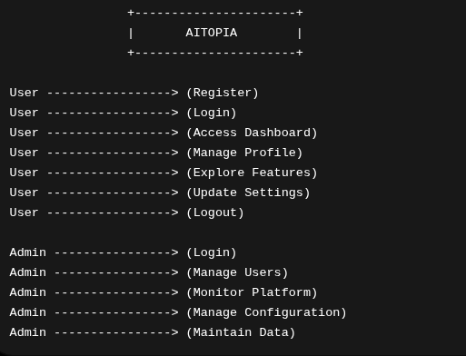

4.3 Project Lifecycle with Gantt Chart:

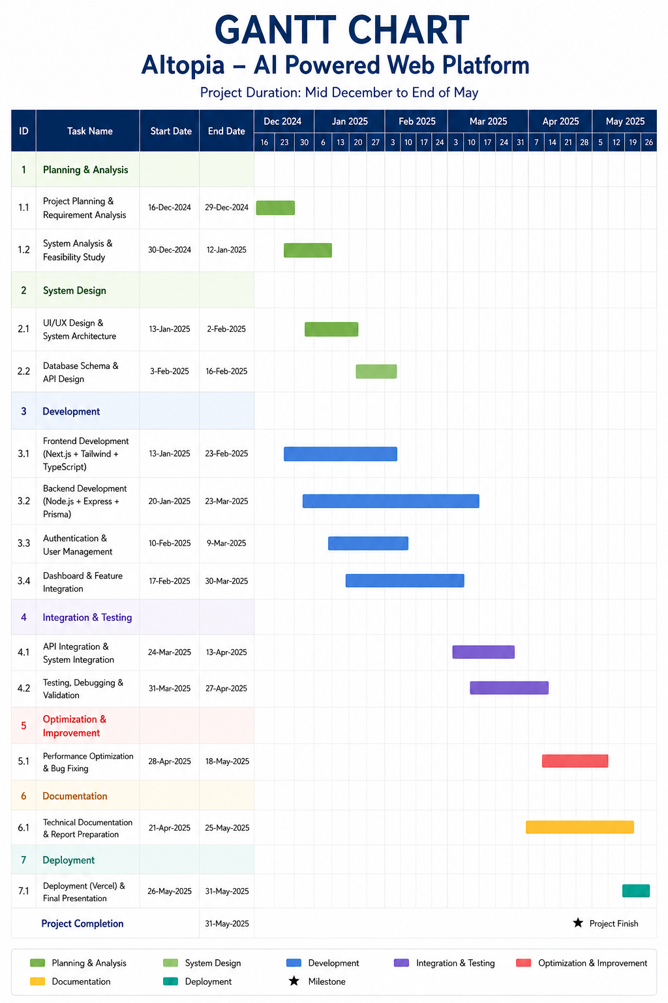

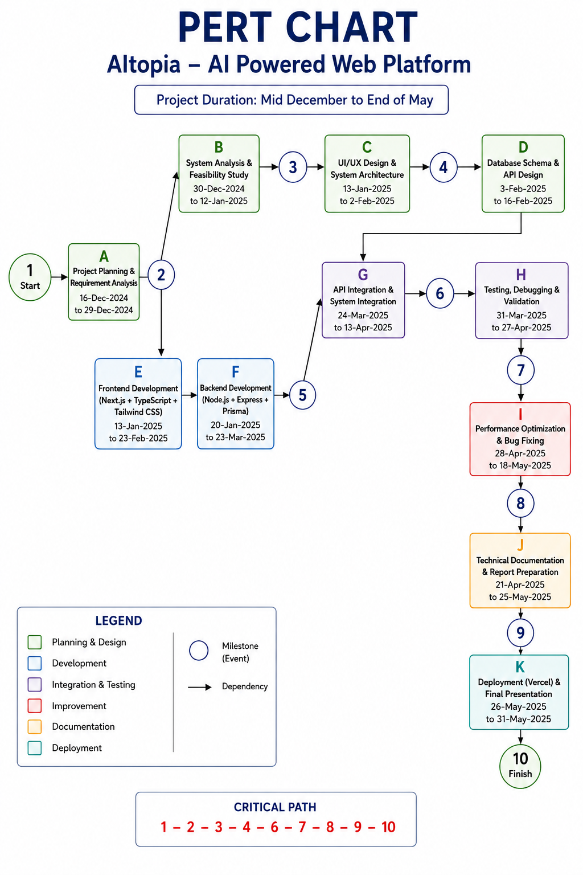
4.4 Pert Chart

4.5 Data Flow Diagram (DFD):
A DFD shows how data moves inside the system
4.5.1 Level 0 DFD
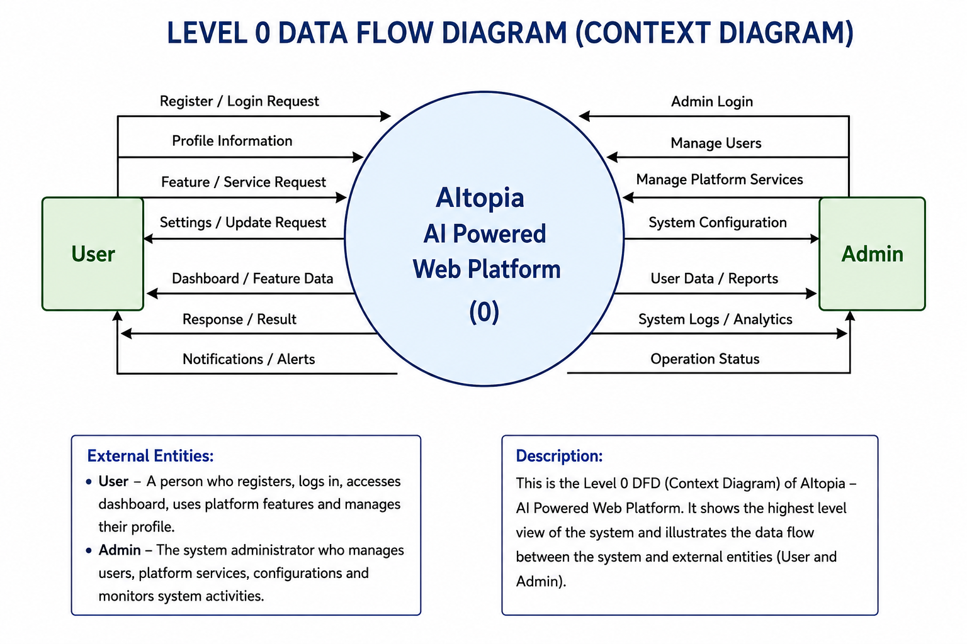
Explanation:
The Level 0 Data Flow Diagram (DFD), also known as the Context Diagram, provides a high-level overview of the AItopia – AI Powered Web Platform. It illustrates how the system interacts with external entities such as the User and the Admin, and how information flows between them.
In this diagram, the entire platform is represented as a single process labeled “AItopia – AI Powered Web Platform (0)”. This process acts as the central unit responsible for handling all platform operations including authentication, dashboard access, feature interaction, user management, and administrative.

🔹 User Interaction with the System
The User is one of the primary external entities in the system. The user interacts with the platform to access services, manage account information, and use available platform functionalities.
- The user sends a registration or login request to access the platform securely.
- After authentication, the user can access the dashboard and navigate through available platform features.
- The user can manage profile information and account settings.
- The user may send feature or service requests to interact with platform functionalities.
In response, the system sends back:
- Dashboard and feature data for platform interaction.
- Response or result information based on user actions.
- Profile and settings updates after successful processing.
- Notifications and alerts regarding updates, activities, or system responses.
This interaction ensures that the user can complete the entire booking process smoothly.

🔹 Admin Interaction with the System
The Admin is responsible for managing the system.
- The admin sends an admin login request to access administrative functionalities.
- The admin can manage users, including monitoring user activities and handling platform accounts.

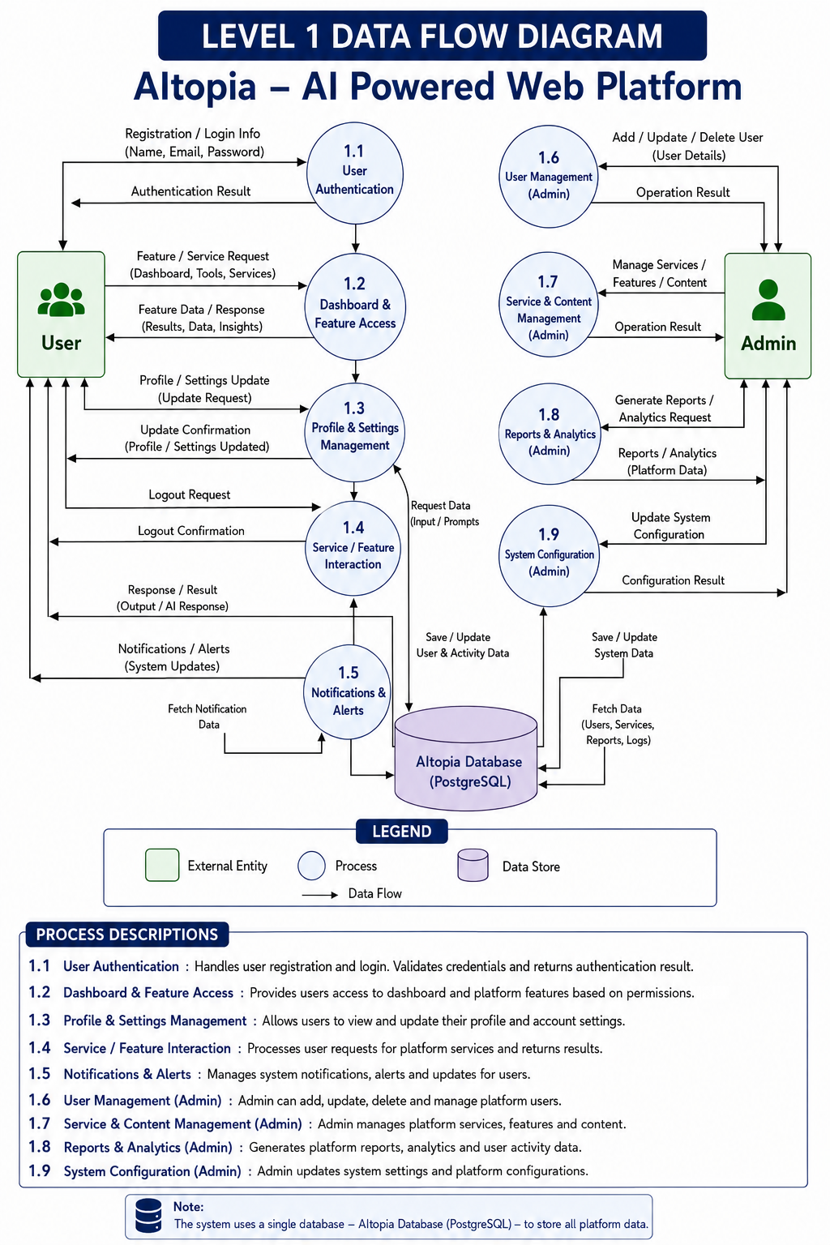
4.5.2 LEVEL 1 DFD:
Explanation:
The Level 1 Data Flow Diagram (DFD) of the AItopia – AI Powered Web Platform provides a detailed representation of how data flows between users, administrators, system processes, and the database. It explains the internal working of the platform by dividing the main system into multiple functional modules.
The diagram contains two main external entities: User and Admin. The user interacts with the platform to register, log in, access dashboard features, manage profile settings, interact with AI services, and receive notifications. The admin manages users, platform services, reports, and system configurations.

User Authentication
This process manages user registration and login operations. Users provide details such as name, email, and password during signup or login. The system validates the credentials and returns the authentication result to the user. User account information is securely stored in the AItopia PostgreSQL Database.

Dashboard & Feature Access
In this process, users access the dashboard and available platform features/services. The system processes requests related to tools, AI services, and platform functionalities. Based on permissions and user actions, the platform retrieves relevant data from the database and displays the appropriate results, insights, or outputs.

Profile & Settings Management
This module allows users to view and update their personal profile and account settings. Users can submit update requests for profile information, preferences, or configurations. The system validates and saves the updated information in the database and returns confirmation to the user.

Notifications & Alerts
This module manages notifications, alerts, and system updates. The system generates important notifications related to user activities, service responses, updates, or account actions. Notification data is retrieved from the database and delivered to users whenever required.

User Management (Admin)
This process is used by administrators to add, update, delete, or manage platform users. The admin sends user management data to the system, and the system processes the request and returns operation results after successful execution.

Service & Content Management (Admin)

This module allows administrators to manage platform services, features, and content. Admins can add, modify, update, or remove system components and configurations related to platform functionality. The system processes these administrative actions and stores the updated information in the database.

AItopia Database (PostgreSQL)
The diagram uses a centralized PostgreSQL database named “AItopia Database” to store all platform information. This includes user accounts, authentication details, profile settings, activity logs, service data, notifications, reports, analytics information, and system configurations.

4.5.3 Level 2 DFD:

Explanation:

User Authentication
This module manages the user registration, verification, and login process of the AItopia – AI Powered Web Platform.
- Register User
The user enters registration details such as name, email, and password. The system validates and stores the information.
- Login User
Registered users enter login credentials to access the system. Authentication is verified, and the login result is returned to the user.
This module ensures secure access to the application.

Dashboard & Feature Access
This process handles user access to the dashboard and platform features..
- Load User Dash board
After successful login, the system loads the personalized dashboard based on the user's role and permissions
- Fetch Features & Services
The platform retrieves available tools, services, and functionalities from the database.
- Display Data / AI Insights
The system displays generated outputs, analytics, AI insights, or requested information to the user.
This module helps users easily to easily access and use platform capabilities.
Profile & Settings Management
This module manages user profile information and account settings.
- View Profile
Users can view their personal account information and saved preferences.
- Update Profile / Settings
Users can modify profile details, account settings, or preferences.
- Save Changes
Updated information is validated and stored in the database.
This module helps users maintain accurate and customizable account information.
Service / Feature Interaction
This process manages interaction between users and platform services or AI features.
- Select Service / Tool
Users select the desired feature, AI tool, or service available on the platform.
- Submit Input / Prompt
Users provide prompts, requests, or input data required by the selected feature.
- Get AI Response / Output
The system processes the request and returns generated results, responses, or outputs.
This module ensures smooth communication between users and system services.

Database Name – AItopia Database (PostgreSQL)
The system uses a centralized PostgreSQL database named “AItopia Database”.
The database stores all platform-related information including:
- User accounts and authentication data
- Dashboard and feature information
- Service requests and AI outputs
- System configuration settings
- Reports, analytics, and logs
- Profile and settings data
The database acts as the central data repository that supports secure storage, retrieval, and management of platform data.
4.6 ER DIAGRAM:

Explanation:

🔹 User Entity
The User entity stores information about users who access and use the AItopia AI Platform.
Attributes include user_id, fullname, email, password, phone, role, status, profile_picture, created_at, and updated_at.
A user can:
- Register and log in to the platform
- Access AI tools and features
- Create AI chat sessions
- Manage profile information
- Receive notifications and save bookmarks

Relationship:
- One user can create multiple AI Chat Sessions (1 : N)
- One user can receive multiple Notifications (1 : N)
- One user can save multiple Bookmarks (1 : N)
- One user has one profile record

🔹 User Session Entity
The User_Session entity stores session-related information of authenticated users.
Attributes include session_id, user_id, token, ip_address, user_agent, last_activity, created_at, and expires_at.

Relationship:
- One user can have multiple active sessions (1 : N)
- Each session belongs to one user

🔹 AI Chat Entity
The AI_Chat entity stores chat conversations created by users.
Attributes include chat_id, user_id, title, created_at, and updated_at.
A chat session contains AI conversations between the user and the system.

Relationship:
- One user can create multiple AI chats (1 : N)
- One AI chat contains multiple messages (1 : N)

🔹 Category Entity
The Category entity organizes platform features into logical groups.
Attributes include category_id, category_name, description, and created_at.
Examples:
- Chat Tools
- Productivity Tools
- Content Generation Tools

Relationship:
- One category can contain multiple features (1 : N)

🔹 Profile Entity
The Profile entity stores additional information related to user accounts.
Attributes include profile_id, user_id, bio, location, website, date_of_birth, created_at, and updated_at.

Relationship:
- One user owns one profile (1 : 1)
- Each profile belongs to one user

🔹 Overall Relationships
- User → User Session (1 : N)
- User → AI Chat (1 : N)
- AI Chat → Message (1 : N)
- User → Bookmark (1 : N)
- User → Profile (1 : 1)
- Category → Feature (1 : N)
- AI Model → Message (1 : N)
- Feature → Category (N : 1)

4.7 DATABASE DESIGN:
The AItopia system uses a relational database (MySQL) to store and manage application data. The database is designed to efficiently handle users, AI tools, tool categories, user sessions, payments, authentication, and related records. Information about AI tools, categories, subscriptions, and user activities is stored in structured tables to ensure fast retrieval, secure access, and reliable system performance.
User Table:

Tool Categories:

SignIn Table:

Payment Table:

SignUp Table:

CHAPTER – 5
IMPLEMENTATON

5.1 Tools and Technologies Used
The AItopia project is developed using modern web technologies and development tools to build a responsive, scalable, and user-friendly AI tools platform. These technologies help provide secure authentication, efficient data handling, and a smooth user experience.

🔹 5.1.1 Operating System
- Windows 10 / Windows 11 / Linux
(Any modern operating system supporting Node.js development can be used)

🔹 5.1.2 Programming Languages
- TypeScript
- HTML5
- CSS3
- JavaScript

🔹 5.1.3 Frameworks & Technologies
- Next.js – Used for frontend development and server-side rendering
- React.js – Used for building reusable UI components
- Tailwind CSS – Used for responsive and modern UI styling
- NextAuth.js / Authentication System – Used for login and session management
- Prisma ORM – Used for database interaction and schema management

🔹 5.1.4 Database
- MySQL – Used as a relational database to store application data

🔹 5.1.5 Development Tools & IDE
- Visual Studio Code (VS Code) – Used for application development
- Git & GitHub – Used for version control and source code management

🔹 5.1.6 Web Technologies
- HTTP / HTTPS – Used for client-server communication
- REST API Routes – Used for backend communication and data handling

🔹 5.1.7 Server
- Next.js Application Server – Used to run the application and handle frontend/backend operations.

5.2 Hardware Requirements
The hardware requirements for the AItopia project are minimal, making the system accessible for development and testing.
- Processor: Intel i5 or above
- RAM: Minimum 8 GB
- Storage: 256 GB SSD
- Internet Connection
The application can be developed and tested on standard-specification systems without requiring high-end hardware.

5.3 Module Description
The AItopia system is divided into multiple logical modules. Each module is responsible for a specific functionality, improving maintainability, organization, and scalability.

🔹 5.3.1 User Module
This module handles all user-related operations.
Functions:
- User registration
- User authentication (login/logout)
- Searching available buses
- Booking tickets
- Viewing booking history
- Cancelling bookings

🔹 5.3.2 Dashboard Management Module
This module handles dashboard-related operations and provides users with a centralized interface to monitor and manage platform activities.
Functions:
- User login and authentication
- Managing user profiles and settings
- Creating and managing AI projects

🔹 5.3.3 AI Tools Module
This module manages AI tool information displayed in the application.
Functions:
- Displaying AI tools
- Viewing tool details
- Filtering tools by category
- Filtering tools by category
- Showing pricing/plan information
- Managing tool visibility

🔹 5.3.4 Categories Module
This module manages AI tool categories.
Functions:
- Displaying categories
- Filtering tools by category
- Organizing tools into groups
- Category-based navigation

🔹 5.3.5 Payment Module
This module manages payment-related activities.
Functions:
- Payment handling
- Tracking payment status
- Linking payment with user access
- Managing subscription/payment records

🔹 5.3.6 Authentication & Session Module
This module manages secure access control.
Functions:
- Session creation
- Session validation
- Protected route access

5.4 Process Logic
The process logic describes how different modules interact and how data flows through the system.

🔹 5.4.1 User Registration & Login Process
- User accesses the signup/login page
- User enters credentials and submits the form
- System validates input data
- User information is stored in the database
- Authentication is verified during login
- Session is created after successful login

🔹 5.4.2 AI Tools Browsing Process
- User opens the AI Tools page
- Tools are displayed in a structured layout
- User can view tool details and plans

🔹 5.4.3 Category Filtering Process
- User selects a category
- System filters matching AI tools
- Filtered results are displayed
- User can switch categories dynamically

🔹 5.4.4 Payment Process
- User selects a plan or premium access option
- Payment details are processed
- Payment status is updated
- Payment record is stored in the database

🔹 5.4.5 Session Management Process
- User logs into the system
- Authentication session is generated
- Session validity is checked for protected routes
- Session is removed during logout or expiration
5.5 PROJECT SCREENSHOTS:
USER SIDE FLOW
5.5.6 Home Page
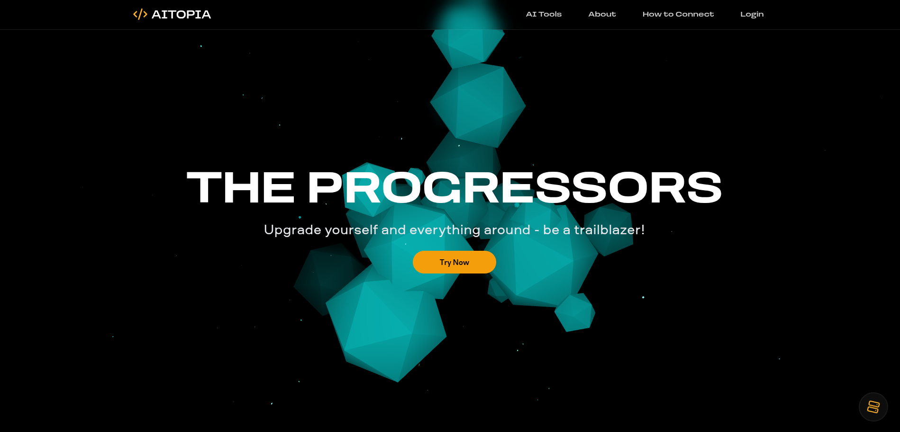

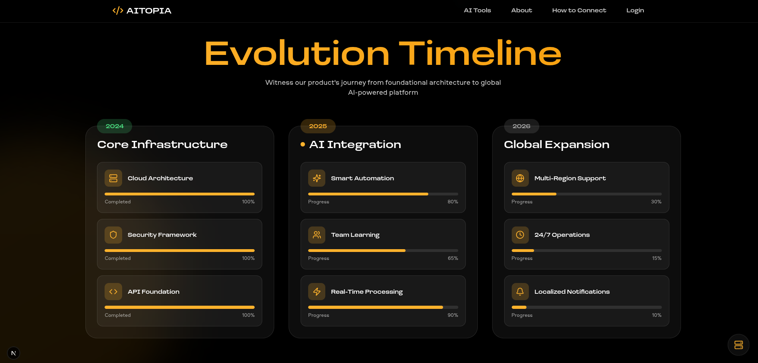

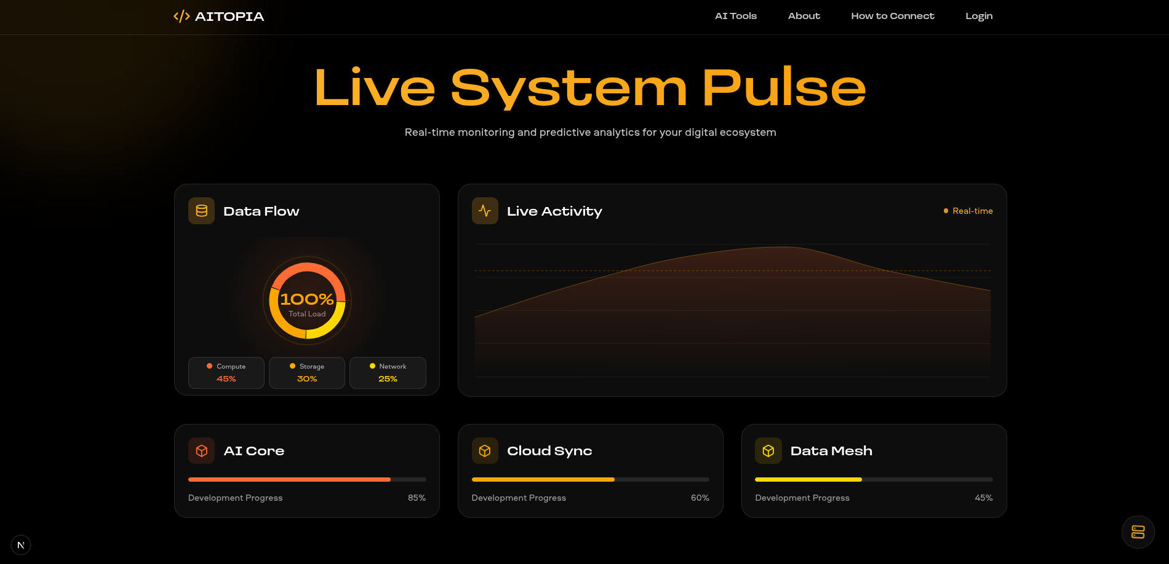

Explanation:
This screen represents the home page of the AItopia AI Tools Platform. The home page is designed with a modern, clean, and interactive interface that allows users to explore different AI tools easily. The top navigation bar includes options such as AI Tools, About, How to Connect, and Login, enabling users to navigate smoothly across different sections of the platform.
The main section of the page highlights the platform’s core objective of providing access to multiple AI-powered tools in one place. Users can browse various categories including Generative AI, Development, Productivity, Image, Video, Audio, and Writing. These category filters help users quickly find tools based on their interests or requirements.
The interface displays AI tool cards such as Artisan AI, VoiceCraft, LingoSync, NeuroChat, CodeForge, and VisionX. Each tool card contains important information including the tool name, category, short description, availability plan, and an “Unlock Access” button. This organized layout makes it easier for users to understand the purpose and accessibility of each AI service.
Another important feature of the home page is the categorized browsing system, which allows users to filter and view tools dynamically. The dark-themed responsive design improves readability, visual appeal, and user experience across different screen sizes and devices.
The home page also provides authentication access through the Login option, allowing users to securely sign in and access platform features based on their account permissions and subscription availability.
Overall, the AItopia home page creates a professional first impression by combining modern UI design, structured AI tool presentation, category-based navigation, and easy accessibility, providing users with a seamless experience while discovering and interacting with AI-powered applications.
5.5.7 Registration Page

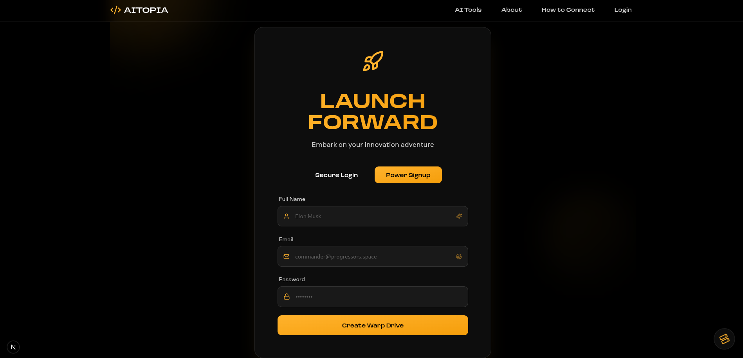

Explanation:
This screen represents the Signup / Registration page of the AItopia AI Platform. The page allows new users to create an account and gain access to the platform’s AI tools and features. The interface is designed with a modern dark-themed layout that provides a clean, professional, and engaging registration experience.
The registration form collects essential user information such as Full Name, Email Address, and Password. Users enter their credentials through clearly labeled input fields designed for simplicity and ease of use. The platform validates user input to ensure proper data submission and secure account creation.
The page highlights the platform’s futuristic branding through the “Launch Forward” theme and provides two authentication options: Secure Login for existing users and Power Signup for new account creation. This tab-based design allows users to switch easily between login and signup functionalities.
After successful form submission, user details are securely processed and stored in the application database. Authentication and session management mechanisms are applied to maintain secure user access and protect account information.
The interface uses a responsive design with a visually appealing dark background, modern typography, and action-focused buttons such as “Create Warp Drive”, improving user engagement and overall usability.
The top navigation bar contains quick-access options including AI Tools, About, How to Connect, and Login, allowing users to navigate the platform while maintaining a consistent user experience across the application.
Overall, the AItopia Signup page provides a secure, visually modern, and user-friendly registration process that enables users to quickly join the platform and begin exploring AI-powered tools and services.

5.5.8 Login Page
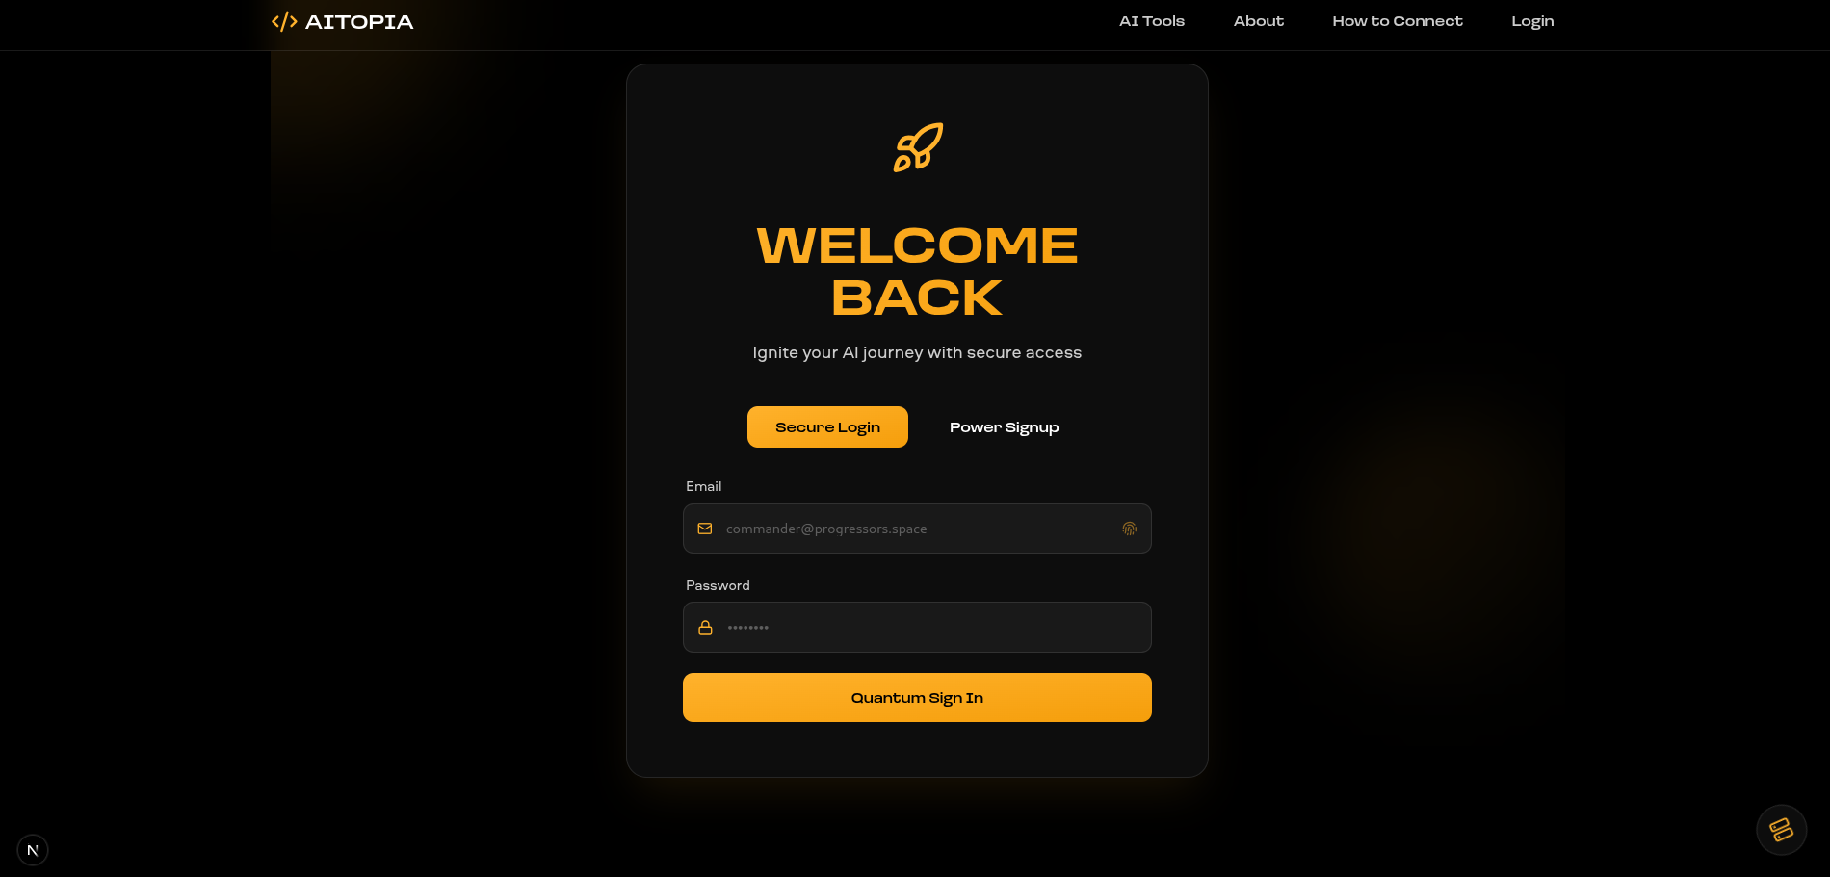

Explanation:
This screen represents the Login page of the AItopia AI Platform, where registered users can securely access their accounts and explore available AI tools and platform features. The login interface is designed with a modern dark-themed layout that provides a professional, clean, and user-friendly authentication experience.
The login form requires users to enter essential credentials such as Email Address and Password to authenticate their identity. Users provide their login information through clearly organized input fields, and the system validates the credentials before granting access to the platform.
The page presents two authentication options: Secure Login for existing users and Power Signup for new users who want to create an account. This tab-based authentication design allows smooth switching between login and registration functionalities without navigation complexity.
Secure authentication and session management mechanisms are applied to protect user accounts and maintain authorized access.
The interface follows a responsive and visually engaging design style featuring the “Welcome Back” branding message, modern typography, dark UI components, and an action button labeled “Quantum Sign In”, enhancing user interaction and platform identity.
The top navigation bar includes important navigation links such as AI Tools, About, How to Connect, and Login, providing users with consistent navigation across the platform while maintaining usability and accessibility.
Overall, the AItopia Login page delivers a secure, responsive, and visually appealing authentication system that enables users to quickly sign in and continue their AI-powered experience on the platform.

5.5.9 Ai Tools Page
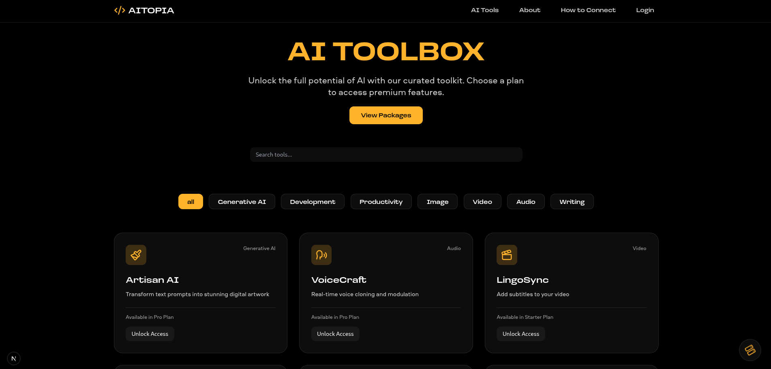

Explanation:
This screen represents the AI Tools page of the AItopia platform, where users can browse, search, and explore a collection of AI-powered applications available within the system. The page is designed with a modern dark-themed interface that provides an organized and interactive environment for discovering different AI services.
The top section of the page highlights the platform’s main objective through the title “AI TOOLBOX”, accompanied by a description encouraging users to unlock AI capabilities through curated tools and subscription plans. A “View Packages” button is provided to allow users to explore available pricing plans and premium feature access.
The page includes a search functionality that enables users to quickly find AI tools by entering keywords or tool names. This improves usability by allowing faster navigation through the available tool collection.
To enhance organization and accessibility, the system provides category-based filtering options such as Generative AI, Development, Productivity, Image, Video, Audio, and Writing. Users can select categories to display tools relevant to their interests or specific tasks.
The main content section displays multiple AI tool cards including Artisan AI, VoiceCraft, and LingoSync. Each tool card presents important information such as the tool name, category, short description, subscription availability, and access options. Users can interact with tools through the “Unlock Access” button based on their plan eligibility.
The interface follows a responsive and structured card-based layout that improves readability, visual consistency, and user interaction across different devices and screen sizes. The dark design theme, modern typography, and clean spacing contribute to a professional and visually appealing user experience.
The top navigation bar contains important navigation links including AI Tools, About, How to Connect, and Login, allowing users to navigate smoothly across different sections of the platform.

5.5.10 About Page

Explanation:
This screen represents the About page of the AItopia AI Platform. The page is designed to provide users with detailed information about the platform’s mission, purpose, features, and overall vision. It helps users understand the objectives of AItopia and how the platform delivers AI-powered solutions through an accessible and modern web environment.
The About page introduces AItopia as a centralized AI tools ecosystem that brings together multiple AI applications across different domains such as Generative AI, Development, Productivity, Image Processing, Video, Audio, and Writing. The platform is developed to simplify user access to advanced AI technologies through a clean and organized interface.
The page explains the platform’s core mission of enabling users to discover, explore, and interact with powerful AI tools from a single location. It highlights the focus on innovation, accessibility, usability, and intelligent digital experiences.
Another important section of the page describes the platform’s functionality and user experience approach. The system is designed using a modern responsive interface that supports smooth navigation, clear content organization, and visually engaging design elements. This ensures that users can comfortably browse information and understand the platform’s capabilities across different devices and screen sizes.
The About page also reinforces the branding and identity of AItopia by presenting the project vision, technological direction, and the value it provides to users interested in AI-powered productivity, creativity, development, and automation tools.
The top navigation bar contains quick-access links such as AI Tools, About, How to Connect, and Login, allowing users to navigate between major sections of the platform while maintaining a consistent user experience.
Overall, the AItopia About page acts as an informational hub that communicates the platform’s purpose, technological focus, design philosophy, and commitment to providing users with a powerful, user-friendly, and future-oriented AI tools environment.

5.5.11 Booking Page

Explanation:
This screen represents the How to Connect / Connect page of the AItopia platform. The page is designed to guide users on how to access, connect with, and start using the platform’s AI tools and services. It provides users with a clear understanding of the connection process, platform accessibility, and interaction flow within the AItopia ecosystem.
The page introduces the process of getting started with AItopia AI services, helping users understand how they can access AI tools, authentication features, and platform capabilities. It serves as an instructional and onboarding section for users who are new to the platform.
The interface explains the steps required to connect with the platform, including creating an account, logging in, accessing available AI tools, and interacting with platform features based on user permissions or subscription availability. This helps users understand the workflow for using AI-powered applications inside the system.
The page also highlights the platform’s emphasis on easy accessibility, guided navigation, and user-friendly interaction. Clear content organization and structured information allow users to understand how different components of the platform work together.
The design follows the overall AItopia visual identity, using a modern dark-themed responsive layout, clean typography, and organized sections to maintain consistency with the rest of the application. This ensures a seamless user experience across different pages and devices.
The top navigation bar contains major navigation options including AI Tools, About, How to Connect, and Login, allowing users to move easily between platform sections while maintaining usability and accessibility.
Overall, the AItopia Connect page acts as a guidance and onboarding section that helps users understand how to connect with the platform, access AI-powered features, and begin exploring available tools in a simple, structured, and user-friendly manner.

5.5.12 Dashboard Page

Explanation:
This screen represents the Dashboard page of the AItopia platform, which serves as the main workspace for authenticated users after logging into the system. The dashboard is designed to provide centralized access to AI tools, categories, user actions, and platform functionality through a modern, organized, and responsive interface.
The dashboard acts as the core control center where users can browse available AI tools, interact with platform features, manage access, and navigate different sections of the application. It provides a structured environment that improves productivity and simplifies user interaction with AI-powered services.
The page displays AI tools using a card-based layout, where each tool includes important information such as the tool name, category, description, availability status, and access options. This layout helps users quickly understand the purpose of each tool and decide which service best matches their requirements.
To improve usability, the dashboard includes search and category filtering features, allowing users to find tools based on keywords or specific categories such as Generative AI, Development, Productivity, Image, Video, Audio, and Writing. These filtering mechanisms make tool discovery faster and more efficient.
The dashboard interface follows a dark-themed modern design, using clear typography, organized spacing, interactive buttons, and responsive components. This design approach ensures a consistent and visually appealing user experience across desktop and mobile devices.
Users can also access platform navigation options through the top navigation bar, which includes sections such as AI Tools, About, How to Connect, and Login / User Access controls. This provides smooth navigation between major platform features and informational pages.
The dashboard supports secure user interaction by working with the platform’s authentication and session management system, ensuring that users access features according to their account permissions and platform availability.
Overall, the AItopia Dashboard page provides a centralized, interactive, and user-friendly environment where users can efficiently discover, manage, and interact with AI-powered tools and platform services.

5.5.13 Paclage Confirmation Page

Explanation:
This screen represents the Package / Subscription Management page of the AItopia Dashboard, where authenticated users can view, compare, and manage available AI tool subscription plans. The page is designed to provide a clear overview of pricing tiers, feature availability, and account package information within the platform.
The left sidebar functions as the dashboard navigation panel, providing quick access to important sections such as Dashboard, Profile, Package, Analytics, Invoices, Support, Settings, and Logout. The currently selected Package section is visually highlighted, helping users easily identify their active location within the dashboard.
The main section of the page displays AI Tool Packages, allowing users to compare different subscription plans offered by the platform. The interface presents multiple pricing tiers including Starter, Professional, and Enterprise packages, each designed for different levels of platform usage and user requirements.
The Starter plan provides a basic access model with features such as limited tool availability, basic AI models, community support, and API usage limits. This plan is suitable for new or entry-level users exploring the platform.
The Professional plan, marked as “Most Popular”, offers enhanced capabilities including access to additional AI tools, advanced AI models, priority support, and expanded API usage. This package is intended for users who require more powerful platform functionality and improved service access.
The Enterprise plan provides premium-level functionality with features such as unlimited tool access, custom AI models, dedicated infrastructure, and 24/7 support, making it suitable for organizations, advanced users, or high-usage environments.
The interface also displays the user’s current subscription status, shown as “Current Plan: Starter Tier”, allowing users to quickly view their active membership level. Action buttons such as “Manage Plan” and “Select Plan” enable users to manage their current package or upgrade to a higher subscription tier.
The page follows AItopia’s modern dark-themed dashboard design, using responsive layouts, clear typography, organized pricing cards, and intuitive navigation to create a professional and user-friendly experience.
Overall, the AItopia Package Management page provides a centralized dashboard interface for viewing subscription options, managing active plans, and selecting AI service packages based on user needs, feature requirements, and platform usage levels.

5.5.14 Advanced Analysis Page
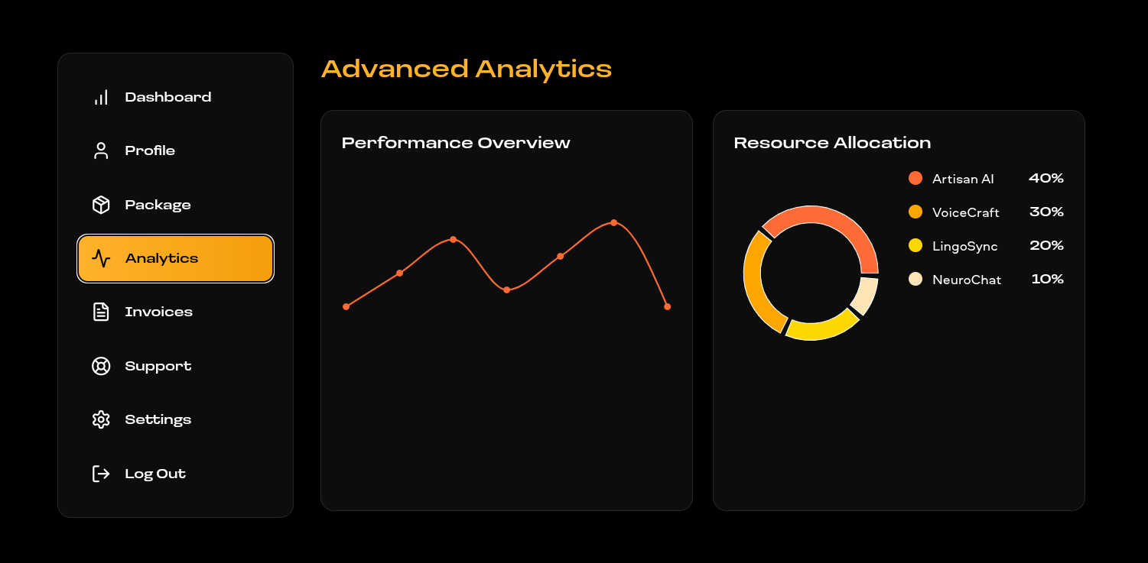
Explanation:
This screen represents the Analytics page of the AItopia Dashboard, where users can monitor platform performance, usage trends, and AI tool resource distribution through visual analytics and performance insights. The page is designed to provide a centralized overview of analytical information using an organized, modern, and data-driven interface.
The left sidebar serves as the dashboard navigation panel, offering quick access to sections such as Dashboard, Profile, Package, Analytics, Invoices, Support, Settings, and Logout. The Analytics option is highlighted, indicating that the user is currently viewing the analytics management section.
The main content area presents Advanced Analytics, providing users with visual representations of system performance and resource allocation. These analytical components help users understand platform activity, usage patterns, and AI service distribution.
The Performance Overview section displays a graphical trend analysis using a line chart. This chart represents changes in system activity, tool usage, or performance metrics over a period of time. Visual performance monitoring allows users to quickly observe fluctuations, growth patterns, and overall operational behavior of the platform.
Another important component is the Resource Allocation section, which uses a circular chart to display the distribution of resources among different AI tools available within the platform. The chart presents allocation percentages for tools such as Artisan AI, VoiceCraft, LingoSync, and NeuroChat, helping users understand how platform resources or usage capacity are distributed across services.
The page follows AItopia’s dark-themed dashboard design, featuring responsive layouts, interactive visual elements, modern typography, and clean spacing to improve readability and user experience across different screen sizes.
The analytics interface supports better decision-making by allowing users to analyze platform behavior, monitor performance indicators, and understand AI tool utilization through clear visual reporting.
Overall, the AItopia Analytics Dashboard page provides a structured environment for viewing analytical insights, tracking performance trends, and monitoring resource allocation, helping users gain a deeper understanding of platform activity and AI service performance.

5.5.15 Advanced Analysis Page
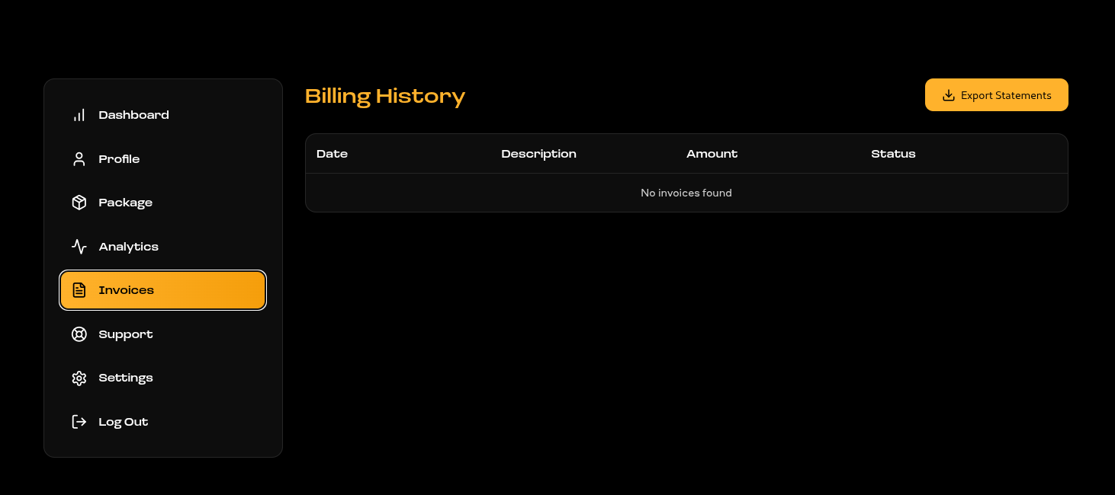
Explanation:
This screen represents the Invoices page of the AItopia Dashboard, where users can manage, review, and export their billing and payment records related to AI tool subscriptions and service plans. The page is designed with a clean dashboard layout that provides easy access to financial and account-related information.
The left sidebar functions as the main navigation menu, allowing users to move between sections such as Dashboard, Profile, Package, Analytics, Invoices, Support, Settings, and Logout. In this view, the Invoices option is highlighted, indicating that the user is currently accessing the billing management section.
The main content area displays the Billing History section, which is used to present a structured overview of payment transactions and invoice records. The billing table is organized into columns including Date, Description, Amount, and Status, allowing users to track subscription charges, payment details, and invoice conditions in an easy-to-read format.
In the example shown, the system displays a “No invoices found” message, indicating that no billing transactions or generated invoices are currently available for the user account. This empty-state feedback ensures transparency and informs users about the current billing status of their account.
An important feature of this page is the “Export Statements” button positioned in the top-right corner. This functionality allows users to download or export billing records and payment statements for financial tracking, reporting, or documentation purposes.
The interface follows AItopia’s modern dark-themed dashboard design, using organized spacing, responsive layouts, clear typography, and highlighted navigation elements to improve usability and maintain a consistent user experience throughout the platform.
The invoices module plays an important role in helping users monitor subscription expenses, access billing information, and manage financial records related to AI tool usage and premium service plans.
Overall, the AItopia Invoices page provides a dedicated environment for viewing billing history, managing invoice data, and exporting financial statements, contributing to better account management and user transparency within the platform.

5.5.16 Advanced Analysis Page

Explanation:
This screen represents the Settings page of the AItopia Dashboard, where users can customize application preferences, manage notification settings, and control account security options. The page is designed to provide a centralized environment for configuring user-specific system settings and maintaining account management features.
The left sidebar acts as the dashboard navigation panel, allowing users to access sections such as Dashboard, Profile, Package, Analytics, Invoices, Support, Settings, and Logout. In this screen, the Settings option is highlighted, indicating that the user is currently working within the system configuration module.
The main section contains a Preferences panel, which allows users to personalize their application experience. Users can choose between different display modes such as Light, Dark, and System Theme. This feature enables customization of the interface appearance according to user preference or device configuration, improving comfort and accessibility.
The settings page also provides Notification Management options. Users can control communication preferences through configurable switches for Email Notifications, Push Notifications, and SMS Alerts. These settings allow users to manage how they receive updates related to account activity, platform announcements, tool updates, or system events.
Another major section of the page is Account Security, which focuses on protecting user credentials and maintaining secure access to the platform. Users can update their account password by entering a new password and confirming the password before submitting the request using the Update Password button. This functionality helps maintain account protection and enhances overall platform security.
Overall, the AItopia Settings page provides essential tools for system personalization, notification configuration, account security management, and user data control, contributing to a secure, flexible, and customizable platform environment.

5.5.17 Support Page
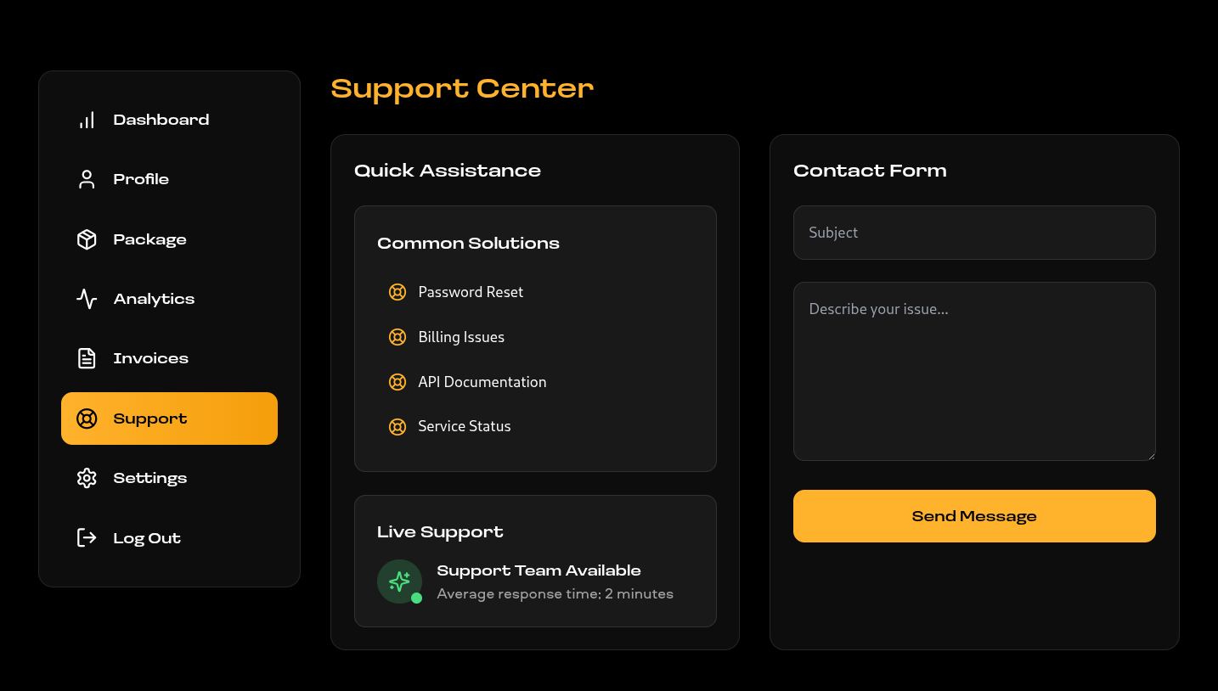

This screen represents the Support page of the AItopia Dashboard, where users can access assistance resources, find common troubleshooting solutions, and contact the support team for technical or account-related issues. The page is designed to provide a centralized help environment that improves user support accessibility and communication.
The left sidebar functions as the dashboard navigation panel, allowing users to navigate between different modules such as Dashboard, Profile, Package, Analytics, Invoices, Support, Settings, and Logout. In this screen, the Support option is highlighted, indicating that the user is currently working within the support management section of the platform.
The main area contains a Quick Assistance section that provides users with frequently used help resources and common issue categories. This panel includes solutions related to Password Reset, Billing Issues, API Documentation, and Service Status. These options help users quickly identify and resolve common problems without requiring direct support interaction.
The page also includes a Live Support section that informs users about the availability of the support team. It displays support status information along with the estimated response time, giving users a clear understanding of support accessibility and expected communication speed.
Another major component of the page is the Contact Form, which enables users to directly submit issues or inquiries to the support team. Users can enter a subject and provide a detailed description of their issue before submitting the request using the Send Message button. This functionality allows structured communication between users and the AItopia support system.
Overall, the AItopia Support page provides an integrated environment for troubleshooting assistance, help resource access, live support availability, and direct issue reporting, contributing to improved user experience, effective problem resolution, and reliable platform support management.

5.5.18 Profile Page

This screen represents the Profile page of the AItopia Dashboard, where users can manage personal account information, view account details, and monitor account security status. The page is designed to provide a dedicated environment for profile customization, identity management, and account information tracking.
The left sidebar serves as the main dashboard navigation panel, allowing users to access modules such as Dashboard, Profile, Package, Analytics, Invoices, Support, Settings, and Logout. In this screen, the Profile option is highlighted, indicating that the user is currently working within the profile management section.
The main profile section allows users to manage their personal identity information. Users can view and update their profile picture and modify their displayed full name through an editable input field. The Save Changes button enables users to submit updated profile information, ensuring that account details remain accurate and personalized.
Another important part of the page is the Account Details panel, which presents essential account-related information in a structured format. This section displays details such as Full Name, Email Address, Last Login Activity, and Two-Factor Authentication (2FA) status. These details help users monitor account information and maintain awareness of recent account activity.
The page also includes a visible Security Status indicator, which provides users with a quick overview of the health and protection level of their account. Features such as 2FA status monitoring and login tracking contribute to improving account security and user confidence.
Overall, the AItopia Profile page provides a centralized interface for profile management, account detail viewing, identity customization, and security monitoring, contributing to a secure, personalized, and user-friendly dashboard experience.

Chapter 6
TESTING
6.1 Introduction to Testing:
Testing is an essential phase of software development that ensures the AItopia platform functions correctly and delivers a reliable user experience. Since AItopia is an AI-tool discovery and management platform, testing helps verify that all modules perform as expected and that users can interact with the system without errors or unexpected behavior.
In the AItopia project, testing is carried out to validate features such as user signup, secure login, AI tools browsing, category filtering, dashboard operations, package selection, analytics monitoring, invoice viewing, and system settings management. Each module is tested to confirm that it generates the correct output for different types of user interactions.
The main objective of testing in this project is to ensure that the application behaves correctly under different scenarios. Valid inputs should produce successful operations, while invalid or missing inputs should generate meaningful error messages. This improves platform usability, reliability, and overall user satisfaction.
Testing in this project is mainly performed using manual testing techniques, where features are tested by interacting with the application through the browser and observing outputs. This approach is suitable for validating user interface behavior, dashboard navigation, authentication workflows, and data handling processes.
Testing is performed throughout the development cycle rather than only after development is completed. Individual modules such as authentication, dashboard, packages, analytics, and settings are tested separately and then verified together to ensure smooth interaction between components.

6.1.2 Testing Strategies
The testing strategy for the AItopia system is designed to ensure that all functionalities operate properly and provide a smooth user experience. Since AItopia is a modern web-based application, testing focuses on user interaction, interface responsiveness, authentication flow, dashboard features, and system stability.
The testing process follows a structured approach where individual modules are first tested independently and then tested together as a complete application. This helps identify issues early and ensures proper integration between different components.
Key areas included in the testing strategy are:
- User registration and secure login
- AI tools browsing and category filtering
- Dashboard navigation and profile management
- Package selection and subscription handling
- Analytics and billing modules
- Settings and account security operations
Input validation testing is also performed by supplying valid and invalid values, such as incorrect login credentials, empty fields, and invalid account details. This ensures the system handles incorrect inputs properly and displays appropriate messages.
The application is additionally tested for end-to-end functionality, where complete user flows are verified. For example, a user registers, logs in, browses AI tools, accesses the dashboard, selects a package, reviews analytics, and updates settings.
Basic security testing is also included to ensure unauthorized users cannot access protected dashboard pages. Only authenticated users can access private dashboard functionality.

6.1.3 Types of Testing
Different types of testing are performed in the AItopia project to ensure reliability, security, and smooth operation.

Functional Testing
Functional testing verifies that all major features work correctly. Modules such as signup, login, AI tools listing, package management, analytics, invoices, and settings are tested to ensure expected functionality.

Validation Testing
Validation testing checks how the system behaves when incorrect inputs are provided. Examples include invalid login credentials, empty signup fields, mismatched passwords, and incorrect account data. The application should handle such situations gracefully.

Integration Testing
Integration testing verifies that different modules communicate correctly. For example, after login, users should be able to access dashboard modules, browse tools, view packages, and manage settings without issues.

System Testing
System testing evaluates the application as a complete system. Entire workflows are tested from beginning to end to confirm that all modules function together correctly.

Security Testing
Security testing ensures protected routes, authenticated access, secure password handling, and restricted dashboard functionality operate properly.
Overall, these testing methods help ensure that AItopia is stable, secure, responsive, and user-friendly.

6.1.4 Test Phases

🔹 Phase 1: Test Planning
In this phase, the testing process is planned and testing objectives are identified. Major modules of the system such as authentication, AI tools management, dashboard features, analytics, packages, invoices, and settings are selected for testing.

🔹 Phase 2: Unit Testing
Individual components are tested separately to ensure they work independently.
Examples:
- Signup form validation
- Login authentication logic
- Tools filtering functionality
- Dashboard component rendering
- Settings update operations
This helps identify issues early in development.

🔹 Phase 3: Integration Testing
After testing individual modules, components are tested together to verify interaction between them.
Examples:
- Login → Dashboard navigation
- Dashboard → Package selection flow

🔹 Phase 4: System Testing
In this phase, the complete AItopia application is tested as a fully integrated system.
Complete user workflows are verified, such as:
- User registration and login
- Browsing AI tools
- Filtering categories
- Accessing dashboard modules
- Selecting subscription packages
- Viewing analytics and invoices
- Updating account settings
This confirms that the application functions correctly as a whole.

🔹 Phase 5: Validation Testing
This phase focuses on checking system behavior for invalid inputs and unexpected conditions.
Examples include:
- Incorrect email/password during login
- Empty required fields
- Invalid form submissions
- Unauthorized dashboard access attempts
The system should respond with clear feedback without crashing.

🔹 Phase 6: Result Evaluation
In the final phase, actual outputs are compared with expected results. Successfully passed test cases confirm that the application behaves correctly and meets project objectives.
6.2 Test Cases and Results
Test Case 1: User Registration
Test Case ID | TC-01
Module | User Registration
Objective | Verify that a new user can register successfully
Input | Valid full name, email address, and password
Expected Result | User account should be created successfully
Actual Result | User registration completed successfully
Status | Passed

The test was performed on the AItopia Signup page. The user entered valid registration details including Full Name, Email, and Password using the Power Signup form. After submitting the form through the “Create Warp Drive” button, the system successfully processed the request and created the user account.

Test Case 2: User Login
Test Case ID | TC-02
Module | User Login
Objective | Verify that registered users can log in
Input | Valid email and password
Expected Result | User should access dashboard/home page
Actual Result | Login successful
Status | Passed

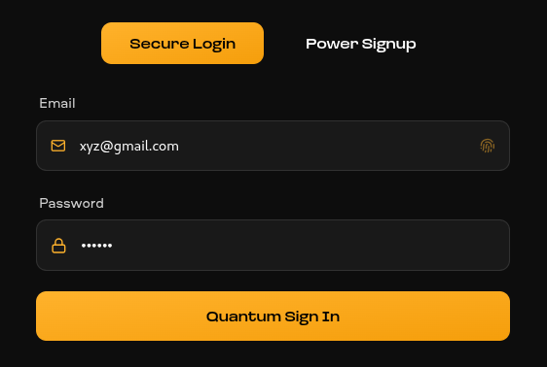

Name of User will be shown here

Test Case 3: Authentication
Test Case ID | TC-03
Module | Authentication
Objective | Verify system behaviour for invalid login
Input | Incorrect password
Expected Result | Error message should appear
Actual Result | Invalid credentials message displayed
Status | Passed

Proof with Wrong Password

Test Case 4: Connect Page
Test Case ID | TC-04
Module | Connect Page
Objective | Verify that users can successfully submit a message through the Connect page
Input | Valid Name, Email, and Message details
Expected Result | Contact request/message should be submitted successfully
Actual Result | Message submitted successfully through the Connect form
Status | Passed

Proof

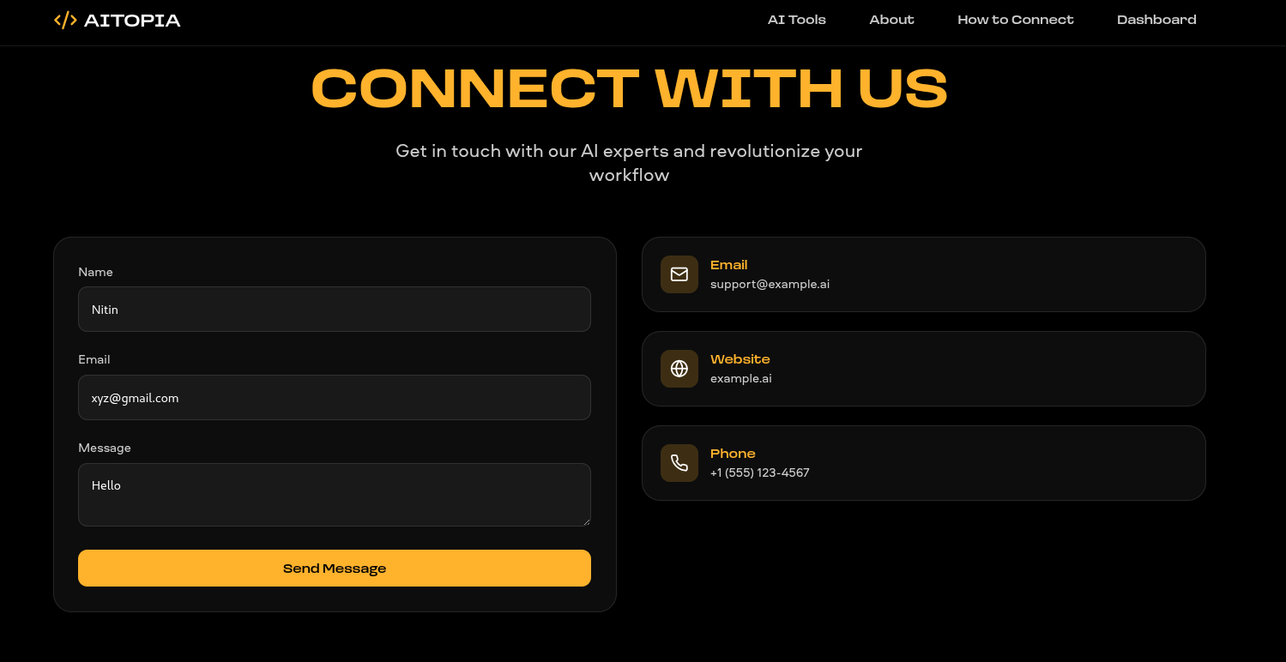

Test Case 5: Package Purchase & Payment Integration (Razorpay Test Mode)
Test Case ID | TC-05
Module | Package Purchase & Payment
Objective | Verify that a user can successfully select an AI package and complete payment using Razorpay Test Mode
Input | User selects Professional Package ($49/month) and performs payment using Razorpay test credentials
Expected Result | Selected package should be purchased successfully and payment status should be updated
Actual Result | Package purchase completed successfully and payment processed through Razorpay Test Mode
Status | Passed

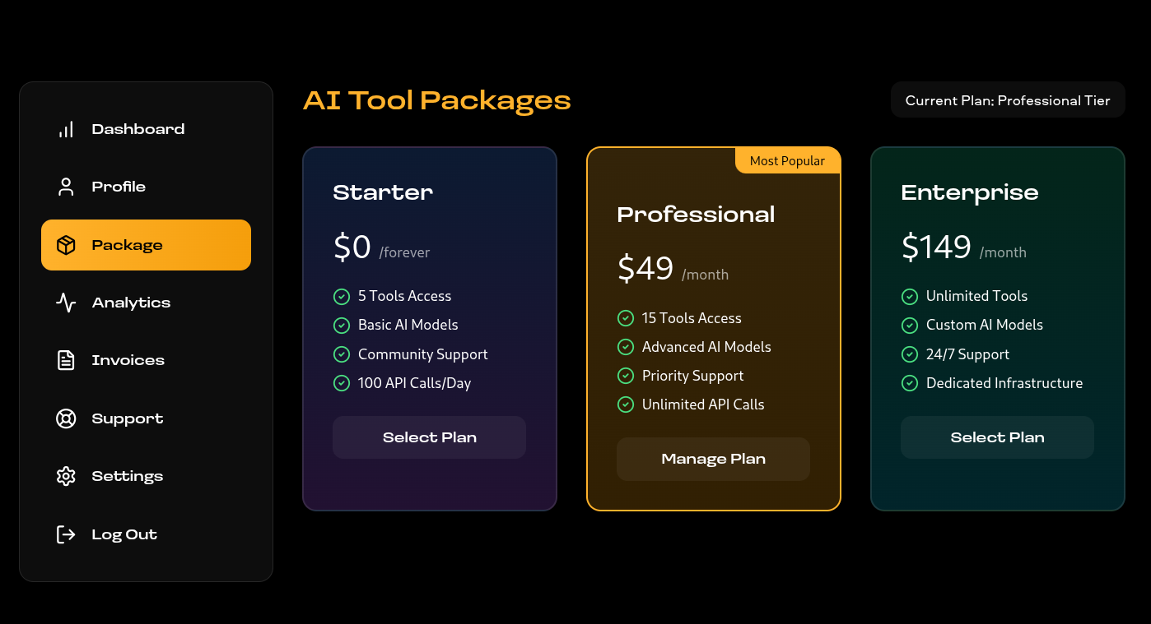

6.2.1 Result Analysis
The result analysis phase is used to evaluate the outcomes of all test cases performed on the AItopia system. During this phase, the actual outputs generated during testing are compared with the expected outputs to verify whether the application is functioning correctly and meeting its intended objectives.
During testing, the major functionalities of the system such as user registration, secure login, AI tool browsing, package selection, dashboard operations, analytics display, contact form submission, and payment processing using Razorpay Test Mode were executed successfully. The application responded correctly to valid inputs and produced the expected results for each operation. This confirms that the core features of the AItopia platform are working properly.
The system was also tested using invalid inputs, including incorrect login credentials, empty form fields, invalid user details, and improper payment scenarios. In these cases, the application handled the inputs effectively by displaying appropriate validation and error messages without crashing or causing unexpected behavior. This demonstrates that proper validation and error-handling mechanisms are implemented throughout the platform.
Integration testing results showed that different modules of the application are well connected and operate smoothly together. Users were able to register accounts, log in securely, explore AI tools, select subscription packages, complete payments, access dashboard functionalities, and manage settings without issues. This confirms that the data flow between different modules is reliable and consistent.
The performance of the system was also found to be satisfactory during testing. The application responded efficiently to user actions, page navigation, dashboard interactions, and payment operations. No major delays, failures, or system instability were observed under normal usage conditions.
Overall, the testing results indicate that AItopia is a stable, responsive, and functional AI platform that successfully delivers its intended features and user experience.

CHAPTER 7
Results and Discussion
7.1 Introduction to Results and Discussion:
This chapter presents the results obtained from the development and testing of the AItopia platform and provides a detailed discussion of its performance, usability, and functionality. After designing and implementing the system, it is important to evaluate how effectively the platform operates in real-world scenarios and whether it satisfies the objectives defined at the beginning of the project.
The main purpose of this chapter is to analyze the outputs generated by the application and understand how efficiently it performs different operations. This includes examining how the system responds to user interactions, how accurately it handles data, and how smoothly it manages features such as authentication, AI tool browsing, category filtering, and subscription access.
In addition to analyzing outputs, this chapter also focuses on evaluating the overall system performance. Factors such as response time, system stability, navigation simplicity, and ease of use are considered to determine whether the application provides a reliable and user-friendly experience.
Another important aspect covered in this chapter is the discussion of results in relation to project objectives. The system is evaluated to determine how effectively it solves the problem of discovering AI tools by providing organized categorization, modern user authentication, subscription management, and an accessible user interface.
Overall, this chapter highlights the strengths of the AItopia platform and provides insights into its practical implementation and overall effectiveness.
7.2 System Execution Overview:
The AItopia platform is designed as a modern web-based application that allows users to browse, explore, and access AI tools through a browser interface. When the application is executed, users can access the system through the home page and interact with different features available within the platform.
The execution flow begins when a visitor opens the application and navigates through pages such as the homepage, AI tools page, category filters, pricing sections, and authentication pages. Users can explore available tools without difficulty using the navigation system.
Users who want personalized access can register as new users or log in using existing credentials. After successful authentication, users gain access to features related to their account, subscriptions, or premium content.
The next stage involves browsing AI tools. Users can search or filter tools based on categories such as Generative AI, Development, Productivity, Image, Video, Audio, and Writing. The platform retrieves relevant information and displays tools in a structured and visually organized layout.
During user interaction, the system processes requests, retrieves data from the database, and displays outputs efficiently. Category filtering, navigation actions, and authentication operations are performed dynamically to ensure a smooth user experience.
From the administrative perspective, the execution flow includes managing platform content, tool information, user records, categories, and subscription-related data. System data is stored and managed using the backend database structure.

7.3 Output Analysis
The output analysis of the AItopia platform focuses on examining the results generated by the application in response to different user activities. The goal is to determine whether the system produces accurate, consistent, and user-friendly outputs.

The output analysis of the AItopia platform focuses on examining the results generated by the application in response to different user activities. The goal is to determine whether the system produces accurate, consistent, and user-friendly outputs.
During AI tool exploration, users can browse categories and view structured information about available tools. The output is displayed using organized cards, categories, descriptions, and access information, making it easy for users to understand and navigate the platform.
The authentication process also produces clear outputs. When registration or login is successful, the system grants account access and maintains the user session properly. In cases of authentication failure, users are informed through clear system feedback.
Additionally, category-based browsing generates filtered outputs. When users select a category, the system displays relevant tools belonging to that section, ensuring that users can quickly discover suitable AI solutions.
Overall, the system generates clean, accurate, and responsive outputs that improve usability and provide a consistent user experience.

7.4 Functional Results
The functional results of the AItopia platform describe how effectively each feature of the application performs during testing and practical usage. The system was developed with multiple functionalities such as user authentication, AI tool browsing, category filtering, subscription handling, and responsive navigation.
Each feature was tested to ensure correct behavior and expected system responses.
The user registration and login functionality worked successfully during testing. New users were able to register using valid information, and login operations authenticated users properly. Invalid login attempts displayed suitable validation messages.
The AI tools browsing feature also performed as expected. Users could browse through different categories, explore tool cards, and access structured tool information. Category filtering displayed accurate results without navigation issues.
The category management functionality operated correctly. Users were able to switch between categories such as Development, Productivity, Audio, Video, Image, and Generative AI, and the platform displayed matching content appropriately.
The subscription and access functionality worked successfully during implementation. Premium tools and access levels were displayed correctly according to available plans and feature conditions.
From the system management perspective, database operations and session handling functioned effectively. User data, signup information, authentication sessions, categories, and related records were processed correctly and maintained consistently.

7.5 User Interface Evaluation
The user interface of the AItopia platform plays an important role in delivering a modern, smooth, and engaging user experience. A well-designed interface makes it easier for users to discover AI tools and interact with the system without confusion.
The layout of the platform is clean, organized, and visually appealing. Important features such as navigation menus, AI tool categories, login, signup, and filtering sections are clearly visible and accessible. Proper spacing, typography, buttons, and component organization help users understand the interface quickly.
The navigation structure of the application is simple and user-friendly. Users can easily move between pages such as Home, AI Tools, About, Login, and category sections without difficulty. This smooth navigation improves overall usability.
The system also provides clear feedback to users during different operations. For example, successful login, registration, category selection, and access actions display appropriate system responses. Error messages are shown whenever invalid data or authentication issues occur.
Responsiveness is another important aspect of the interface. The application is developed using responsive web technologies, allowing it to adapt effectively across different screen sizes and devices. This ensures that the platform remains usable on desktops, tablets, and other supported devices.
Overall, the user interface evaluation demonstrates that AItopia provides a simple, modern, and efficient interface that enhances usability, accessibility, and overall user satisfaction.

7.6 Performance Evaluation
The performance evaluation of the AItopia platform focuses on how efficiently the application responds to user interactions and manages different operations. A well-performing system should be fast, stable, and capable of processing requests smoothly without delays or unexpected errors. During testing, the platform was evaluated based on response time, system stability, database performance, and overall user experience.
One of the key aspects of performance is response time. The platform responded quickly to user actions such as signup, login, navigating between pages, and browsing AI tools. Pages loaded within an acceptable time range, and there were no major delays during normal usage. This indicates that the application is optimized for standard user operations.
Another important factor is system stability. During testing, the system remained stable while handling various operations such as user authentication, category filtering, session management, and page navigation. Users were able to interact with the platform without crashes or unexpected behavior, demonstrating system reliability.
The performance of database operations was also satisfactory. Data such as user details, session records, category information, payment data, and authentication records were stored and retrieved efficiently. Database queries executed properly, ensuring smooth data access and improved user experience.
Another important aspect is data retrieval efficiency. Features such as AI tool listing, category filtering, and user session handling depend on retrieving stored data. During testing, these operations were performed efficiently, and the system displayed results quickly and accurately.
Since the system was tested using a moderate amount of data and normal usage conditions, the application performed well during evaluation. However, performance under very high traffic conditions or extremely large datasets was not fully tested because of project scope limitations.

7.7 Database Performance
The database plays a crucial role in the AITOPIA system, as it is responsible for storing and managing all the data related to users, AI tools, projects, analytics, and platform activities. The performance of the database was evaluated based on how efficiently it handles data storage, retrieval, updates, and real-time processing during system operations.
During testing, the database performed efficiently while handling different types of user requests and AI tool operations. When users accessed tools such as Artisan AI, VoiceCraft, LingoSync, and TextGenix, the system was able to quickly retrieve the required information and display results without noticeable delay. This demonstrates that the database is properly optimized and supports fast data access.
The insertion of data, such as user registration details, login information, project records, generated content, and analytics reports, was handled smoothly. Whenever users created new projects or interacted with AI tools, the system successfully stored all related information in the database without errors. Similarly, updates such as profile modifications, project changes, and dashboard activities were processed correctly and reflected immediately in the system.
The database design uses relational tables with proper relationships to maintain data consistency and integrity. Different entities such as users, projects, AI tools, analytics, and activity logs are connected through structured relationships, ensuring secure and accurate data management throughout the platform.

7.8 Security Evaluation
Security is an important aspect of any modern web application, especially when it involves user authentication, payment handling, and account management. In the AItopia platform, several security measures are implemented to ensure that user data is protected and that only authorized users can access restricted functionalities.
One of the main security features of the platform is user authentication. Users are required to sign in using valid credentials before accessing protected sections of the application. The login system verifies user information, and access is granted only after successful validation. This prevents unauthorized access to user accounts.
The system also implements session management and access control. Different levels of access are maintained for authenticated users and general visitors. Protected routes and authenticated sessions help ensure that sensitive operations remain secure.
Another important security feature is password protection. User passwords are securely handled and protected within the authentication system. This improves data privacy and reduces risks associated with unauthorized credential exposure.
The application also includes input validation and data verification to prevent incorrect, incomplete, or harmful data submissions. Form validation helps ensure that only properly formatted information is accepted, reducing potential security vulnerabilities.
Although the platform provides essential security mechanisms, advanced security features such as full-scale penetration testing, advanced encryption strategies, and enterprise-level threat protection were not implemented due to project scope limitations.

7.9 Result Summary
The results obtained from the development and testing of the AItopia platform demonstrate that the application functions successfully and meets the primary objectives defined at the beginning of the project. Major functionalities such as user signup, login, AI tool browsing, category management, session handling, and responsive navigation were implemented and tested effectively.
The system generated accurate outputs for valid inputs and handled invalid inputs properly by displaying suitable validation and error messages. This confirms that the validation and error-handling mechanisms operate correctly.
The user interface was found to be clean, simple, and easy to use, which improves the overall user experience. Users were able to navigate through different sections of the application smoothly without confusion.
From a database perspective, data storage and retrieval were handled efficiently, ensuring that user records, sessions, categories, payments, and authentication data were maintained properly.
Security features such as authentication, access control, session handling, and input validation were also implemented successfully, contributing to platform reliability and user trust.

7.10 Discussion
The development and evaluation of the AItopia platform show that it successfully addresses the need for a centralized and user-friendly AI tools discovery platform. Many existing approaches require users to search across multiple sources to find suitable AI tools. In contrast, AItopia provides a structured environment where users can explore categorized AI solutions efficiently.
Another important aspect is the organization and automation of platform functionality. Features such as category management, user authentication, session handling, and structured database operations reduce manual complexity and ensure efficient data management.
The implementation of features such as AI tool categorization, responsive design, authentication flows, and protected access improves usability and platform efficiency. Similarly, proper database management contributes to maintaining reliable system performance.
However, the platform also has some limitations. It currently does not include advanced features such as personalized AI recommendations, real-time analytics dashboards, advanced payment workflows, or large-scale performance testing under heavy traffic conditions. These limitations are mainly due to the scope and timeline of the project.
Despite these limitations, the AItopia platform successfully achieves its main goal of providing a functional, organized, and scalable AI tools platform with a modern user experience and a strong foundation for future enhancements.
Chapter 8
Conclusion and Future Scope
8.1 Conclusion:
The AItopia project was developed with the aim of creating a modern, efficient, and user-friendly platform that allows users to discover, explore, and access various AI tools from a single web-based system. Throughout the development process, the focus was on designing a platform that simplifies tool discovery, improves accessibility, and provides a clean and engaging user experience.
The system successfully implements the major functionalities required for an AI tools platform. Users can easily browse AI tools, explore categories, view tool information, create accounts, sign in securely, and access premium features through subscription plans. The platform organizes AI resources in a structured manner, making it easier for users to find tools related to development, productivity, image generation, writing, audio, and other domains.
The use of modern technologies such as Next.js, React, Tailwind CSS, MySQL, Prisma ORM, and NextAuth authentication helped in building a scalable and reliable application. The implementation of secure authentication, protected routes, responsive design, and database management ensured proper separation of concerns and maintainable system architecture.
During testing, the core functionalities of the platform were verified, and the application performed as expected. The interface responded efficiently, data handling remained consistent, and user authentication and navigation worked smoothly under normal operating conditions.
Although the system has some limitations, it successfully achieves the main objectives of the project. It demonstrates how a web-based solution can improve traditional reservation systems by making them more efficient, accessible, and user-friendly.
Although the project has certain limitations, it successfully achieves its primary objective of creating a centralized AI tools discovery platform. It demonstrates how a modern web application can simplify access to AI technologies while maintaining usability, scalability, and structured information management.

8.2 Limitations of the Project:
Although the AItopia system successfully implements its core functionalities, there are certain limitations due to development scope and project constraints.
One limitation is that some tools displayed on the platform may use static or demonstration data rather than fully integrated third-party AI APIs. While this is sufficient for showcasing platform functionality, real-world deployment would require deeper API integrations with AI providers.
Another limitation is the absence of a fully personalized recommendation system. Currently, users can browse tools by categories, but the platform does not yet provide intelligent recommendations based on user preferences, activity history, or behavior analysis.
The system has also been tested under limited deployment conditions, mainly with moderate traffic and sample datasets. It has not been extensively evaluated for very high user loads, concurrent API requests, or enterprise-scale performance scenarios.
In addition, although the user interface is modern and responsive, the platform currently lacks certain advanced features such as dark/light theme customization, advanced filtering, bookmarking tools, and personalized dashboards, which could further improve user experience.
Lastly, the project does not currently include advanced analytics, AI-powered search optimization, or complete integration with all external AI providers. These features could make the platform more intelligent, interactive, and suitable for commercial deployment.
Despite these limitations, the project successfully demonstrates the key concepts of a scalable AI tools discovery platform and provides a solid base for future development.

8.3 Future Enhancements
Although AItopia successfully implements the essential functionalities of an AI tools platform, there are several opportunities for future improvement and expansion.
One major enhancement would be the integration of real-time AI provider APIs. Future versions can connect directly with platforms such as OpenAI, Anthropic, Google AI, or other providers to allow users to interact with AI tools directly within the application.
Another important enhancement is the implementation of a personalized recommendation system. By analyzing user behavior, search history, and interests, the platform could recommend relevant AI tools to improve discovery and engagement.
The system can also be extended by developing a mobile application. With the increasing use of smartphones, a mobile app would make the platform more accessible and convenient, allowing users to discover and access AI tools anytime and anywhere.
In addition, features such as advanced search and filtering can be introduced. Users could search tools based on categories, pricing, popularity, ratings, supported platforms, or specific AI capabilities, improving usability and navigation.
Performance enhancements can also be considered in future development. The system can be optimized to handle larger traffic volumes by implementing database optimization, caching strategies, API rate limiting, and scalable deployment infrastructure.
Another possible improvement is the addition of multi-language support, which would make the platform accessible to users from different regions and increase global usability.
Advanced features such as user reviews and ratings, bookmarking favorite tools, analytics dashboards, subscription management, email notifications, and admin reporting systems can also be introduced to make the platform more feature-rich and commercially viable.

References / Bibliography

References
- Next.js Official Documentation, “Next.js Documentation.” [Online].
Available: https://nextjs.org/docs
- React Official Documentation, “React Documentation.” [Online].
Available: https://react.dev
- Tailwind CSS Documentation, “Tailwind CSS Documentation.” [Online].
Available: https://tailwindcss.com/docs
- TypeScript Documentation, “TypeScript Documentation.” [Online].
Available: https://www.typescriptlang.org/docs/
- MySQL Official Documentation, “MySQL 8.0 Reference Manual.” [Online].
Available: https://dev.mysql.com/doc/
- Prisma ORM Documentation, “Prisma Documentation.” [Online].
Available: https://www.prisma.io/docs
- NextAuth.js Documentation, “Authentication for Next.js.” [Online].
Available: https://next-auth.js.org/
- Vercel Documentation, “Vercel Platform Documentation.” [Online].
Available: https://vercel.com/docs
- ShadCN UI Documentation, “ShadCN/UI Documentation.” [Online].
Available: https://ui.shadcn.com/docs
- Stripe Documentation, “Stripe API Documentation.” [Online].
Available: https://stripe.com/docs
- OpenAI API Documentation, “OpenAI Developer Documentation.” [Online].
Available: https://platform.openai.com/docs
- MDN Web Docs, “Web Development Documentation.” [Online].
Available: https://developer.mozilla.org/
- GeeksforGeeks, “Web Development and Database Concepts.” [Online].
Available: https://www.geeksforgeeks.org
- Robin Wieruch, The Road to React, Self-Published, Latest Edition.
- Lee Robinson, Next.js Best Practices and Full-Stack Development Resources, Vercel Publications.

