CHAPTER – 1
INTRODUCTION TO PROJECT
  - About Project:
GoReserve is a web-based bus reservation system that offers a simple, efficient, and user-friendly way to book bus tickets online. The main goal of the project is to replace the traditional offline ticket booking process with a digital solution that saves time and cuts down on manual work.
Users can register, log in securely, and search for available buses by entering their start and end points. After picking a suitable bus, users can book tickets by entering passenger details. Once the booking is confirmed, they can view their booking history in a clear ticket format. The system also includes a cancellation feature, allowing users to cancel tickets and get a notification about the refund process.
On the admin side, the system has a panel that lets administrators manage buses and users easily. Admins can add new buses, view existing bus details, and maintain control of the overall system.
The project uses modern technologies like Spring Boot for backend development, Thymeleaf for frontend rendering, and MySQL for database management. It implements security with Spring Security to ensure safe authentication and role-based access control.
GoReserve follows the MVC (Model-View-Controller) architecture, which helps organize the code and improve maintainability. The system is designed to be responsive and user-friendly, with additional features like dark mode to enhance the user experience.
Overall, GoReserve shows how modern web technologies can create a reliable and efficient online reservation system.
  - Problem with Existing System:
Many bus ticket booking systems still rely on manual processes or outdated platforms. This creates challenges for both passengers and service providers. Traditional ticket booking methods force users to visit ticket counters in person. This leads to long lines, wasted time, and frustration. There is also a higher chance of human errors in keeping records, which can cause incorrect bookings or data loss.
Current systems often don’t have user-friendly interfaces or real-time information. This makes it hard for users to find buses based on their preferred routes. Managing bookings, cancellations, and payments manually becomes complicated and inefficient. Users also struggle to access their booking history or get timely updates about their tickets.
From the administrative side, managing bus details, user data, and bookings without a centralized system is time-consuming and error-prone. There is also a lack of secure authentication systems, leading to unauthorized access and data security problems
There is a need for a reliable, secure, and easy-to-use online bus reservation system. This system should automate the booking process, lower manual effort, and improve service for users. It should allow for easy searching, booking, cancellation, and management of tickets while ensuring data accuracy and security.
GoReserve has been developed to tackle these challenges and provide a digital solution that streamlines bus reservation management.
  - Key Benefits:
The GoReserve system offers several important benefits for users and administrators by improving the bus reservation process.
One main advantage is time efficiency. Users can book tickets online from anywhere, eliminating the need to visit a ticket counter. This saves time and effort. The system also provides easy access to information, letting users quickly search for buses based on their starting point and destination.
Another key benefit is accuracy and reliability. The automated system reduces human errors in booking and record management. All booking details are stored securely in the database, making it simple to retrieve information when needed.
The project ensures secure authentication using Spring Security, which protects user data and prevents unauthorized access. The system also includes a booking history feature, allowing users to view their past and current bookings in a clear ticket format.
For administrators, the system simplifies management tasks, such as adding buses and monitoring user activity. This leads to better control and improved efficiency in handling operations.
Features like ticket cancellation with refund notifications and a user-friendly interface with dark mode further improve the user experience.
Overall, GoReserve makes the bus reservation process faster, more secure, and more convenient.

  - Various Functionalities of Project:
The GoReserve project stands out from basic bus reservation systems due to several unique design choices and user-focused features. These enhancements improve both system performance and user experience.

1.4.1 Simplified Database Design
One of the most important unique aspects of this project is the absence of a separate route table. Instead of creating an additional entity for routes, the system directly stores source and destination information within the Bus and Booking data. This approach simplifies the database structure, reduces complexity, and makes data handling more efficient while still supporting effective bus search functionality.

1.4.2 Ticket-Style Booking Interface
The project provides a ticket-style layout for displaying booking history. Instead of showing plain text records, bookings are presented in a structured format similar to real bus tickets. This improves readability and gives users a more interactive and realistic experience.

1.4.3 Role-Based Authentication and Redirection
GoReserve implements a secure login system using role-based authentication. After logging in, users are redirected to different pages based on their roles. Admins are directed to the admin dashboard, while normal users are redirected to the user interface. This ensures proper access control and enhances system security.

1.4.4 Cancellation
The system includes a user-friendly ticket cancellation feature. When a user cancels a booking, a clear message is displayed stating that the refund will be processed within a specific time period. This feature improves transparency and builds user trust in the system.

1.4.5 Dark Mode Feature
A modern dark mode option is included to enhance user experience. It allows users to switch between light and dark themes based on their preference, making the interface more comfortable to use, especially in low-light conditions.

1.4.6 Responsive and User-Friendly Design
The system is designed to be responsive and easy to use across different devices. The clean layout, intuitive navigation, and well-structured pages ensure that users can interact with the system smoothly without confusion.
  - Objectives of Project:
The primary objective of the GoReserve project is to design and develop a reliable, efficient, and user-friendly web-based bus reservation system that simplifies the entire process of ticket booking and management. The system aims to transform the traditional manual booking method into a modern digital platform that is accessible anytime and from anywhere.
One of the key objectives of this project is to provide users with a simple and efficient bus search functionality, where they can easily find available buses by entering their source and destination. This helps users save time and reduces the effort required to gather travel information.
Another important objective is to enable users to book tickets online in a secure and convenient manner. The system allows users to enter passenger details, confirm bookings, and access their booking information at any time. It also provides a booking history feature, which helps users keep track of their previous and current reservations in an organized ticket format.
The project also focuses on implementing a secure authentication and authorization system using Spring Security. This ensures that user data is protected and access to system features is controlled based on roles such as admin and user. Maintaining data privacy and system security is one of the core goals of this project.
From an administrative perspective, the system aims to simplify management operations. Admins can easily add new buses, view existing records, and manage users efficiently through a centralized platform. This reduces manual work and minimizes the chances of errors.
Additionally, the project aims to improve overall user experience by providing features like easy ticket cancellation with refund notification, a responsive interface, and dark mode support.
Overall, the objective of GoReserve is to create a complete, secure, and scalable solution that enhances the efficiency, accuracy, and convenience of the bus reservation process for both users and administrators.
  - Scope of Project:
The scope of the GoReserve project includes developing an online system for bus reservation with basic facilities available for users and administrators. The project deals with the complete cycle of booking, managing and simple administration of bus tickets in an efficient manner.
The features available for the users will be login, registration, search bus by source and destination, list available buses, book bus tickets by entering passenger details, show history, cancel bus tickets, notify with refund policy.
Features available for the administrators will be managing buses, managing users (add buses, show bus details, see user activities) in a centralized system.
Advanced features like real-time bus tracking, seat booking and using external payment gateways have not been considered for the scope of this project but will be incorporated in future phases.
Technically the project includes backend development with Spring Boot, front end with Thymeleaf and the database is maintained using MySQL. The system has Spring Security for providing authentication and authorization.
All features are developed with the goal of maintaining a functional, safe, scalable web application system for bus reservation.
  - Assumptions & Constraints:
The development and implementation of the GoReserve bus reservation system are based on certain assumptions and constraints that define the scope, functionality, and limitations of the project. These factors help in setting realistic expectations and provide a clear understanding of the system’s operational boundaries.

1.7.1 Assumptions
The system assumes that users have basic knowledge of operating web applications, such as registering, logging in, and navigating through different pages. It is also assumed that users have access to a stable internet connection, as the application is entirely web-based and requires online access for all operations.
Another important assumption is that users will provide accurate and valid information while registering and booking tickets. The system relies on user-input data for storing booking details, and incorrect information may lead to issues in booking management.
It is also assumed that the administrator will manage the system responsibly. The admin is expected to regularly update bus details, monitor bookings, and ensure that the system data remains accurate and up to date. Additionally, the system assumes that the server environment, database, and application services will function smoothly without major technical failures or downtime.
Furthermore, it is assumed that the system will be used in a controlled environment with a moderate number of users, as it is primarily developed for academic purposes.

1.7.2 Constraints
The GoReserve system has several constraints that limit its functionality. One of the major constraints is the absence of integration with a real-time payment gateway. The current system simulates payment functionality, and actual online transactions are not implemented.
Another limitation is that advanced features such as seat selection, real-time bus tracking, and automated notifications (SMS or email) are not included in this version of the project. These features can be added in future enhancements.
The system is highly dependent on internet connectivity, and any network issues may affect performance and accessibility. Additionally, the application is designed for a limited scale and may not efficiently handle a very large number of concurrent users without further optimization.
Finally, the project is developed under academic constraints, including limited development time, resources, and infrastructure. These limitations have influenced the scope and feature set of the system.
  - Organization of Report:
This report for the project is presented in a structured format in separate chapters according to the need of the project. The report is organized as follows:
Chapter 1: Introduction describes the whole project overview which is divided into the introduction to the system, problem definition, objective of the project, scope of the project and overall description of the report.
Chapter 2: Literature Review / Existing System is about the existing system, literature survey for the already existing system or the related previous system, also the shortcomings of the existing system are stated.
Chapter 3: Proposed System / Methodology describes the proposed solution of the system, designing and working of the system GoReserve, its architecture and methodology used and its benefits.
Chapter 4: System Analysis & Design describes about system requirement analysis including functional requirements, non-functional requirements and various types of diagram which includes Use Case diagram, DFD, ER diagrams and Database Design.
Chapter 5: Implementation gives the information about the tool used, technology used and the various components of the project and its screen-shots.
Chapter 6: Testing describes the testing and various type of testing done to make sure that the system is working as expected. It also shows the test cases and results obtained.
Chapter 7: Result and Discussion shows the result of the project done and performance of the project and its features.
Chapter 8: Conclusion and Future Scope summarizes the whole project, gives its limitations and possible future developments for the system.
Last part includes the reference and the appendix.

CHAPTER-2
Literature Review / Existing System
2.1 Introduction to Literature Review:
A literature review is an important part of any project as it helps in understanding the work that has already been done in a particular field. It gives an idea about existing systems, technologies, and approaches used by others to solve similar problems. By studying these systems, we can identify their strengths and weaknesses, which helps in building a better and more improved solution.
In the case of the GoReserve project, the literature review focuses on studying different types of reservation systems, especially those related to transportation such as bus, train, and flight booking systems. Over time, many systems have been developed to make the booking process easier and faster. These systems allow users to check availability, book tickets, and manage their reservations online.
This chapter mainly discusses how reservation systems have evolved from traditional manual methods to modern online platforms. It also includes a review of existing systems, the technologies used in them, and the common features they provide. Along with this, the limitations of these systems are also analyzed to understand what problems still exist.
By studying all these aspects, we get a clear idea of what is missing in current systems and what improvements can be made. This helps in designing a better system like GoReserve, which aims to provide a simple, efficient, and user-friendly bus reservation experience.
Another important aspect of reviewing existing work is learning from the mistakes and limitations of earlier systems. Some systems may have good features but lack proper user interface design, while others may be secure but difficult to use. By analyzing both the positive and negative aspects, it becomes easier to design a system that balances functionality, usability, and performance.

2.2 Evolution of Reservation Systems:
Reservation systems have changed a lot over time with the advancement of technology. Earlier, booking tickets was a completely manual process, but today it has become fast, digital, and easily accessible. This evolution has played an important role in improving the overall experience of users.
In the beginning, ticket booking was done through manual methods at ticket counters. People had to visit bus stations or travel agencies to book their tickets. This process was time-consuming and often involved long queues. There was also a higher chance of errors, as all records were maintained manually. Managing bookings and cancellations was difficult, and users had very limited options.
After that, the concept of telephone booking was introduced. In this system, users could call a booking office and reserve their tickets. This reduced the need to visit ticket counters physically, but it still had limitations. The process depended heavily on the availability of operators, and there was no proper system to track bookings efficiently.
With the advancement of technology, early computer-based reservation systems were developed. These systems allowed staff to manage bookings digitally using computers. Data storage became more organized, and searching for records became faster. However, these systems were still not directly accessible to users and required trained personnel to operate them.
The next major step was the introduction of online reservation websites. These platforms allowed users to book tickets directly through the internet. Users could search for buses, check availability, and make bookings from their homes. This greatly improved convenience and reduced dependency on manual systems. Online systems also introduced features like booking history and cancellation options.
In recent years, reservation systems have further evolved into mobile applications. With the increasing use of smartphones, users can now book tickets anytime and anywhere. Mobile apps provide a faster, more user-friendly experience with additional features like notifications, real-time updates, and easy payment options.

2.3 Review of Related Work:
In recent years, online booking systems have become an important part of the transportation and travel industry. Many applications and websites have been developed to simplify the process of ticket booking for buses, trains, and flights. These systems are designed to provide users with convenience, speed, and easy access to booking services without the need to visit physical ticket counters.
Most online booking systems follow a similar working pattern. Users are required to register and log in to the system, after which they can search for available services by entering details such as source, destination, and travel date. Once the results are displayed, users can select a suitable option and proceed with the booking process. These systems have made ticket booking faster and more efficient compared to traditional methods.
One of the key features of modern booking systems is the search functionality. It allows users to quickly find available buses or other transport options based on their requirements. Advanced systems also provide filters such as price range, timing, and availability, which help users make better decisions.
Another important feature is the online booking and reservation system, where users can enter passenger details and confirm their tickets instantly. This eliminates the need for manual intervention and reduces the chances of errors. Along with this, most systems provide a booking history feature, which allows users to view their past and current reservations.
The payment system is also a major part of online booking platforms. Many systems integrate secure payment gateways that support multiple payment methods such as credit cards, debit cards, and digital wallets. This ensures a smooth and secure transaction process for users.
From a technical perspective, many modern reservation systems are developed using frameworks like Spring Boot, which helps in building scalable and efficient backend applications. For frontend development, technologies like HTML, CSS, JavaScript, and templating engines such as Thymeleaf are commonly used. These tools help in creating dynamic and user-friendly interfaces.
For database management, systems often use relational databases like MySQL, which store user data, booking details, and transaction records in an organized manner. Security is also an important aspect, and many systems implement authentication mechanisms using frameworks like Spring Security to protect user data and prevent unauthorized access.
Although these systems provide many useful features, they can sometimes become complex and difficult to manage. Some platforms focus heavily on advanced features but ignore simplicity and user experience.

2.4 Study of Existing Systems:
Before developing any new system, it is important to study the systems that already exist. This helps in understanding how current booking systems work, what features they provide, and what problems users face while using them. In the case of reservation systems, both offline and basic online systems have been widely used over time.

2.4.1 Offline Reservation System
The offline reservation system is the traditional method of booking tickets. In this system, users have to visit bus stations or travel agencies physically to book their tickets. The entire process is handled manually by staff members. They check availability, record passenger details, and issue tickets.
Although this system has been used for many years, it has several drawbacks. It is time-consuming because users have to stand in long queues, especially during peak travel seasons. There is also a higher chance of human errors, such as incorrect data entry or loss of records. Managing cancellations and refunds is also difficult in this system.
Another limitation is the lack of transparency. Users cannot easily check availability or compare different options. They depend completely on the staff for information. Overall, the offline system is less efficient and not suitable for modern needs.

2.4.2 Basic Online Reservation Systems
With the growth of the internet, basic online reservation systems were introduced to overcome the limitations of offline systems. These systems allow users to book tickets through websites using computers or mobile devices.
In basic online systems, users can register, log in, and search for available buses by entering details such as source and destination. After selecting a bus, users can proceed with booking by entering passenger details. Some systems also provide features like booking history and cancellation options.
These systems are more convenient compared to offline methods, as users can book tickets from anywhere without visiting a physical location. They also reduce manual work and improve data accuracy.
However, many basic online systems still have limitations. Some systems have complex interfaces that are difficult to use. Others may lack proper security features or do not provide real-time updates. In some cases, the performance of the system depends heavily on internet speed.

2.4.3 Working of Existing Systems
In earlier years, reservation systems were not as advanced as modern web applications. The working of these systems was mostly based on manual processes and simple computer-based applications. These systems were designed mainly for internal use by staff and were not directly accessible to customers.
In the offline reservation system, the process started when a customer visited a ticket counter. The staff would check the availability of seats using registers or basic computer records. If seats were available, the staff manually entered the passenger details into a register or a simple software system. After that, a ticket was issued to the customer. All records were maintained either on paper or in basic computer files, which made the process slow and difficult to manage.
With the introduction of computers, some organizations started using desktop-based reservation systems. These systems were developed using older programming languages such as C, C++, and early versions of Java. The user interface was very simple and not user-friendly. These applications were installed on specific computers and could not be accessed remotely.
In these systems, the staff would enter booking details into the software, and the data was stored in local databases or files. There was no real-time synchronization, meaning that data was not updated instantly across different locations. This sometimes led to issues like double booking or incorrect availability information.
Networking was also limited during that time. Some systems used basic client-server architecture, but they required a local network and were not connected to the internet. As a result, users had to depend completely on the staff for booking and information.
Overall, the working of existing systems in earlier times was slow, less efficient, and highly dependent on manual effort. These limitations created the need for more advanced and user-friendly online reservation systems.

2.5 Technologies Used in Existing Systems:
Earlier reservation systems were developed using basic technologies that were available at that time. These systems were mainly designed for internal use and did not provide direct access to users. The technologies used were simple, less interactive, and had limited capabilities compared to modern systems.

2.5.1 Programming Languages
Most early reservation systems were developed using programming languages such as C and C++. These languages were used to build desktop-based applications that could run on specific computers. In later stages, early versions of Java were also introduced, which helped in developing slightly more advanced applications.
However, these programs were not very user-friendly and required trained staff to operate them. The focus was more on functionality rather than user experience.

2.5.2 User Interface (UI)
The user interface of these systems was very basic. Most applications used command-line interfaces (CLI) or simple text-based screens. In some cases, basic graphical user interfaces (GUI) were used, but they were not visually appealing or easy to navigate.
Users could not interact with these systems directly. Only staff members could operate them, which limited accessibility.

2.5.3 Database Systems
Data in early reservation systems was stored using file-based systems or simple databases. Instead of advanced database management systems, many applications used flat files or basic storage methods to save booking records.
Later, some systems started using early relational databases, but they were limited in functionality and not optimized for handling large amounts of data.

2.5.4 Networking Technology
Networking capabilities in old systems were very limited. Most systems were standalone applications, meaning they worked on a single computer without any connection to other systems.
In some cases, local area networks (LAN) were used to connect multiple computers within the same office. However, these systems were not connected to the internet, so remote access was not possible.

2.5.5 Security Mechanisms
Security in older systems was minimal. Basic login systems were used, but there was no strong encryption or advanced authentication methods. This made the system less secure compared to modern applications.

2.6 Comparative Analysis of Reservation Systems:
2.6.1 Traditional System VS Online Reservation System
Feature | Traditional System (Old) | Online Reservation System
Booking Method | Manual booking at counters | Online booking through website/app
Time Required | High (long queues) | Low (quick process)
Accessibility | Limited to specific location | Accessible anytime, anywhere
User Interaction | Staff-dependent | Direct user interaction
Accuracy | Low (human errors possible) | High (automated system)
Data Storage | Paper records or local files | Digital database systems
Availability Check | Manual checking | Real-time availability
Payment System | Cash-based | Online payment options
Booking History | Not easily available | Easily accessible
Cancellation Process | Difficult and slow | Simple and quick
User Interface | Basic or no interface | User-friendly interface
Security | Low security | High security with authentication
Scalability | Limited | Highly scalable

2.6.2 Explanation of Comparison
In traditional reservation systems, the entire booking process was manual and required users to visit ticket counters. This made the process slow and inconvenient, especially during peak times when long queues were common. In contrast, online reservation systems allow users to book tickets from anywhere, reducing time and effort significantly.
Another major difference is accessibility. Traditional systems were limited to specific locations and working hours, whereas online systems are available 24/7. This makes modern systems much more flexible and user-friendly.
Accuracy is also greatly improved in online systems. Manual systems often led to errors in data entry, while automated systems ensure that booking information is stored and processed correctly. Similarly, data storage has evolved from paper-based records to organized digital databases, making it easier to manage and retrieve information.
Payment methods have also improved. Earlier systems mainly relied on cash transactions, but modern systems provide multiple online payment options, making transactions faster and more secure.
In addition, features like booking history, cancellation options, and real-time availability were either missing or difficult to manage in traditional systems. Online systems have simplified these processes and made them more transparent.

2.7 Limitations of Existing Systems:
Although reservation systems have improved over time, earlier systems (especially traditional and basic online systems) had several limitations. These issues made the booking process less efficient and created inconvenience for users as well as administrators.

2.7.1 Time Consuming Process
One of the major limitations of existing systems was that they were very time-consuming. In traditional systems, users had to visit ticket counters physically and wait in long queues to book their tickets. This process was slow and frustrating, especially during busy seasons or holidays.
Even in early computer-based systems, the process was not very fast because it depended on staff to handle each request manually. There was no instant access to booking services, which increased the overall time required to complete a reservation.

2.7.2 High Chances of Errors
Another important issue was the high possibility of human errors. In manual systems, staff had to write or enter data themselves, which could lead to mistakes such as incorrect names, wrong travel details, or duplicate bookings.
Since data was often stored in registers or simple files, it was difficult to correct errors once they were made. These mistakes could create serious problems for both users and system administrators.

2.7.3 Lack of Real-Time Information
Older systems did not provide real-time updates. Seat availability was not updated instantly, which sometimes led to confusion or double booking. Users had to depend on staff for information, and the data provided was not always accurate.
This lack of real-time data made it difficult to plan travel efficiently and reduced the reliability of the system.

2.7.4 Poor User Interface
The user interface of existing systems was very basic and not user-friendly. In many cases, systems used text-based or simple screens that were difficult to understand. Only trained staff could operate these systems, which limited accessibility for general users.
There was no focus on user experience, which made the system less convenient and harder to use.

2.7.5 Security Issues
Security was another major limitation of older systems. There were no strong authentication or encryption mechanisms to protect user data. Basic login systems were used, but they were not secure enough to prevent unauthorized access.
Sensitive information such as personal details and booking records could be easily misused or lost, making the system unreliable.

2.8 Need for Proposed System:
From the study of existing reservation systems, it is clear that although these systems have helped in improving the booking process, they still suffer from several limitations. Issues such as time-consuming procedures, lack of real-time updates, poor user interface, and weak security make these systems less efficient and inconvenient for users.
In traditional systems, users had to depend on ticket counters and staff for booking, which created delays and reduced accessibility. Even basic online systems, though better than manual methods, often lacked simplicity and user-friendly design. Many systems were complex to use, making it difficult for users to navigate and complete bookings easily.
Due to these limitations, there is a strong need for a system that is simple, fast, secure, and easily accessible. A modern reservation system should allow users to search for available buses, book tickets, and manage their bookings without any confusion or delay. It should also provide accurate and real-time information to avoid issues like incorrect availability or double booking.
The proposed system, GoReserve, is developed to overcome these problems and provide an improved solution. It focuses on creating a user-friendly interface that makes the booking process simple and efficient. The system also ensures better data management, improved accuracy, and secure access through proper authentication mechanisms.
In addition, GoReserve aims to provide features like booking history, easy cancellation, and a smooth user experience. By addressing the limitations of existing systems, the proposed system offers a more reliable and convenient platform for bus reservation.

Chapter 3
Proposed System / Methodology

3.1 Introduction to Proposed System:
The limitations of existing reservation systems highlight the need for a better and more efficient solution. Traditional methods were time-consuming and required manual effort, while some early online systems were complex and not very user-friendly. These issues created the need for a system that is simple, fast, and reliable.
The proposed system, GoReserve, is designed to overcome these problems by providing a web-based platform for bus ticket booking. It allows users to easily search for buses, book tickets, and manage their bookings without any difficulty. The system focuses on improving user experience by offering a clean interface and smooth navigation.
Unlike older systems, the proposed system is accessible anytime and from anywhere, making it more convenient for users. It also ensures better accuracy by automating the booking process and reducing human errors. Security is another important aspect, and the system provides proper authentication to protect user data.
In addition, the proposed system simplifies the work of administrators by providing tools to manage buses and users efficiently. All data is stored in an organized manner, making it easy to access and maintain.
In addition to this, the system is designed to provide a smooth and hassle-free experience for users by reducing unnecessary steps in the booking process. It focuses on making the interaction simple so that even first-time users can easily understand and use the system without any difficulty.
The proposed system also aims to improve overall reliability by ensuring that data is stored properly and can be accessed whenever required. This helps in maintaining consistency and avoids issues like data loss or incorrect information.
3.2 Description of the Proposed System:
The proposed system, GoReserve, is a web-based application designed to simplify and improve the process of bus ticket booking. It provides an easy-to-use platform where users can search for available buses, book tickets, and manage their bookings without any confusion. The system is developed to overcome the limitations of traditional and existing reservation systems by offering a more efficient and user-friendly solution.
In this system, users first need to register and log in securely. Once logged in, they can search for buses by entering their source and destination. The system then displays a list of available buses based on the entered details. Users can select a suitable bus and proceed with the booking process by entering passenger information.
After confirming the booking, the system stores all the details in the database and generates a record that can be accessed later. Users can view their booking history at any time, which helps them keep track of their previous and current reservations. The system also provides a cancellation feature, allowing users to cancel their bookings easily. A message is displayed informing them about the refund process, which improves transparency and user trust.
From the administrative side, the system provides a separate interface for admins. Administrators can add new buses, update existing details, and manage users. This helps in maintaining proper control over the system and ensures that the data remains accurate and up to date.
One of the key aspects of the proposed system is its focus on simplicity. The interface is designed in a way that even users with basic computer knowledge can easily use it. Navigation is kept clear and straightforward, reducing confusion and improving overall user experience.
The system also ensures better performance by handling data efficiently. Since all operations are automated, the chances of errors are significantly reduced. In addition, proper authentication mechanisms are used to protect user information and prevent unauthorized access.
3.3 System Architecture:
The system architecture of GoReserve is designed in a structured way to ensure that the application works efficiently and is easy to manage. The project follows the Model-View-Controller (MVC) architecture, which helps in separating different parts of the application and makes development more organized.
In this architecture, the system is divided into three main components: Model, View, and Controller. Each component has a specific role, and together they handle the complete working of the application.

3.3.1 Model (Data Layer)
The Model represents the data and business logic of the system. It is responsible for storing and managing all the information related to users, buses, bookings, and payments.
In the GoReserve system, the model includes entities such as User, Bus, Booking, and Payment. These entities are connected to the database and help in storing and retrieving data whenever required. Whenever a user performs an action like booking a ticket, the data is processed and saved through the model.
The model ensures that all data is handled properly and remains consistent throughout the system.

3.3.2 View (User Interface Layer)
The View is the part of the system that users interact with. It is responsible for displaying information and collecting input from users.
In this project, the view is developed using web pages that provide a clean and user-friendly interface. Users can register, log in, search for buses, and book tickets through these pages. The design is kept simple so that users can easily understand how to use the system.
The view only displays data and does not handle any logic. It communicates with the controller to get the required information.

3.3.3 Controller (Logic Layer)
The Controller acts as a bridge between the Model and the View. It handles user requests, processes them, and returns the appropriate response.
When a user performs an action, such as searching for a bus or booking a ticket, the request is first sent to the controller. The controller then interacts with the model to fetch or update data and sends the result back to the view.
This separation of responsibilities makes the system more organized and easier to maintain.

3.3.4 Working of the Architecture
The working of the system follows a simple flow. First, the user interacts with the interface (View) by entering input. This input is sent to the Controller, which processes the request. The controller then communicates with the Model to retrieve or update data. Finally, the processed data is sent back to the View and displayed to the user.
This flow ensures smooth communication between different parts of the system and helps in maintaining a clear structure.

3.3.5 Benefits of MVC Architecture
Better organization of code
MVC separates the application into Model, View, and Controller, which makes the code clean and well-structured. This makes it easier to understand and manage.
Easy maintenance and updates
Since each part of the system is independent, changes can be made in one section without affecting others. This makes the system easier to maintain and update.
Supports teamwork and development
Different developers can work on different parts (UI, logic, data) at the same time. This speeds up development and improves productivity.

3.4 Methodology Used:
The development of the GoReserve system follows a structured and step-by-step approach to ensure that the final product is efficient, reliable, and easy to use. The methodology used in this project is based on an iterative and practical development process, where the system is built and improved in stages.
At the beginning of the project, the first step was understanding the problem. This included studying existing reservation systems and identifying their limitations, such as time-consuming processes, lack of real-time data, and poor user experience. This step helped in defining the requirements of the new system.
The next step was requirement analysis, where all the features of the system were clearly defined. This included both user and admin functionalities, such as registration, login, bus search, booking, and management. This step ensured that the system would meet all the necessary needs.
After that, the system design phase was carried out. In this phase, the overall structure of the system was planned. The MVC architecture was selected to organize the system properly. Database design was also considered to store user, bus, and booking information efficiently.
Once the design was completed, the project moved to the implementation phase. In this stage, the actual coding of the system was done. Different modules were developed step by step, such as the user module, booking module, and admin module. Each part was tested individually to ensure it worked correctly.
The next step was testing and debugging. The system was tested to check for errors and ensure that all functionalities were working as expected. Any issues found during testing were fixed to improve system performance and reliability.
Finally, the system was reviewed and improved based on testing results. Small changes and improvements were made to enhance usability and performance.
Overall, the methodology followed in this project ensures a smooth development process and helps in building a system that is efficient, reliable, and user-friendly.

3.5 Advantages of the Proposed System:
The proposed system, GoReserve, offers several advantages over traditional and existing reservation systems. It is designed to provide a better, faster, and more convenient experience for both users and administrators.
One of the main advantages of the system is time efficiency. Users can book tickets online without visiting any ticket counter. The entire process, from searching buses to confirming bookings, can be completed within a few minutes. This saves a lot of time and effort, especially during busy travel periods.
Another important advantage is ease of use. The system is designed with a simple and user-friendly interface, making it easy for users to navigate and perform actions like searching, booking, and cancellation. Even users with basic computer knowledge can use the system without difficulty.
The system also provides accurate and reliable information. Since all operations are handled automatically, the chances of human errors are reduced. Users get correct details about bus availability, booking status, and other information.
Accessibility is another key benefit. The system can be accessed anytime and from anywhere, as long as there is an internet connection. This makes it much more convenient compared to traditional systems that are limited by location and working hours.
GoReserve also improves data management. All information related to users, buses, and bookings is stored in an organized manner in the database. This makes it easy to retrieve and manage data whenever required.
From a security perspective, the system provides secure authentication. Only authorized users can access their accounts, which helps in protecting personal and booking information.
For administrators, the system simplifies management tasks. Admins can easily add buses, update details, and monitor the system. This reduces manual work and improves efficiency.

Chapter 4
System Analysis & Design

4.1 Requirement Analysis:
Requirement analysis is an important step in system development. It helps in identifying what the system should do and what features it must include. In the GoReserve project, requirement analysis is done to understand both user and admin needs so that the system can work efficiently.
Requirements are mainly divided into functional requirements and non-functional requirements.

4.1.1 Functional Requirements
Functional requirements describe what the system should do.
- The system should allow users to register and log in securely.
- Users should be able to search buses using source and destination.
- The system should display available buses based on user input.
- Users should be able to book tickets by entering passenger details.
- The system should store booking information and allow users to view booking history.
- Users should be able to cancel bookings.
- Admin should be able to add, update, and manage buses.
- Admin should be able to manage users.

4.1.2 Non-Functional Requirements
Non-functional requirements describe how the system should perform.
- The system should be fast and responsive.
- It should be secure, with proper authentication.
- The system should be easy to use with a simple interface.
- It should be reliable, with minimal errors.
- The system should be scalable for future improvements.

4.2 Use Case Diagram:
A use case diagram shows how users interact with the system.

4.2.1 Main Actors
- User
- Admin

4.2.2 User Actions
- Register
- Login
- Search Bus
- Book Ticket
- View Booking
- Cancel Booking

4.2.3 Admin Actions
- Login
- Add Bus
- Manage Bus
- Manage Users

DIAGRAM:
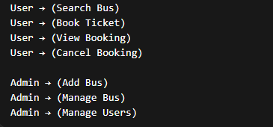

4.3 Data Flow Diagram (DFD):
A DFD shows how data moves inside the system.

4.3.1 Level 0 DFD
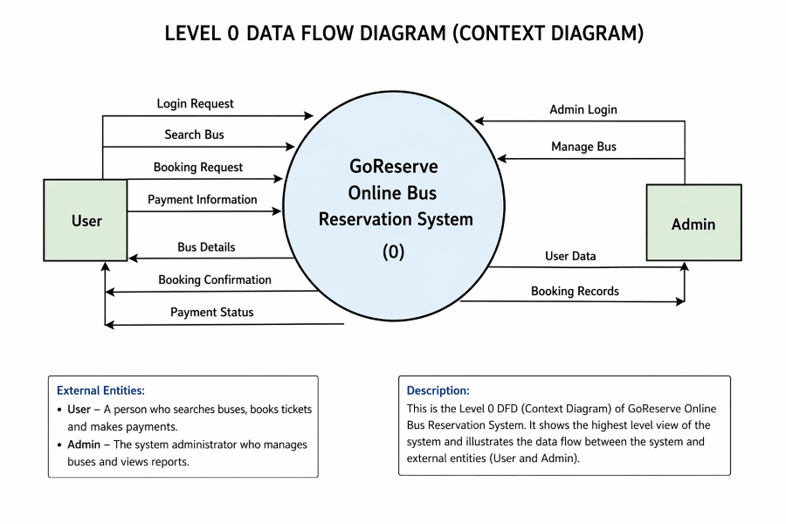

Explanation:
The Level 0 Data Flow Diagram, also known as the Context Diagram, provides a high-level overview of the GoReserve Online Bus Reservation System. It shows how the system interacts with external entities such as the User and the Admin, and how data flows between them.
In this diagram, the entire system is represented as a single process labeled “GoReserve Online Bus Reservation System (0)”. This process acts as the central unit that handles all operations related to bus booking and management.

🔹 User Interaction with the System
The User is one of the main external entities in the system. The user interacts with the system to perform various actions related to booking.
- The user sends a login request to access the system.
- After logging in, the user can search for buses by entering travel details such as source and destination.
- The user then sends a booking request by selecting a bus and entering passenger details.
- The user also provides payment information to complete the booking process.
In response, the system sends back:
- Bus details based on the search
- Booking confirmation after successful booking
- Payment status indicating whether the transaction was successful
This interaction ensures that the user can complete the entire booking process smoothly.

🔹 Admin Interaction with the System
The Admin is responsible for managing the system.
- The admin sends an admin login request to access administrative features.
- The admin can manage buses, which includes adding or updating bus details.
In return, the system provides:
- User data
- Booking records

4.3.2 LEVEL 1 DFD:
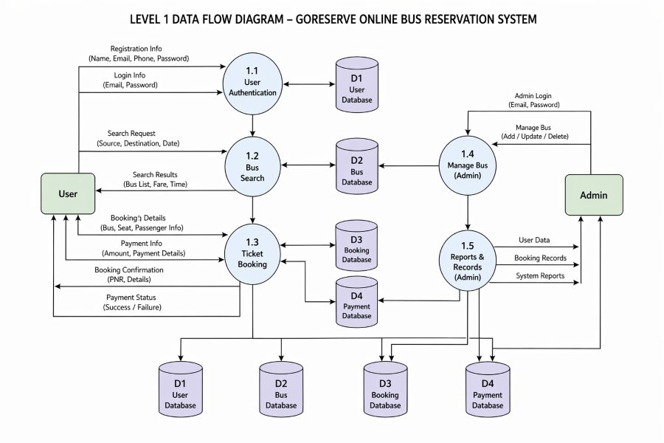
Explanation:

🔷 External Entities
- User
- Admin

🔷 Processes
1.1 User Authentication
1.2 Bus Search
1.3 Ticket Booking
1.4 Manage Bus (Admin)
1.5 Reports & Records (Admin)

🔷 Data Stores
- D1 – User Database
- D2 – Bus Database
- D3 – Booking Database
- D4 – Payment Database

🔷 Data Flow (Write exactly like this in diagram)

👤 User → System
- Registration Info → 1.1
- Login Info → 1.1
- Search Request → 1.2
- Booking Details → 1.3
- Payment Info → 1.3

🔁 System → User
- Search Results ← 1.2
- Booking Confirmation ← 1.3
- Payment Status ← 1.3

⚙️ Admin → System
- Admin Login → 1.4
- Manage Bus → 1.4

🔁 System → Admin
- User Data ← 1.5
- Booking Records ← 1.5

🗄️ Process ↔ Data Store
- 1.1 ↔ D1 (User Data)
- 1.2 ↔ D2 (Bus Data)
- 1.3 ↔ D3 (Booking Data)
- 1.3 ↔ D4 (Payment Data)
- 1.4 ↔ D2 (Bus Management)
- 1.5 ↔ D1, D3, D4

4.3.3 Level 2 DFD:

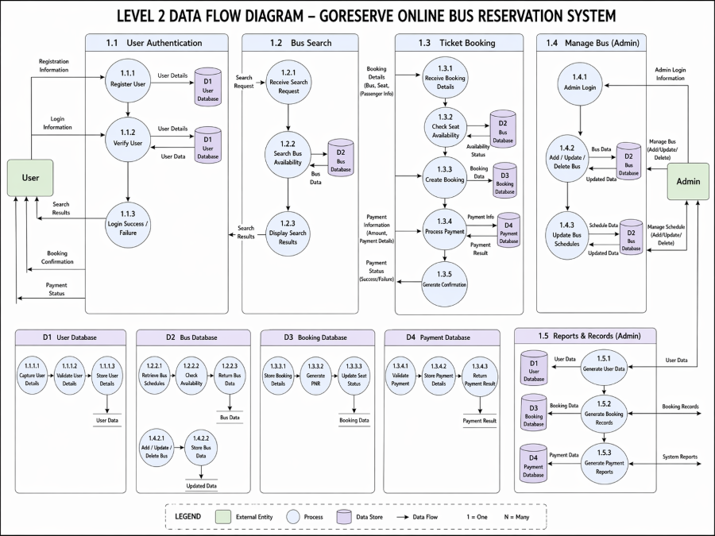

Explanation:
The Level 2 Data Flow Diagram provides a more detailed view of the GoReserve Online Bus Reservation System by breaking down the main processes into smaller sub-processes. It shows how data flows within each module and how different parts of the system interact with each other and with the database.

🔹 User Authentication
This process handles user registration and login.
- Register User: The user enters registration details, which are stored in the User Database (D1).
- Verify User: The system checks login details with stored data.
- Login Success/Failure: Based on verification, the system allows or denies access.
This ensures that only valid users can access the system.

🔹 Bus Search
This process allows users to search for available buses.
- Receive Search Request: The system takes input such as source, destination, and date.
- Check Bus Availability: It retrieves data from the Bus Database (D2).
- Display Search Results: The system shows available buses to the user.
This helps users find suitable travel options quickly.

🔹 Ticket Booking
This is the main process where booking is completed.
- Receive Booking Details: User selects a bus and enters passenger details.
- Check Seat Availability: The system verifies seat availability.
- Create Booking: Booking data is stored in the Booking Database (D3).
- Process Payment: Payment information is processed and stored in Payment Database (D4).
- Generate Confirmation: The system generates booking confirmation and payment status.
This process ensures smooth and accurate ticket booking.

🔹 Manage Bus (Admin)
This process is handled by the admin.
- Admin Login: Admin logs into the system.
- Add/Update/Delete Bus: Admin manages bus details stored in Bus Database (D2).
- Update Bus Schedule: Admin updates schedule and availability.
This helps maintain updated bus information in the system.

🔹 Reports & Records (Admin)
This process provides system reports to the admin.
- Generate User Data: Retrieves user information from D1.
- Generate Booking Records: Retrieves booking data from D3.
- Generate Payment Reports: Retrieves payment data from D4.
This helps the admin monitor system activities and performance.

🔹 Data Stores Used
- D1: User Database
- D2: Bus Database
- D3: Booking Database
- D4: Payment Database

4.4 ER DIAGRAM:

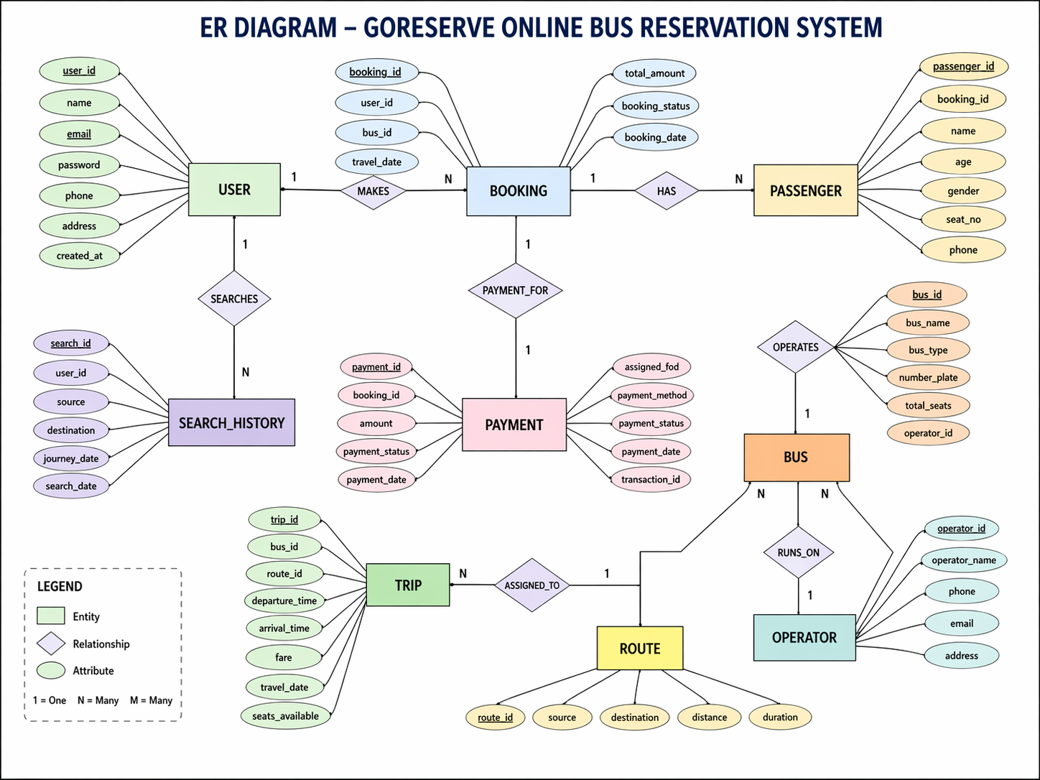

Explanation:

🔹 User Entity
The User entity stores information about people who use the system.
Attributes include user_id, name, email, password, phone, address, and created_at.
A user can:
- Make bookings
- Search for buses
Relationship:
- One user can make multiple bookings (1 : N)
- One user can have multiple search records

🔹 Booking Entity
The Booking entity contains details of ticket reservations.
Attributes include booking_id, user_id, bus_id, travel_date, booking_date, booking_status, and total_amount.
Relationship:
- Each booking is made by one user
- One booking can include multiple passengers (1 : N)
- Each booking is linked to one payment

🔹 Passenger Entity
The Passenger entity stores details of passengers traveling in a booking.
Attributes include passenger_id, booking_id, name, age, gender, seat_no, and phone.
Relationship:
- One booking can have multiple passengers
- Each passenger belongs to one booking

🔹 Bus Entity
The Bus entity contains information about buses available in the system.
Attributes include bus_id, bus_name, bus_type, number_plate, and total_seats.
Relationship:
- One bus can have multiple bookings
- Bus details are managed by the admin

🔹 Payment Entity
The Payment entity stores payment-related details.
Attributes include payment_id, booking_id, amount, payment_method, payment_status, and payment_date.
Relationship:
- Each booking has one payment (1 : 1)
- Payment is linked directly to booking

🔹 Search History Entity
The Search History entity stores user search activities.
Attributes include search_id, user_id, source, destination, journey_date, and search_date.
Relationship:
- One user can perform multiple searches

🔹 Overall Relationships
- User → Booking (1 : N)
- Booking → Passenger (1 : N)
- Booking → Payment (1 : 1)
- User → Search History (1 : N)
- Bus → Booking (1 : N)

4.5 DATABASE DESIGN:

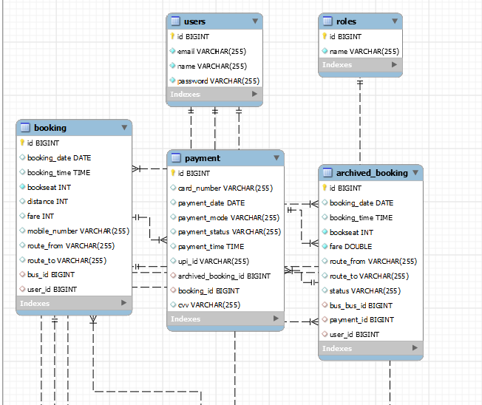

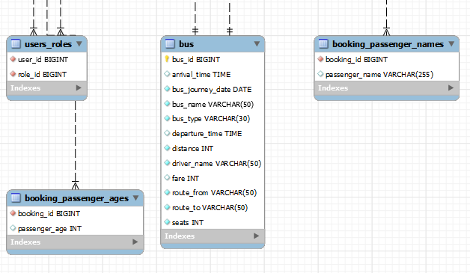
The GoReserve system uses a relational database (MySQL) to store and manage application data. The database is designed to efficiently handle users, buses, bookings, payments, and archived records. Route information is not stored in a separate table; instead, source and destination details are stored within the booking and bus records.

User Table:
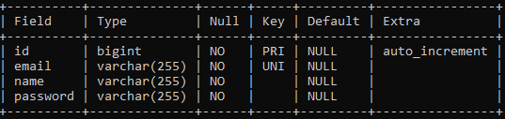

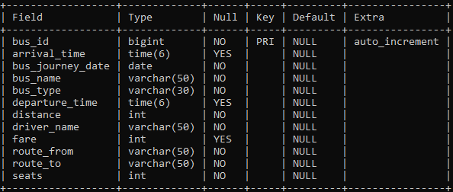
Bus Table:

Booking Table:
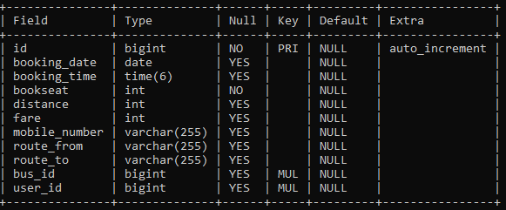

Payment Table:
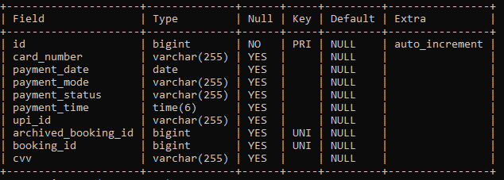

Archived Booking Table:
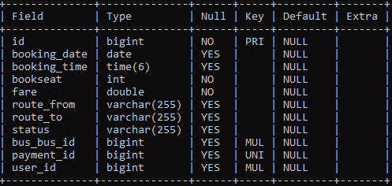
CHAPTER – 5
IMPLEMENTATON

5.1 Tools and Technologies Used
The GoReserve system is developed using a combination of modern tools and technologies that help in building a reliable, secure, and efficient web-based application. These technologies are selected to ensure smooth performance, easy maintenance, and better user experience.

🔹 5.1.1 Operating System
- Windows 10 / Windows 11
(Any modern operating system supporting Java can be used)

🔹 5.1.2 Programming Languages
- Java (JDK 21)
- HTML5
- CSS3
- JavaScript

🔹 5.1.3 Frameworks & Technologies
- Spring Boot – Used for backend development and application configuration
- Spring MVC – Helps in implementing MVC architecture
- Spring Security – Provides authentication and authorization
- Thymeleaf – Used for creating dynamic web pages
- Hibernate / JPA – Used for database interaction and ORM

🔹 5.1.4 Database
- MySQL – Used as a relational database to store all system data

🔹 5.1.5 Development Tools & IDE
- Eclipse IDE (Spring Tool Suite – STS)
- Maven – Used for dependency management and project build

🔹 5.1.6 Web Technologies
- Bootstrap – Used for responsive UI design
- HTTP/HTTPS – Used for communication between client and server

🔹 5.1.7 Server
- Embedded Apache Tomcat server is used to run the application without requiring external server setup.

5.2 Hardware Requirements
The hardware requirements for the GoReserve project are minimal, making the system cost-effective and accessible.
- Processor: Intel i5 or above
- RAM: Minimum 8 GB
- Storage: 256 GB SSD
- Internet Connection
The system was developed and tested on an average-specification PC and does not require high-end hardware.

5.3 Module Description
The GoReserve system is divided into multiple logical modules, each responsible for a specific functionality. This modular design improves system organization, maintainability, and scalability.

🔹 5.3.1 User Module
This module handles all user-related operations.
Functions:
- User registration
- User authentication (login/logout)
- Searching available buses
- Booking tickets
- Viewing booking history
- Cancelling bookings

🔹 5.3.2 Bus Management Module
This module is used by the admin to manage bus-related data.
Functions:
- Add new buses
- Update bus details
- Delete buses
- Manage bus routes and availability

🔹 5.3.3 Booking Module
This module handles ticket booking operations.
Functions:
- Enter passenger details
- Basic seat allocation
- Booking confirmation
- Storing booking details in database

🔹 5.3.4 Payment Module
This module manages payment-related activities.
Functions:
- Simulated payment processing
- Payment status tracking
- Linking payment with booking
- Handling cancelled payments

🔹 5.3.5 Admin Module
This module provides administrative control over the system.
Functions:
- Admin login
- Monitoring users
- Monitoring bookings
- Managing buses

🔹 5.3.6 Archived Booking Module
This module manages cancelled bookings separately.
Functions:
- Move cancelled bookings to archive
- Maintain payment linkage
- Support refund tracking

5.4 Process Logic
The process logic describes how different modules interact with each other and how data flows through the system during various operations.

🔹 5.4.1 User Registration & Login Process
- User accesses the registration page
- User enters details and submits the form
- Password is encrypted using BCrypt
- User data is stored in the Users table
- During login, credentials are validated
- On success, the user is redirected to the dashboard

🔹 5.4.2 Bus Search Process
- User enters source and destination
- System retrieves matching buses from the Bus table
- Available buses are displayed to the user

🔹 5.4.3 Ticket Booking Process
- User selects a bus and enters booking details
- Fare is calculated based on predefined bus price
- Booking details are stored in the Booking table
- User is redirected to the payment process

🔹 5.4.4 Payment Process
- User selects payment mode (simulated)
- Payment details are processed
- Payment status is updated as PAID or CANCELLED
- Payment record is stored in the Payment table

🔹 5.4.5 Booking Cancellation Process
- User requests cancellation
- Booking status is updated
- Booking is moved to ArchivedBooking table
- Refund process is initiated (informational)
5.5 PROJECT SCREENSHOTS:

