Figure 1cropped-DMSE-Favicon-32x32
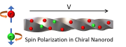
Figure 2cropped-DMSE-Favicon-180x180
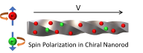
Figure 3cropped-DMSE-Favicon-192x192

Figure 4IMG_0668-final-scaled-aspect-ratio-425-490-scaled-425x490-c-default

Figure 5IMG_0668-final-scaled-aspect-ratio-425-490-scaled-850x980-c-default

Figure 6Icon001
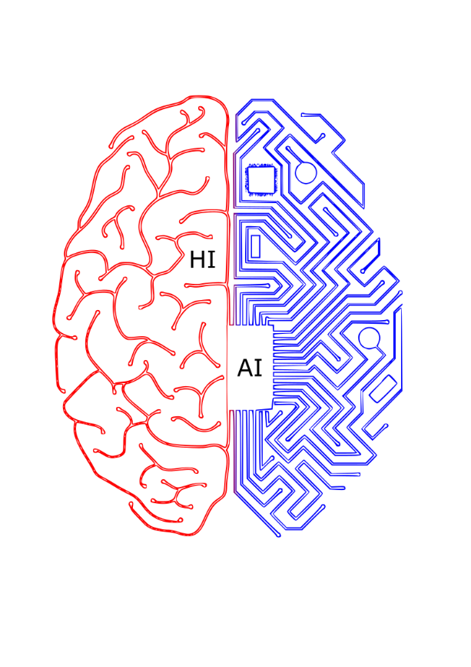
Figure 7Icon-ViKo-web
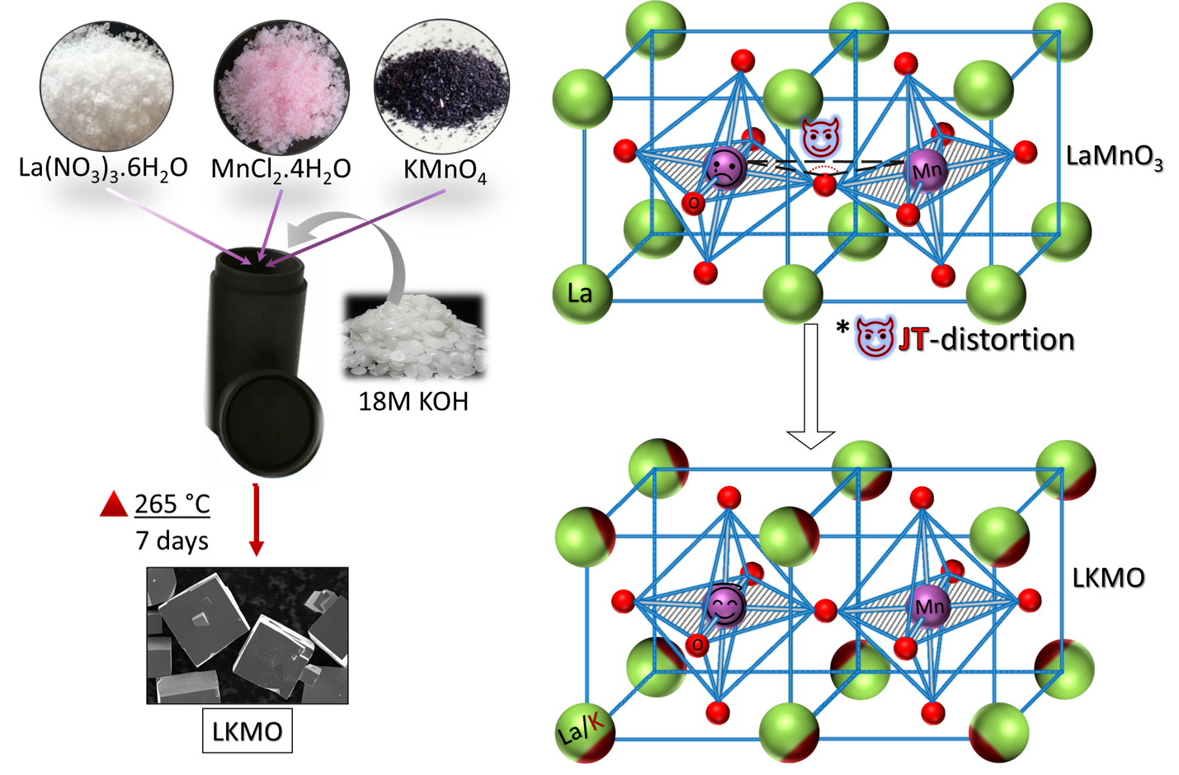
Figure 8K-Substitution
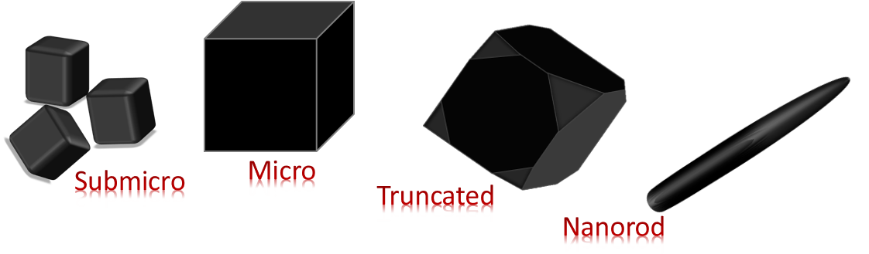
Figure 9Morphology

