**Asset Dashboard**

Emossy assets dashboard is an interactive graph and analytical visualize tool used for viewing assets from different perspectives. These perspectives provide insight on asset categories, conditions, costs, warranty and usage behavior. The Assets dashboard is particularly useful for the ITIO user role. Viewing assets at a global level or view a smaller set of assets by applying local filters on the graph, chart or table view.

**Key Features Of Using The Emossy Assets Dashboard Include The Following:**

• Identify over-provisioned resources.

• Obtain insights that identify ways to use resources more efficiently and more cost-effectively.

• View your asset count, the warehouse location of your assets, and the condition & costs of your assets.

• View detailed information history about an asset.

• Determine whether your assets are underutilized or over-utilized and if a specific asset requires action or further investigation.

• Apply depreciation calculation on assets.

• Apply Tags to Multiple Assets (Bulk Tagging)

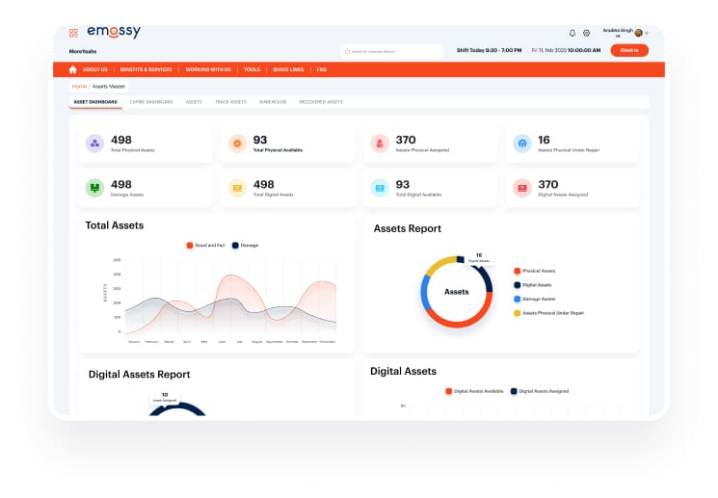

**Asset Tracker**

• Emossy’s assets management helps businesses identify bottlenecks, make informed decisions, monitor the cloud based ITIL asset management solution performance, and improves service delivery with predefined and custom reporting capabilities.  
  
Emossy digital assets tracking also plans license purchase and detect contract infringements proactively with timely notifications. It helps in speeding up contract renewals easily by leveraging automated approval workflows

**Emossy assets management helps you with:**

• Hardware assets tracking

• Software assets tracking

• Associated vendors and contracts

• Managing asset groups & warehouses

• Asset relationship & condition with respect to asset type 7 categories

• Asset history

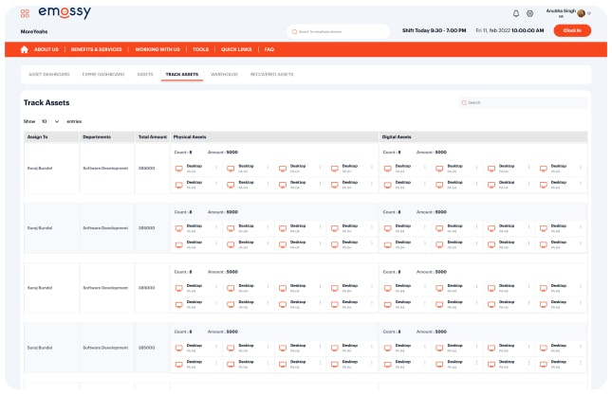

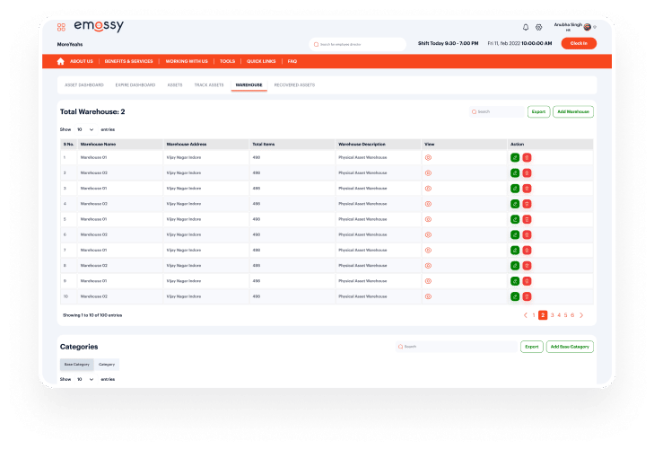

**Assets Warehouse Management**

• Emossy assets warehouse management enables a company to manage multiple warehouses within a single system. Our integrated systems help efficiently manage the tracking and assigning of items to a specific warehouse along with its location. Also have the system send assets information or alerts automatically to people, groups or other systems.

**Assets Reports**

Emossy assets reports shows the Purchase Amount, Depreciated Amount and accumulated total depreciation for all the assets under the selected date range, type & categories of assets. It also shows the current value & warranty and current depreciation status of the Asset. It also provides a unified view of all the details regarding current status or condition of an asset.

